**Trivial File Transfer Protocol (TFTP)**

**ECEN 602 Network Programming Assignment 3**

Yinan Zhu 825008922 Liuyi Jin 225009797

Case (1): transfer a binary file of 2048 bytes and check that it matches the source file

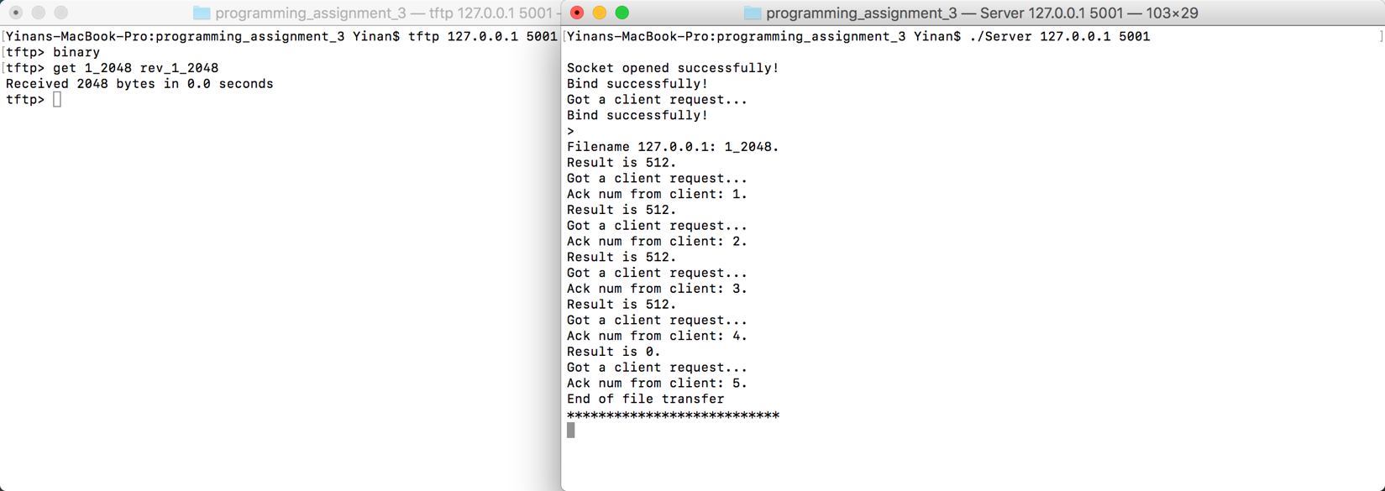

Case (2): transfer a binary file of 2047 bytes and check that it matches the source file

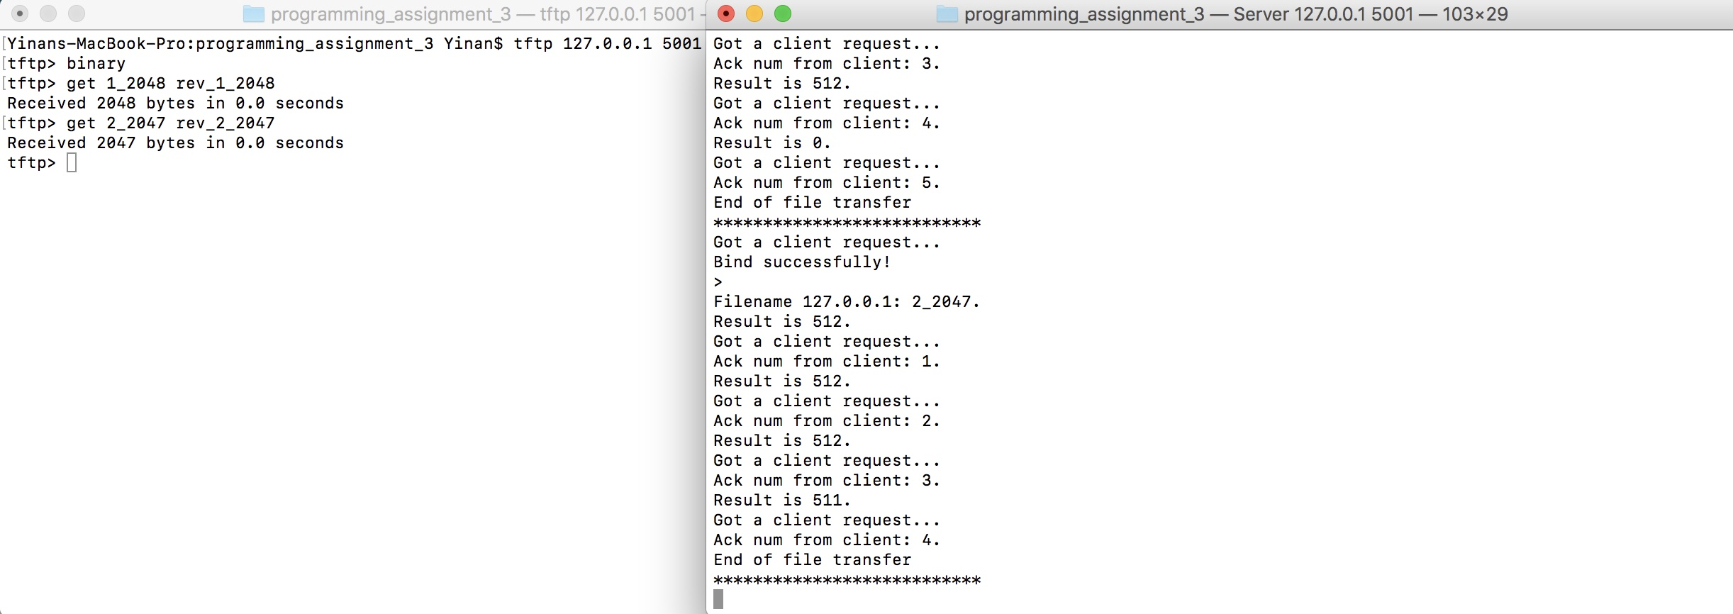

Case (3): transfer a netascii file that includes two CR’s and check that the resulting file matches the input file

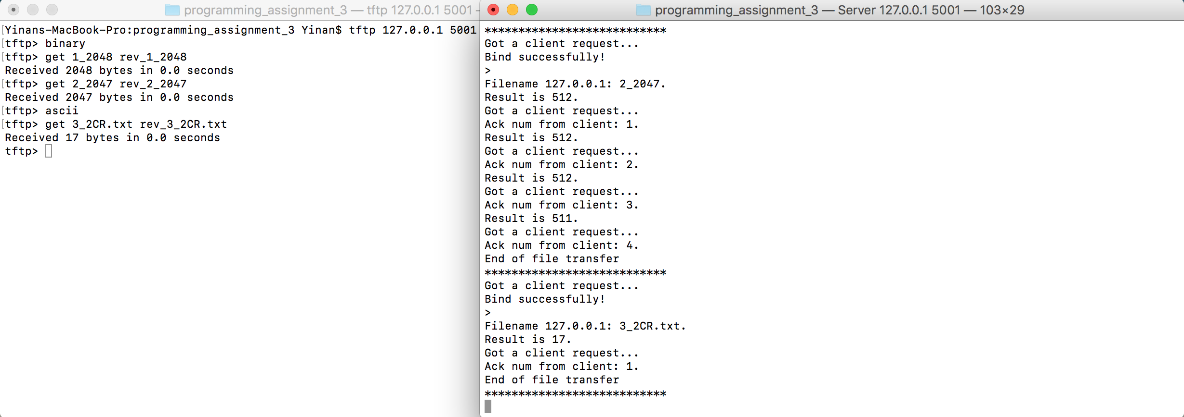

Case (4): transfer a binary file of 34 MB and see if block number wrap-around works

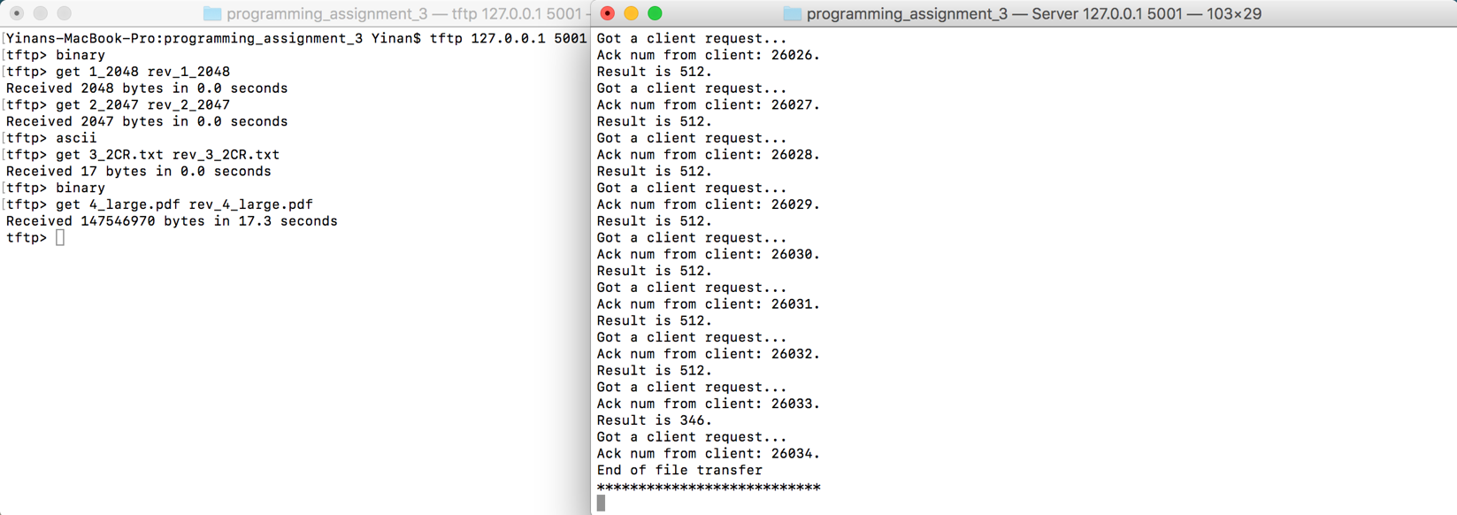

Case (5): check that you receive an error message if you try to transfer a file that does not exist and that your server cleans up and the child process exits

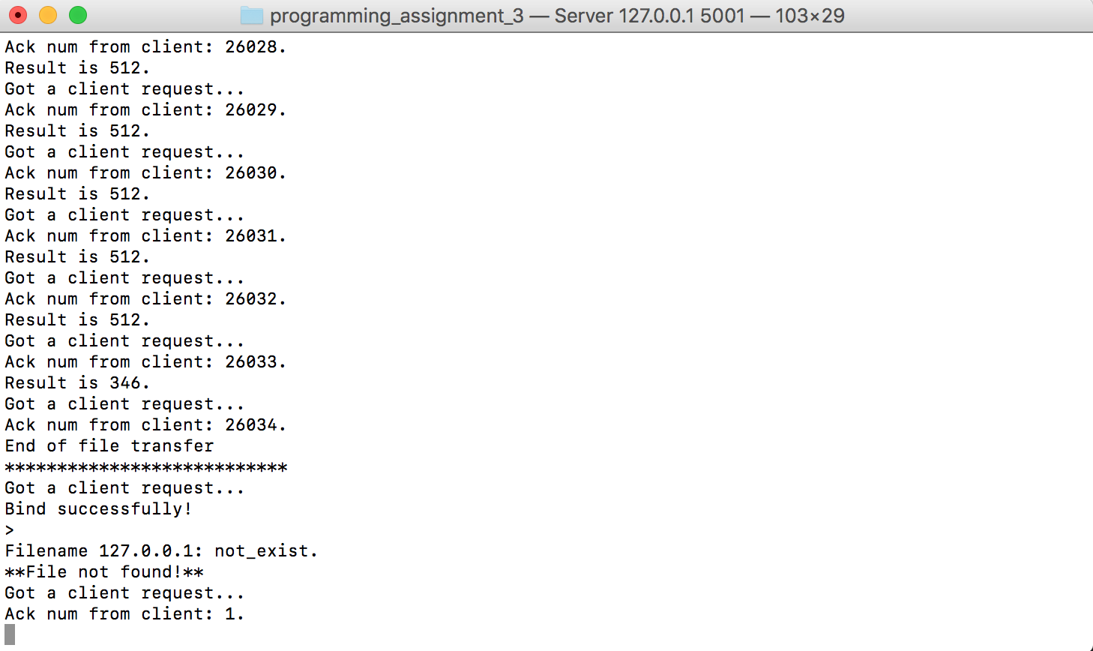

Case (6): connect to the TFTP server with three clients simultaneously and test that the transfers work correctly

