Data Regression

Yishan Liu

November 1, 2015

# Data Analysis about Ozone Data

## Read the data

setwd("/Users/Gracie/Desktop/BigData")  
mydata<-read.csv("ozone_data.csv")

## Create Linear Regression Model

summary(lm(Ozone~Temp+Wind,data=mydata))

##   
## Call:  
## lm(formula = Ozone ~ Temp + Wind, data = mydata)  
##   
## Residuals:  
## Min 1Q Median 3Q Max   
## -42.156 -13.216 -3.123 10.598 98.492   
##   
## Coefficients:  
## Estimate Std. Error t value Pr(>|t|)   
## (Intercept) -67.3220 23.6210 -2.850 0.00524 **   
## Temp 1.8276 0.2506 7.294 5.29e-11 ***  
## Wind -3.2948 0.6711 -4.909 3.26e-06 ***  
## ---  
## Signif. codes: 0 '***' 0.001 '**' 0.01 '*' 0.05 '.' 0.1 ' ' 1  
##   
## Residual standard error: 21.73 on 108 degrees of freedom  
## Multiple R-squared: 0.5814, Adjusted R-squared: 0.5736   
## F-statistic: 74.99 on 2 and 108 DF, p-value: < 2.2e-16

From the summary we get regression model is as follows:

The value is 0.5611, it is a fair but not a very good model.

## Explore the data by drawing correlation plot and calculate Pearson's correlation coefficient

pairs(mydata)

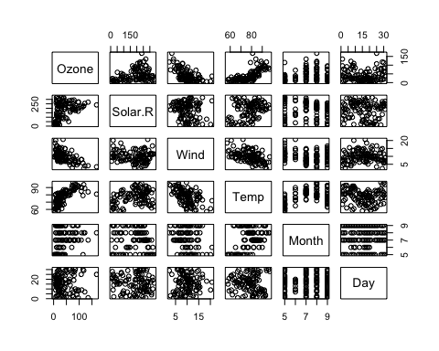

cor(mydata)

## Ozone Solar.R Wind Temp Month  
## Ozone 1.000000000 0.34834169 -0.61249658 0.6985414 0.142885168  
## Solar.R 0.348341693 1.00000000 -0.12718345 0.2940876 -0.074066683  
## Wind -0.612496576 -0.12718345 1.00000000 -0.4971897 -0.194495804  
## Temp 0.698541410 0.29408764 -0.49718972 1.0000000 0.403971709  
## Month 0.142885168 -0.07406668 -0.19449580 0.4039717 1.000000000  
## Day -0.005189769 -0.05775380 0.04987102 -0.0965458 -0.009001079  
## Day  
## Ozone -0.005189769  
## Solar.R -0.057753801  
## Wind 0.049871017  
## Temp -0.096545800  
## Month -0.009001079  
## Day 1.000000000

From the plot and the correlation value, we could see that Wind and Temp have relative greater effects on Ozone value. Let's try another model add predictor Temp*Wind

summary(model1<-lm(Ozone~Temp+Wind+Temp*Wind,data=mydata))

##   
## Call:  
## lm(formula = Ozone ~ Temp + Wind + Temp * Wind, data = mydata)  
##   
## Residuals:  
## Min 1Q Median 3Q Max   
## -40.930 -11.193 -3.034 8.193 97.456   
##   
## Coefficients:  
## Estimate Std. Error t value Pr(>|t|)   
## (Intercept) -239.8918 48.6200 -4.934 2.97e-06 ***  
## Temp 4.0005 0.5935 6.741 8.26e-10 ***  
## Wind 13.5975 4.2835 3.174 0.001961 **   
## Temp:Wind -0.2173 0.0545 -3.987 0.000123 ***  
## ---  
## Signif. codes: 0 '***' 0.001 '**' 0.01 '*' 0.05 '.' 0.1 ' ' 1  
##   
## Residual standard error: 20.37 on 107 degrees of freedom  
## Multiple R-squared: 0.6355, Adjusted R-squared: 0.6253   
## F-statistic: 62.19 on 3 and 107 DF, p-value: < 2.2e-16

We could see that we had increased the by adding the multiplicated predictor.

#Calculate 95% confidence interval  
confint(model1,conf.level=0.95)

## 2.5 % 97.5 %  
## (Intercept) -336.2751998 -143.5084539  
## Temp 2.8240024 5.1770536  
## Wind 5.1059971 22.0889184  
## Temp:Wind -0.3253122 -0.1092398

## Hypothesis Test about Ozone value

H0:Value of Ozone in population is >=50 H1:Value of Ozone in population is <50

newdata<-mydata[(1)]  
t.test(newdata,alternative="less",mu=50)

##   
## One Sample t-test  
##   
## data: newdata  
## t = -2.5015, df = 110, p-value = 0.006919  
## alternative hypothesis: true mean is less than 50  
## 95 percent confidence interval:  
## -Inf 47.33835  
## sample estimates:  
## mean of x   
## 42.0991

Since P-value 0.006919 is less than alpha=0.05, we should reject the null hypothesis. The Ozone value in population should be less then 50.