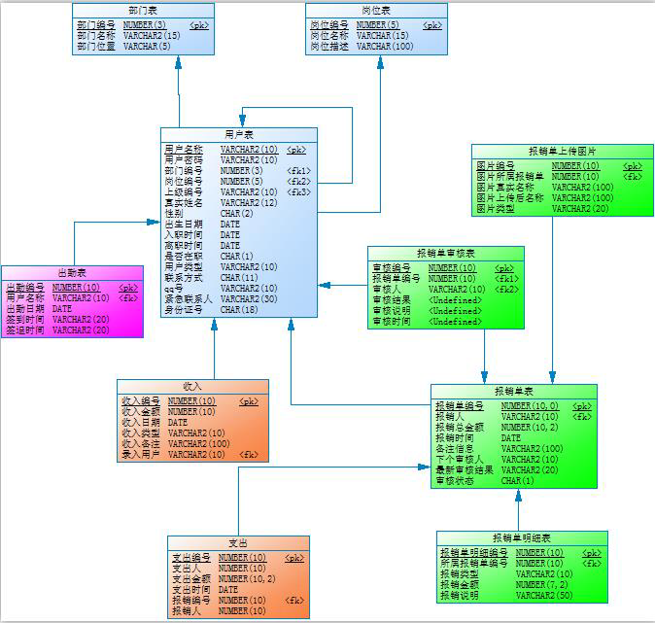

用户表

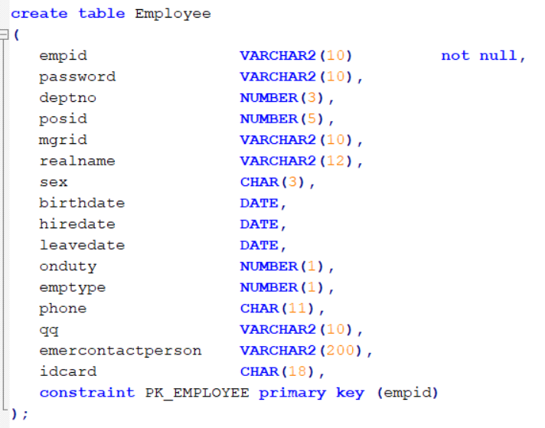

onduty : 0-离职, 1-在职

emptype : 1-普通员工, 2-管理员:含经理, 总监, 总裁等, 3-管理员

报销单上传图片表

CREATE TABLE ExpImage

(

   imgid                INT(10)           NOT NULL,

   expid                INT(10),

   realname             VARCHAR(100),

   filename             VARCHAR(100),

   filetype             VARCHAR(20),

   CONSTRAINT PK_EXPIMAGE PRIMARY KEY (imgid)

);

报销单审核表

CREATE TABLE auditing

(

   auditid              INT(10)           NOT NULL,

   expid                INT(10),

   empid                VARCHAR(10),

   result               VARCHAR(10),

   auditdesc            VARCHAR(50),

   TIME                 DATE,

   CONSTRAINT PK_AUDITING PRIMARY KEY (auditid)

);

部门表

CREATE TABLE dept

(

   deptno               INT(3)            NOT NULL,

   deptname             VARCHAR(15),

   location             VARCHAR(5),

   CONSTRAINT PK_DEPT PRIMARY KEY (deptno)

);

出勤表

CREATE TABLE duty

(

   dtid                 INT(10)           NOT NULL,

   emprid               VARCHAR(10),

   dtdate               DATE,

   signintime           VARCHAR(20),

   signouttime          VARCHAR(20),

   CONSTRAINT PK_DUTY PRIMARY KEY (dtid)

);

报销单表

CREATE TABLE expense

(

   expid                INT(10)         NOT NULL,

   empid                INT(10),

   totalamount          FLOAT(10,2),

   exptime              DATE,

   expdesc              VARCHAR(100),

   nextauditor          VARCHAR(10),

   lastResult           VARCHAR(20),

   STATUS               CHAR(1),

   CONSTRAINT PK_EXPENSE PRIMARY KEY (expid)

);

报销单明细表

CREATE TABLE expenseitem

(

   itemid               INT(10)           NOT NULL,

   expid                INT(10),

   TYPE                 VARCHAR(10),

   amount               FLOAT(7,2),

   itemdesc             VARCHAR(50),

   CONSTRAINT PK_EXPENSEITEM PRIMARY KEY (itemid)

);

收入表

CREATE TABLE income

(

   icid                 INT(10)           NOT NULL,

   amount               INT(10),

   icdate               DATE,

   ictype               VARCHAR(10),

   indesc               VARCHAR(100),

   userid               VARCHAR(10),

   CONSTRAINT PK_INCOME PRIMARY KEY (icid)

);

支出表

CREATE TABLE payment

(

   pid                  INT(10)           NOT NULL,

   payempid             INT(10),

   amount               FLOAT(10,2),

   paytime              DATE,

   expid                INT(10),

   empid                VARCHAR(10),

   CONSTRAINT PK_PAYMENT PRIMARY KEY (pid)

);

岗位表

create table position

(

   posid                NUMBER(5)            not null,

   pname                VARCHAR(15),

   pdesc                VARCHAR(100),

   constraint PK_POSITION primary key (posid)

);