# 1. topo

topo as following

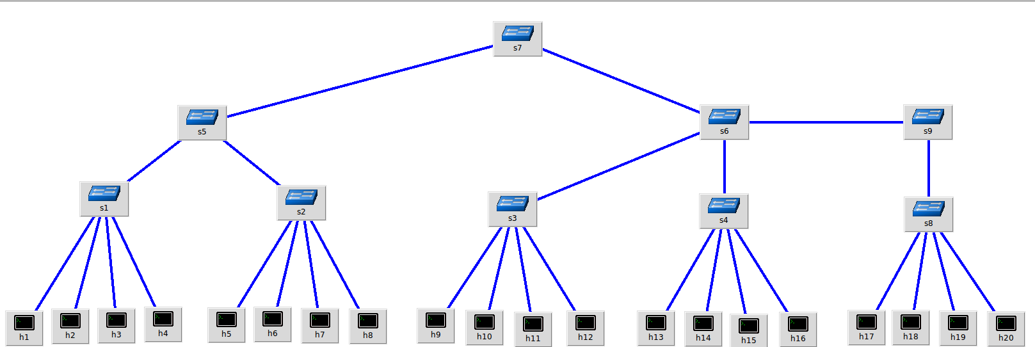

topo.png

end to end network as table below:

|  |  |  |  |  |
| --- | --- | --- | --- | --- |
| No | From | To | Delay(ms) | Bandwidth(Mbps) |
| 1 | h1 | h2 | 2 | 1000 |
| 2 | h1 | h5 | 20 | 1000 |
| 3 | h1 | h9 | 30 | 1000 |
| 4 | h1 | h13 | 40 | 1000 |
| 5 | h1 | h17 | 50 | 1000 |

# 2. TCP Fairness

setup 5 concurrent flow, traffic distribution as following  
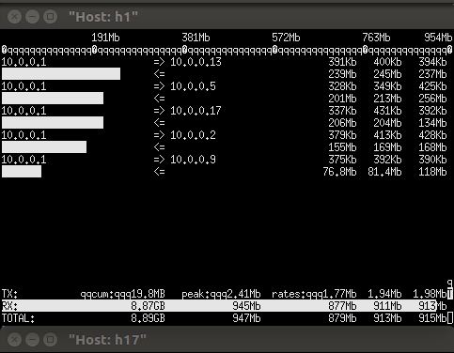

throughput faireness details as below

|  |  |  |
| --- | --- | --- |
| No | delay(ms) | throughput_AVG(Mbps) |
| 1 | 2 | 202 |
| 2 | 20 | 330 |
| 3 | 30 | 150 |
| 4 | 40 | 127 |
| 5 | 50 | 129 |

2ms  
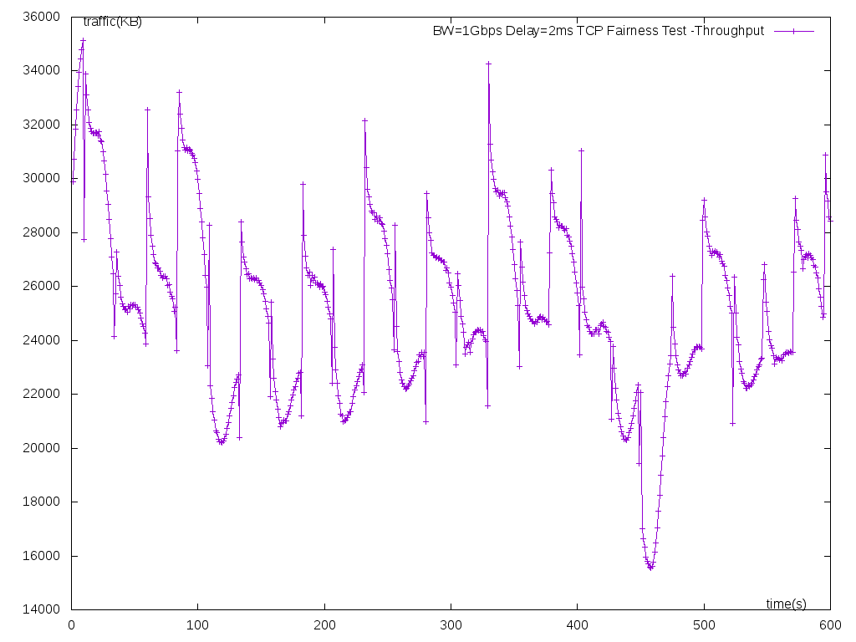

20ms  
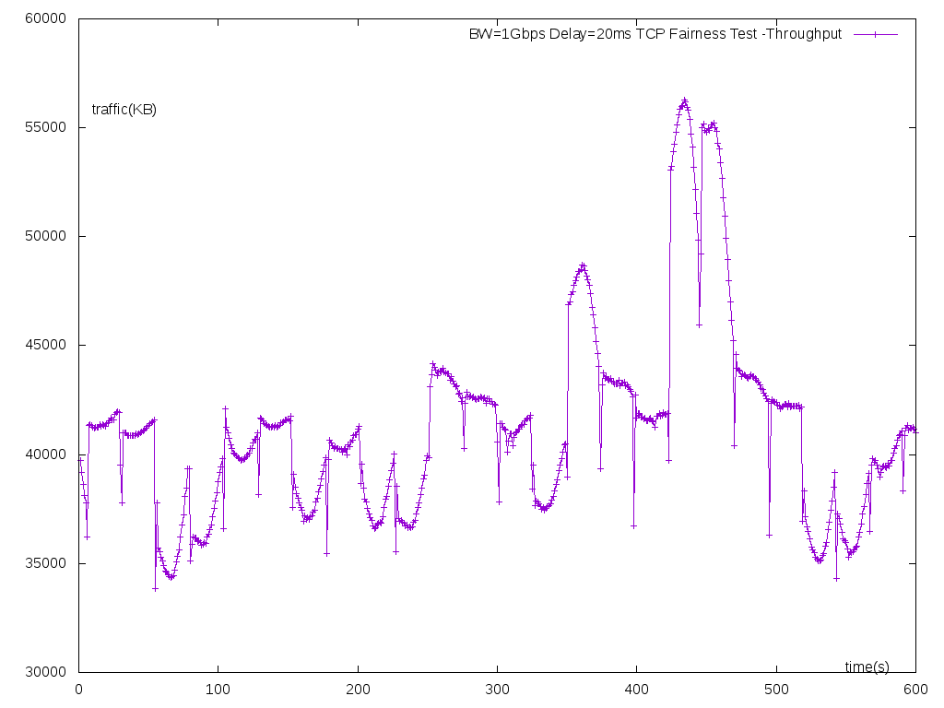

30ms  
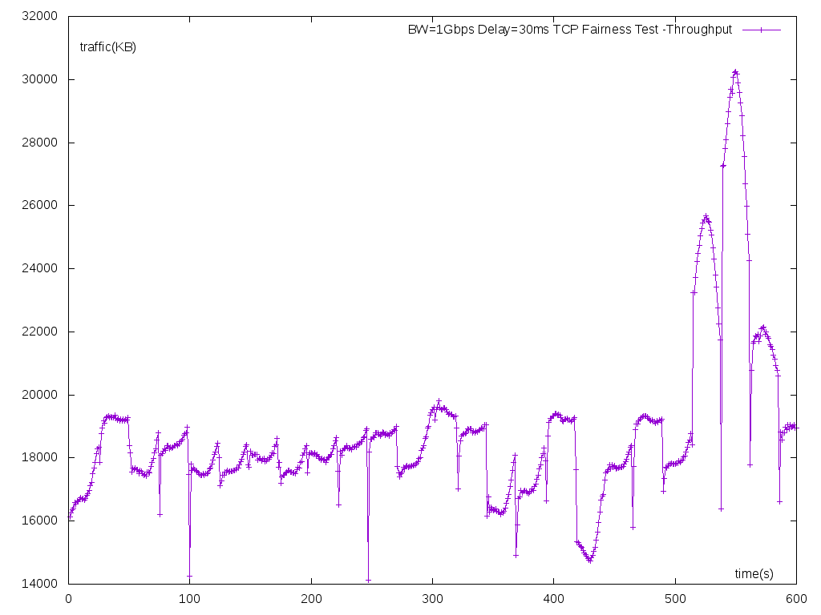

40ms  
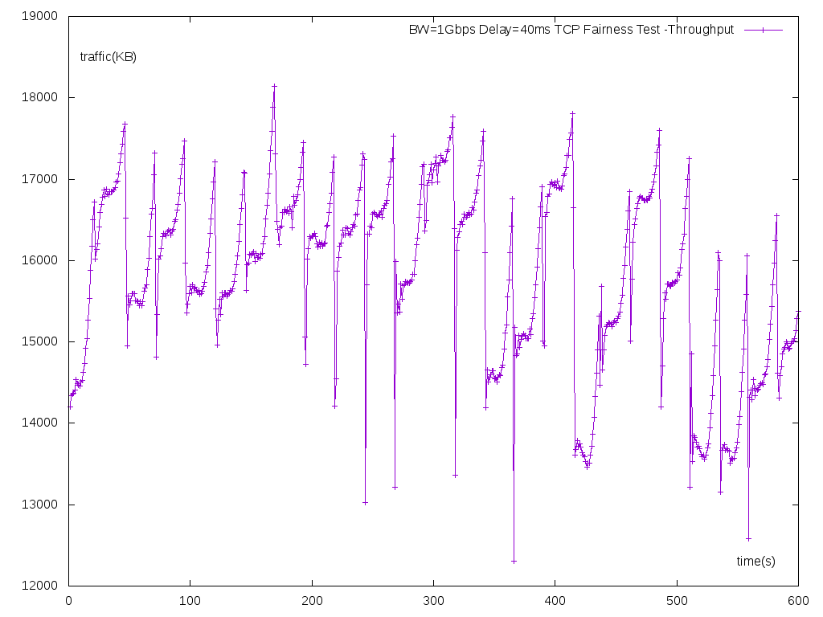

50ms  
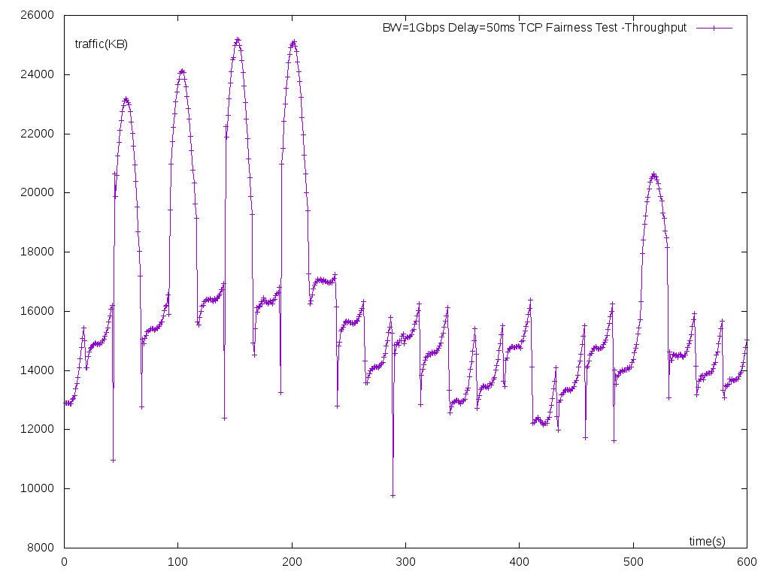

# 3. UDT Fairness

setup 5 concurrent flows, traffic distribution as following  
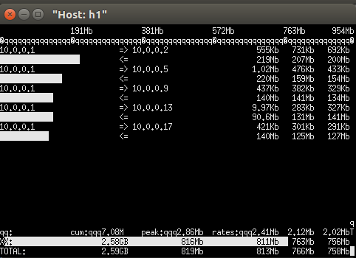

throughput faireness details as below

|  |  |  |  |
| --- | --- | --- | --- |
| No | delay(ms) | throughput_AVG(Mbps) | 下降比例 (%) |
| 1 | 2 | 233 | 0 |
| 2 | 20 | 189 | 19 |
| 3 | 30 | 170 | 27 |
| 4 | 40 | 167 | 28 |
| 5 | 50 | 161 | 31 |

2ms  
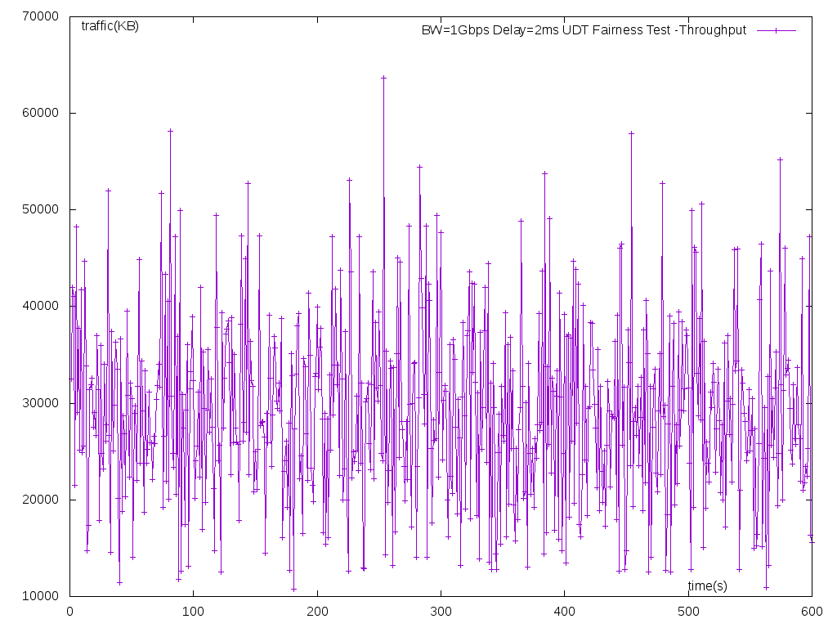

20ms  
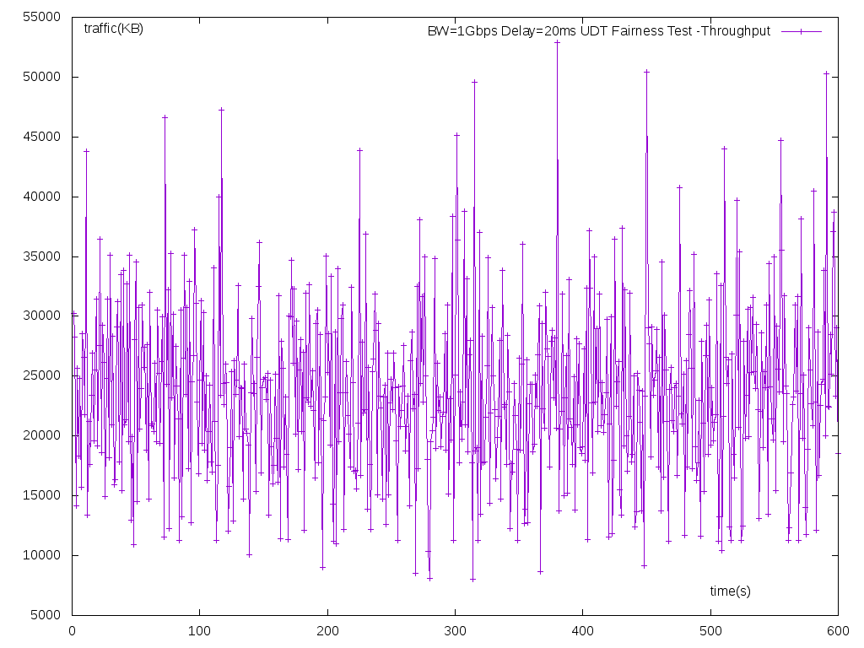

30ms  
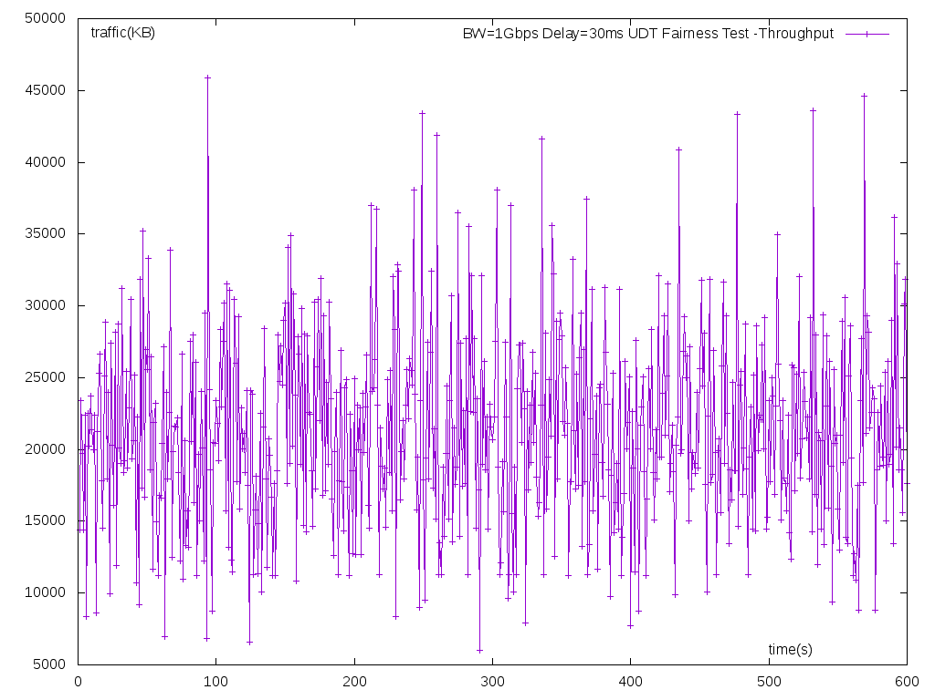

40ms  
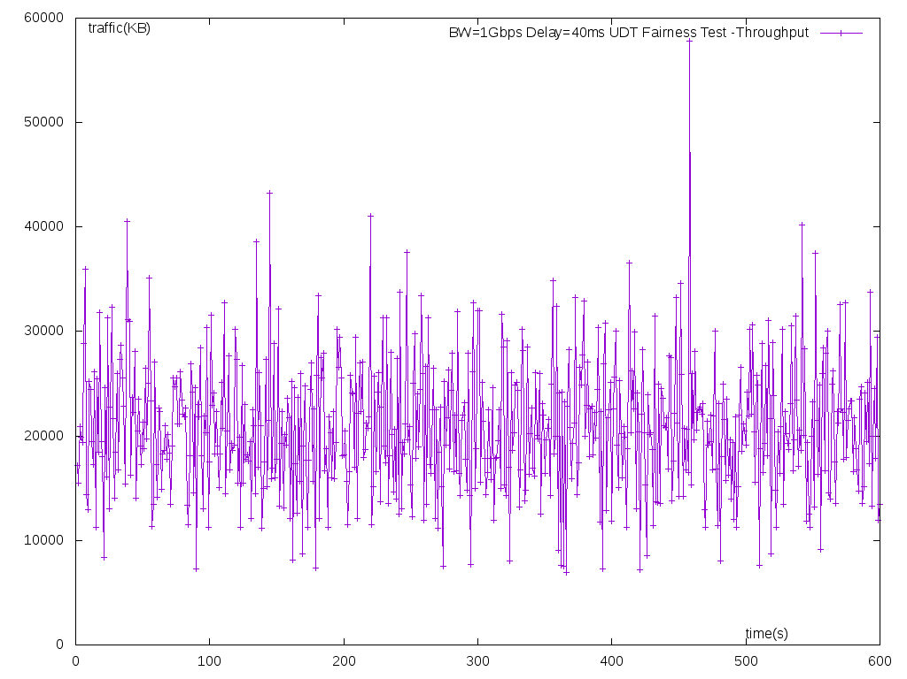

50ms  
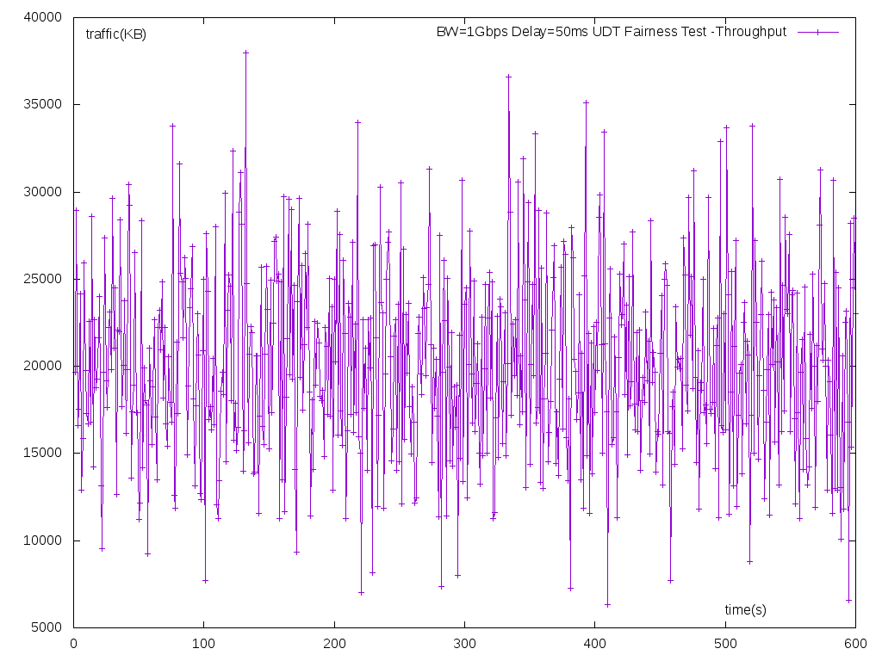

# 4. conclusion

|  |  |  |  |
| --- | --- | --- | --- |
| No | delay(ms) | TCP throughput_AVG(Mbps) | UDT throughput_AVG(Mbps) |
| 1 | 2 | 202 | 233 |
| 2 | 20 | 330 | 189 |
| 3 | 30 | 150 | 170 |
| 4 | 40 | 127 | 167 |
| 5 | 50 | 129 | 161 |
| sum | - | 938 | 920 |

在带宽相同的条件下，TCP 拥塞控制算法(cube) 会为延迟较小的节点分配较高的带宽，但还存在先启动的服务占用更大带宽的可能性。

UDT的拥塞控制也有这个趋势，但是带宽分配随延迟的变化幅度较小，在带宽分配上会更加公平一些