实验四：工厂模式

(1) 简单工厂方法（50分）
保险理赔包含几个基本类型：驾驶员身体受伤、汽车损坏、人员伤亡、多种事故。使用简单工厂方法模式设计并实现一个可以创建不同保险理赔对象的应用。具体界面要求如下。

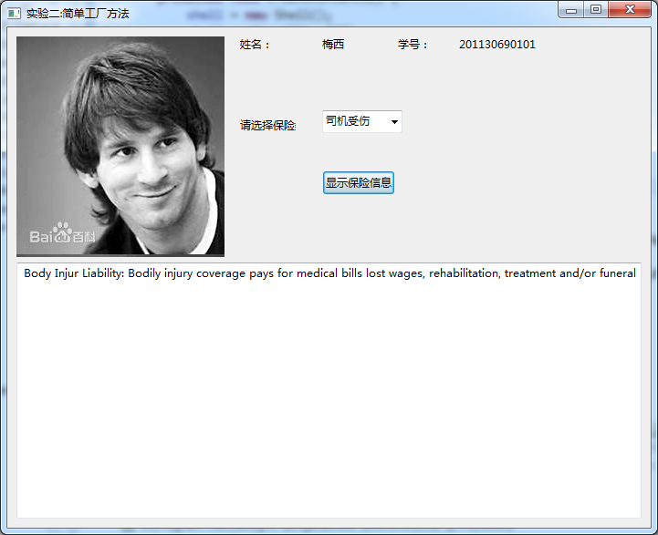
实验名称
本人的自拍照
姓名
学号

1.1 UML图

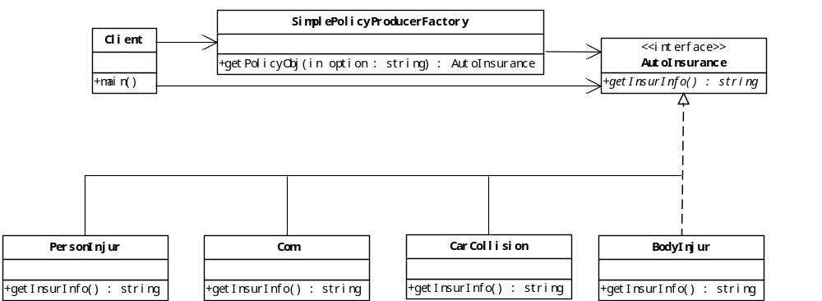

1.2 代码
package cn.scau.edu.chenpeifu.client;

import java.io.BufferedReader;
import java.io.IOException;
import java.io.InputStreamReader;

import cn.scau.edu.chenpeifu.simplefactory.domain.AutoInsurance;
import cn.scau.edu.chenpeifu.simplefactory.domain.SimplePolicyProducerFactory;

public class SimpleFactoryClient {

public static void main(String[] args) {
// TODO Auto-generated method stub
System.out.println("please enter your InsuranceType:");
InputStreamReader is = new InputStreamReader(System.in); // new构造InputStreamReader对象
BufferedReader br = new BufferedReader(is); // 拿构造的方法传到BufferedReader中
try { // 该方法中有个IOExcepiton需要捕获
String type = br.readLine();
AutoInsurance ai = SimplePolicyProducerFactory.getPolicyObj(type);
String desc = ai.getInsurInfo();
System.out.println("The information is about " + desc);
} catch (IOException e) {
e.printStackTrace();
}

}

}

package cn.scau.edu.chenpeifu.simplefactory.domain;

public class SimplePolicyProducerFactory {
public static AutoInsurance getPolicyObj(String option){
AutoInsurance policy = null;
if(option.compareToIgnoreCase("BodyInjur") == 0) {policy = new BodyInjur();}
else if(option.compareToIgnoreCase("CarCollision") == 0) {policy = new CarCollision();}
else if(option.compareToIgnoreCase("PersonInjur") == 0) {policy = new PersonInjur();}
else if(option.compareToIgnoreCase("Com") == 0) {policy = new Com();}

return policy;
}
}

package cn.scau.edu.chenpeifu.simplefactory.domain;

public class PersonInjur implements AutoInsurance {

@Override
public String getInsurInfo() {
// TODO Auto-generated method stub
return "PersonInjur";
}

}

package cn.scau.edu.chenpeifu.simplefactory.domain;

public class Com implements AutoInsurance {

@Override
public String getInsurInfo() {
// TODO Auto-generated method stub
return "Com";
}

}

package cn.scau.edu.chenpeifu.simplefactory.domain;

public class CarCollision implements AutoInsurance {

@Override
public String getInsurInfo() {
// TODO Auto-generated method stub
return "CarCollision";
}

}

package cn.scau.edu.chenpeifu.simplefactory.domain;

public class BodyInjur implements AutoInsurance {

@Override
public String getInsurInfo() {
// TODO Auto-generated method stub
return "BodyInjur";
}

}

package cn.scau.edu.chenpeifu.simplefactory.domain;

public interface AutoInsurance {
abstract String getInsurInfo();
}

(2) 工厂方法模式（30分）
利用工厂方法实现上面的要求。

2.1 UML图
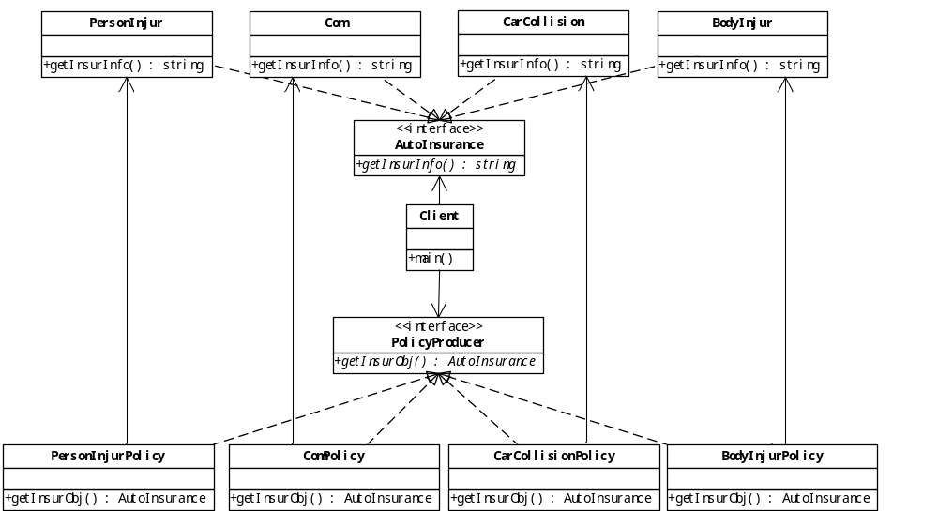
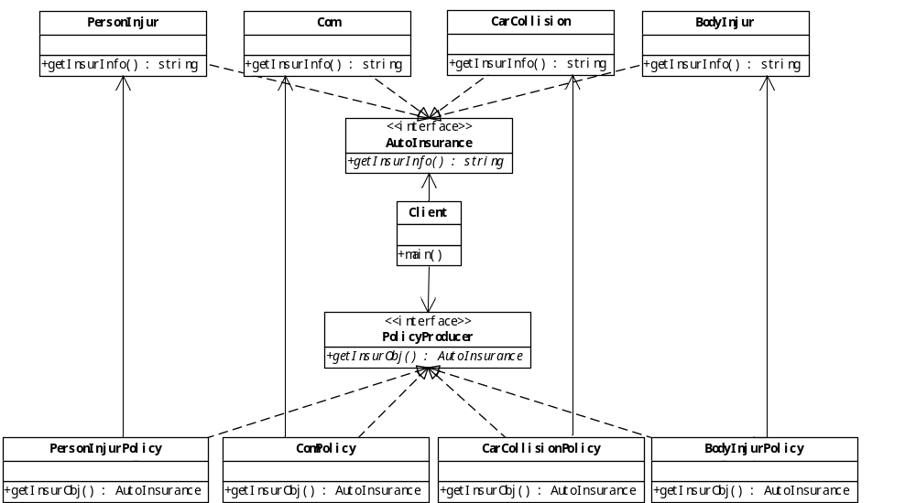

2.2 代码
package cn.scau.edu.chenpeifu.client;

import java.util.Scanner;

import cn.scau.edu.chenpeifu.factory.domain.AutoInsurance;
import cn.scau.edu.chenpeifu.factory.policyproducer.BodyInjurPolicy;
import cn.scau.edu.chenpeifu.factory.policyproducer.CarCollisionPolicy;
import cn.scau.edu.chenpeifu.factory.policyproducer.ComPolicy;
import cn.scau.edu.chenpeifu.factory.policyproducer.PersonInjurPolicy;
import cn.scau.edu.chenpeifu.factory.policyproducer.PolicyProducer;

public class FactoryClient {

@SuppressWarnings("resource")
public static void main(String[] args) {
// TODO Auto-generated method stub
System.out.println("please enter your InsuranceType:");
String type = new Scanner(System.in).nextLine();
PolicyProducer pp = null;
if (type.compareToIgnoreCase("BodyInjur") == 0) {
pp = new BodyInjurPolicy();
} // 建立具体工厂
else if (type.compareToIgnoreCase("Com") == 0) {
pp = new ComPolicy();
} else if (type.compareToIgnoreCase("CarCollision") == 0) {
pp = new CarCollisionPolicy();
} else if (type.compareToIgnoreCase("PersonInjur") == 0) {
pp = new PersonInjurPolicy();
}
AutoInsurance ai = pp.getInsurObj();// 获取产品
String desc = ai.getInsurInfo();// 使用产品
System.out.println("The information is about " + desc);
}
}

package cn.scau.edu.chenpeifu.factory.policyproducer;

import cn.scau.edu.chenpeifu.factory.domain.AutoInsurance;
import cn.scau.edu.chenpeifu.factory.domain.BodyInjur;

public class BodyInjurPolicy implements PolicyProducer {

@Override
public AutoInsurance getInsurObj() {
// TODO Auto-generated method stub
return new BodyInjur();
}
}

package cn.scau.edu.chenpeifu.factory.policyproducer;

import cn.scau.edu.chenpeifu.factory.domain.AutoInsurance;
import cn.scau.edu.chenpeifu.factory.domain.CarCollision;

public class CarCollisionPolicy implements PolicyProducer {
@Override
public AutoInsurance getInsurObj() {
// TODO Auto-generated method stub
return new CarCollision();
}
}

package cn.scau.edu.chenpeifu.factory.policyproducer;

import cn.scau.edu.chenpeifu.factory.domain.AutoInsurance;
import cn.scau.edu.chenpeifu.factory.domain.Com;

public class ComPolicy implements PolicyProducer {

@Override
public AutoInsurance getInsurObj() {
// TODO Auto-generated method stub
return new Com();
}
}

package cn.scau.edu.chenpeifu.factory.policyproducer;

import cn.scau.edu.chenpeifu.factory.domain.AutoInsurance;
import cn.scau.edu.chenpeifu.factory.domain.PersonInjur;

public class PersonInjurPolicy implements PolicyProducer {

@Override
public AutoInsurance getInsurObj() {
// TODO Auto-generated method stub
return new PersonInjur();
}
}

package cn.scau.edu.chenpeifu.factory.policyproducer;

import cn.scau.edu.chenpeifu.factory.domain.AutoInsurance;

public interface PolicyProducer {
public AutoInsurance getInsurObj();
}

package cn.scau.edu.chenpeifu.factory.domain;

public class PersonInjur implements AutoInsurance {

@Override
public String getInsurInfo() {
// TODO Auto-generated method stub
return "PersonInjur";
}

}

package cn.scau.edu.chenpeifu.factory.domain;

public class Com implements AutoInsurance {

@Override
public String getInsurInfo() {
// TODO Auto-generated method stub
return "Com";
}
}

package cn.scau.edu.chenpeifu.factory.domain;

public class CarCollision implements AutoInsurance {

@Override
public String getInsurInfo() {
// TODO Auto-generated method stub
return "CarCollision";
}
}

package cn.scau.edu.chenpeifu.factory.domain;

public class BodyInjur implements AutoInsurance {

@Override
public String getInsurInfo() {
// TODO Auto-generated method stub
return "BodyInjur";
}
}

package cn.scau.edu.chenpeifu.factory.domain;

public interface AutoInsurance {
abstract String getInsurInfo();
}

(3) 抽象工厂模式（20分）
现有两大保险公司：中国人寿保险(PICC)和平安保险(PingAn)，每个保险公司又分别有驾驶员身体受伤、汽车损坏、人员伤亡、多种事故这四种保险。请利用抽象工厂模式方法设计并实现创建不同保险公司的不同保险理赔对象。界面根据实际情况，在工程方法模式的界面基础上进行适当修改。

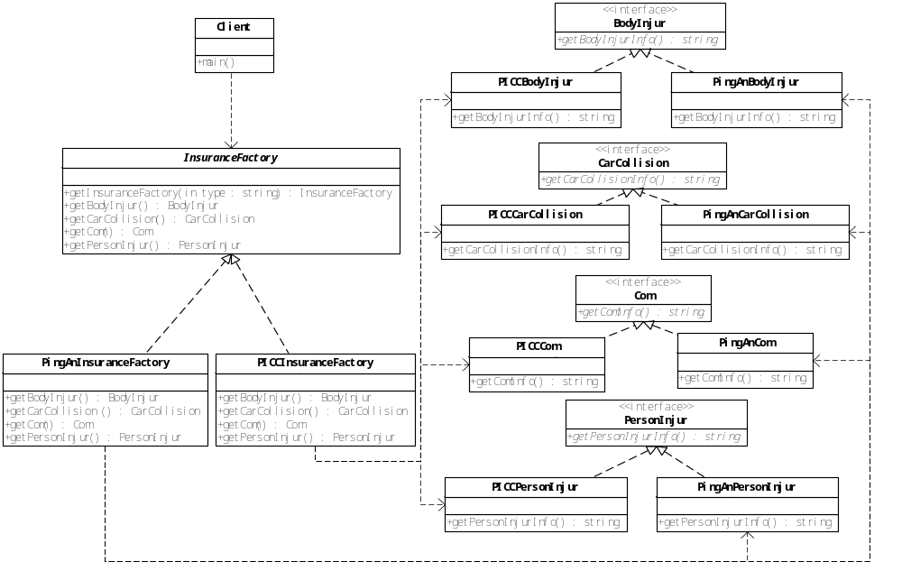

3.1 UML图

3.2 代码
package cn.scau.edu.chenpeifu.client;

import java.util.Scanner;
import cn.scau.edu.chenpeifu.abstractfactory.domaininterface.BodyInjur;
import cn.scau.edu.chenpeifu.abstractfactory.domaininterface.CarCollision;
import cn.scau.edu.chenpeifu.abstractfactory.domaininterface.Com;
import cn.scau.edu.chenpeifu.abstractfactory.domaininterface.PersonInjur;
import cn.scau.edu.chenpeifu.abstractfactory.factory.InsuranceFactory;

public class AbstractFactoryClient {

public static void main(String[] args) {
// TODO Auto-generated method stub
@SuppressWarnings("resource")
Scanner scan = new Scanner(System.in);
String ans = "";
System.out.println("Please enter company(PICC,PingAn):");
String c1 = scan.nextLine();
System.out.println("Please enter kind of insurance(BodyInjur,CarCollision,Com,PersonInjur):");
String c2 = scan.nextLine();
InsuranceFactory inf = InsuranceFactory.getInsuranceFactory(c1);
if (c2.compareToIgnoreCase("BodyInjur") == 0) {
BodyInjur bi = inf.getBodyInjur();
ans = bi.getBodyInjurInfo();
} else if (c2.compareToIgnoreCase("CarCollision") == 0) {
CarCollision ca = inf.getCarCollision();
ans = ca.getCarCollisionInfo();
} else if (c2.compareToIgnoreCase("Com") == 0) {
Com com = inf.getCom();
ans = com.getComInfo();
} else if (c2.compareToIgnoreCase("PersonInjur") == 0) {
PersonInjur pe = inf.getPersonInjur();
ans = pe.getPersonInjurInfo();
}
System.out.println(ans);
}
}

package cn.scau.edu.chenpeifu.abstractfactory.domain;

import cn.scau.edu.chenpeifu.abstractfactory.domaininterface.PersonInjur;

public class PingAnPersonInjur implements PersonInjur {

@Override
public String getPersonInjurInfo() {
// TODO Auto-generated method stub
return "this is PingAn 's Person Injur.";
}

}

package cn.scau.edu.chenpeifu.abstractfactory.domain;

import cn.scau.edu.chenpeifu.abstractfactory.domaininterface.Com;

public class PingAnCom implements Com {

@Override
public String getComInfo() {
// TODO Auto-generated method stub
return "this is PingAn 's Com.";
}
}

package cn.scau.edu.chenpeifu.abstractfactory.domain;

import cn.scau.edu.chenpeifu.abstractfactory.domaininterface.CarCollision;

public class PingAnCarCollision implements CarCollision {

@Override
public String getCarCollisionInfo() {
// TODO Auto-generated method stub
return "this is PingAn 's Car Collision.";
}
}

package cn.scau.edu.chenpeifu.abstractfactory.domain;

import cn.scau.edu.chenpeifu.abstractfactory.domaininterface.BodyInjur;

public class PingAnBodyInjur implements BodyInjur {

@Override
public String getBodyInjurInfo() {
// TODO Auto-generated method stub
return "this is PingAn 's bodyinjur.";
}
}

package cn.scau.edu.chenpeifu.abstractfactory.domain;

import cn.scau.edu.chenpeifu.abstractfactory.domaininterface.PersonInjur;

public class PICCPersonInjur implements PersonInjur {

@Override
public String getPersonInjurInfo() {
// TODO Auto-generated method stub
return "this is PICC 's Person Injur.";
}
}

package cn.scau.edu.chenpeifu.abstractfactory.domain;

import cn.scau.edu.chenpeifu.abstractfactory.domaininterface.Com;

public class PICCCom implements Com {

@Override
public String getComInfo() {
// TODO Auto-generated method stub
return "this is PICC 's Com.";
}
}

package cn.scau.edu.chenpeifu.abstractfactory.domain;

import cn.scau.edu.chenpeifu.abstractfactory.domaininterface.CarCollision;

public class PICCCarCollision implements CarCollision {

@Override
public String getCarCollisionInfo() {
// TODO Auto-generated method stub
return "this is PICC 's Car Collision.";
}
}

package cn.scau.edu.chenpeifu.abstractfactory.domain;

import cn.scau.edu.chenpeifu.abstractfactory.domaininterface.BodyInjur;

public class PICCBodyInjur implements BodyInjur {

@Override
public String getBodyInjurInfo() {
// TODO Auto-generated method stub
return "this is PICC 's bodyinjur.";
}
}

package cn.scau.edu.chenpeifu.abstractfactory.factory;

import cn.scau.edu.chenpeifu.abstractfactory.domain.PingAnBodyInjur;
import cn.scau.edu.chenpeifu.abstractfactory.domain.PingAnCarCollision;
import cn.scau.edu.chenpeifu.abstractfactory.domain.PingAnCom;
import cn.scau.edu.chenpeifu.abstractfactory.domain.PingAnPersonInjur;
import cn.scau.edu.chenpeifu.abstractfactory.domaininterface.BodyInjur;
import cn.scau.edu.chenpeifu.abstractfactory.domaininterface.CarCollision;
import cn.scau.edu.chenpeifu.abstractfactory.domaininterface.Com;
import cn.scau.edu.chenpeifu.abstractfactory.domaininterface.PersonInjur;

public class PingAnInsuranceFactory extends InsuranceFactory {

@Override
public BodyInjur getBodyInjur() {
// TODO Auto-generated method stub
return new PingAnBodyInjur();
}

@Override
public CarCollision getCarCollision() {
// TODO Auto-generated method stub
return new PingAnCarCollision();
}

@Override
public Com getCom() {
// TODO Auto-generated method stub
return new PingAnCom();
}

@Override
public PersonInjur getPersonInjur() {
// TODO Auto-generated method stub
return new PingAnPersonInjur();
}

}

package cn.scau.edu.chenpeifu.abstractfactory.factory;

import cn.scau.edu.chenpeifu.abstractfactory.domain.PICCBodyInjur;
import cn.scau.edu.chenpeifu.abstractfactory.domain.PICCCarCollision;
import cn.scau.edu.chenpeifu.abstractfactory.domain.PICCCom;
import cn.scau.edu.chenpeifu.abstractfactory.domain.PICCPersonInjur;
import cn.scau.edu.chenpeifu.abstractfactory.domaininterface.BodyInjur;
import cn.scau.edu.chenpeifu.abstractfactory.domaininterface.CarCollision;
import cn.scau.edu.chenpeifu.abstractfactory.domaininterface.Com;
import cn.scau.edu.chenpeifu.abstractfactory.domaininterface.PersonInjur;

public class PICCInsuranceFactory extends InsuranceFactory {

@Override
public BodyInjur getBodyInjur() {
// TODO Auto-generated method stub
return new PICCBodyInjur();
}

@Override
public CarCollision getCarCollision() {
// TODO Auto-generated method stub
return new PICCCarCollision();
}

@Override
public Com getCom() {
// TODO Auto-generated method stub
return new PICCCom();
}

@Override
public PersonInjur getPersonInjur() {
// TODO Auto-generated method stub
return new PICCPersonInjur();
}

}

package cn.scau.edu.chenpeifu.abstractfactory.factory;

import cn.scau.edu.chenpeifu.abstractfactory.domaininterface.BodyInjur;
import cn.scau.edu.chenpeifu.abstractfactory.domaininterface.CarCollision;
import cn.scau.edu.chenpeifu.abstractfactory.domaininterface.Com;
import cn.scau.edu.chenpeifu.abstractfactory.domaininterface.PersonInjur;

public abstract class InsuranceFactory {
public static final String PICC = "PICC";
public static final String PINGAN = "PingAn";
public abstract BodyInjur getBodyInjur();
public abstract CarCollision getCarCollision();
public abstract Com getCom();
public abstract PersonInjur getPersonInjur();
public static InsuranceFactory getInsuranceFactory(String type){
InsuranceFactory inf =null;
if(type.equals(PICC)) {inf = new PICCInsuranceFactory();}
else if(type.equals(PINGAN)) {inf = new PingAnInsuranceFactory();}
return inf;
}
}

package cn.scau.edu.chenpeifu.abstractfactory.domaininterface;

public interface PersonInjur {
public String getPersonInjurInfo();
}

package cn.scau.edu.chenpeifu.abstractfactory.domaininterface;

public interface Com {
public String getComInfo();
}

package cn.scau.edu.chenpeifu.abstractfactory.domaininterface;

public interface CarCollision {
public String getCarCollisionInfo();
}

package cn.scau.edu.chenpeifu.abstractfactory.domaininterface;

public interface BodyInjur {
public String getBodyInjurInfo();
}

