## The result details of Figure 2

In our paper, we show the trade-off results between the performance and encoder parameter size of SCA and the human-designed baselines on Aishell-1 and HKUST. For SCA, we conduct experiments with η∈{0,0.1,0.5,0.8}, respectively. For the human-designed baselines, we adjust the block number to get results of different encoder parameters.

We further list the result details of our experiments as follow:

The result details of Aishell-1:

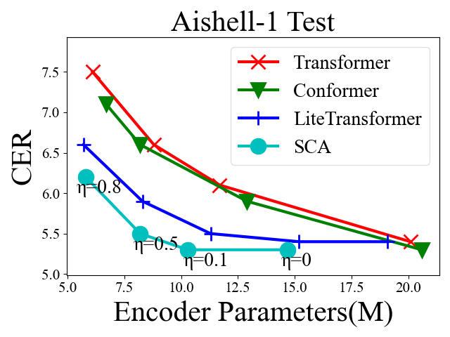

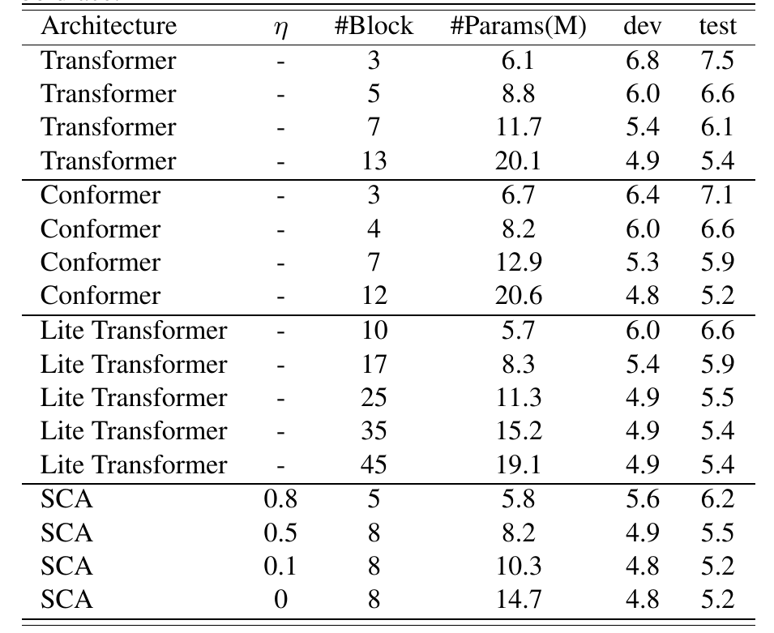

The result details of HKUST:

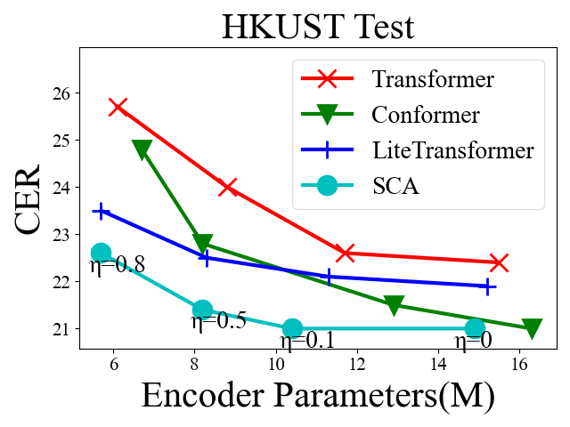

For HKUST, we sample 5% from the train set as the dev data.

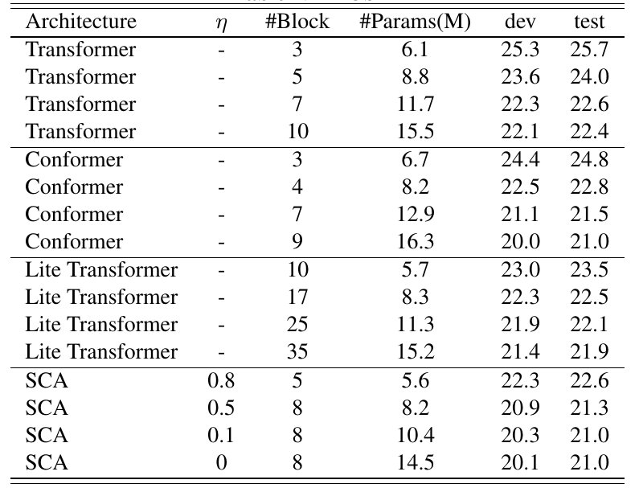

## More human-designed baselines

To demonstrate that SCA does obtain a better performance-resource trade-off than the human-designed architectures, more Transformer and Conformer baselines are conducted by adjusting the attention head number and convolution kernel size.

For Transformer, we set the attention head number as 4, 8, 16, denoted as H4, H8, H16, respectively.

For Conformer, a set of architectures with diverse convolution kernel sizes and attention head numbers are provided, e.g., CxHy denotes the Conformer architecture with the convolution kernel size *x* and attention head number *y*.

The detailed results are provided as follows:

For more **Transformer** baselines:

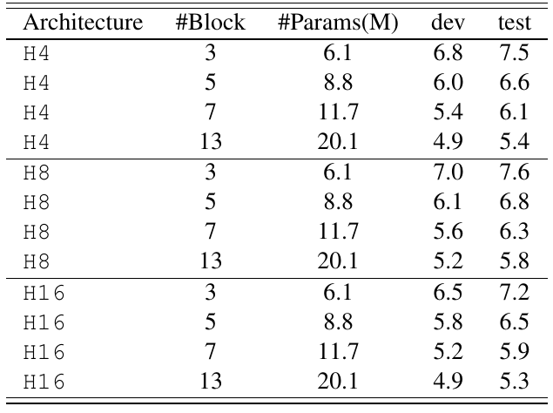

Also, we plot the performance-resource trade-off result.

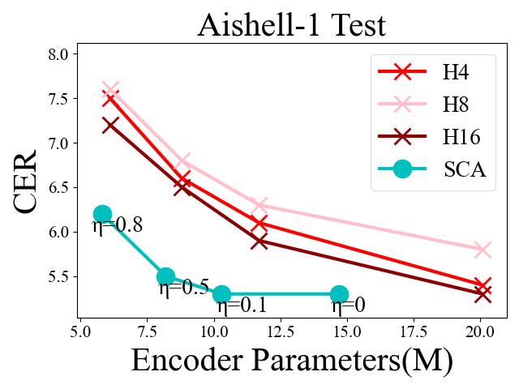

For more **Conformer** baselines:

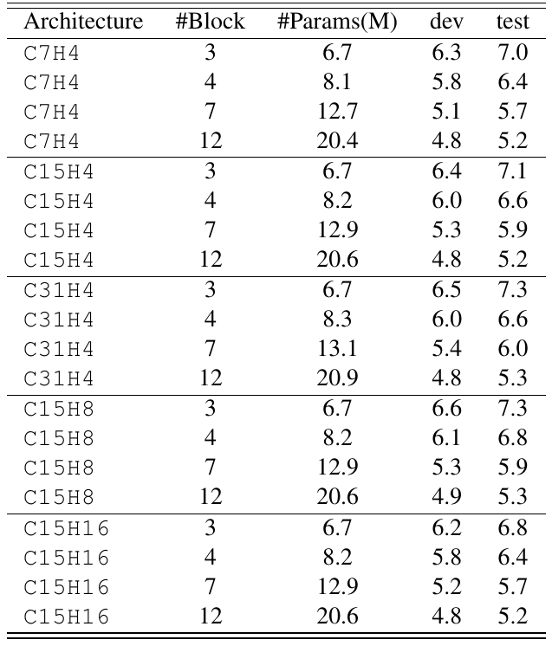

And we plot the performance-resource trade-off result.

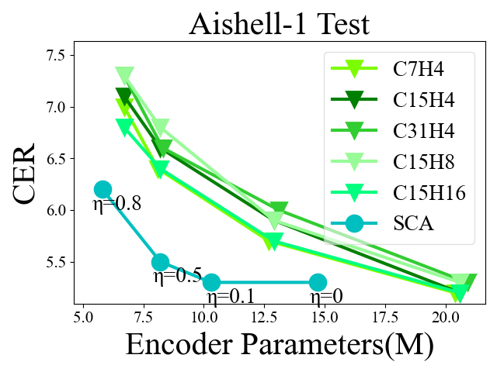

The Transformer or Conformer baselines with different architectures vary slightly, while SCA still can outperform the best of them, which demonstrates the effectiveness of SCA.

## Ablation study on DSS

To explore the influence of DSS, we provide the comparison result against SCA without DSS, as a supplement of the ablation study of our paper.

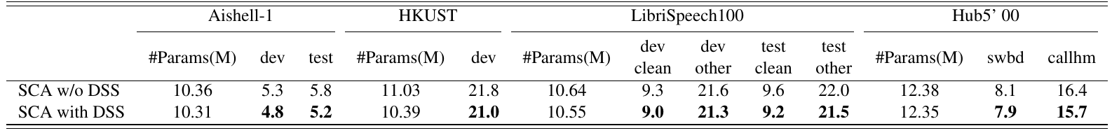

Even though the searched architectures have similar parameter numbers, SCA with DSS consistently outperforms those without DSS, which illustrates the necessity of DSS.