IFCM is an effective binning method for metagenomic contigs binning. This method is easy to use. Before use it, please read readme.txt first for requirements and commands. The following will conduct a real application to illustrate how to use IFCM.

1. Just input ‘make’ in terminal in Linux. Then an executive file IFCM will be generated in this dictionary.
2. Prepare your dataset. Only dataset with fasta format is allowed. For example,

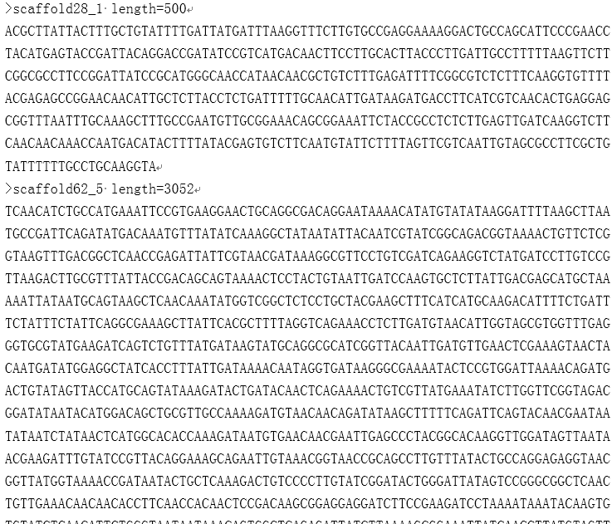

1. use Nonpareil (https://github.com/lmrodriguezr/nonpareil/) or other similar method to estimate the coverage of metagenome
2. Input *./IFCM example.fna coverage* in terminal. Then IFCM is called to bin this dataset.
3. Finally a file titled ‘result.txt’ will be generated, which contains the binning result.