An example of how to use IMI2

**Example Code:**

%%%%%%%%%%%%%%%%%%%%%%

cd ./demo

d='D_5';

load (d)

X=X';

[clusteringLabel, k_imi2]=IMI2(X, 2, 10, 10);

%%%%%%%%%%%%%%%%%%%%%%%%%%%%%

After performing the above codes, the following separation curve will be plotted, and the number of merged clusters should be determined to finish the clustering of IMI2. From this curve, the first two values are much lower than others, so the number of merged clusters should be 2.

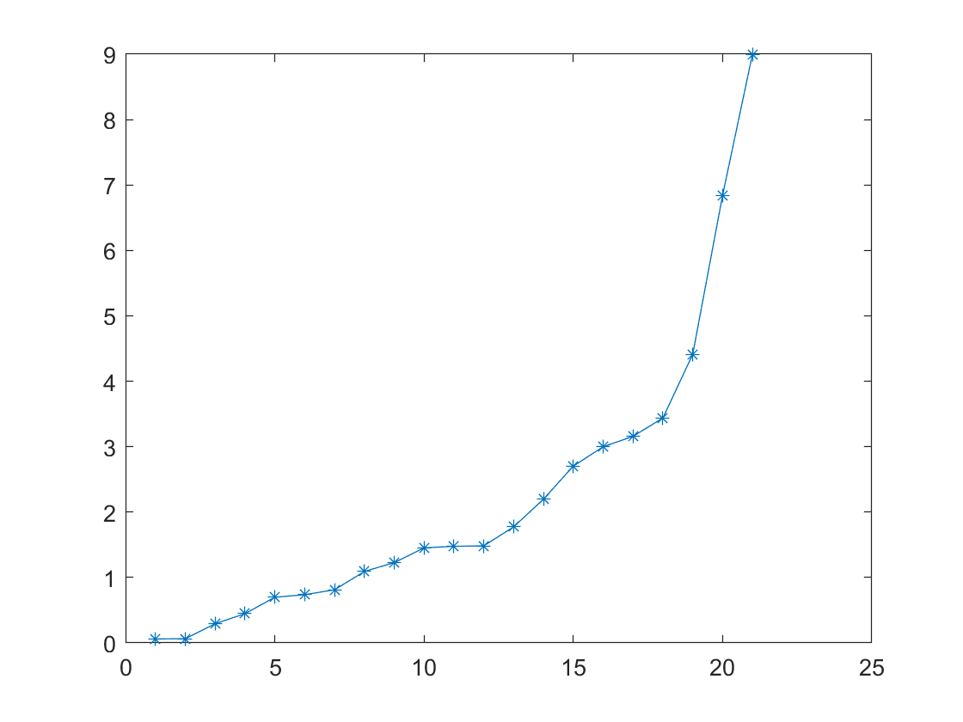

Type 2 in the command window, and the program will continue to get the clustering result of the demo data set.