

Project Propoasol

AI used in game



October 6, 2015

Yuntian Liu

C00151315

Contents

AI in game 2

Project proposal 2

Technology use 2

Development tools 2

Language 2

Library 3

Design ideas 3

Reference 4

# AI in game

Artificial intelligence is a comprehensive discipline, the artificial intelligence in the game can be understood as computer “thinking” in the game.

To explore artificial intelligence used in a game, I decided to develop a small version of the maze game.

## Project proposal

This project is to explore how artificial intelligence used in a game.

Description of this game:

1. Create a random maze map by users’ needs;
2. Game rules should be written in the game;
3. Set a start point and an end point, users can move using their keyboard;
4. AI algorithms to go through the maze as quickly as possible;

I hope to study AI algorithms by this project

## Technology use

### Development tools

Visual Studio is a comprehensive collection of tools and services to help you create a wide variety of apps, both for the Microsoft platform and beyond. Visual Studio also connects all of your projects, teams, and stakeholder. It is an [integrated development environment](http://en.wikipedia.org/wiki/Integrated_development_environment) from [Microsoft](http://en.wikipedia.org/wiki/Microsoft). It is used to develop computer program for windows, websites, web applications, and web service. Visual studio uses MS software development platforms such as windows API, it can produce both native code and managed code.

### Language

C++ is a strong object oriented programming (OOP) language. C++ has been found useful in many other contexts, and it is a compiled language, with implementations of it available on many platforms and provided by various organizations. The most important is that we have learned C++ these two years. We should choose language which we are familiar with.

### Library

Microsoft Foundation Classes (MFC) is class libraries provided by Microsoft. It wraps portion of the Windows API in C++ classes, including functionality that enables them to use a default application framework.

### Design ideas

* Create map

In general, the default rules are:

1. Maze map is a rectangular area;
2. Walls will take place in a maze map;
3. Walls and roads are separated.

We can use Depth-first search algorithm. This approach is one of the simplest way to generate a maze using a computer. We consider the space for a maze being a large grid of cells, and each cell starting with four walls. Starting from a random cell, the computer then selects a random neighbouring cell that has not yet been visited. Computer removes the wall between the two cells and adds the new cell to a stack. The computer continues this process, with a cell that has no unvisited neighbours being considered a dead-end. When at a dead-end it backtracks through the path until it reaches a cell with an unvisited neighbor, continuing the path generation by visiting this new, unvisited cell. This process continues until every cell has been visited, causing the computer to backtrack all the way back to the beginning cell. This approach guarantees that the maze space is completely visited.

* Move event

Keyboard listener can control and move object.

* Mazes way finding

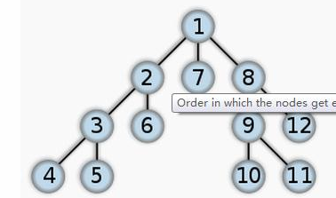Similar as creating a map, we also can use Depth-first search algorithm to find a way to go through the maze.

We can find a branch in an order and keep going to the end, then find another way…until find the destination.

Here is a sample of binary search tree:

Another algorithms:

Breadth-First search (BFS)

This method is find each braches’ first layer, then second layer….until find the destination.

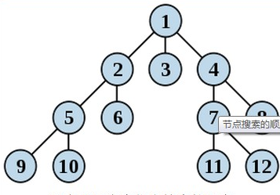

BFS method

Other functions:

Custom maze:

Create a menu asks user to input mazes height and width, use algorithms above to create a random maze map.

Time:

Create a time header file to count time, user will lose the game if beyond the required time.

Help:

Computer will find ways to destination if user choose this function.

About:

Display author details: name, age, finish date…

## Reference

<https://en.wikipedia.org/wiki/Maze_generation_algorithm>

[Search algorithms]

<https://en.wikipedia.org/wiki/Maze>

[Maze]

<https://msdn.microsoft.com/en-us/library/aa270890(v=vs.60).aspx>

[MFC ]