Neural network-based amplitude-spectral dynamic optical coherence tomography
D1劉雨松 (Yusong Liu) 11th July 2024
指導教員: 安野 嘉晃 副指導教員: 伊藤 雅英

1. Introduction
Dynamic optical coherence tomography (DOCT) is the combination of sequential OCT acquisition and subsequent temporal-signal-fluctuation analysis, and is a promising method for label-free and volumetric imaging of intra-cellular motility. Several DOCT algorithms were successfully developed. Some of them are sensitive to the magnitude of OCT signal fluctuation, and some others are sensitive to the speed or frequency of the intra-cellular motility. Logarithmic intensity variance (LIV) [1] and authentic LIV (aLIV) [2] are the examples of former, and amplitude-spectrum-based (AS-) DOCT [3] and swiftness [2] are latter.
Despite its success, DOCT requires tens to hundreds of OCT-frames acquisitions at each position of the sample, it leads to a very long volumetric measurement time. To overcome this problem, we have demonstrated a neural network (NN) method which generates an LIV image only from four frames, it significantly reduced the volumetric acquisition time from 52 s to 6 s. However, this NN only generates LIV, and was not compatible with DOCT methods sensitive to the frequency of the intra-cellular motility. Here we proposed a new NN method that generates AS-DOCT images, a frequency-sensitive DOCT.

2. Method
A swept source OCT was utilized to acquire 32-frame OCT sequence. The conventional AS-DOCT was computed by Fourier transform of the frame sequence. The integrated amplitude spectra were computed at [0, 0.15 Hz], [0.15, 1.1 Hz], and [1.1, 2.44 Hz] (i.e., low, moderate, and high frequency ranges, respectively). And a pseudo-color AS-DOCT image was computed by assigning these spectra into red, green, and blue channels, respectively. This image is used as a target image of the subsequent NN training.
An NN architecture was designed based on the previously used U-Net architecture [4]. For extracting the temporal features, the long short-term memory (LSTM) and 3-dimensional (3D) convolutional layer were used. The NN accepts 4-frame sequence of OCT image as input and outputs three amplitude spectral images corresponding to the low-, moderate-, and high-frequency ranges. The input frames were temporally unevenly obtained at the time points of 0Δt, 1Δt, 23Δt, 24Δt, where Δt = 204.8 ms and they correspond to 8th, 9th, 31st, and 32nd frames of the 32-frame sequence. The NN was trained based on the dataset of 96 cancer spheroids.
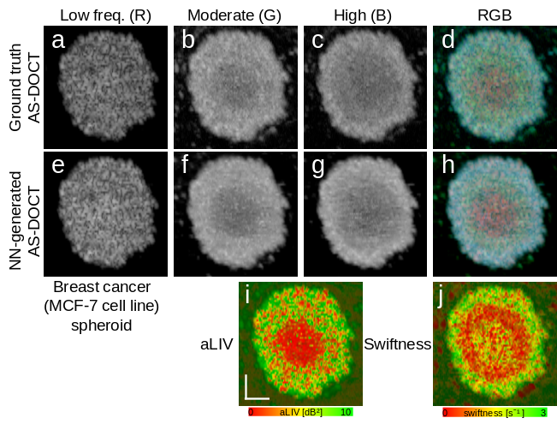
Fig. 1: (a-d) Gray-scale single channel images and RGB images of ground truth amplitude spectrum computed from 32-frame OCT sequence. (e-h) Those images of NN-generated amplitude spectrum computed from 4-frame OCT sequence. (i-j) aLIV and swiftness image. The scale bar indicates 100 µm.

3. Result
The presented method was examined with cancer spheroid images as exemplified in Fig. 1. The first row shows the ground truth AS-DOCT images, and the second row shows the corresponding NN-generated images. It can be found that the NN-generated images well resemble the ground truth images.
In particular, reduction of moderate frequency can be found both in the ground truth and NN-generated images (central red part of RGB images), it corresponds to the low signal fluctuation region (red) found in the corresponding aLIV [Fig. 1(i)]. In addition, relatively large circular region exhibits reduction of high-frequency components both in the ground truth and NN-generated images (dim yellow circle in the RGB image). This region corresponds to the red ring in the swiftness image [Fig. 1(j)] that indicates low speed of intra-cellular dynamics.

4. Conclusion
The proposed NN method generated AS-DOCT images by using only four OCT frames. It may significantly reduce the measurement time of AS-DOCT.

Reference
[1] I. Abd El-Sadek, Sci Rep 13(1), 15377 (2023). [2] R. Morishita, (SPIE, 2024), p. 55. [3] M. Münter, Biomed. Opt. Express 12(10), 6024 (2021). [4] Y. Liu, Biomed. Opt. Express 15(5), 3216 (2024).

