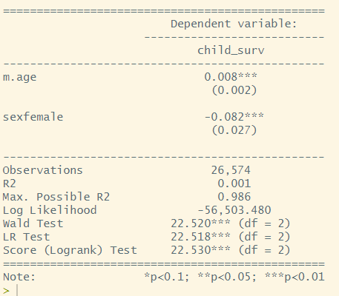

One unit increase in mother’s age associate with a 0.008 increase in the expected to log of the hazard , holding infant’s gender constant.

There is a 0.08 decrease in the expected log of hazard for female babies compared to male,holding mother’s age constant.

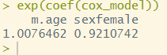

The hazard ratio of female babies is 0.92 that of male babies, female babies are less likely to die(92 female babies die for every 100 male babies; female deaths are 8% lower)

One unit increase of mother’s age associate with hazard by 1.0076.