1

clc,clear,close all

dt=0.01;

t1=-3:dt:3;

t2=-3:dt:4;

f1=2*[t1>=-1&t1<=2];

f2=(3/4)*[t2>=0&t2<=3];

t=t1(1)+t2(1):dt:t1(end)+t2(end);

ft=conv(f1,f2);

ftxz=ft*dt;

plot(t,ftxz);

xlabel('t');

ylabel('ft');

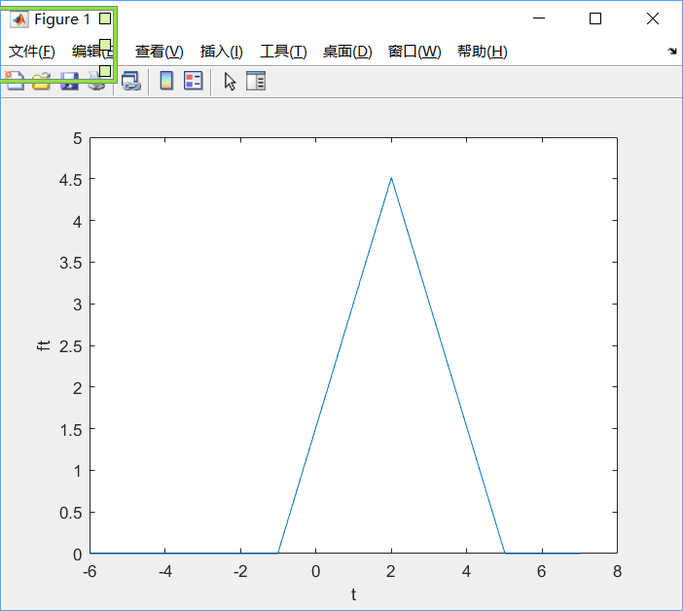

2

function [R12,tao] = my_xcorr(f1,t1,f2,t2,dt)

%这是第二题

t2f=fliplr(-t2);

f2f=fliplr(f2);

tao=(t1(1)+t2f(1)):dt:(t1(end)+t2f(end));

R12=conv(f1,f2f)*dt;

end

3

clc,clear,close all

dt=0.01;

xt=-2:dt:2;

x=1*[xt>=-1&xt<=0];

yt=-2:dt:2;

y=1*[yt>=0&yt<=1];

[R12,tao]=my_xcorr(y,yt,x,xt,dt);

plot(tao,R12),grid

xlabel('tao');ylabel('Rxy');

[m,index]=max(R12);

a=num2str(tao(index));

title(['延迟为',a]);

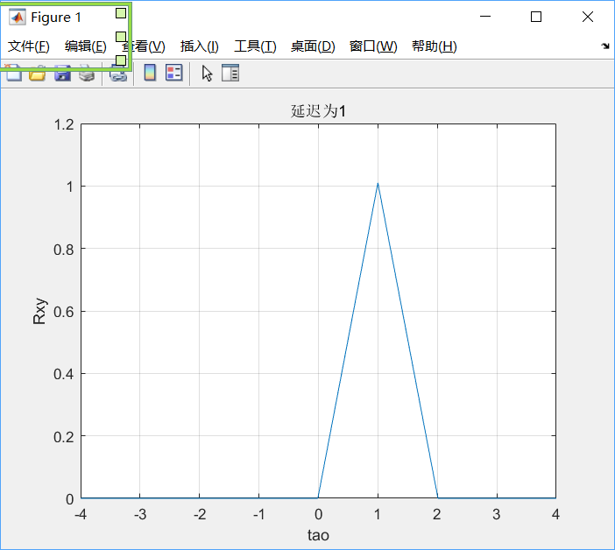

4

%带回声的音频信号的产生

clc,clear,close all

[x,fs]=audioread('au.m4a');

tau=0.2;

N=tau*fs;

%延迟量,tau自定

x1=[x(:,1)',zeros(1,N)];

x2=[zeros(1,N),0.6*x(:,1)'];%衰减系数自定

y=x1+x2;

sound(y,fs);

audiowrite('au_1.m4a',y,fs);

r=xcorr(y);

[~,index]=max(r);

[~,fakeN]=max(r(index+fs*0.01:end));

getN=fakeN-1+fs*0.01;

t=1/fs*(0:length(r)-1);

plot(t,r)

title("延迟量为"+getN)

