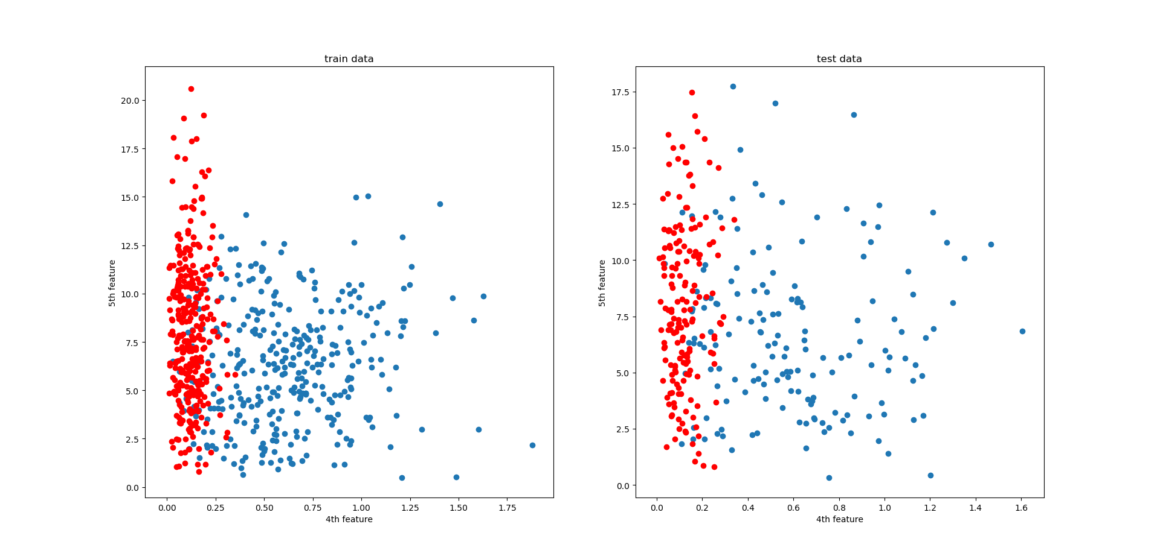

Figure 1 scatter plot of 10d dataset with 4th and 5th feature

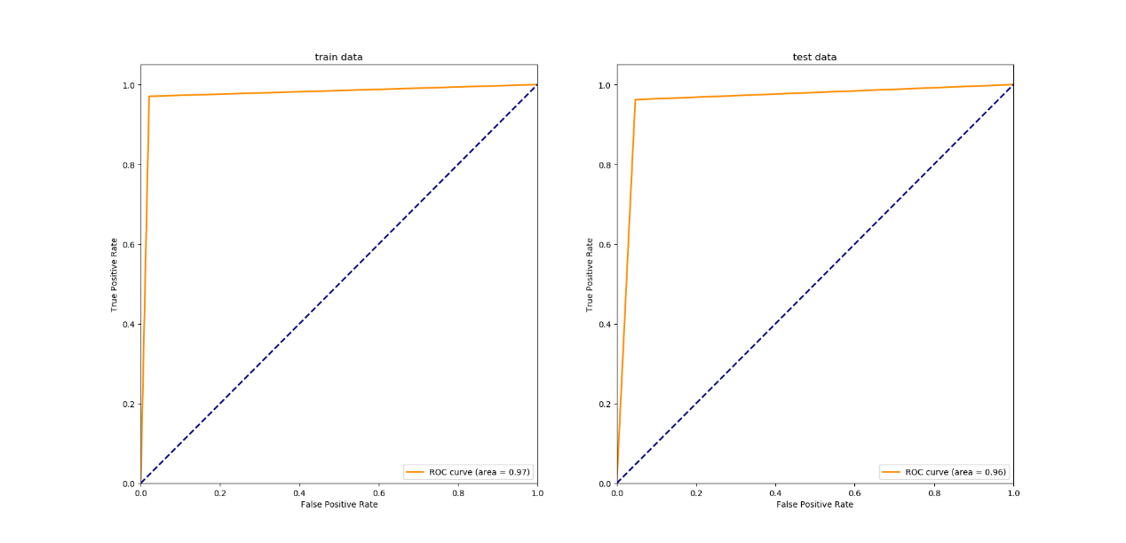

Figure 2 ROC curve of probabilistic generative classifier on 10d dataset

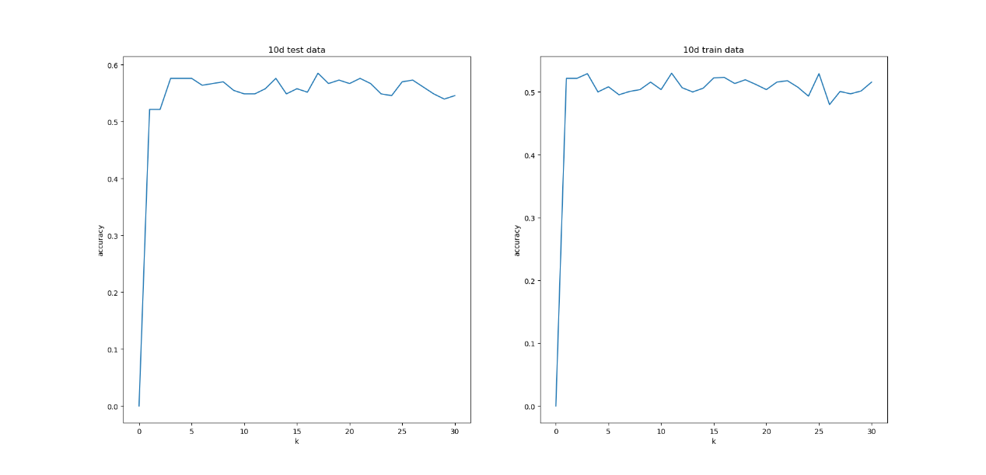

Figure 3 the accuracy as varying K for KNN

1)

|  |  |  |
| --- | --- | --- |
| Crab_Probabilistic Generative Model | | |
|  | Actual Ture | Actual False |
| Predicted Ture | 32 | 0 |
| Predicted False | 0 | 34 |

|  |  |  |
| --- | --- | --- |
| 10D_Probabilistic Generative Model | | |
|  | Actual Ture | Actual False |
| Predicted Ture | 153 | 8 |
| Predicted False | 6 | 163 |

|  |  |  |
| --- | --- | --- |
| Crab_KNN | | |
|  | Actual Ture | Actual False |
| Predicted Ture | 28 | 3 |
| Predicted False | 4 | 31 |

|  |  |  |
| --- | --- | --- |
| 10D_KNN | | |
|  | Actual Ture | Actual False |
| Predicted Ture | 96 | 71 |
| Predicted False | 63 | 100 |

The confusion matrixes of both KNN model are a little different after every training. Because I use cross-validation and split train data randomly.

2)

The problem is that the covariance matrix of the carb dataset is singular. My solution is regularization. I add an identity matrix of n times to the covariance matrix so that it is not singular.

3)

If the K value is small, the model complexity is high and it is easy to overfit. If K is too large, the points of different class that are far away from it become neighbors, the deviation becomes larger, and the accuracy is lower. Classification accuracy decreases as K value increases

4)

Because there are too many features in 10d dataset. And it is difficult to classify the data by Euclidean distance. To improve it, I add weight to the distance.

Also, many features in 10d dataset are very similar in both classes. So when I use KNN classifier, it is difficult to classify the data just from their neighbors. To improve it, I can find the most unique features from their 10 features and use those unique features to train the model.

5)

I will use probabilistic generative classifier for both datasets. Because after cross-validation, I find that probabilistic generative classifier has higher accuracy and stability.

|  |  |  |
| --- | --- | --- |
| Mean score about 2 model | | |
|  | Crab | 10D |
| Probabilistic Generative | 1.0 | 0.974 |
| KNN | 0.937 | 0.571 |

6)

1.

Data likelihood is

$$\prod_{n=1}^{N}{p\left(x_{n} | λ\right)}=\prod_{n=1}^{N}{\frac{λ^{x_{n}}}{x_{n}!}e^{-λ}}$$

Take the log:

$$L=ln\prod_{n=1}^{N}{\frac{λ^{x_{n}}}{x_{n}!}e^{-λ}}=\sum_{n=1}^{N}{\ln\left(\frac{λ^{x_{n}}}{x_{n}!}e^{-λ}\right)}=\sum_{n=1}^{N}{[x_{n}ln{λ}-ln{(x}_{n}!)]}-Nλ$$

$$\frac{∂L}{∂λ}=\sum_{n=1}^{N}{\frac{x_{n}}{λ}}-N=0$$

$$→λ=\frac{1}{N}\sum_{n=1}^{N}{x_{n}}$$

2.

Gamma distribution:

$$p\left(λ | a\right)= \frac{λ^{a}e^{-λ}}{Γ\left(a\right)}$$

The Gamma function:

$$Γ\left(x\right)=\int_{0}^{+∞}{t^{x-1}e^{-t}dt}(x>0)$$

If x is positive integer, $Γ\left(x\right)=\left(x-1\right)!$

$$p\left(λ | X, a\right)∝p\left(X | λ\right)p\left(λ|a\right)=\prod_{n=1}^{N}{\frac{λ^{x_{n}}}{x_{n}!}e^{-λ}}∙\frac{λ^{a}e^{-λ}}{Γ\left(a\right)}$$

Take the log:

$$L=ln\prod_{n=1}^{N}{\frac{λ^{x_{n}}}{x_{n}!}e^{-λ}}∙\frac{λ^{a}e^{-λ}}{Γ\left(a\right)}=\sum_{n=1}^{N}{[x_{n}ln{λ}-ln{(x}_{n}!)]}-Nλ+alnλ-λ-\ln\left(Γ\left(a\right)\right)$$

$$\frac{∂L}{∂λ}=\sum_{n=1}^{N}{\frac{x_{n}}{λ}}-N+\frac{a}{λ}-1=0$$

$$→λ=\frac{1}{N+1}(a+\sum_{n=1}^{N}{x_{n}})$$