# 1 PCA

## 1

## 2

By hand:

$$\text{Χ}Χ^{Τ}=\left[\begin{matrix}112 & 137 \\ 137 & 170\end{matrix}\right]$$

$$\left|XX^{Τ}-λI\right|=\left[\begin{matrix}112-λ & 137 \\ 137 & 170-λ\end{matrix}\right]$$

$$\left(112-λ\right)\left(170-λ\right)-{137}^{2}=0$$

$$λ_{1}=0.96429 { λ}_{2}=281.03571$$

$$when λ_{1}=0.96429:$$

$$\left(XX^{T}-λ_{1}I\right)x=\left(\begin{matrix}111.03571 & 137 \\ 137 & 169.03571\end{matrix}\right)\left(\begin{aligned}x_{1} \\ x_{2}\end{aligned}\right)=0$$

$$so,after normalization$$

$$x_{1}=-0.77688 x_{2}=0.62965$$

$$ξ_{1}=\left(\begin{aligned}-0.77688 \\ 0.62965\end{aligned}\right)$$

$$when λ_{2}=281.03571:$$

$$\left(XX^{T}-λ_{2}I\right)x=\left(\begin{matrix}-169.03571 & 137 \\ 137 & -111.03571\end{matrix}\right)\left(\begin{aligned}x_{1} \\ x_{2}\end{aligned}\right)=0$$

$$so,after normalization$$

$$x_{1}=0.62965 x_{2}=0.77688$$

$$ξ_{2}=\left(\begin{aligned} 0.62965 \\ 0.77688\end{aligned}\right)$$

By code:



## 3

They are the same.

$$The eigenvalues and eigenvectors of X^{T}X are: λ_{1}υ_{1}=X^{T}Xυ_{1}$$

$$Multiply matrix X at the left: {Xλ}_{1}υ_{1}={XX}^{T}Xυ_{1}$$

$$λ_{1} is a number and thus,λ_{1} (Xυ_{1})={XX}^{T}(Xυ_{1})$$

$$The eigenvalues and eigenvectors of {XX}^{T} are: λ_{2}υ_{2}={XX}^{T}υ_{2}$$

$$Let Xυ_{1}=υ_{2}, then λ_{2}Xυ_{1}={XX}^{T}Xυ_{1}$$

$$After compared :\left(λ_{1} {-λ}_{2} \right)Xυ_{1}=0$$

$$If and only {if λ}_{1}=0 and λ_{2}=0 or λ_{1}{=λ}_{2} can we get the=.$$

$$Thus, the they have the same non-zero eigenvalues.$$

## 4

By hand:

$$after subtract mean：$$

$$X=\left(\begin{matrix}\begin{matrix}-2 & -1 & -1\end{matrix} & \begin{matrix}0 & 1 & 3\end{matrix} \\ \begin{matrix}-3 & -1 & 0\end{matrix} & \begin{matrix}0 & 1 & 3\end{matrix}\end{matrix}\right)$$

$$\text{Χ}Χ^{Τ}=\left(\begin{matrix}16 & 17 \\ 17 & 20\end{matrix}\right)$$

$$\left|\frac{1}{6}XX^{Τ}-λI\right|=\left[\begin{matrix}\frac{16}{6}-λ & \frac{17}{6} \\ \frac{17}{6} & \frac{20}{6}-λ\end{matrix}\right]$$

$$\left(\frac{16}{6}-λ\right)\left(\frac{20}{6}-λ\right)-{\frac{17}{6^{2}}}^{2}=0$$

$$λ_{1}=0.147 { λ}_{2}=5.853$$

$$when λ_{1}=0.147:$$

$$ξ_{1}=\left(\begin{aligned}0.747 \\ -0.665\end{aligned}\right)$$

$$when λ_{2}=5.853:$$

$$ξ_{2}=\left(\begin{aligned} 0.665 \\ 0.747\end{aligned}\right)$$

$$1-dimension data:$$

$$Y=\left(\begin{matrix}0.665 & 0.747\end{matrix}\right)\left(\begin{matrix}\begin{matrix}-2 & -1 & -1\end{matrix} & \begin{matrix}0 & 1 & 3\end{matrix} \\ \begin{matrix}-3 & -1 & 0\end{matrix} & \begin{matrix}0 & 1 & 3\end{matrix}\end{matrix}\right)=\left(\begin{matrix}\begin{matrix}-3.571 & -1.412 & -0.665\end{matrix} & \begin{matrix}0 & 1.412 & 4.235\end{matrix}\end{matrix}\right)$$

By code:

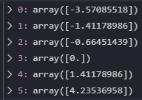

# 2 EM

## 2.1

No. it can not be solved directly. Because we do not know which coins were flipped after we flipped A. There are some latent data in this problem.

Also, the Eq $\hat{θ}=argmaxlogP\left(Y | θ\right)$ is difficult to maximize.

## 2.2

$$μ_{j}^{i+1}=\frac{π^{i}{(p^{i})}^{y_{j}}{(1-p^{i})}^{1-y_{j}}}{π^{i}{(p^{i})}^{y_{j}}{(1-p^{i})}^{1-y_{j}}+{(1-π}^{i}){(q^{i})}^{y_{j}}{(1-q^{i})}^{1-y_{j}}}\underset{⇒}{ }$$

$$μ_{j}^{1}=\frac{π^{0}{(p^{0})}^{y_{j}}{(1-p^{0})}^{1-y_{j}}}{π^{0}{(p^{0})}^{y_{j}}{(1-p^{0})}^{1-y_{j}}+{(1-π}^{0}){(q^{0})}^{y_{j}}{(1-q^{0})}^{1-y_{j}}}$$

|  |  |  |  |  |  |  |  |  |  |  |
| --- | --- | --- | --- | --- | --- | --- | --- | --- | --- | --- |
| j | 1 | 2 | 3 | 4 | 5 | 6 | 7 | 8 | 9 | 10 |
| $$μ_{j}^{1}$$ | 0.5 | 0.5 | 0.5 | 0.5 | 0.5 | 0.5 | 0.5 | 0.5 | 0.5 | 0.5 |

## 2.3

$$π^{i+1}=\frac{1}{10}\sum_{j=1}^{10}{μ_{j}^{i+1}}\underset{⇒}{ }$$

$$π^{1}=\frac{1}{10}\sum_{j=1}^{10}{μ_{j}^{1}}$$

$$p^{i+1}=\frac{\sum_{j=1}^{10}{μ_{j}^{i+1}}y_{j}}{\sum_{j=1}^{10}{μ_{j}^{i+1}}}\underset{⇒}{ }$$

$$p^{1}=\frac{\sum_{j=1}^{10}{μ_{j}^{1}}y_{j}}{\sum_{j=1}^{10}{μ_{j}^{1}}}$$

$$q^{i+1}=\frac{\sum_{j=1}^{10}{(1-μ_{j}^{i+1})}y_{j}}{\sum_{j=1}^{10}{(1-μ_{j}^{i+1})}}\underset{⇒}{ }$$

$$q^{1}=\frac{\sum_{j=1}^{10}{(1-μ_{j}^{1})}y_{j}}{\sum_{j=1}^{10}{(1-μ_{j}^{1})}}$$

|  |  |
| --- | --- |
| $$π^{1}$$ | 0.5 |
| $$p^{1}$$ | 0.6 |
| $$q^{1}$$ | 0.6 |

## 2.4

$$μ_{j}^{2}=\frac{π^{1}{(p^{1})}^{y_{j}}{(1-p^{1})}^{1-y_{j}}}{π^{1}{(p^{1})}^{y_{j}}{(1-p^{1})}^{1-y_{j}}+{(1-π}^{1}){(q^{1})}^{y_{j}}{(1-q^{1})}^{1-y_{j}}}$$

|  |  |  |  |  |  |  |  |  |  |  |
| --- | --- | --- | --- | --- | --- | --- | --- | --- | --- | --- |
| j | 1 | 2 | 3 | 4 | 5 | 6 | 7 | 8 | 9 | 10 |
| $$μ_{j}^{2}$$ | 0.5 | 0.5 | 0.5 | 0.5 | 0.5 | 0.5 | 0.5 | 0.5 | 0.5 | 0.5 |

## 2.5

$$π^{2}=\frac{1}{10}\sum_{j=1}^{10}{μ_{j}^{2}}$$

$$p^{2}=\frac{\sum_{j=1}^{10}{μ_{j}^{2}}y_{j}}{\sum_{j=1}^{10}{μ_{j}^{2}}}$$

$$q^{2}=\frac{\sum_{j=1}^{10}{(1-μ_{j}^{2})}y_{j}}{\sum_{j=1}^{10}{(1-μ_{j}^{2})}}$$

|  |  |
| --- | --- |
| $$π^{2}$$ | 0.5 |
| $$p^{2}$$ | 0.6 |
| $$q^{2}$$ | 0.6 |

## 2.6

$$μ_{j}^{1}=\frac{π^{0}{(p^{0})}^{y_{j}}{(1-p^{0})}^{1-y_{j}}}{π^{0}{(p^{0})}^{y_{j}}{(1-p^{0})}^{1-y_{j}}+{(1-π}^{0}){(q^{0})}^{y_{j}}{(1-q^{0})}^{1-y_{j}}}$$

|  |  |  |  |  |  |  |  |  |  |  |
| --- | --- | --- | --- | --- | --- | --- | --- | --- | --- | --- |
| j | 1 | 2 | 3 | 4 | 5 | 6 | 7 | 8 | 9 | 10 |
| $$μ_{j}^{1}$$ | 0.3636 | 0.3636 | 0.4706 | 0.3636 | 0.4706 | 0.4706 | 0.3636 | 0.4706 | 0.3636 | 0.3636 |

|  |  |
| --- | --- |
|  | 0.4064 |
| $$p^{1}$$ | 0.5368 |
| $$q^{1}$$ | 0.6433 |

|  |  |  |  |  |  |  |  |  |  |  |
| --- | --- | --- | --- | --- | --- | --- | --- | --- | --- | --- |
| j | 1 | 2 | 3 | 4 | 5 | 6 | 7 | 8 | 9 | 10 |
| $$μ_{j}^{2}$$ | 0.3636 | 0.3636 | 0.4706 | 0.3636 | 0.4706 | 0.4706 | 0.3636 | 0.4706 | 0.3636 | 0.3636 |

|  |  |
| --- | --- |
|  | 0.4064 |
| $$p^{2}$$ | 0.5368 |
| $$q^{2}$$ | 0.6433 |

$θ^{2}$ is not the same as that in Question 2.5.

### 2.7

The results are not the same with different initialization.

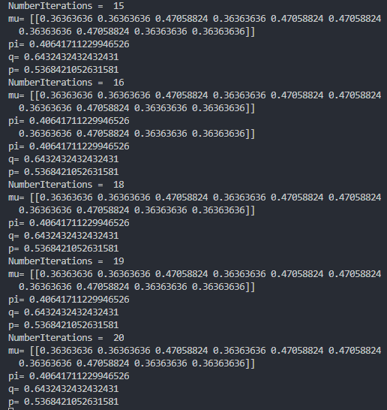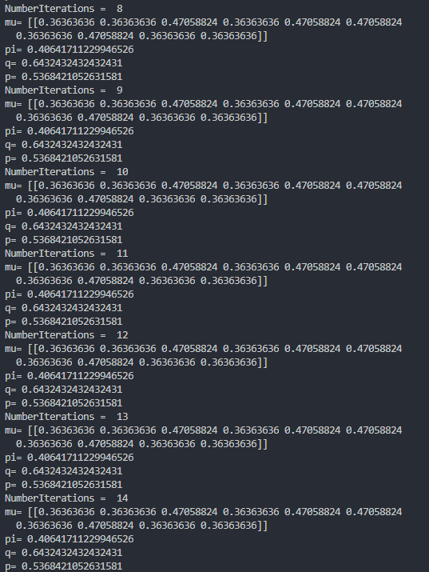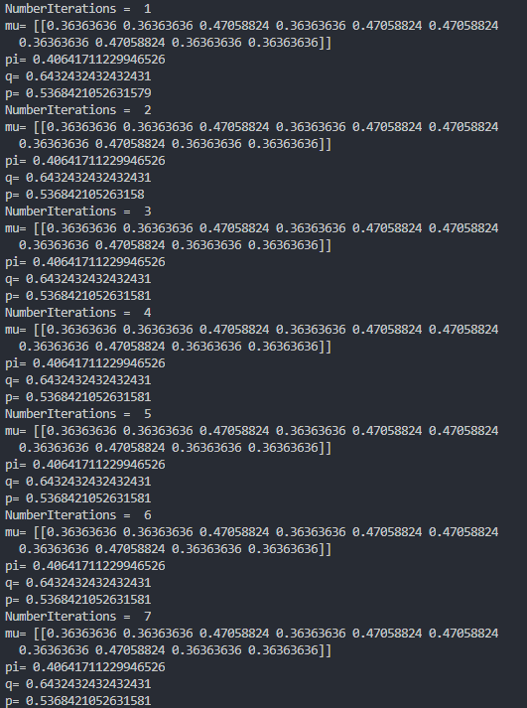 $π^{0}=0.4, p^{0}=0.6, q^{0}=0.7:$

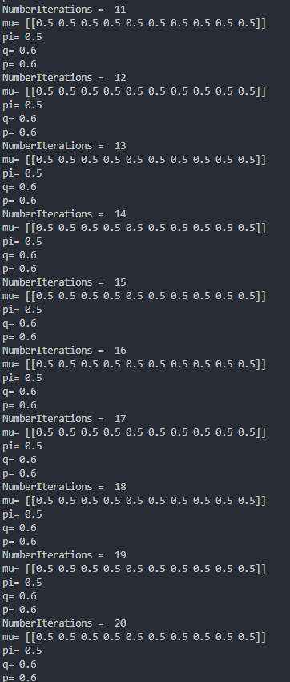 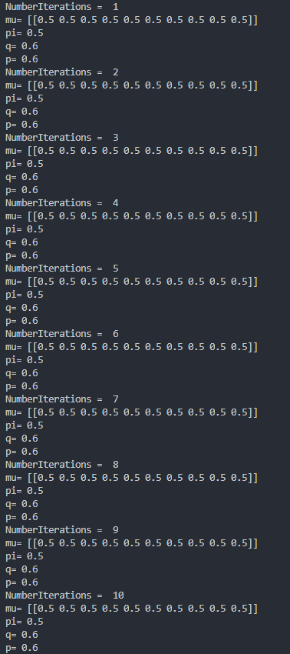

$π^{0}=0.5, p^{0}=0.5, q^{0}=0.5:$