# Problem 1

## i



Figure 1 WSNR of window size = 100,500,1000 (filters of order = 5)

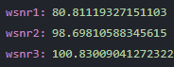

Figure 2 WSNR of window size = 100,500,1000 (filters of order = 15)

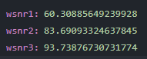

Figure 3 WSNR of window size = 100,500,1000 (filters of order = 30)

|  |  |  |  |
| --- | --- | --- | --- |
|  | 5 | 15 | 30 |
| 100 | 34.96 | 80.81 | 60.31 |
| 500 | 54.99 | 98.70 | 83.69 |
| 1000 | 63.95 | 100.83 | 93.74 |

Figure 4 table about WSNR

From the table, we can see that the WSNR gets bigger as the larger window size. But as the filter orders changing, the WSNR increases first and then decreases.

## ii

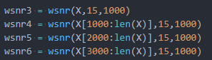

Figure 5 setting for different windows

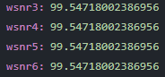

Figure 6 WSNR for different windows

From the figures above we can see that after applying the Wiener filter in different windows(0,1000,2000,3000), the result is the same. So only one window suffices.

## iii

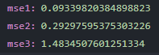

Figure 7 MSE of different noise(0.1,0.3,1.5)

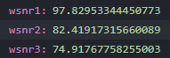

Figure 8 WSNR of different noise(0.1,0.3,1.5)

From the figures above we can see that with the noise increasing, the results of Wiener filter become worse. Because the noise makes Wiener filter more difficult get right results.

## iv



Figure 9 MSE of LMS and Wiener filter

From the figure above we can see that the MSE of LMS is larger than the MSE of Wiener solution. So the performance of Wiener filter is better.

# Problem 2

## i

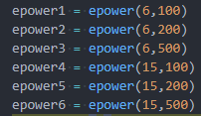

Figure 10 setup for filters

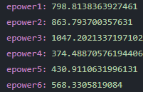

Figure 11 error power for prediction

|  |  |  |
| --- | --- | --- |
|  | 6 | 15 |
| 100 | 798.81 | 374.49 |
| 200 | 863.79 | 430.91 |
| 500 | 1047.20 | 568.33 |

Figure 12 table about error power

From the table above we can see that the performance of filter order=15 is better than the performance of filter order=6. And the bigger the window size, the worse the performance of the predictor.

## ii

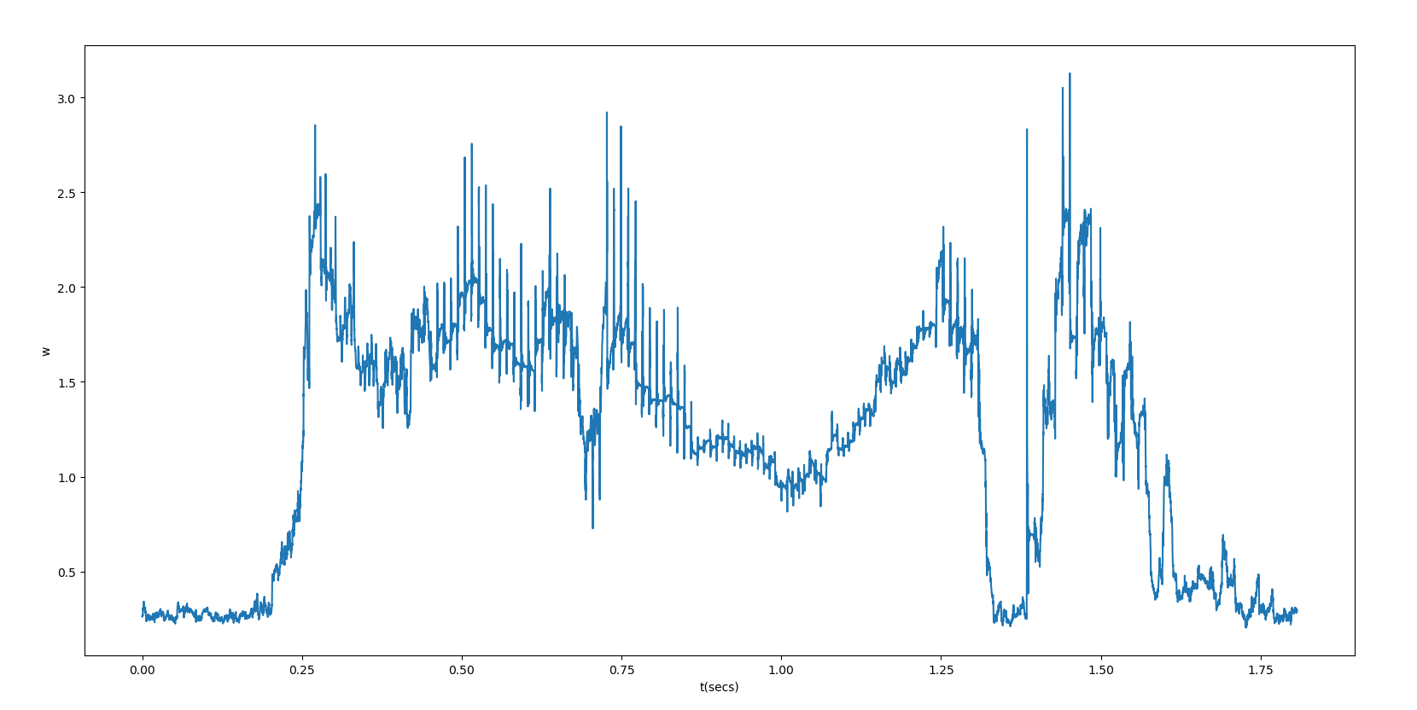

Figure 13 w changes over time

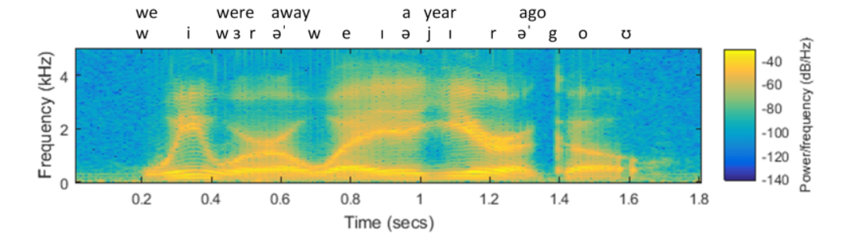

Figure 14 wide-band sound spectrogram

From the figure above we can see that the trend of w changes is the same as the changing of frequency of the sounds.

## iii

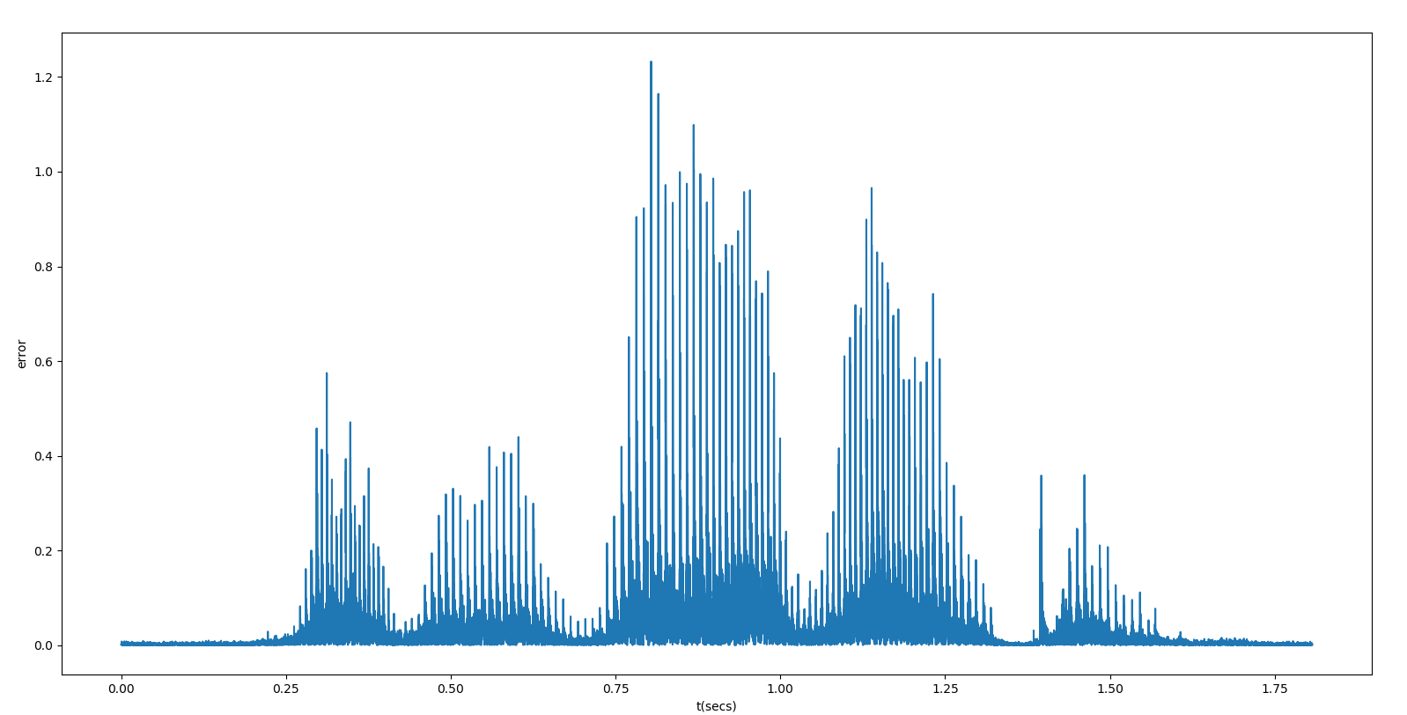

Figure 15 prediction error changes over time



Figure 16 wide-band sound spectrogram

After comparing the two figures above, we can see that when the frequency of the sounds changes a lot, the prediction error will also change a lot. The trends of the sound frequency and the prediction error are the same.

For improving prediction, we can change the window size with sound frequency. If the sound frequency does not change much over time, we can set windows during this time to improve prediction. Also, we can increase the orders of filter.

Convergence rate is important because it can tell us how to set window. If the convergence rate becomes smaller over a period of time, we can make the window size larger. Otherwise, if the convergence rate becomes very big, we should know that there are some big changes about the sounds, so we should make the window size smaller.

## iv



Figure 17 error power of LMS and Wiener filter

From the figure above we can see that the error power of Wiener filter is larger than the error power of LMS. So the performance of LMS is better.