# Problem 1

## Implementation details:

For problem 1, I use characteristic function with α=1.5 and γ=1 to generate 10000 samples as input x[n]. This input is alpha stable noise. Then I use the 10000 samples as the input of the transfer function . After getting the output of the transfer function, I add white Gaussian noise with power N=0.1 to the output and treat them as desired value(d[n]). Also, I form X (filter length*length of x) by using the x[n]. And I use matrix X as the input of RLS algorithm.

## 

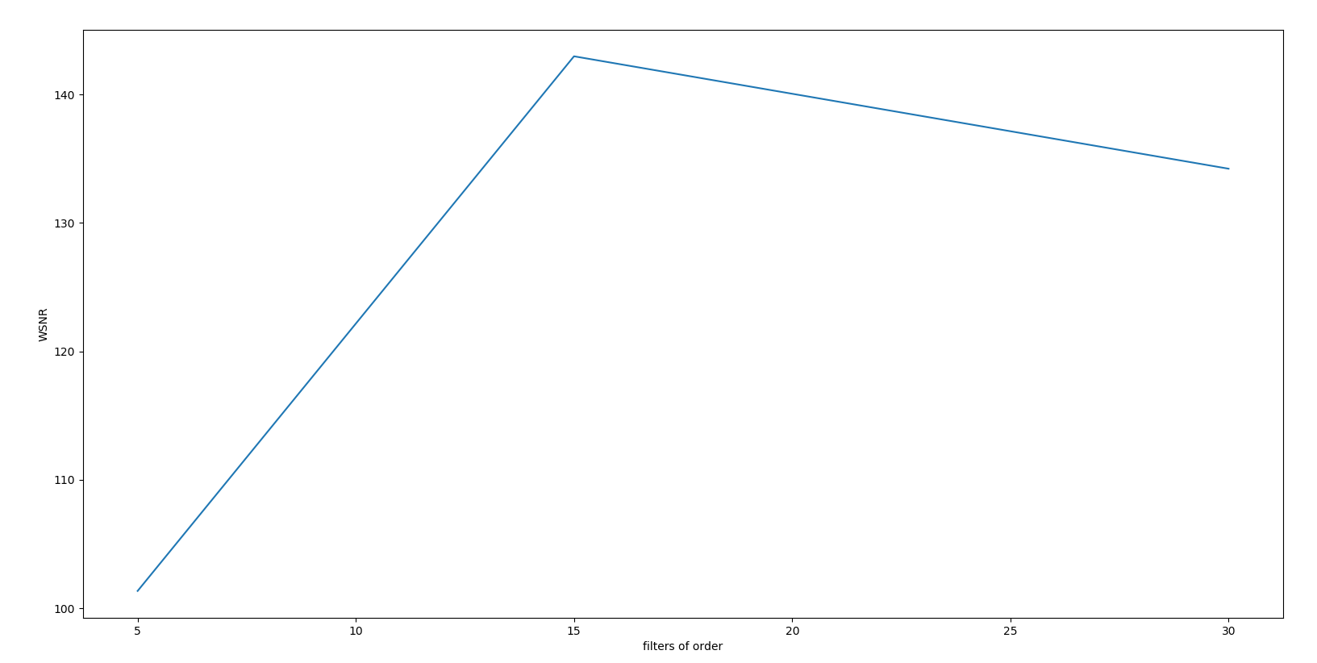

Figure 1 WSNR of different filters of order (5,15,30)

|  |  |  |  |
| --- | --- | --- | --- |
| Filters of order | 5 | 15 | 30 |
| WSNR | 101.35 | 142.97 | 134.22 |

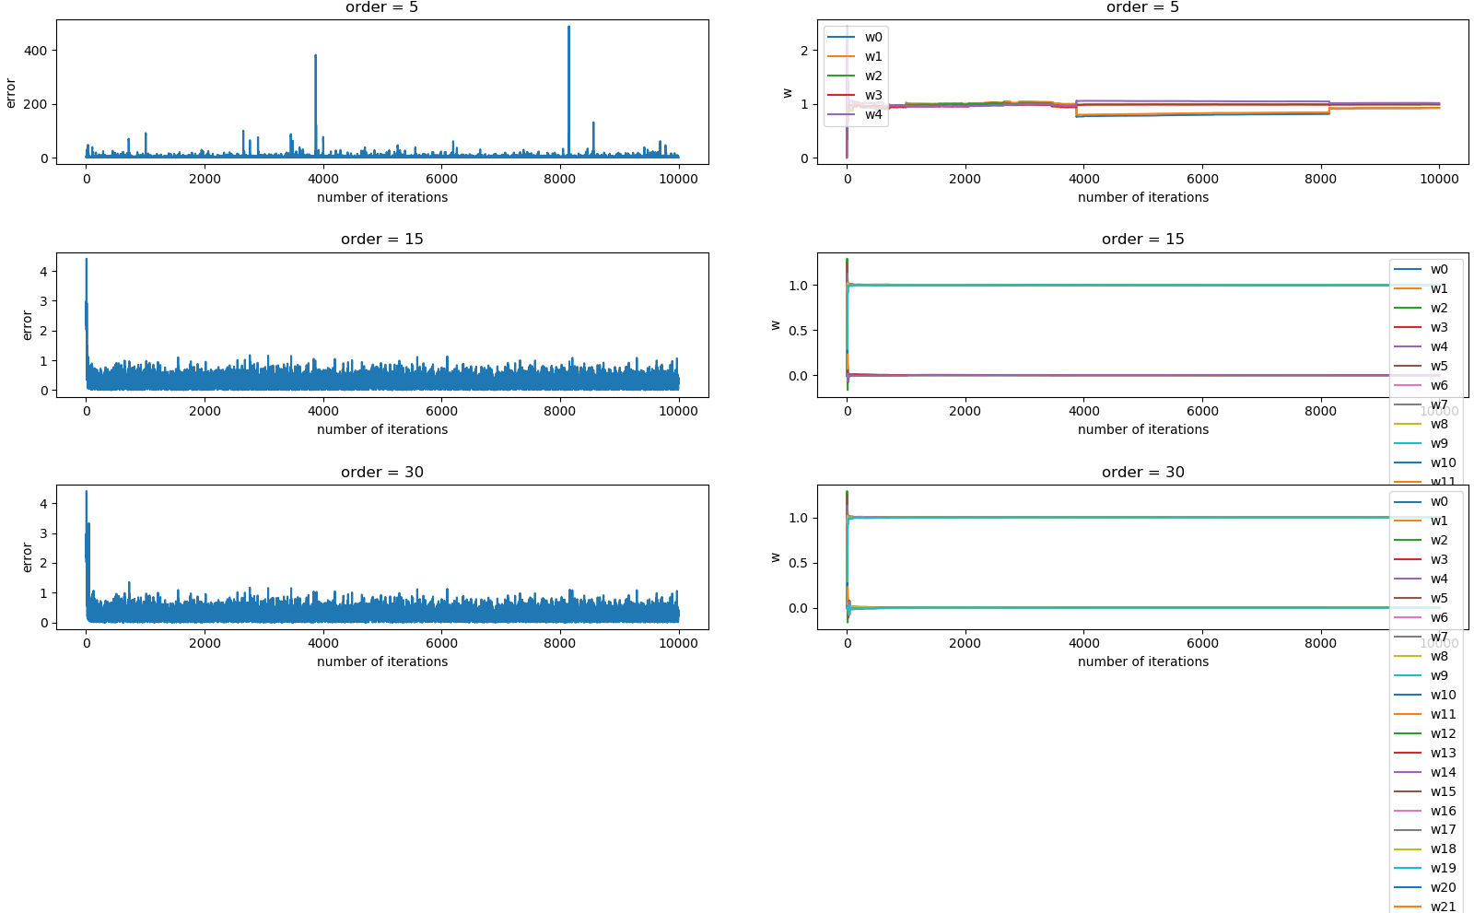

Figure 2 learning curve and weight track of different filter length (order 5,15,30)

From the table and figures above we can see that when filters of order = 15, the accuracy of the system identification is highest. Because if filter length is too short, we may make inaccurate system identification due to lack of information. But if filter length is too long, there will be more noise and interference.

## 

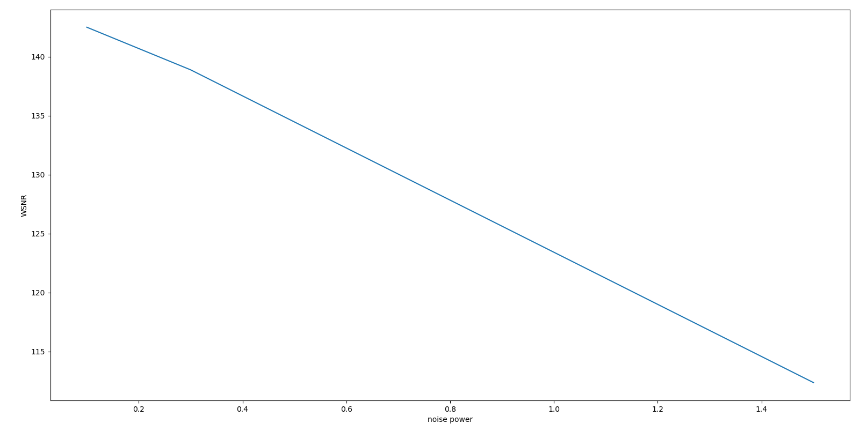

Figure 3 WSNR of different noise power (0.1, 0.3, 1.5)

|  |  |  |  |
| --- | --- | --- | --- |
| Noise power | 0.1 | 0.3 | 1.5 |
| WSNR | 142.50 | 138.88 | 112.36 |

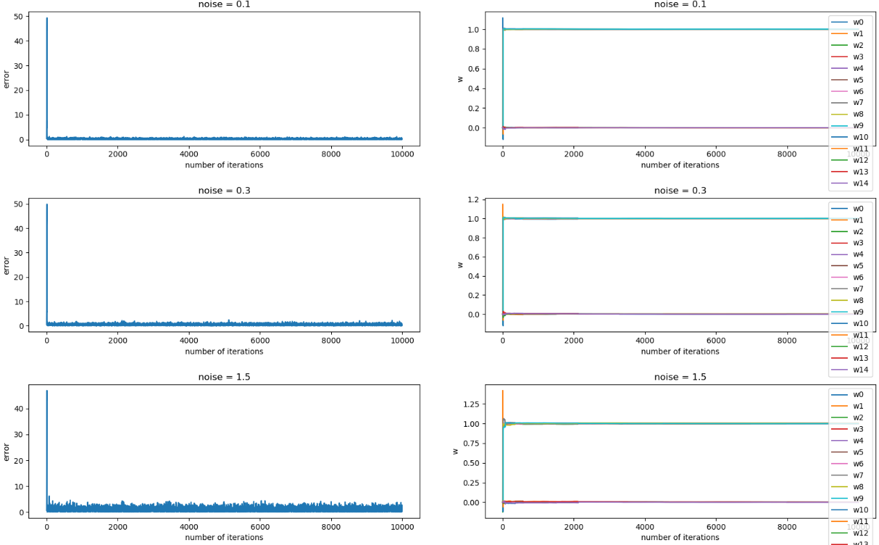

Figure 4 learning curve and weight track of different noise power (0.1, 0.3, 1.5)

In question 2, I set filters of order 15, noise power =0.1, 0.3, 1.5.

From the figures and table above, we can see that with the noise increasing, the WSNR of RLS become smaller, and the vibration of the learning curve is increasing. Because the noise makes it more difficult get right results.

## 

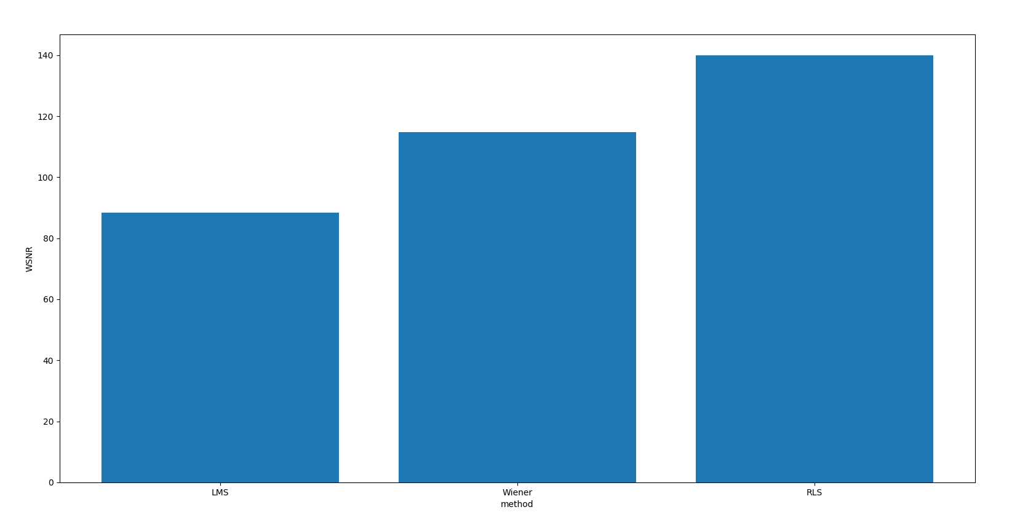

Figure 5 WSNR of different method (LMS, Wiener, RLS)

|  |  |  |  |
| --- | --- | --- | --- |
| Method | LMS | Wiener | RLS |
| WSNR | 88.48 | 114.84 | 139.90 |

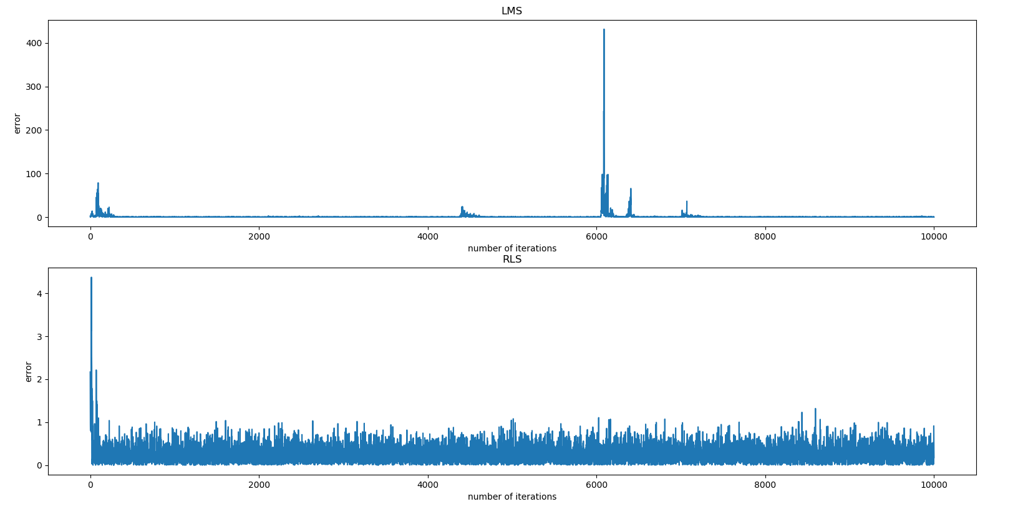

Figure 6 learning curve of LMS and RLS

In question 2, I set filters of order 15, noise power =0.1, window of Wiener filter = 1000.

From the table and figures above, we can see that WSNR of RLS is bigger than the WSNR of LMS and Wiener. The learning curve shows that the error of LMS sometimes changes a lot while the error of RLS remains below 1 after several iterations. So, the performance of RLS is better than LMS and Wiener solution.

# Problem 2

## 

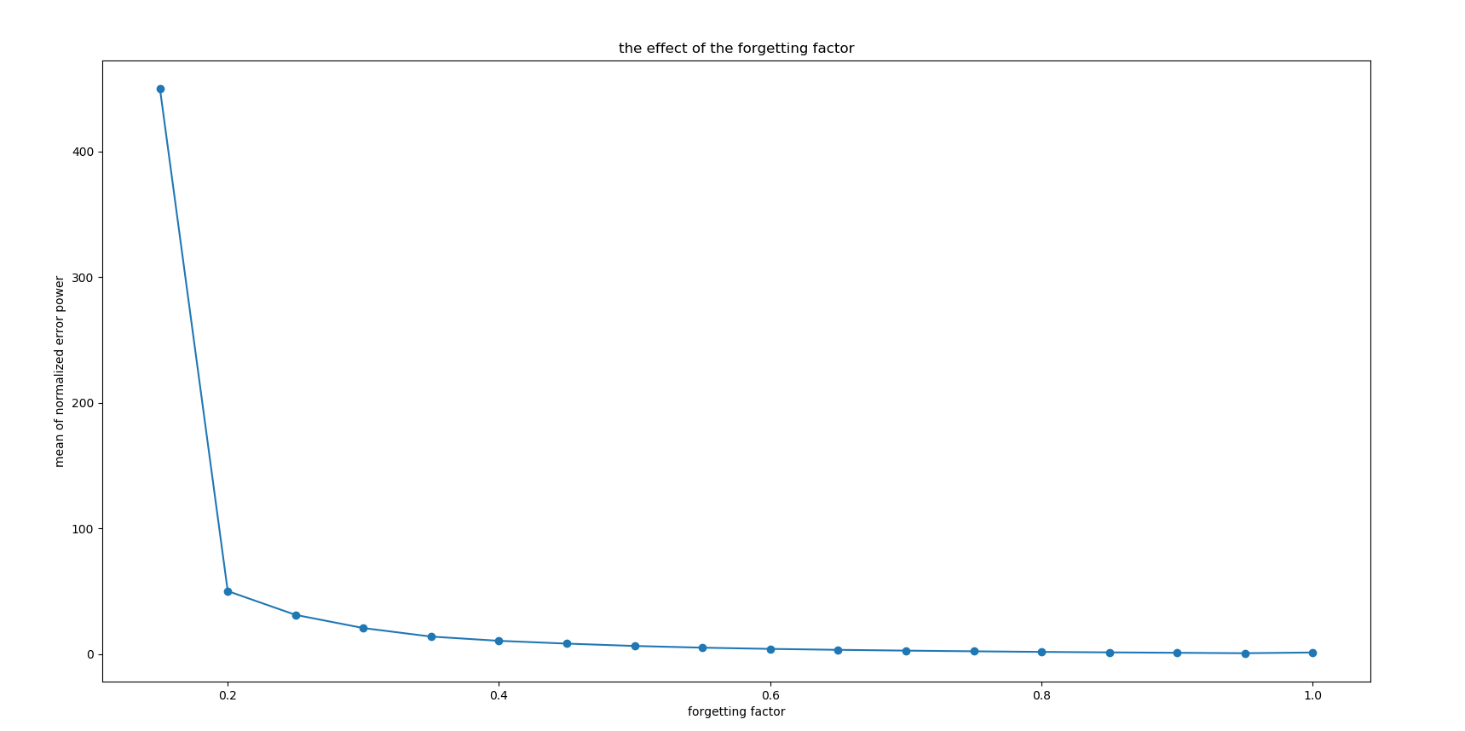

Figure 7 RLS-the effect of the forgetting factor (forgetting factor = (0:1))

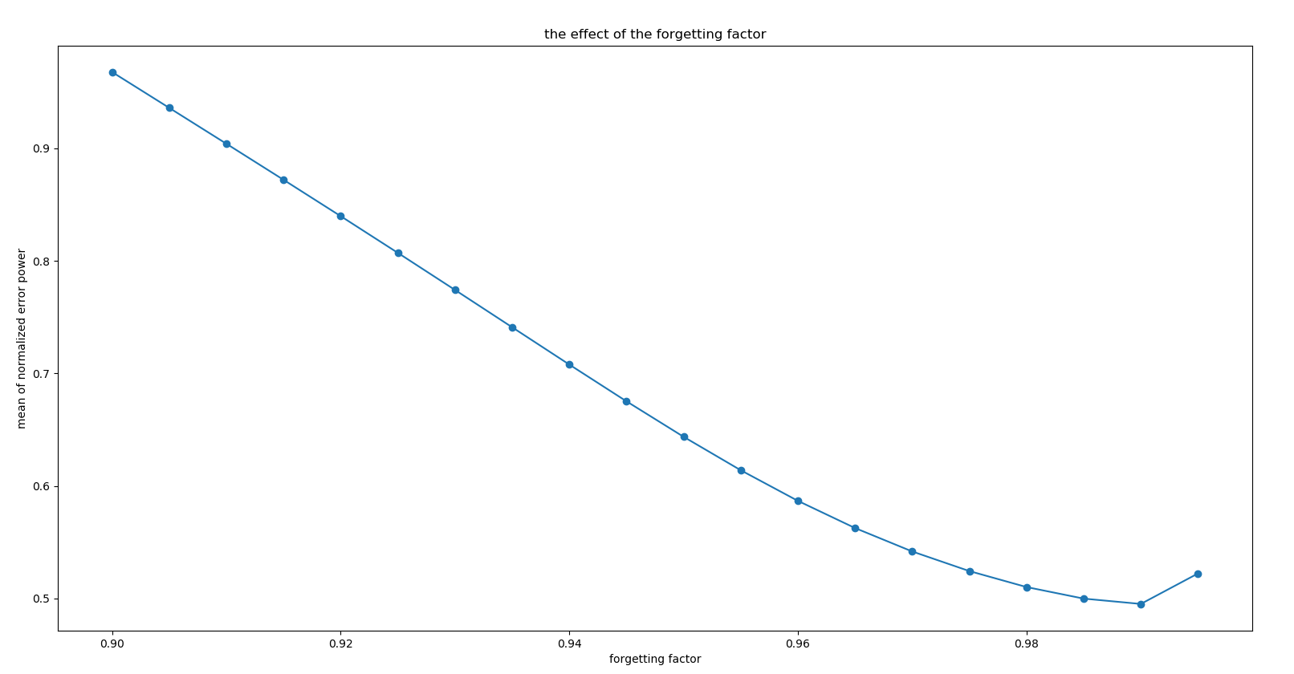

Figure 8 RLS-the effect of the forgetting factor (forgetting factor = (0.9:1))

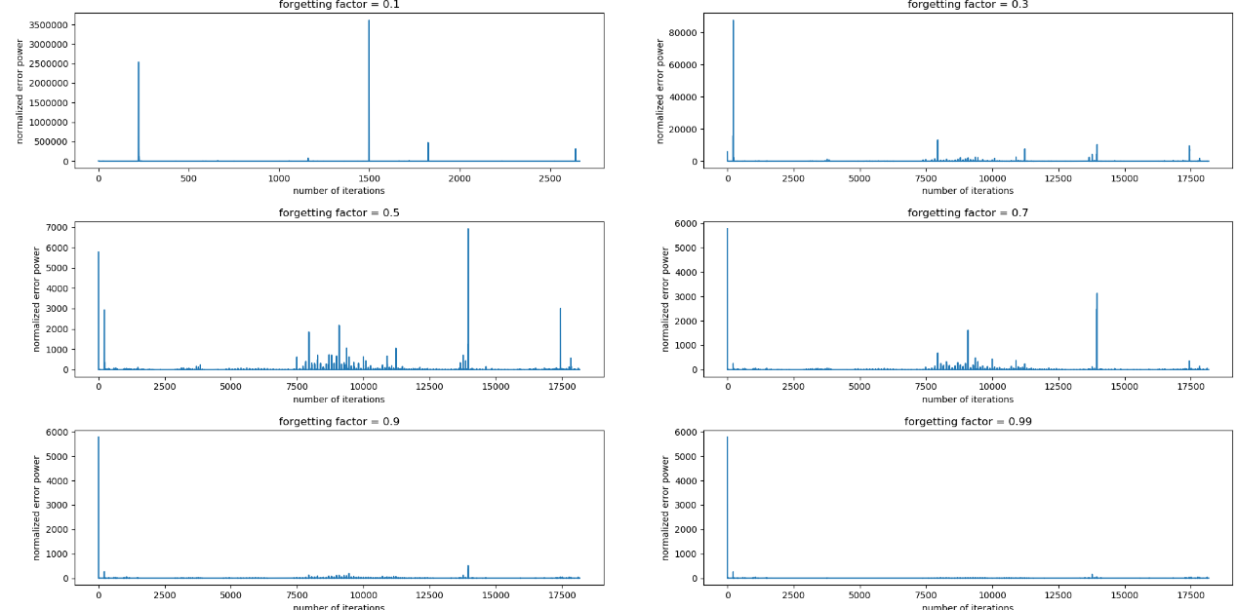

Figure 9 RLS-learning curve of different forgetting factor

In this question, I set filters of order 15 to study the effect of the forgetting factor. I calcualated the mean of the normalized error power which is the standard for comparing performance.

From the figures above we can see that RLS has the best performance when forgetting factor = 0.99. The smaller the forgetting factor, the stronger the tracking ability of the system, and the more sensitive it is to noise. The larger the forgetting factor, the weaker the tracking ability of the system, but less sensitive to noise, and the smaller the estimation error when converging.

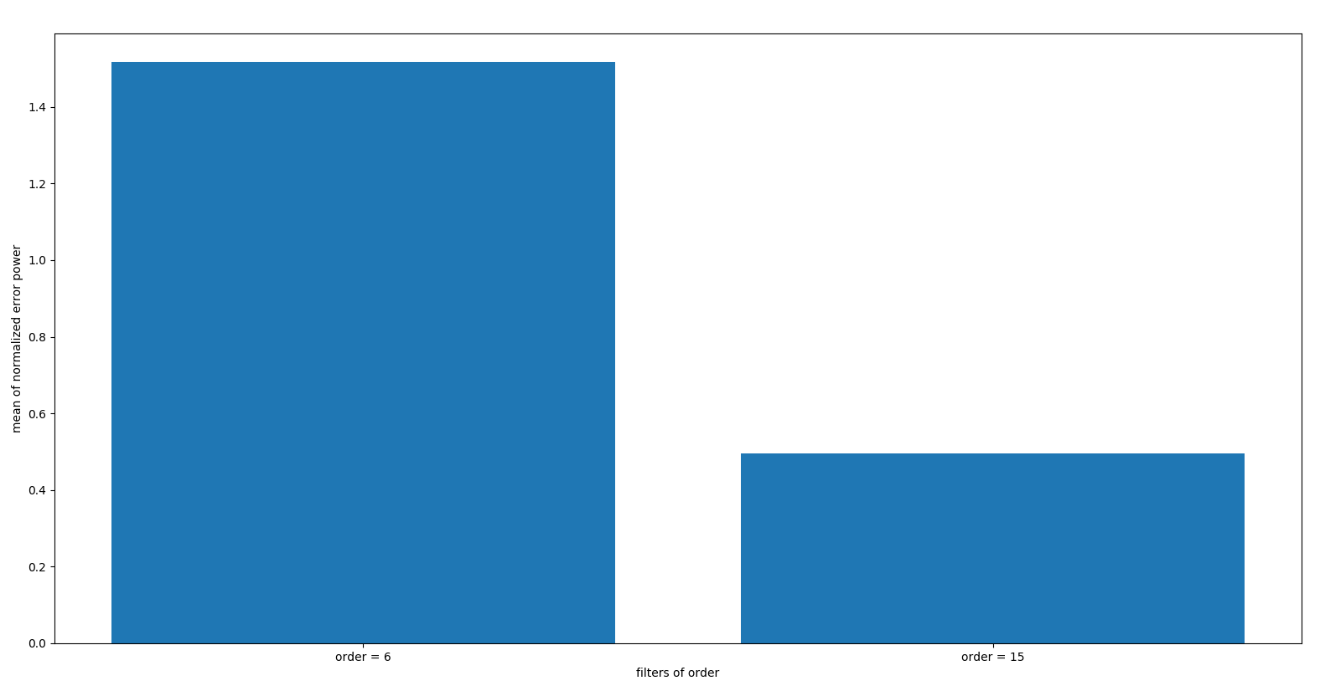

Figure 10 RLS-the effect of the filter length (filters of order 6,15)

I set forgetting factor = 0.99 to study the effect of the filter length. I calcualated the mean of the normalized error power which is the standard for comparing performance.

After comparing the normalized error power of filters of order 6 and 15, we can see from the figure above that filters of order 15 has better prediction performance. Because if filter length is too short, we may make inaccurate system identification due to lack of information. But if filter length is too long, there will be more noise and interference.

## 

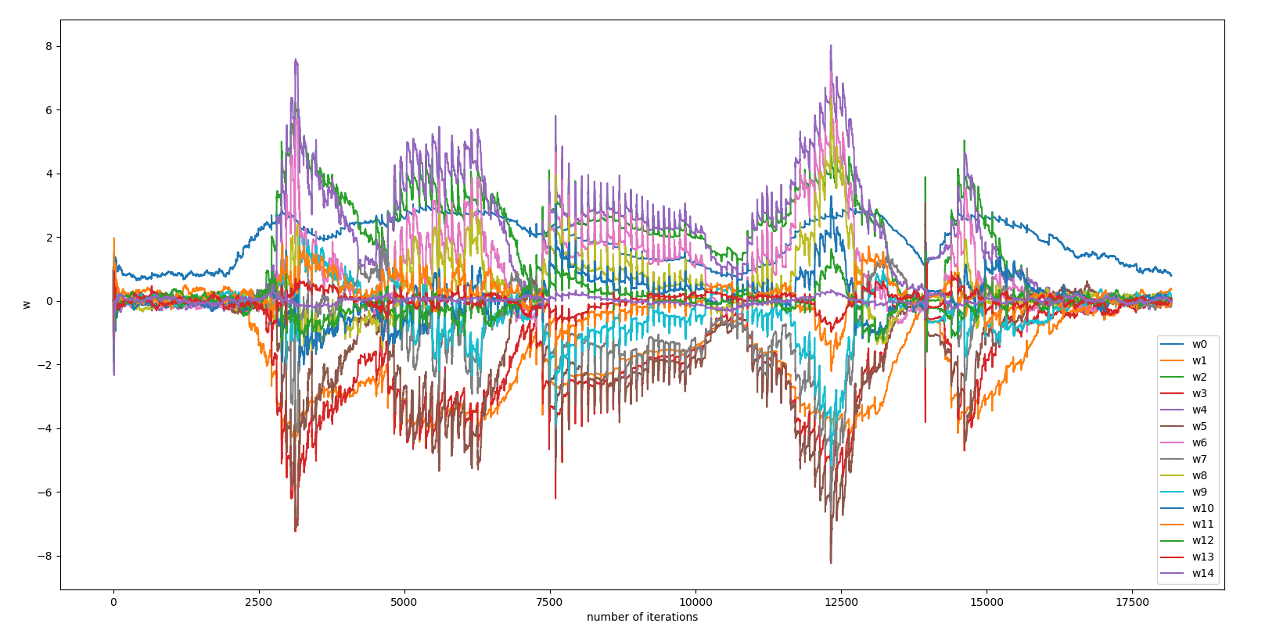

Figure 11 RLS-how weights change over time

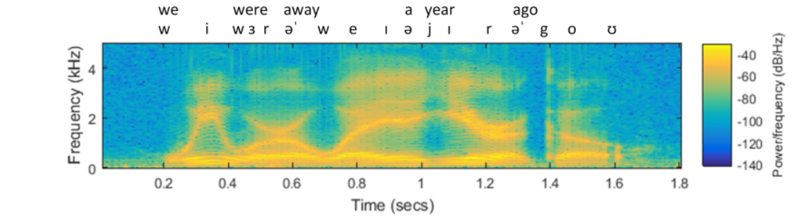

Figure 12 wide-band sound spectrogram

I set forgetting factor = 0.99 and filters of order 15.

From the figures above we can see that the changing of weight values is the same as the changing of frequency of the sounds. When the speaker said a word, the weights became bigger.

## 

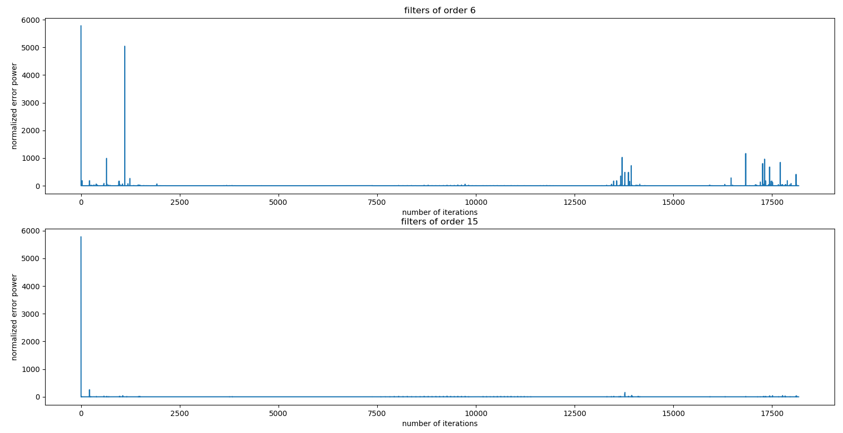

Figure 13 learning curve of RLS (forgetting factor = 0.99, filters of order 6 and 15)



Figure 14 wide-band sound spectrogram

After comparing the two figures above, we can see that when the frequency of the sounds changes a lot, the prediction error will first increase and then quickly converge. It is more obvious in the first figure (filters of order 6).

For improving prediction, we can change the convergence rate (forgetting factor) with sound frequency. If the sound frequency does not change much over time, we can set convergence rate bigger which is close to 1 during this time to improve prediction. But if the sound frequency changes a lot at some time, we should set convergence rate smaller to reduce the impact of previous values. Also, we can set a suitable filter order to improve prediction.

Convergence rate (forgetting factor) is important because it is mainly used to increase the weight of new data to enhance the adaptability to non-stationary signals, so that the adaptive filter has the ability to quickly respond to changes in input process characteristics

## 

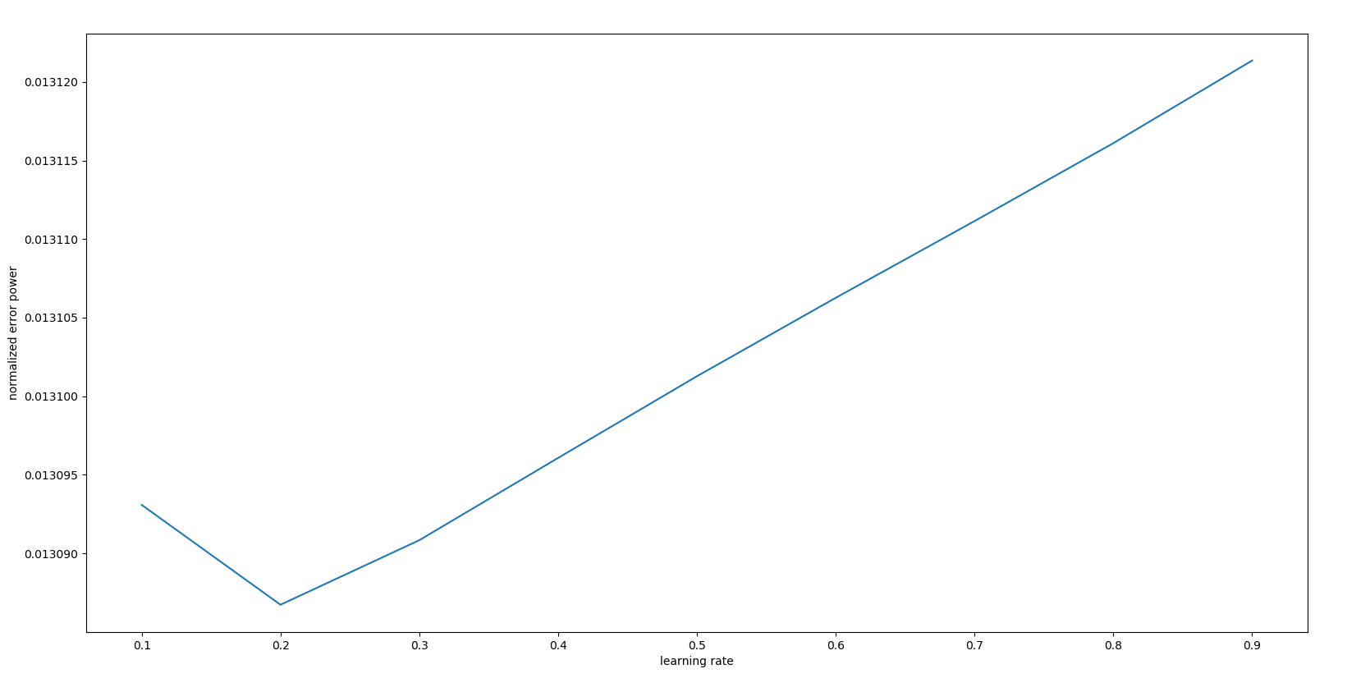

Figure 15 APA-the effect of the learning rate (learning rate = (0.1:1))

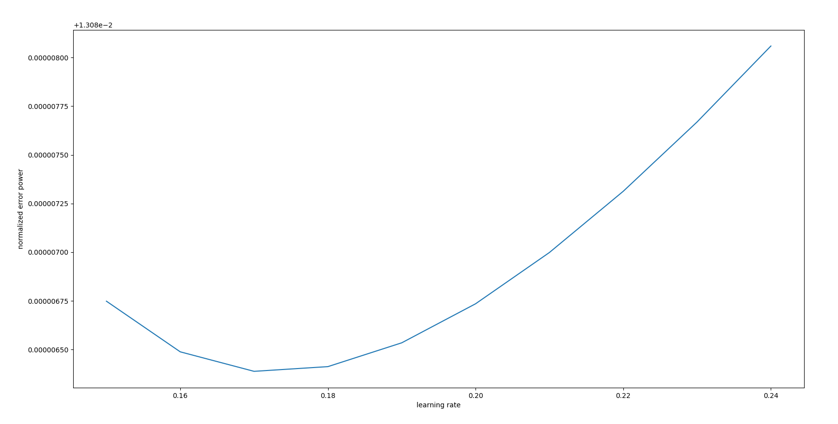

Figure 16 APA-the effect of the learning rate (learning rate = (0.15:0.24))

I use non-Regularized APA by Newton’s Recursion (APA2) as my APA algorithm in the whole problem 2.

In this question, I set filters of order 15 and number of samples = 100 to study the effect of the learning rate. I calcualated the mean of the normalized error power which is the standard for comparing performance.

From the figures above we can see that APA has the best performance when learning rate = 0.17.

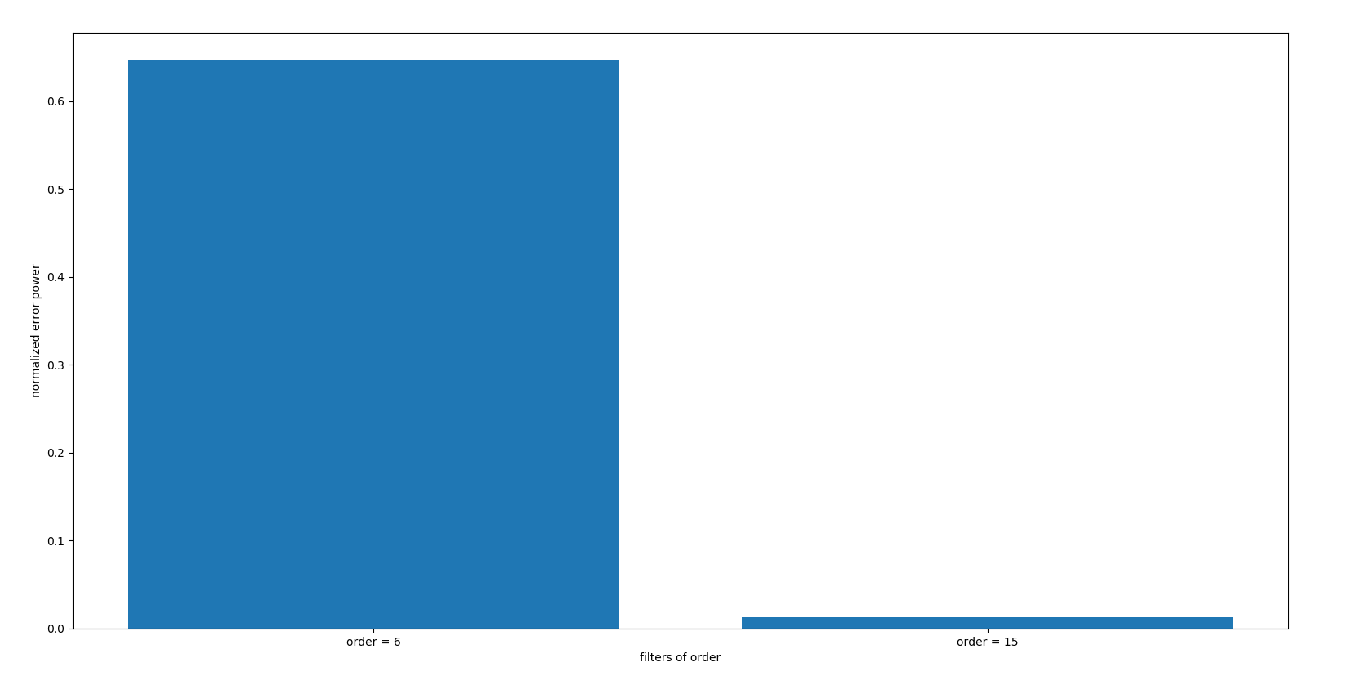

Figure 17 APA-the effect of the filter length (filters of order 6,15)

I set learning rate = 0.17 and number of samples = 100 to study the effect of the filter length. I calcualated the mean of the normalized error power which is the standard for comparing performance.

After comparing the normalized error power of filters of order 6 and 15, we can see from the figure above that filters of order 15 has better performance. Because if filter length is too short, we may make inaccurate system identification due to lack of information. But if filter length is too long, there will be more noise and interference.

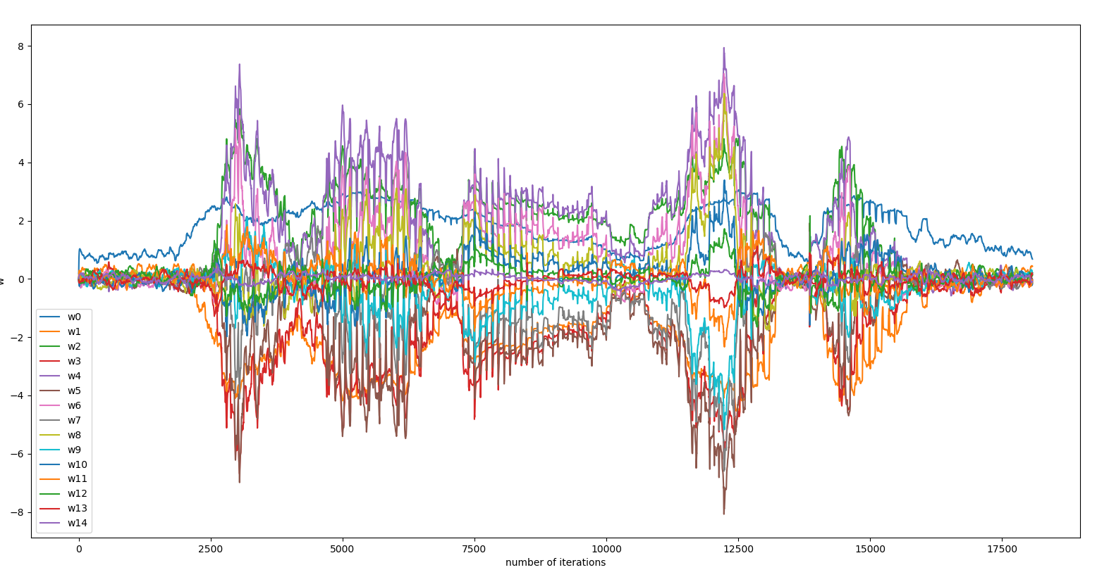

Figure 18 APA-how weights change over time

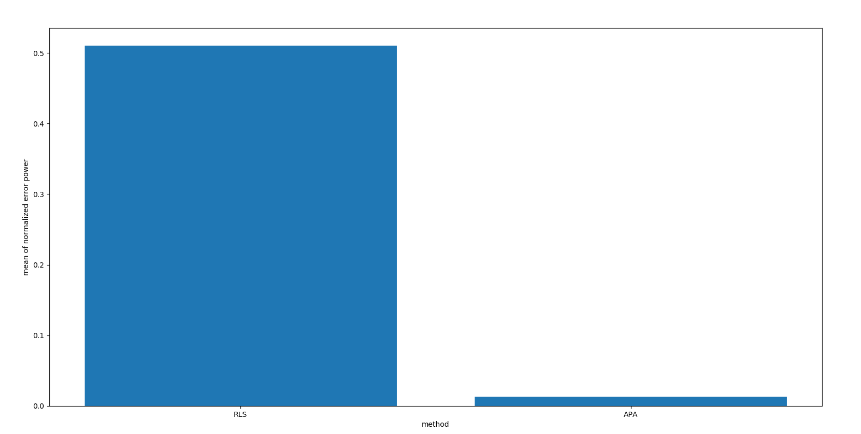

Figure 19 mean of normalized error power between RLS and APA

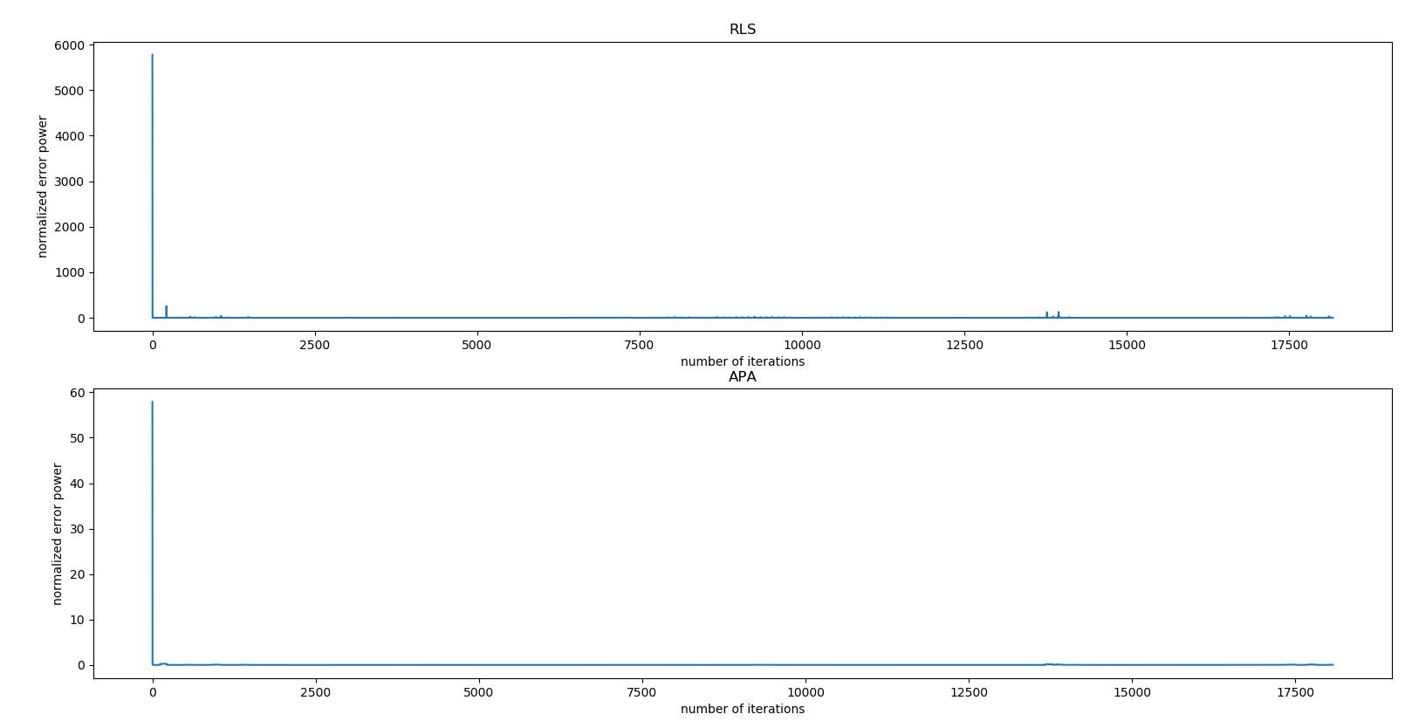

Figure 20 learning curve between RLS and APA

I use non-Regularized APA by Newton’s Recursion (APA2) as my APA algorithm because it uses the least squares cost and Newton update which has smaller error and faster convergence speed.

In RLS, I set filters of order 15, forgetting factor = 0.99.

In APA, I set filters of order 15, learning rate = 0.17, number of samples = 100.

From the figures above we can see that APA has better performance than RLS.

## 

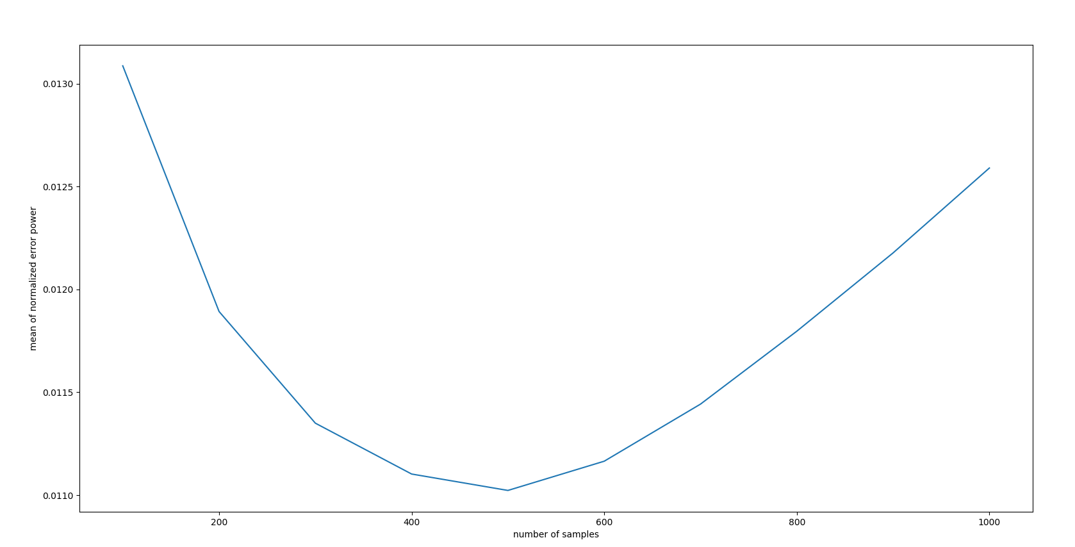

Figure 21 the effect of different number of samples

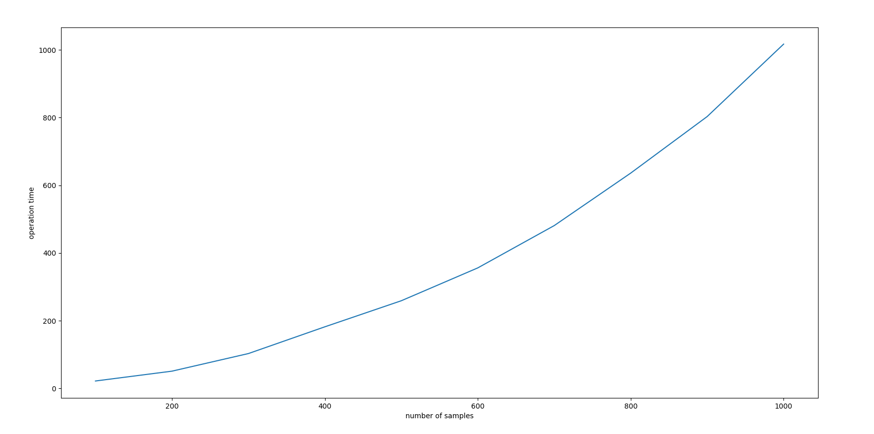

Figure 22 operation time (sec) of different number of samples

In the previous question we discussed the effect of learning rate and filter length. We concluded that learning rate = 0.17 and filters of order 15 have better prediction performance. So, I set learning rate = 0.17 and filters of order 15 to study the effect of the number of samples.

From the figures above we can see that when number of samples = 500, APA has the best prediction performance. Prediction performance is not good when number of samples is too many or too few. When the number of samples is too small, we do not have enough information to predict the next value. But too many samples give us a lot of information that is not useful for prediction and may interfere with our prediction.

The Figure 22 shows the operation time of different number of samples, we can conclude that the large the number of samples, the longer the code runs and the higher the complexity.