Project 1 Report

Zexi Liu

University of Florida

Gainesville, FL

zexiliu@ufl.edu

*Abstract*— In this project we design a machine learning model using normalized Least mean square (NLMS) algorithm to clean the desired input from the machine noise and evaluate the performance of this model. The performance of NLMS algorithm is tested for non- stationary signals like speech signal. The output of NLMS algorithm is measured with mean square error (MSE) and echo return loss enhancement (ERLE). And we also compare the performance between Recursive Least square (RLS) and normalized Least mean square. The results can be appreciated that NLMS algorithm has a great effect on noise cancellation, and it is better than RLS algorithm.

Keywords— NLMS algorithm, adaptive filtering, noise cancellation, machine learning

# Introduction

## Introduction of LMS and NLMS

The LMS adaptive algorithm is based on the steepest descent method. It is a very useful and simple method for estimating gradients. It was invented in 1960 by Stanford University professor Bernard Widrow and his first Ph.D. student, Ted Hoff. The biggest advantage of the traditional LMS algorithm is that the algorithm is simple, but its disadvantages are also obvious. For non-stationary strong-correlated speech signal excitation and impulse response echoes with a long duration, the LMS algorithm has a heavy burden of identification and calculation and a slow convergence speed when directly implemented in the time domain. In order to overcome these shortcomings, many methods have been proposed in recent years to improve the traditional LMS algorithm. NLMS algorithm is one of the most famous improved LMS algorithms.

Because the size of the input signal has an impact on the LMS algorithm, that is, under the same conditions, the signal with low energy will cause gradient amplification, and the algorithm with high energy will converge slowly. Normalize the input signal according to its average energy to obtain the normalized LMS algorithm, also known as the NLMS algorithm. The principle of the NLMS algorithm is to minimize the mean square error of the predicted signal. The NLMS algorithm using an iterative algorithm is expressed as in:

$$\begin{aligned}\overline{w}\left(n+1\right)= \overline{w}\left(n\right)+\frac{η}{δ+{\left\|x\left(n\right)\right\|}^{2}}\overline{x}\left(n\right)e\left(n\right)\#\left(1\right)\end{aligned}$$

Note that w is the weight, $η$ is the step size, $δ$ is the compensation factor.

The NLMS algorithm is the most important technology to improve the convergence speed. If you want to improve the convergence speed of the LMS algorithm, you can use a variable step size method to shorten its adaptive convergence process. Since the NLMS algorithm is relatively simple and easy to implement, it is widely used.

## Principle of adaptive noise canceller

From the fig.1 we can see that the adaptive noise canceller includes two inputs and one output. The desired signal d(n) contains the useful speech signal and an uncorrelated additive noise signal. The input signal x(n) is, a noise related to the noise signal. In fact, the noise in d(n) and x(n) are often noise signals generated by the same set of noise sources and reaching the two input channels of the noise canceller through different transmission paths. The input of x(n) to the adaptive filter generates an approximate noise estimate y(n) which is approximately d(n). After that, y(n) is subtracted from the desired signal d(n) to obtain the system output e(n) of the entire canceller at time n. At the same time, e(n) is also used as the error signal of the adaptive filter to return to the adaptive filter to adjust its own parameters or structure to generate the next output. According to the characteristics of the adaptive filter, after repeated adjustment and correction of the weights, the output y(n) of the adaptive filter gradually approaches the noise signal in d(n), eventually achieving the effect of eliminating the noise component in the original input signal. Obviously, if the degree to which y(n) approaches the noise signal in d(n) is greater, the degree to which the final e(n) approximates the original speech signal is also greater, and the effect of noise cancellation is better.

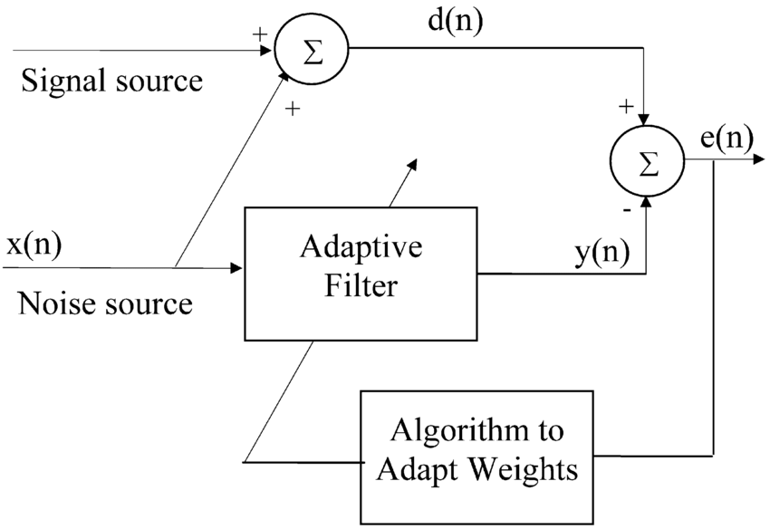

1. Adaptive noise canceller model

# 2-Tap Nlms Algorithm

## Implementation Details

In chapter II, we set filters of order 2, step size $η$ = 0.01, compensation factor $δ$ = 0.0001. The desired response d(n) includes speech signal with the vacuum cleaner noise. The input signal x(n) only includes the vacuum cleaner noise. The sampling frequency is 21 KHz.

## Performance Surface Contours

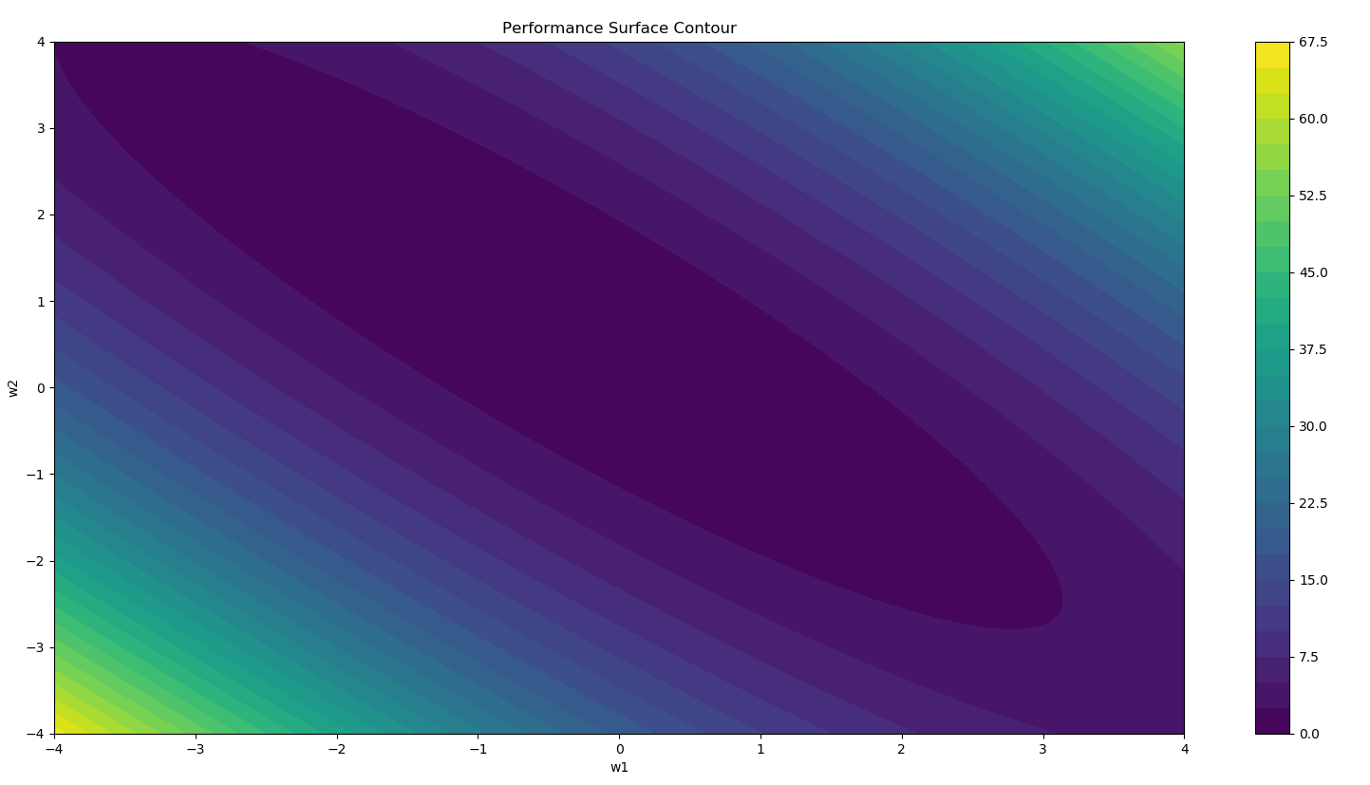

1. Performance Surface Contour

From the Fig.2 we can see that the process of adaptive adjustment is to successively correct the filter weights along the negative direction of the gradient vector. The correction amount at each step is proportional to the negative number of the gradient vector. This is equivalent to moving the adjustment process along the steepest descent direction of the error performance surface. The filter coefficient is adjusted step by step from the current point to the next point, and finally reaches the minimum point of the bowl bottom with the smallest mean square error, to obtain the optimal filtering or optimal working state.

Since the mean square error performance surface has only a minimum value, as long as the convergence step is properly selected, regardless of the initial weight vector, it can converge to the smallest point of the error surface or within a neighborhood of it.

## Weight Tracks

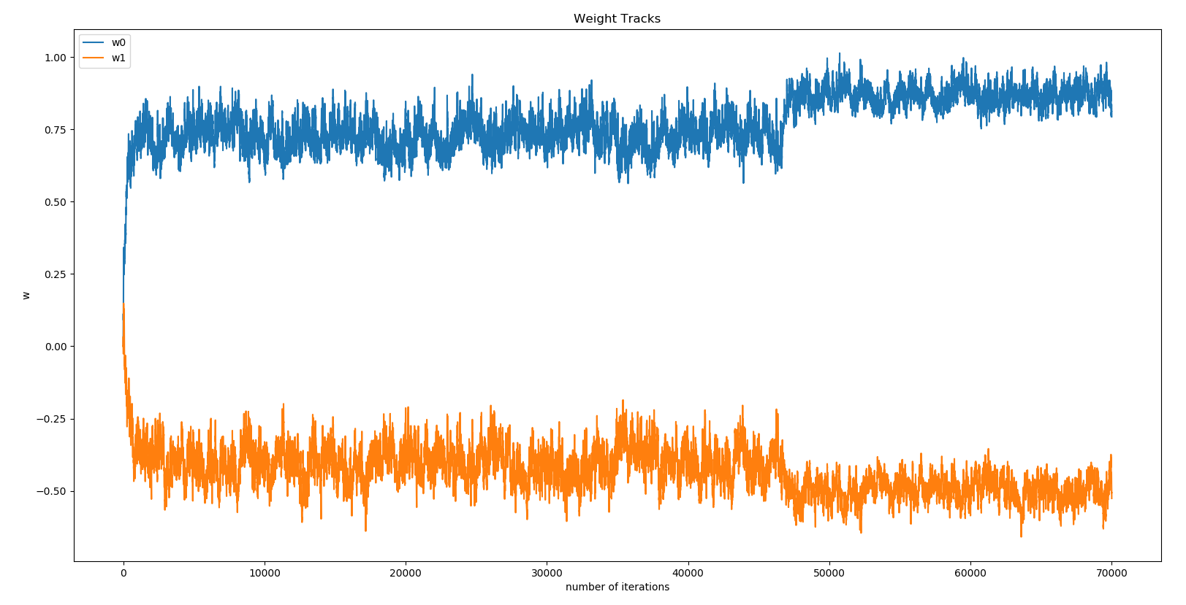

1. Weight Tracks

From the Fig.3 we can see that w0 fluctuates around 0.75 at first and then rises to 0.9 after about 46,000 iterations. W1 fluctuates around -0.4 and then drops to -0.5 after about 46,000 iterations.

## Learning Curce and Interpretation

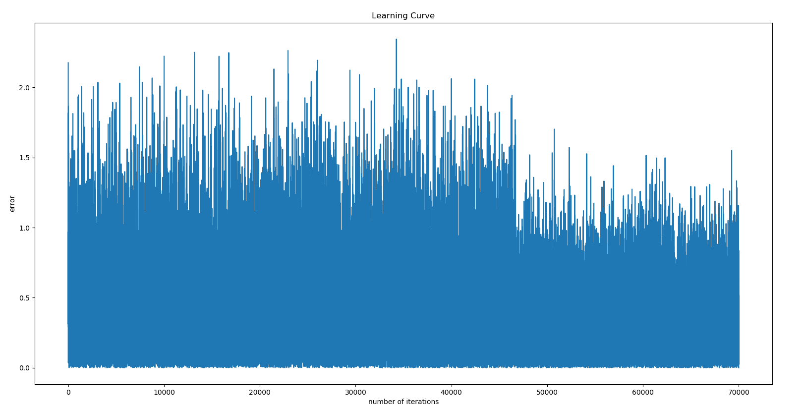

1. Learning Curve(Step Size = 0.01)

After each iteration, I calculated the error which is the difference between d(n) and y(n). In Fig. 4., errors from 0 to 46,000 iterations are fluctuating between 0 and 2, while errors from 46,000 to 70,000 iterations are fluctuating between 0 and 1.5. This is because errors are the volume of the voice. The volume in the first half is high, so the errors are large. The volume in the second half is low, so the errors are small.

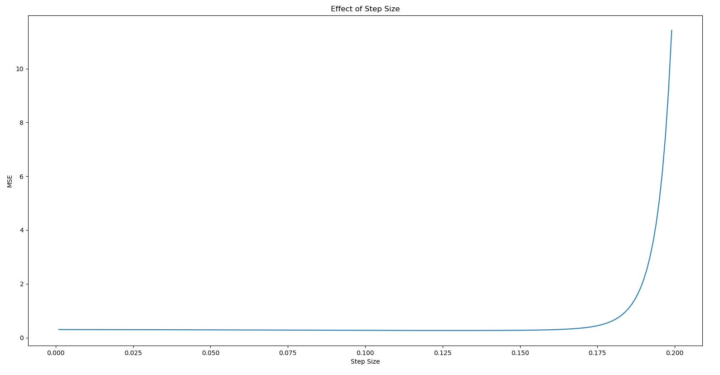

1. The Effect of Step Size

From Fig. 5, we studied the effect of step size. We can see that the when step size is around 0.125, the adaptive filter has the smallest MSE. Too high or too low step size will cause MSE to increase. But I think when the MSE is the smallest, it may not mean that the adaptive filter has the best performance. Because error is the speech signal. If error is too low, it may be over-fitting, which means that speech signal may be distorted.

## Frequency Response From The Desired Signal To The Error

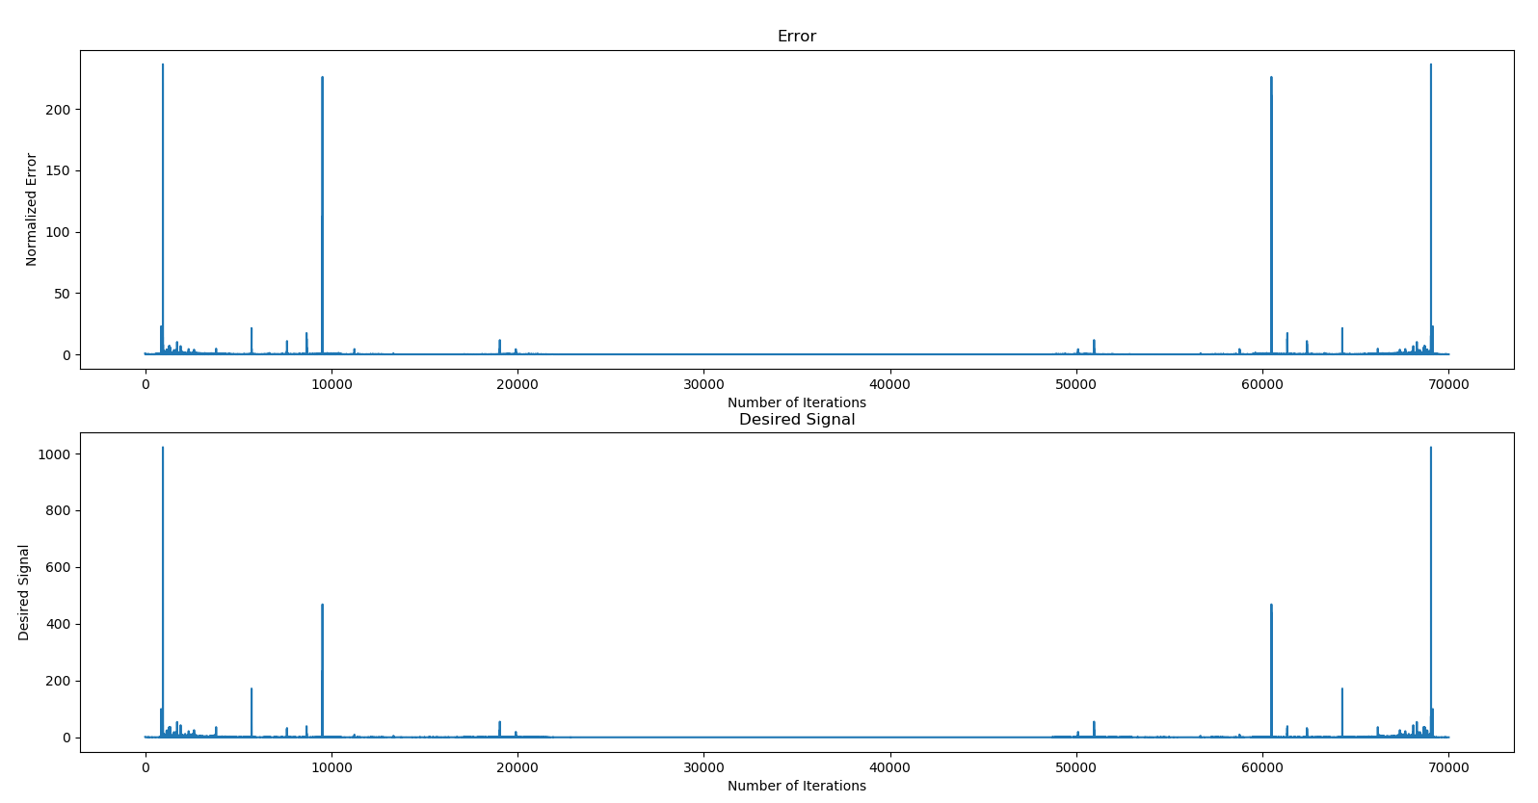

1. Frequency Response From The Desired Signal To The Error

To draw Fig. 6, we calculated absolute value of the FFT of the desired signal d(n) and error signal e(n). And then, we normalized those two frequency responses by dividing by the input signal power.

From the Fig. 6, we can see that the error signal value is much smaller than the desired signal value, which means that the adaptive filter filtered most of the noise.

## the SNR Improvement

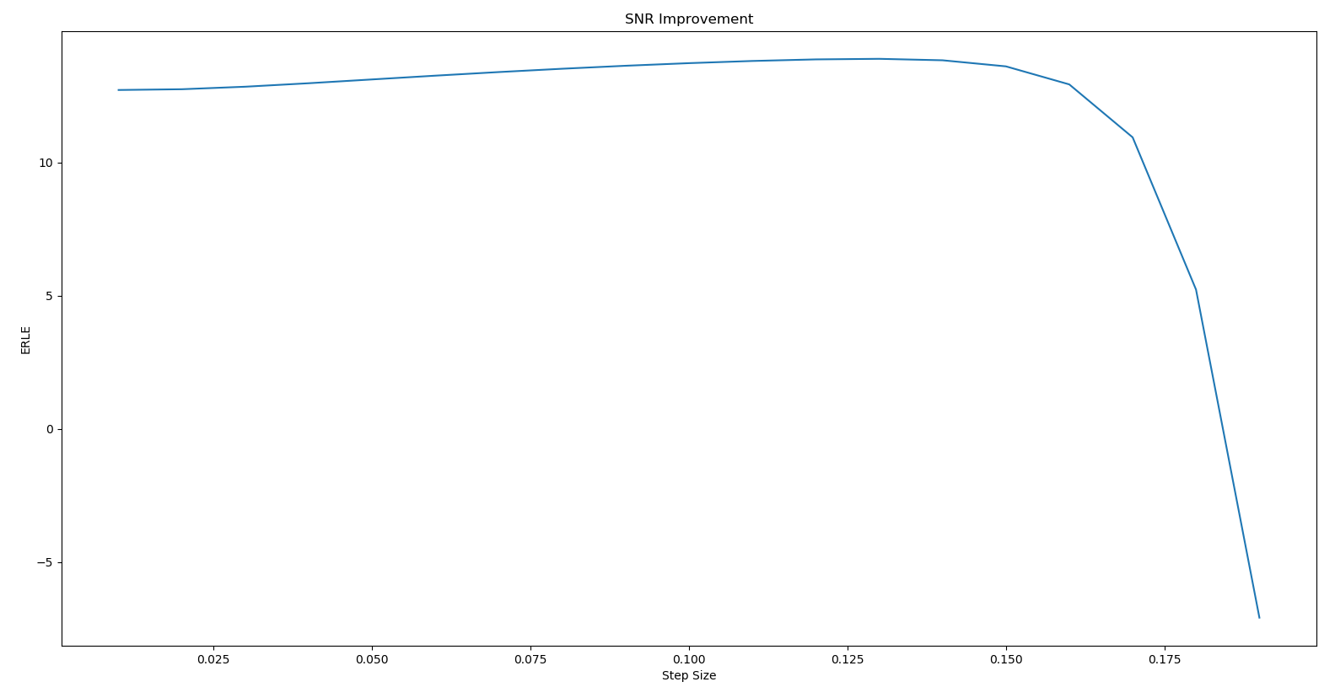

1. The Impact of Step Size on SNR

For SNR, we calculated the ERLE by the formula:

$$\begin{aligned}ERLE=10\log\left(\frac{E\left[d^{2}\right]}{E\left[e^{2}\right]}\right)\#\left(1\right)\end{aligned}$$

Form (2) we can see that if the expected value of desired signal d does not change, the smaller the expected value of the error e, the bigger the value of ERLE.

The Fig. 7 illustrates the impact of step size on SNR. We can see that when step size = 0.125, ERLE has the biggest value, which also means the smallest MSE showed in Fig.5.

# increase the filter order in nlms algorithm

I set step size = 0.01 to study the effect of the filter order number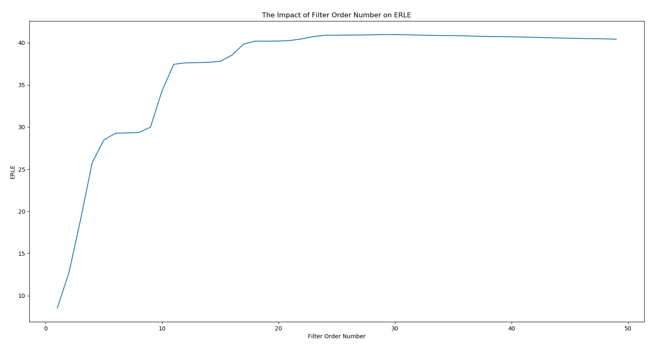

1. The Impact of Filter Order Number on ERLE(Step Size = 0.01)

Fig. 8 illustrates the impact of filter order number on ERLE. In the figure we know that ERLE initially increases with the increase of the filter order number. After the filter order number is greater than 20, the value of ERLE is almost unchanged.

Also, I compare filter performance by listening to different sounds from different errors. After listening to the filtered sounds from filters of order 2,5,10,20,50, I choose the clearest speech sound which is from filters of order 20.

In chapter III, I set step size = 0.01 to compare the performance between filters of order 2 and filters of order 20.

## Frequency Response From The Desired Signal To The Error

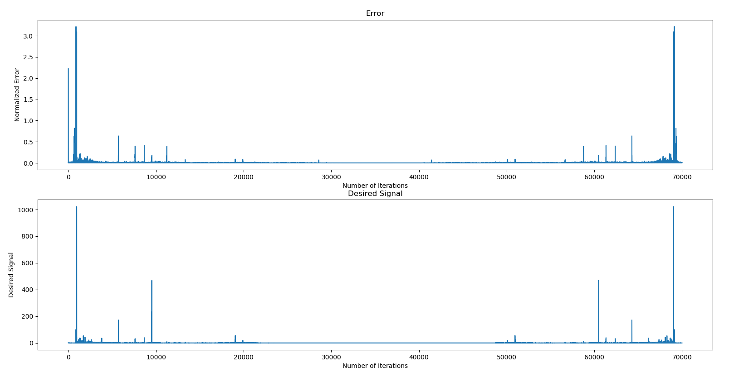

1. Frequency Response From The Desired Signal To The Error (Filters of Order 20)

After comparing the frequency response from Fig. 6 and Fig. 9, we can see that the normalized error in Fig. 9 is much smaller than the normalized error in Fig.6. This is because the adaptive filter of order 20 filtered more noise, so the there is much more speech signal in the error from filter of order 20.

## SNR improvement in dB

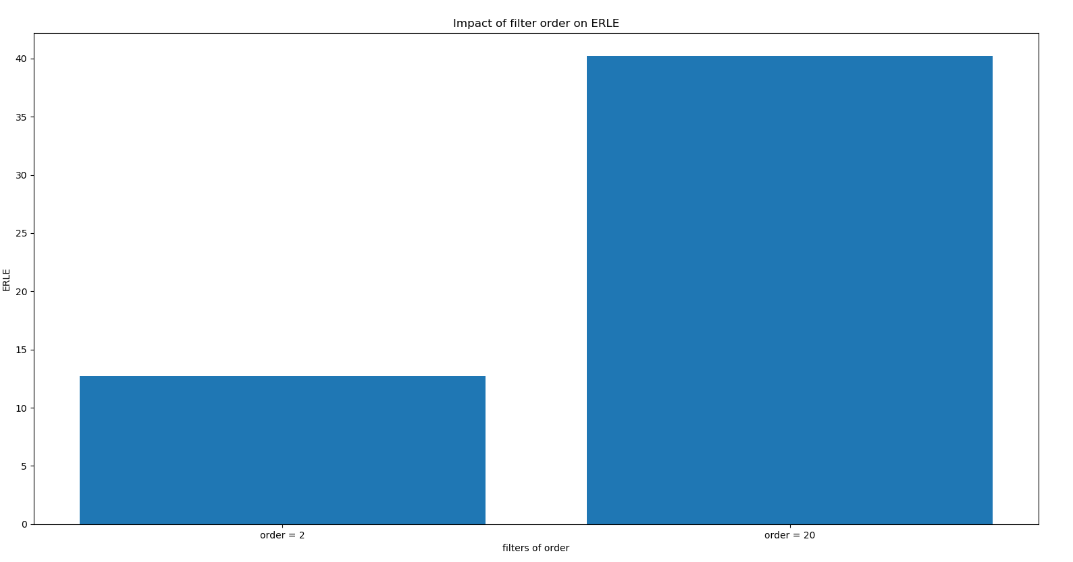

1. The Impact of Filter Order Number on ERLE

The ERLE of filters of order 2 = 12.7, the ERLE of filters of order 20 = 40.2. And we also can see from the Fig. 8 that ERLE initially increases with the increase of the filter order number. After the filter order number is greater than 20, the value of ERLE is almost unchanged.

## The Impact of the Step Size on the Filter Perfomance

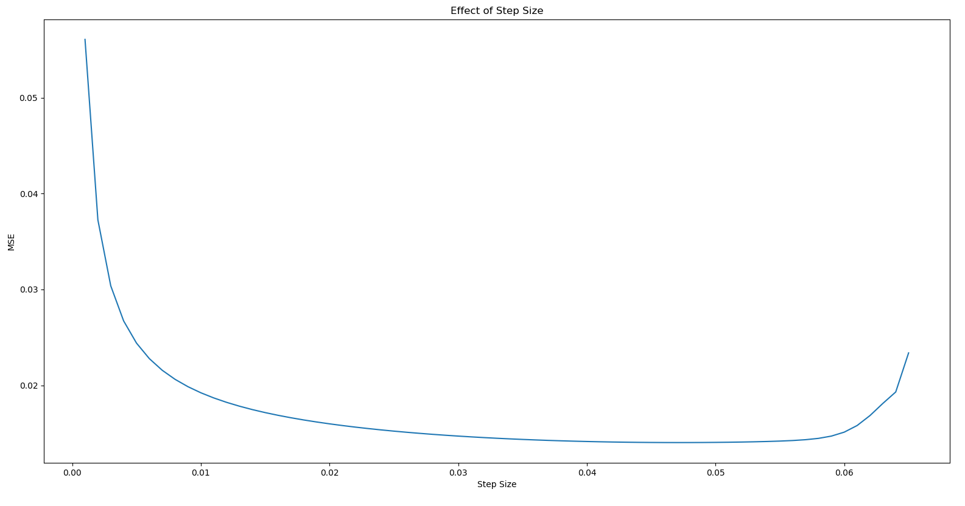

1. The Impact of Step Size on MSE

We set filters of order 20 to study the impact of step size on the filter performance. From the Fig. 11 we can see that MSE first decreases and then increases. When the step size is around 0.05, the MSE is the lowest. But when the MSE is the smallest, it may not mean that the adaptive filter has the best performance. Because error is the speech signal. If error is too low, it may be over-fitting, which means that the adaptive filter have filtered the speech signal and speech signal may be distorted.

After listening to the sound of the 0.05-stepsize filter and comparing it with the sound of the 0.01-stepsize filter, I conclude that the performance of 0.05-stepsize filter is not better than the performance of 0.01-stepsize filter.

## Misadjustment

The misadjustment is given by

$$\begin{aligned}M= η*tr\left[R\right]\#\left(1\right)\end{aligned}$$

Note that $η$ is the step size and $R$ is the auto correlation function. To approximate we consider $2*input power$ as an approximation for $tr[R]$.

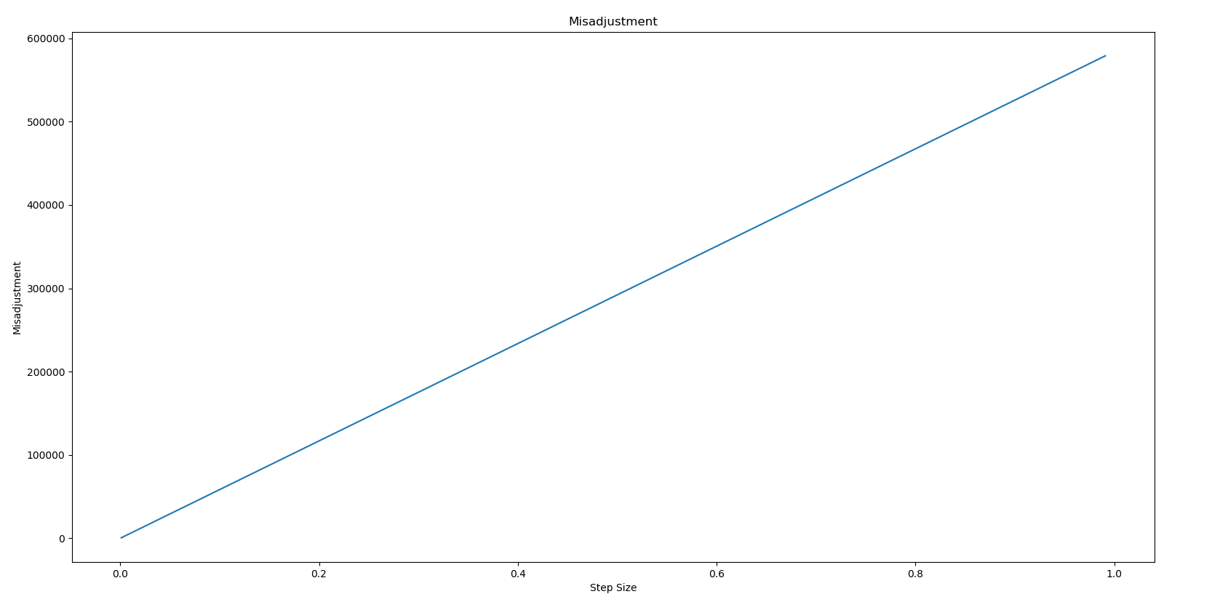

1. The Impact of Step Size on Misadjustment

From the Fig. 12 we can see that the misadjustment is proportional to the step size. The range of misadjustment is 0 to 600,000. If the step size is too small, the rate of convergence is slow. But if the step size is too big, the misadjustment is too high. So we need to choose a suitable step size.

## Comment

From the above analyses we can conclude that the performance of filters of order 20 is better than the performance of filters of order 2 when other variables are the same. But it is not that the higher the filter order, the better the performance of the filter.

For the issue related to the convergence of the NLMS algorithm in non-stationary environments, we can adjust the rate of the convergence by changing the step size. The larger the step size, the faster the convergence speed. But excessive step size may cause the gradient to oscillate back and forth around the minimum. So after comparing the MSE and SNR and listening to the sound from the error e[n], we choose the final step size is 0.01.

# Performance Comparison Of NLMS Algorithm And RLS Algorithm

In chapter IV, we compared the performance between NLMS and RLS.

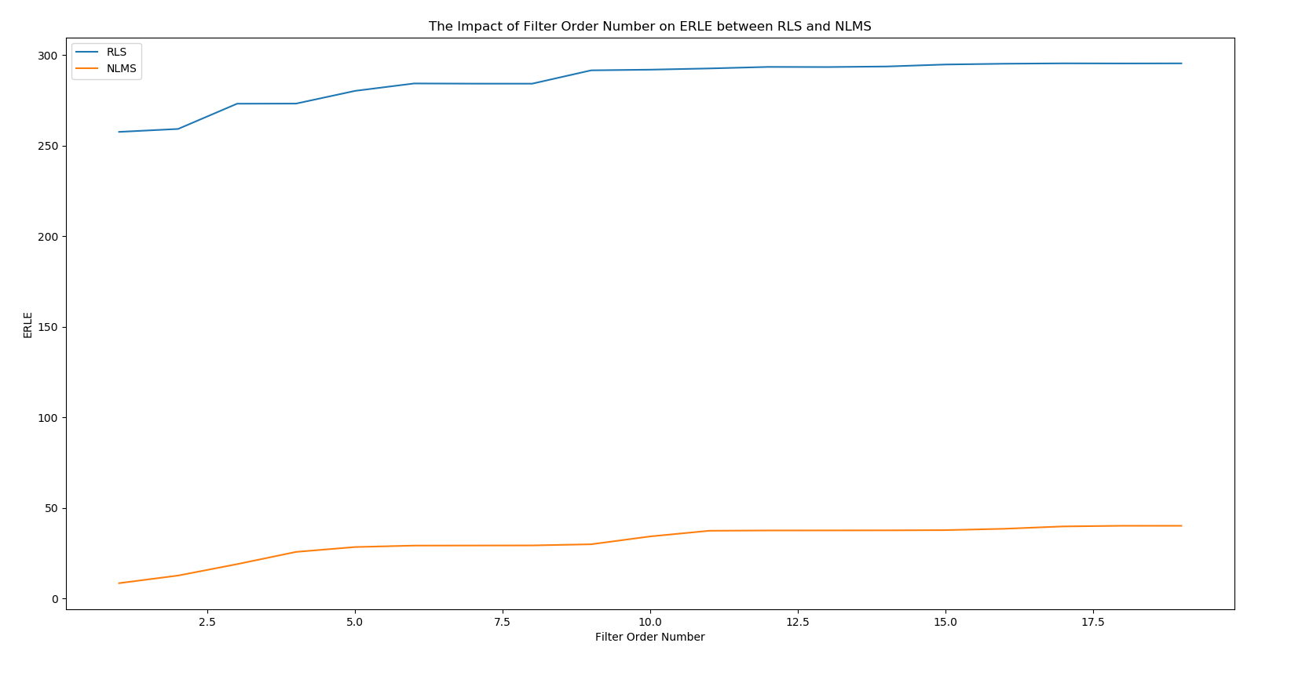

1. Comparison of ERLE with RLS and NLMS

We set the forgetting factor to 0.99 to study the impact of filter order number and we calculated the ERLE of RLS algorithm when changing the filter order number from 1 to 20. Fig. 13 compares the ERLE between RLS and NLMS. We can see that the ERLE of RLS algorithm is much bigger than the ERLE of NLMS. But it does not mean RLS algorithm has better performance. From (2) we know that the smaller the e, the bigger the ERLE, so a bigger ERLE does not mean a better performance.

After listening to the sound from RLS and NLMS, we conclude that the RLS algorithm does not have a better performance.

# Conclusion

In this project we design a machine learning model using normalized LMS algorithm to clean the desired input from the machine noise and evaluate the performance of this model. The simulations and analyses proposed in section II and III illustrate the performance of NLMS algorithm. Section IV illustrates the comparison of RLS and NLMS. We conclude that the NLMS algorithm can clean the desired input from the machine noise. The NLMS algorithm also increases convergence speed. So the NLMS algorithm can be used in speech enhancement applications like interference canceling.