一、RS485通讯协议

(仿MODBUS ASCII协议)

表1 协议结构

|  |  |  |  |
| --- | --- | --- | --- |
| 名称 | 内容 | 字节 | 数据内容 |
| 初始结构 | “:”(0x3A) | 1字节 |  |
| **地址码** |  | **2字节** | **1~9；** |
| **功能码** |  | **2字节** | **00；01~16；91~99** |
| **数据区** |  | **N字节** | **0~6字节** |
| 错误校验 | LRC校验 | 2字节 |  |
| 结束结构 | CR;LF(0x0D;0x0A) | 2字节 |  |
| 数据部分 | | 4+N |  |
| 协议整体 | | 9+N |  |

表2 地址码定义

|  |  |
| --- | --- |
| **地址码** | **设备** |
| 01 | 液晶屏 |
| 11 | - |
| 21 | - |
| 31 | - |
| 41 | - |
| 51 | - |
| 61 | - |
| 71 | - |
| 81 | - |
| 91 | - |
|  |  |
| 02 | 单片机STM32F103主控-全通道 |
| 12 | 单片机STM32F103主控-通道1 |
| 22 | 单片机STM32F103主控-通道2 |
| 32 | 单片机STM32F103主控-通道3 |
| 42 | 单片机STM32F103主控-通道4 |
| 52 | 单片机STM32F103主控-通道5 |
| 62 | 单片机STM32F103主控-通道6 |
| 72 | 单片机STM32F103主控-通道7 |
| 82 | 单片机STM32F103主控-通道8 |
| 92 | 单片机STM32F103主控-通道9 |
| 04 | 单片机STM32F103主控-通道10 |
| 14 | 单片机STM32F103主控-通道11 |
| 24 | 单片机STM32F103主控-通道12 |
|  |  |
|  |  |

表3 功能代码（单片机端）

|  |  |  |  |  |  |
| --- | --- | --- | --- | --- | --- |
| **编号** | **收发**  **状态** | **功能** | **格式** | **单位** |  |
| 00 | T | 指令接受错误 | 9 |  | 1：校验不合格  2：BUSY有指令没有执行完毕  3： |
| 01 | T | 指令接受正确 |  |  |  |
| 02 | R | 转速设置 | 9999 | **10×rpm** | 250.0rpm |
| 03 | T | 转述回传 | 9999 | **10×rpm** | 250.0rpm |
| 04 | R | 温度设置 | 999 | **10×℃** | 25.0℃ |
| 05 | T | 温度回传 | 999 | **10×℃** | 25.0℃ |
| 06 | R | 工作台 | 9 |  | 0：停止  1：上升  2：下降 |
| 07 | T | 工作台 | 99 |  | 0：停止  1：上升  2：下降  3：上升限位  4：下降限位  5：高度 |
| 08 | R | 加热棒 | 9 |  | 0：停止加热  1：开始加热 |
| 09 | T | 加热棒 | 9 |  | 0：停止加热  1：开始加热 |
| 10 | R | 水泵 | 9 |  | 0：停止水循环  1：开始水循环 |
| 11 | T | 水泵 | 9 |  | 0：停止水循环  1：开始水循环 |
| 12 | R | 时间价格设置 | 99 | 10sec |  |
| 13 | - | - | - | - |  |
| 14 | R | 时间校准 | 999999 |  |  |
| 15 | T | 时间校准 | 999999 |  |  |
| 16 | R | 日期校准 | 999999 |  |  |
| 17 | T | 日期校准 | 999999 |  |  |
| 18 |  |  |  |  |  |
| 19 |  |  |  |  |  |
| 20 |  |  |  |  |  |
| 21 |  |  |  |  |  |
| 22 | R | 通道 | 99 |  |  |
| 23 | T | 通道 | 99 |  |  |
| 24 | R | 打印 |  |  |  |
| 25 | T | 打印 |  |  |  |
| 26 |  |  |  |  |  |
| 27 |  |  |  |  |  |
| 28 |  |  |  |  |  |
| 29 |  |  |  |  |  |
| 30 |  |  |  |  |  |
| 31 |  |  |  |  |  |
| 32 |  |  |  |  |  |
| 33 |  |  |  |  |  |
| 34 |  |  |  |  |  |
| 35 |  |  |  |  |  |
| 36 |  |  |  |  |  |

**二、界面设计初稿**

（检查界面尺寸是否足够）

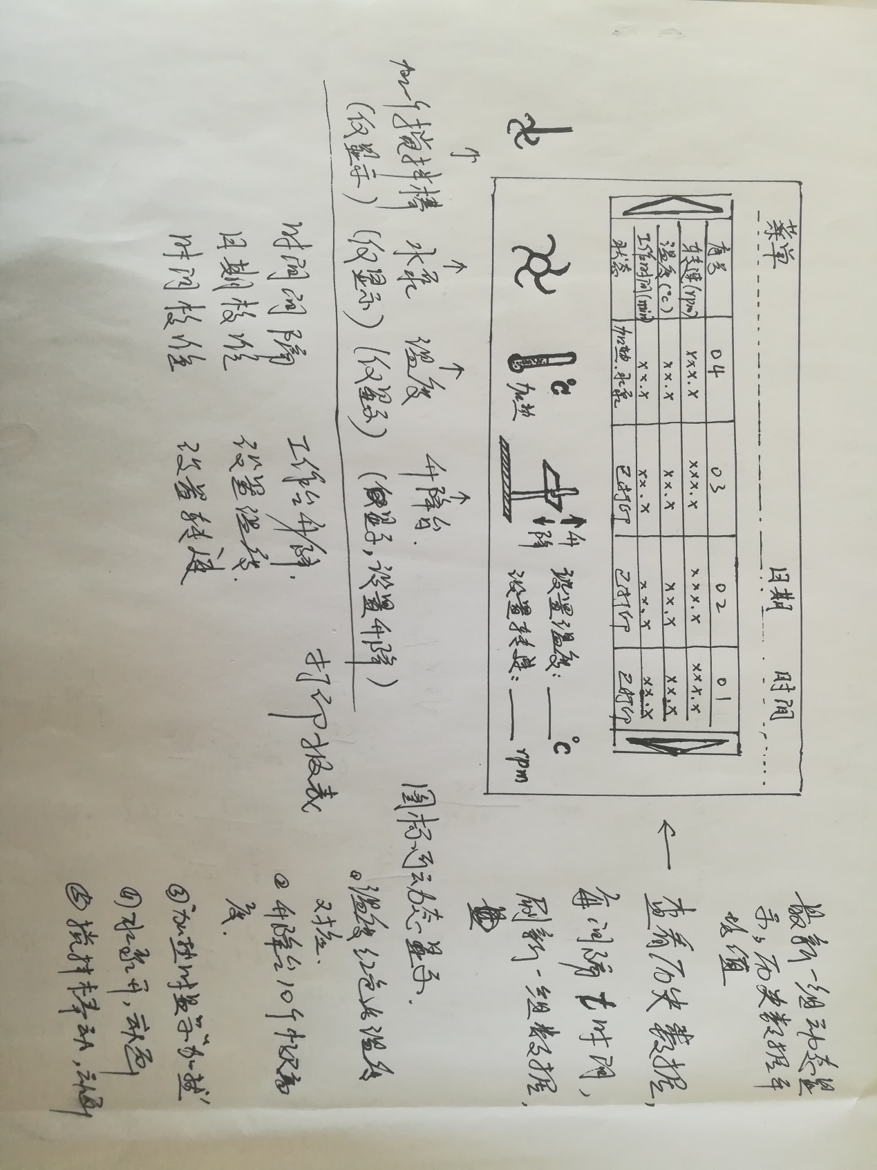

图1 界面设计初稿

菜单：

1、菜单内容：设置温度、设置转速、工作台、时间间隔、日期校准、时间校准、打印间隔、打印（使能定时打印）、定时启动、定时关闭、工作模式（预制工作时间）、数据下载（到U盘）

如何分组尚未考虑，又不能实现的告诉我。

2、设置时弹出界面。

左下：

1、四个动画图标（搅拌棒、水泵、加热器（温度计改为加热器，不用显示汉字加热）、工作台），四个图标均可以动画显示，激活时动画显示，停止时静态图片。

2、工作台增加升降按钮。

右下：

1、温度快捷设置，静态

2、转速快捷设置，静态

3、打印价格设置，静态

中间：

1、数据表格，按照设置的时间间隔，显示数据，历史数据向右自动移动，

2、最左侧为当前实时数据，动态显示；

3、左右有箭头，可以查看历史数据，失去激活一定时间自动回到最新数据状态。

三、显示屏功能

主要功能都集中在在这里了。

1、功能控制：控制温度

2、数据存储，USB下载

3、打印功能

4、

数据上传时间间隔固定，间隔时间30s，如有其他RS485通讯，暂停上传数据。

四、单片机功能

1、执行液晶屏指令

2、检测温度，控制温度，需要控温算法

3、检测速度，控制速度，需要控速算法

表3 ASCII代码对照表

|  |  |  |  |  |  |  |
| --- | --- | --- | --- | --- | --- | --- |
| DEC | OCT | HEX | BIN | Symbol | HTML Code | Description |
| 0 | 000 | 00 | 00000000 | NUL | &#000; | Null char |
| 1 | 001 | 01 | 00000001 | SOH | &#001; | Start of Heading |
| 2 | 002 | 02 | 00000010 | STX | &#002; | Start of Text |
| 3 | 003 | 03 | 00000011 | ETX | &#003; | End of Text |
| 4 | 004 | 04 | 00000100 | EOT | &#004; | End of Transmission |
| 5 | 005 | 05 | 00000101 | ENQ | &#005; | Enquiry |
| 6 | 006 | 06 | 00000110 | ACK | &#006; | Acknowledgment |
| 7 | 007 | 07 | 00000111 | BEL | &#007; | Bell |
| 8 | 010 | 08 | 00001000 | BS | &#008; | Back Space |
| 9 | 011 | 09 | 00001001 | HT | &#009; | Horizontal Tab |
| 10 | 012 | 0A | 00001010 | LF | &#010; | Line Feed |
| 11 | 013 | 0B | 00001011 | VT | &#011; | Vertical Tab |
| 12 | 014 | 0C | 00001100 | FF | &#012; | Form Feed |
| 13 | 015 | 0D | 00001101 | CR | &#013; | Carriage Return |
| 14 | 016 | 0E | 00001110 | SO | &#014; | Shift Out / X-On |
| 15 | 017 | 0F | 00001111 | SI | &#015; | Shift In / X-Off |
| 16 | 020 | 10 | 00010000 | DLE | &#016; | Data Line Escape |
| 17 | 021 | 11 | 00010001 | DC1 | &#017; | Device Control 1 (oft. XON) |
| 18 | 022 | 12 | 00010010 | DC2 | &#018; | Device Control 2 |
| 19 | 023 | 13 | 00010011 | DC3 | &#019; | Device Control 3 (oft. XOFF) |
| 20 | 024 | 14 | 00010100 | DC4 | &#020; | Device Control 4 |
| 21 | 025 | 15 | 00010101 | NAK | &#021; | Negative Acknowledgement |
| 22 | 026 | 16 | 00010110 | SYN | &#022; | Synchronous Idle |
| 23 | 027 | 17 | 00010111 | ETB | &#023; | End of Transmit Block |
| 24 | 030 | 18 | 00011000 | CAN | &#024; | Cancel |
| 25 | 031 | 19 | 00011001 | EM | &#025; | End of Medium |
| 26 | 032 | 1A | 00011010 | SUB | &#026; | Substitute |
| 27 | 033 | 1B | 00011011 | ESC | &#027; | Escape |
| 28 | 034 | 1C | 00011100 | FS | &#028; | File Separator |
| 29 | 035 | 1D | 00011101 | GS | &#029; | Group Separator |
| 30 | 036 | 1E | 00011110 | RS | &#030; | Record Separator |
| 31 | 037 | 1F | 00011111 | US | &#031; | Unit Separator |
| 32 | 040 | 20 | 00100000 |  | &#32; | Space |
| 33 | 041 | 21 | 00100001 | ! | &#33; | Exclamation mark |
| 34 | 042 | 22 | 00100010 | " | &#34; | Double quotes |
| 35 | 043 | 23 | 00100011 | # | &#35; | Number |
| 36 | 044 | 24 | 00100100 | $ | &#36; | Dollar |
| 37 | 045 | 25 | 00100101 | % | &#37; | Procenttecken |
| 38 | 046 | 26 | 00100110 | & | &#38; | Ampersand |
| 39 | 047 | 27 | 00100111 | ' | &#39; | Single quote |
| 40 | 050 | 28 | 00101000 | ( | &#40; | Open parenthesis |
| 41 | 051 | 29 | 00101001 | ) | &#41; | Close parenthesis |
| 42 | 052 | 2A | 00101010 | * | &#42; | Asterisk |
| 43 | 053 | 2B | 00101011 | + | &#43; | Plus |
| 44 | 054 | 2C | 00101100 | , | &#44; | Comma |
| 45 | 055 | 2D | 00101101 | - | &#45; | Hyphen |
| 46 | 056 | 2E | 00101110 | . | &#46; | Period, dot or full stop |
| 47 | 057 | 2F | 00101111 | / | &#47; | Slash or divide |
| 48 | 060 | 30 | 00110000 | 0 | &#48; | Zero |
| 49 | 061 | 31 | 00110001 | 1 | &#49; | One |
| 50 | 062 | 32 | 00110010 | 2 | &#50; | Two |
| 51 | 063 | 33 | 00110011 | 3 | &#51; | Three |
| 52 | 064 | 34 | 00110100 | 4 | &#52; | Four |
| 53 | 065 | 35 | 00110101 | 5 | &#53; | Five |
| 54 | 066 | 36 | 00110110 | 6 | &#54; | Six |
| 55 | 067 | 37 | 00110111 | 7 | &#55; | Seven |
| 56 | 070 | 38 | 00111000 | 8 | &#56; | Eight |
| 57 | 071 | 39 | 00111001 | 9 | &#57; | Nine |
| 58 | 072 | 3A | 00111010 | : | &#58; | Colon |
| 59 | 073 | 3B | 00111011 | ; | &#59; | Semicolon |
| 60 | 074 | 3C | 00111100 | < | &#60; | Less than |
| 61 | 075 | 3D | 00111101 | = | &#61; | Equals |
| 62 | 076 | 3E | 00111110 | > | &#62; | Greater than |
| 63 | 077 | 3F | 00111111 | ? | &#63; | Question mark |
| 64 | 100 | 40 | 01000000 | @ | &#64; | At symbol |
| 65 | 101 | 41 | 01000001 | A | &#65; | Uppercase A |
| 66 | 102 | 42 | 01000010 | B | &#66; | Uppercase B |
| 67 | 103 | 43 | 01000011 | C | &#67; | Uppercase C |
| 68 | 104 | 44 | 01000100 | D | &#68; | Uppercase D |
| 69 | 105 | 45 | 01000101 | E | &#69; | Uppercase E |
| 70 | 106 | 46 | 01000110 | F | &#70; | Uppercase F |
| 71 | 107 | 47 | 01000111 | G | &#71; | Uppercase G |
| 72 | 110 | 48 | 01001000 | H | &#72; | Uppercase H |
| 73 | 111 | 49 | 01001001 | I | &#73; | Uppercase I |
| 74 | 112 | 4A | 01001010 | J | &#74; | Uppercase J |
| 75 | 113 | 4B | 01001011 | K | &#75; | Uppercase K |
| 76 | 114 | 4C | 01001100 | L | &#76; | Uppercase L |
| 77 | 115 | 4D | 01001101 | M | &#77; | Uppercase M |
| 78 | 116 | 4E | 01001110 | N | &#78; | Uppercase N |
| 79 | 117 | 4F | 01001111 | O | &#79; | Uppercase O |
| 80 | 120 | 50 | 01010000 | P | &#80; | Uppercase P |
| 81 | 121 | 51 | 01010001 | Q | &#81; | Uppercase Q |
| 82 | 122 | 52 | 01010010 | R | &#82; | Uppercase R |
| 83 | 123 | 53 | 01010011 | S | &#83; | Uppercase S |
| 84 | 124 | 54 | 01010100 | T | &#84; | Uppercase T |
| 85 | 125 | 55 | 01010101 | U | &#85; | Uppercase U |
| 86 | 126 | 56 | 01010110 | V | &#86; | Uppercase V |
| 87 | 127 | 57 | 01010111 | W | &#87; | Uppercase W |
| 88 | 130 | 58 | 01011000 | X | &#88; | Uppercase X |
| 89 | 131 | 59 | 01011001 | Y | &#89; | Uppercase Y |
| 90 | 132 | 5A | 01011010 | Z | &#90; | Uppercase Z |
| 91 | 133 | 5B | 01011011 | [ | &#91; | Opening bracket |
| 92 | 134 | 5C | 01011100 | \ | &#92; | Backslash |
| 93 | 135 | 5D | 01011101 | ] | &#93; | Closing bracket |
| 94 | 136 | 5E | 01011110 | ^ | &#94; | Caret - circumflex |
| 95 | 137 | 5F | 01011111 | _ | &#95; | Underscore |
| 96 | 140 | 60 | 01100000 | ` | &#96; | Grave accent |
| 97 | 141 | 61 | 01100001 | a | &#97; | Lowercase a |
| 98 | 142 | 62 | 01100010 | b | &#98; | Lowercase b |
| 99 | 143 | 63 | 01100011 | c | &#99; | Lowercase c |
| 100 | 144 | 64 | 01100100 | d | &#100; | Lowercase d |
| 101 | 145 | 65 | 01100101 | e | &#101; | Lowercase e |
| 102 | 146 | 66 | 01100110 | f | &#102; | Lowercase f |
| 103 | 147 | 67 | 01100111 | g | &#103; | Lowercase g |
| 104 | 150 | 68 | 01101000 | h | &#104; | Lowercase h |
| 105 | 151 | 69 | 01101001 | i | &#105; | Lowercase i |
| 106 | 152 | 6A | 01101010 | j | &#106; | Lowercase j |
| 107 | 153 | 6B | 01101011 | k | &#107; | Lowercase k |
| 108 | 154 | 6C | 01101100 | l | &#108; | Lowercase l |
| 109 | 155 | 6D | 01101101 | m | &#109; | Lowercase m |
| 110 | 156 | 6E | 01101110 | n | &#110; | Lowercase n |
| 111 | 157 | 6F | 01101111 | o | &#111; | Lowercase o |
| 112 | 160 | 70 | 01110000 | p | &#112; | Lowercase p |
| 113 | 161 | 71 | 01110001 | q | &#113; | Lowercase q |
| 114 | 162 | 72 | 01110010 | r | &#114; | Lowercase r |
| 115 | 163 | 73 | 01110011 | s | &#115; | Lowercase s |
| 116 | 164 | 74 | 01110100 | t | &#116; | Lowercase t |
| 117 | 165 | 75 | 01110101 | u | &#117; | Lowercase u |
| 118 | 166 | 76 | 01110110 | v | &#118; | Lowercase v |
| 119 | 167 | 77 | 01110111 | w | &#119; | Lowercase w |
| 120 | 170 | 78 | 01111000 | x | &#120; | Lowercase x |
| 121 | 171 | 79 | 01111001 | y | &#121; | Lowercase y |
| 122 | 172 | 7A | 01111010 | z | &#122; | Lowercase z |
| 123 | 173 | 7B | 01111011 | { | &#123; | Opening brace |
| 124 | 174 | 7C | 01111100 | | | &#124; | Vertical bar |
| 125 | 175 | 7D | 01111101 | } | &#125; | Closing brace |
| 126 | 176 | 7E | 01111110 | ~ | &#126; | Equivalency sign (tilde) |
| 127 | 177 | 7F | 01111111 |  | &#127; | Delete |