The expression level of PON1 in tumor liver tissue

https://www.proteinatlas.org/ENSG00000005421-PON1/cancer/liver+cancer#img

Figure 1:

HPA001610
Male, age 76
Liver (T-56000)
Carcinoma, Hepatocellular, NOS (M-81703)
Patient id: 2325
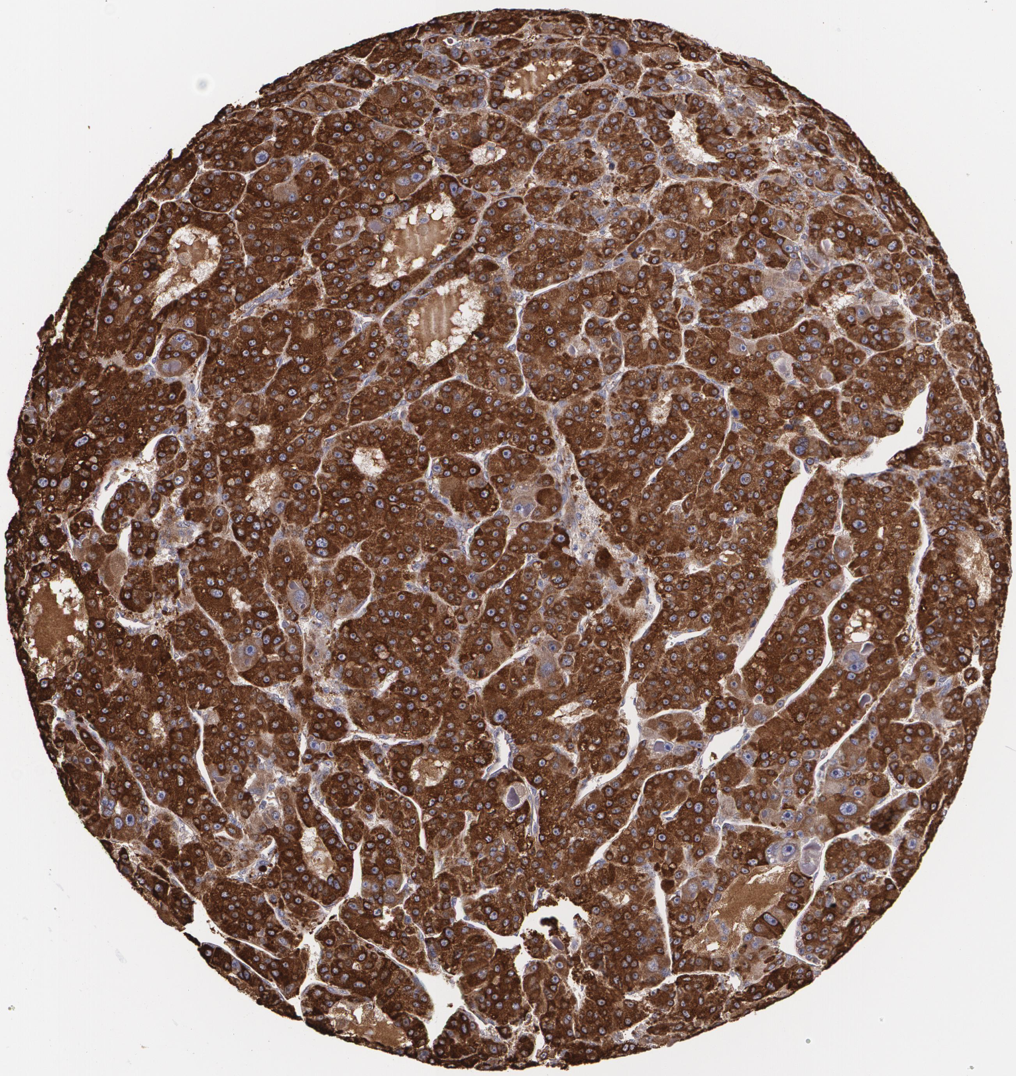

Figure 2:
HPA001610
Male, age 72
Liver (T-56000)
Carcinoma, Hepatocellular, NOS (M-81703)
Patient id: 2556
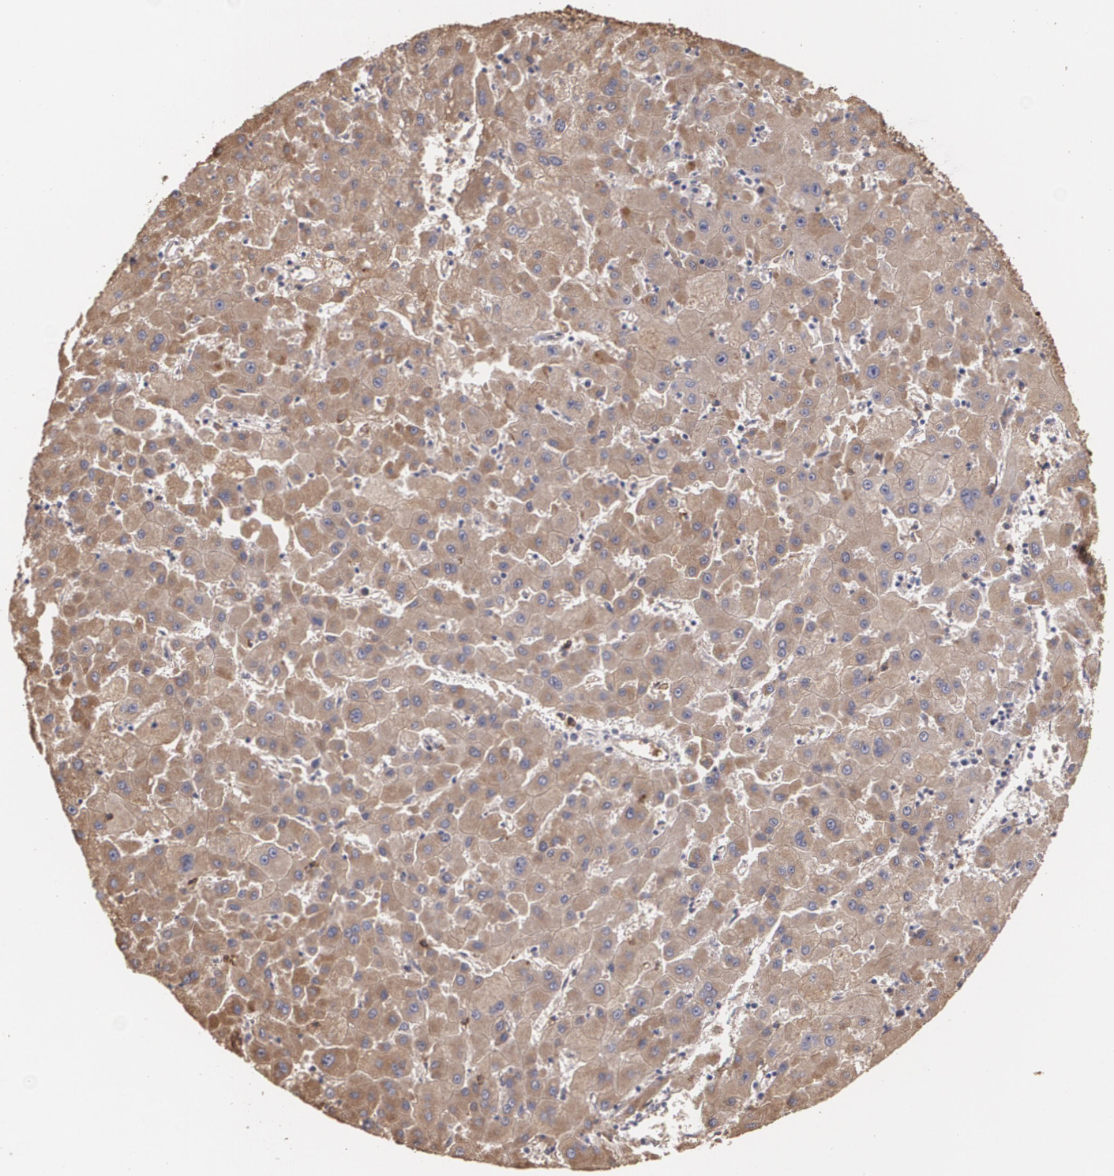

Figure 3:
HPA001610
Male, age 70
Liver (T-56000)
Carcinoma, Hepatocellular, NOS (M-81703)
Patient id: 879
