The expression level of PON1 in normal liver tissue

https://www.proteinatlas.org/ENSG00000005421-PON1/tissue/liver#img

Figure 1:
HPA001610
Female, age 29
Liver (T-56000)
Fibrosis, NOS (M-49000)
Normal tissue, NOS (M-00100)
Patient id: 1899
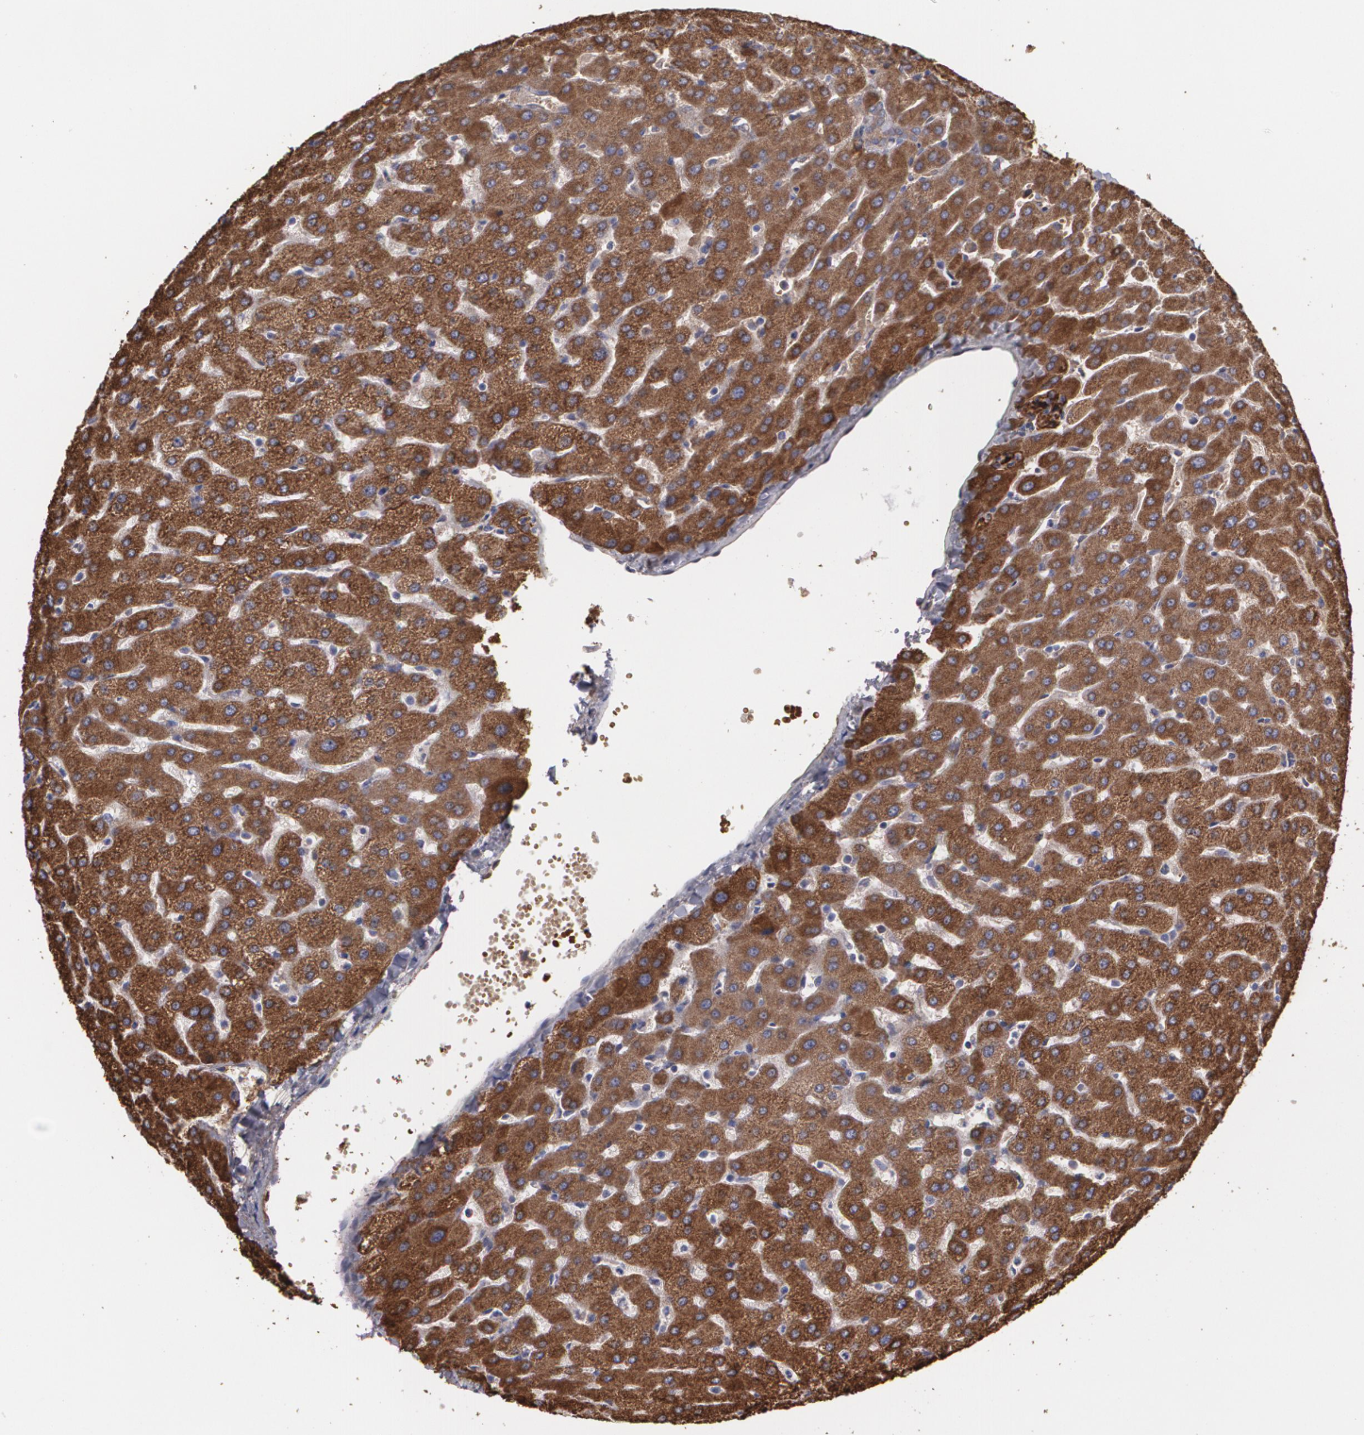

Figure 2:
HPA001610
Female, age 32
Liver (T-56000)
Normal tissue, NOS (M-00100)
Patient id: 1846
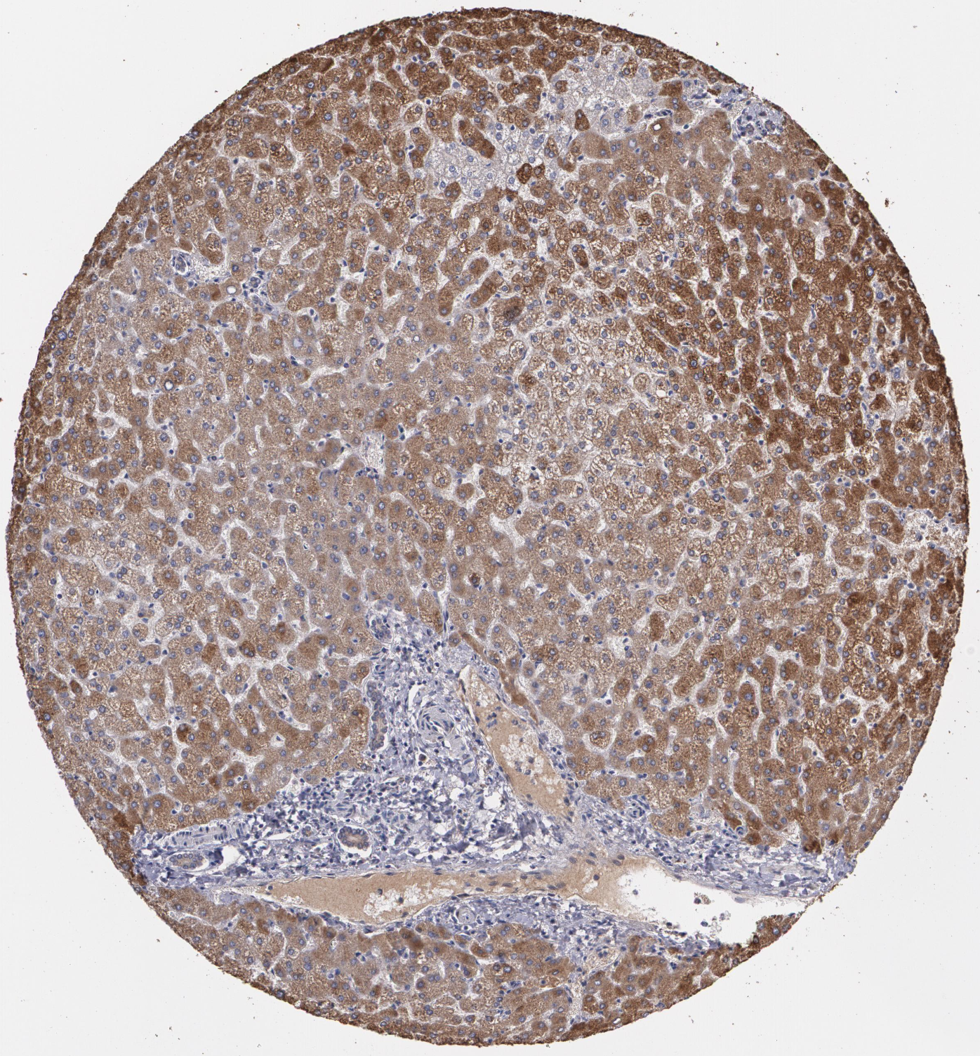

Figure 3:
HPA001610
Male, age 67
Liver (T-56000)
Normal tissue, NOS (M-00100)
Patient id: 1720
