**A exam Research Proposal**

April 30, 2021, 10 AM, 458 ST Olin

**Zhe LIU (刘哲)**

Graduate Student

Department of Biomedical Sciences

Committee Chair:

Committee Members:

1. **Title**

Apply bioinformatics technologies to study the response of stretching stimuli to skin cells and explain the pathogenesis of complex diseases

**Subtitle 1**: Molecular dissection of the skin cellular response to stretch

**Subtitle 2**: The comprehensive identification of AS events that RBPs regulated in the relapse of glioma

**Subtitle 3**: The MEGENA co-expression network analysis reveals the key CSC regulators of HCC

1. **Molecular dissection of the cellular response to stretch.**
2. **Background and Significance**

As the largest organ of mammals, the skin is a mechanical barrier between the body and the outside world. It has a complex tissue structure and multiple physiological functions. The skin is divided into two layers: the epidermis and the dermis. The epidermis is located on the top of the dermis and consists of stratified flat epithelium, thin and contains no blood vessels. The basal layer to the surface can be divided into five layers: the basal layer, spinous layer, granular layer, transparent layer, and stratum corneum. Although researchers have explored some mechanisms of skin to stress, there is no skin response at the molecular level research in complex model organisms *in vivo* at different period of times. There is also no comprehensive description of cell sub-populations different responses to the same mechanism stretch.

The stretching can regulate the fate of many different kinds of cell types. For example, shear stress, axial stress, and synergy can affect vascular endothelial cells' stress response through the Ca2+ signal pathway. It is known that the Ca2+ transfer pathways of the endothelial cell plasma membrane and the Ca2+ pool include voltage-gated Ca+ channels, agonist-receptor-gated Ca2+ channels, stretch-activated Ca+ channels (Ca2+ channels for short) permeable Ca2+ channels, Ca2+ pumps, and Na+- Ca2+ converter and so on. The effect of shear stress on the Ca2+ signal in the inner wall of the cell is achieved by directly or indirectly affecting some of the Cat2+ channels through the shear stress so that Ca2+ is released from the extracellular or Ca2+ pool to the cytosol, thereby changing the Ca2+ concentration. And there is another research about the short-term influence of stem cells (SCs). Biologists study the transient transition of stem cell fate to renewal allows the basal cell population to expand while maintaining differentiation. They conclude that the regulators of the actomyosin cytoskeleton, including formin-like proteins and non-muscle myosin, are essential for skin stretch sensing in the body and are typically mechanically transduced in YAP1 and MAL. The upstream of the child works. It is worth noting that the same signalling pathways are activated during embryonic pancreatic development, indicating that these signalling pathways and transcriptional regulators play a conservative role in the animal’s mechanical transduction, embryonic development and adult tissue regeneration. They conclude that short-term mechanical stretching can induce SC proliferation by activating YAP's main transcription factor, and YAP is a key regulator of epidermal proliferation.

Mining the key TF and regulatory relationship in skin cell are very important for clinical cell regeneration.

**Innovation**: The importance of skin’s response to stretch has been explained by plastic surgery and biologists. However, little research is performed *in vivo*. Cell response to stress is crucial for many cellular functions, yet its molecular mechanisms are not yet fully understood. Previous studies of the cellular stress response were performed on single cultured cell or isolated muscle fibers devoid of cell and/or tissue contexts. Thus, the emerging results were limited to the specific cell types or tissues analyzed and dependent on the growth matrix elasticity.

In the present study, we looked for changes in transcriptome, epigenomics, and functional pathway levels at short and long term in response to stretching of mouse skin cells.

1. **Specific aims**

As a graduate student in BMS, CityU, my long-term goal is to contribute a novel mechanism of regulatory element - TF in cellular response to stretch in a short period and long period at the single-cell resolution level, separately.

**Aim 1: The overview of the shared mechanism of skin’s response to stretch.**

Previous works summarise the shared mechanism of skin response to stretch, including cell-cell junction, inflammation activities, and stem cell renewal. We now want to qualify the dysfunctional pathways in the long term and short term individually.

**Aim 2: The molecular alternations of skin’s response to stretch.**

Recently ten years, a majority of previous work is about protein alternations. Only recently, two years, researchers are focus on gene expression. Here, we identified differentially expressed genes (DEGs) at the molecular level. And based on the known motifs, we can infer the TF involved in this regulation progress. In addition, we give a motif’s footprint to validate our hypothesis.

**Aim 3: The cell-cell communication of sub-populations.**

Published studies apply one or more cell types. They didn’t consider the factors of one cell line contains many cell sub-populations. One cell can release signal molecules, and the other cell can receive this signal from the receptor. Further, we can infer the time trajectory of cell transition.

1. **Research design, methods and preliminary data**

**Methods:**

To explore the differential expressed genes between the short time and long time, we utilized the microarray data (AffymetrixHTMG-430) 12-O-tetradecanoylphorbol-13-acetate (TPA) treatment in a short time of 4days with the accession number: GSE126231. T-test and Fold Change are used for identifying the DEGs.

ATAC-seq data was downloaded from the GEO database with the accession number: GSE126734. There are two treatments: control and expansion two days. Firstly, we used the ATACseqQC R package to assess the insert length of Tn5. We can observe the periodically flanking at 100bp (nucleosome-free regions, NFR), 200bp (mononucleosome), 400bp (dinucleosome), 600bp (trinucleosome) and so on. Then, we infer the TFs that involved in this process. Finally, we can get the motif footprint figures.

GSE146637 downloaded processed scRNA-seq data. We used two independent methods for annotating cell sub-populations: SingleR and SCINA. One is based on the correlation between known transcriptome data and our scRNA-seq data. And the other is based on the expression of known marker genes. In the second method, we provided known marker genes in common cell types information. Finally, we annotate cell types by manual. Seurat R package is used for integrated data and plot the basic figures. Cellphone is used for cell-cell communication analysis. Slingshot R package is used for infer the evolution trajectory.

**The shared mechanism of skin’s response to stretch.**

These shared functional pathways’ genes are up-regulated in 4 days after expansion compared to TPA treated, including cell adhesion, cytoskeleton, proliferation, MAPK and so on.

We select 5 adhesion genes: Itga3, Itga6, Itgb1, Parva, and Pxn.

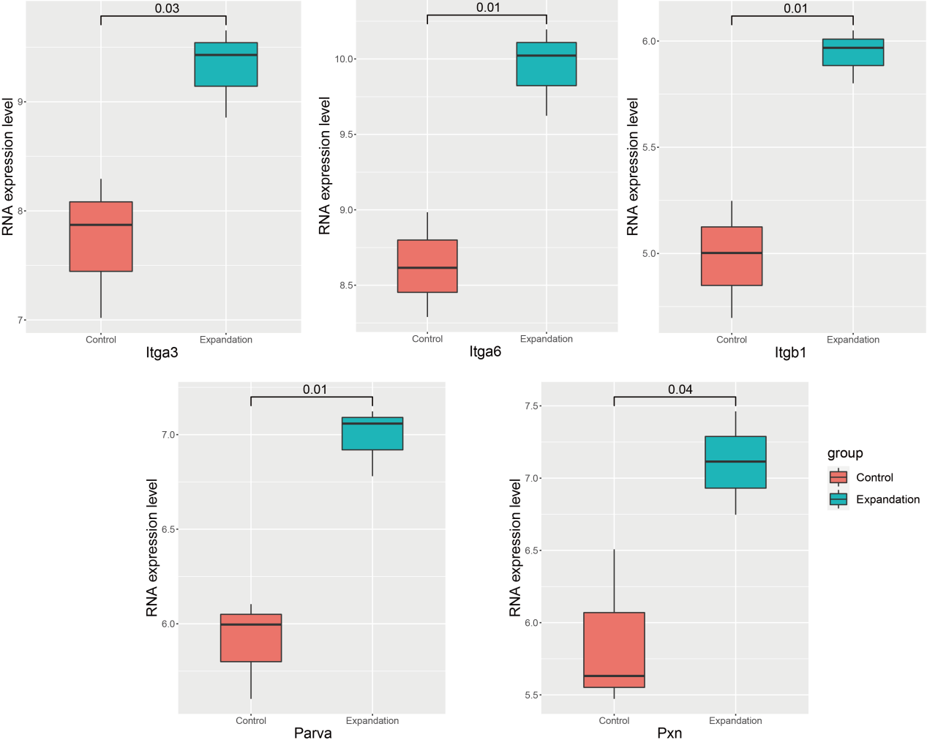

**Figure 1. The selected adhesion genes’s expression in control, expansion 4 days, and TPA treatments.** The x-axis indicates the treatment of the skin cells and the y-axis indicates the normalized RNA expression levels. The value in the single line represents the significance of a difference between groups.

We select 6 cytoskeleton genes: Actn1, Arpc4, Flna, Myh9, Twf1, and Nav1.

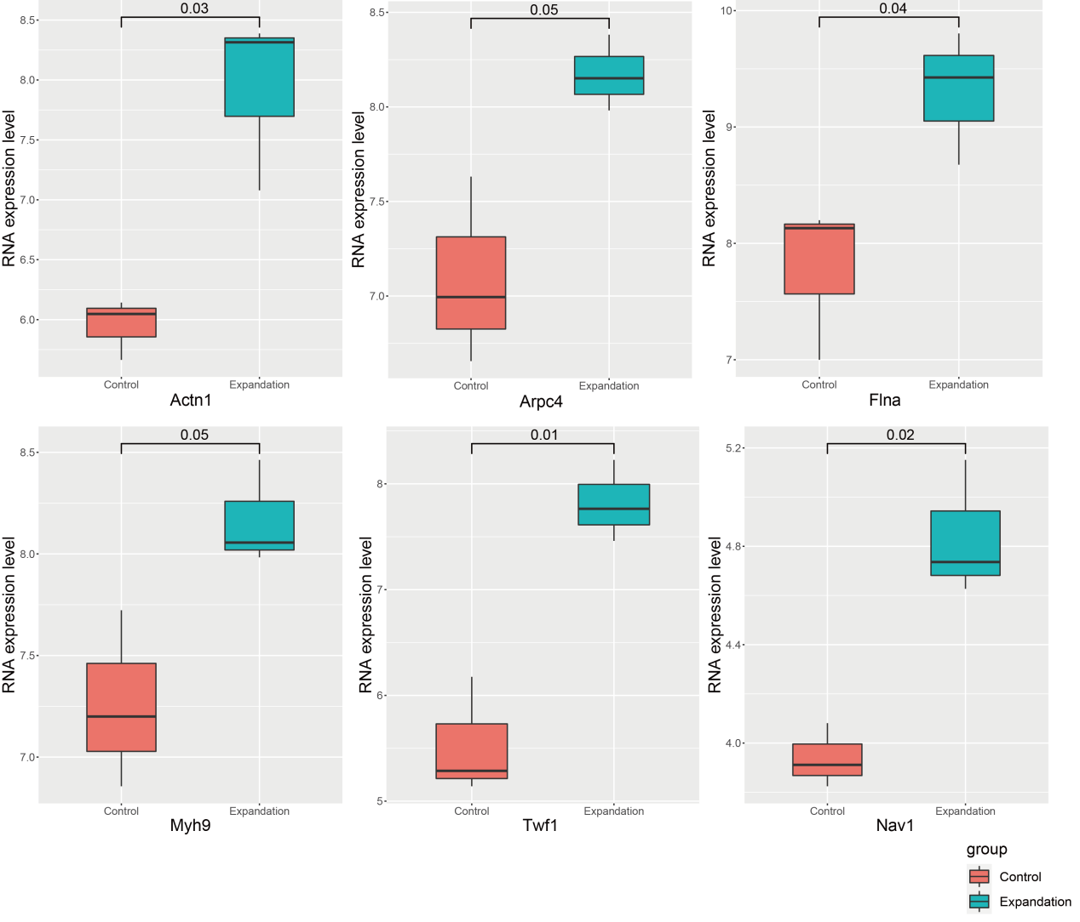

**Figure 2. The selected cytoskeleton genes’s expression in control, expansion 4 days, and TPA treatments.** The x-axis indicates the treatment of the skin cells and the y-axis indicates the normalized RNA expression levels. The value in the single line represents the significance of a difference between groups.

We select 2 proliferation genes: Rras2, Krt6a, Ccnb2, Ccnb1, and Cdk1.

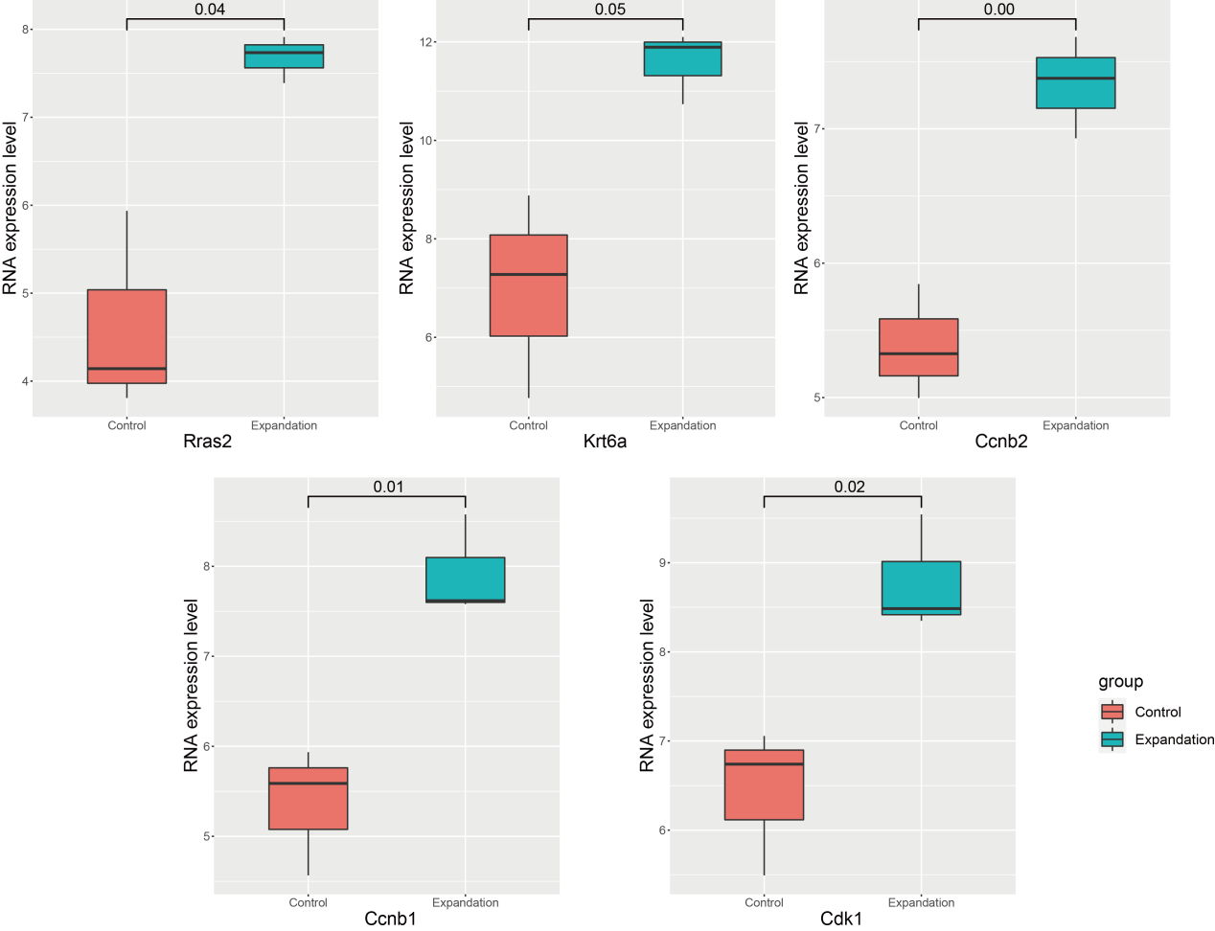

**Figure 3. The selected proliferation genes’s expression in control and expansion 4 days treatments.** The x-axis indicates the treatment of the skin cells and the y-axis indicates the normalized RNA expression levels. The value in the single line represents the significance of a difference between groups.

We select 6 immune genes: Tnfaip8l2, Myd88, Il33, Ikbke, Irak1, and Nfkb1.

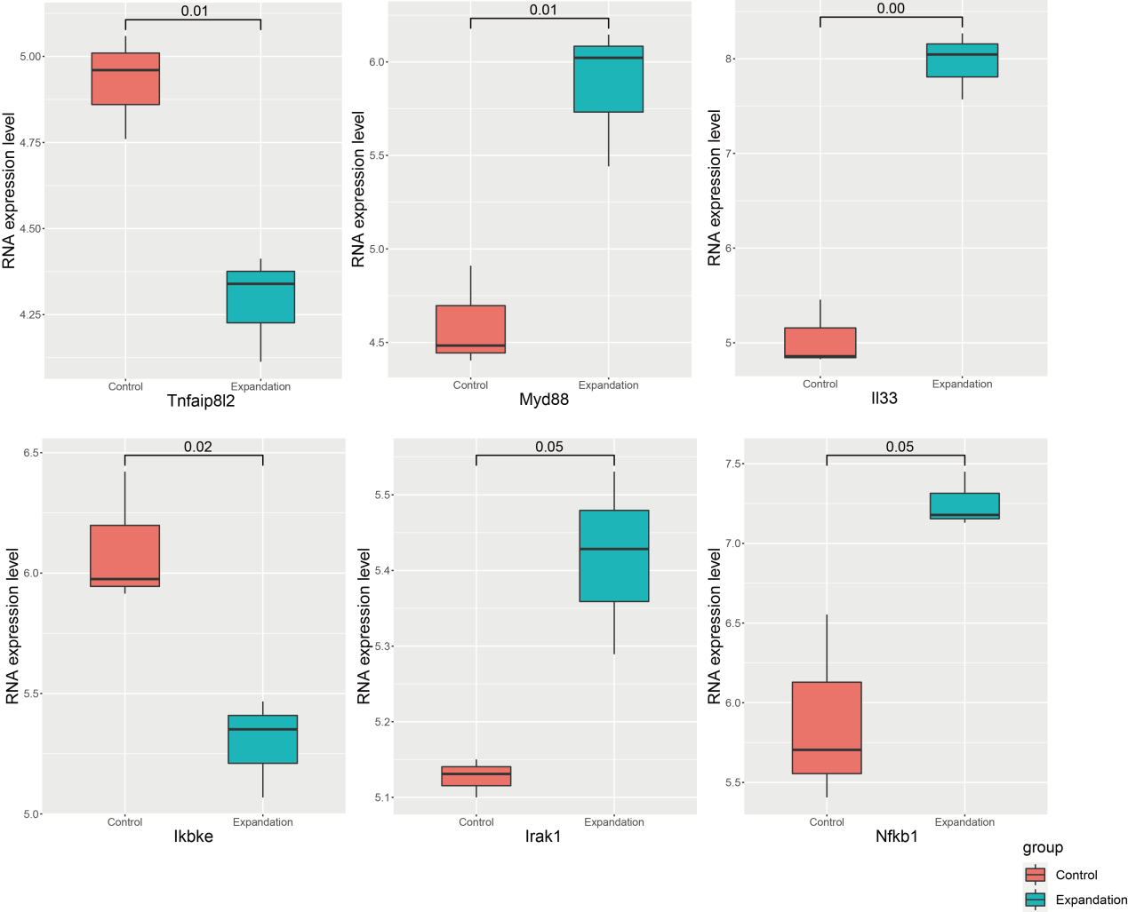

**Figure 4. The selected immune pathway genes’s expression in control and expansion 4 days treatments.** The x-axis indicates the treatment of the skin cells and the y-axis indicates the normalized RNA expression levels. The value in the single line represents the significance of a difference between groups.

**Molecular alternation of stretch induced**

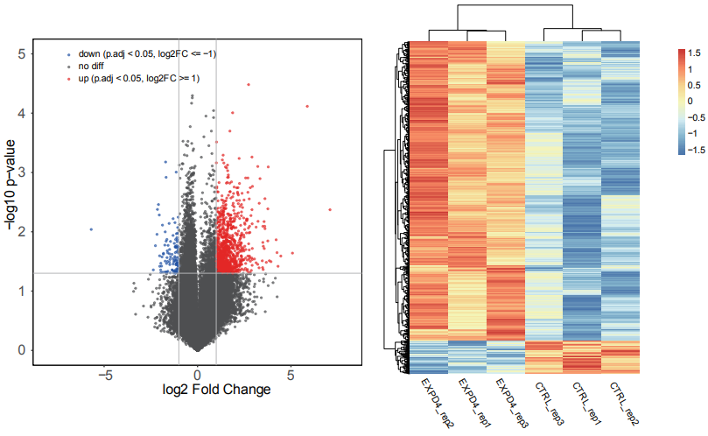

**Figure 5. The DEGs between control and expansion 4 days treated mouse skin cells.** A. The x-axis indicates the log2FC, while the y-axis indicates the -log10(p-value). B. The heatmap of DEGs across 6 samples.

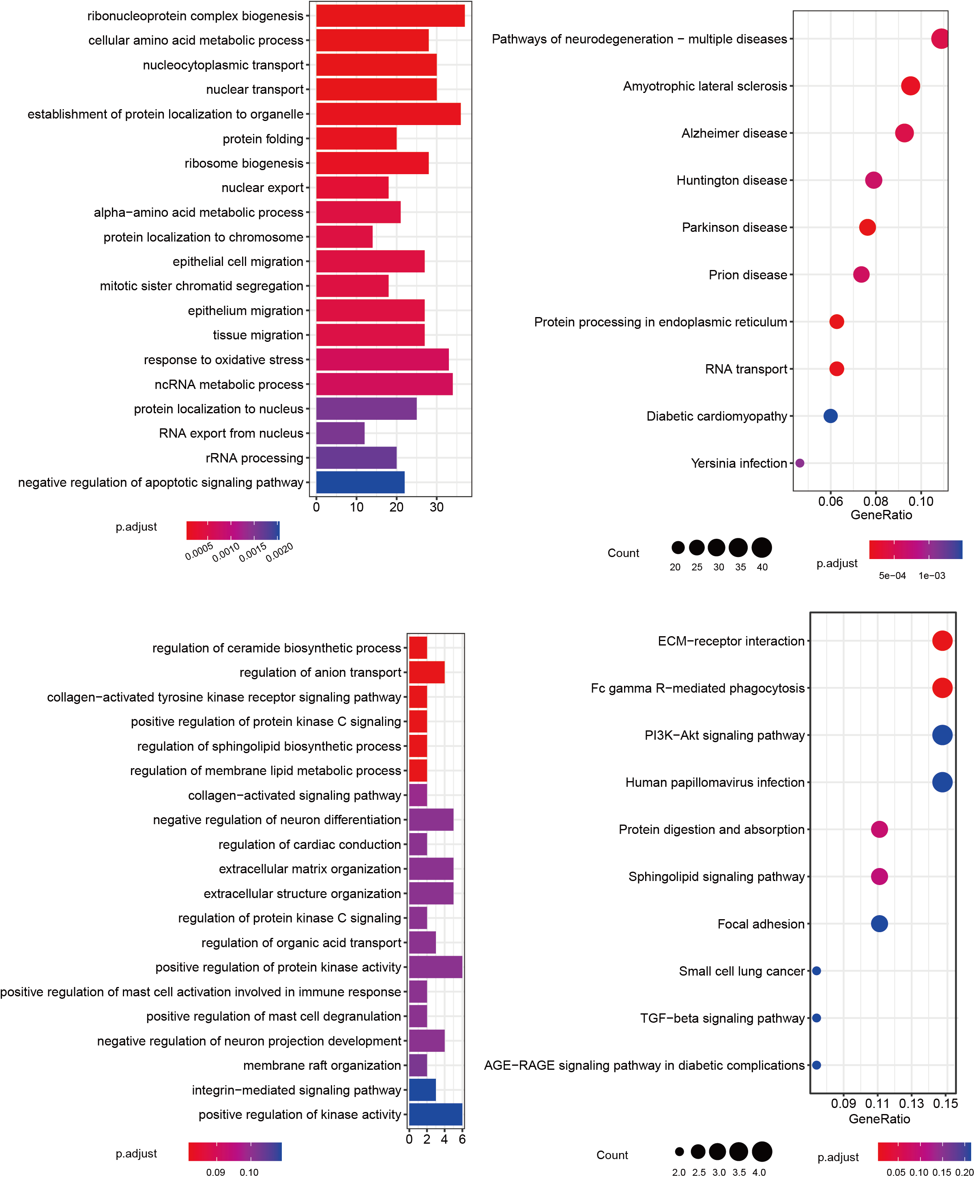

**Figure 6. The dysfunctional biological pathways that DEGs involved in.** AB. The dysfunctional biological pathways (GO_BP and KEGG pathways) that up-regulated genes in expansion 4 days treatment. CD. The dysfunctional biological pathways (GO_BP and KEGG pathways) that down-regulated genes in expansion 4 days treatment.

**The regulatory model of TF**

**Table 1. The statistics of ATAC-seq data.**

|  |  |  |  |  |
| --- | --- | --- | --- | --- |
| Sample | # raw reads | # clean reads | % map reads | # remove duplicates |
| Ctl_S18 | 131,087,101 | 129,279,102 | 77.86% | 93,124,764 |
| Exp-D2 | 109,031,667 | 107,629,069 | 83.28% | 63,465,284 |

According to the results of ATAC-seq, we got 2 significant motifs, and their TFs are: AP1 and TEAD.

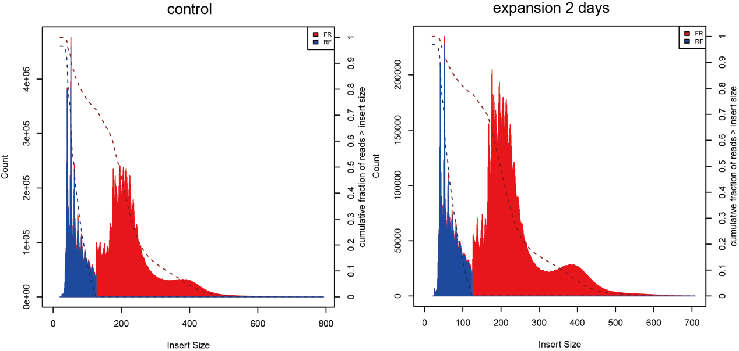

**Figure 7. The distribution of Tn5 insert length in control (A) and expansion 2days (B) ATAC-seq data.**  x-axis indicates the length, and the y-axis indicates the number of counts in mapped data.

**Table 2. The TF motifs that enriched in ATAC-seq’s peaks.**

The first column indicates TFs’ symbol, the second column indicates motifs’ sequence, and the last column indicates the significant value.

|  |  |  |  |  |
| --- | --- | --- | --- | --- |
| Rank | TF | Motif | pvalue | Target |
| 1 | Fos(bZIP) | known1.logo | 1e-1340 | 17.85% |
| 2 | JunB(bZIP) | motif1.logo | 1e-1315 | 18.18% |
| 3 | AP-1(bZIP) | known6.logo | 1e-1262 | 19.51% |
| 4 | Fosl2(bZIP) | known8.logo | 1e-1104 | 12.34% |
| 5 | Jun-AP1(bZIP) | known9.logo | 1e-975 | 9.80% |
| 6 | KLF1(Zf) | motif2.logo | 1e-392 | 27.30% |
| 7 | NFIA | motif3.logo | 1e-249 | 22.64% |
| 8 | Elk1(ETS) | motif4.logo | 1e-157 | 22.36% |
| 9 | p53(p53) | motif6.logo | 1e-146 | 4.28% |
| 10 | GRHL1 | motif7.logo | 1e-129 | 13.68% |
| 11 | CTCF(Zf) | motif8.logo | 1e-126 | 1.28% |
| 12 | CREB3L4(var.2) | motif9.logo | 1e-104 | 13.91% |
| 13 | NFYC | motif10.logo | 1e-104 | 25.73% |
| 14 | MXI1 | motif11.logo | 1e-80 | 20.08% |
| 15 | RELA | motif12.logo | 1e-64 | 10.15% |
| 16 | TBX5 | motif13.logo | 1e-60 | 0.29% |
| 17 | BARHL1 | motif14.logo | 1e-56 | 17.59% |
| 18 | NRF(NRF) | motif15.logo | 1e-55 | 3.08% |
| 19 | POL012.1_TATA-Box | motif16.logo | 1e-55 | 0.27% |
| 20 | RUNX3 | motif17.logo | 1e-52 | 0.21% |
| 21 | GATA6 | motif18.logo | 1e-52 | 3.34% |
| 22 | Stat3(Stat) | motif19.logo | 1e-50 | 5.11% |
| 23 | NFYA | motif21.logo | 1e-41 | 0.24% |
| 24 | TEAD4(TEA) | known89.logo | 1e-34 | 8.63% |
| 25 | TEAD1(TEAD) | known100.logo | 1e-28 | 9.41% |
| 26 | TEAD3(TEA) | known105.logo | 1e-24 | 10.83% |
| 27 | Smad3(MAD) | known106.logo | 1e-24 | 30.93% |
| 28 | SOX14 | motif25.logo | 1e-19 | 2.65% |
| 29 | TEAD(TEA) | motif26.logo | 1e-19 | 0.10% |
| 30 | TEAD2(TEA) | known140.logo | 1e-13 | 5.01% |
| 31 | TEAD(TEA) | known161.logo | 1e-9 | 6.00% |
| 32 | ZNF384 | motif27.logo | 1e-2 | 3.10% |

We select 2 AP1 regulated genes: Fosl1 and Fos.

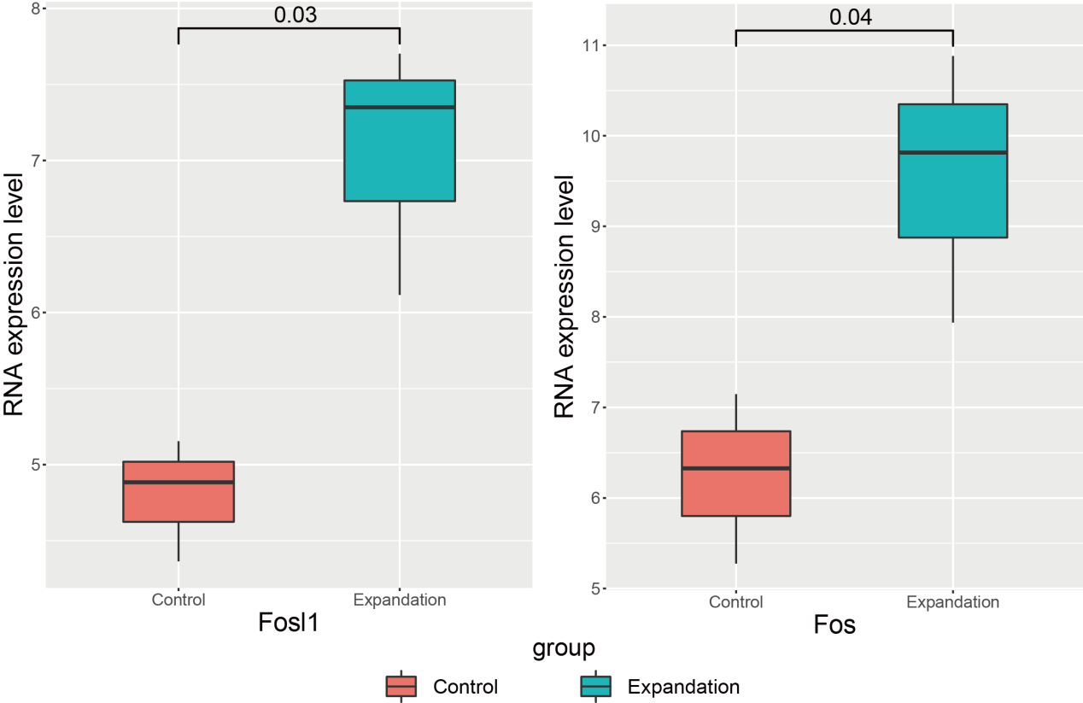

**Figure 8. The selected AP1 regulated genes’s expression in control, expansion 4 days, and TPA treatments.** The x-axis indicates the treatment of the skin cells and the y-axis indicates the normalized RNA expression levels. The value in the single line represents the significance of a difference between groups.

We select 2 TEAD regulated genes: Tead1 and Cyr61.

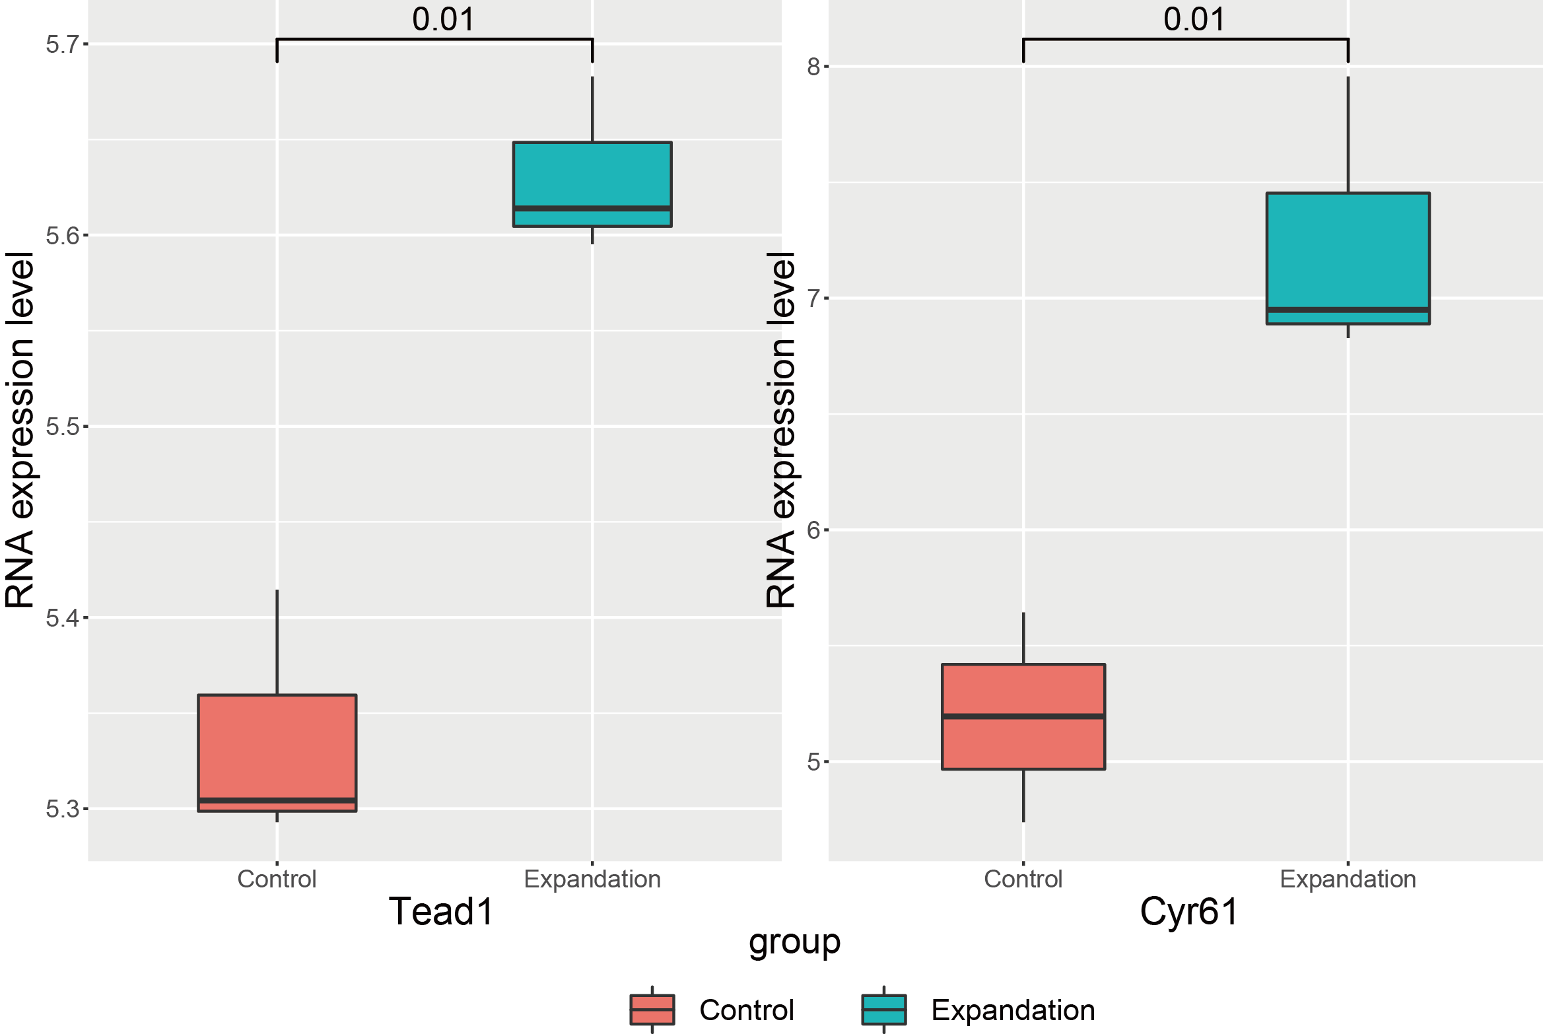

**Figure 9. The selected TEAD regulated genes’s expression in control, expansion 4 days, and TPA treatments.** The x-axis indicates the treatment of the skin cells and the y-axis indicates the normalized RNA expression levels. The value in the single line represents the significance of a difference between groups.

**The cell-cell communication.**

According to the results of ATAC-seq, we got 2 significant motifs, and their TFs are: AP1 and TEAD.

In the past few years, the focus of developmental research has shifted from embryonic development to the mechanism of tissue homeostasis (tissue homeostasis), and significant progress has been made, which largely relies on cell lineage tracking (Lineage- tracing) and clonal analysis. The emerging cell lineage tracking technology can also exert its unique advantages in these fields. Due to skin’s clear tissue anatomical structure and cell biology characteristics can be used as a good tool for this research. The epidermis comprises hair follicles (HFs) and the interfollicular epidermis (IFE) around them. The IFE contains a layer of basal cells (BC) expressing K14/K15 and an upper basal cell layer expressing K1/K10 multi-layer terminal differentiation.

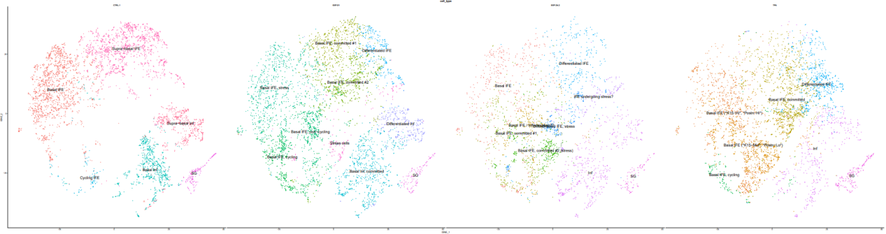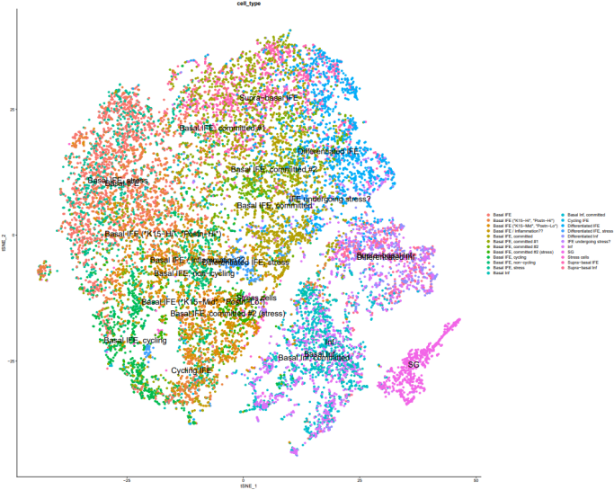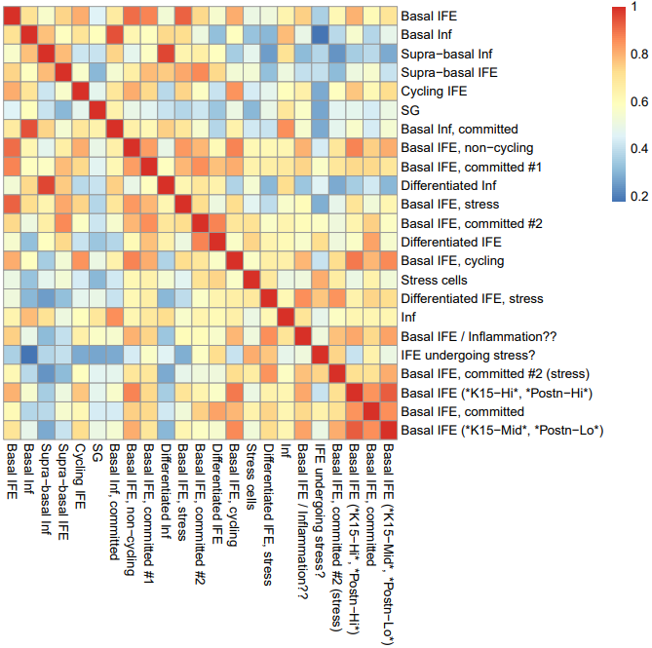

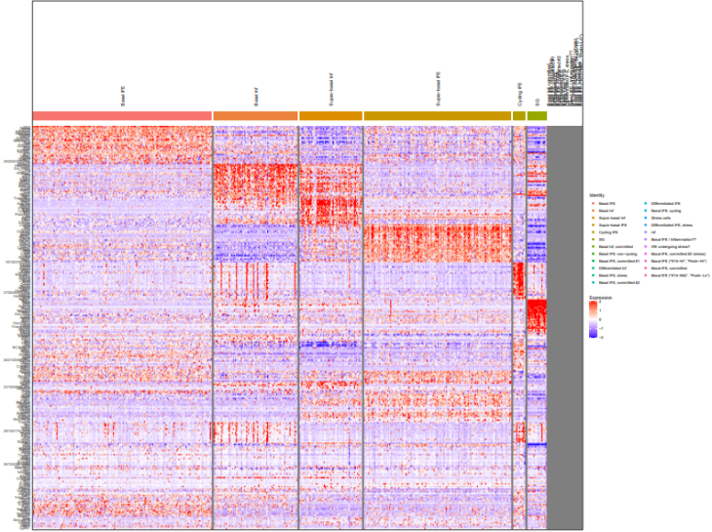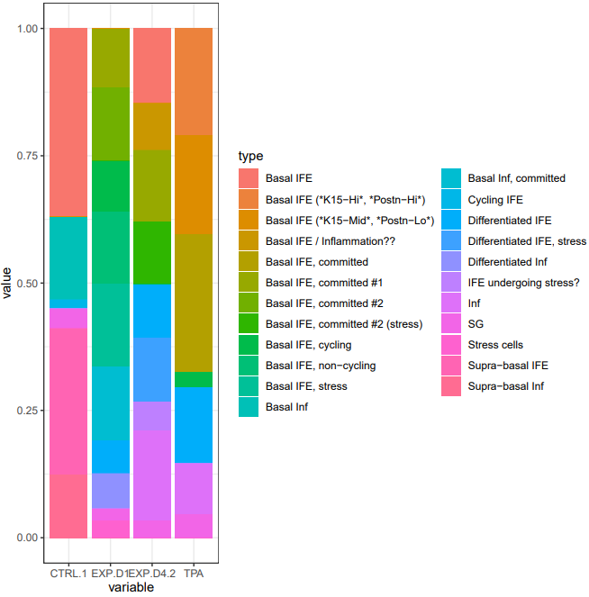

**Figure 10. The integrated UMAP visualization of scRNA-seq of control, expansion 1, 4 days, and TPA treated skin cells.** A. The visualization of integrated scRNA-seq data . B. The heatmap of average top 30 marker genes’ expression across 23 cell types. C. The heatmap of top 30 marker genes’ expression in 23 cell types. D. The proportion of each cell types across 4 treatments.

**Table 3. The statistics of cell sub-populations.**

|  |  |  |  |  |  |  |  |  |  |  |
| --- | --- | --- | --- | --- | --- | --- | --- | --- | --- | --- |
|  | #CTRL | %CTRL | #EXP.D1 | %EXP.D1 | #EXP.D4 | %EXP.D4 | #TPA | %TPA | #Total | %Total |
| Basal IFE | 1718 | 10.32% | 0 | 0.00% | 396 | 2.38% | 0 | 0.00% | 2114 | 12.70% |
| Basal Inf | 760 | 4.56% | 0 | 0.00% | 0 | 0.00% | 0 | 0.00% | 760 | 4.56% |
| Supra-basal Inf | 578 | 3.47% | 0 | 0.00% | 0 | 0.00% | 0 | 0.00% | 578 | 3.47% |
| Supra-basal IFE | 1338 | 8.04% | 0 | 0.00% | 0 | 0.00% | 0 | 0.00% | 1338 | 8.04% |
| Cycling IFE | 85 | 0.51% | 0 | 0.00% | 0 | 0.00% | 0 | 0.00% | 85 | 0.51% |
| SG | 180 | 1.08% | 123 | 0.74% | 94 | 0.56% | 205 | 1.23% | 602 | 3.62% |
| Basal Inf, committed | 0 | 0.00% | 721 | 4.33% | 0 | 0.00% | 0 | 0.00% | 721 | 4.33% |
| Basal IFE, non-cycling | 0 | 0.00% | 700 | 4.20% | 0 | 0.00% | 0 | 0.00% | 700 | 4.20% |
| Basal IFE, committed #1 | 0 | 0.00% | 571 | 3.43% | 383 | 2.30% | 0 | 0.00% | 954 | 5.73% |
| Differentiated Inf | 0 | 0.00% | 334 | 2.01% | 0 | 0.00% | 0 | 0.00% | 334 | 2.01% |
| Basal IFE, stress | 0 | 0.00% | 801 | 4.81% | 0 | 0.00% | 0 | 0.00% | 801 | 4.81% |
| Basal IFE, committed #2 | 0 | 0.00% | 712 | 4.28% | 0 | 0.00% | 0 | 0.00% | 712 | 4.28% |
| Differentiated IFE | 0 | 0.00% | 318 | 1.91% | 288 | 1.73% | 644 | 3.87% | 1250 | 7.51% |
| Basal IFE, cycling | 0 | 0.00% | 489 | 2.94% | 0 | 0.00% | 137 | 0.82% | 626 | 3.76% |
| Stress cells | 0 | 0.00% | 165 | 0.99% | 0 | 0.00% | 0 | 0.00% | 165 | 0.99% |
| Differentiated IFE, stress | 0 | 0.00% | 0 | 0.00% | 343 | 2.06% | 0 | 0.00% | 343 | 2.06% |
| Inf | 0 | 0.00% | 0 | 0.00% | 477 | 2.86% | 433 | 2.60% | 910 | 5.47% |
| Basal IFE / Inflammation | 0 | 0.00% | 0 | 0.00% | 252 | 1.51% | 0 | 0.00% | 252 | 1.51% |
| IFE undergoing stress | 0 | 0.00% | 0 | 0.00% | 152 | 0.91% | 0 | 0.00% | 152 | 0.91% |
| Basal IFE, committed #2 (stress) | 0 | 0.00% | 0 | 0.00% | 331 | 1.99% | 0 | 0.00% | 331 | 1.99% |
| Basal IFE (*K15-Hi*, *Postn-Hi*) | 0 | 0.00% | 0 | 0.00% | 0 | 0.00% | 911 | 5.47% | 911 | 5.47% |
| Basal IFE, committed | 0 | 0.00% | 0 | 0.00% | 0 | 0.00% | 1170 | 7.03% | 1170 | 7.03% |
| Basal IFE (*K15-Mid*, *Postn-Lo*) | 0 | 0.00% | 0 | 0.00% | 0 | 0.00% | 842 | 5.06% | 842 | 5.06% |

1. **The comprehensive identification of AS events that RBPs regulated in the relapse of glioma**
2. **Background and Significance**

Glioma is an intracranial malignant tumour derived from the neuroepithelium, which accounts for about half of all primary intracranial tumours. It is the most common and highly aggressive primary tumour of the central nervous system. The treatment method is an intensive treatment, but the median survival time of the patient is about 15 months, the recurrence rate is extremely high, and the prognosis is inferior. Glioma is characterized by aggressive proliferation, high aggressiveness and high mortality. It can spread to the spinal cord and other parts of the brain, which is a huge challenge in the current treatment process. Genetic changes cause the occurrence of glioma. Genetically, mutations or deletions of genes such as EGFR, IDH1, PDGFRA, HDM2, PIK3CA, PI3KR1, PTEN, TP53, CDKN2A, NF1, ATRX, and RB1 are known to be related to genetic changes. The occurrence of mass tumours is closely related. At present, the diagnostic methods of glioma mainly rely on histopathological examination, imaging examination and molecular diagnoses, such as isocitrate dehydrogenase (IDH) mutation, chromosome 1p/19q coding deletion, and telomerase reverse transcriptase (TERT). Promoter mutations, and so on.

The treatment of glioma generally adopts traditional treatment methods, such as radiotherapy, chemotherapy and surgical resection. However, due to the high heterogeneity and complexity of gliomas, these treatments have little effect on the survival of patients, and no substantial progress has been made in improving the prognosis of GBM. Temozolomide (TMZ) is an internationally recognized glioma chemotherapy drug of choice. Its treatment of glioma has a history of more than ten years. Studies have shown that although TMZ can slightly extend the survival time of patients, almost all patients will eventually develop Drug resistance, so the overall curative effect of TMZ is not good, and it is easy to relapse after treatment. After radiotherapy and TMZ chemotherapy, the median recurrence time is generally seven months, and patients die typically after seven months. The current clinical status of glioma treatment is frustrating, and there is an urgent need for a new understanding of the molecular mechanisms of disease progression.

Alternative splicing is a way of regulating gene expression. The gene sequence of eukaryotic cells contains introns and exons, which are interspersed with each other. Generally speaking, introns are removed by RNA splices after genes are transcribed into mRNA precursors, and the remaining exons are fragments that can exist in mature mRNA (which will be further translated into proteins). An unspliced RNA contains multiple exons that are cut into different combinations to translate different proteins. This ensures that the exons in the same gene are combined in different forms so that a gene can produce other proteins at different times and in different environments, which increases the complexity or adaptability of the system under physiological conditions. At present, 35% of human genetic diseases may be caused by alternative splicing of RNA, such as retinitis pigmentosa and spinal muscular atrophy. In the human genome, about 95% of multi-exon genes have alternative splicing. It is common for a single gene to produce more than a dozen splicing isoforms through alternative splicing. The most prominent example is the Dscam gene in Drosophila, which has 38,016 potential alternative splicing types. Several typical splicing variants are associated with diseases, such as, SP3B1 in uveal melanoma and U2AF1 in lung cancer.

RNA-Binding Protein (RBP) plays an indispensable role in post-transcriptional regulation. It has a diverse structure of RNA binding domains, so it can participate in regulating multiple transcription mechanisms. RBP is involved in regulating mRNA, and its abnormal regulation is closely related to different kinds of cancer.

Here, we show that many RBPs in tumors have abnormal changes, which affect the translation of mRNA to the protein level and further participate in the occurrence and metastasis of glioma. Our study will help better understand the pathological mechanism of the tumorigenesis and metastasis of glioma.

**Innovation**: Few studies have been conducted on AS for the recurrence or grade of glioma.

1. **Specific aims**

My long-term goal as a graduate student in BMS, CityU is to determine some novel AS events in recurrent glioma compared to primary glioma and identify the different regulatory model of RBP.

**Aim 1: The overview of the AS events in primary and recurrent glioma.**

There are few matched primary and recurrent glioma samples for collection. Thus, few surveys are related to glioma relapse. At the beginning of our analysis, we need to give statistics data for all AS events in primary and recurrent glioma.

**Aim 2: The selection of candidate AS events in known oncogenes.**

From the above results, we can summarize more AS events in recurrent glioma compared to primary glioma. Then, we identified differential splicing events across primary and recurrent glioma RNA-seq data.

**Aim 3: The identification of key RBPs and their regulatory mechanism.**

We think the RBP has a differential expression pattern if the RBP involved in the glioma relapse. So we calculate the DEGs and intersect them with RBPs.

1. **Research design, methods and preliminary data**

In order to explore the differential expressed RBPs between primary and recurrent glioma samples, we utilized the RNA-seq data from the GEO database (GSE139533). Miso and rMAT are used for double-checking our identified AS events by calculating the PSI value.

DESeq2 R packages were used for identifying DEGs across primary and recurrent glioma samples with the criteria: |log2FC|>1 and p-value<0.05. Then, we intersect our DEGs list with the 4,689 known RBPs using combing three papers’ supplementary data.

Piranha is used for peak calling of candidate RBP CLIP-seq data.

**Table 4. The collection sample statistics data. The number in the cell indicates the number of samples are sequenced.**

|  |  |  |  |  |
| --- | --- | --- | --- | --- |
| **Accession number** | **#raw reads*2** | **#clean reads*2** | **#map reads** | **cancer type** |
| GSM4143105 | 9,122,543 | 6,946,156 | 92.10% | primary glioma |
| GSM4143106 | 13,580,250 | 10,597,363 | 92.66% | primary glioma |
| GSM4143107 | 13,681,397 | 10,818,499 | 92.53% | recurrent glioma |
| GSM4143108 | 13,765,737 | 10,465,082 | 91.74% | recurrent glioma |

1. **The MEGENA co-expression network analysis reveals the key CSC regulators of HCC.**
2. **Background and Significance**

Hepatocellular carcinoma (HCC) is one of the most common tumours in the world, which is the sixth-largest malignant tumour in the world and the third cause of death caused by tumours. Liver cancer is characterized by easily invading the vascular system of the liver. HCC merges Portal vein tumour thrombus (PVTT) affects the prognosis of liver cancer patients, the recurrence of liver cancer, and the choice of treatment methods. Despite continuous eradication or improvement of various treatment techniques, the prognosis of patients with liver cancer is still inferior. The pathogenesis of HCC is complicated. How to monitor the malignant transformation of liver cells or early diagnosis of HCC is still a medical problem.

HCC is prone to invade the portal venous system. 10%-40% of patients have PVTT when they are first diagnosed with liver cancer, and 5.4%-26.0% of patients undergoing liver resection have PVTT; in non-surgical treatment, PVTT occurred in 11.3%-38.0% of the patients, and the incidence rate during the autopsy was 44.0%-62.2%. An important reason for the poor prognosis of liver cancer is the formation of PVTT. Once formed, the disease progresses rapidly, causing portal hypertension, jaundice, ascites, intra-hepatic metastasis. The median survival time of untreated liver cancer with PVTT is only 2.7 months, and the median survival time without PVTT can reach 24 months.

The development of high-throughput sequencing technologies provides new views into mining the genomic, transcriptomic, and epigenomic signatures of various tumours by generating a large number of sequencing reads. That allows us better understand and delineate the mechanism of multiple cancers at the molecular level. The development of the TCGA project provides a rich data-based platform for cancer research. Systems biology, especially network biology methods, has proven to be an effective method for integrating multiple, large-scale data sets of complex human diseases, especially cancer. Multiscale embedded gene co-expression network analysis (MEGENA) is an efficient and accurate method for extensive data multi-gene analysis. MEGENA has been widely used to identify related clinical modules and hub genes in different cancer types. For example, Yun et al., used MEGENA to validate that the expression of six hub genes highly is associated with the progression and prognosis of clear human cell renal cell carcinoma. Based on the gene expression data of breast cancer from GEO and TCGA database, Jin et al. combined with the MEGENA algorithm identified 15 hub genes as candidate breast cancer biomarkers. Wang et al. used MEGENA to analyze the differentially expressed genes (DEGs) of adrenocortical carcinoma. They found four hub genes that may be candidate biomarkers of adrenocortical carcinoma in clinical treatment. To better explore the pathogenesis of HCC, MEGENA is a powerful method to systematically explain the pathogenesis of the HCC.

The heterogeneity of tumours and the dry characteristics of cancer stem cells (CSCs) are one of the main reasons why tumours are challenging to cure, and they are also the main obstacles to cancer treatment research. **Table 5** lists some common tumours: cancer stem cell markers and signalling pathways. CSCs cells have the following characteristics:

1. *In vitro* culture can form neurosphere-like cells
2. Expression of stem cell marker genes SOX2 and CD133
3. Self-renewal and proliferation ability
4. After orthotopic transplantation, it can be Form a tumour similar in nature to the original tumour

It is speculated that CSCs are closely related to the occurrence and development of diseases, recurrence and treatment resistance, and even play a decisive role. Molecular and genomic heterogeneity and the persistence of sub-populations of cancer cells with stem characteristics after radiotherapy and chemotherapy are considered the main reasons for treatment resistance and related poor prognosis.

**Table 5. The CSC markers and signaling pathways of common tumors.**

|  |  |  |
| --- | --- | --- |
| **Cancer Type** | **CSC markers** | **Main stemness pathways** |
| Lung cancer | CD44+ CD24-，CD133+ | Wnt/β-catenin，SCF-c-kit |
| Liver cancer | CD133+，CD13+，CD45-CD90+ | Wnt/β-catenin，Notch |
| Esophageal cancer | ALDH1A1+ | Pten/PI3K/Akt |
| Breast cancer | ALDH1+ CD44+ CD24- | JAK2/STAT3，Pten |
| Stomach cancer | CD44+，CD133+，ALDH1+ | Hedgehog |
| Pancreatic cancer | CD133+ CXCR4+ | Hedgehog |
| Colorectal cancer | Lgr5+ | Wnt/β-catenin，Yap1 |
| Kidney cancer | CD133+，CD105+ | Hedgehog |
| Prostate cancer | CD44+ | Hedgehog |
| Bladder cancer | CD47+，ABCG2+ | Hedgehog，Wnt/β-catenin |
| Cervical cancer | CD44+，CD49+ | Notch |
| Leukemia | CD133+，CD34+/CD38- | Hedgehog，Wnt/β-catenin |
| Brain cancer | CD133+，CD44 | Notch，Pten |

Recently, accumulated data have shown the potential value of new blood-brone markers such as circulating blood tumor cells, key signaling molecules in related pathways, carcinoembryonic-specific proteins, long non-coding RNAs, and microRNAs in the diagnosis of liver cancer. This article focus on the gene co-expression network in the tumorigenesis and metastasis of HCC.

1. **Specific aims**

**Aim 1: The construction of MEGENA network.**

In order to identify the gene-gene interactions at the systematical biology, we need to construct two networks. The first network describe the interact between modules. We can identify hub module. And the second network describe the gene-gene interactions of each module. We can identify hub genes.

**Aim 2: The determination of gene sets of CSC.**

We identify candidate module based on the association with these genes in CSC.

**Aim 3: The determination of hub genes.**

The gene plays an important role in the biological process if the gene is located upstream of the regulatory relationship. We want to find the important biomarkers instead of passenger biomarkers.

1. **Research design, methods and preliminary data**

Firstly, the Pearson correlation coefficient (PCC) score is calculated for each gene pair. And the gene pair is sorted by the PCC value from big to small. Then, the network is embedded into the planar filtered networks (PFN). Finally, the shortest distance, local path index, and whole module are all used for iteration.

To optimize the modules that related to stem cells, we download 24 embryonic stem cells (ESCs) and 11 mesenchymal stem cells (MSCs) gene list from GSEA MSigDB database. Hypergeometric distribution test is applied for enrichment analysis of top 20 significant modules and each gene list.

The randomForest R package is used for constructing the regulatory network. There are two parameters in our algorithm: 1. The number of decision tree (10,000), and 2. The number of candidate input genes that can be selected for each node (the square root of the numbers of all input genes).

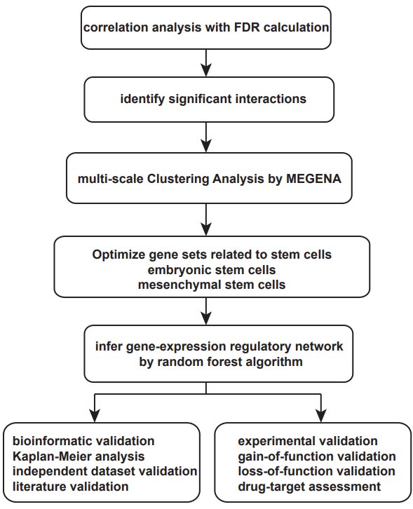

**Figure 11. The workflow of the MEGENA network analysis of HCC RNA-seq data.** The MEGENA algorithm first calculates the correlation between any two genes, and sorts the gene pairs according to the size of the correlation; then embeds them into the topological network through the planar maximum filtered graph (PMFG) algorithm to construct a planar filter network (PFN), and then perform multiple iterations on the original PFNs to obtain a more accurate classification by the shortest path distance, local path index and overall modularity. The enrichment analysis was performed on the modules obtained by the MEGENA algorithm and the gene sets related to the two kinds of stem cells(ESCs and MSCs) downloaded from the MSigDB data. Finally, our hub genes was validated by bioinformatics (survival analysis, an independent dataset, and literature) and experiments (knock-down, over-expression, MGMT dysfunction experiments in U87 cell line) technologies.

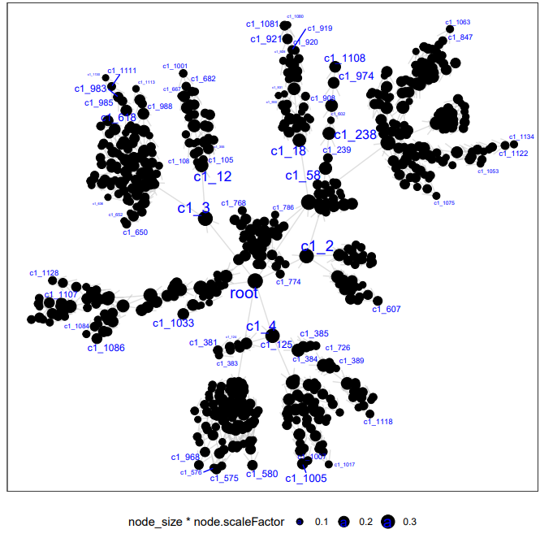

**Figure 12. The module hierarchy.** The node in the network indicates the module, and the edge indicates clustering relationship between two modules. The size of node represents the number of genes in the module multiple the scale factor of the module.

**Table 6. The characterise of the top 20 significant modules**

|  |  |  |
| --- | --- | --- |
| module | size | hub genes |
| M1 | 1634 | TBX3(51),RNF43(40),DYNC1I1(38),FAM124A(37),DUXA(36),ACSBG1(34),AQP9(32),ABCB5(31),LAMA3(31),MLANA(30),NMNAT2(30),FBXO31(30),NKD1(30),GSTM5(28),TREX2(28),WNT6(28),DCLK2(27),CLSTN2(27),B4GALT6(27),CTSK(26),IL13(25),IGFBP5(25),SPARCL1(25),ZNF503(24),ADIPOQ(23),CHRDL1(23),TRIM63(23),HLF(23),IGFN1(22),POPDC2(22),ATP8B4(21),C16orf89(21),DAPL1(21),ITPR2(21),LEP(20),DCLK1(20),AVIL(20),OR7C1(20),SYT14(20),ARHGAP28(19),CRTAC1(19),ANK2(19),LRRC39(19),LMO3(19),CRISP2(19),ABL1(19),SERF2(19),PMP22(19),FABP3(18),CDHR1(18),MAMDC2(18),IGFBP6(18),CPEB1(17),HHATL(17),CHRM3(17),COX4I1(17),PSAP(17),HSPB2(16),AEBP1(16),GLUL(16),COX7B(16),MERTK(16),GCK(16),SP5(16),PTCH2(15),CMA1(15),TRDN(15),PLN(15),MEIS3(15),IGFBP7(15),NOTUM(15),FAM8A1(15),MYL9(14),FABP4(14),NDUFB7(14),MYBPHL(14),AP1S2(14),ESRRG(14),ARHGAP1(14),IRS1(14),NUTF2(14),CD63(14),FAM168B(14),TIMP2(14),AZU1(13),CASQ1(13),JPH2(13),GPNMB(13),EXOC6B(13),CDC14A(13),PCYT1B(13),AXIN2(13),MXRA8(13),HEPACAM(13),DISC1(13),TECR(13),TWIST1(13),TCEAL5(13),TSPAN5(13) |
| M2 | 2354 | TPX2(79),ADAMTS14(63),TOP2A(42),CACNG7(38),FABP7(36),OAS2(35),SASH3(35),ACTB(32),BMP5(31),CLEC14A(31),MCM6(31),TYROBP(31),YWHAQ(31),FERMT3(29),CD53(27),KIF2C(27),RPN2(26),LCK(25),CYBB(25),LAPTM5(25),CDH5(25),CCNB1(25),MFSD10(25),SPARC(24),ACTR2(24),FCER2(23),ARHGAP30(23),NUSAP1(23),CYYR1(23),KPNB1(23),THBS2(23),IL16(22),TMSB15A(22),HCLS1(22),CD93(22),NEK2(22),FOXM1(22),NCAPD2(22),CD5(21),IKZF1(21),CSF1R(21),LGALS1(21),KIFC1(21),LMNB1(21),CRISPLD1(20),CORO1A(20),SPI1(20),PTN(20),KLHDC7B(20),RACGAP1(20),ESAM(20),ACTG1(20),S100A11(20),GPR84(19),PLAU(19),DDX11(19),PTHLH(19),ADAM33(19),APCDD1L(19),CDC20(19),MS4A4A(19),PSMB9(19),RUNX2(19),CDK1(19),PCNA(19),RCC2(19),TSHZ3(19),HS3ST3A1(18),SLC35E4(18),OLFML2B(18),CD3E(18),AIF1(18),TCF19(18),CLTC(18),UBE2C(18),DAPP1(17),LOXL1(17),GPSM3(17),MCM2(17),COL4A2(17),TAP1(17),MYH9(17),CLEC11A(16),MMP2(16),DIO3(16),COL1A2(16),SELPLG(16),MELK(16),C1QBP(16),BPTF(16),TPM4(16),CANT1(16),AP1G1(16),UBE2L6(16),B3GALT2(15),HLA-DPB1(15),DSE(15),FOXH1(15),ANTXR1(15),RANBP17(15),NDC80(15),KHDRBS1(15),DBN1(15),HLA-E(15),CALR(15),DHX38(15),CDC42(15),PLCD4(15),DYNC1LI2(15),CTBP1(15),MBTPS1(15),FCRL3(14),GLI3(14),COL1A1(14),DOCK2(14),MS4A6A(14),GCNT1(14),GMFG(14),TUBA1B(14),MCM3(14),NOTCH3(14),PTTG1(14),RAB31(14),DNAJC8(14),RSAD2(14),EFTUD2(14),UBE2Z(14),SET(14),OLAH(14),SEC61A1(14),ATXN1L(14),RBP2(14) |
| M3 | 1416 | DHX9(45),KIAA0319(44),ANXA8(40),ATP1A1(35),HNRNPA1(35),HNRNPU(35),LCA5(30),PDGFD(30),GPR50(29),HDGFL1(26),ILF3(26),PTBP1(26),TOMM20(26),KCNH3(25),KHSRP(25),HNF1B(25),ITGB1(25),KLK6(24),EIF4G2(24),VTCN1(24),WDR91(24),CITED1(23),CTTNBP2(23),SLC4A2(23),NEURL3(22),PMEPA1(22),AQP1(21),COL11A1(20),CFTR(20),RHOV(20),CCT6A(20),HNRNPK(20),HNRNPUL1(20),RAPSN(19),SCD5(19),TPR(19),CHST3(18),FAM117B(18),SFRP5(18),TGFB2(18),ADSL(18),IGFL1(17),SLC34A2(17),CTTNBP2NL(17),DCDC2(17),NEO1(17),BAZ1B(17),EIF4H(17),SUCNR1(17),GALNT6(16),ATP8A2(16),MITF(16),IAPP(16),RAB36(16),ANXA4(16),CUL4A(16),FGFR3(16),LARP1(16),XRCC6(16),DPPA2(15),HUNK(15),PKHD1(15),ITIH5(15),BAZ2A(15),REPIN1(15),TCF12(15),ZMIZ1(15),PHOX2A(14),B3GNT7(14),RPL6(14),TNF(14),DRG1(14),SPNS2(14),COPB1(14),TMEM127(14),ZDHHC1(14),ARL14(13),CEACAM7(13),KCNJ4(13),TMEM72(13),SCTR(13),GRM8(13),RPL3(13),EEF1A1(13),CBX3(13),KDM3B(13),AHCTF1(13),EEF2(13),ZNF317(13) |
| M4 | 4258 | RPL38(66),MRPL27(60),GALR2(50),ZBTB8OS(46),MRPL52(44),ZNF774(43),ZNF19(39),C7orf61(39),RPL24(39),MRPL22(38),RPL37A(37),SCAMP3(37),ZNF492(36),NDUFA7(36),SEC24C(36),NCAN(35),MRPL47(35),SDHAF2(35),SNRPF(35),BLOC1S1(35),ZNF778(33),ARID3A(32),FBL(31),RPL32(31),TXNRD1(31),ZNF20(30),SNRPD2(30),FNBP4(29),VPS52(29),SHARPIN(28),RPL36A(28),RPL31(28),SNRPG(28),TKT(28),RPL37(27),BRPF3(27),PI4KB(27),LSM3(27),HPSE2(26),ZNF519(26),ZNF625(26),ZNF658(26),RBM39(26),SF3B4(26),GPS1(26),RPS27A(25),NCL(25),SMARCC2(25),ZNF423(24),ZNF442(24),SNORD91B(24),TIA1(24),GEMIN7(23),RPS3(23),HSPB11(23),POLR2H(22),ISG20L2(22),POLR2J(22),PRCC(22),PYGO2(22),RPL35(22),PSMA2(22),CNIH4(22),EIF3A(22),EP300(22),ARID1A(22),CRH(21),CA3(21),ZNF486(21),RPL18(21),RPL27A(21),SNHG6(21),RPL35A(21),SEC61G(21),DYNLRB1(21),PSMC5(21),SSB(21),NHP2(21),PRPF31(21),PCBP1(21),CHST13(21),UBE2J2(21),FGF17(20),RPL34(20),NUDT1(20),SCRIB(20),ADNP(20),ARPC3(20),NEDD8(20),UBL4A(20),ZNF713(19),ENY2(19),CCT4(19),NOP58(19),NOSIP(19),ANAPC11(19),PEX2(19),STX8(19),SNRPD1(19),ZNHIT1(19),CDC20B(18),CAGE1(18),RPL14(18),RPL23(18),NME1(18),ARMC1(18),SALL3(18),SETDB1(18),MEA1(18),HGS(18),TRIM28(18),UQCR11(18),SEMA4G(18),TPRKB(18),TOM1L1(18),ZP4(17),ZPBP2(17),RPS21(17),MT1IP(17),NDUFA2(17),EXOSC4(17),AURKAIP1(17),NAA38(17),BCCIP(17),CLK2(17),VPS28(17),SNRPE(17),SNRPC(17),FAM122B(17),EHMT2(17),MRPL45(17),RAN(17),PIR(17),PSMD10(17),MED11(17),RPS8(17),PABPC1L(17),HCFC1(17),ZNF256(17),TIMM9(17),UBAP2L(17),SNRNP200(17),TIMM50(17),NCCRP1(16),RBPJL(16),HHLA2(16),TKTL1(16),POLR2K(16),RPS24(16),ZNF90(16),RPS10(16),NDUFA9(16),HAX1(16),MRPS7(16),CSNK2B(16),CCT7(16),PPP2R5D(16),PSMA4(16),ASXL1(16),NDUFB8(16),TTC1(16),HIC2(16),SF3B5(16),GOPC(16),ZNF770(16),MAK16(15),ZNF223(15),ZNF235(15),CYHR1(15),MRPL13(15),ZNF549(15),BOP1(15),COPS6(15),NOP56(15),SYMPK(15),AGAP6(15),CPNE3(15),RP9P(15),RPS18(15),PABPC1(15),DNTTIP2(15),ANAPC7(15),SSNA1(15),DHX16(15),AARS2(15),MRPS33(15),REXO4(15),UBR5(15),TRAF7(15),LUC7L3(15),CREBZF(15),ZCCHC3(15),ZNF606(15),TTC13(15),SERINC1(15),ZNF732(14),HOXD13(14),PIK3CG(14),PUF60(14),DUS1L(14),HSF1(14),PFDN4(14),NDUFB1(14),PTRH2(14),MPDU1(14),CHCHD1(14),ATP6AP1(14),RPS23(14),RPS29(14),FIS1(14),FARSB(14),MRPS21(14),VBP1(14),TATDN1(14),SS18L2(14),ZNF551(14),CHCHD5(14),NSMCE1(14),TPD52L2(14),NUP43(14),IK(14),LSM14B(14),UBE2F(14),DPH2(14),ANKRD17(14),PSMD13(14),HNF1A(14),GSDMB(14),RPF1(14),VPS72(14),TRIM71(14),YWHAZ(14),MATN4(13),DMWD(13),RPS12(13),BNIPL(13),LSM14A(13),NUDCD1(13),UBA2(13),DENR(13),SNRPB2(13),NDUFA13(13),COX16(13),KATNA1(13),NDUFA11(13),PFDN5(13),POGZ(13),AKR1B10(13),DPM2(13),UBE2A(13),ZNF444(13),SSU72(13),WDR46(13),EXOSC1(13),MCTS1(13),PCYT2(13),PPIH(13),MED6(13),CPSF3(13),HRAS(13),PIH1D1(13),NDUFS6(13),TIMM8B(13),WAC(13),NMT1(13),ATXN2L(13),BTAF1(13),SAP30BP(13),NOP16(13),SMG7(13),PPAN(13),MIIP(13),RFNG(13),RPS27(13),PSMA5(13),SRRM2(13),YTHDF1(13),SDF4(13),ZNF687(13) |
| M5 | 1261 | GRIK1(47),KIF26A(43),MIA(41),KLK10(39),CDC42BPG(37),PFKP(30),TMC4(29),NKAIN4(28),ITGB4(28),SEL1L3(28),FAM167A(27),SPINT2(25),SPINT1(25),PLAC4(24),ELOVL7(24),TMEM132A(24),SLC16A14(24),MUCL1(23),AGRN(23),PTPRR(22),SFMBT2(22),DSG2(22),THSD4(22),SLC25A15(22),BIRC7(21),ATP1A3(21),SCEL(20),MAPRE1(20),ALDOA(20),CTNND1(20),IQGAP1(19),MSLN(18),DDR1(18),PDE3A(18),CHMP4B(18),TMPRSS4(18),CAPN9(17),C3orf70(17),PAX2(17),DCST2(17),OTOP3(17),ARG2(17),EPCAM(17),AKAP12(17),SYNGR3(17),VSIG1(16),C2orf15(16),LGALS9B(16),MOS(16),APLP1(16),PDE1C(16),ESRP1(16),CHRNB3(15),MSTN(15),BCL2L15(15),C2CD4C(15),GALNT3(15),C9orf57(15),IRF4(15),SHANK2(15),MGAT5(15),SULT2B1(15),SERHL2(15),TMC5(15),ERN2(14),FAM83E(14),DPP10(14),GPRC5A(14),CKMT1B(14),SOX1(14),AHNAK2(14),ATP8A1(14),BHLHA15(14),PCDHGB5(14),RAB25(14),NCEH1(14),MUC12(14),SOD3(14),PLEKHB2(14),SFTA2(14),ZDHHC5(14),VTRNA1-2(14),WNT1(14),ZPLD1(14),AGR3(13),SLC22A8(13),HSPA6(13),SYT13(13),UNC5D(13),EPHB4(13),GANAB(13) |
| M6 | 1807 | GLYATL1(115),AADAT(66),GYS2(63),DMGDH(61),SLC27A5(52),ETFDH(47),LCAT(45),ALDH6A1(43),LDHD(42),CSRNP1(41),SORD(41),PEX11G(40),ABAT(40),PLK3(39),EHHADH(39),GLYAT(35),SARDH(35),ASPDH(31),ANGPTL6(29),PCK2(28),COLEC10(26),MPDZ(26),MOGAT2(25),DAO(25),SGMS2(25),ZFP36(25),SCP2(24),CPT2(23),HINT2(23),FCN2(22),DHODH(22),ACAA1(22),GNE(22),SERTAD1(22),GHR(21),EPHA2(21),PHLDA1(21),HMGCL(21),SOCS3(21),GLYCTK(21),CLEC4G(20),DCAF11(20),SAR1B(20),PINK1(20),ZFAND5(20),CAT(19),RALGDS(19),NUBP2(19),CHMP7(19),SLC10A1(19),FNDC5(19),KLF15(19),TTC36(18),C8A(18),SEC14L2(18),HPX(18),MRPL54(18),NNMT(18),IVD(17),AOX1(17),STEAP3(17),GRHPR(16),METTL7A(16),XDH(16),CYP4V2(15),C1RL(15),FAHD2A(15),PFKFB1(15),CYP3A4(15),HIBADH(15),C9(15),OIT3(15),HAGH(15),SLC39A9(15),PIGV(15),SLC35D1(15),C19orf38(14),CT47B1(14),MTHFD1(14),DHRS4L2(14),GPD1(14),FOXO1(14),GCDH(14),ACACB(14),SPRYD4(14),SPOCK3(14),CD302(14),SLC6A1(14),TTC37(14),SLC25A46(14),DCN(13),HSD17B8(13),EPHX2(13),CDC14B(13),ASB15(13),FAM149A(13),KLF9(13),ETS2(13),PAFAH2(13),AASS(13),PJA2(13),GBP7(13),NAT2(13) |
| M7 | 1057 | FAM124A(37),DUXA(36),ACSBG1(34),ABCB5(31),MLANA(30),NMNAT2(30),GSTM5(28),DCLK2(27),CLSTN2(27),B4GALT6(27),CTSK(26),WNT6(26),IL13(25),IGFBP5(25),ADIPOQ(23),CHRDL1(23),TRIM63(23),IGFN1(22),POPDC2(22),ATP8B4(21),C16orf89(21),DAPL1(21),LEP(20),DCLK1(20),AVIL(20),OR7C1(20),SYT14(20),ARHGAP28(19),CRTAC1(19),ANK2(19),LRRC39(19),LMO3(19),CRISP2(19),ABL1(19),SERF2(19),PMP22(19),FABP3(18),IGFBP6(18),CPEB1(17),HHATL(17),MAMDC2(17),CHRM3(17),COX4I1(17),PSAP(17),HSPB2(16),AEBP1(16),COX7B(16),GCK(16),PTCH2(15),CMA1(15),TRDN(15),PLN(15),IGFBP7(15),MYL9(14),FABP4(14),MEIS3(14),NDUFB7(14),MYBPHL(14),AP1S2(14),ARHGAP1(14),NUTF2(14),CD63(14),FAM168B(14),TIMP2(14) |
| M8 | 197 | TREX2(28),CDHR1(18),ESRRG(14),DISC1(13) |
| M9 | 380 | TBX3(51),RNF43(40),DYNC1I1(38),AQP9(32),LAMA3(31),FBXO31(30),NKD1(30),SPARCL1(25),ZNF503(24),HLF(23),ITPR2(21),GLUL(16),SP5(16),NOTUM(15),MERTK(15),FAM8A1(15),IRS1(14),AXIN2(13),HEPACAM(13),TSPAN5(13) |
| M10 | 1728 | ADAMTS14(63),CACNG7(38),FABP7(36),OAS2(35),SASH3(35),ACTB(32),BMP5(31),CLEC14A(31),TYROBP(31),YWHAQ(31),FERMT3(29),CD53(27),RPN2(26),LCK(25),CYBB(25),LAPTM5(25),CDH5(25),MFSD10(25),SPARC(24),ACTR2(24),FCER2(23),ARHGAP30(23),CYYR1(23),THBS2(23),IL16(22),TMSB15A(22),HCLS1(22),CD93(22),CD5(21),IKZF1(21),CSF1R(21),LGALS1(21),CORO1A(20),SPI1(20),PTN(20),KLHDC7B(20),ESAM(20),ACTG1(20),S100A11(20),GPR84(19),CRISPLD1(19),PLAU(19),DDX11(19),PTHLH(19),ADAM33(19),APCDD1L(19),MS4A4A(19),PSMB9(19),RUNX2(19),TSHZ3(19),HS3ST3A1(18),SLC35E4(18),OLFML2B(18),CD3E(18),AIF1(18),DAPP1(17),LOXL1(17),GPSM3(17),COL4A2(17),TAP1(17),MYH9(17),CLEC11A(16),MMP2(16),DIO3(16),COL1A2(16),SELPLG(16),C1QBP(16),TPM4(16),AP1G1(16),UBE2L6(16),B3GALT2(15),HLA-DPB1(15),DSE(15),ANTXR1(15),RANBP17(15),DBN1(15),HLA-E(15),CALR(15),DHX38(15),CDC42(15),PLCD4(15),DYNC1LI2(15),CTBP1(15),MBTPS1(15),FCRL3(14),GLI3(14),COL1A1(14),DOCK2(14),MS4A6A(14),GCNT1(14),GMFG(14),NOTCH3(14),RAB31(14),DNAJC8(14),RSAD2(14),OLAH(14),SEC61A1(14),ATXN1L(14),RBP2(14) |
| M11 | 626 | TPX2(79),TOP2A(42),MCM6(31),KIF2C(27),CCNB1(25),NUSAP1(23),KPNB1(23),NEK2(22),FOXM1(22),NCAPD2(22),KIFC1(21),LMNB1(21),RACGAP1(20),CDC20(19),CDK1(19),PCNA(19),RCC2(19),TCF19(18),CLTC(18),UBE2C(18),MCM2(17),MELK(16),BPTF(16),CANT1(16),FOXH1(15),NDC80(15),KHDRBS1(15),TUBA1B(14),MCM3(14),PTTG1(14),EFTUD2(14),UBE2Z(14),SET(14) |
| M12 | 887 | KIAA0319(44),ANXA8(40),ATP1A1(35),LCA5(30),PDGFD(30),KCNH3(25),HNF1B(25),ITGB1(25),VTCN1(24),WDR91(24),CITED1(23),CTTNBP2(23),SLC4A2(23),NEURL3(22),PMEPA1(22),AQP1(21),CFTR(20),RHOV(20),RAPSN(19),SCD5(19),CHST3(18),FAM117B(18),SFRP5(18),TGFB2(18),IGFL1(17),SLC34A2(17),CTTNBP2NL(17),DCDC2(17),NEO1(17),BAZ1B(17),EIF4H(17),SUCNR1(17),ATP8A2(16),MITF(16),IAPP(16),RAB36(16),ANXA4(16),CUL4A(16),FGFR3(16),DPPA2(15),HUNK(15),PKHD1(15),ITIH5(15),REPIN1(15),TCF12(15),ZMIZ1(15),PHOX2A(14),B3GNT7(14),TNF(14),SPNS2(14),TMEM127(14),ZDHHC1(14),ARL14(13),CEACAM7(13),TMEM72(13),SCTR(13),GRM8(13),EEF2(13),ZNF317(13) |
| M13 | 122 | GPR50(29),HDGFL1(26),KLK6(24),COL11A1(20),GALNT6(14) |
| M14 | 407 | DHX9(45),HNRNPU(35),HNRNPA1(34),ILF3(26),PTBP1(26),TOMM20(26),KHSRP(25),EIF4G2(24),CCT6A(20),HNRNPK(20),HNRNPUL1(20),TPR(19),ADSL(18),LARP1(16),XRCC6(16),BAZ2A(15),RPL6(14),DRG1(14),COPB1(14),KCNJ4(13),CBX3(13),KDM3B(13),AHCTF1(13) |
| M15 | 1141 | GALR2(50),ZNF774(43),ZNF19(39),ZNF492(36),NCAN(35),ZNF778(33),FBL(31),TXNRD1(31),ZNF20(30),SNRPD2(30),TKT(28),HPSE2(26),ZNF519(26),ZNF625(26),ZNF658(26),NCL(25),ZNF423(24),ZNF442(24),GEMIN7(23),CRH(21),CA3(21),ZNF486(21),NHP2(21),UBE2J2(21),ZNF713(19),RPS3(19),CDC20B(18),TRIM28(18),ZP4(17),ZPBP2(17),RPS21(17),MT1IP(17),AURKAIP1(17),RAN(17),PIR(17),RPS8(17),TIMM50(17),NCCRP1(16),RBPJL(16),HHLA2(16),TKTL1(16),ZNF90(16),MAK16(15),ZNF223(15),ZNF235(15),ZNF549(15),NOP56(15),SYMPK(15),ZCCHC3(15),ZNF732(14),HOXD13(14),ZNF551(14),TPD52L2(14),IK(14),LSM14B(14),DPH2(14),MATN4(13),DMWD(13),RPS12(13),BNIPL(13),LSM14A(13),UBA2(13),AKR1B10(13),SSU72(13),PPIH(13),MIIP(13),YTHDF1(13),SDF4(13) |
| M16 | 2609 | RPL38(66),MRPL27(60),ZBTB8OS(46),MRPL52(44),C7orf61(39),RPL24(39),MRPL22(38),RPL37A(37),NDUFA7(36),SEC24C(36),MRPL47(35),SDHAF2(35),SNRPF(35),BLOC1S1(35),ARID3A(32),RPL32(31),VPS52(29),SHARPIN(28),RPL36A(28),RPL31(28),SNRPG(28),RPL37(27),BRPF3(27),LSM3(27),GPS1(26),RPS27A(25),SMARCC2(25),SNORD91B(24),HSPB11(23),POLR2H(22),POLR2J(22),RPL35(22),PSMA2(22),EIF3A(22),EP300(22),ARID1A(22),SNHG6(21),RPL35A(21),SEC61G(21),DYNLRB1(21),PSMC5(21),SSB(21),PRPF31(21),PCBP1(21),CHST13(21),FGF17(20),RPL27A(20),RPL34(20),NUDT1(20),SCRIB(20),ARPC3(20),NEDD8(20),UBL4A(20),ENY2(19),CCT4(19),NOP58(19),NOSIP(19),ANAPC11(19),PEX2(19),STX8(19),SNRPD1(19),ZNHIT1(19),CAGE1(18),RPL14(18),RPL23(18),NME1(18),ARMC1(18),MEA1(18),HGS(18),UQCR11(18),SEMA4G(18),TPRKB(18),TOM1L1(18),RPL18(17),NDUFA2(17),EXOSC4(17),NAA38(17),BCCIP(17),VPS28(17),SNRPC(17),FAM122B(17),EHMT2(17),MRPL45(17),PSMD10(17),MED11(17),HCFC1(17),TIMM9(17),SNRNP200(17),POLR2K(16),RPS24(16),RPS10(16),NDUFA9(16),MRPS7(16),CSNK2B(16),CCT7(16),PPP2R5D(16),PSMA4(16),NDUFB8(16),TTC1(16),HIC2(16),SF3B5(16),GOPC(16),ZNF770(16),CYHR1(15),MRPL13(15),BOP1(15),COPS6(15),CPNE3(15),RP9P(15),RPS18(15),PABPC1(15),DNTTIP2(15),ANAPC7(15),SSNA1(15),DHX16(15),AARS2(15),MRPS33(15),REXO4(15),UBR5(15),SERINC1(15),PIK3CG(14),PUF60(14),DUS1L(14),HSF1(14),PFDN4(14),NDUFB1(14),PTRH2(14),MPDU1(14),CHCHD1(14),ATP6AP1(14),RPS23(14),RPS29(14),FIS1(14),SNRPE(14),FARSB(14),VBP1(14),TATDN1(14),SS18L2(14),CHCHD5(14),NSMCE1(14),NUP43(14),UBE2F(14),ANKRD17(14),PSMD13(14),HNF1A(14),RPF1(14),TRIM71(14),YWHAZ(14),NUDCD1(13),DENR(13),SNRPB2(13),NDUFA13(13),COX16(13),KATNA1(13),NDUFA11(13),PFDN5(13),DPM2(13),UBE2A(13),ZNF444(13),WDR46(13),EXOSC1(13),MCTS1(13),PCYT2(13),MED6(13),CPSF3(13),HRAS(13),PIH1D1(13),NDUFS6(13),TIMM8B(13),WAC(13),NMT1(13),SAP30BP(13),NOP16(13),PPAN(13),RFNG(13),RPS27(13),PSMA5(13) |
| M17 | 507 | SCAMP3(37),FNBP4(29),PI4KB(27),RBM39(26),SF3B4(26),TIA1(24),ISG20L2(22),PRCC(22),PYGO2(22),CNIH4(22),ADNP(20),SALL3(18),SETDB1(18),CLK2(17),PABPC1L(17),ZNF256(17),UBAP2L(17),HAX1(16),ASXL1(16),AGAP6(15),TRAF7(15),LUC7L3(15),CREBZF(15),ZNF606(15),TTC13(15),MRPS21(14),GSDMB(14),VPS72(14) |
| M18 | 366 | GRIK1(47),MIA(41),NKAIN4(28),PLAC4(24),MUCL1(23),PTPRR(22),BIRC7(21),SCEL(20),MSLN(18),TMPRSS4(18),C3orf70(17),PAX2(17),DCST2(17),LGALS9B(16),BCL2L15(15),GALNT3(15),ERN2(14),FAM83E(14),GPRC5A(14),CKMT1B(14),ATP8A1(14),MUC12(14),SOD3(14),SFTA2(14),VTRNA1-2(14) |
| M19 | 895 | KIF26A(43),KLK10(39),CDC42BPG(37),PFKP(30),TMC4(29),ITGB4(28),SEL1L3(28),FAM167A(27),SPINT2(25),SPINT1(25),ELOVL7(24),TMEM132A(24),SLC16A14(24),AGRN(23),SFMBT2(22),DSG2(22),THSD4(22),SLC25A15(22),ATP1A3(21),MAPRE1(20),ALDOA(20),CTNND1(20),IQGAP1(19),DDR1(18),PDE3A(18),CHMP4B(18),CAPN9(17),OTOP3(17),ARG2(17),EPCAM(17),AKAP12(17),SYNGR3(17),VSIG1(16),C2orf15(16),MOS(16),APLP1(16),PDE1C(16),ESRP1(16),CHRNB3(15),MSTN(15),C2CD4C(15),C9orf57(15),IRF4(15),SHANK2(15),MGAT5(15),SULT2B1(15),SERHL2(15),TMC5(15),DPP10(14),SOX1(14),AHNAK2(14),BHLHA15(14),PCDHGB5(14),RAB25(14),NCEH1(14),PLEKHB2(14),ZDHHC5(14),WNT1(14),ZPLD1(14),SLC22A8(13),SYT13(13),UNC5D(13),GANAB(13) |
| M20 | 76 | COLEC10(22),CLEC4G(19),ANGPTL6(18),FCN2(17),OIT3(15) |

**Table 7. Embryonic stem cell-related geneset from MSigDB**

|  |  |  |
| --- | --- | --- |
| gene set | collection | genes |
| BENPORATH_ES_1 | c2 | 379 |
| BENPORATH_ES_2 | c2 | 40 |
| BENPORATH_ES_CORE_NINE | c2 | 9 |
| BENPORATH_ES_CORE_NINE_CORRELATED | c2 | 100 |
| BENPORATH_ES_WITH_H3K27ME3 | c2 | 1114 |
| MEISSNER_ES_ICP_WITH_H3K4ME3 | c2 | 31 |
| MEISSNER_ES_ICP_WITH_H3K4ME3_AND_H3K27ME3 | c2 | 14 |
| MIKKELSEN_ES_HCP_WITH_H3_UNMETHYLATED | c2 | 66 |
| MIKKELSEN_ES_HCP_WITH_H3K27ME3 | c2 | 41 |
| MIKKELSEN_ES_ICP_WITH_H3K27ME3 | c2 | 43 |
| MIKKELSEN_ES_ICP_WITH_H3K4ME3 | c2 | 733 |
| MIKKELSEN_ES_ICP_WITH_H3K4ME3_AND_H3K27ME3 | c2 | 136 |
| MIKKELSEN_ES_LCP_WITH_H3K27ME3 | c2 | 14 |
| MIKKELSEN_ES_LCP_WITH_H3K4ME3 | c2 | 145 |
| MIKKELSEN_ES_LCP_WITH_H3K4ME3_AND_H3K27ME3 | c2 | 7 |
| TESAR_ALK_AND_JAK_TARGETS_MOUSE_ES_D4_DN | c2 | 6 |
| TESAR_ALK_AND_JAK_TARGETS_MOUSE_ES_D4_UP | c2 | 5 |
| TESAR_ALK_TARGETS_HUMAN_ES_4D_DN | c2 | 6 |
| TESAR_ALK_TARGETS_HUMAN_ES_5D_DN | c2 | 7 |
| TESAR_ALK_TARGETS_HUMAN_ES_5D_UP | c2 | 5 |
| TESAR_JAK_TARGETS_MOUSE_ES_D3_DN | c2 | 8 |
| WP_LET7_INHIBITION_OF_ES_CELL_REPROGRAMMING | c2 | 15 |
| BHATTACHARYA_EMBRYONIC_STEM_CELL | c2 | 84 |
| WONG_EMBRYONIC_STEM_CELL_CORE | c2 | 335 |

**Table 8. Mesenchymal stem cells-related geneset from MSigDB**

|  |  |  |
| --- | --- | --- |
| gene set | collection | genes |
| GOBP_MESENCHYMAL_STEM_CELL_DIFFERENTIATION | c5 | 9 |
| GOBP_MESENCHYMAL_STEM_CELL_MAINTENANCE_INVOLVED_IN_NEPHRON_MORPHOGENESIS | c5 | 5 |
| GOBP_MESENCHYMAL_STEM_CELL_PROLIFERATION | c5 | 8 |
| GOBP_REGULATION_OF_MESENCHYMAL_STEM_CELL_DIFFERENTIATION | c5 | 6 |
| BOQUEST_STEM_CELL_CULTURED_VS_FRESH_DN | c2 | 31 |
| BOQUEST_STEM_CELL_CULTURED_VS_FRESH_UP | c2 | 427 |
| BOQUEST_STEM_CELL_DN | c2 | 218 |
| BOQUEST_STEM_CELL_UP | c2 | 261 |
| IZADPANAH_STEM_CELL_ADIPOSE_VS_BONE_DN | c2 | 107 |
| IZADPANAH_STEM_CELL_ADIPOSE_VS_BONE_UP | c2 | 128 |
| GOBP_POSITIVE_REGULATION_OF_MESENCHYMAL_STEM_CELL_PROLIFERATION | c5 | 5 |

**Table 9. Identify modules related to stem cells**

|  |  |  |  |  |
| --- | --- | --- | --- | --- |
| Module | gene set | pvalue | categories | rank |
| M11 | WONG_EMBRYONIC_STEM_CELL_CORE | 1.50E-36 | ESC | 1 |
| M10 | BOQUEST_STEM_CELL_DN | 4.97E-16 | MSC | 2 |
| M2 | BOQUEST_STEM_CELL_DN | 2.29E-10 | MSC | 3 |
| M11 | BHATTACHARYA_EMBRYONIC_STEM_CELL | 1.53E-08 | ESC | 4 |
| M2 | WONG_EMBRYONIC_STEM_CELL_CORE | 1.49E-07 | ESC | 5 |
| M10 | BOQUEST_STEM_CELL_UP | 3.95E-07 | MSC | 6 |
| M16 | WONG_EMBRYONIC_STEM_CELL_CORE | 1.03E-05 | ESC | 7 |
| M11 | BENPORATH_ES_CORE_NINE_CORRELATED | 9.55E-05 | ESC | 8 |
| M10 | BOQUEST_STEM_CELL_CULTURED_VS_FRESH_UP | 2.90E-04 | MSC | 9 |
| M7 | BOQUEST_STEM_CELL_CULTURED_VS_FRESH_UP | 3.23E-04 | MSC | 10 |
| M4 | WONG_EMBRYONIC_STEM_CELL_CORE | 3.44E-04 | ESC | 11 |
| M20 | BOQUEST_STEM_CELL_CULTURED_VS_FRESH_DN | 7.96E-04 | MSC | 12 |
| M20 | BOQUEST_STEM_CELL_UP | 8.78E-04 | MSC | 13 |
| M7 | IZADPANAH_STEM_CELL_ADIPOSE_VS_BONE_DN | 1.09E-03 | MSC | 14 |
| M3 | GOBP_MESENCHYMAL_STEM_CELL_DIFFERENTIATION | 1.40E-03 | MSC | 15 |
| M2 | BHATTACHARYA_EMBRYONIC_STEM_CELL | 1.62E-03 | ESC | 16 |
| M2 | BOQUEST_STEM_CELL_UP | 1.87E-03 | MSC | 17 |
| M12 | GOBP_MESENCHYMAL_STEM_CELL_DIFFERENTIATION | 2.16E-03 | MSC | 18 |
| M10 | IZADPANAH_STEM_CELL_ADIPOSE_VS_BONE_UP | 2.98E-03 | MSC | 19 |
| M8 | MIKKELSEN_ES_HCP_WITH_H3K27ME3 | 3.50E-03 | ESC | 20 |
| M2 | BENPORATH_ES_1 | 4.42E-03 | ESC | 21 |
| M14 | WONG_EMBRYONIC_STEM_CELL_CORE | 5.11E-03 | ESC | 22 |
| M18 | BOQUEST_STEM_CELL_CULTURED_VS_FRESH_UP | 5.52E-03 | MSC | 23 |
| M2 | BOQUEST_STEM_CELL_CULTURED_VS_FRESH_UP | 6.15E-03 | MSC | 24 |
| M2 | BENPORATH_ES_CORE_NINE_CORRELATED | 1.14E-02 | ESC | 25 |
| M7 | BOQUEST_STEM_CELL_CULTURED_VS_FRESH_DN | 1.15E-02 | MSC | 26 |
| M3 | GOBP_REGULATION_OF_MESENCHYMAL_STEM_CELL_DIFFERENTIATION | 2.07E-02 | MSC | 27 |
| M10 | IZADPANAH_STEM_CELL_ADIPOSE_VS_BONE_DN | 2.66E-02 | MSC | 28 |
| M15 | BENPORATH_ES_CORE_NINE_CORRELATED | 3.05E-02 | ESC | 29 |
| M12 | BOQUEST_STEM_CELL_UP | 3.81E-02 | MSC | 30 |
| M20 | BOQUEST_STEM_CELL_DN | 4.03E-02 | MSC | 31 |
| M11 | BENPORATH_ES_2 | 4.37E-02 | ESC | 32 |
| M8 | IZADPANAH_STEM_CELL_ADIPOSE_VS_BONE_UP | 4.73E-02 | MSC | 33 |
| M10 | MIKKELSEN_ES_LCP_WITH_H3K4ME3 | 4.84E-02 | ESC | 34 |

To optimize the modules that related to stem cells, we download 24 embryonic stem cells (ESCs) and 11 mesenchymal stem cells (MSCs) gene list from GSEA MSigDB database. Hypergeometric distribution test is applied for enrichment analysis of top 20 significant modules and each gene list.

The randomForest R package is used for constructing the regulatory network. There are two parameters in our algorithm: 1. The number of decision tree (10,000), and 2. The number of candidate input genes that can be selected for each node (the square root of the numbers of all input genes).

**Bibliography**

1. Ovariectomy in female C57BL/6 mice leads to a dynamic alteration of the gut microbiota associated with obesity and intestinal inflammation. Hui Zhao, Qi Wang, Liqiu Hu, Shaojun Xing, Hui Gong, **Zhe Liu**, Panpan Qin, Jihui Du, Wen Ai, Songlin Peng, Yifan Li. European Journal of Epidemiology. (reback to the journal)
2. Comprehensive identification of key genes and latent pathways of thyroid cancer by integrated bioinformatics analysis. Lei Wang, Liu Xudong, Yu Zhang, **Zhe Liu**, Ling Xu, Ying Ma, Bohang Zhang, Linlin Zhao, Meng Wu, Jinjin Xie, Xinqiang Song, Yuxuan Chen, Dayun Feng, Zhiguo Feng. Frontiers in Oncology. (Under the 4th reviewer)
3. Identification of Hub Genes in Colorectal Cancer by integrating WGCNA and Clinical information from TCGA. Yu Zhang,Jia Luo, **Zhe Liu**, Xudong Liu, Ying Ma, Bohang Zhang, Yuxuan Chen, Xiaofei Li, Zhiguo Feng, Ningning Yang, Dayun Feng, Xinqiang Song. Frontiers in Oncology. (revision of the research manuscript to the company)