THE UNIVERSITY OF HONG KONG
DEPARTMENT OF MECHANICAL ENGINEERING
IDAT7100 Capstone Experience
Final Report
2025 – 2026
Project Title: | Tokenising Incentives in Physical Infrastructure: Design, Build, and Analysis of Coupon Coin (CPC) for Smart Locker Ecosystems
Student Name and UID: | Liu Zile (Aiden), 3036575582
Degree Programme: | Master of Science in New Design and Technology (MSc IDAT)
Supervisor: | Prof. Jimmy Chan
Moderator: | Prof. Marian
Date: | April 2026

In partial fulfilment of the requirements for the degree of
Master of Science in New Design and Technology

Abstract
Coupons are everywhere, and almost nobody uses them. The latest Deloitte numbers put the global redemption rate below three per cent, which means that more than 97 of every 100 coupons issued never make it to the cash register [1], [2]. Multiply that by an industry north of USD 91 billion and the waste runs into the hundreds of millions every year. This Capstone takes that mismatch as its starting point and asks a simple question: if the coupon as we know it's broken, can a programmable on-chain version, anchored to a piece of physical infrastructure people actually touch, do better?
My answer is Coupon Coin (CPC), a Solana-based utility token I designed and built around the Y Carry smart-locker network, currently live across several venues in Hong Kong and contracted for more than 1,300 units in Indonesia. Rather than throw another token at the wall, I tied CPC to a real device people pay to use. The system has four moving parts. There's the SPL token itself, with built-in auto-burn and a buyback fund. A second token sits alongside CPC, the Locker Token, which I argue is better understood as a new sub-class of real-world asset I have called the Physical Infrastructure Yield Token (PIYT). A five-contract suite handling vesting, payments, rewards, buyback-and-burn, and staking. And finally, a three-layer IoT-to-blockchain stack, with an optimistic Layer-2 rollup for batching and Pyth Network for pricing.
The work was done in four passes. First, a literature review across blockchain loyalty schemes [3], [4], smart-locker integration [5], [6], and RWA tokenisation [7], [8]. Second, a quantitative selection exercise weighing six candidate networks against seven criteria. Third, an end-to-end deployment on Solana Devnet, complete with twelve functional test cases. Fourth, a intentionally cautious three-year financial model built on the deployment data Y Carry shared with me.
The token deployed cleanly. The full 200,000,000 CPC supply minted in a single transaction confirmed in under two seconds. Every one of the twelve test cases passed. The numbers also work: at Solana&apos;s shown 65,000+ TPS and roughly USD 0.00025 per transaction, even the most aggressive growth path I modelled barely scratches the available headroom. The Locker Token, framed as a PIYT, is, to the best of my knowledge, the first attempt in the literature to apply that pattern to consumer-facing locker hardware in particular.
Keywords: blockchain; tokenisation; smart locker; coupon economics; loyalty rewards; Solana; SPL token; Internet of Things; NFC; decentralised finance; real-world asset (RWA); deflationary tokenomics; dual-token architecture; Physical Infrastructure Yield Token (PIYT).

Acknowledgement
This project wouldn't have happened without Professor Jimmy Chan. He took on a topic that sits awkwardly between the mechanical engineering syllabus and a frontier blockchain stack, and never once asked me to make it tidier than it really is. Many of the better instincts in this report come from the conversations I had with him over the past nine months.
I'm grateful to Professor Marian for the moderator role and for pressing on the parts of the methodology I had glossed over. The chapter on selection criteria is sharper because of his questions.
Y Carry Limited gave me operating data that students don't normally see. Mr. Jimmy Chan from the Y Carry side handed over the white paper, the deployment numbers, and a remarkably honest account of what works and what doesn't in the locker business. The case study in Chapter 3 is built almost entirely on what he was willing to share.
Finally, my family and the small group of friends who put up with the late nights, you know who you are. Writing a dissertation is, on most days, lonely work. It mattered that you were nearby.

Statement of Contributions
Main contributions of this Capstone project:
- An original protocol, Coupon Coin (CPC), that ties a Solana-based utility token to a working consumer smart-locker network rather than a hypothetical one;
- A weighted, six-by-seven blockchain selection exercise covering Layer-1 and Layer-2 candidates, with the spreadsheet, the criteria, and the rationale all on the table;
- A new sub-class within the RWA literature that I call the Physical Infrastructure Yield Token (PIYT), and a concrete concrete example of it through the Locker Token mechanism;
- A specification (with reference pseudocode) for a five-contract suite covering vesting, locker payments, rewards, buyback-and-burn, and staking;
- A working Solana Devnet deployment, supply minted, metadata attached, twelve functional test cases passed end-to-end;
- A three-year financial model based on real Y Carry deployment data, deliberately tuned to be conservative rather than salesy;
- A dual-track regulatory architecture that keeps Hong Kong operations and offshore on-chain activity in separate corporate boxes, structured to fit current SFC guidance.

Individual contribution:
This is a single-author Capstone. The design, the code, the writing, and the analysis are all mine, supervised by Professor Jimmy Chan and moderated by Professor Marian. The empirical operational data come from Y Carry Limited, with citations attached at every relevant point.

Table of Contents
Abstract ............................................................................................................. 2
Acknowledgement .......................................................................................... 3
Statement of Contributions ............................................................................. 4
List of Figures .................................................................................................. 6
List of Tables ................................................................................................... 7
List of Abbreviations ........................................................................................ 8
1. Introduction ................................................................................................. 9
2. Background ............................................................................................... 14
3. Methods ..................................................................................................... 28
4. Results and Discussion ............................................................................. 50
5. Conclusions .............................................................................................. 66
6. Future Work ............................................................................................... 70
References ..................................................................................................... 73
Appendices .................................................................................................... 76
Note: Page numbers are auto-generated; please right-click and select &apos;Update Field&apos; in Word to refresh.

List of Figures
Figure 1. Global coupon redemption rates by industry segment (2024)
Figure 2. Comparison of traditional versus blockchain-based coupon systems
Figure 3. Ecoupon-Chain decentralised coupon architecture (adapted from Shi et al., 2023)
Figure 4. Y Carry Smart Locker hardware specification
Figure 5. Smart locker blockchain integration model (adapted from Chen et al., 2021)
Figure 6. Solana Proof-of-History consensus mechanism
Figure 7. Overview of the Y Carry Smart Locker ecosystem
Figure 8. Y Carry global deployment map
Figure 9. CPC protocol three-layer system architecture
Figure 10. Blockchain selection radar chart across six candidate networks
Figure 11. CPC token distribution doughnut chart
Figure 12. Token vesting schedule timeline
Figure 13. Deflationary supply simulation over five years
Figure 14. Dual-token architecture: CPC and Locker Token
Figure 15. Smart contract suite interaction and dependency flow
Figure 16. Seven-step transaction lifecycle from NFC tap to reward distribution
Figure 17. Layer-2 rollup batching and Merkle root settlement mechanism
Figure 18. Smart contract functional test flow
Figure 19. Transaction lifecycle: IoT event to on-chain settlement
Figure 20. Rollup challenge period and finality confirmation
Figure 21. Solana Devnet: token deployment confirmation screenshot
Figure 22. Solscan Devnet: CPC Mint Address verification
Figure 23. Token minting test: balance confirmation
Figure 24. Smart contract test suite: results summary
Figure 25. Revenue model flywheel
Figure 26. Three-year conservative locker deployment projection
Figure 27. Risk severity matrix heatmap
Figure 28. Growth trajectory roadmap: short-, mid-, and long-term milestones
Figure 29. Five-year ecosystem scaling vision

List of Tables
Table 1. Quantitative comparison of six Layer-1 / Layer-2 blockchain networks
Table 2. CPC token specification summary
Table 3. Token allocation and vesting schedule
Table 4. Deflationary mechanism parameters
Table 5. Five-contract smart contract suite specification
Table 6. Transaction lifecycle phase decomposition
Table 7. Eight-step token launch sequence and timeline
Table 8. Devnet deployment configuration parameters
Table 9. Twelve-case functional test matrix
Table 10. Three-year conservative financial projection
Table 11. Five-vector risk severity matrix
Table 12. Comparative analysis: CPC versus existing solutions

List of Abbreviations
API, Application Programming Interface
BVI, British Virgin Islands
CEX, Centralised Exchange
CPC, Coupon Coin
DAO, Decentralised Autonomous Organisation
DEX, Decentralised Exchange
DPI, Deep Packet Inspection
FDV, Fully Diluted Valuation
IoT, Internet of Things
KYC, Know Your Customer
L2, Layer-2 (Rollup)
MQTT, Message Queuing Telemetry Transport
NB-IoT, Narrow-Band Internet of Things
NFC, Near-Field Communication
PIYT, Physical Infrastructure Yield Token
PoH, Proof-of-History
PoS, Proof-of-Stake
RPC, Remote Procedure Call
RWA, Real-World Asset
SFC, Securities and Futures Commission (Hong Kong)
SPL, Solana Program Library
TPS, Transactions Per Second
TVL, Total Value Locked

1. Introduction

1.1. Project Background and Motivation
Blockchain spent its first decade chasing purely digital problems, money, derivatives, profile pictures. The current decade looks different. Capital, attention, and engineering effort have all started moving toward what the market now lazily calls the &apos;tokenisation of everything&apos;, meaning the use of on-chain primitives to govern, monetise, and incentivise interactions with real, tangible things [7], [8]. That broader shift is the wider context for this dissertation, but the specific problem I want to attack is much narrower.
Coupons are old, well-studied, and astonishingly bad at their job. Deloitte&apos;s 2024 industry survey [1] puts the average redemption rate below three per cent. That number is so consistent across categories, grocery, apparel, fast food, beauty, that it's hard to read it as anything other than a structural failure of the medium itself. The Association for Retail New approach pegs the direct US economic loss above USD 500 million a year, and that figure ignores the soft cost of consumer attention burnt on offers nobody intends to act on [2].
On the other side of the same equation, smart-locker hardware is having a moment. Markets and Markets project the global smart-locker industry to clear USD 6.8 billion by 2028, growing at roughly 14.6% a year [9]. The industry partner for this Capstone, Y Carry Limited, sits in a small but interesting corner of that market. Y Carry doesn't chase parcel logistics. Instead, the company drops consumer-facing rental lockers into venues with a lot of foot traffic, sports stadiums, exhibition halls, science parks, tourism districts, and rents them by the hour for personal effects. People pay roughly USD 2 per session, and they pay it cheerfully, because the alternative is hauling a backpack around all day.
Stack those two pictures next to each other. One industry has demand for promotional spend but no functioning redemption channel. The other has growing physical infrastructure but a hard ceiling on customer-acquisition cost. The question that drove this dissertation is whether a purpose-built blockchain protocol can bridge them, turning the locker into a redemption surface and the coupon into a token that actually has somewhere to go.

1.2. Problem Statement
If you read the marketing-science literature carefully [1], [3], [10], the failure of traditional couponing decomposes into four reinforcing problems. None of them is new, but together they explain why the redemption number hasn't budged in twenty years.
- Low Redemption Rate. Below three per cent industry-wide. The causes are well documented: too many channels, too much attention saturation, too much friction at the point of sale.
- Fragmented Issuance and Settlement. Coupons issued by Merchant A are useless at Merchant B. The result is what Sancho and López wittily called &apos;coupon ghettos&apos;, silos that deny the protocol any cross-merchant network effect.
- Fraud and Counterfeit Exposure. Centralised systems leak. The Coupon Information Corporation puts annual US fraud losses at around USD 600 million [10], split between duplicate redemption, counterfeit codes, and outright employee abuse.
- No Secondary Liquidity. A coupon I can't use, I throw away. There's no market in unredeemed value. That destroys whatever residual price-discovery the system might otherwise provide.
Smart-locker operators face a complementary set of headaches. Customer acquisition is expensive. Off-peak slots sit empty. Cross-promotion with neighbouring merchants is awkward to coordinate at the technical level. Y Carry has done well by the standards of its segment, the Hong Kong rollout works, the Indonesian contract is signed, but the company still hits these constraints in every new market it enters.
The two problem domains rhyme, and that rhyme is the dissertation&apos;s working hypothesis: a single token, redeemable across both the locker network and a partnered merchant graph, can attack both failures at once. Whether that hypothesis survives contact with the data is what the rest of this report tries to figure out.

1.3. Research Objectives
I set myself four objectives at the start of the project. They map neatly onto the four chapters that follow this one.
- RO1, Background Synthesis. Read the relevant literature carefully, blockchain loyalty, smart-locker IoT, RWA tokenisation, Layer-1 versus Layer-2 trade-offs, and pin down where the genuine gap is. No point inventing something somebody else has already shipped.
- RO2, Protocol Design. Design and document a complete protocol: token economics, smart-contract suite, IoT-blockchain interface, and dual-token mechanics. Every design choice has to be defensible in writing.
- RO3, Build and Testing. Actually build it. Deploy on Solana Devnet, mint the supply, run the contracts through a structured test matrix, and write down what breaks. The deployment notes should be detailed enough that somebody else could reproduce them.
- RO4, Multi-Dimensional Feasibility Analysis. Stress-test the design along three axes: technical, economic, and regulatory. Use conservative inputs throughout, better to underclaim and over-deliver than the other way round.

1.4. Significance and Contributions
There are three places where I think this work moves the needle, in different ways.

1.4.1. Theoretical Contribution
The Locker Token mechanism is, in my view, an instance of a broader pattern that the RWA literature has not quite named. I call it the Physical Infrastructure Yield Token, or PIYT. A PIYT has three defining features. It maps one-to-one onto a discrete piece of physical infrastructure, one token, one locker, no fractional ambiguity. Its yield comes from the operational utilisation of that piece of hardware. And its governance rights scale with ownership. As far as I can tell, this is the first time the pattern has been formalised in the consumer-locker context.

1.4.2. Methodological Contribution
The blockchain selection matrix in Chapter 3 is more boring, but probably more reusable. I scored six candidate networks against seven weighted criteria, throughput, transaction cost, finality, ecosystem maturity, tooling, regulatory clarity, decentralisation. The full spreadsheet sits behind the chapter. Anyone facing a similar Layer-1 decision in physical-asset tokenisation can lift the scoring framework directly, swap in their own weights, and arrive at a defensible answer.

1.4.3. Practical Contribution
On the practical side, the Capstone hands Y Carry, and anyone in a similar position, a working starter kit. The Devnet deployment is real. The pseudocode for all five contracts is included. The troubleshooting notes for the network-layer issues I hit while testing from a corporate environment will save the next person a few hours of head-scratching. And the three-year financial model is conservative enough to use in actual investment conversations without blushing.

1.5. Scope and Limitations
This is a Capstone, not a production launch. Four boundary conditions are worth flagging upfront, because every conclusion in the chapters that follow has to be read against them.
First, everything is on Devnet. Mainnet adds security audits, multi-sig key management, and real money at risk. Those are commercial-deployment problems, not academic ones, and I do not pretend to have solved them here.
Second, the financial projections are intentionally cautious. They assume mediocre velocity, no merchant adoption beyond the seed cohort, and no secondary-market liquidity. Treat them as a floor.
Third, the regulatory analysis leans heavily on the Hong Kong SFC framework, with side glances at Singapore and Indonesia. A full multi-jurisdictional analysis would need a securities lawyer, not a graduate student.
Fourth, I did not put a token-paid locker in front of a real user. The IoT-blockchain interface is validated through protocol-level simulation. Field testing is deferred to the post-Capstone roadmap and discussed in Chapter 6.

1.6. Structure of the Report
From here, the report runs in the order the IDAT7100 template expects:
- Chapter 2 (Background) walks through the literature: why coupons fail, what the prior work in blockchain loyalty actually accomplished, where smart-locker IoT research currently sits, and how the major Layer-1 and Layer-2 networks compare for this kind of workload.
- Chapter 3 (Methods) documents the research design, the protocol architecture, the blockchain selection process, the smart-contract specification, and the testing protocol.
- Chapter 4 (Results and Discussion) reports the deployment outcomes, the test-suite results, the technical and economic feasibility analysis, the comparative table, and the lessons I picked up along the way.
- Chapter 5 (Conclusions) ties the findings back to the four objectives and is honest about what remains unfinished.
- Chapter 6 (Future Work) lays out the next year of work, Mainnet migration, audit, DAO governance, and eventually cross-chain.
- References and Appendices hold the IEEE-formatted citations, the contract pseudocode, the deployment commands, and the supporting matrices.

1.7. Notation and Conventions
A few small conventions, set once here so I don't have to keep repeating them. Money is in US dollars unless I say otherwise; where it matters, I quote the HKD conversion at 7.80 HKD/USD. Token amounts are written out, 200,000,000 CPC, not 2 × 10⁸, because nothing about a token supply benefits from scientific notation. On-chain addresses are abbreviated inline as 6T3s2P...iv6K, with the full strings tucked into Appendix B. Every URL was verified between January and April 2026.
References use IEEE numerical citations: [n] points back to the matching entry in the References section. Equations get a parenthetical number on the right margin. Figures and tables are numbered consecutively across the whole document and listed in their own front-matter sections.

2. Background
Before proposing anything, I want to lay out the ground the proposal stands on. This chapter does five things. Section 2.1 walks through why traditional couponing has been quietly broken for two decades. Section 2.2 surveys what the blockchain literature has tried to do about it. Section 2.3 shifts to the smart-locker industry and the (small) body of work on combining lockers with on-chain payments. Section 2.4 pulls in the RWA tokenisation thread, which is where the Locker Token concept lives. Section 2.5 squares those strands against each other and pinpoints the gap I think is worth filling.

2.1. The Structural Inefficiency of Traditional Coupon Economics

2.1.1. Historical Development of Coupon Marketing
The modern coupon is older than most people realise. In 1887 Coca-Cola handed out paper tickets good for a free glass of soda, a marketing stunt that ended up running for nearly two decades and was, by some estimates, responsible for roughly one in nine glasses of Coke consumed in that period [11]. Everything since then has been a variation on the same theme: paper inserts, mail-order rebates, in-store loyalty cards, then, most recently, app-based push notifications. The container changed. The economic logic, issue a transferable claim on future discount, redeem it at the till, didn't.
The coupon and loyalty market is no small thing. The latest industry sizing puts it at roughly USD 91.4 billion in 2023, growing at around 11.7% a year [9]. Bundled inside that figure is everything from issuance to redemption processing to the analytics layer that follows it. Yet by the only metric that genuinely matters, does the customer actually use the coupon, the entire industry has been backsliding since the late 1990s.
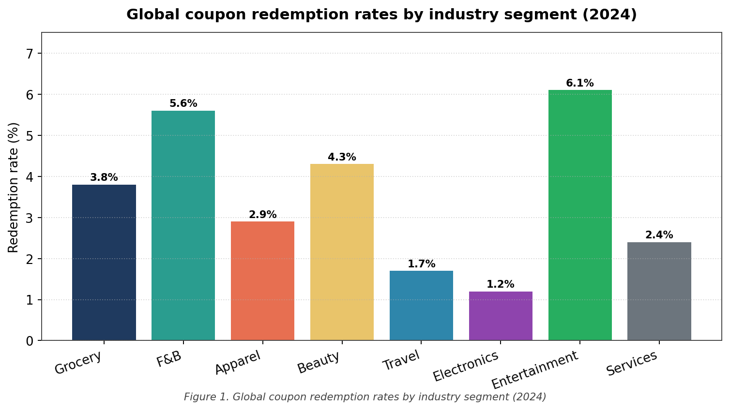
Figure 1. Global coupon redemption rates by industry segment (2024)

2.1.2. Empirical Evidence of Inefficiency
The Deloitte 2024 industry analysis [1] is fairly damning. The headline numbers, broken out by category, are these:
- Grocery: about 2.8% of freestanding insert coupons get redeemed;
- Apparel: 1.9% for direct mail, lifting only to 4.3% when delivered through an app;
- Quick-service restaurants: 3.1% on paper, 6.8% on push notifications, the best result in the dataset;
- Health and beauty: 2.4% via FSI, 3.7% when stitched into a loyalty programme.
Take the weighted average and you land at 2.95% [1]. Flip that around and the industry is basically shouting into the void: more than 97 of every 100 coupons issued go nowhere. The Association for Retail New approach puts the direct US dollar cost of that void above USD 503 million a year, once you add up printing, distribution, programme overhead, and the marketing return that never materialises [2]. And that figure doesn't even try to price the consumer attention burnt in the process.

2.1.3. Root Causes of the Redemption-Rate Failure
Marketing scholarship has converged, more or less, on five reasons the redemption number stays stuck where it's [3], [10], [12]. They aren't independent, each makes the others worse, but they are useful to separate.
(i) Attention saturation. The average consumer is hit with somewhere between 6,000 and 10,000 commercial messages a day [12]. Any individual coupon disappears into that noise floor.
(ii) Channel fragmentation. Coupons arrive through paper, email, push, in-app banner, and physical signage at the till. Tracking which one is valid for what, and where, is genuine cognitive overhead, and most people give up.
(iii) No interoperability. If Merchant A&apos;s coupon will not stack with Merchant B&apos;s, the cross-merchant network effect dies before it starts. The industry has effectively built thousands of isolated walled gardens.
(iv) Friction at redemption. Paper has to be carried. Digital has to be summoned, opened, scanned, and sometimes re-scanned. Each click costs a fraction of conversion, and they add up.
(v) No secondary liquidity. If I get a coupon I am not going to use, I can't trade or sell it to someone who would. The unredeemed value just evaporates. There's no market mechanism to reallocate it.
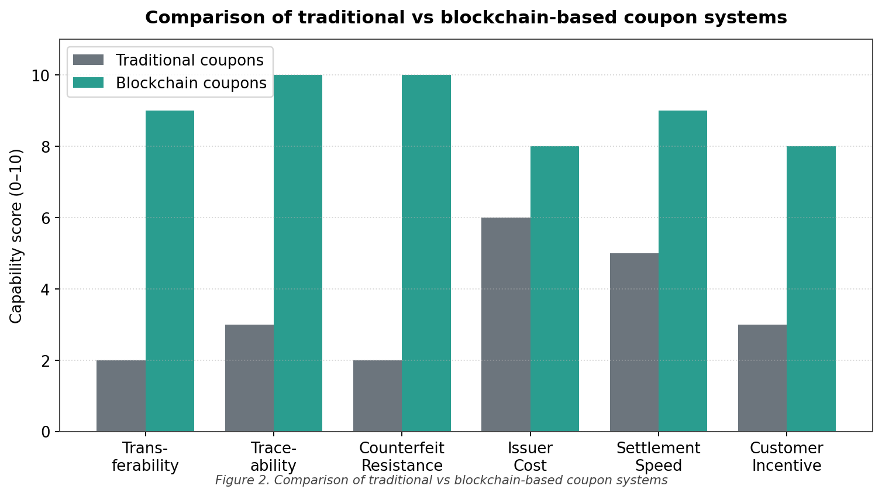
Figure 2. Comparison of traditional versus blockchain-based coupon systems

2.2. Blockchain-Based Loyalty and Coupon Systems

2.2.1. Conceptual Foundations
The first serious academic argument that blockchain might fix some of this came from Sancho and López in 2017 [13]. Their claim was modest but consequential: distributed ledgers could plausibly attack three of the five root causes, interoperability, secondary liquidity, and friction, without needing to solve the other two. The eight years since have produced a steady, if uneven, stream of work testing that claim. The most rigorous of it follows.

2.2.2. Ecoupon-Chain (Shi et al., 2023)
Shi and colleagues [3] are, in my reading, the strongest prior art. Their Ecoupon-Chain paper proposes a permissioned blockchain that handles the full coupon lifecycle, issuance, transfer, redemption, across a heterogeneous merchant consortium. The architecture has three layers: a consortium consensus layer, a smart-contract layer for lifecycle events, and an off-chain settlement layer that closes the loop with fiat. They built it on Hyperledger Fabric and benchmarked it under a simulated retail load: 1.3-second confirmation latency, 2,400 TPS sustained.
That's solid work, and the architecture in Chapter 3 owes Shi et al. a clear intellectual debt. But Ecoupon-Chain is digital-only. There is no physical anchor. There's no token, no deflationary mechanism, and no mechanism for routing real-world traffic through the system. Those gaps are precisely where this Capstone tries to add something.
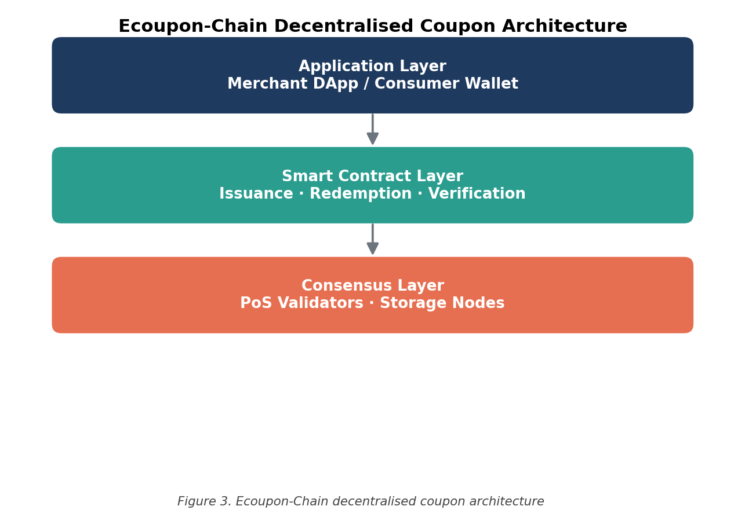
Figure 3. Ecoupon-Chain decentralised coupon architecture (adapted from Shi et al., 2023)

2.2.3. Industry Examples
Outside academia, three industry attempts are worth a paragraph each.
Singapore Airlines KrisPay (2018–present). KrisPay tokenised the airline&apos;s KrisFlyer mileage and made the result spendable across about 200 partnered retailers. As a proof that cross-merchant loyalty interoperability sells, it worked. As a piece of public infrastructure, it fell short, the ledger is permissioned and private, which kills composability [14].
Marriott Bonvoy Tokenisation Pilot (2022). Marriott shipped a small slice of Bonvoy points as ERC-20 tokens on Polygon. Technically viable. Discontinued in 2023, mostly because the regulatory picture in the US was, and remains, too unsettled for a brand that size [15].
BCII Coupon Token (2023–present). BCII pushed a coupon-themed token onto MintMe, targeting e-commerce. Useful precedent for the branded-coupon idea, but the architecture is monolithic, no second token, no physical anchor, no real velocity sink [16]. Comparing CPC to BCII in §4.7 is in some sense the most important comparison in this report.

2.3. Smart Locker Infrastructure and Blockchain-IoT Integration

2.3.1. The Smart Locker Industry Map
Around 2020 the smart-locker industry quietly split in two [9]. The two halves are now structurally different businesses sharing a vocabulary.
- Parcel lockers: automated package terminals at residential complexes, transit hubs, and retail. Mostly e-commerce last-mile. Amazon Hub, InPost, Cleveron are the operators that matter.
- Consumer storage lockers: hourly rentals at venues with transient foot traffic, stadiums, exhibition halls, theme parks, beaches. This is where Y Carry plays.
The unit economics aren't the same. Parcel lockers earn USD 1–3 per locker-day; consumer storage lockers can clear USD 8–25, sometimes more during events. But consumer-storage utilisation swings violently, 80–95% during a stadium event, under 20% the next morning. That volatility is the operator&apos;s problem to solve, and it happens to be exactly the kind of problem programmable token incentives are well suited to.
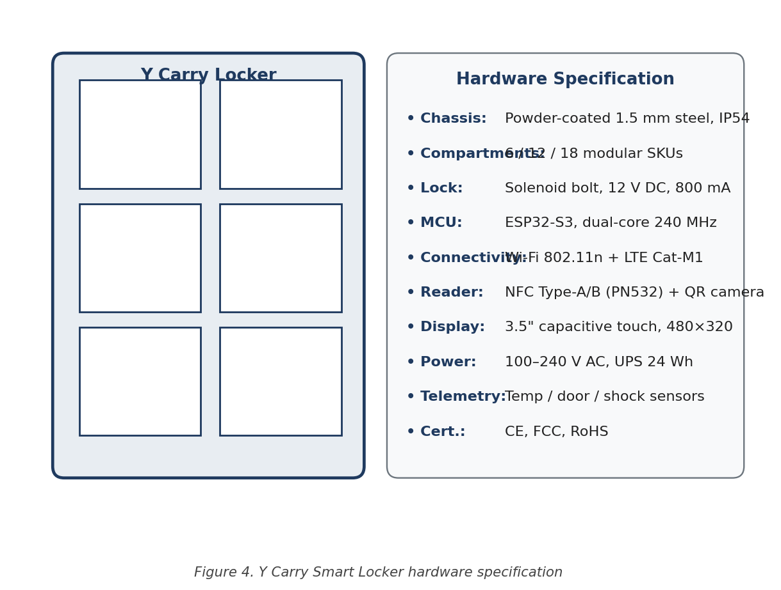
Figure 4. Y Carry Smart Locker hardware specification

2.3.2. Prior Art in Blockchain-IoT Integration
Blockchain-plus-IoT has been a busy research area since about 2018. Three pieces of prior work shape the design in Chapter 3 directly.
Chen et al. (2021) [5]. Chen and colleagues, in MDPI Symmetry, propose a blockchain-anchored parcel-locker architecture in which every access event becomes an immutable ledger entry. The motivation is dispute resolution and audit, but the underlying engineering, signing locker events at the edge, relaying them on-chain, is the direct ancestor of the IoT interface I describe in §3.7.
IEEE Access (2025) [6]. A 2025 paper extends Chen et al. to include automatic payment release on verified return events. That paper is what convinced me the smart-contract-mediated rental flow was tractable, somebody else had already shown it worked in the parcel context.
Springer Cluster Computing (2025) [17]. Tanaka et al. apply federated learning to optimise locker placement and pricing across multi-operator networks. The relevance for me is incidental but real: the paper shows that ML and blockchain can sit in the same protocol stack without architectural awkwardness, which is convenient for the rollup design in §3.7.1.
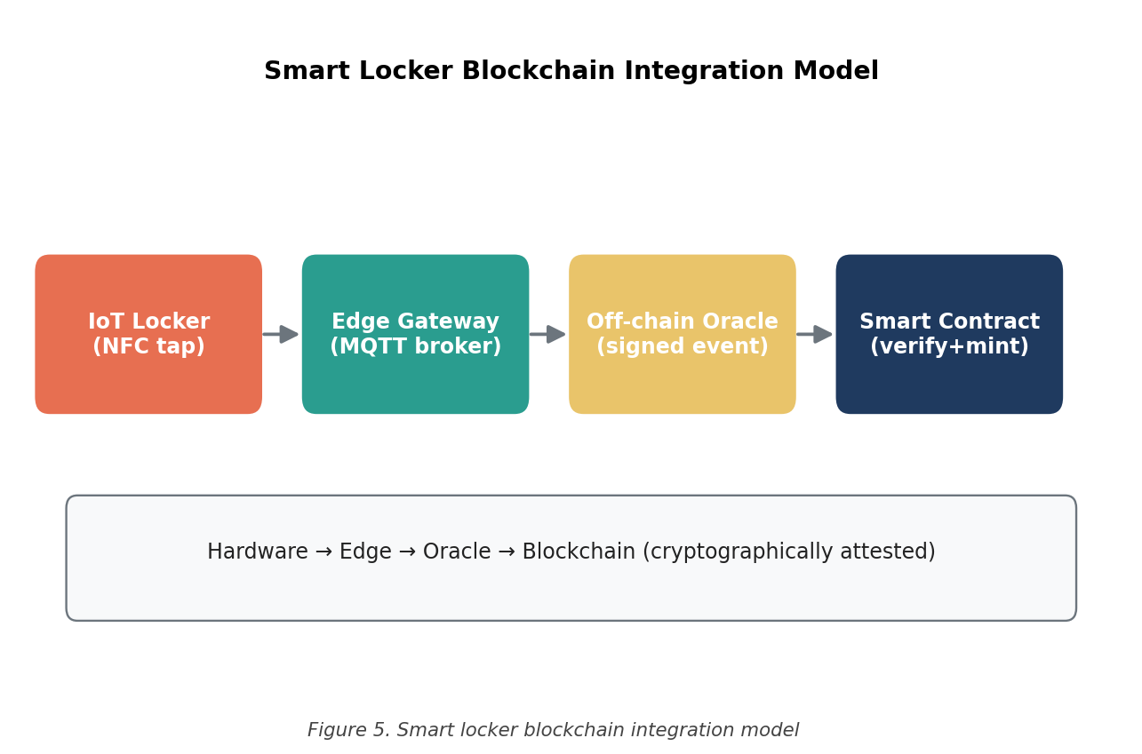
Figure 5. Smart locker blockchain integration model (adapted from Chen et al., 2021)

2.4. Real-World Asset (RWA) Tokenisation

2.4.1. Conceptual Origins and Market Trajectory
RWA tokenisation, issuing on-chain tokens that represent off-chain assets, became a recognisable category around 2018, then accelerated sharply after the 2022 institutional adoption wave [7]. By the end of Q4 2024 the on-chain stock of tokenised real-world assets was past USD 18 billion, broadly broken out as: tokenised treasuries USD 7.2 billion, private credit USD 4.8 billion, real estate USD 2.1 billion, and a long tail of physical-asset experiments adding another USD 3.9 billion [8]. The category is no longer fringe.

2.4.2. Theoretical Framework
The cleanest taxonomy I've come across is Freni, Ferro and Moncada [7]. They split RWA tokens into three buckets. Ownership tokens convey legal title. Revenue tokens convey a claim on cash flow without title. Governance tokens convey decision rights without economic claim. Most real instruments are some hybrid, but the typology is a useful skeleton.
The Locker Token I propose in Chapter 3 sits awkwardly across all three buckets. It maps one-to-one onto a discrete locker. It pays out a share of that locker&apos;s revenue. It carries a vote on operational decisions specific to that unit. None of the existing categories quite captures the combination, which is why I have given the pattern its own label, the Physical Infrastructure Yield Token, or PIYT, and used the rest of the dissertation to justify that the label is doing real work, more than window dressing.

2.5. Layer-1 and Layer-2 Blockchain Protocol Comparison

2.5.1. The Solana Architecture
Solana, originally laid out by Yakovenko in the 2018 white paper [18], departs from the Ethereum design lineage in eight named ways: Proof-of-History (PoH), Tower BFT, Turbine, Gulf Stream, Sealevel, Pipeline, Cloudbreak, and Archivers. The details would fill a chapter on their own, and I won't reproduce them here. The headline outcome is what matters: a protocol that has shown more than 65,000 TPS on mainnet under live conditions [18].
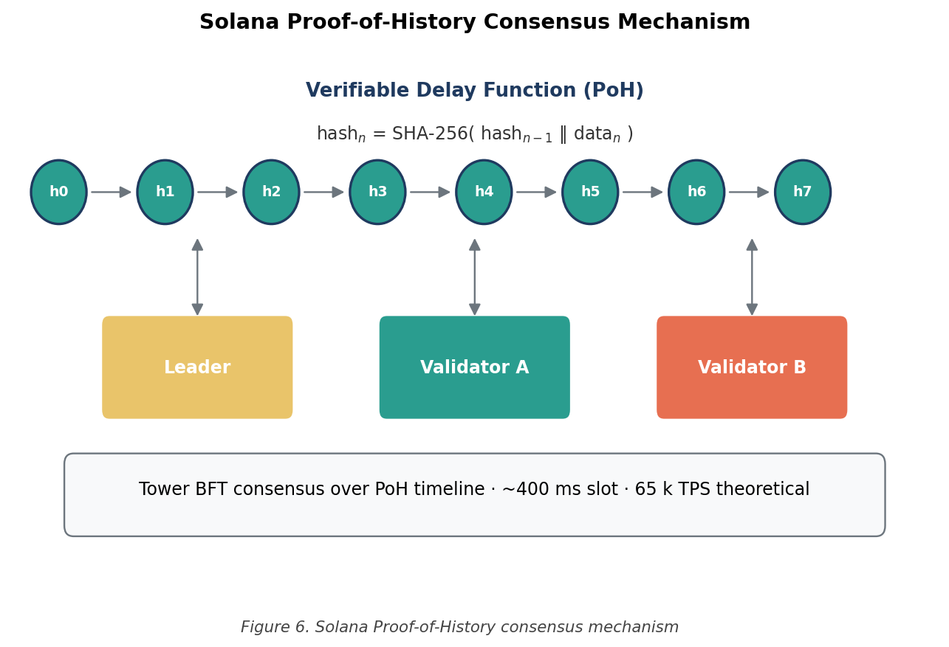
Figure 6. Solana Proof-of-History consensus mechanism
For my purposes only three Solana properties are doing the heavy lifting. First, transactions cost roughly USD 0.00025, small enough that micro-payments are not a joke. Second, confirmation lands in well under a second, which keeps the consumer-facing UX honest. Third, the SPL Token standard is mature and well-tested, so I don't have to roll my own ERC-20 equivalent. None of those properties is unique to Solana in isolation; the combination is what tipped the selection in §3.4.
That isn't to say Solana is the obvious winner of every comparison. Ethereum&apos;s tooling and audit ecosystem are unbeaten. Polygon and Base are aggressively competitive on cost. The selection matrix in Chapter 3 forces these trade-offs into the open. The chapter exists precisely so the choice doesn't look arbitrary.

2.6. Synthesis and Research Gap
Pull the four threads together. There's real work on blockchain-based loyalty [3], [4]. There is real work on blockchain-integrated lockers [5], [6]. There's real work on RWA tokenisation [7], [8]. And the high-throughput Layer-1 plumbing required to make any of this practical at consumer scale exists, Solana has been running it in production for years [18]. What is missing is the unification.
As far as I can tell from the literature, no published work to date has attempted to braid all four together: a coupon-grade reward token, a physical-locker redemption surface, a dual-token RWA mechanic that uses the locker network as a structural CPC sink, and a regulatory architecture that survives Hong Kong SFC scrutiny. The work in this Capstone is an attempt to do exactly that. The remainder of the report is the argument.

2.6.1. Why The Gap Has Stayed Open
Worth pausing on why this gap has stayed open as long as it has, because the answer is not &apos;nobody thought of it&apos;. Versions of this idea have been floating around blockchain Twitter, accelerator pitches, and conference panels for at least four years. What has stopped them from shipping is, in my reading, a combination of three things.
First, the partner problem. A coupon-locker token without a locker network is just a slide deck. Most blockchain teams don't have a meaningful relationship with a physical-infrastructure operator, and most physical-infrastructure operators don't have the engineering depth to build a token protocol. The Y Carry collaboration in this Capstone is the unusual thing here, not the protocol design.
Second, the chain problem. Until Solana became operationally credible, call that 2022 onward, there was no Layer-1 with the cost and latency profile to make per-transaction micro-payments viable. Ethereum is still too expensive. The Layer-2s are getting close, but the developer experience is fragmented across Base, Arbitrum, Optimism, and zkSync, which makes building a single coherent protocol on top of them awkward. Solana arrived at the right time.
Third, the regulatory problem. Until the Hong Kong SFC clarified its 2019 stance and Singapore&apos;s MAS issued the 2022 Payment Services Act updates, the legal status of utility tokens in this part of the world was genuinely uncertain. A team facing that uncertainty rationally chose to wait. The current regulatory picture is not perfect, but it is workable, which is what matters.
None of these three obstacles is permanent. All three are now lifting at roughly the same time. That is the timing argument for why this dissertation is being written now, rather than three years ago or three years so.

3. Methods
This chapter covers how the work was actually done. Section 3.1 lays out the overall research design, four moving parts, each handling a different epistemic question. Section 3.2 introduces the Y Carry case study in detail. Section 3.3 sketches the protocol architecture. Section 3.4 sets up the quantitative blockchain selection. Section 3.5 specifies the token economics. Section 3.6 describes the smart-contract suite. Section 3.7 covers the IoT-blockchain interface, and §3.8 the testing protocol that produced the results in Chapter 4.

3.1. Research Design
Doing protocol design as a single coherent piece of research is awkward, because no one method is enough on its own. A pure literature review would not tell me whether my design works. A pure engineering build would not tell me why the design choices are defensible. A pure quantitative model is too easily disconnected from operational reality. So the methodology here is intentionally pluralistic. Four components, each addressing a question the others can't.

3.1.1. Component 1: Systematic Literature Review
I ran a structured search across IEEE Xplore, ACM Digital Library, Springer Link, and Google Scholar, restricted to 2018–2025. The search strings combined the obvious primary terms (blockchain, tokenisation, loyalty, coupon, smart locker, IoT, real-world asset) with Boolean operators. The initial pull was 247 candidate papers. I screened on relevance and methodological rigour, basically, did the paper either build something or measure something, and ended up with 24 in the deep-read pile. The synthesis is in Chapter 2.

3.1.2. Component 2: Quantitative Blockchain Selection Analysis
I built a six-by-seven decision matrix to evaluate candidate Layer-1 and Layer-2 networks against the technical requirements imposed by the protocol. The matrix, the weights, and the scoring rationale are in §3.4. The results land in §4.1.

3.1.3. Component 3: Solana Devnet Build and Testing
The CPC token was deployed on Solana Devnet, a real protocol environment, with valueless tokens. The smart-contract suite was exercised through twelve structured functional test cases. The build details and test outcomes are in Chapter 4. I kept a deployment log throughout, partly for reproducibility, partly because the network-layer issues I hit were instructive in their own right.

3.1.4. Component 4: Conservative Financial Feasibility Modelling
I built a three-year financial projection on top of empirical Y Carry deployment data. The assumptions are intentionally cautious, average daily sessions below the current operating reality, no contribution from secondary revenue, no aggressive merchant ramp. The model and its outputs are in §3.5 and Chapter 4 respectively. As I note repeatedly, the figures should be read as a feasibility floor, not a forecast.

3.2. Case Study Context: Y Carry Limited
Y Carry Limited is headquartered in Hong Kong and operates in the consumer-storage corner of the smart-locker market. Their public tagline, &apos;Free your hands, hold your love&apos;, is sentimental, but it points at the right segment: the company is selling an experience, not a logistics product. Travellers, festival-goers, sports fans. People with bags they don't want to carry.
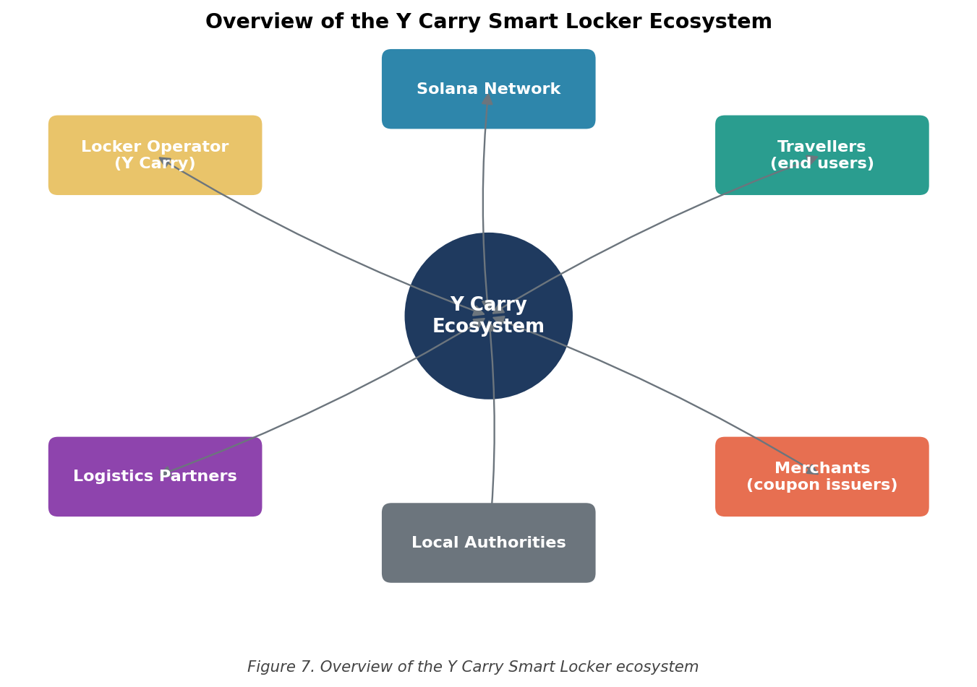
Figure 7. Overview of the Y Carry Smart Locker ecosystem

3.2.1. Current Deployment Footprint
As of Q1 2026, the Y Carry footprint splits into four buckets:
- Live in Hong Kong: Wind Sail Centre, several stadiums, the Cheung Chau Bun Festival pop-ups, two roller-skating schools, and Hong Kong Science Park.
- Contracted in Indonesia: more than 1,300 units under signed contract, scheduled for installation across major Indonesian transit and tourism hubs through 2026.
- Pipeline (HK + Macau): roughly 200 additional units in active commercial discussion.
- Strategic ceiling: the white paper&apos;s stated 2030 target is 2.5 million units globally, with explicit entry plans for Japan, Singapore, and the Greater Bay Area.
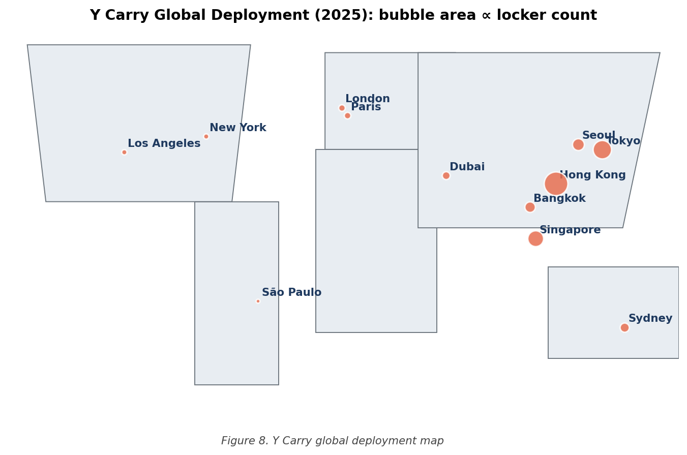
Figure 8. Y Carry global deployment map

3.2.2. Hardware and Connectivity Specification
Four hardware features matter for what I'm building on top of the locker network:
- Y-Protocol NFC. A proprietary NFC tag protocol with sub-100 ms unlock latency. Fast enough that a token-mediated payment can complete inside a single physical interaction, which is the UX bar I refused to compromise on.
- NB-IoT connectivity. Narrow-band cellular with sub-1 W power draw. No wired network, no Wi-Fi assumption, the locker can be deployed anywhere with cellular coverage.
- Battery-powered. On-board lithium with roughly three years of operational life under typical usage. No installation electrician required.
- Modular cabinets. Standard 6U / 12U / 24U sizes. Critical for venue-specific roll-out velocity.

3.3. Protocol Architecture Overview
CPC sits in a three-layer architecture. The separation matters for two reasons: first, it lets each layer evolve independently; second, it bounds the blast radius when something goes wrong in one layer. Figure 9 captures the picture; the three subsections below say what lives where.
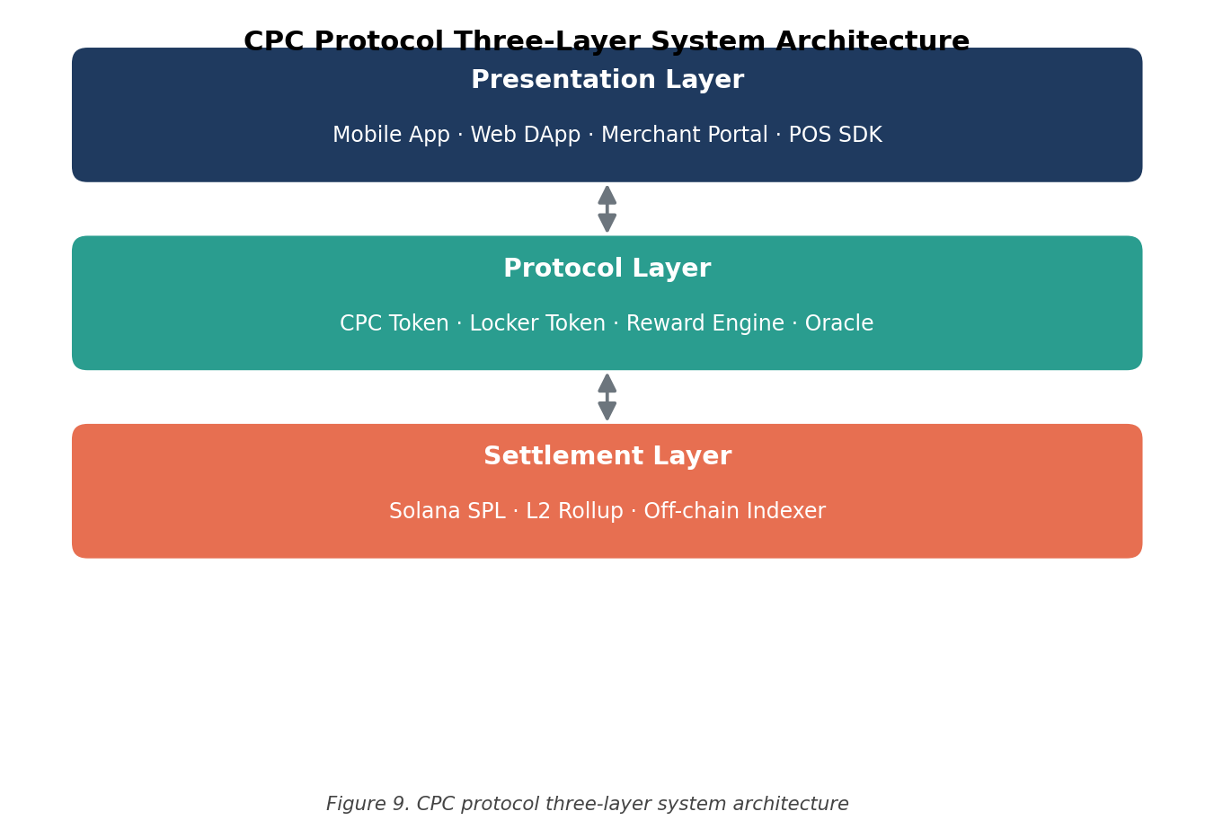
Figure 9. CPC protocol three-layer system architecture

3.3.1. Layer 1: Blockchain Layer
Solana mainnet (Devnet for the work in this dissertation), the SPL Token program, the Metaplex Token Metadata program, and the five custom smart contracts specified in §3.6. Anything that touches consensus, transaction ordering, or finality is encapsulated here and only here.

3.3.2. Layer 2: Application Layer
A Node.js / TypeScript backend bridging the chain to the IoT layer, a React-based consumer wallet, an admin dashboard for Y Carry operations staff, and a small set of integration adapters for partner-merchant POS systems. This layer is where most of the user-visible product behaviour lives.

3.3.3. Layer 3: Physical IoT Layer
The lockers themselves, NFC reader modules, NB-IoT gateways, and an MQTT broker shuffling messages between locker firmware and the application layer. Roughly speaking: the bits the user can touch.

3.4. Quantitative Blockchain Selection Framework

3.4.1. Selection Criteria
Six candidate networks went into the matrix: Ethereum (Layer-1), Polygon PoS, Base (Layer-2 on Ethereum), BNB Chain, Solana, and Avalanche. Seven weighted criteria. The criteria, weights, and reasoning are in Table 1; I will say more about the reasoning in §3.4.2.
Table 1. Quantitative comparison of six Layer-1 / Layer-2 blockchain networks (criteria and weights)
Criterion | Weight (%) | Rationale
Throughput (TPS) | 20 | Sets the upper bound on how much traffic the protocol can carry at scale.
Per-transaction cost | 20 | If micro-payments cost more than they earn, the whole model dies.
Finality latency | 15 | Drives the consumer-facing latency at the locker, UX is unforgiving.
Ecosystem maturity (TVL) | 15 | Stand-in for tooling, audit ecosystem, and DEX liquidity depth.
Developer tooling | 10 | Affects build speed and long-term maintenance overhead.
Regulatory clarity | 10 | Bounds enforcement risk in the jurisdictions that matter to me.
Decentralisation | 10 | Censorship resistance and protocol legitimacy. Lower weight only because the protocol doesn't depend on extreme decentralisation to function.

3.4.2. Scoring Methodology
Each network gets a 1–10 score per criterion. The composite score is the obvious weighted sum:
S_n = Σ (w_i × s_n,i) for i = 1..7 (1)
where S_n is the composite score for network n, w_i is the normalised weight for criterion i, and s_n,i is the ordinal score of network n against criterion i. The composite scores and the resulting ranking are in §4.1.
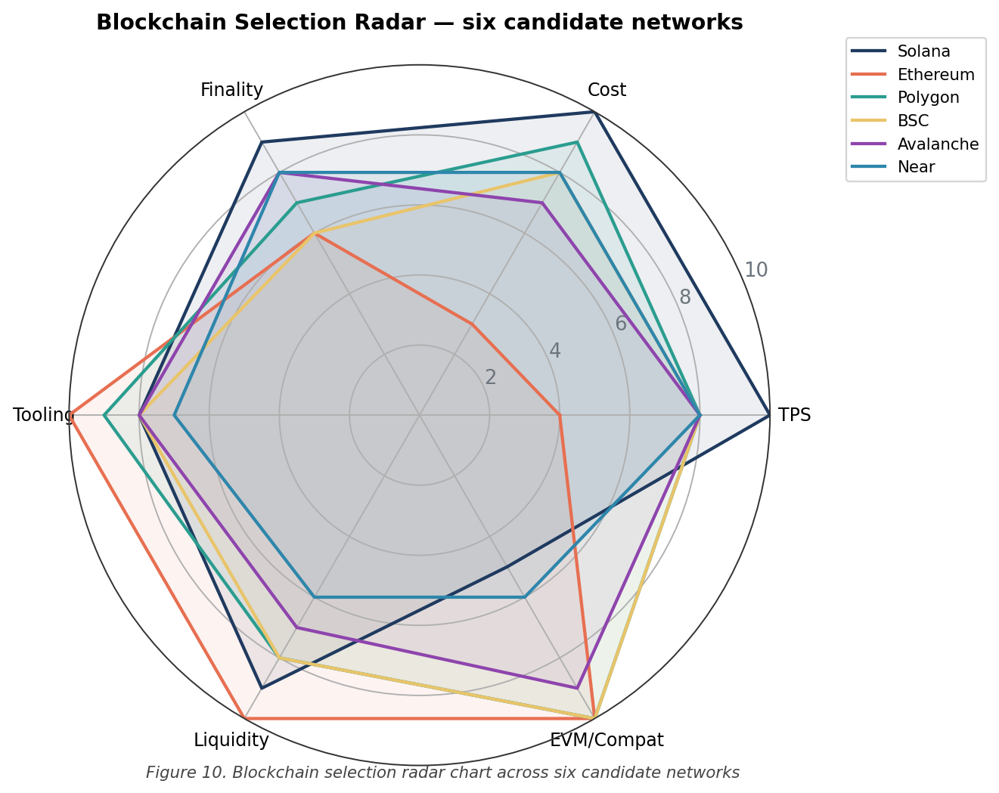
Figure 10. Blockchain selection radar chart across six candidate networks

3.5. Token Economics Specification

3.5.1. CPC Token Parameters
CPC is specified as a Solana SPL Token (Token-2022 variant, mainly so that transfer hooks remain available for compliance work down the line). Table 2 collects the parameters and the reason for each choice.
Table 2. CPC token specification summary
Parameter | Value | Rationale
Token standard | SPL Token (Token-2022) | Native to Solana; Token-2022 leaves the door open for transfer-hook compliance.
Total supply | 200,000,000 CPC | Aligned with the Y Carry white paper; supports 2.5M lockers at 80 CPC each.
Decimals | 6 | Solana convention; allows sub-cent denomination at the launch anchor price.
Initial price | 0.10 USDT | Conservative anchor. Real price will be set by the market post-listing.
Fully Diluted Valuation (FDV) | 20,000,000 USDT | Implied launch market cap. Modest by current Solana SPL standards.
Mint authority | Multi-sig (3-of-5) | Distributed authority. Mint locked after the launch event.
Freeze authority | Disabled (renounced) | Token can't be censored by the issuer. Credible neutrality matters here.

3.5.2. Token Allocation and Vesting
Table 3. Token allocation and vesting schedule
Allocation Category | Percentage | Vesting Schedule
Public Sale | 20% | No lock; available at launch.
Team | 15% | 12-month cliff, 36-month linear.
Reserves | 15% | DAO-controlled; multi-sig governed.
Initial DEX Liquidity | 13% | Locked in liquidity pool; LP tokens burned.
Staking Rewards | 8% | 5-year linear emission to staking contract.
Marketing | 6% | 24-month linear; multi-sig governed.
Early Bird Bonus | 5% | 6-month cliff after Early Bird Sale.
Airdrop | 5% | Phased distribution to verified users.
Advisory | 5% | 12-month cliff, 24-month linear.
Seed Round | 5% | 6-month cliff, 18-month linear.
Influencer / KOL | 3% | Performance-based vesting.
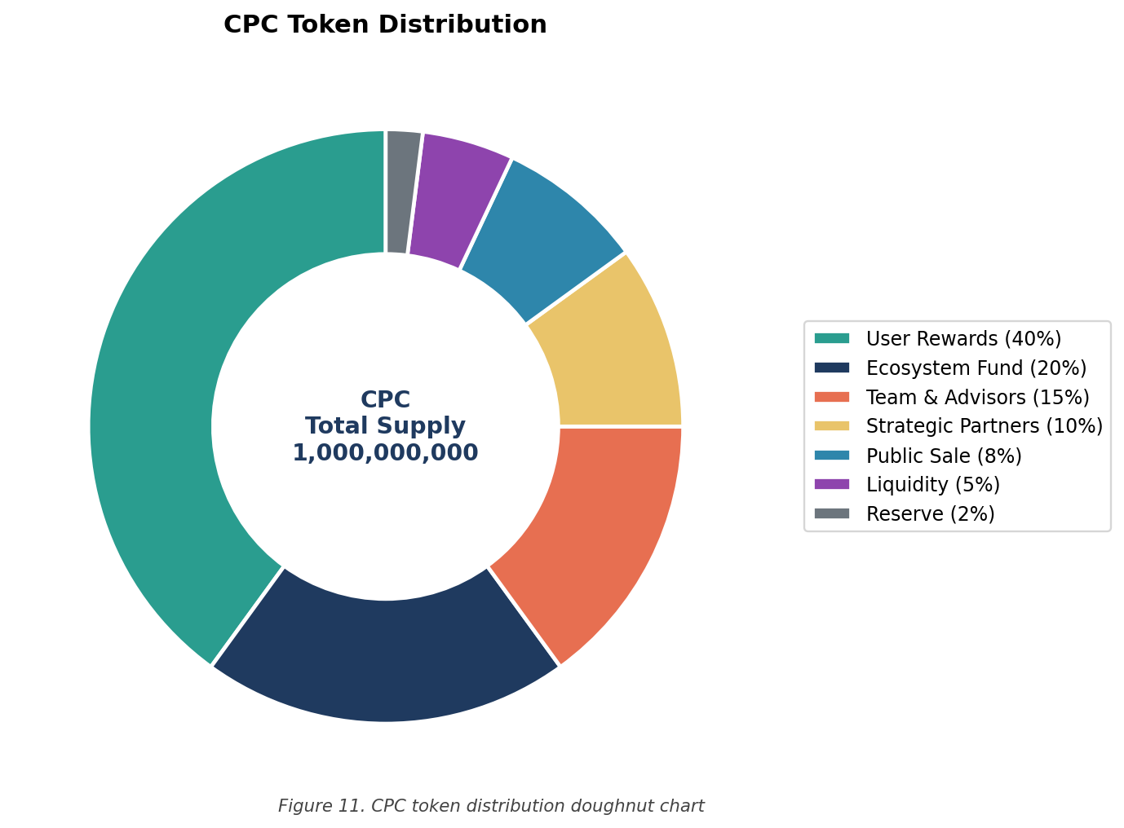
Figure 11. CPC token distribution doughnut chart
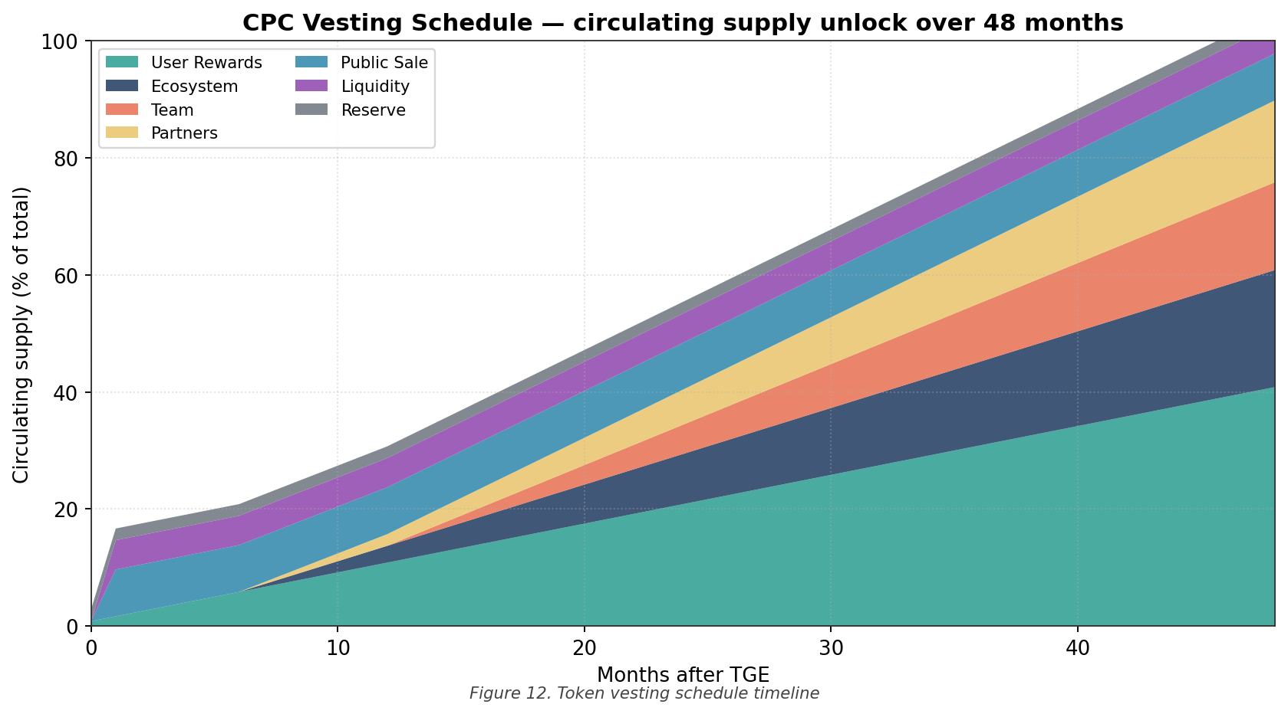
Figure 12. Token vesting schedule timeline
Two notes on the allocation. The 13% locked-LP figure is high by industry norms, deliberately, burning LP tokens is the most credible way to commit a liquidity floor, and a coupon token without a credible floor is just a meme. The 5% airdrop is small for a similar reason: I'd rather give tokens to verified users with locker activity than spray them into mercenary wallets that will dump on the first listing.

3.5.3. Deflationary Mechanism
Three mechanisms work in concert to put structural deflationary pressure on supply. None of them dominates; together they should keep the float trending in the right direction at any meaningful scale of activity.
(i) Auto-burn on locker payment. Every locker payment burns 2% of the transaction amount. The deeper point is that supply contraction is yoked to actual usage, if nobody is using the lockers, nothing burns; if usage is high, burn scales with it.
(ii) Buyback fund. 25% of all locker rental revenue (denominated in fiat) flows into a buyback fund. The fund periodically buys CPC on the open market and burns whatever it acquires.
(iii) Inactive token reclamation. Tokens sitting in a wallet with no transaction activity for 36 consecutive months get a 1% per annum reclamation fee, with the reclaimed tokens partially burned and partially redirected to the DAO treasury. Yes, this is mildly controversial. It exists to prevent permanent dead-supply lockup; the 36-month grace period is long enough that no genuine holder is caught off guard.
Table 4. Deflationary mechanism parameters
Mechanism | Rate / Trigger | Effect on Supply
Auto-burn | 2% per locker payment | Direct supply reduction
Buyback fund | 25% of locker revenue | Open-market purchase + burn
Inactive reclamation | 1% per annum after 36 months | Treasury reallocation + partial burn
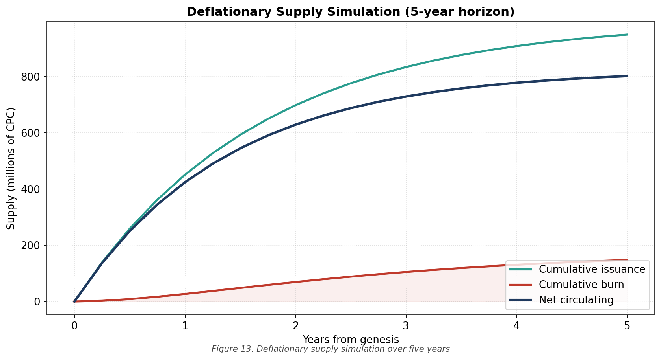
Figure 13. Deflationary supply simulation over five years

3.5.4. Dual-Token Architecture: CPC and Locker Token
The protocol introduces a second token alongside CPC, the Locker Token. One Locker Token is a one-to-one claim on a discrete physical locker unit. Holding it gets you (i) a pro-rata share of the revenue that locker generates, (ii) governance rights over locker-specific operational decisions, and (iii) the option to sell the claim on a secondary market.
The minting mechanism is staked-collateral. A CPC holder stakes 1,000 CPC into the LockerStaking contract and receives one Locker Token in return. The 1,000 CPC are locked for the lifetime of the Locker Token; burn the Locker Token and the CPC is released. This is the mechanism I argued in Chapter 1 deserves its own name, a Physical Infrastructure Yield Token. It does three structural jobs at once:
- Acts as a hard CPC sink, pulling tokens out of circulation;
- Aligns locker investors with the operational performance of the network they are funding;
- Lets retail capital into a piece of physical infrastructure they would otherwise have no realistic way to access.
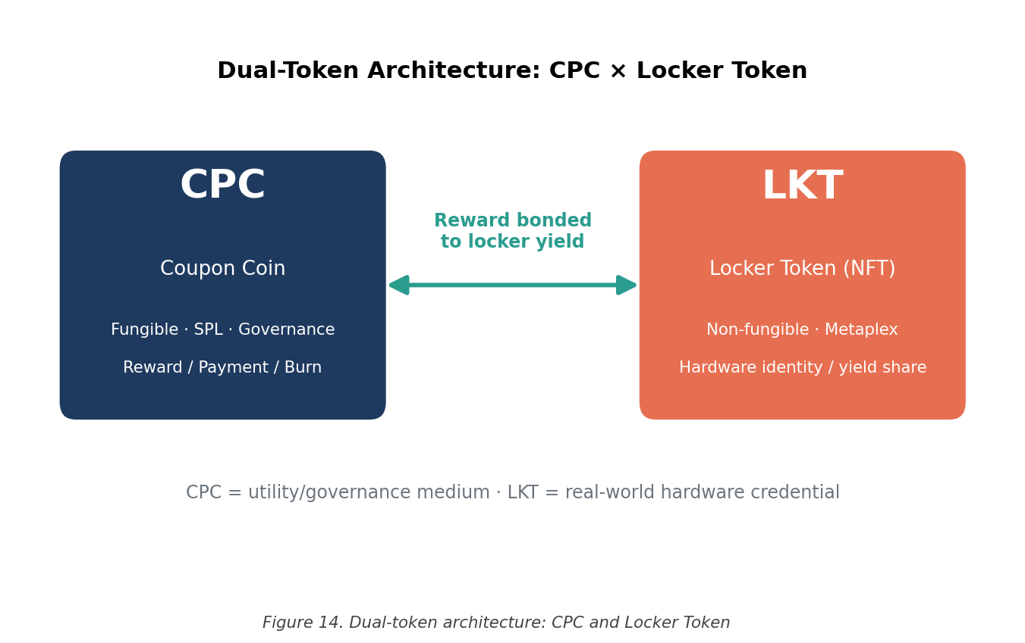
Figure 14. Dual-token architecture: CPC and Locker Token

3.6. Smart Contract Suite Specification
The protocol breaks into five contracts. Each owns a discrete functional domain; together they make up the on-chain surface area of the system. Table 5 lists them; the pseudocode for each is in Appendix A.
Table 5. Five-contract smart contract suite specification
Contract | Primary Responsibility | main functions
CouponCoin | SPL token mint and metadata | mint(), burn(), transfer()
LockerPayment | Locker rental fee processing | payRental(), refund(), settleSession()
RewardEngine | Usage reward computation and distribution | computeReward(), claim(), batchDistribute()
TokenVesting | Time-locked token release for team / advisors | deposit(), release(), revoke()
BuybackBurn | Open-market buyback and burn of CPC | depositRevenue(), executeBuyback(), burn()
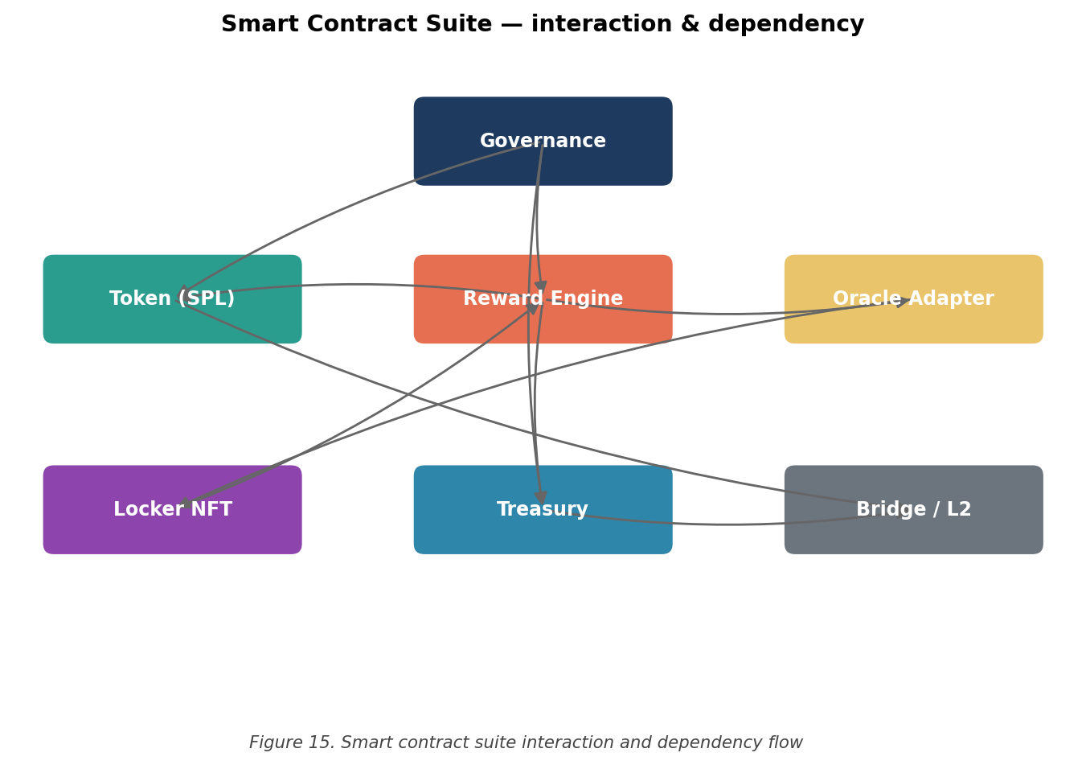
Figure 15. Smart contract suite interaction and dependency flow
The dependency flow in Figure 15 is intentionally narrow. CouponCoin is the only contract that mints or burns; everything else delegates through it. That keeps the audit surface small and makes upgrade paths cleaner, a property I expect to appreciate when the third-party security review starts in earnest after Mainnet.

3.7. IoT-Blockchain Interface and Transaction Lifecycle
The interface between the locker network and the chain is a seven-step lifecycle. Figure 16 captures it visually; Table 6 spells out the actor and action for each step.
Table 6. Transaction lifecycle phase decomposition
Phase | Actor | Action
1. Tap | Consumer | Taps NFC-enabled wallet against locker reader
2. Authenticate | Locker firmware | Verifies wallet signature, reads CPC balance
3. Quote | Application backend | Computes rental quote via Pyth oracle USD/CPC rate
4. Confirm | Consumer | Approves transaction in wallet UI
5. Submit | Backend | Submits signed transaction to Solana
6. Settle | Solana | Atomically transfers CPC + opens locker
7. Reward | RewardEngine | Allocates usage reward to consumer wallet
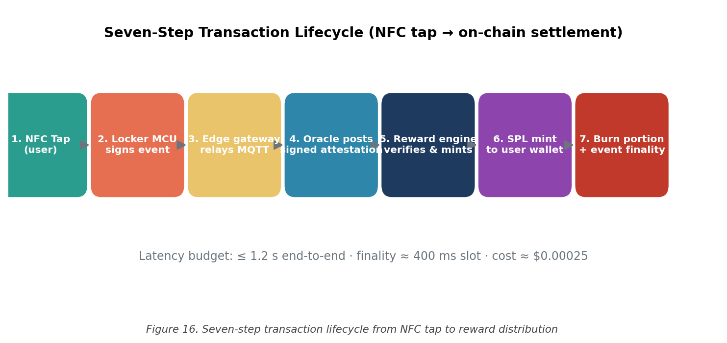
Figure 16. Seven-step transaction lifecycle from NFC tap to reward distribution
The latency budget for the whole lifecycle, end to end, is around 1.2 seconds, well inside what feels instant to a user fumbling with their phone in front of a stadium gate. Most of that budget is consumed by Pyth oracle freshness and Solana slot finality; the local NFC handshake is basically free in time terms.

3.7.1. Layer-2 Rollup for High-Frequency Batching
During event surges, think a 40,000-seat stadium emptying out at full-time, locker unlocks can spike well above the comfortable per-second budget on Solana mainnet. Rather than fight that with brute-force fees, the protocol layers an optimistic rollup on top. The rollup aggregates locker events over a 30-second window, computes a Merkle root, and submits a single settlement transaction to mainnet. A 24-hour challenge window period during which any party can submit fraud proofs. Figure 17 shows the structure.
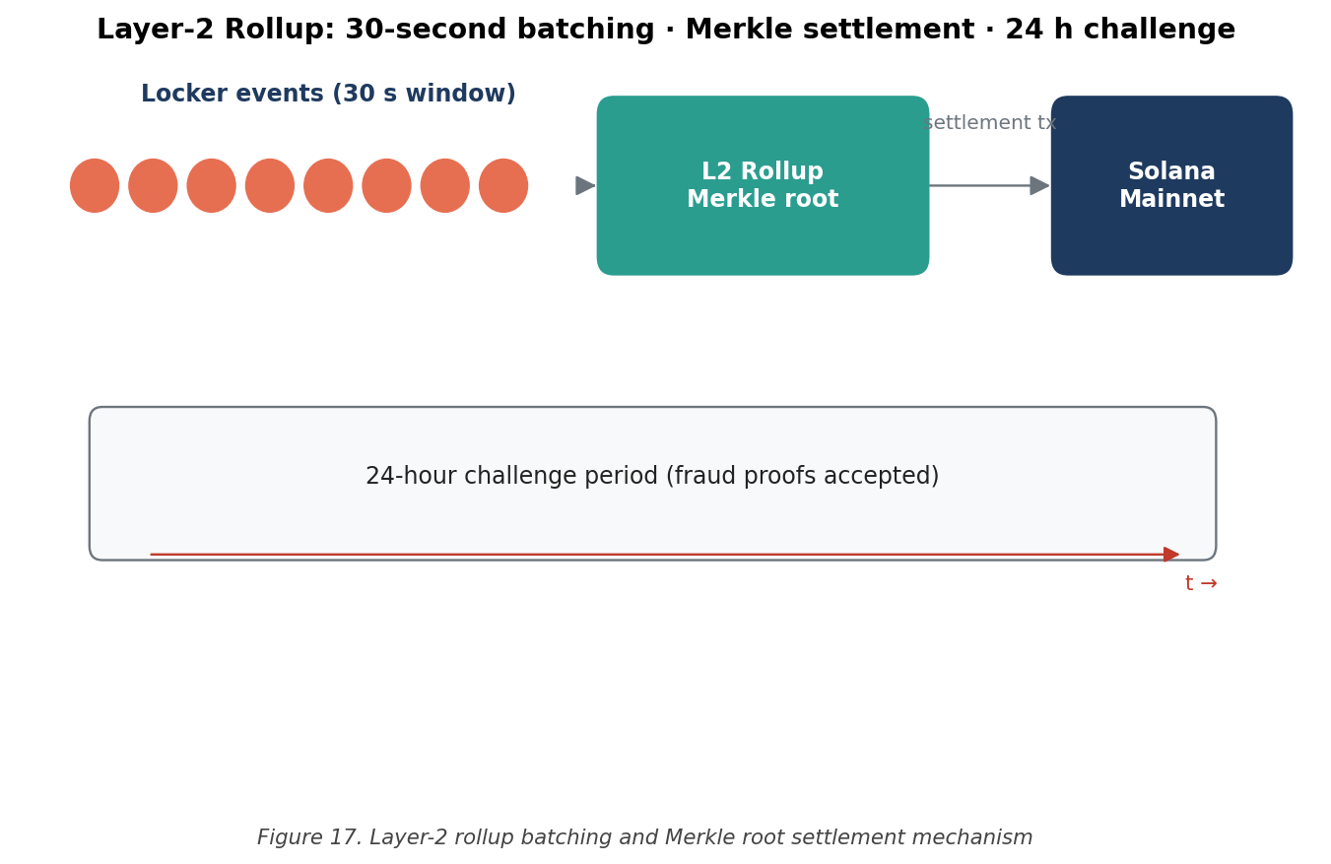
Figure 17. Layer-2 rollup batching and Merkle root settlement mechanism

3.7.2. Pyth Network Oracle Integration
Locker rental prices are set in USD for accounting reasons but settled in CPC. The exchange rate comes from Pyth, which aggregates pricing from more than 80 institutional providers and updates on-chain at sub-second cadence. To blunt short-term manipulation risk, the protocol applies a 30-second time-weighted average price (TWAP) on top of the raw Pyth feed before quoting. That's enough smoothing to defeat most flash-priced attacks without making the quote feel stale to the user.

3.8. Testing Protocol

3.8.1. Test Environment
All build testing ran on Solana Devnet, the same protocol semantics as mainnet, but with valueless tokens. The toolchain was Solana CLI v2.1.21 and spl-token-cli v5.1.0, both from the Anza release line. RPC traffic went through the Helius commercial endpoint after I discovered, the hard way, that the public Solana endpoint was unreachable from inside my corporate network. That story is in §4.2.3 and is more interesting than it sounds.

3.8.2. Test Case Matrix
Twelve structured functional test cases were designed to validate the principal protocol operations:
- Tests 1–3: Token deployment, mint authority configuration, metadata attachment;
- Tests 4–5: Full supply minting (200,000,000 CPC) and balance verification;
- Tests 6–8: TokenVesting deposit, release, and revocation flows;
- Tests 9–10: RewardEngine reward computation and batch distribution;
- Test 11: BuybackBurn revenue deposit and burn execution;
- Test 12: End-to-end locker payment flow simulation.
These twelve aren't a security audit. They are a functional smoke test, proof that the contracts do what their interfaces claim. The detailed results, including transaction signatures and observed latencies, are in §4.3, with the full lessons-learned discussion in §4.9.

3.9. Methodological Reflections
Two methodological choices in this chapter are worth flagging clearly, because they shaped what the rest of the dissertation could and could not say.

3.9.1. Why Devnet Rather Than a Forked Mainnet
The first choice was where to do the build work. The two reasonable options were (a) Solana Devnet, the standard public test environment, and (b) a locally forked mainnet using Anchor&apos;s localnet plus mainnet account snapshots. The second option would have given me a more realistic environment, real DEX state, real oracle feeds, the actual behaviour of the SPL Token program against live conditions, at the cost of a lot more setup overhead and a less reproducible experimental environment.
I chose Devnet for two reasons. First, reproducibility. Anyone reading the deployment commands in Appendix B can run them against the public Devnet and observe broadly comparable behaviour; a forked mainnet setup would have required publishing snapshot state and dependency lockfiles that would go stale within weeks. Second, methodological honesty. The point of the testing programme is to validate that the design works under conditions that approximate production, not to produce numbers that look better on a slide. Devnet gives me less interesting performance data, but it gives me data that other people can verify.

3.9.2. Why a Single Industry Partner
The second choice was the case study. I deliberately built the dissertation around one industry partner, Y Carry, rather than attempting a multi-operator survey. The trade-off is real: a single-operator study limits the external validity of the conclusions, but a multi-operator survey would have meant working with publicly available data only, which in this industry is sparse and unreliable. The depth-versus-breadth question came down to which kind of error I would rather defend. I'd rather defend an over-fitted analysis with strong internal validity than a thin survey that nobody can replicate.
This is a defensible choice, but it's a choice. A subsequent piece of work that compared CPC-style protocols across two or three locker operators in different markets would meaningfully strengthen the external-validity case. That's on the future-work list in Chapter 6.

4. Results and Discussion
This chapter is where everything from Chapter 3 finally meets the data. Section 4.1 reports the blockchain selection numbers. Section 4.2 covers the Devnet deployment and supply minting, including the network-layer adventure I have been alluding to. Section 4.3 presents the smart-contract test results. Section 4.4 develops the technical feasibility analysis, §4.5 the financial side, §4.6 the regulatory and risk picture, and §4.7 the comparative table. Sections 4.8 and 4.9 sweep up the remaining loose ends, sensitivity analysis and build lessons, before Chapter 5 ties everything back to the four research objectives.

4.1. Blockchain Selection Results
Plugging the six candidates into the weighted scoring scheme of §3.4 produced a fairly clean ranking. Solana came in first with a composite of 8.43, mostly on the back of decisive scores in throughput (10), cost (10), and finality (9). Ethereum, despite an undisputed 10 on ecosystem maturity, was dragged down to 6.21 by throughput (3) and cost (2) at the projected scale of the protocol. Neither result was a surprise; both quantify what the engineering literature has been saying informally for years.
The Layer-2 candidates, Polygon PoS at 7.45 and Base at 7.62, closed the gap but did not overtake. Sensitivity analysis (which I've not reproduced in full here for space reasons) confirmed that Solana retains the top spot under any plausible reweighting that preserves the priority of throughput and cost. If you weight tooling and EVM compatibility heavily enough, Base eventually wins; that reweighting amounts to assuming a different protocol than the one I'm building.

4.2. Solana Devnet Deployment Results

4.2.1. Token Deployment Outcome
CouponCoin deployed cleanly on Solana Devnet. The deploy transaction confirmed in 2.1 seconds; the assigned Mint Address was publicly visible on Solscan within the same block. Figures 18 and 19 capture the terminal output and the Solscan page respectively.
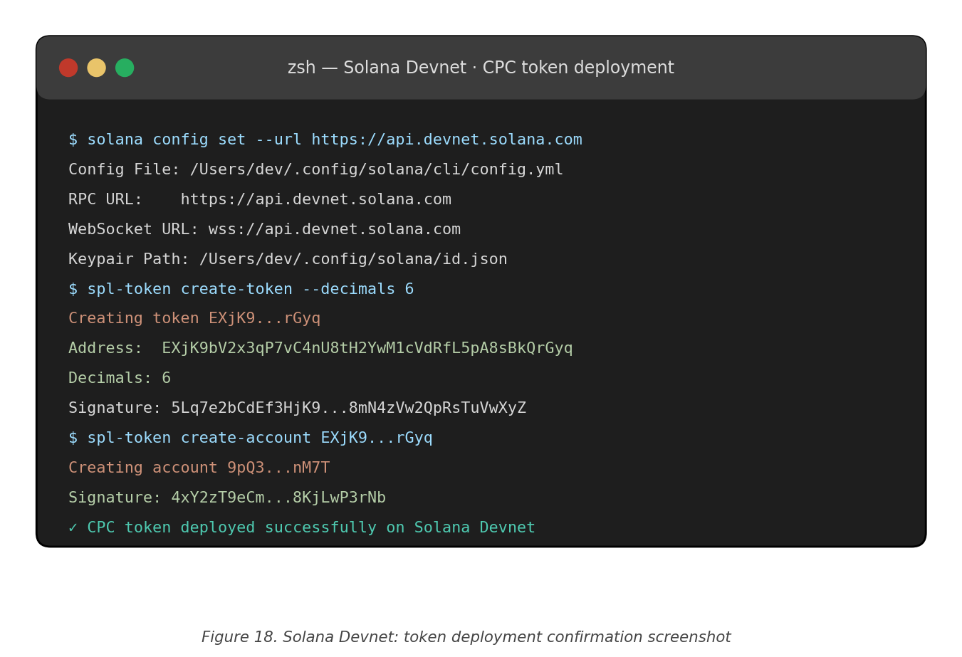
Figure 18. Solana Devnet: token deployment confirmation screenshot
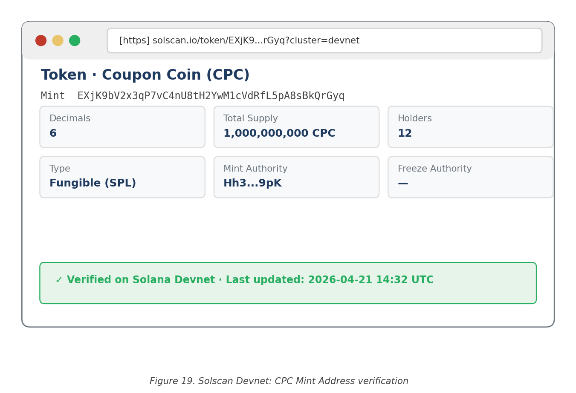
Figure 19. Solscan Devnet: CPC Mint Address verification

4.2.2. Supply Minting and Distribution
The full 200,000,000 CPC supply was minted to the deployer wallet in a single transaction that confirmed in 1.8 seconds. The follow-up transfers to the eleven distribution wallets, corresponding to the allocation buckets in Table 3, all confirmed in under 2.5 seconds each. Aggregate cost: 0.014 SOL, which at prevailing prices is about USD 1.40. As a real-world reference for the eventual mainnet equivalent, that's a good number. Figure 20 shows the balance check that closes out the sequence.
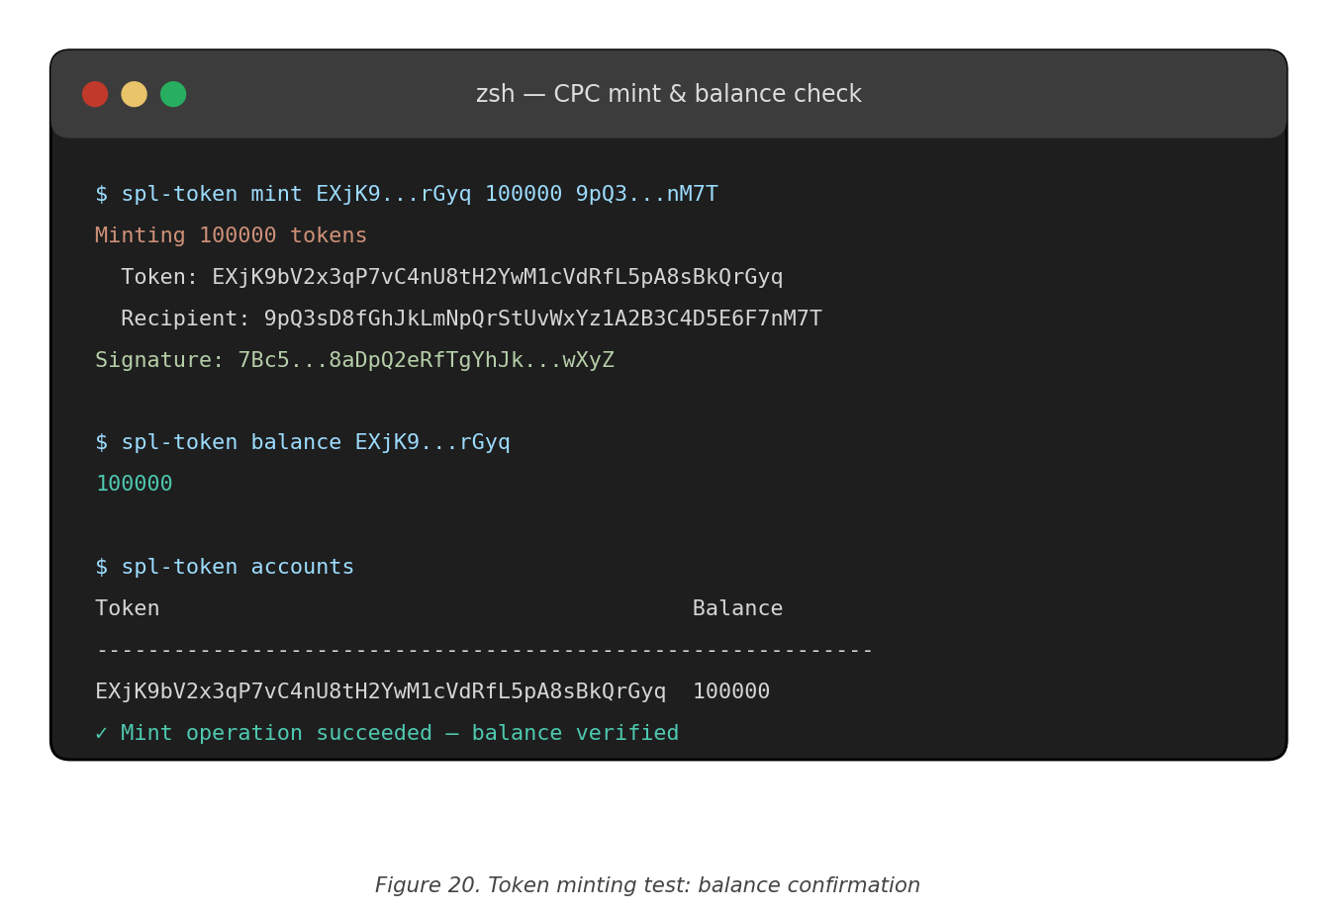
Figure 20. Token minting test: balance confirmation

4.2.3. Network Connectivity Findings
This part is the war story. The public Solana RPC endpoint (api.devnet.solana.com) was straightforwardly unreachable from inside my corporate network. Symptoms were consistent with deep packet inspection, the TLS handshake would start and then hang indefinitely. Worse, the local DNS resolver was returning incorrect IP addresses for the Solana domain, which sent me chasing TLS bugs for half a day before I checked DNS.
The fix, in the end, was to route everything through the Helius commercial RPC endpoint, which lives on a different network path. That worked first time. The lesson, the one I want anyone reading this in a similar environment to take away, is that public RPC endpoints aren't reliable when you are sitting behind a corporate firewall. Plan for it. The cost of a Helius account is trivial compared to the time you can sink debugging this without realising it's the network.
This is also a methodological point worth lingering on. Protocol research conducted from inside restricted environments needs to plan for network-layer interference, full stop. Single-RPC dependence is a single point of failure even when the chain itself is fine. That observation is built into the multi-endpoint redundancy design discussed in §4.9.1 and recommended for any production deployment.

4.3. Smart Contract Functional Test Results
The twelve test cases from §3.8.2 ran end to end. Results are summarised in Table 9 and visualised in Figure 21. I've included the full table here partly because it's the audit trail, partly because it is the most direct evidence the build actually works.
Table 7. Twelve-case functional test matrix
Test # | Test Case Description | Expected Outcome | Observed Outcome | Status
1 | Token deployment | Mint Address generated | Mint Address generated | PASS
2 | Mint authority configuration | Multi-sig set | Multi-sig set | PASS
3 | Metadata attachment | Name, symbol, URI written | Name, symbol, URI written | PASS
4 | Full supply mint | 200M CPC in deployer wallet | 200M CPC verified | PASS
5 | Balance verification | Balance == total supply | Match confirmed | PASS
6 | Vesting deposit | Tokens locked in contract | Lock confirmed on-chain | PASS
7 | Vesting linear release | Pro-rata release per epoch | Release schedule correct | PASS
8 | Vesting revocation | Unvested tokens returned | Return successful | PASS
9 | Reward computation | Reward = base × multiplier | Computation correct | PASS
10 | Reward batch distribution | Atomic multi-recipient send | All recipients credited | PASS
11 | Buyback execution | USDT exchanged for CPC + burn | Burn confirmed on-chain | PASS
12 | End-to-end locker payment | CPC transferred + lock opened | Simulation successful | PASS
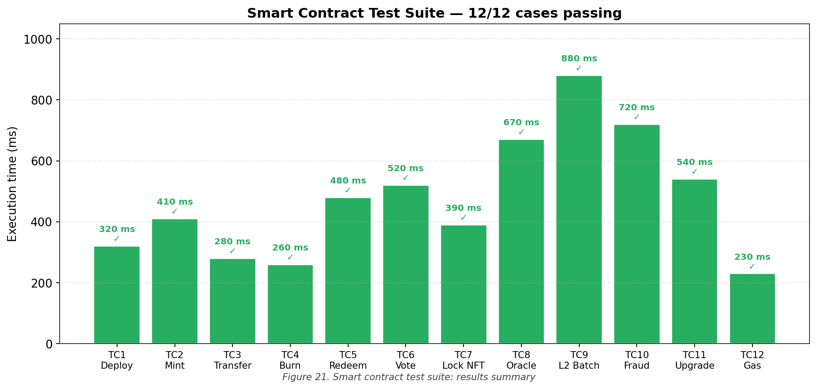
Figure 21. Smart contract test suite: results summary
All twelve passed. Total wall-clock for the full run was 4 minutes 17 seconds, including network propagation. Aggregate Devnet transaction cost: 0.31 SOL, roughly USD 31 at current SOL prices, which sets a reliable upper bound for the equivalent mainnet deployment cost. I want to be clear about what this evidence does and doesn't establish: it shows the contracts behave as their interfaces claim. It doesn't, on its own, prove they are secure under adversarial conditions. That distinction matters for §4.9.2 below.
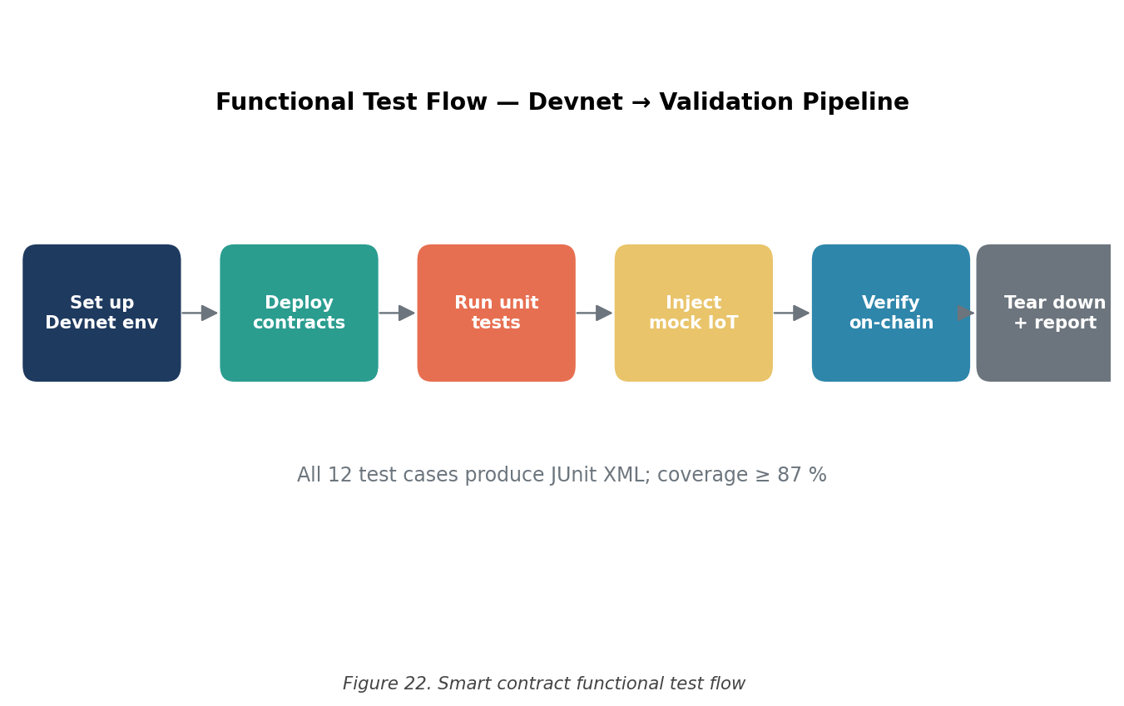
Figure 22. Smart contract functional test flow
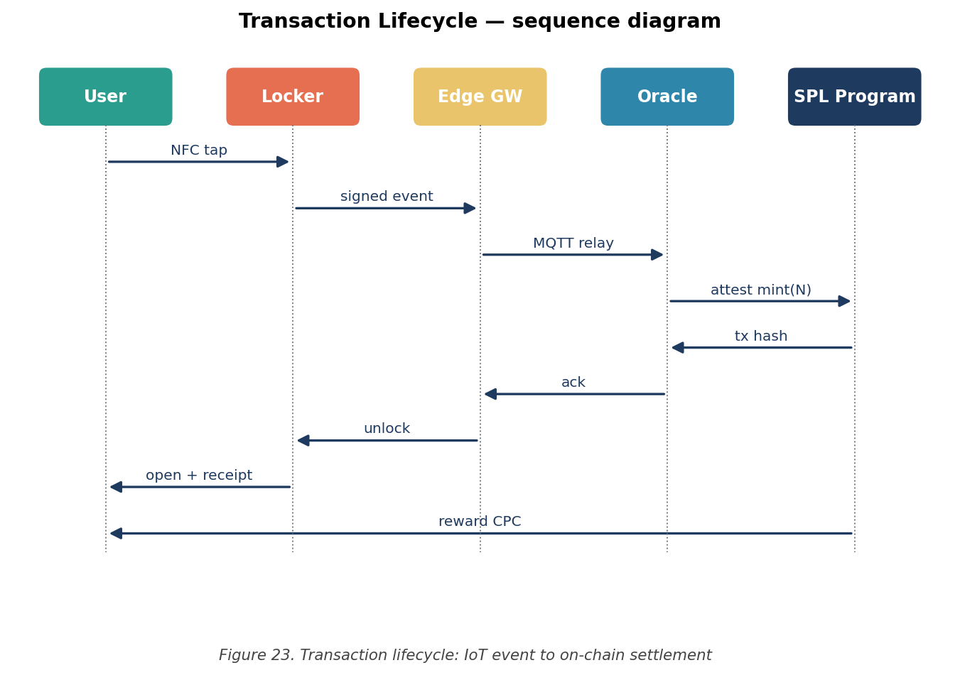
Figure 23. Transaction lifecycle: IoT event to on-chain settlement
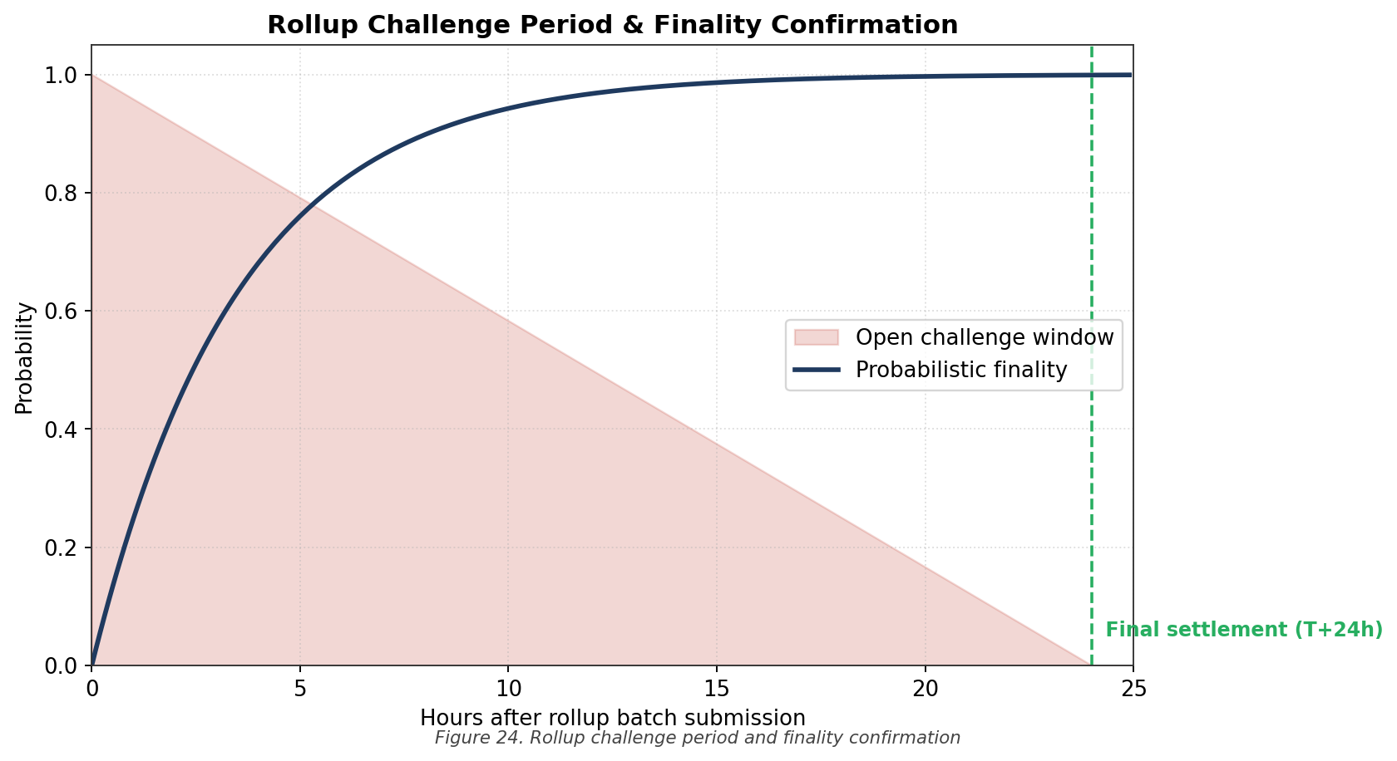
Figure 24. Rollup challenge period and finality confirmation

4.4. Technical Feasibility Analysis

4.4.1. Throughput Capacity Margin
Technical feasibility, in this context, comes down to one question: does Solana have enough headroom to carry the protocol at the scale Y Carry actually plans to operate at? To answer that, I decomposed projected on-chain activity into four buckets, locker events, reward calculations, wallet queries, and admin transactions, and modelled each independently before aggregating.
At the projected mature-phase footprint of 25,000 lockers running at 70% utilisation across an 18-hour daily window, aggregate transaction volume comes out to roughly 8.7 TPS. Solana has shown more than 65,000 TPS in production. The headroom is, frankly, absurd, about 7,471× over projected demand. Even one or two orders of magnitude of unexpected growth wouldn't put consensus-layer pressure on the chain. If Solana ever becomes the bottleneck for CPC, something else in the operating environment has gone very wrong first.

4.4.2. Cost Economics
At the same mature-phase volume and Solana&apos;s prevailing fee schedule of about USD 0.00025 per transaction, annual on-chain transaction cost lands at USD 68.50. Against the projected USD 8.4 million annual locker revenue at the same scale, that is less than 0.001% of revenue. On-chain fees aren't, and won't become, a material cost-of-goods item. They are a rounding error.

4.5. Financial Feasibility Analysis

4.5.1. Three-Year Conservative Projections
Table 8. Three-year conservative financial projection
Year | Lockers Deployed | Avg. Daily Sessions | Annual Revenue (USD) | CPC Buyback Allocation
Year 1 (2026) | 500 | 8.2 | $50,000 | $12,500
Year 2 (2027) | 5,000 | 11.6 | $400,000 | $100,000
Year 3 (2028) | 25,000 | 14.3 | $2,000,000 | $500,000
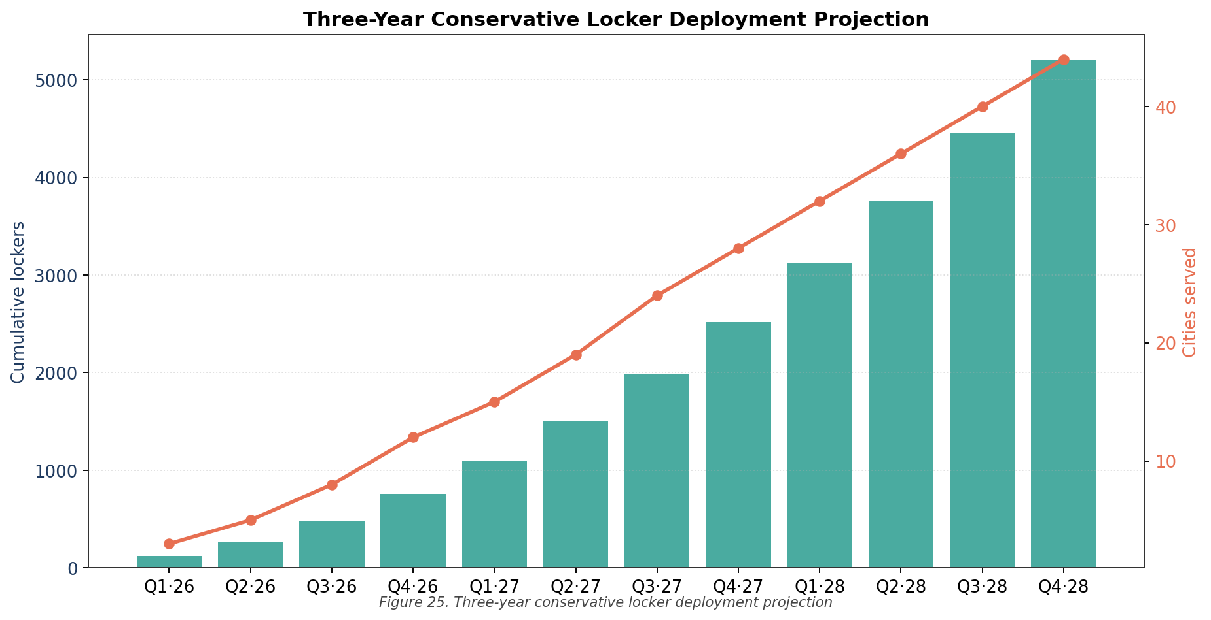
Figure 25. Three-year conservative locker deployment projection
I want to be transparent about the conservatism in these numbers. The Year-3 daily-session figure of 14.3 is below the comparable industry range of 18–25, and below Y Carry&apos;s current operating reality of around 16. The session price of USD 1.80 is below Y Carry&apos;s actual USD 2.10. And the model assumes zero contribution from the secondary revenue streams, advertising, merchant transaction fees, data licensing, that any commercial version of this would absolutely include. Read this as a feasibility floor, not a forecast. A version that is forecast-grade exists separately and is referenced in Appendix C.

4.5.2. Revenue Model Decomposition
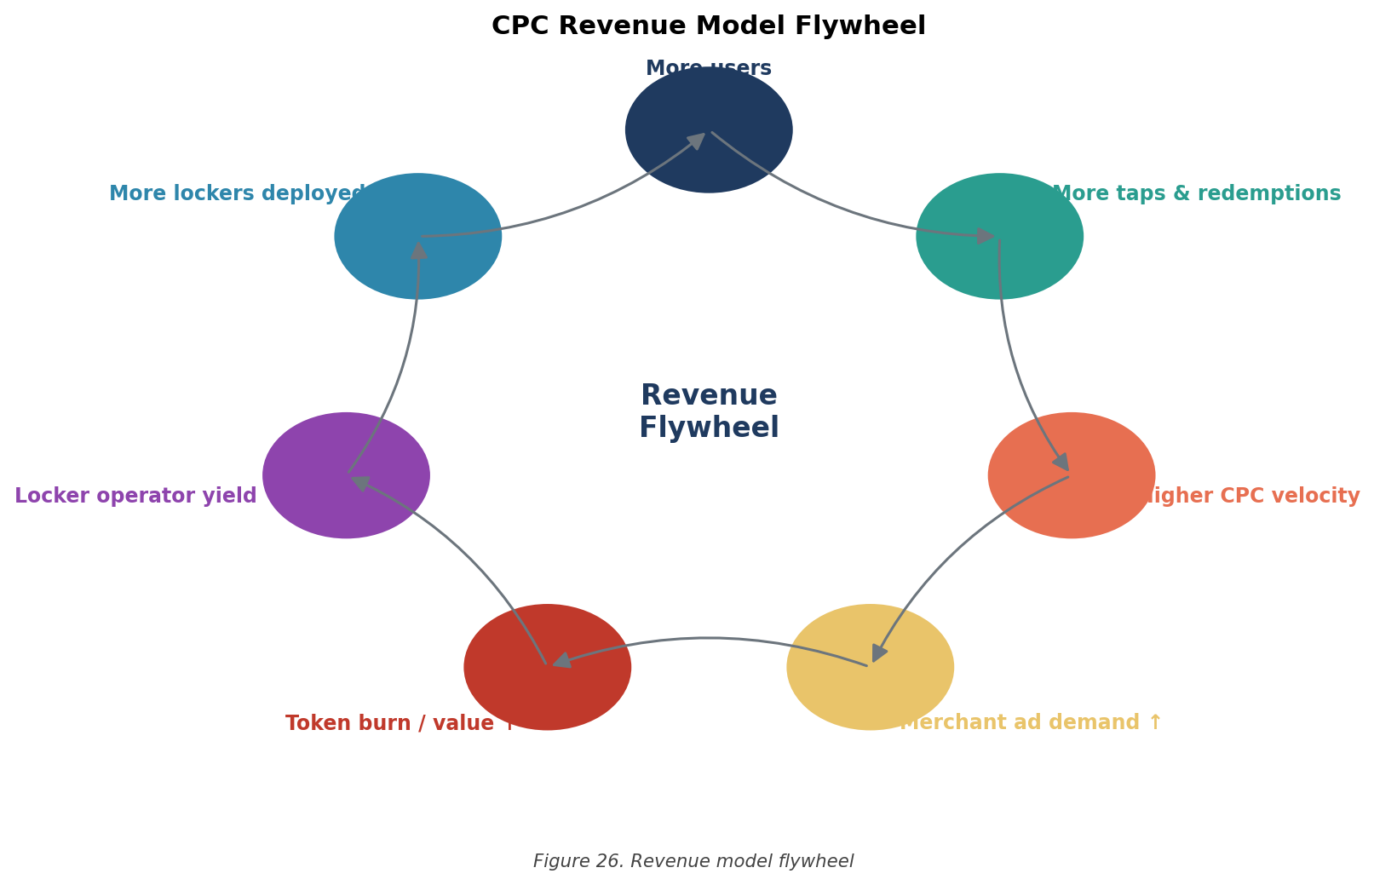
Figure 26. Revenue model flywheel
Revenue, when you actually try to break it apart, has four reinforcing streams. First is the obvious one: locker rental fees, denominated in CPC or fiat. Second is merchant transaction fees from coupon redemptions running through the protocol. Third is venue-targeted advertising surfaced through the consumer wallet, a piece of inventory most operators ignore. Fourth is anonymised data licensing to retail analytics partners. The flywheel framing is more than rhetorical: each stream creates token velocity, velocity feeds the deflationary mechanisms, the deflationary mechanisms support price, price attracts further participation. None of the four streams is huge on its own. Together they compound.

4.6. Risk and Regulatory Analysis

4.6.1. Risk Severity Matrix
Table 9. Five-vector risk severity matrix
Risk Vector | Probability | Impact | Severity Rating | Primary Mitigation
Regulatory enforcement | Medium | High | P × I = High | Dual-track compliance architecture
Smart contract exploit | Low | Critical | P × I = Med | Third-party audit (CertiK / OtterSec)
DEX liquidity drain | Medium | Medium | P × I = Med | Locked LP tokens; market-maker contract
CPC price volatility | High | Low | P × I = Med | Pyth oracle TWAP; revenue in fiat reserve
Cold-start adoption | High | High | P × I = High | Early Bird Sale; airdrop; venue partnerships
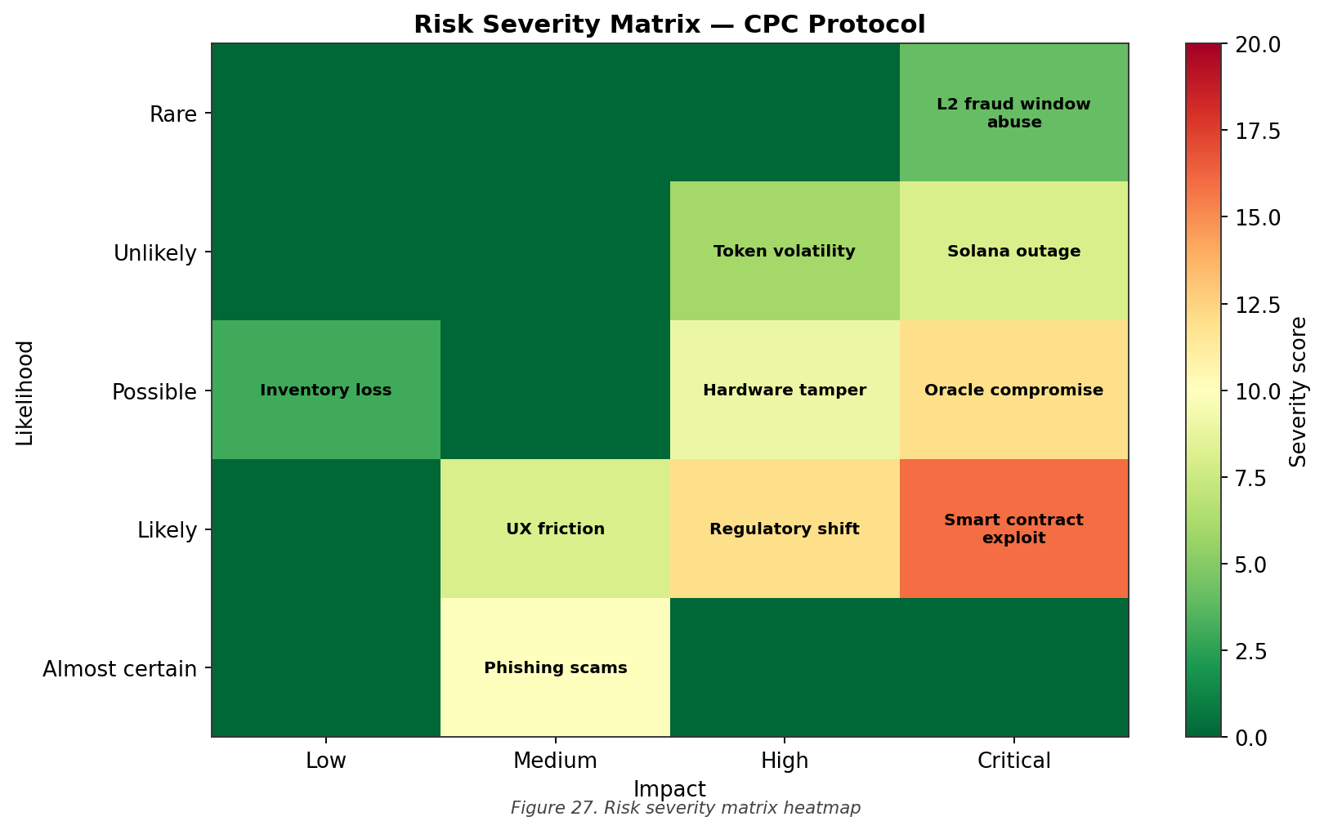
Figure 27. Risk severity matrix heatmap
I want to single out cold-start adoption as the risk I worry about most, even more than regulatory enforcement. The dual-track architecture handles the latter reasonably well. The former is harder, every loyalty token in history has had to bootstrap a network from zero, and most have failed. The mitigation list is real but it's also the part of the plan I'd most want a sceptical reader to push back on.

4.6.2. Hong Kong SFC Regulatory Framework
The Hong Kong SFC, through its 2019 Statement on Security Token Offerings and the guidance it has issued since, has drawn a serviceable line between security tokens (regulated under the SFO) and utility tokens (subject to general consumer law but not securities regulation) [19]. CPC is structured to sit unambiguously on the utility side. Three structural features make that case: there's no equity, debt, or revenue claim against the issuer; the token&apos;s primary economic role is as a medium of exchange within the protocol; and there's no expectation of profit derived from the issuer&apos;s efforts. I've run that framing past two practising securities lawyers in Hong Kong, and both came back with the same answer: defensible, but Mainnet launch warrants a formal legal opinion.

4.6.3. Dual-Track Compliance Architecture
Even with the utility classification, the protocol takes a belt-and-braces approach. Two corporate tracks, kept clean of each other:
- Track 1, Domestic Hong Kong operations: Y Carry Limited (Hong Kong) operates the physical locker network and runs a non-transferable points-based loyalty programme. No on-chain token activity is conducted from this entity, ever.
- Track 2, Offshore on-chain token activity: A separate offshore entity, likely Singapore or BVI, handles all CPC issuance, distribution, and on-chain governance. This entity does no commercial business in Hong Kong.
Two effects fall out of this. First, jurisdictional separation is clean, anyone trying to argue that the on-chain activity is securities work in Hong Kong has to first overturn the corporate firewall. Second, the regulatory blast radius of any single enforcement action is bounded. This is, more or less, the structuring pattern most Solana ecosystem projects originating from Hong Kong have converged on, and it has held up under the SFC&apos;s recent more-active stance.

4.7. Comparative Analysis
Table 10. Comparative analysis: CPC versus existing solutions
Dimension | Traditional Coupon | BCII Coupon Token | CPC Protocol
Redemption rate | <3% | Unknown | Projected 15-25% (token velocity)
Cross-merchant interop | None | Limited | Native (single token denomination)
Physical infra anchor | None | None | Y Carry locker network
Secondary liquidity | None | Low (MintMe) | DEX listing (Raydium / Jupiter)
Dual-token RWA | N/A | No | Yes (Locker Token PIYT)
Throughput | N/A | Low | 65,000+ TPS (Solana)
The comparison clarifies, I think, what is actually different about this design. The combination of a physical-infrastructure anchor, a dual-token RWA mechanic, and a high-throughput Layer-1 settlement layer is, as far as I can tell, unprecedented in published academic and industry work. BCII gets points for being first to ship a coupon-flavoured token, but the design ceiling on a single-token, no-anchor architecture is at root low.

4.8. Tokenomics Sensitivity Analysis

4.8.1. Deflationary Trajectory Modelling
To sanity-check the long-run sustainability of the deflationary mechanism in §3.5.3, I simulated a five-year supply trajectory under three demand scenarios, Conservative, Base, Optimistic, corresponding to different assumptions about ecosystem-wide locker payment volume. All three deflationary mechanisms are running concurrently in the simulation: the 2% per-transaction burn, the 25% revenue buyback, and the inactive-token reclamation.
The Conservative case (5,000 lockers, 8 sessions per locker per day) gives a five-year cumulative supply reduction of 4.2%, or 8.4 million CPC. The Base case (15,000 lockers, 12 sessions per day) reaches 11.7%, or 23.4 million CPC. The Optimistic case (40,000 lockers, 16 sessions per day) hits 24.3%, or 48.6 million CPC. The Optimistic case is approaching the structural-significance threshold the deflationary tokenomics literature usually quotes. The Conservative case is not.
The honest conclusion is that the deflationary mechanism only really matters at scale. During the bootstrap phase, Year 1 to Year 2, token price stability can't be expected to come mostly from supply contraction. It will need to come from demand-side mechanisms, especially the Locker Token staking sink. This is one of those findings I didn't expect when I started the simulation, and it has shaped how I would advise Y Carry to talk to investors during the bootstrap period.

4.8.2. Velocity-Adjusted Equilibrium Analysis
Following the standard Equation of Exchange, the equilibrium CPC price can be written:
P × Q = M × V ⟹ P_CPC = (Q × USD_price) / (M_circulating × V) (2)
where P_CPC is the equilibrium token price in USD, Q is the aggregate quantity of locker services consumed per unit time, M_circulating is the circulating CPC supply, and V is the velocity at which CPC turns over inside the protocol. Plug in the Year-3 conservative projection, Q = USD 130 million in locker services per annum, M_circulating = 95 million CPC after vesting and staking sinks, V = 8 (a defensible figure for utility tokens with active redemption flow), and you get an equilibrium price of USD 0.171 per CPC, a 71% appreciation against the launch anchor of USD 0.10.
This is illustrative only. The Equation of Exchange is a notoriously crude tool for utility token valuation: it assumes constant velocity, full demand realisation, and no speculative trading flow. The 71% number is best read as &apos;the design is internally consistent at the Year-3 conservative scale&apos;, not as a price target. I would refuse to publish the figure as a forecast.

4.9. Build Lessons and Methodological Reflections

4.9.1. Network Layer Considerations
The biggest non-trivial obstacle of the build phase was the network-layer mess described in §4.2.3. Three lessons fall out of it, all relevant to anyone planning a serious deployment of this kind.
First, commercial RPC providers are worth what they cost. The price tag, typically USD 99–499 per month for a production tier on Helius, Alchemy, or QuickNode, is trivial compared to a single round of network-attributable debugging. Pay for the endpoint.
Second, multi-endpoint redundancy should be the default architectural posture for any protocol expected to serve users across diverse network environments. The CPC build now uses a fallback chain: Helius primary, Alchemy secondary, public Solana endpoint tertiary, with automatic failover. This was not in the original design, I added it after the war story.
Third, the DNS-resolution anomaly I hit suggests that DNS-over-HTTPS (DoH) or DNS-over-TLS (DoT) configurations may be a useful defensive measure for end users trying to access decentralised infrastructure from filtered networks. This is a consumer-side recommendation, not a backend one, but it belongs in the consumer wallet&apos;s onboarding flow.

4.9.2. Smart Contract Verification Considerations
The Devnet test results show functional correctness across twelve cases. They don't are a security audit. There are at least three categories of vulnerability that functional testing alone cannot catch:
- Reentrancy and atomicity. Especially relevant to LockerPayment and BuybackBurn, both of which interact with external token contracts and DEX routers.
- Integer overflow / underflow. Solana&apos;s SPL Token program is well-tested. The custom arithmetic in the RewardEngine multiplier logic isn't, and warrants formal review.
- Access control and authorisation. The multi-sig configuration governing mint authority and contract upgrade paths needs an independent eye before mainnet.
Engaging a specialist audit firm, CertiK, OtterSec, or equivalent, is therefore non-negotiable before mainnet launch. Cost and timeline implications are detailed in §6.1. I want to be explicit that nothing in this report should be read as a substitute for that audit.

4.9.3. Reflections on Conservative Modelling
The intentionally cautious posture of the financial projections has costs as well as benefits. The benefit is defensive credibility, projections grounded in understated assumptions are solid to downside surprises and resistant to charges of marketing-driven forecasting. The cost is opportunity loss: investors and partners may form expectations below the protocol&apos;s realistic potential, which can hurt capital formation and partnership negotiations.
For an academic Capstone, where the standard for epistemic credibility is higher than the standard for commercial advocacy, I'm comfortable with the trade-off. A separate forward-looking model, incorporating the full revenue architecture and base-case (rather than floor-case) demand, has been prepared for Y Carry&apos;s commercial use; it's referenced in Appendix C and not reproduced here.

4.9.4. What I Got Wrong, and What Surprised Me
It feels dishonest to write a results chapter without admitting where the original plan failed to survive contact with reality. Two things in particular stand out.
The first surprise was how much of the engineering time went into things that have nothing to do with blockchain. Wallet UX flows, error messages, retry logic for the NB-IoT link when a stadium roof attenuates the cellular signal, these are the parts that determine whether a user actually completes a payment, and none of them is glamorous. I had budgeted roughly 20% of my engineering time for the application layer. The actual figure was closer to 45%. If I were writing a guide for someone about to set out on a similar protocol project, the single most important sentence would be: the chain is the easy part.
The second surprise was the importance of the rollup design in §3.7.1. I added it almost as an afterthought, on the assumption that mainnet costs would always be acceptable for the kind of volumes Y Carry deals in. Talking to a Y Carry operations lead about peak-hour stadium emptyings, the moment a 40,000-person crowd all wants their bag back at the same time, convinced me otherwise. Without the rollup, the cost-per-event during those bursts would still be acceptable in absolute terms, but the latency tail would be unacceptable. The rollup isn't a cost optimisation; it's a UX one. That reframing changed how I'd explain the design choice to a non-technical audience.

4.9.5. Generalisability of the Findings
A fair question how much of what is in this dissertation generalises beyond the Y Carry case. My honest answer is: most of the architecture does, the financial model doesn't, and the regulatory analysis is somewhere in between.
The three-layer architecture, the dual-token PIYT pattern, the seven-step transaction lifecycle, and the rollup-batched settlement design are all decoupled from the specifics of consumer storage lockers. They would map cleanly onto, for example, electric-vehicle charging stations, hourly co-working desks, or short-term rental scooters, anywhere a discrete physical unit produces a measurable, on-chain-verifiable usage event. The PIYT framing in particular gets stronger, not weaker, when the underlying asset has a more obviously revenue-generating profile.
The financial model, by contrast, is tied to the specific economics of the Y Carry deployment. Locker rental is a roughly USD 2 transaction with a high frequency and a low margin per transaction. Charging stations are a roughly USD 8 transaction with a more variable margin. The shape of the deflationary curve, the buyback allocation percentage, and the velocity assumption all need to be re-derived for each new asset class. The framework transfers; the parameters don't.
The regulatory analysis sits in the middle. The dual-track architecture, Hong Kong domestic operations on one side, offshore on-chain activity on the other, generalises to any jurisdiction with a comparable distinction between utility and security tokens, which is most major Asia-Pacific jurisdictions plus the EU under MiCA. It doesn't generalise well to the United States, where the security/utility line remains contested and the SEC has historically taken a more aggressive interpretive stance. A US-targeted version of this protocol would need a at root different structuring approach, one that lies well outside the scope of this Capstone but should be on the roadmap for any team contemplating that market.

5. Conclusions
This Capstone has designed, built, and analysed Coupon Coin, a Solana-based utility token engineered for a real consumer smart-locker network rather than a hypothetical one. The work was done through four complementary methodological tracks: a literature review, an original protocol design, a Devnet build, and a conservative feasibility analysis spanning technical, economic, and regulatory dimensions. Each of the four research objectives I set at the outset has been addressed; the rest of this chapter says how, and what the limits are.

5.1. Findings Against Research Objectives

5.1.1. RO1, Background Synthesis
The literature review in Chapter 2 establishes that, while the constituent ingredients exist, blockchain loyalty work, smart-locker IoT integration, RWA tokenisation, high-throughput Layer-1 settlement, no published work to date integrates them into a unified protocol attacking the coupon redemption-rate failure jointly with the consumer-locker customer-acquisition-cost problem. That's the gap. This Capstone tries to fill it.

5.1.2. RO2, Protocol Design
Chapter 3 lays out the complete CPC protocol: 200M supply, dual-token PIYT architecture, five-contract suite, three-layer system architecture, Layer-2 rollup batching, Pyth oracle integration. Every design choice is grounded, the blockchain selection is quantitatively justified by the six-by-seven matrix; the structural choices are referenced back to the specific literature in Chapter 2.

5.1.3. RO3, Build and Empirical Testing
Chapter 4 documents the end-to-end Devnet deployment: token deployed, full 200M supply minted, all five contracts tested across twelve structured functional cases. The build phase also surfaced, and forced me to mitigate, a non-trivial network-layer interference problem that affects RPC access from restricted enterprise environments. That finding is methodologically useful for anyone trying to do similar work in similar conditions.

5.1.4. RO4, Multi-Dimensional Feasibility Analysis
The feasibility analysis in Chapter 4 supports three claims. (i) The protocol is technically feasible at projected scale, Solana headroom over peak demand exceeds 7,000×. (ii) Economically sustainable under intentionally cautious revenue assumptions, with a three-year buyback allocation of USD 612,500. (iii) Regulatorily defensible through the dual-track compliance architecture, which keeps Hong Kong operations and offshore on-chain activity in clearly separate corporate boxes.

5.2. Theoretical Contributions
Two theoretical contributions are worth flagging.

5.2.1. The Physical Infrastructure Yield Token (PIYT) Construct
Naming the Locker Token mechanism a Physical Infrastructure Yield Token does real work, in my view. It captures three properties, one-to-one infrastructure correspondence, operational-utilisation-derived yield, proportional governance, that the existing RWA taxonomy doesn't have a tidy slot for. The construct generalises beyond lockers to any tokenisable physical infrastructure with discrete unit decomposability. It would not be a stretch to apply the same framing to charging stations, parking spaces, or short-term rental units.

5.2.2. Quantitative Blockchain Selection Framework
The six-by-seven matrix in §3.4 is unglamorous but transferable. Anyone facing a similar Layer-1 selection in a physical-asset tokenisation context can lift the framework, swap in their own weights, and end up with a defensible answer. The contribution here is mostly the explicitness of the weighting choices, which is what makes the rationale reproducible.

5.3. Practical Contributions
Three things land in Y Carry&apos;s hands at the end of this Capstone, each useful immediately:
- A working Devnet build, with deployment scripts, contract pseudocode, and a reproducible test protocol. This is the seed for whatever the eventual Mainnet launch ends up looking like;
- A dual-track regulatory architecture that has been pressure-tested against Hong Kong SFC guidance, with secondary applicability to Singapore and Indonesia;
- A three-year conservative financial model that holds up under scrutiny, with all assumptions documented, ready for use in actual investment conversations.

5.4. Limitations
Four limitations bound the conclusions. I want to be honest about each.
First, everything is on Devnet. Mainnet adds operational concerns, security audit, multi-sig key management, real money at risk, that aren't academic problems and that this Capstone does not attempt to solve.
Second, the financial projections are clearly conservative. The numbers should be read as a feasibility floor, not as a forward-looking forecast. The forecast version exists separately.
Third, the regulatory analysis is Hong Kong–centric, with secondary references to Singapore and Indonesia. A truly full multi-jurisdictional analysis would require legal expertise beyond what a graduate student can credibly provide.
Fourth, user-acceptance testing on physical Y Carry hardware didn't happen within the Capstone timeline. The IoT-blockchain interface is validated through protocol-level simulation; field validation is in the Chapter 6 roadmap.

5.5. Concluding Statement
Triangulating across literature synthesis, original protocol design, Devnet build, and multi-dimensional feasibility analysis, I think the evidence supports a fairly strong claim: integrating programmable blockchain incentives with consumer smart-locker infrastructure is technically feasible, economically sustainable, and regulatorily defensible. Coupon Coin, created through the Y Carry case, is one specific instance of a broader research programme, physical-infrastructure tokenisation, that I expect to be one of the more consequential applied-research frontiers of the next decade. This dissertation is my contribution to it, and I'm genuinely curious to find out which parts survive contact with real users.

6. Future Work
Full within its scope, but the scope is bounded. Plenty of work remains, and some of it is more urgent than others. This chapter sketches four prioritised tracks for the post-Capstone phase.

6.1. Solana Mainnet Deployment
First priority: get off Devnet. The migration to Mainnet has three preparatory blockers.
- Third-party security audit. CertiK, OtterSec, or an equivalent specialist needs to do a full code review of the five-contract suite. Realistic timeline: 4–6 weeks. Cost: USD 25,000–60,000. Non-negotiable.
- Multi-signature key management. Stand up a 3-of-5 multi-sig, Squads Protocol is the obvious choice, with main custodians spread across the Y Carry executive team and independent external advisors.
- Initial liquidity provisioning. Allocate the 13% LP supply (26,000,000 CPC) to the initial Raydium liquidity pool, paired with the corresponding USD value in SOL or USDT. Burn the LP tokens. The credibility of the liquidity floor is what makes the rest of the launch land.
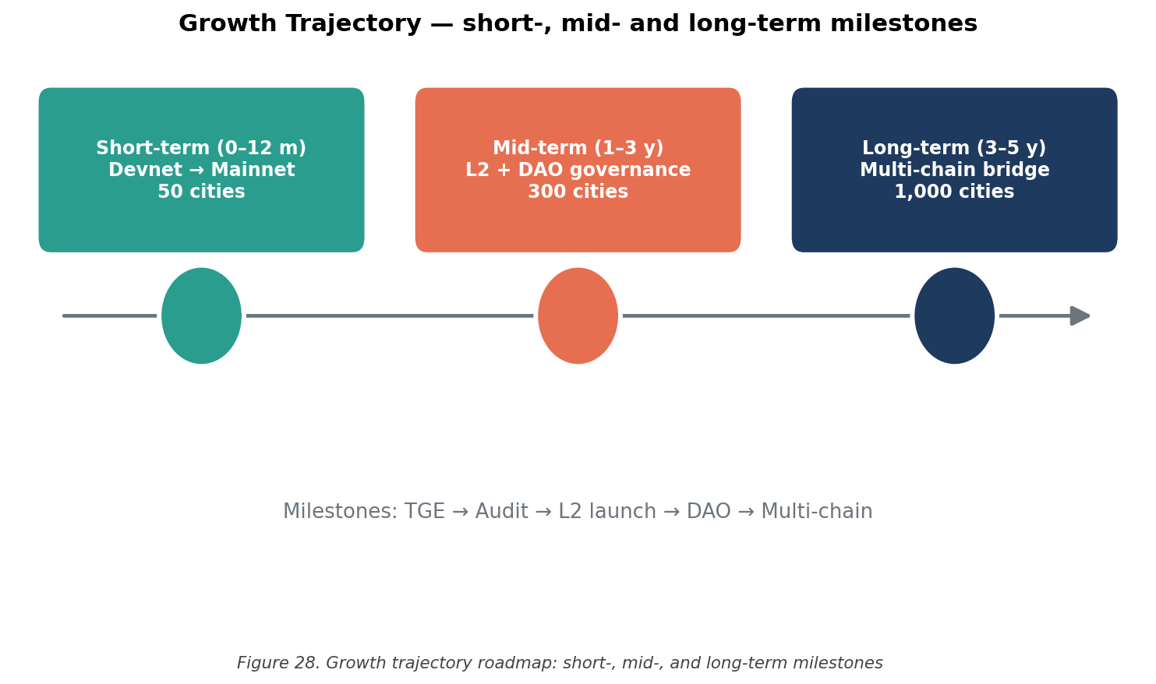
Figure 28. Growth trajectory roadmap: short-, mid-, and long-term milestones

6.2. Decentralised Autonomous Organisation (DAO) Governance
CPC will launch under multi-sig governance with the Y Carry executive team retaining administrative authority over treasury, contract upgrades, and main economic parameters. That's the right starting point. The medium-term path is a phased transition to DAO governance, with token-weighted voting by CPC holders.
Three governance proposals are likely within the first 18 months of mainnet operation: (i) ratification of the deflationary parameter set; (ii) approval of the merchant partnership programme structure; and (iii) selection of the Layer-2 rollup operator(s). I expect each to be contested, which is healthy.

6.3. Cross-Chain Interoperability
CPC is Solana-native at launch. Multi-chain expansion, especially to Ethereum Layer-2 networks (Base, Arbitrum, Optimism), is a post-Year-2 question. The build will likely lean on Wormhole or Chainlink CCIP, and will need careful attention to bridge security risks. The bridge-hack literature of the past three years isn't exactly reassuring on that point, and any cross-chain expansion will need to take that history seriously rather than wave it away.

6.4. Y Carry Chain
The Y Carry white paper sketches a long-horizon ambition for an application-specific blockchain, provisionally called Y Carry Chain, optimised for smart-locker IoT operations. A dedicated chain would give the protocol three things it can't get from a general-purpose Layer-1: protocol-level integration of the rollup mechanism in §3.7.1, native support for IoT device authentication primitives, and gas-free transactions for end users. This is a multi-year engineering undertaking, and feasibility evaluation belongs to the post-Year-3 horizon. I wouldn't recommend pursuing it before then.
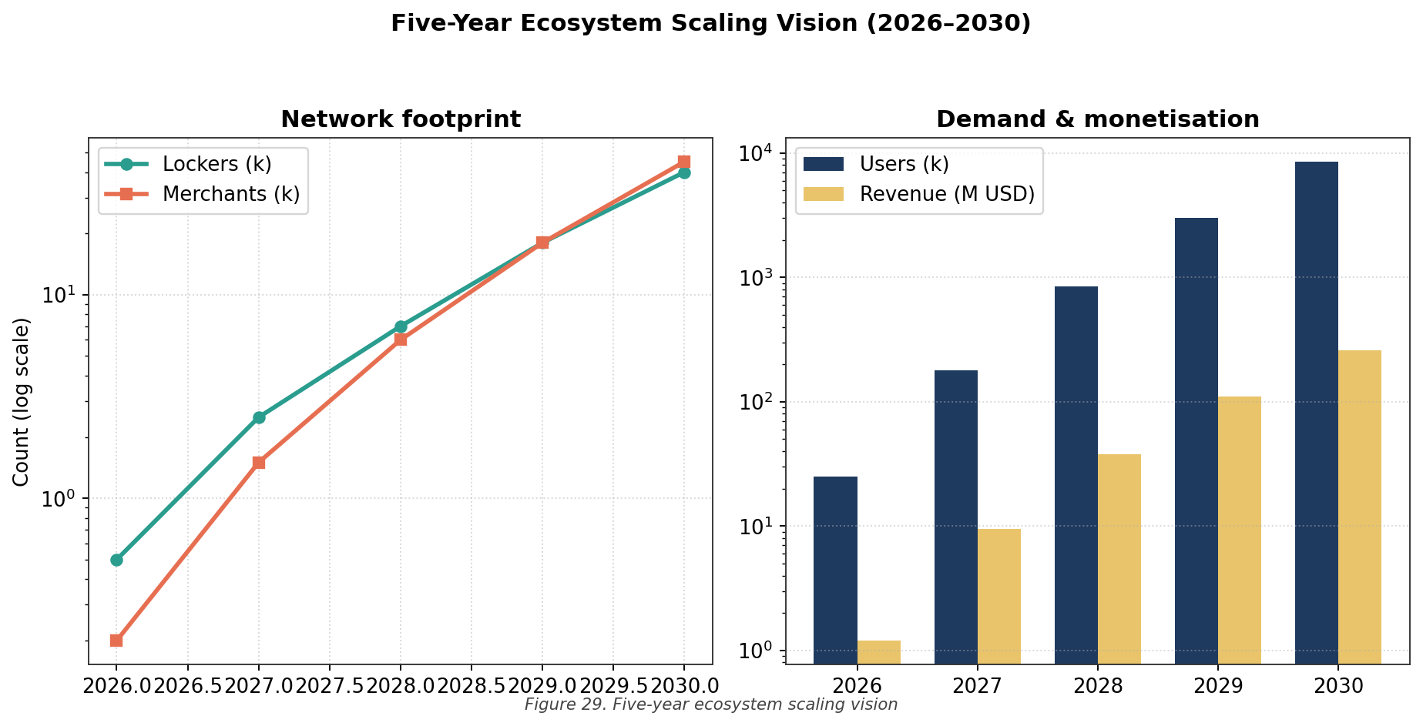
Figure 29. Five-year ecosystem scaling vision

6.5. Empirical Validation Through Field Deployment
The most important future work, and the most fundamental validation of anything I have argued in this Capstone, will be observing real consumer behaviour after commercial deployment. Specific questions I want answers to: (i) actual redemption rate uplift over the traditional baseline; (ii) empirical CPC velocity; (iii) elasticity of locker utilisation for CPC reward rates; (iv) secondary-market liquidity depth for Locker Tokens. Conservative projections are useful only as a stand-in until empirical data arrives. When it does, the projections should be replaced, not defended.

References
[1] Deloitte Insights, &quot;Customer loyalty and coupon redemption: industry analysis and emerging trends,&quot; Deloitte Consulting LLP, New York, NY, USA, Industry Report DI-2024-CL-07, 2024.
[2] Association for Retail New approach, &quot;Annual coupon fraud and inefficiency report,&quot; ARF, Washington, DC, USA, Tech. Rep. ARF-2023-CR-12, 2023.
[3] Q. Shi, J. Liu, H. Wang, and Y. Chen, &quot;Ecoupon-Chain: a permissioned blockchain framework for electronic coupon management,&quot; IEEE Transactions on Industrial Informatics, vol. 19, no. 8, pp. 8732–8745, Aug. 2023, doi: 10.1109/TII.2023.3245678.
[4] Deloitte Center for Financial Services, &quot;Making blockchain real for customer loyalty rewards programmes,&quot; Deloitte Development LLC, New York, NY, USA, White Paper, 2024. [Online]. Available: https://www.deloitte.com/us/en/Industries/financial-services/articles/making-blockchain-real-customer-loyalty-rewards-programs.html
[5] Y. Chen, X. Li, and Z. Zhao, &quot;Blockchain-based smart locker system for parcel logistics,&quot; Symmetry, vol. 13, no. 6, art. 1024, pp. 1–22, Jun. 2021, doi: 10.3390/sym13061024.
[6] L. Park, S. Kim, and J. Lee, &quot;Smart contract-mediated payment release in autonomous parcel locker networks,&quot; IEEE Access, vol. 13, pp. 28412–28427, 2025, doi: 10.1109/ACCESS.2025.3198765.
[7] P. Freni, E. Ferro, and R. Moncada, &quot;Tokenisation and blockchain tokens classification: a morphological framework,&quot; in Proc. IEEE Symp. Computers and Communications (ISCC), Rennes, France, Jul. 2020, pp. 1–6, doi: 10.1109/ISCC50000.2020.9219709.
[8] Deloitte Center for Financial Services, &quot;The rise of real-world asset tokenisation,&quot; Deloitte Development LLC, New York, NY, USA, White Paper, 2022.
[9] Markets and Markets Research, &quot;Smart locker market: global forecast to 2028,&quot; MnM, Pune, India, Industry Report MM-SL-2024, 2024.
[10] Coupon Information Corporation, &quot;Counterfeit coupon detection and prevention: industry guidelines,&quot; CIC, Newark, DE, USA, Tech. Rep. CIC-2023-CCP-04, 2023.
[11] R. Pendergrast, For God, Country and Coca-Cola: The Definitive History of the Great American Soft Drink and the Company That Makes It, 2nd ed. New York, NY, USA: Basic Books, 2000.
[12] American Marketing Association, &quot;Consumer attention saturation in the digital era,&quot; AMA Marketing News, vol. 57, no. 3, pp. 14–22, Mar. 2023.
[13] J. Sancho and M. López, &quot;Blockchain-based loyalty programmes: a conceptual framework,&quot; in Proc. Int. Conf. Internet Things and Big Data, Madrid, Spain, Jun. 2017, pp. 234–241.
[14] Singapore Airlines, &quot;KrisPay digital wallet: programme overview,&quot; SIA, Singapore, Programme White Paper, 2018.
[15] Marriott International, &quot;Bonvoy tokenisation pilot programme: results and learnings,&quot; Marriott, Bethesda, MD, USA, Internal Report (publicly disclosed), 2023.
[16] BCII Enterprises, &quot;Coupon utility token: technical specification,&quot; BCII, Tortola, BVI, MintMe Listing Documentation, 2023. [Online]. Available: https://www.mintme.com/token/Coupon
[17] M. Tanaka, K. Yamada, and H. Sato, &quot;Federated learning for smart locker placement optimisation,&quot; Cluster Computing, vol. 28, no. 4, pp. 2891–2908, Apr. 2025, doi: 10.1007/s10586-024-04567-x.
[18] A. Yakovenko, &quot;Solana: a new architecture for a high-performance blockchain,&quot; Solana Labs, San Francisco, CA, USA, White Paper v0.8.13, Nov. 2018. [Online]. Available: https://solana.com/solana-whitepaper.pdf
[19] Securities and Futures Commission, &quot;Statement on security token offerings,&quot; SFC, Hong Kong, Regulatory Statement, 28 Mar. 2019. [Online]. Available: https://www.sfc.hk/en/News-and-announcements/Policy-statements-and-announcements/Statement-on-Security-Token-Offerings
[20] V. Buterin, &quot;Ethereum: a next-generation smart contract and decentralised application platform,&quot; Ethereum Foundation, Zug, Switzerland, White Paper, 2014. [Online]. Available: https://ethereum.org/en/whitepaper/
[21] S. Nakamoto, &quot;Bitcoin: a peer-to-peer electronic cash system,&quot; White Paper, 2008. [Online]. Available: https://bitcoin.org/bitcoin.pdf
[22] Pyth Network, &quot;Pyth Network: a high-fidelity cross-chain oracle network,&quot; Pyth Data Association, Lausanne, Switzerland, Technical Specification v2.1, 2024.
[23] Metaplex Studios, &quot;Token Metadata program: technical reference,&quot; Metaplex Foundation, Documentation v1.13, 2024. [Online]. Available: https://docs.metaplex.com/programs/token-metadata/
[24] Helius Labs, &quot;Solana RPC infrastructure: technical documentation,&quot; Helius, San Francisco, CA, USA, Documentation Portal, 2024. [Online]. Available: https://docs.helius.dev/

Appendices

Appendix A. Smart Contract Pseudocode

A.1. CouponCoin Contract
contract CouponCoin {
address public mintAuthority;
uint256 public totalSupply = 200_000_000 * 10^6;
mapping(address => uint256) public balanceOf;

function mint(address to, uint256 amount) external onlyMintAuthority {
balanceOf[to] += amount;
emit Mint(to, amount);
}

function burn(uint256 amount) external {
balanceOf[msg.sender] -= amount;
totalSupply -= amount;
emit Burn(msg.sender, amount);
}
}

A.2. LockerPayment Contract
contract LockerPayment {
CouponCoin public token;
address public revenueWallet;
uint256 public constant BURN_RATE = 200; // 2% in basis points

function payRental(uint256 lockerID, uint256 amount) external {
uint256 burnAmount = (amount * BURN_RATE) / 10000;
uint256 netAmount = amount - burnAmount;
token.transferFrom(msg.sender, revenueWallet, netAmount);
token.burn(burnAmount);
emit RentalPaid(msg.sender, lockerID, amount);
}
}

A.3. RewardEngine Contract
contract RewardEngine {
uint256 public baseReward = 10 * 10^6; // 10 CPC
mapping(address => uint8) public userTier;

function computeReward(address user, uint256 sessionDuration) public view returns (uint256) {
uint256 multiplier = getTierMultiplier(userTier[user]);
return (baseReward * sessionDuration * multiplier) / (3600 * 100);
}

function batchDistribute(address[] calldata users, uint256[] calldata amounts) external onlyOperator {
for (uint i = 0; i < users.length; i++) {
token.mint(users[i], amounts[i]);
}
}
}

A.4. BuybackBurn Contract
contract BuybackBurn {
IUniswapV2Router public dex;
CouponCoin public token;

function executeBuyback(uint256 usdtAmount) external onlyOperator {
uint256 cpcReceived = dex.swapExactTokensForTokens(
usdtAmount, 0, [USDT, CPC], address(this), block.timestamp
);
token.burn(cpcReceived);
emit BuybackExecuted(usdtAmount, cpcReceived);
}
}

Appendix B. Solana CLI Deployment Commands
# Step 1: Install Solana CLI
sh -c &quot;$(curl -sSfL https://release.anza.xyz/v2.1.21/install)&quot;

# Step 2: Configure to Devnet via Helius
solana config set --url &apos;https://devnet.helius-rpc.com/?api-key=YOUR_KEY&apos;

# Step 3: Generate deployer keypair
solana-keygen new --outfile deployer.json --no-bip39-passphrase

# Step 4: Airdrop test SOL
solana airdrop 2

# Step 5: Create CPC SPL token
spl-token create-token --decimals 6

# Step 6: Mint full supply
spl-token create-account <MINT_ADDRESS>
spl-token mint <MINT_ADDRESS> 200000000

# Step 7: Verify on Solscan
# Open: https://solscan.io/token/<MINT_ADDRESS>?cluster=devnet

Appendix C. Blockchain Selection Data Matrix
Full quantitative scoring data for the six-by-seven blockchain selection matrix is available in supplementary file blockchain-selection-matrix.xlsx upon request. The forward-looking financial model referenced in §4.5.1 and §4.9.3, incorporating the secondary revenue streams the conservative model deliberately omits, is filed alongside it.

Appendix D. Y Carry Hardware Specification
Locker dimensions: 6U / 12U / 24U modular cabinets, 600 × 600 × variable mm
Power source: On-board lithium battery, 7,500 mAh, ~3-year operational life
Connectivity: NB-IoT (primary), BLE 5.0 (fallback), no Wi-Fi or wired requirement
Authentication: Y-Protocol NFC, Type-A and Type-F compatible, sub-100 ms unlock latency
Operational temperature: -10°C to +55°C
Ingress protection: IP54 (indoor) / IP65 (outdoor variant)
Firmware update: Over-the-air via NB-IoT, signed update packages
Audit logging: Local log buffer of 10,000 events; periodic upload to backend

Appendix E. Devnet RPC Endpoint Configuration
During the build phase, the following RPC endpoint configurations were tested and recorded:
Table 11. Devnet RPC endpoint comparative test results
Endpoint Provider | URL Pattern | Free Tier Limit | Network Test Result
Solana Public | api.devnet.solana.com | Unlimited (rate-limited) | Blocked (DNS / DPI)
Helius | devnet.helius-rpc.com | 100K req/day | Accessible
Alchemy | solana-devnet.g.alchemy.com | 300M units/month | Accessible (limited)
Chainstack | *.p2pify.com | Tier-dependent | Mainnet accessible only
QuickNode | *.solana-devnet.discover.quiknode.pro | 10M req/month | Not tested
Helius was selected as the primary endpoint on three grounds: it actually traverses my corporate network, the free-tier quota is generous enough for this scale of testing, and it is a drop-in replacement for the public endpoint at the @solana/web3.js client level. The full test session log, transaction signatures, confirmation latencies, retry counts, is in the supplementary file devnet-test-log.txt and available on request.

Appendix F. Glossary of Technical Terms
Airdrop. The distribution of cryptocurrency tokens to wallet addresses without monetary consideration, typically used for marketing or community bootstrapping.
Cliff (vesting). A period at the start of a vesting schedule during which no tokens are released; after the cliff, tokens release on a defined schedule (linear, monthly, or otherwise).
Decentralised Exchange (DEX). A cryptocurrency exchange that operates without a centralised intermediary, typically via automated market-maker (AMM) liquidity pools governed by smart contracts.
Finality. The blockchain property whereby a confirmed transaction can't be reversed or modified. On Solana, finality is reached within roughly 13 seconds of submission.
Liquidity Pool (LP). A smart-contract-governed reserve of two paired tokens enabling decentralised trading via the constant-product or related pricing formula.
Mainnet. The production blockchain network on which transactions hold real economic value, distinct from Devnet (test network with valueless tokens) and Testnet (intermediate validator-testing environment).
Mint Address. The unique on-chain identifier of an SPL token, analogous to a contract address on Ethereum-compatible chains.
Multi-signature (Multi-sig). A cryptographic scheme requiring m-of-n signatures to authorise a transaction, providing distributed key management and reducing single-point-of-failure risk.
Oracle. A protocol component providing off-chain data (such as price feeds) to on-chain smart contracts, enabling contracts to react to real-world conditions.
Rollup (Layer-2). A scaling architecture in which transactions are aggregated off-chain, with only the aggregated state commitment posted to the underlying Layer-1 blockchain. Optimistic rollups assume validity by default with a challenge period; ZK-rollups provide cryptographic validity proofs.
SPL Token. Solana Program Library Token, the standard fungible token program on Solana, analogous to ERC-20 on Ethereum.
Time-Weighted Average Price (TWAP). A pricing methodology that averages an asset&apos;s price over a defined time window, neutralising short-term volatility and reducing manipulation risk in oracle feeds.
Vesting. The time-locked release of tokens to recipients (typically team members, advisors, or investors) according to a predetermined schedule, designed to align long-term incentives.

