//1.2.

select * from

(select * from student_course where student_course.courseId = '1') as t1,

(select * from student_course where student_course.courseId = '2') as t2

where t1.studentId = t2.studentId;

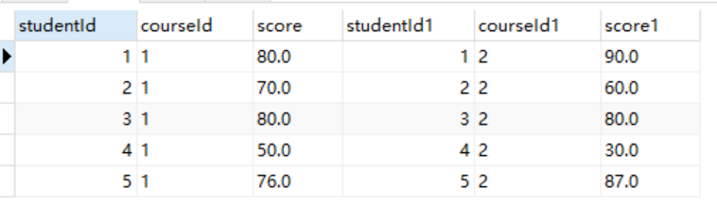

//3.

select student.id,name,ss from student,(

select student_course.studentId, AVG(student_course.score) as ss from student_course

GROUP BY student_course.studentId

HAVING AVG(student_course.score)> 60

)r

where student.id = r.studentId;

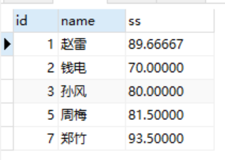

//4.

select student.id, student.name,r.courseId,r.scoresum

from student,

(select student_course.studentId, student_course.courseId,

sum(student_course.score) as scoresum,

count(student_course.courseId) as coursenumber

from student_course

group by student_course.studentId)r

where student.id = r.studentId;

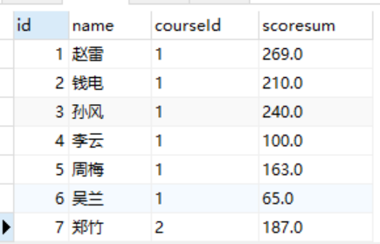

//5.

select DISTINCT student.*

from student,student_course

where student.id=student_course.studentId;

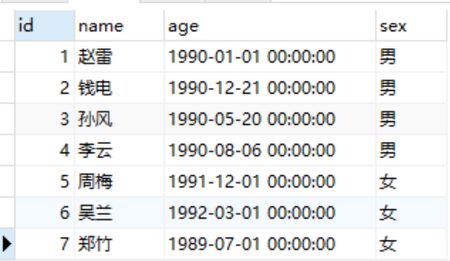

//6.

select * from

(select * from student_course where student_course.courseId = '1') as t1,

(select * from student_course where student_course.courseId = '2') as t2,

(select * from student) as t3

where t1.studentId = t2.studentId and t3.id=t1.studentId and t3.id=t2.studentId;



//7.

select student.*, student_course.score from student, student_course

where student.id = student_course.studentId

and student_course.score < 60

and student_course.courseId = "1"

ORDER BY student_course.score DESC;

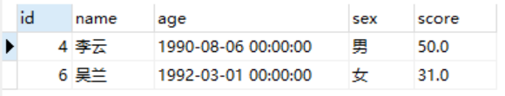

//8.

select student_course.courseId,avg(score) as avscore

from student_course

group by student_course.courseId

order by avscore desc;

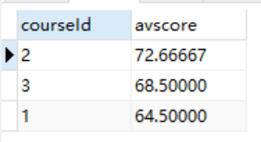

//9.

select student.name,student_course.score,course.name

from student ,student_course,course

where student.id=student_course.studentId

and student_course.courseId=course.id

and course.name="数学";

and student_course.score<60;

