Summary: The purpose of this site is to showcase my technical skills, project expertise, internship experiences, and personal interests to recruiters. It serves as a comprehensive platform to provide deeper insights into my technical strengths, work philosophy, and professional journey, going beyond the confines of a traditional resume.

User Persona

site diagram

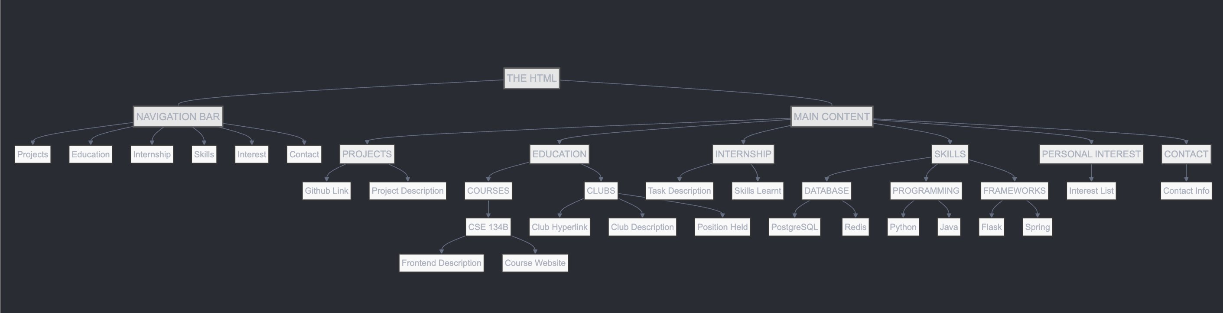

Site frame:

1. **Technical requirements**   
  
Plans:   
1. Have all the content ready – internship experience, product description, etc

2. create HTML skeleton – a clear division between each section, so the overall structure is clear

3. add CSS to add the site

4. add javascript to make it interactive

Host: Netlify

Technology: HTML, CSS, Javascript

2. **Content requirements**

The primary content areas include projects, education, internships, skills, and contact information.  
Project: GitHub repository links and detailed descriptions highlighting objectives, technologies utilized, and project outcomes.

The education: course content, descriptions, and comprehensive club involvement documentation including positions and responsibilities.

The skills: database technologies, programming languages (Python, Java), and frameworks (Flask, Spring), complete with proficiency indicators.

Internship content includes task descriptions, skills acquired, and key accomplishments.

Required media assets encompass profile photographs, project screenshots, company logos, technology icons, and professional documents such as PDF resumes.

https://timliupersonalwebsite.netlify.app/