Electronic Supplementary Information
Structure- and composition-derived prediction of global mineral Raman spectral features
Prepared for submission to Physical Chemistry Chemical Physics (PCCP)
Zhao Liu | ORCID: 0009-0008-0757-1398
Yihao Chen | ORCID: 0009-0001-6870-6232
Chunguang Dong | ORCID: 0009-0008-4643-9218
Meijie Zhang | ORCID: 0000-0003-3630-819X
Current analysis cohort: 1,838 quality-controlled spectra; results and tables generated from the refreshed analysis outputs.

S1. Scope and principal findings
This supporting information documents the cohort construction, endpoint definitions, analysis settings, and supplementary results for formula-grouped prediction of mineral Raman spectral features. Eleven endpoints were evaluated: detected peak count, peak-intensity evenness, median linewidth, median peak spacing, peak overlap ratio, low-, mid-, and high-band peak fractions, Wasserstein distance to a reference spectrum, spectral centroid, and spectral skewness. Mapping efficiency (N_peak/N_Raman) was used for inference only because it is mathematically coupled to its numerator and denominator.
The refreshed cohort contains 1,838 spectra. The full structural/composition descriptor model improved on the family-plus-crystal-system baseline for 8 of 11 endpoints; the increments for peak-intensity evenness and the low- and mid-band fractions were not distinguishable from zero. The largest gain was for median linewidth (delta R2 = 0.233; 95% CI 0.195 to 0.274). All reported estimates below are refreshed from the machine-readable outputs in results/tables and rounded for presentation.
Table S1. Sequential quality-control funnel.
Selection step | Retained n | Removed
Linked structure-spectrum records | 2,043 | 0
Spectrum quality in {excellent,fair} | 1,901 | 142
SNR >= 20 | 1,876 | 25
Detected peaks >= 3 | 1,841 | 35
Orientation = unoriented | 1,838 | 3

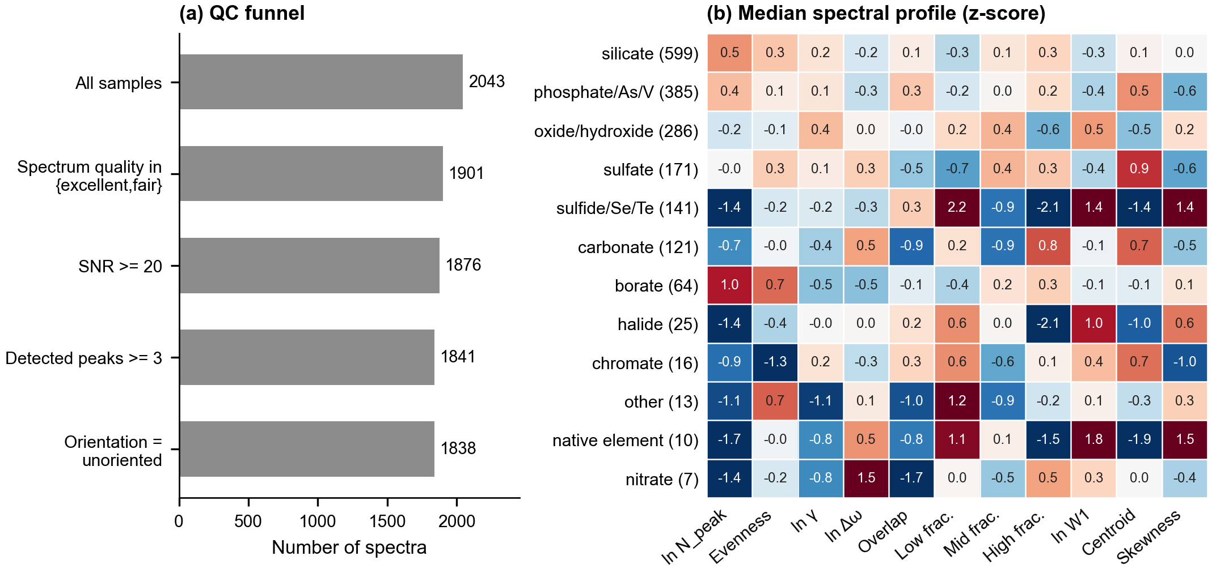
Figure S1. Quality-control funnel and median standardized spectral profile by chemical family.

S2. Endpoints and reproducibility
Raman spectra were sorted and restricted to 100-1300 cm^-1. The rolling-minimum baseline was subtracted and clipped at zero; a Savitzky-Golay-smoothed trace was used for peak detection. Peaks were required to pass relative-height, prominence, robust-noise, and separation thresholds. Width is the half-prominence width returned by peak-width analysis; it is summarized as the median linewidth. The final high-frequency band includes its 1300 cm^-1 endpoint.
Table S2. Definitions of all predictive endpoints.
Endpoint | Operational definition
N_peak (peak count) | N_peak = number of detected local maxima with 100 ≤ ν ≤ 1300 cm⁻¹.
E_peak (peak-intensity evenness) | E_peak = −(Σᵢ pᵢ ln pᵢ)/ln(N_peak), where pᵢ = Aᵢ/(Σⱼ Aⱼ) and Aᵢ is the integrated area of peak i. Undefined when N_peak = 1.
γ (median linewidth) | γ = median of wᵢ over detected peaks, where wᵢ is the peak width at half prominence (relative height 0.5).
Δω_med (median peak spacing) | Δω_med = median(νᵢ₊₁ − νᵢ) for detected peaks ordered by wavenumber.
R_overlap (peak overlap ratio) | R_overlap = γ/Δω_med.
f_low (low-band fraction) | f_low = N_low/N_peak, where N_low is the number of detected peaks in [100, 400) cm⁻¹.
f_mid (mid-band fraction) | f_mid = N_mid/N_peak, where N_mid is the number of detected peaks in [400, 700) cm⁻¹.
f_high (high-band fraction) | f_high = N_high/N_peak, where N_high is the number of detected peaks in [700, 1300] cm⁻¹; the upper bound is inclusive.
W₁ (Wasserstein distance) | W₁ = ∫_{100}^{1300} |F_obs(ν) − F_unif(ν)| dν, where F_obs and F_unif are the cumulative distributions of normalized baseline-corrected intensity and uniform spectral weight over the full window, respectively. Units: cm⁻¹.
μ_spec (spectral centroid) | μ_spec = Σₖ qₖνₖ, where qₖ = I_bc,k/(Σₗ I_bc,l) is the normalized baseline-corrected intensity weight at wavenumber νₖ.
g₁,spec (spectral skewness) | g₁,spec = [Σₖ qₖ(νₖ − μ_spec)³]/[Σₖ qₖ(νₖ − μ_spec)²]^(3/2), where qₖ is the normalized baseline-corrected intensity weight.

HistGradientBoosting models used 150 iterations, learning rate 0.06, maximum depth 3, minimum leaf size 15, L2 regularization 1.0, and no early stopping. No hyperparameter search was performed. Models were evaluated with three repeats of five-fold cross-validation grouped by chemical formula (repeat seeds 0, 1, and 2). Reported R2 is the mean pooled out-of-fold R2 across repeats. Formula-cluster bootstrap intervals used 300 resamples, shared across paired comparisons. Training-fold preprocessing was used where required; the similarity baseline standardizes numeric descriptors and is not a direct interatomic structural distance.

S3. Representative mode-window examples
Group-theoretical counts describe symmetry-allowed Gamma-point modes without frequency assignment, whereas observed peaks are restricted to the measured 100-1300 cm^-1 interval and depend on experimental resolvability. The selected mineral examples are illustrative and do not constitute complete peak assignments.
Table S3. Illustrative mineral mode counts and detected Raman peaks.
mineral | formula | rruff id | n raman active modes | n detected peaks 100 1300 | detected peak positions cm1 | representative assignment | assignment source | interpretation
Anatase | TiO2 | R060277 | 6 | 5 | 143.04;395.67;513.79;636.73;789.08 | Six symmetry-allowed fundamentals: Eg ~144 and 197; B1g ~399 and 513; A1g ~519; Eg ~639 cm-1. The ~513/519 pair can merge near room temperature. | Ohsaka et al. (1978), DOI:10.1002/jrs.1250070606 | Illustrative case study; database mode count is Gamma-point symmetry availability, not a frequency-resolved prediction of the measured spectrum.
Quartz | SiO2 | R040031 | 12 | 7 | 127.15;203.33;263.59;354.23;463.67;807.90;1081.26 | The strong alpha-quartz Raman line near 464 cm-1 is within the measurement window; additional lattice and internal modes contribute to the unrestricted count. | Krishnan (1945), DOI:10.1038/155452a0 | Illustrative case study; database mode count is Gamma-point symmetry availability, not a frequency-resolved prediction of the measured spectrum.
Gypsum | CaH4SO6 | R040029 | 36 | 6 | 180.19;413.53;492.60;617.95;1007.98;1139.60 | Sulfate stretching/bending modes fall in the fingerprint region, whereas structural-water O-H stretching bands occur above 1300 cm-1 and are absent from the analyzed trace. | Berenblut et al. (1971), DOI:10.1016/0584-8539(71)80238-6; Couty et al. (1983), DOI:10.1007/bf00309590 | Illustrative case study; database mode count is Gamma-point symmetry availability, not a frequency-resolved prediction of the measured spectrum.

S4. Association and inference outputs
Partial Spearman associations adjust for ln(N_atom) and ln(SNR); p values are controlled using the Benjamini-Hochberg false-discovery-rate procedure. Selected displays are exploratory. Complete machine-readable association and regression results are supplied in the accompanying results/tables directory.
Table S4. Twenty strongest non-null partial associations (by adjusted q).
Descriptor | Endpoint | Partial rho | 95% CI low | 95% CI high | Adjusted q | n
raman mode fraction | eta | -0.478 | -0.514 | -0.440 | <0.001 | 1,829
is centrosymmetric | eta | 0.375 | 0.334 | 0.415 | <0.001 | 1,829
polymerization index | shape skewness | 0.409 | 0.360 | 0.456 | <0.001 | 1,244
mean reduced mass | n peak | -0.331 | -0.373 | -0.289 | <0.001 | 1,804
n anion group types | frac high | 0.326 | 0.283 | 0.367 | <0.001 | 1,838
mean reduced mass | frac low | 0.329 | 0.286 | 0.370 | <0.001 | 1,804
n anion group types | shape w1 distance | -0.324 | -0.365 | -0.281 | <0.001 | 1,838
mean reduced mass | frac high | -0.324 | -0.365 | -0.281 | <0.001 | 1,804
degeneracy fraction | eta | 0.321 | 0.278 | 0.363 | <0.001 | 1,829
sigma chi | frac low | -0.318 | -0.359 | -0.275 | <0.001 | 1,838
max raman irrep mult | eta | -0.314 | -0.356 | -0.271 | <0.001 | 1,829
polymerization index | shape centroid | -0.367 | -0.416 | -0.317 | <0.001 | 1,244
n anion group types | shape centroid | 0.299 | 0.256 | 0.341 | <0.001 | 1,838
n wyckoff orbits | eta | -0.298 | -0.340 | -0.255 | <0.001 | 1,829
mean delta chi bond | frac low | -0.285 | -0.327 | -0.241 | <0.001 | 1,804
soap n env | eta | -0.279 | -0.322 | -0.235 | <0.001 | 1,825
mixing entropy | gamma | 0.277 | 0.234 | 0.320 | <0.001 | 1,838
n anion group types | n peak | 0.276 | 0.233 | 0.319 | <0.001 | 1,838
sigma chi | n peak | 0.271 | 0.227 | 0.314 | <0.001 | 1,838
n anion group types | shape skewness | -0.266 | -0.309 | -0.223 | <0.001 | 1,838

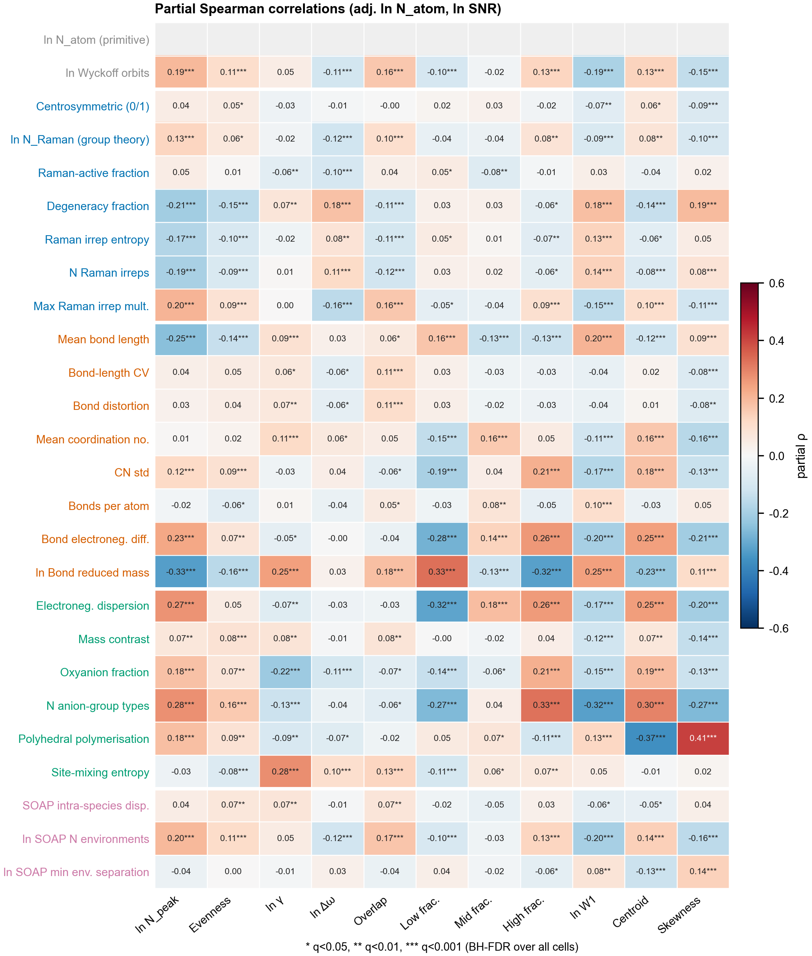
Figure S2. Full partial-Spearman correlation matrix adjusted for ln(N_atom) and ln(SNR); significance is BH-FDR adjusted.
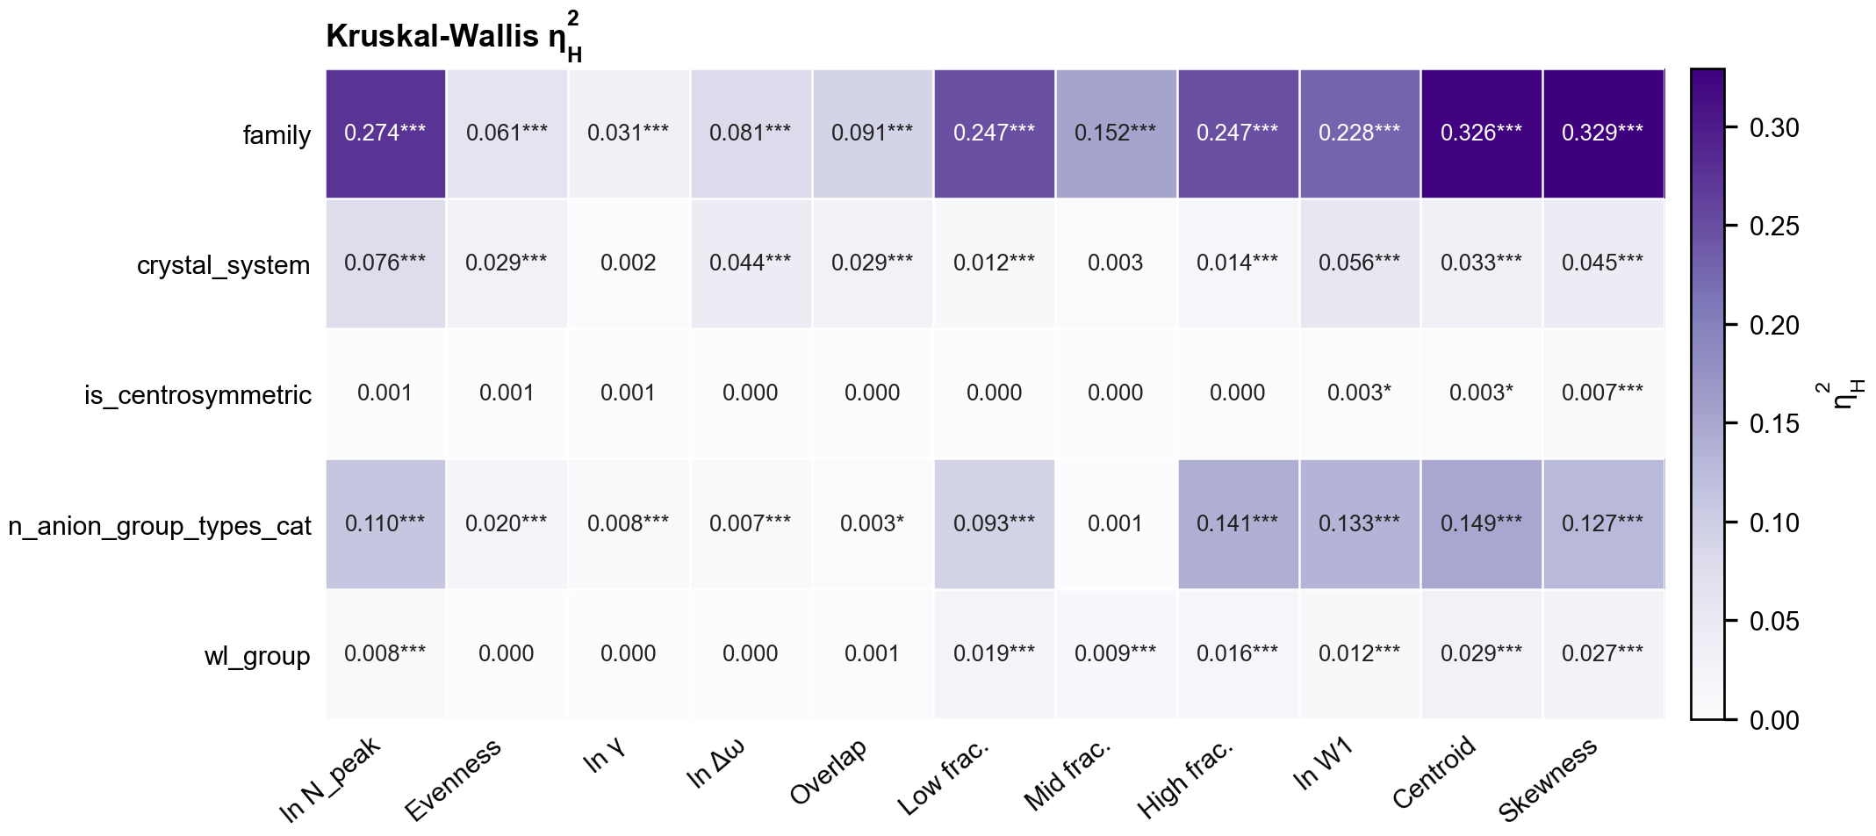
Figure S3. Kruskal-Wallis eta2_H effect sizes for categorical and discretized factors across endpoints.
Table S5. Thirty lowest-q terms from the extended OLS models (M2/M3).
Model | Response | Predictor | Standardized beta | 95% CI low | 95% CI high | Adjusted q | Model R2
M2 extended | frac low | mean reduced mass | 0.403 | 0.327 | 0.478 | <0.001 | 0.359
M2 extended | eta | n atom primitive | -0.378 | -0.468 | -0.288 | <0.001 | 0.302
M2 extended | frac high | mean reduced mass | -0.306 | -0.381 | -0.231 | <0.001 | 0.243
M3 extended + family FE | eta | n atom primitive | -0.367 | -0.459 | -0.275 | <0.001 | 0.309
M2 extended | n peak | mean reduced mass | -0.263 | -0.331 | -0.195 | <0.001 | 0.289
M2 extended | shape centroid | mean reduced mass | -0.278 | -0.351 | -0.205 | <0.001 | 0.254
M2 extended | r overlap | n atom primitive | 0.209 | 0.153 | 0.265 | <0.001 | 0.071
M2 extended | n peak | raman channel entropy | -0.141 | -0.179 | -0.102 | <0.001 | 0.289
M2 extended | n peak | n atom primitive | 0.200 | 0.144 | 0.256 | <0.001 | 0.289
M2 extended | shape skewness | mass contrast | -0.132 | -0.172 | -0.091 | <0.001 | 0.258
M2 extended | shape skewness | mean reduced mass | 0.242 | 0.165 | 0.318 | <0.001 | 0.258
M3 extended + family FE | r overlap | n atom primitive | 0.192 | 0.133 | 0.251 | <0.001 | 0.160
M2 extended | eta | degeneracy fraction | 0.272 | 0.182 | 0.361 | <0.001 | 0.302
M3 extended + family FE | eta | degeneracy fraction | 0.266 | 0.178 | 0.354 | <0.001 | 0.309
M3 extended + family FE | n peak | raman channel entropy | -0.115 | -0.154 | -0.077 | <0.001 | 0.370
M2 extended | shape centroid | n atom primitive | 0.157 | 0.102 | 0.212 | <0.001 | 0.254
M3 extended + family FE | n peak | mean reduced mass | -0.229 | -0.309 | -0.149 | <0.001 | 0.370
M2 extended | domega median | degeneracy fraction | 0.153 | 0.097 | 0.208 | <0.001 | 0.056
M2 extended | r overlap | raman channel entropy | -0.125 | -0.171 | -0.079 | <0.001 | 0.071
M2 extended | domega median | raman channel entropy | 0.119 | 0.075 | 0.163 | <0.001 | 0.056
M3 extended + family FE | frac low | mean reduced mass | 0.218 | 0.139 | 0.298 | <0.001 | 0.455
M2 extended | shape w1 distance | mean cn | -0.137 | -0.188 | -0.085 | <0.001 | 0.216
M2 extended | shape w1 distance | degeneracy fraction | 0.124 | 0.077 | 0.172 | <0.001 | 0.216
M2 extended | r overlap | mean reduced mass | 0.246 | 0.152 | 0.340 | <0.001 | 0.071
M2 extended | frac mid | mean reduced mass | -0.204 | -0.282 | -0.125 | <0.001 | 0.095
M2 extended | gamma | n atom primitive | 0.149 | 0.091 | 0.208 | <0.001 | 0.064
M2 extended | n peak | degeneracy fraction | -0.126 | -0.175 | -0.077 | <0.001 | 0.289
M2 extended | shape skewness | soap intra species dispersion | 0.132 | 0.080 | 0.184 | <0.001 | 0.258
M2 extended | shape w1 distance | mean reduced mass | 0.254 | 0.154 | 0.354 | <0.001 | 0.216
M3 extended + family FE | gamma | n atom primitive | 0.159 | 0.099 | 0.219 | <0.001 | 0.116

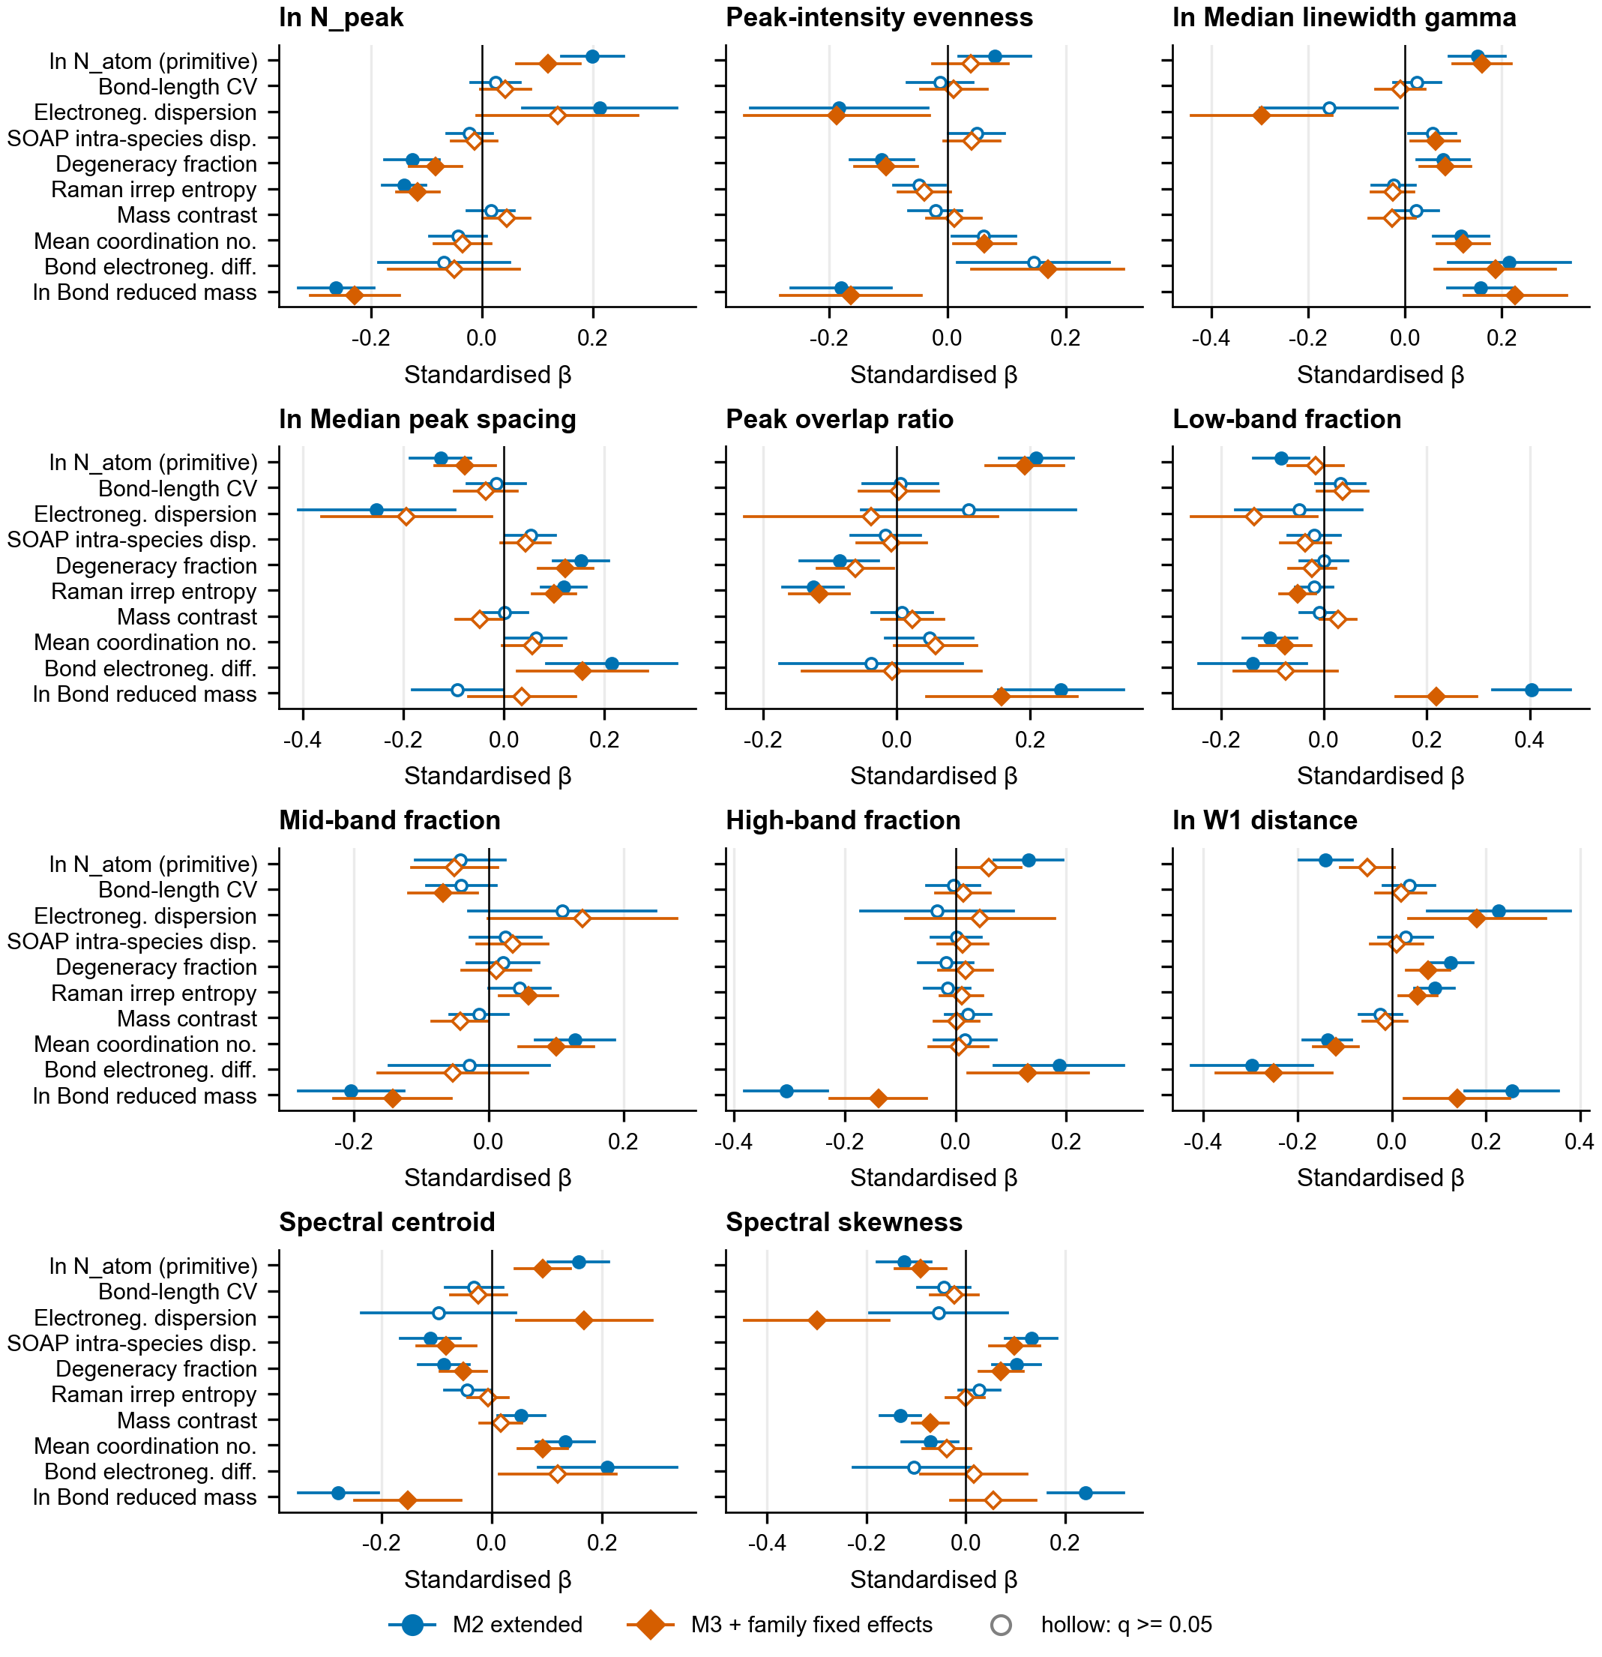
Figure S4. Standardized OLS coefficients and 95% confidence intervals for M2 and M3.

S5. Predictive validation and model baselines
Table S6. Grouped-CV scores for the measurement, categorical, and full numeric models.
Endpoint | Predictor set | R2 | 95% CI low | 95% CI high | n
n peak | Measurement baseline | 0.158 | 0.121 | 0.196 | 1,838
n peak | Family + crystal-system baseline | 0.315 | 0.275 | 0.351 | 1,838
n peak | All numeric descriptors | 0.384 | 0.347 | 0.418 | 1,838
evenness | Measurement baseline | 0.163 | 0.133 | 0.194 | 1,838
evenness | Family + crystal-system baseline | 0.059 | 0.030 | 0.087 | 1,838
evenness | All numeric descriptors | 0.083 | 0.050 | 0.117 | 1,838
gamma | Measurement baseline | 0.088 | 0.058 | 0.119 | 1,838
gamma | Family + crystal-system baseline | 0.020 | 0.002 | 0.039 | 1,838
gamma | All numeric descriptors | 0.253 | 0.218 | 0.294 | 1,838
domega median | Measurement baseline | 0.045 | 0.012 | 0.075 | 1,838
domega median | Family + crystal-system baseline | 0.118 | 0.077 | 0.163 | 1,838
domega median | All numeric descriptors | 0.164 | 0.118 | 0.207 | 1,838
r overlap | Measurement baseline | 0.070 | 0.038 | 0.101 | 1,838
r overlap | Family + crystal-system baseline | 0.086 | 0.054 | 0.120 | 1,838
r overlap | All numeric descriptors | 0.155 | 0.122 | 0.197 | 1,838
frac low | Measurement baseline | 0.042 | 0.006 | 0.074 | 1,838
frac low | Family + crystal-system baseline | 0.379 | 0.319 | 0.431 | 1,838
frac low | All numeric descriptors | 0.391 | 0.329 | 0.446 | 1,838
frac mid | Measurement baseline | -0.008 | -0.029 | 0.013 | 1,838
frac mid | Family + crystal-system baseline | 0.174 | 0.132 | 0.214 | 1,838
frac mid | All numeric descriptors | 0.174 | 0.136 | 0.217 | 1,838
frac high | Measurement baseline | 0.016 | -0.010 | 0.039 | 1,838
frac high | Family + crystal-system baseline | 0.297 | 0.246 | 0.341 | 1,838
frac high | All numeric descriptors | 0.336 | 0.278 | 0.378 | 1,838
shape w1 distance | Measurement baseline | 0.110 | 0.079 | 0.141 | 1,838
shape w1 distance | Family + crystal-system baseline | 0.243 | 0.199 | 0.285 | 1,838
shape w1 distance | All numeric descriptors | 0.295 | 0.246 | 0.335 | 1,838
shape centroid | Measurement baseline | 0.032 | 0.005 | 0.062 | 1,838
shape centroid | Family + crystal-system baseline | 0.340 | 0.301 | 0.374 | 1,838
shape centroid | All numeric descriptors | 0.428 | 0.385 | 0.466 | 1,838
shape skewness | Measurement baseline | 0.046 | 0.010 | 0.085 | 1,838
shape skewness | Family + crystal-system baseline | 0.346 | 0.310 | 0.384 | 1,838
shape skewness | All numeric descriptors | 0.438 | 0.399 | 0.475 | 1,838

Table S7. Reviewer-requested predictor baselines, including combined numeric/categorical and nearest-neighbour models.
Endpoint | Predictor set | R2 | 95% CI low | 95% CI high | n
n peak | Categorical only | 0.315 | 0.275 | 0.353 | 1,838
n peak | All numerical descriptors | 0.384 | 0.344 | 0.426 | 1,838
n peak | All descriptors + family and crystal system | 0.402 | 0.360 | 0.446 | 1,838
n peak | Nearest mineral (k=1) | -0.045 | -0.127 | 0.022 | 1,838
n peak | Five-neighbour mineral similarity | 0.266 | 0.218 | 0.320 | 1,838
evenness | Categorical only | 0.059 | 0.028 | 0.087 | 1,838
evenness | All numerical descriptors | 0.083 | 0.046 | 0.116 | 1,838
evenness | All descriptors + family and crystal system | 0.090 | 0.055 | 0.123 | 1,838
evenness | Nearest mineral (k=1) | -0.591 | -0.716 | -0.458 | 1,838
evenness | Five-neighbour mineral similarity | -0.054 | -0.106 | -0.007 | 1,838
gamma | Categorical only | 0.020 | -0.002 | 0.043 | 1,838
gamma | All numerical descriptors | 0.253 | 0.218 | 0.293 | 1,838
gamma | All descriptors + family and crystal system | 0.256 | 0.222 | 0.296 | 1,838
gamma | Nearest mineral (k=1) | -0.347 | -0.434 | -0.260 | 1,838
gamma | Five-neighbour mineral similarity | 0.117 | 0.073 | 0.161 | 1,838
domega median | Categorical only | 0.118 | 0.076 | 0.156 | 1,838
domega median | All numerical descriptors | 0.164 | 0.121 | 0.211 | 1,838
domega median | All descriptors + family and crystal system | 0.184 | 0.139 | 0.226 | 1,838
domega median | Nearest mineral (k=1) | -0.420 | -0.548 | -0.305 | 1,838
domega median | Five-neighbour mineral similarity | 0.045 | -0.021 | 0.112 | 1,838
r overlap | Categorical only | 0.086 | 0.054 | 0.118 | 1,838
r overlap | All numerical descriptors | 0.155 | 0.117 | 0.193 | 1,838
r overlap | All descriptors + family and crystal system | 0.187 | 0.145 | 0.229 | 1,838
r overlap | Nearest mineral (k=1) | -0.538 | -0.661 | -0.439 | 1,838
r overlap | Five-neighbour mineral similarity | 0.023 | -0.020 | 0.071 | 1,838
frac low | Categorical only | 0.379 | 0.313 | 0.430 | 1,838
frac low | All numerical descriptors | 0.391 | 0.329 | 0.445 | 1,838
frac low | All descriptors + family and crystal system | 0.431 | 0.372 | 0.481 | 1,838
frac low | Nearest mineral (k=1) | -0.065 | -0.174 | 0.024 | 1,838
frac low | Five-neighbour mineral similarity | 0.301 | 0.241 | 0.360 | 1,838
frac mid | Categorical only | 0.174 | 0.129 | 0.216 | 1,838
frac mid | All numerical descriptors | 0.174 | 0.130 | 0.214 | 1,838
frac mid | All descriptors + family and crystal system | 0.237 | 0.190 | 0.278 | 1,838
frac mid | Nearest mineral (k=1) | -0.478 | -0.607 | -0.372 | 1,838
frac mid | Five-neighbour mineral similarity | 0.048 | -0.009 | 0.096 | 1,838
frac high | Categorical only | 0.297 | 0.247 | 0.344 | 1,838
frac high | All numerical descriptors | 0.336 | 0.290 | 0.377 | 1,838
frac high | All descriptors + family and crystal system | 0.349 | 0.305 | 0.394 | 1,838
frac high | Nearest mineral (k=1) | -0.142 | -0.232 | -0.051 | 1,838
frac high | Five-neighbour mineral similarity | 0.258 | 0.206 | 0.310 | 1,838
shape w1 distance | Categorical only | 0.243 | 0.200 | 0.281 | 1,838
shape w1 distance | All numerical descriptors | 0.295 | 0.245 | 0.340 | 1,838
shape w1 distance | All descriptors + family and crystal system | 0.308 | 0.256 | 0.355 | 1,838
shape w1 distance | Nearest mineral (k=1) | -0.192 | -0.272 | -0.115 | 1,838
shape w1 distance | Five-neighbour mineral similarity | 0.201 | 0.151 | 0.245 | 1,838
shape centroid | Categorical only | 0.340 | 0.297 | 0.379 | 1,838
shape centroid | All numerical descriptors | 0.428 | 0.388 | 0.464 | 1,838
shape centroid | All descriptors + family and crystal system | 0.469 | 0.428 | 0.505 | 1,838
shape centroid | Nearest mineral (k=1) | -0.015 | -0.090 | 0.061 | 1,838
shape centroid | Five-neighbour mineral similarity | 0.313 | 0.265 | 0.354 | 1,838
shape skewness | Categorical only | 0.346 | 0.295 | 0.388 | 1,838
shape skewness | All numerical descriptors | 0.438 | 0.394 | 0.480 | 1,838
shape skewness | All descriptors + family and crystal system | 0.467 | 0.423 | 0.504 | 1,838
shape skewness | Nearest mineral (k=1) | 0.049 | -0.052 | 0.118 | 1,838
shape skewness | Five-neighbour mineral similarity | 0.324 | 0.274 | 0.370 | 1,838

Table S8. Paired R2 differences for the reviewer-requested model comparisons.
Endpoint | Paired contrast | delta R2 | 95% CI low | 95% CI high
n peak | All numerical + categories - All numerical | 0.018 | 0.005 | 0.030
n peak | All numerical + categories - categorical | 0.087 | 0.059 | 0.117
n peak | All numerical - five-neighbour similarity | 0.118 | 0.085 | 0.151
n peak | All numerical - nearest mineral | 0.428 | 0.361 | 0.515
evenness | All numerical + categories - All numerical | 0.007 | -0.003 | 0.016
evenness | All numerical + categories - categorical | 0.031 | -0.002 | 0.061
evenness | All numerical - five-neighbour similarity | 0.137 | 0.084 | 0.188
evenness | All numerical - nearest mineral | 0.674 | 0.543 | 0.810
gamma | All numerical + categories - All numerical | 0.003 | -0.004 | 0.009
gamma | All numerical + categories - categorical | 0.236 | 0.191 | 0.280
gamma | All numerical - five-neighbour similarity | 0.137 | 0.097 | 0.177
gamma | All numerical - nearest mineral | 0.600 | 0.490 | 0.712
domega median | All numerical + categories - All numerical | 0.021 | -0.004 | 0.043
domega median | All numerical + categories - categorical | 0.066 | 0.036 | 0.097
domega median | All numerical - five-neighbour similarity | 0.118 | 0.075 | 0.166
domega median | All numerical - nearest mineral | 0.584 | 0.453 | 0.726
r overlap | All numerical + categories - All numerical | 0.032 | 0.012 | 0.050
r overlap | All numerical + categories - categorical | 0.101 | 0.063 | 0.145
r overlap | All numerical - five-neighbour similarity | 0.132 | 0.088 | 0.176
r overlap | All numerical - nearest mineral | 0.693 | 0.571 | 0.828
frac low | All numerical + categories - All numerical | 0.040 | 0.027 | 0.055
frac low | All numerical + categories - categorical | 0.052 | 0.015 | 0.086
frac low | All numerical - five-neighbour similarity | 0.090 | 0.061 | 0.118
frac low | All numerical - nearest mineral | 0.456 | 0.382 | 0.546
frac mid | All numerical + categories - All numerical | 0.063 | 0.038 | 0.089
frac mid | All numerical + categories - categorical | 0.062 | 0.031 | 0.093
frac mid | All numerical - five-neighbour similarity | 0.126 | 0.085 | 0.174
frac mid | All numerical - nearest mineral | 0.652 | 0.509 | 0.819
frac high | All numerical + categories - All numerical | 0.013 | -0.002 | 0.026
frac high | All numerical + categories - categorical | 0.052 | 0.020 | 0.084
frac high | All numerical - five-neighbour similarity | 0.078 | 0.038 | 0.115
frac high | All numerical - nearest mineral | 0.478 | 0.388 | 0.567
shape w1 distance | All numerical + categories - All numerical | 0.014 | 0.002 | 0.024
shape w1 distance | All numerical + categories - categorical | 0.066 | 0.031 | 0.099
shape w1 distance | All numerical - five-neighbour similarity | 0.094 | 0.060 | 0.129
shape w1 distance | All numerical - nearest mineral | 0.487 | 0.377 | 0.601
shape centroid | All numerical + categories - All numerical | 0.042 | 0.025 | 0.057
shape centroid | All numerical + categories - categorical | 0.130 | 0.096 | 0.162
shape centroid | All numerical - five-neighbour similarity | 0.115 | 0.082 | 0.149
shape centroid | All numerical - nearest mineral | 0.443 | 0.365 | 0.523
shape skewness | All numerical + categories - All numerical | 0.030 | 0.016 | 0.044
shape skewness | All numerical + categories - categorical | 0.121 | 0.077 | 0.159
shape skewness | All numerical - five-neighbour similarity | 0.114 | 0.072 | 0.149
shape skewness | All numerical - nearest mineral | 0.389 | 0.309 | 0.490

S6. Applicability, missingness, and extraction failures
Descriptor availability is classified by reason rather than treating all missing values alike. Not applicable denotes a structural or chemical case where the descriptor is undefined by construction; extraction failures are reported separately. The statuses are descriptor-specific and should not be interpreted as interchangeable missing-data mechanisms.
Table S9. Non-available descriptor counts by reason in the QC cohort.
Descriptor | Block | Availability reason | Count | Fraction
n raman active modes | sym | unresolved or not applicable | 9 | 0.005
raman mode fraction | sym | unresolved or not applicable | 3 | 0.002
degeneracy fraction | sym | unresolved or not applicable | 3 | 0.002
mean bond | bond | not applicable no bond pairs | 34 | 0.018
cv bond | bond | not applicable no bond pairs | 34 | 0.018
bond distortion | bond | not applicable no bond pairs | 34 | 0.018
mean cn | bond | not applicable no bond pairs | 34 | 0.018
cn std | bond | not applicable no bond pairs | 34 | 0.018
mean delta chi bond | bond | not applicable no bond pairs | 34 | 0.018
mean reduced mass | bond | not applicable no bond pairs | 34 | 0.018
anion group o fraction | chem | not applicable no detected oxyanion group | 189 | 0.103
polymerization index | chem | not applicable no detected oxyanion group | 594 | 0.323
soap intra species dispersion | soap | extraction failed | 4 | 0.002
soap n env | soap | extraction failed | 4 | 0.002
soap min env sep | soap | not applicable no within species environment pair | 206 | 0.112
soap min env sep | soap | extraction failed | 4 | 0.002

Table S10. Predictive sensitivity to native missing values, median imputation, missingness indicators, and indicators alone.
Endpoint | Missing-data treatment | R2 | 95% CI low | 95% CI high | n
n peak | native missing | 0.384 | 0.337 | 0.422 | 1,838
n peak | median only | 0.382 | 0.337 | 0.418 | 1,838
n peak | values plus mask | 0.384 | 0.339 | 0.419 | 1,838
n peak | mask only | 0.218 | 0.172 | 0.259 | 1,838
evenness | native missing | 0.083 | 0.051 | 0.114 | 1,838
evenness | median only | 0.089 | 0.058 | 0.120 | 1,838
evenness | values plus mask | 0.089 | 0.058 | 0.120 | 1,838
evenness | mask only | 0.032 | 0.012 | 0.053 | 1,838
gamma | native missing | 0.253 | 0.215 | 0.293 | 1,838
gamma | median only | 0.251 | 0.216 | 0.290 | 1,838
gamma | values plus mask | 0.251 | 0.216 | 0.290 | 1,838
gamma | mask only | 0.028 | 0.008 | 0.044 | 1,838
domega median | native missing | 0.164 | 0.122 | 0.214 | 1,838
domega median | median only | 0.160 | 0.118 | 0.210 | 1,838
domega median | values plus mask | 0.158 | 0.116 | 0.208 | 1,838
domega median | mask only | 0.037 | 0.013 | 0.064 | 1,838
r overlap | native missing | 0.155 | 0.116 | 0.199 | 1,838
r overlap | median only | 0.158 | 0.119 | 0.201 | 1,838
r overlap | values plus mask | 0.158 | 0.118 | 0.201 | 1,838
r overlap | mask only | 0.034 | 0.011 | 0.054 | 1,838
frac low | native missing | 0.391 | 0.330 | 0.441 | 1,838
frac low | median only | 0.389 | 0.327 | 0.442 | 1,838
frac low | values plus mask | 0.390 | 0.328 | 0.443 | 1,838
frac low | mask only | 0.332 | 0.273 | 0.380 | 1,838
frac mid | native missing | 0.174 | 0.129 | 0.219 | 1,838
frac mid | median only | 0.166 | 0.120 | 0.211 | 1,838
frac mid | values plus mask | 0.165 | 0.120 | 0.211 | 1,838
frac mid | mask only | 0.098 | 0.060 | 0.138 | 1,838
frac high | native missing | 0.336 | 0.287 | 0.379 | 1,838
frac high | median only | 0.341 | 0.291 | 0.384 | 1,838
frac high | values plus mask | 0.337 | 0.290 | 0.381 | 1,838
frac high | mask only | 0.254 | 0.205 | 0.296 | 1,838
shape w1 distance | native missing | 0.295 | 0.252 | 0.339 | 1,838
shape w1 distance | median only | 0.300 | 0.257 | 0.344 | 1,838
shape w1 distance | values plus mask | 0.298 | 0.255 | 0.342 | 1,838
shape w1 distance | mask only | 0.205 | 0.171 | 0.246 | 1,838
shape centroid | native missing | 0.428 | 0.387 | 0.465 | 1,838
shape centroid | median only | 0.422 | 0.383 | 0.459 | 1,838
shape centroid | values plus mask | 0.423 | 0.382 | 0.461 | 1,838
shape centroid | mask only | 0.250 | 0.206 | 0.288 | 1,838
shape skewness | native missing | 0.438 | 0.392 | 0.477 | 1,838
shape skewness | median only | 0.434 | 0.389 | 0.477 | 1,838
shape skewness | values plus mask | 0.437 | 0.394 | 0.477 | 1,838
shape skewness | mask only | 0.297 | 0.249 | 0.335 | 1,838

Table S11. Complete-case versus native-missingness grouped-CV sensitivity.
Endpoint | All n | Complete-case n | All R2 | Complete-case R2 | delta R2
n peak | 1,838 | 1,184 | 0.382 | 0.271 | -0.111
evenness | 1,838 | 1,184 | 0.091 | 0.166 | 0.076
gamma | 1,838 | 1,184 | 0.259 | 0.300 | 0.041
domega median | 1,838 | 1,184 | 0.167 | 0.177 | 0.009
r overlap | 1,838 | 1,184 | 0.173 | 0.201 | 0.028
frac low | 1,838 | 1,184 | 0.388 | 0.115 | -0.273
frac mid | 1,838 | 1,184 | 0.174 | 0.069 | -0.105
frac high | 1,838 | 1,184 | 0.324 | 0.087 | -0.237
shape w1 distance | 1,838 | 1,184 | 0.302 | 0.107 | -0.195
shape centroid | 1,838 | 1,184 | 0.434 | 0.255 | -0.180
shape skewness | 1,838 | 1,184 | 0.445 | 0.351 | -0.094

S7. Descriptor-group ablation
Each ablation removes one descriptor group and refits the model. The reported paired loss is the full-model R2 minus the drop-group R2; negative values indicate that removal improved the score. Confidence intervals are based on shared formula-cluster bootstrap resamples.
Table S12. Complete drop-group ablation with paired 95% confidence intervals.
Endpoint | Removed descriptor group | R2 loss | 95% CI low | 95% CI high
n peak | size | 0.001 | -0.002 | 0.005
n peak | sym | 0.011 | 0.003 | 0.019
n peak | bond | 0.028 | 0.010 | 0.046
n peak | chem | 0.028 | 0.017 | 0.039
n peak | soap | -0.001 | -0.007 | 0.004
evenness | size | -0.001 | -0.005 | 0.004
evenness | sym | -0.011 | -0.023 | 0.001
evenness | bond | 0.006 | -0.013 | 0.022
evenness | chem | 0.021 | 0.009 | 0.036
evenness | soap | -0.011 | -0.021 | -0.000
gamma | size | -0.001 | -0.005 | 0.003
gamma | sym | 0.010 | 0.000 | 0.019
gamma | bond | 0.034 | 0.016 | 0.055
gamma | chem | 0.086 | 0.064 | 0.111
gamma | soap | -0.001 | -0.007 | 0.007
domega median | size | -0.002 | -0.006 | 0.002
domega median | sym | 0.002 | -0.010 | 0.014
domega median | bond | -0.000 | -0.015 | 0.015
domega median | chem | 0.034 | 0.021 | 0.047
domega median | soap | -0.007 | -0.016 | 0.001
r overlap | size | -0.001 | -0.004 | 0.003
r overlap | sym | 0.003 | -0.005 | 0.014
r overlap | bond | 0.006 | -0.012 | 0.022
r overlap | chem | 0.044 | 0.023 | 0.065
r overlap | soap | -0.008 | -0.015 | -0.001
frac low | size | -0.001 | -0.004 | 0.002
frac low | sym | -0.008 | -0.015 | 0.000
frac low | bond | 0.012 | -0.007 | 0.029
frac low | chem | 0.016 | 0.001 | 0.032
frac low | soap | -0.002 | -0.009 | 0.003
frac mid | size | -0.004 | -0.008 | 0.000
frac mid | sym | 0.004 | -0.007 | 0.015
frac mid | bond | 0.030 | 0.010 | 0.046
frac mid | chem | 0.020 | 0.007 | 0.033
frac mid | soap | -0.002 | -0.011 | 0.006
frac high | size | -0.002 | -0.005 | 0.002
frac high | sym | -0.006 | -0.012 | -0.000
frac high | bond | 0.038 | 0.017 | 0.058
frac high | chem | 0.039 | 0.020 | 0.059
frac high | soap | 0.000 | -0.005 | 0.005
shape w1 distance | size | -0.004 | -0.007 | -0.001
shape w1 distance | sym | -0.005 | -0.013 | 0.001
shape w1 distance | bond | 0.037 | 0.022 | 0.057
shape w1 distance | chem | 0.042 | 0.025 | 0.061
shape w1 distance | soap | -0.004 | -0.011 | 0.002
shape centroid | size | -0.002 | -0.004 | 0.001
shape centroid | sym | -0.001 | -0.009 | 0.006
shape centroid | bond | 0.056 | 0.038 | 0.076
shape centroid | chem | 0.094 | 0.072 | 0.116
shape centroid | soap | 0.006 | 0.000 | 0.013
shape skewness | size | -0.000 | -0.002 | 0.002
shape skewness | sym | 0.003 | -0.005 | 0.010
shape skewness | bond | 0.042 | 0.027 | 0.058
shape skewness | chem | 0.088 | 0.068 | 0.107
shape skewness | soap | 0.001 | -0.006 | 0.007

S8. Alternative preprocessing settings
The default Raman pipeline was compared with twice the Savitzky-Golay smoothing window, stricter peak thresholds, and twice the rolling-minimum baseline window. Default and alternative scores use their common valid spectra and the same grouped folds. Changes are endpoint-specific; the table reports paired delta R2 and formula-cluster-bootstrap 95% intervals.
Table S13. Preprocessing sensitivity for each endpoint and alternative setting.
Processing setting | Endpoint | Common n | Default R2 | Alternative R2 | delta R2 | 95% CI low | 95% CI high | Rank rho
default | n peak | 1,838 | 0.384 | 0.384 | 0 | 0 | 0 | 1
smooth 2x | n peak | 1,838 | 0.384 | 0.392 | 0.008 | -0.023 | 0.042 | 0.922
strict peak detection | n peak | 1,838 | 0.384 | 0.339 | -0.045 | -0.069 | -0.021 | 0.911
broad baseline | n peak | 1,838 | 0.384 | 0.382 | -0.002 | -0.018 | 0.015 | 0.967
default | evenness | 1,838 | 0.083 | 0.083 | 0 | 0 | 0 | 1
smooth 2x | evenness | 1,832 | 0.097 | 0.104 | 0.006 | -0.018 | 0.032 | 0.936
strict peak detection | evenness | 1,834 | 0.087 | 0.064 | -0.023 | -0.047 | -0.001 | 0.932
broad baseline | evenness | 1,837 | 0.091 | 0.117 | 0.026 | 0.001 | 0.053 | 0.903
default | gamma | 1,838 | 0.253 | 0.253 | 0 | 0 | 0 | 1
smooth 2x | gamma | 1,838 | 0.253 | 0.220 | -0.033 | -0.063 | -0.009 | 0.898
strict peak detection | gamma | 1,838 | 0.253 | 0.248 | -0.006 | -0.031 | 0.019 | 0.944
broad baseline | gamma | 1,838 | 0.253 | 0.246 | -0.007 | -0.030 | 0.015 | 0.943
default | domega median | 1,838 | 0.164 | 0.164 | 0 | 0 | 0 | 1
smooth 2x | domega median | 1,832 | 0.177 | 0.160 | -0.018 | -0.049 | 0.015 | 0.837
strict peak detection | domega median | 1,834 | 0.173 | 0.157 | -0.016 | -0.051 | 0.018 | 0.817
broad baseline | domega median | 1,837 | 0.184 | 0.181 | -0.002 | -0.029 | 0.025 | 0.890
default | r overlap | 1,838 | 0.155 | 0.155 | 0 | 0 | 0 | 1
smooth 2x | r overlap | 1,832 | 0.170 | 0.154 | -0.016 | -0.050 | 0.017 | 0.840
strict peak detection | r overlap | 1,834 | 0.166 | 0.178 | 0.012 | -0.031 | 0.054 | 0.846
broad baseline | r overlap | 1,837 | 0.163 | 0.154 | -0.009 | -0.039 | 0.025 | 0.865
default | frac low | 1,838 | 0.391 | 0.391 | 0 | 0 | 0 | 1
smooth 2x | frac low | 1,838 | 0.391 | 0.448 | 0.058 | 0.024 | 0.098 | 0.904
strict peak detection | frac low | 1,838 | 0.391 | 0.429 | 0.038 | 0.007 | 0.071 | 0.881
broad baseline | frac low | 1,838 | 0.391 | 0.361 | -0.030 | -0.050 | -0.009 | 0.942
default | frac mid | 1,838 | 0.174 | 0.174 | 0 | 0 | 0 | 1
smooth 2x | frac mid | 1,838 | 0.174 | 0.201 | 0.027 | -0.004 | 0.060 | 0.871
strict peak detection | frac mid | 1,838 | 0.174 | 0.208 | 0.034 | 0.005 | 0.064 | 0.845
broad baseline | frac mid | 1,838 | 0.174 | 0.141 | -0.033 | -0.056 | -0.011 | 0.908
default | frac high | 1,838 | 0.336 | 0.336 | 0 | 0 | 0 | 1
smooth 2x | frac high | 1,838 | 0.336 | 0.381 | 0.045 | 0.010 | 0.081 | 0.882
strict peak detection | frac high | 1,838 | 0.336 | 0.353 | 0.017 | -0.018 | 0.053 | 0.861
broad baseline | frac high | 1,838 | 0.336 | 0.314 | -0.021 | -0.042 | 0.001 | 0.933
default | shape w1 distance | 1,838 | 0.295 | 0.295 | 0 | 0 | 0 | 1
smooth 2x | shape w1 distance | 1,838 | 0.295 | 0.295 | 0 | 0 | 0 | 1
strict peak detection | shape w1 distance | 1,838 | 0.295 | 0.295 | 0 | 0 | 0 | 1
broad baseline | shape w1 distance | 1,838 | 0.295 | 0.311 | 0.016 | 0.003 | 0.027 | 0.989
default | shape centroid | 1,838 | 0.428 | 0.428 | 0 | 0 | 0 | 1
smooth 2x | shape centroid | 1,838 | 0.428 | 0.428 | 0 | 0 | 0 | 1
strict peak detection | shape centroid | 1,838 | 0.428 | 0.428 | 0 | 0 | 0 | 1
broad baseline | shape centroid | 1,838 | 0.428 | 0.431 | 0.003 | -0.004 | 0.011 | 0.996
default | shape skewness | 1,838 | 0.438 | 0.438 | 0 | 0 | 0 | 1
smooth 2x | shape skewness | 1,838 | 0.438 | 0.438 | 0 | 0 | 0 | 1
strict peak detection | shape skewness | 1,838 | 0.438 | 0.438 | 0 | 0 | 0 | 1
broad baseline | shape skewness | 1,838 | 0.438 | 0.437 | -0.001 | -0.010 | 0.008 | 0.996

S9. Richer SOAP scalar summaries
The primary local-environment block comprises three scalar SOAP summaries. The richer sensitivity adds six scalar statistics: mean, median, 90th and 95th percentiles, and maximum of within-species environment distances, plus environment-count entropy. These are not the full SOAP power spectrum or a SOAP kernel.
Table S14. Core versus richer SOAP scalar feature-set comparison.
Endpoint | Feature set / paired increment | R2 or delta R2 | 95% CI low | 95% CI high | n
n peak | Core numeric descriptors (three scalar SOAP summaries) | 0.384 | 0.346 | 0.425 | 1,838
n peak | Core plus pairwise-distance SOAP statistics | 0.378 | 0.339 | 0.421 | 1,838
n peak | Paired richer-SOAP increment | -0.005 | -0.012 | 0.002 | 1,838
evenness | Core numeric descriptors (three scalar SOAP summaries) | 0.083 | 0.051 | 0.115 | 1,838
evenness | Core plus pairwise-distance SOAP statistics | 0.091 | 0.060 | 0.121 | 1,838
evenness | Paired richer-SOAP increment | 0.007 | -0.006 | 0.021 | 1,838
gamma | Core numeric descriptors (three scalar SOAP summaries) | 0.253 | 0.218 | 0.287 | 1,838
gamma | Core plus pairwise-distance SOAP statistics | 0.254 | 0.219 | 0.289 | 1,838
gamma | Paired richer-SOAP increment | 0.001 | -0.011 | 0.012 | 1,838
domega median | Core numeric descriptors (three scalar SOAP summaries) | 0.164 | 0.116 | 0.211 | 1,838
domega median | Core plus pairwise-distance SOAP statistics | 0.162 | 0.113 | 0.209 | 1,838
domega median | Paired richer-SOAP increment | -0.002 | -0.013 | 0.010 | 1,838
r overlap | Core numeric descriptors (three scalar SOAP summaries) | 0.155 | 0.114 | 0.192 | 1,838
r overlap | Core plus pairwise-distance SOAP statistics | 0.154 | 0.113 | 0.192 | 1,838
r overlap | Paired richer-SOAP increment | -0.001 | -0.010 | 0.008 | 1,838
frac low | Core numeric descriptors (three scalar SOAP summaries) | 0.391 | 0.322 | 0.440 | 1,838
frac low | Core plus pairwise-distance SOAP statistics | 0.393 | 0.328 | 0.440 | 1,838
frac low | Paired richer-SOAP increment | 0.002 | -0.011 | 0.014 | 1,838
frac mid | Core numeric descriptors (three scalar SOAP summaries) | 0.174 | 0.134 | 0.212 | 1,838
frac mid | Core plus pairwise-distance SOAP statistics | 0.175 | 0.134 | 0.213 | 1,838
frac mid | Paired richer-SOAP increment | 0.001 | -0.012 | 0.016 | 1,838
frac high | Core numeric descriptors (three scalar SOAP summaries) | 0.336 | 0.278 | 0.378 | 1,838
frac high | Core plus pairwise-distance SOAP statistics | 0.339 | 0.284 | 0.384 | 1,838
frac high | Paired richer-SOAP increment | 0.003 | -0.007 | 0.013 | 1,838
shape w1 distance | Core numeric descriptors (three scalar SOAP summaries) | 0.295 | 0.244 | 0.333 | 1,838
shape w1 distance | Core plus pairwise-distance SOAP statistics | 0.296 | 0.247 | 0.335 | 1,838
shape w1 distance | Paired richer-SOAP increment | 0.001 | -0.008 | 0.012 | 1,838
shape centroid | Core numeric descriptors (three scalar SOAP summaries) | 0.428 | 0.380 | 0.464 | 1,838
shape centroid | Core plus pairwise-distance SOAP statistics | 0.425 | 0.376 | 0.461 | 1,838
shape centroid | Paired richer-SOAP increment | -0.002 | -0.011 | 0.006 | 1,838
shape skewness | Core numeric descriptors (three scalar SOAP summaries) | 0.438 | 0.376 | 0.478 | 1,838
shape skewness | Core plus pairwise-distance SOAP statistics | 0.435 | 0.377 | 0.475 | 1,838
shape skewness | Paired richer-SOAP increment | -0.002 | -0.012 | 0.007 | 1,838

S10. Multi-output model comparison
A random-forest regressor predicting the eleven transformed responses jointly (100 trees, minimum leaf size 3, maximum feature fraction 0.7) was compared with separate endpoint-specific forests on the complete-outcome cohort and identical formula-grouped splits. Paired bootstrap differences are shown separately.
Table S15. Shared-partition multi-output versus separate single-output model scores.
Endpoint | Model | R2 | 95% CI low | 95% CI high | n
n peak | Shared-partition multi-output RF | 0.394 | 0.346 | 0.430 | 1,838
n peak | Separate single-output RF | 0.399 | 0.353 | 0.432 | 1,838
evenness | Shared-partition multi-output RF | 0.135 | 0.105 | 0.167 | 1,838
evenness | Separate single-output RF | 0.117 | 0.082 | 0.151 | 1,838
gamma | Shared-partition multi-output RF | 0.253 | 0.222 | 0.276 | 1,838
gamma | Separate single-output RF | 0.263 | 0.230 | 0.294 | 1,838
domega median | Shared-partition multi-output RF | 0.195 | 0.145 | 0.243 | 1,838
domega median | Separate single-output RF | 0.189 | 0.143 | 0.239 | 1,838
r overlap | Shared-partition multi-output RF | 0.173 | 0.137 | 0.207 | 1,838
r overlap | Separate single-output RF | 0.165 | 0.126 | 0.201 | 1,838
frac low | Shared-partition multi-output RF | 0.411 | 0.360 | 0.457 | 1,838
frac low | Separate single-output RF | 0.397 | 0.345 | 0.446 | 1,838
frac mid | Shared-partition multi-output RF | 0.195 | 0.155 | 0.234 | 1,838
frac mid | Separate single-output RF | 0.190 | 0.143 | 0.232 | 1,838
frac high | Shared-partition multi-output RF | 0.345 | 0.299 | 0.393 | 1,838
frac high | Separate single-output RF | 0.333 | 0.286 | 0.382 | 1,838
shape w1 distance | Shared-partition multi-output RF | 0.319 | 0.270 | 0.361 | 1,838
shape w1 distance | Separate single-output RF | 0.314 | 0.264 | 0.358 | 1,838
shape centroid | Shared-partition multi-output RF | 0.414 | 0.373 | 0.452 | 1,838
shape centroid | Separate single-output RF | 0.438 | 0.397 | 0.481 | 1,838
shape skewness | Shared-partition multi-output RF | 0.433 | 0.392 | 0.474 | 1,838
shape skewness | Separate single-output RF | 0.447 | 0.406 | 0.492 | 1,838

Table S16. Paired multi-output minus separate-model R2 differences.
Endpoint | delta R2 | 95% CI low | 95% CI high
n peak | -0.005 | -0.018 | 0.008
evenness | 0.018 | -0.002 | 0.037
gamma | -0.009 | -0.032 | 0.015
domega median | 0.006 | -0.015 | 0.025
r overlap | 0.008 | -0.014 | 0.031
frac low | 0.014 | -0.003 | 0.030
frac mid | 0.005 | -0.016 | 0.030
frac high | 0.012 | -0.005 | 0.028
shape w1 distance | 0.005 | -0.010 | 0.020
shape centroid | -0.024 | -0.044 | -0.003
shape skewness | -0.014 | -0.031 | 0.001

S11. Wasserstein-reference sensitivity and rationale
The fixed uniform distribution is the maximum-entropy reference when only the finite 100-1300 cm^-1 window is specified. It is a reproducible null for spectral-weight unevenness, not a physical baseline or a claim that a uniform spectrum is mineral-like. A training-fold pooled empirical reference was also evaluated: it is computed from training spectra only, and the same fold-specific reference defines both the training and held-out outcomes.
Table S17. Fixed-uniform versus training-fold pooled empirical W1 reference.
Reference definition | n | R2 | 95% CI low | 95% CI high | Rank rho vs uniform
fixed uniform over 100-1300 cm^-1 | 1,838 | 0.295 | 0.247 | 0.337 | 1
training-fold pooled empirical spectrum | 1,838 | 0.247 | 0.204 | 0.285 | 0.722

S12. Extrapolation and robustness
Table S18. Pooled leave-one-family-out (LOFO) performance, matched grouped-CV scores, and generalization gaps.
Endpoint | n | LOFO R2 | Matched grouped-CV R2 | Gap
n peak | 1,808 | 0.207 | 0.367 | 0.160
evenness | 1,808 | 0.015 | 0.095 | 0.080
gamma | 1,808 | 0.162 | 0.251 | 0.089
domega median | 1,808 | -0.036 | 0.170 | 0.206
r overlap | 1,808 | -0.009 | 0.156 | 0.165
frac low | 1,808 | 0.280 | 0.402 | 0.122
frac mid | 1,808 | -0.019 | 0.178 | 0.197
frac high | 1,808 | 0.213 | 0.342 | 0.129
shape w1 distance | 1,808 | 0.155 | 0.305 | 0.151
shape centroid | 1,808 | 0.264 | 0.432 | 0.168
shape skewness | 1,808 | 0.255 | 0.445 | 0.190

Table S19. Sensitivity of the partial-correlation screen to alternative QC thresholds.
QC setting | n | Strong pairs | Same-sign fraction | Same sign and q<0.05 | Rank agreement
SNR>=10 | 1,860 | 41 | 1 | 1 | 0.999
SNR>=40 | 1,777 | 41 | 1 | 1 | 0.999
peaks>=2 | 1,868 | 41 | 1 | 1 | 0.998
peaks>=5 | 1,716 | 41 | 1 | 1 | 0.990

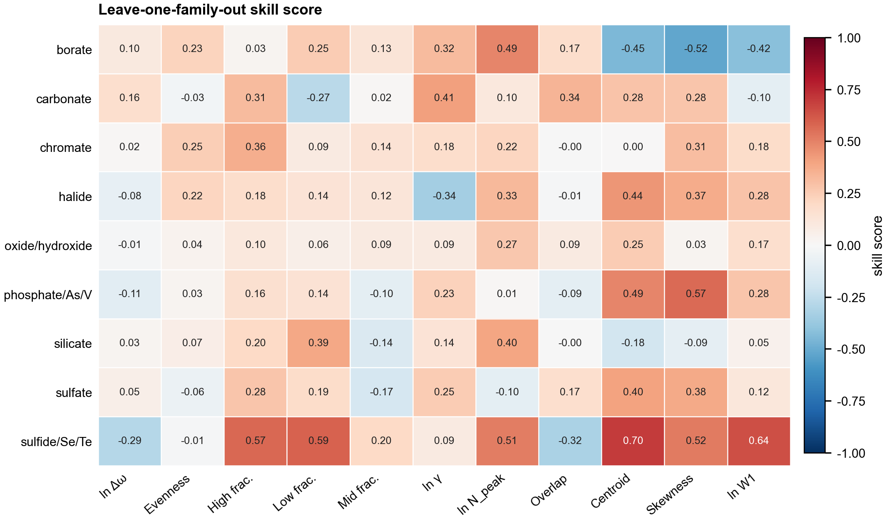
Figure S5. Leave-one-family-out extrapolation performance relative to the training-family mean baseline.
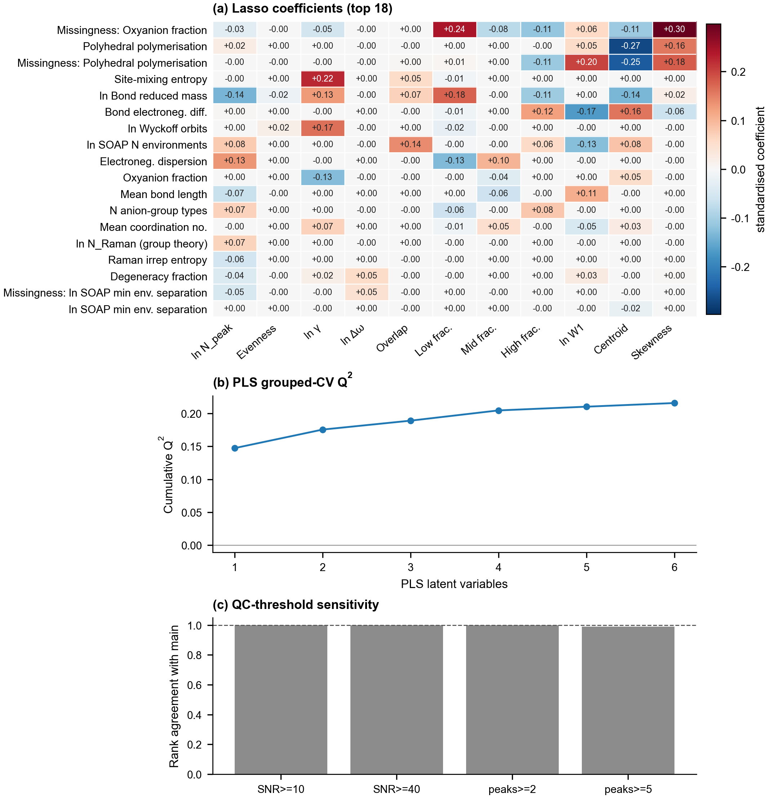
Figure S6. Nested grouped-CV Lasso, cumulative PLS Q2, and QC-threshold sensitivity.

S13. Data and reproducibility files
The tables above are reproduced from the machine-readable CSV outputs in results/tables. These include the full grouped-CV and paired-comparison outputs, descriptor availability status, complete ablation, preprocessing and SOAP sensitivities, multi-output comparisons, empirical-reference sensitivity, and LOFO results. The current analysis is implemented in scripts/data_analysis.py and scripts/structure_features.py; Raman feature extraction and cohort construction are implemented in scripts/raman_features.py and scripts/build_dataset.py. The complete raw correlation, regression, and Lasso coefficient/selection-frequency results remain available as CSV rather than being truncated to the selected display tables in this document.
Interpretive caution. Predictive associations and descriptor-availability patterns are not causal effects. Formula grouping reduces leakage from repeated formulas but does not eliminate all dependencies within solid-solution series. The RRUFF cohort is observational and does not represent uniform coverage of all crystalline minerals.

