Lesson 1 — Functions, Graph Analysis, Parent Functions & Transformations
Name: ______________________ Date: ____________
Textbook | Larson, Precalculus with Limits 6e, §1.4 – §1.7 (review §1.1 – §1.3 as needed)
Test-out topics | relation vs. function · function notation · domain & range · Vertical/Horizontal Line Test · relative max/min · piecewise functions · odd/even functions · parent graphs · shifts, reflections, non-rigid transformations
AP Precalculus | 1.1 Change in Tandem · 1.2 Rates of Change · 1.3 Rates of Change in Linear and Quadratic Functions · 1.12 Transformations of Functions
Calculator | None
Why this matters in AP Calculus BC Calculus studies how functions change. On almost every BC exam question you must read a graph, find a domain, decide where a function increases or decreases, and handle piecewise functions. The average rate of change you learn today becomes the derivative. The transformations you learn today turn into the chain rule.

Learning Objectives
By the end of this lesson I can: 1. Decide whether a relation is a function (from ordered pairs, a table, an equation, or a graph) and evaluate functions, including expressions like $f(x+h)$. 2. Find the domain and range of a function algebraically and from a graph, in interval notation. 3. Analyze a graph: zeros, increasing/decreasing intervals, relative extrema, average rate of change, and even/odd symmetry. 4. Evaluate, graph, and analyze piecewise and step functions. 5. Recognize the nine parent functions and apply transformations $y=a f\left(b(x−h)\right)+k$ to graphs, points, and equations.

Warm-Up (5 minutes, no calculator)
W1. Find the distance between $(−2, 3)$ and $(4, −5)$, and the midpoint of the segment joining them.

W2. Find the slope and the slope-intercept equation of the line through $(1, 4)$ and $(3, −2)$.

W3. Factor completely: $2x^{3}−8x$

W4. Solve and write in interval notation: $x^{2}−2x−15≤0$

W5. Simplify: $\frac{\frac{1}{x+h}−\frac{1}{x}}{h}$

Block 1 — Relations, Functions, and Domain & Range

Key definitions
- A relation is any set of ordered pairs $(x,y)$.
- A function is a relation in which each input $x$ is paired with exactly one output $y$.
- The domain is the set of all inputs; the range is the set of all outputs.
- Vertical Line Test (VLT): a graph represents $y$ as a function of $x$ if and only if no vertical line crosses the graph more than once.
- Function notation: $f(a)$ means “the output of $f$ when the input is $a$.” To evaluate, replace every $x$ with $a$, using parentheses.

Finding the implied domain
Unless a domain is stated, the domain is all real numbers that make the expression a real number. In precalculus, check for two main restrictions (a third arrives in Lesson 6):
Look for… | Restriction | Example
a denominator | denominator $≠0$ | $\frac{1}{x−2}$: $x≠2$
an even root ($\sqrt{ }, \sqrt[4]{ },…$) | radicand $≥0$ | $\sqrt{x+5}$: $x≥−5$
a logarithm (Lesson 6) | argument $>0$ | $ln(x−1)$: $x>1$
Odd roots ($\sqrt[3]{ }$) have no restriction: $\sqrt[3]{−8}=−2$. An even root in a denominator needs radicand $>0$ (strictly).

Example 1 (Is it a function?) Decide whether each relation represents $y$ as a function of $x$.
- $\{(1,2), (2,3), (1,5)\}$ (b) $x^{2}+y=4$ (c) $x+y^{2}=4$
Solution. (a) Not a function. The input $1$ is paired with two outputs, $2$ and $5$. (b) Solve for $y$: $y=4−x^{2}$. Each $x$ gives exactly one $y$. Function. (c) Solve for $y$: $y^{2}=4−x⇒y=±\sqrt{4−x}$. For $x=0$, $y=2$ or $y=−2$. Not a function.

Example 2 (Evaluating) Let $f(x)=x^{2}−3x+1$. Find (a) $f(−2)$ and (b) $f(x+h)−f(x)$.
Solution. (a) $f(−2)=(−2)^{2}−3(−2)+1=4+6+1=\boxed{11}$
- First find $f(x+h)$ by replacing every $x$ with $(x+h)$:
$$f(x+h)=(x+h)^{2}−3(x+h)+1=x^{2}+2xh+h^{2}−3x−3h+1$$
- Then subtract $f(x)$:
$$f(x+h)−f(x)=\left(x^{2}+2xh+h^{2}−3x−3h+1\right)−\left(x^{2}−3x+1\right)=\boxed{2xh+h^{2}−3h}$$
📌 Keep this answer. Dividing by $h$ gives the difference quotient, which is the first step toward the derivative (Lesson 2 and Lesson 19).

Example 3 (Domain algebraically) Find the domain of each function in interval notation.
- $g(x)=\sqrt{6−2x}$ (b) $h(x)=\frac{x+1}{x^{2}−4x−5}$ (c) $k(x)=\frac{\sqrt{x+2}}{x−3}$ (d) $p(x)=\frac{1}{\sqrt{9−x^{2}}}$
Solution. (a) Need $6−2x≥0⇒x≤3$. Domain: $(−∞, 3]$.
- Need $x^{2}−4x−5≠0⇒(x−5)(x+1)≠0⇒x≠5, x≠−1$. Domain: $(−∞,−1)∪(−1,5)∪(5,∞)$. ⚠️ Do not cancel $(x+1)$ first. The original function is still undefined at $x=−1$; its graph has a hole there (Lesson 5).
- Two conditions: $x+2≥0$ and $x−3≠0$. So $x≥−2$ and $x≠3$. Domain: $[−2, 3)∪(3, ∞)$.
- The even root is in the denominator, so $9−x^{2}>0⇒x^{2}<9⇒−3<x<3$. Domain: $(−3, 3)$.

Range. Often the easiest way to find the range is to start from a known graph and track what happens to the $y$-values. - $y=\sqrt{x−1}+2$: $\sqrt{x−1}≥0$, so $y≥2$. Range: $[2,∞)$. - $y=−x^{2}+4$: $−x^{2}≤0$, so $y≤4$. Range: $(−∞,4]$.

✏️ Your Turn 1
- Find the domain of $f(x)=\sqrt{x^{2}−9}$.

- Find the domain of $g(x)=\frac{2x}{x^{2}+1}$.

- If $f(x)=3−2x^{2}$, find and simplify $f(x−1)$.

⚠️ Common Mistakes (Block 1)
- $f(x+h)≠f(x)+h$. Always substitute the whole expression $(x+h)$ in parentheses.
- Canceling before finding the domain. Find restrictions from the original expression.
- Brackets vs. parentheses. Use $[ ]$ only when the endpoint is included. Always use $( )$ with $±∞$.
- $−x^{2}$ means $−(x^{2})$. So $f(−2)$ for $f(x)=−x^{2}$ is $−4$, not $4$.

Block 2 — Analyzing Graphs of Functions

Key ideas
Concept | Meaning
Zeros of $f$ | the $x$-values where $f(x)=0$ (the graph’s $x$-intercepts)
Increasing on an interval | as $x$ moves right, $f(x)$ goes up: $x_{1}<x_{2}⇒f(x_{1})<f(x_{2})$
Decreasing on an interval | as $x$ moves right, $f(x)$ goes down
Relative maximum $f(a)$ | $f(a)≥f(x)$ for all $x$ near $a$ (a “hilltop”)
Relative minimum $f(a)$ | $f(a)≤f(x)$ for all $x$ near $a$ (a “valley”)
Average rate of change on $[a,b]$ | $\frac{f(b)−f(a)}{b−a}$ = slope of the secant line through $(a,f(a))$ and $(b,f(b))$
Even function | $f(−x)=f(x)$ for all $x$ in the domain; graph symmetric about the $y$-axis
Odd function | $f(−x)=−f(x)$ for all $x$ in the domain; graph symmetric about the origin
Horizontal Line Test (HLT) | if no horizontal line hits the graph more than once, $f$ is one-to-one (it has an inverse function; see Lesson 2)
Conventions used in this course (same as Larson): - Increasing/decreasing intervals are written as open intervals using $x$-values. - “The relative maximum is $2$” is the $y$-value. “It occurs at $x=−1$” is the location. - Relative extrema are only at interior points of the domain, not endpoints.

Example 4 (Reading a graph) The graph of $f(x)=x^{3}−3x$ is shown.
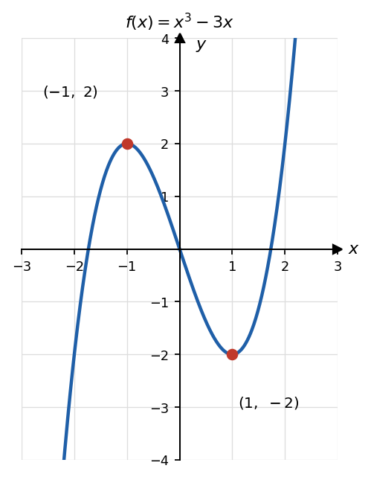
Graph of f(x) = x^3 - 3x
- Find the zeros algebraically. (b) State the intervals where $f$ is increasing or decreasing. (c) State the relative extrema. (d) Is $f$ even, odd, or neither?
Solution. (a) $x^{3}−3x=x(x^{2}−3)=0⇒x=0, x=±\sqrt{3}$. (b) Increasing on $(−∞,−1)$ and $(1,∞)$; decreasing on $(−1,1)$. (c) Relative maximum $2$ at $x=−1$; relative minimum $−2$ at $x=1$. (d) $f(−x)=(−x)^{3}−3(−x)=−x^{3}+3x=−(x^{3}−3x)=−f(x)$, so $f$ is odd. This matches the graph: rotating it ${180}^{∘}$ about the origin gives the same graph.

Example 5 (Average rate of change) For $f(x)=x^{3}−3x$, find the average rate of change on (a) $[0,2]$ and (b) $[−1,1]$.
Solution. (a) $\frac{f(2)−f(0)}{2−0}=\frac{2−0}{2}=\boxed{1}$ (b) $\frac{f(1)−f(−1)}{1−(−1)}=\frac{−2−2}{2}=\boxed{−2}$
Interpretation: on $[−1,1]$, the function’s output drops by an average of $2$ units for every $1$ unit increase in $x$.

Example 6 (Even, odd, or neither — algebraically) Substitute $−x$, simplify, and compare with $f(x)$ and $−f(x)$.
Function | $f(−x)$​ | Conclusion
$f(x)=x^{4}−2x^{2}+5$​ | $x^{4}−2x^{2}+5$​ | $=f(x)$ → even
$g(x)=x^{5}+2x$​ | $−x^{5}−2x$​ | $=−g(x)$ → odd
$h(x)=x^{2}+x$​ | $x^{2}−x$​ | neither $h(x)$ nor $−h(x)$ → neither
$k(x)=\frac{|x|}{x^{2}+1}$​ | $\frac{|−x|}{x^{2}+1}=\frac{|x|}{x^{2}+1}$​ | $=k(x)$ → even

Example 7 (AP Precalc: how the rate of change changes) For $f(x)=x^{2}$, find the average rate of change over $[0,1]$, $[1,2]$, and $[2,3]$. What pattern do you see?
Solution. $\frac{1−0}{1}=1, \frac{4−1}{1}=3, \frac{9−4}{1}=5$.
Over equal-length intervals, the average rates of change increase by a constant amount ($+2$ each time). The graph is increasing at an increasing rate (it is concave up).
AP fact: For a linear function, average rates of change over equal intervals are constant. For a quadratic function, they change by a constant amount.

✏️ Your Turn 2
- For $g(x)=−x^{2}+4x$, find the relative extremum and the intervals where $g$ is increasing or decreasing. (Hint: complete the square or find the vertex.)

- Find the average rate of change of $g$ on $[1,4]$.

- Even, odd, or neither? $p(x)=x^{3}+1 q(x)=\frac{x}{x^{2}−1}$

⚠️ Common Mistakes (Block 2)
- Giving a point $(−1,2)$ when asked for the relative maximum value ($2$), or giving the value when asked where it occurs.
- Writing increasing intervals using $y$-values. Intervals are always in terms of $x$.
- Thinking “odd function” means “odd degree.” $p(x)=x^{3}+1$ has odd degree but is not odd.
- For even/odd, one numerical example is not a proof. Show $f(−x)$ algebraically.

Block 3 — Parent Functions, Piecewise and Step Functions

The nine parent functions (memorize shape, domain, range, symmetry)
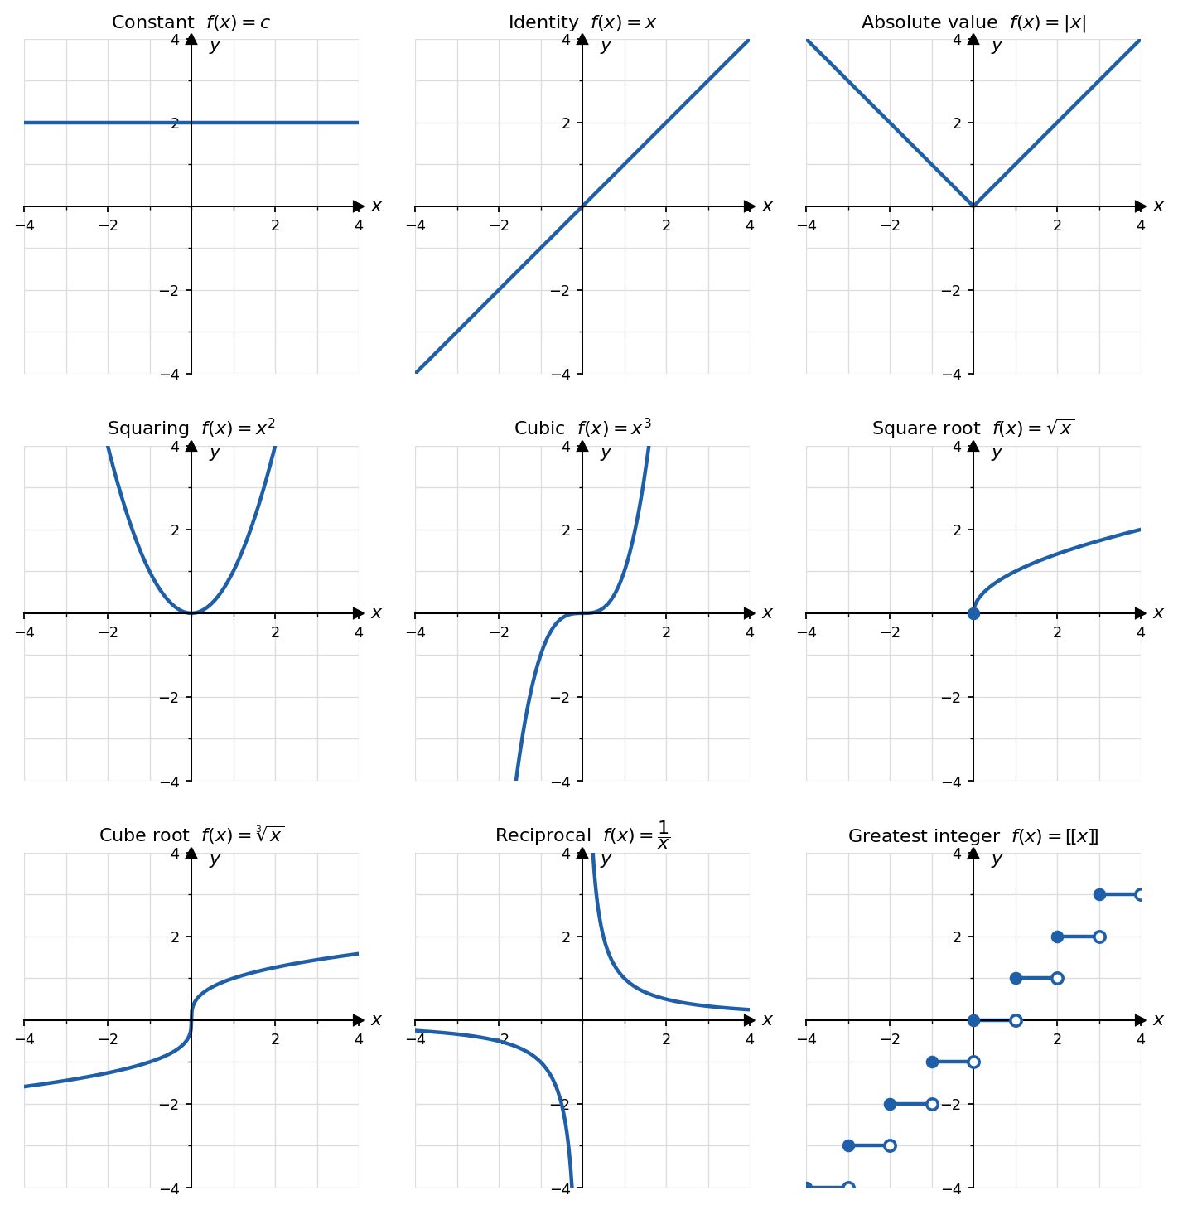
Library of parent functions
Name | Equation | Domain | Range | Symmetry
Constant | $f(x)=c$​ | $(−∞,∞)$​ | $\{c\}$​ | even
Identity | $f(x)=x$​ | $(−∞,∞)$​ | $(−∞,∞)$​ | odd
Absolute value | $f(x)=|x|$​ | $(−∞,∞)$​ | $[0,∞)$​ | even
Squaring | $f(x)=x^{2}$​ | $(−∞,∞)$​ | $[0,∞)$​ | even
Cubic | $f(x)=x^{3}$​ | $(−∞,∞)$​ | $(−∞,∞)$​ | odd
Square root | $f(x)=\sqrt{x}$​ | $[0,∞)$​ | $[0,∞)$​ | neither
Cube root | $f(x)=\sqrt[3]{x}$​ | $(−∞,∞)$​ | $(−∞,∞)$​ | odd
Reciprocal | $f(x)=\frac{1}{x}$​ | $x≠0$​ | $y≠0$​ | odd
Greatest integer | $f(x)=[​[x]​]$​ | $(−∞,∞)$​ | all integers | neither
$[​[x]​]$ = the greatest integer less than or equal to $x$. Calculus books write $⌊x⌋$ (“floor”). $[​[2.7]​]=2, [​[−2.7]​]=−3$ (not $−2$!), $[​[5]​]=5$. Exponential and logarithmic parent graphs are added in Lesson 6.

Piecewise-defined functions
A piecewise function uses different formulas on different parts of the domain. To evaluate, first decide which piece the input belongs to, then use only that formula.

Example 8 (Piecewise function)
$$f(x)=\left\{\begin{matrix}x^{2}−1, & x<1 \\ 3−x, & 1≤x≤4 \\ 2, & x>4\end{matrix}\right.$$
- Find $f(−2), f(1), f(4), f(5)$. (b) Sketch the graph. (c) As $x$ approaches $1$ from the left, what value does $f(x)$ approach? Is the graph connected at $x=1$?
Solution. (a) $f(−2)=(−2)^{2}−1=3$ (first piece); $f(1)=3−1=2$ (second piece, since $1≤1$); $f(4)=3−4=−1$; $f(5)=2$.
- 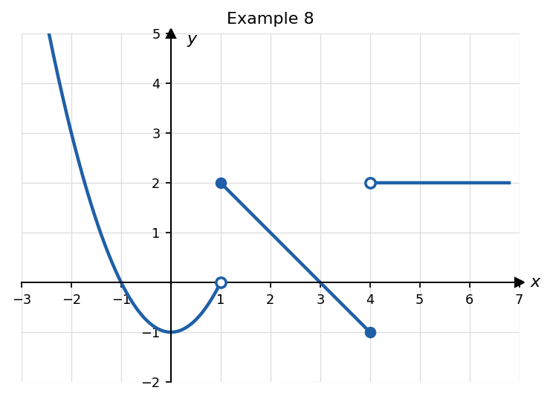
- Piecewise function for Example 8
Closed dot = point included; open dot = point not included.
- From the left, use $x^{2}−1$: the values approach $1^{2}−1=0$. But $f(1)=2$. The graph jumps at $x=1$, so it is not connected there.
📌 BC preview: In calculus we write this as $\lim_{x→1^{−}}f(x)=0$ (“the limit as $x$ approaches $1$ from the left”). Because this does not equal $f(1)=2$, $f$ is not continuous at $x=1$.

Example 9 (Step function) Evaluate: (a) $[​[2.7]​]$ (b) $[​[−2.7]​]$ (c) $g(−0.5)$ for $g(x)=[​[x]​]+1$.
Solution. (a) $2$ (b) $−3$ (c) $[​[−0.5]​]+1=−1+1=0$.

Example 10 (Absolute value as a piecewise function) Write $y=|x−2|$ without absolute value bars.
Solution. $|x−2|=\left\{\begin{matrix}x−2, & x≥2 \\ −(x−2)=2−x, & x<2\end{matrix}\right.$

✏️ Your Turn 3
$$g(x)=\left\{\begin{matrix}2x+3, & x≤−1 \\ x^{2}, & −1<x<2 \\ 5, & x≥2\end{matrix}\right.$$
(a) Find $g(−3), g(−1), g(0), g(2)$.

- Sketch the graph. Mark open and closed dots carefully.

- As $x$ approaches $2$ from the left, what does $g(x)$ approach? Is the graph connected at $x=2$? At $x=−1$?

⚠️ Common Mistakes (Block 3)
- Using the wrong piece at a boundary value. Check the inequality signs ($≤$ vs. $<$).
- $[​[−2.7]​]=−3$, not $−2$. “Greatest integer $≤−2.7$” means move left on the number line.
- Drawing a closed dot where the inequality is strict.

Block 4 — Transformations of Functions

The general form
$$\boxed{ y=a f\left(b(x−h)\right)+k }$$
Parameter | Effect on the graph of $y=f(x)$ | Acts on
$k>0$ / $k<0$ | shift up / down $|k|$ | $y$ (outside)
$h>0$ / $h<0$ | shift right / left $|h|$ ⚠️ opposite of the sign you see | $x$ (inside)
$|a|>1$ / $0<|a|<1$ | vertical stretch / shrink by factor $|a|$ | $y$​
$a<0$​ | reflection in the $x$-axis | $y$​
$|b|>1$ / $0<|b|<1$ | horizontal shrink / stretch by factor $\frac{1}{|b|}$ | $x$​
$b<0$​ | reflection in the $y$-axis | $x$​
Rigid transformations (shifts, reflections) keep the shape. Non-rigid transformations (stretches, shrinks) distort it.

⭐ The Point-Mapping Rule (most reliable method)
$$\boxed{(x_{0}, y_{0}) \text{on }y=f(x) → \left(\frac{x_{0}}{b}+h, a y_{0}+k\right) \text{on }y=a f\left(b(x−h)\right)+k}$$
- $x$: divide by $b$, then add $h$. (Undo what’s inside.) - $y$: multiply by $a$, then add $k$. (Do what’s outside.)
⚠️ Always factor out $b$ first. $f(2x−6)=f\left(2(x−3)\right)$ shifts right $3$, not $6$.

Example 11 (Describe the transformations) Describe how $g(x)=−2\sqrt{x+3}+1$ is obtained from $f(x)=\sqrt{x}$. State the domain and range of $g$, and find the image of the point $(4,2)$.
Solution. Here $a=−2, b=1, h=−3, k=1$. - shift left 3 - vertical stretch by factor $2$ - reflect in the $x$-axis - shift up 1
Domain: $x+3≥0⇒[−3,∞)$. Range: $\sqrt{x+3}≥0⇒−2\sqrt{x+3}≤0⇒g(x)≤1$, so $(−∞,1]$. Image of $(4,2)$: $\left(4−3, −2(2)+1\right)=(1,−3)$. ✔ Check: $g(1)=−2\sqrt{4}+1=−3$.

Example 12 (Transform a graph) The graph of $y=f(x)$ is shown. Sketch (a) $y=−f(x+1)+3$ and (b) $y=1/2f(2x)$.
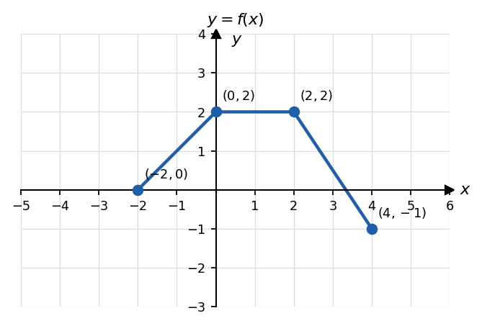
Base graph y = f(x)
Solution. Transform the four key points, then connect them in order.
$(x_{0},y_{0})$​ | (a) $(x_{0}−1, −y_{0}+3)$ | (b) $\left(\frac{x_{0}}{2}, \frac{y_{0}}{2}\right)$
$(−2,0)$​ | $(−3,3)$​ | $(−1,0)$​
$(0,2)$​ | $(−1,1)$​ | $(0,1)$​
$(2,2)$​ | $(1,1)$​ | $(1,1)$​
$(4,−1)$​ | $(3,4)$​ | $(2,−1/2)$​

Example 13 (Write the equation from a graph) The graph below is a transformation of $y=\sqrt{x}$. Write its equation.
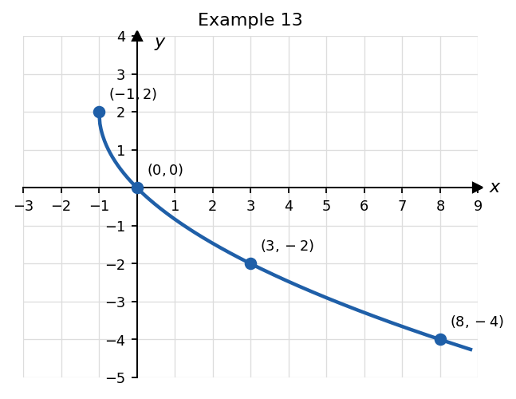
Transformed square root graph
Solution. The “starting point” of $\sqrt{x}$ is $(0,0)$; here it is $(−1,2)$. So $h=−1$ and $k=2$: $y=a\sqrt{x+1}+2$. Use another point, $(3,−2)$: $−2=a\sqrt{4}+2⇒2a=−4⇒a=−2$.
$$\boxed{y=−2\sqrt{x+1}+2} \text{Check }(8,−4): −2\sqrt{9}+2=−4 ✔$$

Example 14 (Horizontal changes: factor first!) Describe how $g(x)=\sqrt{4−2x}$ is obtained from $f(x)=\sqrt{x}$.
Solution. Factor inside: $4−2x=−2(x−2)$, so $g(x)=\sqrt{−2(x−2)}$ with $b=−2, h=2$. - horizontal shrink by factor $1/2$ - reflection in the $y$-axis - shift right 2
Point check: $(4,2)→\left(4/{−2}+2, 2\right)=(0,2)$. ✔ $g(0)=\sqrt{4}=2$. Domain: $4−2x≥0⇒(−∞,2]$.

✏️ Your Turn 4
- Describe the transformations from $y=x^{3}$ to $h(x)=1/2(x−4)^{3}−2$.

- Using the graph of $f$ from Example 12, list the key points of $y=f(x−3)+1$.

- Write the equation: $y=\sqrt{x}$ is reflected in the $y$-axis and then shifted up $4$.

⚠️ Common Mistakes (Block 4)
- $f(x−3)$ shifts right, not left.
- $f(2x)$ is a horizontal shrink (points move closer to the $y$-axis), not a stretch.
- Vertical: stretch/reflect first, then shift. For $y=2f(x)+3$, the point $(1,5)$ goes to $(1, 2⋅5+3)=(1,13)$, not $(1,16)$.
- Forgetting to factor out $b$: $f(3x+6)=f\left(3(x+2)\right)$ shifts left $2$.

🚀 BC Connection — From Average Rate to Instantaneous Rate
1. Secant lines → tangent line. For $f(x)=x^{2}$, the average rate of change on $[1, 1+h]$ is
$$\frac{f(1+h)−f(1)}{h}=\frac{(1+h)^{2}−1}{h}=\frac{2h+h^{2}}{h}=2+h (h≠0).$$
$h$​ | $1$​ | $0.5$​ | $0.1$​ | $0.01$​ | $→0$​
slope of secant $=2+h$ | $3$​ | $2.5$​ | $2.1$​ | $2.01$​ | $→2$​
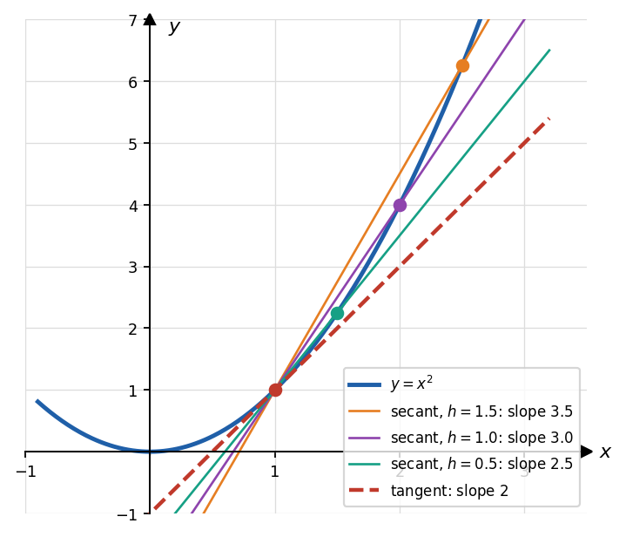
Secant lines approaching the tangent line
As $h→0$, the secant slopes approach $2$, the slope of the tangent line at $x=1$. In calculus this is the derivative: $f^{′}(1)=2$.
2. Relative extrema come from derivatives. In BC you will learn that $f(x)=x^{2}−3x$ has derivative $f^{′}(x)=2x−3$.
3. Piecewise functions test continuity. “Is $f$ continuous at $x=1$?” (Example 8) is a standard BC free-response question.
4. Odd functions and area. For an odd function, the area above the axis on $[0,a]$ cancels the area below it on $[−a,0]$. In BC: $\int_{−a}^{a}{f}(x) dx=0$.

📋 Lesson 1 Summary
Topic | Key fact
Domain | denominators $≠0$; even radicands $≥0$; (logs: argument $>0$)
Average rate of change | $\frac{f(b)−f(a)}{b−a}$ = slope of secant line
Even | $f(−x)=f(x)$; $y$-axis symmetry
Odd | $f(−x)=−f(x)$; origin symmetry
VLT / HLT | VLT → function; HLT → one-to-one
Relative max/min | a $y$-value, occurring at an interior $x$-value
Piecewise | choose the piece by the input; check boundary signs
Transformations | $y=a f\left(b(x−h)\right)+k$: $(x_{0},y_{0})→\left(\frac{x_{0}}{b}+h, ay_{0}+k\right)$

🎫 Exit Ticket (10 minutes, hand in)
1. What is the domain of $f(x)=\frac{\sqrt{x+4}}{x−1}$?
- $[−4,∞)$ (B) $(−4,1)∪(1,∞)$ (C) $[−4,1)∪(1,∞)$ (D) $(−∞,−4]∪(1,∞)$
2. The point $(6,−2)$ is on the graph of $y=f(x)$. Which point must be on the graph of $y=3f​\left(1/2x\right)−1$?
- $(3,−7)$ (B) $(12,−7)$ (C) $(12,−5)$ (D) $(3,−5)$
3. Let $f(x)=x^{3}−4x$. (a) Show algebraically that $f$ is an odd function. (b) Find the average rate of change of $f$ on $[1,3]$. (c) $f$ has a relative minimum value of $−\frac{16\sqrt{3}}{9}$ at $x=\frac{2\sqrt{3}}{3}$. Use part (a) to state the relative maximum value of $f$ and where it occurs. Explain your reasoning.

