# eureka

## Eureka概览图

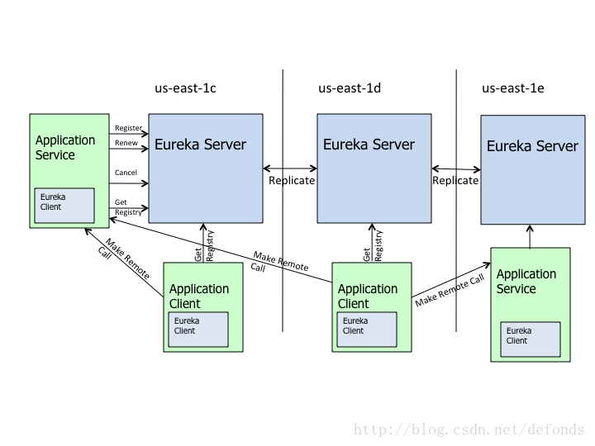

## Eureka Server（发现服务）

### Java

|  |
| --- |
| **package** lzg;  **import** org.springframework.boot.SpringApplication;  **import** org.springframework.boot.autoconfigure.SpringBootApplication;  **import** org.springframework.cloud.netflix.eureka.server.EnableEurekaServer;  @SpringBootApplication  @EnableEurekaServer  **public** **class** ServiceRegistrationServer {  **public** **static** **void** main(String[] args) {  // Tell Boot to look for application-server.yml  System.*setProperty*("spring.config.name", "application");  SpringApplication.*run*(ServiceRegistrationServer.**class**, args);  }  } |

### application.yml

|  |
| --- |
| # Configure this Discovery Server  eureka:  instance:  hostname: localhost  client: # Not a client, don't register with yourself  registerWithEureka: **false**  fetchRegistry: **false**  server:  port: 1111 # HTTP (Tomcat) port |

### Build.gradle

|  |
| --- |
| apply plugin: 'java'  apply plugin: 'spring-boot'  //war时使用  apply plugin: 'war'  **def** version='1.0-beta'  //中文字符集设置  [compileJava, javadoc, compileTestJava]*.options*.encoding = 'UTF-8'  buildscript {  repositories { maven { url 'http://localhost:8081/nexus/content/groups/public/'} }  dependencies { classpath("org.springframework.boot:spring-boot-gradle-plugin:1.3.5.RELEASE") }  }  //源代码jdk版本  sourceCompatibility='1.7'  repositories { maven { url 'http://localhost:8081/nexus/content/groups/public/'} }  //war时使用  war{  **if**(project.*hasProperty*('build.version')){  version=project.ext['build.version']  }  baseName ="hbtms"  manifest {  attributes("Implementation-Title": "lzg",  "Implementation-Vendor": "lzg",  "Implementation-Version": version)  }  }  configurations{ providedRuntime }  dependencies {  //spring-boot  compile("org.springframework.boot:spring-boot-starter")  compile("org.springframework.boot:spring-boot-starter-logging")  compile "org.springframework.cloud:spring-cloud-starter:1.0+"  compile "org.springframework.cloud:spring-cloud-starter-eureka-server:1.0+"  compile "com.google.guava:guava:18.0+"  compile ('org.roboguice:roboguice:2.0+')  compile ('com.netflix.servo:servo-core:0.12+')  //增加项目本地依赖  compile fileTree(dir: "$projectDir*/libs"* )  } |

## Eureka client – application service

### Java

|  |
| --- |
| package test;  import org.springframework.boot.SpringApplication;  import org.springframework.boot.autoconfigure.SpringBootApplication;  import org.springframework.boot.builder.SpringApplicationBuilder;  import org.springframework.boot.context.web.SpringBootServletInitializer;  import org.springframework.cloud.client.discovery.EnableDiscoveryClient;  @SpringBootApplication  @EnableDiscoveryClient  public class Application extends SpringBootServletInitializer {  /**  * jar启动  */  public static void main(String[] args) {  System.setProperty("spring.config.name", "registration-client");  SpringApplication.run(Application.class, args);  }  } |

### application.yml

|  |
| --- |
| # Spring properties  spring:  application:  name: test-service  mvc:  view:  prefix: /webapp/view/  suffix: .html  # Discovery Server Access  eureka:  client:  serviceUrl:  defaultZone: http://localhost:1111/eureka/  # HTTP Server  server:  port: 2222 # HTTP (Tomcat) port |

### Build.gradle

|  |
| --- |
| apply plugin: 'java'  apply plugin: 'spring-boot'  //war时使用  apply plugin: 'war'  **def** version='1.0-beta'  //中文字符集设置  [compileJava, javadoc, compileTestJava]*.options*.encoding = 'UTF-8'  buildscript {  repositories { maven { url 'http://localhost:8081/nexus/content/groups/public/'} }  dependencies { classpath("org.springframework.boot:spring-boot-gradle-plugin:1.3.5.RELEASE") }  }  //源代码jdk版本  sourceCompatibility='1.7'  repositories { maven { url 'http://localhost:8081/nexus/content/groups/public/'} }  //war时使用  war{  **if**(project.*hasProperty*('build.version')){  version=project.ext['build.version']  }  baseName ="hbtms"  manifest {  attributes("Implementation-Title": "lzg",  "Implementation-Vendor": "lzg",  "Implementation-Version": version)  }  }  configurations{ providedRuntime }  dependencies {  //spring-boot  compile("org.springframework.boot:spring-boot-starter")  compile("org.springframework.boot:spring-boot-starter-logging")  compile "org.springframework.cloud:spring-cloud-starter:1.0+"  compile "org.springframework.cloud:spring-cloud-starter-eureka-server:1.0+"  compile "com.google.guava:guava:18.0+"  compile ('org.roboguice:roboguice:2.0+')  compile ('com.netflix.servo:servo-core:0.12+')  //增加项目本地依赖  compile fileTree(dir: "$projectDir*/libs"* )  } |

## 查看eureka当前应用

* <http://localhost:1111/>
* <http://localhost:1111/eureka/apps>
* <http://localhost:1111/eureka/apps/TEST-SERVICE>