**ABSTRACT**

Underwater image processing is a prominent area of digital image processing which can be used in various different applications. It is a complex field because of the physical features of the underwater environment. They are mainly concerned with light dispersion, absorption and deterioration due to low visibility circumstances. This study is divided into two sections. The first section includes the performance examination of several histogram equalization approaches and the second section is about the color balance method for underwater picture improvements.

The objective is to find an efficient approach for enhancing underwater photographs that have deteriorated due to medium scattering and absorption without the need any special equipment or understanding of the underwater environment. For achieving this objective, the methods of white balancing, gamma correction, image sharpening, multiscale fusion and Laplace function are used in this process. This procedure includes two crucial steps. The first step is to figure out how to provide acceptable inputs and the second step is to choose appropriate weight maps which are the background facts and related algorithms.

In the final results, it is understood that the images are better exposed, saturated and have sharper edges. It can be concluded that this approach provides a fusion-based technique for improving underwater image quality with little complexity and excellent efficiency.

# CHAPTER-1: PROJECT DESCRIPTION AND OUTLINE

## Introduction

The Earth is an aquatic planet and water covers 70% of the earth’s surface. Exploration of underwater image vision is difficult due to bad visibility caused by ocean environment and therefore underwater image processing is a prominent area of digital image processing. The underwater image enhancement process is also used in various other applications. For example, such a procedure can monitor marine environment and also can be used in making pipeline inspection easier. Underwater imaging is a complex field because of the various physical features of the underwater environment. These physical features are mainly concerned with light dispersion and absorption. Underwater photos lose contrast and suffer deterioration due to low visibility circumstances and processes such as light absorption, reflection, bending and light scattering.

For an ideal transmission medium, the received light is influenced mainly by the properties of the target objects and the camera lens characteristics. This is not the case in underwater. First, the amount of light available under water, depends on several factors. The interaction between the sunlight and the sea surface is affected by the time of the day, which influences the light incidence angle, and by the shape of the interface between air and water that is rough sea or calm sea. The diving location also directly impacts the available light, due to a location-specific color cast: deeper seas and oceans induce green and blue casts, tropical waters appear cyan, while protected reefs are characterized by high visibility. In addition to the variable amount of light available under water, the density of particles that the light has to go through is several hundreds of times denser in seawater than in normal atmosphere. As a consequence, sub-sea water absorbs gradually different wavelengths of light.

There are various problems with capturing pictures underwater. If water has any particulate matter in it, it shows up on the photographs. Water also refracts the incident light differently than air. It sometimes magnifies objects in a way that they appear more closer than they actually are. These issues are beyond the means of many cameras’ white balance and other auto-exposure settings. However, there are various methods and algorithms that can be used to solve these problems. These methods and algorithms include red channel method, underwater image dehazing, contrast enhancement algorithm and depth estimation method. However, these methods provide a few drawbacks including less contrast and unsharp edges that make them not feasible to use.

In the view of this knowledge, this proposed work is constructed using a devised method which provides a one stop solution to all these problems by using the methods including color channel histograms, white balancing, gamma correction, multi-scale fusion and laplace functions.

## Problem statement

Develop a code that takes an underwater captured image, enhances it using methods of white balancing, gamma correction, sharpening, multiscale fusion and laplace functions.

## Project Objective

* + - The objective is to find an efficient approach for enhancing underwater photographs that have deteriorated due to medium scattering and absorption.
    - It does not require any special equipment or understanding of the underwater environment.
    - It Enhance a wide variety of underwater photographs with great accuracy.
    - Recover crucial features and edges that have faded over time.
    - The dark portions of our upgraded photographs and movies are better exposed, the overall contrast is increased and the edges are sharper.

## Organization of Project

The following are the chapters in which the project is organized:

**Chapter 1:** Project description and outline:

Chapter 1 consists the basic overview of the project. This includes introduction to the proposed work, problem statement, the objectives that are being accomplished from this project, organization and the scope. This chapter will provide a brief idea of the proposed work that is being carried out.

**Chapter 2:** Related work investigation:

This chapter consists of the existing work that aim towards the enhancement of the underwater images but using different techniques and procedures. This section will provide the related work investigations and how the proposed work is different existing works.

**Chapter 3:** Underwater image enhancement:

Chapter 3 consists of the in-depth knowledge of the project. This includes the introduction to the project, experimental setup which includes the step-by-step procedure in which the project was carried out, architectural diagrams and discussions that were carried out while creation of the project.

## Scope of the project

* Images will be enhanced easily and efficiently.
* The code runs on any python compiler like spyder, jupyter notebook, VS code, google colab etc.
* Only input image is to be provided by the user. All the other functions are performed by the compiler and final image is given. Therefore, manual work is reduced.

# CHAPTER-2: RELATED WORK INVESTIGATION

## Introduction

Image enhancement is the technique for processing the input underwater image to result it in a proper and clearly visible image which can be used for the various research applications. Image enhancement in the underwater images would be difficult task as it would eliminate the information which is present inside the image while the enhancement process is carried out. Enhancement process is carried out by modifying the image features like edges, contrast and saturation.

Various existing algorithm of the enhancement process shows the images have the poor quality because of the nature of the light. When the light is entering into the water, the light gets refracted and it was absorbed and scattered as the water is denser medium than air. Light has different intensity and different wavelength according to the red, green and blue colors present in the water.

## Existing Works

The underwater image enhancement is a prominent area of the digital image processing due to which there are a lot of experiments and procedure devised in order to achieve the results. The following are the existing works which have proved to be quite successful in this experiment.

* + 1. The article titled ‘Underwater Image Processing: State of the Art of Restoration and Image Enhancement Methods’ has used the method of light attenuation which uses absorption and scattering method. The images used in this process can suffer one or more of the following problems: limited range visibility, low contrast, non-uniform lighting, blurring, bright artifacts, color diminished and noise. Application of standard computer vision techniques is also used in this method.
    2. The article titled 'Underwater Image Enhancement with Image Colorfulness Measure' is made up of two parts. First is a non-parameter layers for preliminary color correction. Second part is a parametric layer for self-adaptive refinement namely channel-wise linear shift. For better details, contrast and colorfulness, this enhancement network is jointly optimized by the pixel-level and characteristic-level training criteria.
    3. The article titled ‘An approach for underwater image enhancement based on color correction and dehazing’ is a solution to solve the problems of color deviation, low contrast, varying degrees of fuzziness and blurry details. This approach for single underwater image enhancement is based on fusion technology. The following are the steps used in this method:

first, the original image is preprocessed by the white balance algorithm and dark channel prior dehazing technologies, respectively; then two input images were obtained by color correction and contrast enhancement; and finally, the enhanced image was obtained by utilizing the multiscale fusion strategy which is based on the weighted maps constructed by combining the features of global contrast, local contrast, saliency and exposedness.

* + 1. The article 'Restoration and Enhancement of Underwater Images Based on Bright Channel Prior' introduces a method of underwater images restoration and enhancement which is inspired by the dark channel prior in image dehazing field. Firstly, authors have used the bright channel prior of underwater environment. By estimating and rectifying the bright channel image, estimating the atmospheric light, and estimating and refining the transmittance image, eventually underwater images are restored. Secondly, in order to rectify the color distortion, the restoration images are equalized by using the deduced histogram equalization. The experiment results have showed that this method could enhance the quality of underwater images effectively.
    2. The article titled ‘Underwater Image Enhancement Using Image Processing Technique’ has used the method of photographic fusion which is devised in such a way that it uses the following steps: pre-processing, hybrid wavelet transforms, background removal, histogram mapping, wavelet fusion and adaptive local histogram specification. Even though background removal sometimes affects the details in the photograph, this method can still be used efficiently for enhancement purposes.

The following is the detailed experimental information of the photographic fusion method:

###### Photographic fusion

Photographic fusion is the approach of producing a single fused snapshot utilizing a set of input pictures. Input image would be multi-sensor, multimodal, multifocal or multi-temporal. Then, the hybrid wavelet transform is applied on it for sharpening the image. The low-frequency background is removed using a high-pass filter. Image histograms are then mapped based on the intermediate color channel to reduce the gap between the inferior and dominant color channels. Then wavelet fusion is applied followed by adaptive local histogram specification process. The resultant images processed through the proposed approach could be further used for detection and recognition to extract more valuable information.

The existing work method is an underwater image enhancement technique which is normally used as a pre-processing method for object detection and recognition of underwater image. This method consists of integrated steps namely pre-processing, hybrid wavelet transforms, background removal, histogram mapping, wavelet fusion, and adaptive local histogram specification. With the aim of enhancing the image contrast and visibility, it provides a platform for image detection and recognition.

###### Methodology

The following are the steps into which the existing method is divided:

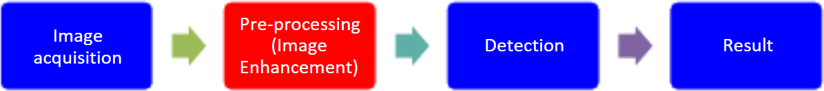

**Figure 2.1: Photogrpahic fusion methodology**

###### Image Acquisition:

* Input image is captured from the underwater through the camera.
* This captured image is in the form of RGB image which consists of red, green and blue region.
* The captured image undergoes the pre-processing stage the bigger the pixel values the more in center of attention the photograph.
* As a consequence, this algorithm chooses the in-focus areas from each and every enter photograph through picking the finest value for each and every pixel, resulting in particularly targeted output.

###### Pre-processing:

* The pre-processing stages in image processing consists of various number of processes which depends according to the input image.
* The RGB image is converted towards the gray scale image which have the pixel range of 0 to 255.
* Filtering process comes under the pre-processing stage. This filtering process reduces the disturbances which is present in the image.

###### Detection:

* The detection process which includes the enhancement of image which is taken as an input image.
* In the proposed work enhancement process is carried out using hybrid wavelet transform technique. Using this technique noise can be removed and the enhancement of image will be higher.

###### Results:

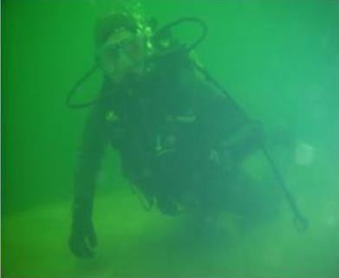Input image:

**Figure 2.2: Input image used in photographic fusion method**

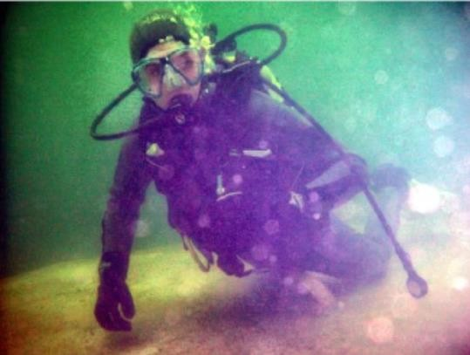Resultant image:

**Figure 2.3: Output image used in photographic fusion method**

###### Exisiting Work

The following is the block diagram for the existing work:

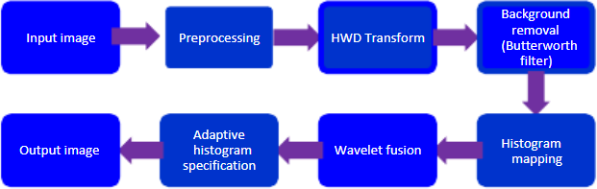

**Figure 2.4: Photogrpahic fusion block diagram**

The following input image is being processed:



###### Pre-processing:

* The image is converted from RGB to grey scale. Grey scale is a range of shades of grey without apparent color.
* Grey scale Images are more suitable for many applications such as edge detection.
* After the conversion to grey scale, the image will appear like the following:

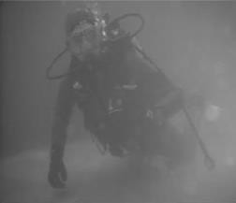

###### Hybrid wavelet transform:

* Hybrid wavelet transform is a two-tier transform, where initially a conventional discrete wavelet transform is applied, followed by the directional ﬁlters on the detail subbands.
* The following image is the representation of the hybrid wavelet transform:

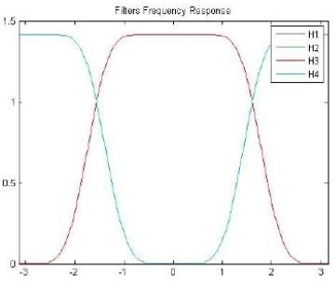

###### Background removal:

* The image will be first converted into natural logarithm domain before the Fast Fourier transformation is applied.
* The high pass filter is then applied using the Butterworth filter.
* Butterworth high-pass filter is an effective high-pass filter to eliminate low frequency signal which is normally used for background removal.
* 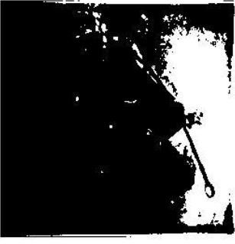Background removal will appear like the following image:

###### Histogram mapping:

* Red color channel is normally the inferior color channels while green and blue color channels are the dominant color channels.
* The percentage of red color channel is the lowest while highest color channel percentage commonly taken by green or blue color channel.
* 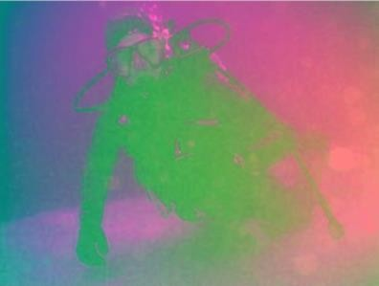The following is the image obtained after histogram mapping:
* Once the histogram mapping is done, the obtained image will go through the wavelet fusion and the resultant image will be obtained as follows:



###### Summary

* This project makes the image go through gray scale correction, hybrid wavelet transformation, background subtraction and histogram mapping**.**
* This method is an underwater image enhancement technique which is normally used as a pre- processing method for object detection and recognition of underwater image.
* The integrated steps include pre-processing, hybrid wavelet transform, background removal, histogram mapping, wavelet fusion, and adaptive local histogram specification.
* With the aim of enhancing the image contrast and visibility, this method provides a platform for image detection and recognition

# 