Paper Template for ICLC 2015
First Author | Second Author | Third Author
Affiliation1  author1@leeds.ac.uk | Affiliation2  author2@sussex.ac.uk | Affiliation3  author3@roulette.mx

ABSTRACT
The abstract should contain around 150–200 words.
- INTRODUCTION
This template includes all the information about formatting manuscripts for the 2015 International Conference on Live Coding. Please use either the present Microsoft Word template, or the markdown templates when preparing your submission, and follow these guidelines to give the final proceedings a uniform look. If you have any questions, please contact the organisers at livecodenet@gmail.com.
The latest version of this template can be downloaded from the conference website.
- PAGE size AND FORMAT
The proceedings will be formatted as portrait A4-size paper (21.0cm x 29.7cm). All material on each page should fit within a rectangle of 17.2cm x 25.2cm, centered on the page, beginning 2.0cm from the top of the page and ending with 2.5cm from the bottom. The left and right margins should be 1.9cm. The text should be in a single column. All text must be justified.
- Typeset Text
If this template looks bad, and you are reading it in Word, that is probably because you do not have the right fonts installed. In general the font to use is Linux Libertine, with the Inconsolata font used for any code examples. You should have received these fonts with the present template, and they are also downloadable online.
  - Body Text
Please use an 11pt (point) Linux Libertine font.
  - Code examples
Code examples should be in Inconsolata, using colour syntax highlighting if you wish.
  - Title and Authors
The title is 16pt Linux Libertine, bold, capitalised, centered. Authors’ names are centered. The lead author’s name is to be listed first (leftmost), and the co-authors’ names after. If the addresses for all authors are the same, include the address only once, centered. If the authors have different addresses, put the addresses, evenly spaced, under each authors’ name.
  - First Page Copyright Notice
Please include the copyright notice exactly as it appears here in the lower left-hand corner of the page. It is set in 8pt Linux Libertine.
  - Page Numbering, Headers and Footers
Do not include headers, footers or page numbers in your submission.
- headings
First level headings are in Linux Libertine 12pt bold, with 1 line of space above the section head, and 1/2 space below it. For a section header immediately followed by a subsection header, the space should be merged.
  - Second Level Headings
Second level headings are in Linux Libertine 10pt bold, flush left, with 1 line of space above the section head, and 1/2 space below it. The first letter of each significant word is capitalised.
    - Third Level Headings
Third level headings are in Linux Libertine 10pt italic, flush left, with 1/2 line of space above the section head, and 1/2 space below it. The first letter of each significant word is capitalised.
Please do not use more than three levels of headings.
- Floats
  - Figures, Tables, and Captions
All artwork must be centered, neat, clean, and legible. All lines should be very dark for purposes of reproduction and artwork should not be hand-drawn. The proceedings will be distributed in electronic form only, therefore color figures are allowed. However, you may want to check that your figures are understandable even if they are printed in black-and-white.

String value | Numeric value
Hello ICLC | 2015
Table 1. Table captions should be placed below the table.
Numbers and captions of figures and tables always appear below the figure/table. Leave 1 line space between the figure or table and the caption. Figure and tables are numbered consecutively. Captions should be Linux Libertine 10pt. Place tables/figures in text as close to the reference as possible, and preferably at the top of the page.
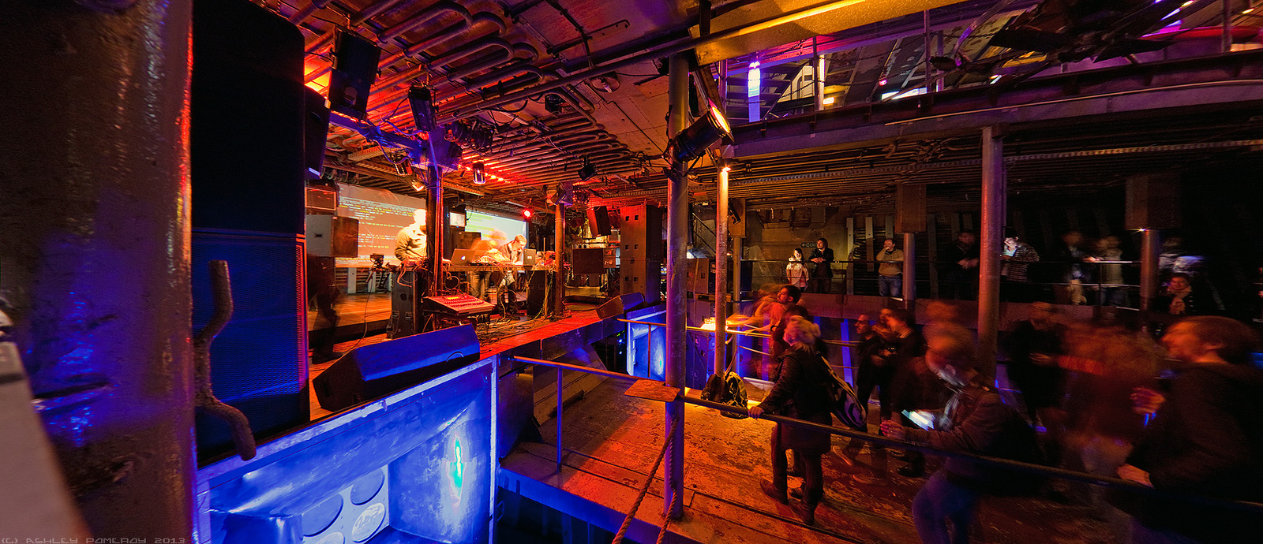
Figure 1. Figure captions should be placed below the figure, like this. Photo © Ashley Pomeroy, 2013.
Always refer to tables and figures in the main text, for example: see Figure 1 and Table 1. Figures and tables may extend the page to a maximum width of 17.2cm.
Vectorial figures are preferred, e.g. using Postscript or PDF formats. Also, in order to optimise readability, the font size of text within a figure should be at list identical to footnote font size. If bitmap figures are used, please make sure that the resolution is enough for print quality.
  - Footnotes
Indicate footnotes with a number in the text. Use 8pt type for footnotes. Place the footnotes at the bottom of the page on which they appear. Precede the footnote with a 0.5pt horizontal rule.
- Citations
All bibliographical references should be listed at the end, inside an unnumbered section named “REFERENCES”.
References must be given in alphabetic order, and in Chicago author-date format. Please do not list references that are not referred to in the text.
When making bibliographic references, authors may be referenced inline, such as the following; the German artist Schwitters (1932) wrote the Ursonate sound poem. Alternatively, the author may be placed in parenthesis, e.g., Ursonate is a sound poem (Schwitters 1932). Multiple references should be grouped together like so (Schwitters 1932; Miller 1956; Greenewalt 1946).
- CONCLUSIONS
We look forward to receiving your completed papers. Submission is fully electronic and automated through Easychair. Do not send papers directly by e-mail.

Acknowledgments
At the end of the Conclusions, acknowledgements to people, projects, funding agencies, etc. can be included after the second-level heading “Acknowledgments” (with no numbering).

REFERENCES
Greenewalt, Mary H. 1946. Nourathar, the Fine Art of Light Color Playing. Philadelphia. Pa. Westbrook.
Miller, George. A. 1956. “The Magical Number Seven Plus or Minus Two: Some Limits on Our Capacity for Processing Information.” Psychological Review 63 (2): 81–97.
Schwitters, Kurt. 1932. “Ursonate.” Merz 24. Merz.

This is a footnote.

