**Site description**

The mean annual temperature was -1 °C and the mean annual precipitation was 390 mm. The studied sites were located on a gentle (~4˚), north-facing, and relatively upland slope. Permafrost temperature in this area has been monitored in a 30 m deep borehole near the Mo site since 1985. An organic layer of 45 cm to 65 cm in thickness covered the mineral soil composed mostly of glacial till and loess. The vegetation of Mi site was characterized of graminoid-dominated tundra and was dominated by tussock-forming sedge *Eriophorum vaginatum* with *Sphagnum* *spp.* mosses and shrubs (Schuur *et al.* 2007). The vegetation shifted to shrub-dominated tundra in Ex, with the dominance of *Vaccinium ulignosum* and *Sphagnum spp.* mosses. The Mo site was co-dominated by both graminoids and shrubs.

**PCR amplification and sequencing**

PCR amplification was performed in 25 μl reactions containing 2.5 μl 10×AccuPrime PCR buffer Ⅱ(including dNTPs) (Invitrogen, Grand Island, NY), 0.4 μM of both forward and reverse primers, 10 ng template DNA and 0.2 U AccuPrime High Fidelity Taq Polymerase. Triplicates of amplification were made for each sample and mixed after PCR amplification to minimize potential biases from amplification (Zhou *et al.* 2011). Thermal cycling conditions were as follows: initial denaturation at 94°C for 1 min, followed by 30 cycles of 94 °C for 20 s, 53 °C for 25 s, and 68 °C for 45 s, with final extension at 68 °C for 10 min. A total of 200 ng PCR product from each sample was pooled together and purified through QIAquick Gel Extraction Kit (Qiagen, Valencia, CA). Sample libraries for sequencing were prepared according to the MiSeqTM Reagent Kit Preparation Guide (Illumina, San Diego, CA, USA) and the protocol described previously (Caporaso *et al.* 2012; Caporaso *et al.* 2011). Briefly, sample denaturation was performed by mixing 10 µl of combined PCR products (2 nM) and 10 µl 0.1 M NaOH. Denatured DNA was diluted to 8 pM and mixed with equal volume of 8 pM Phix library. A total of 600 µl sample mixture, together with customized sequencing primers for forward, reverse, and index reads, were loaded into the corresponding wells on the reagent cartridge of a Miseq 300 cycles kit and run on Miseq for 2x150 bp paired-ends sequencing (Illumina, San Diego, CA).

**Table S1**: Variation of soil physical-chemical characteristics with soil depth and soil layers

|  |  |  |  |  |
| --- | --- | --- | --- | --- |
|  | With soil depth | |  | With soil layers |
|  | Correlation | Pearson ***P*** |  | ANOVA ***P*** |
| Water % | -0.00616 | *** |  | *** |
| pH | 0.0162 | *** |  | *** |
| C % | -0.395 | *** |  | *** |
| N % | -0.00552 | ** |  | *** |
| Bulk Density | 0.00471 | *** |  | *** |

*** ***P*** <0.001, ** ***P*** < 0.01

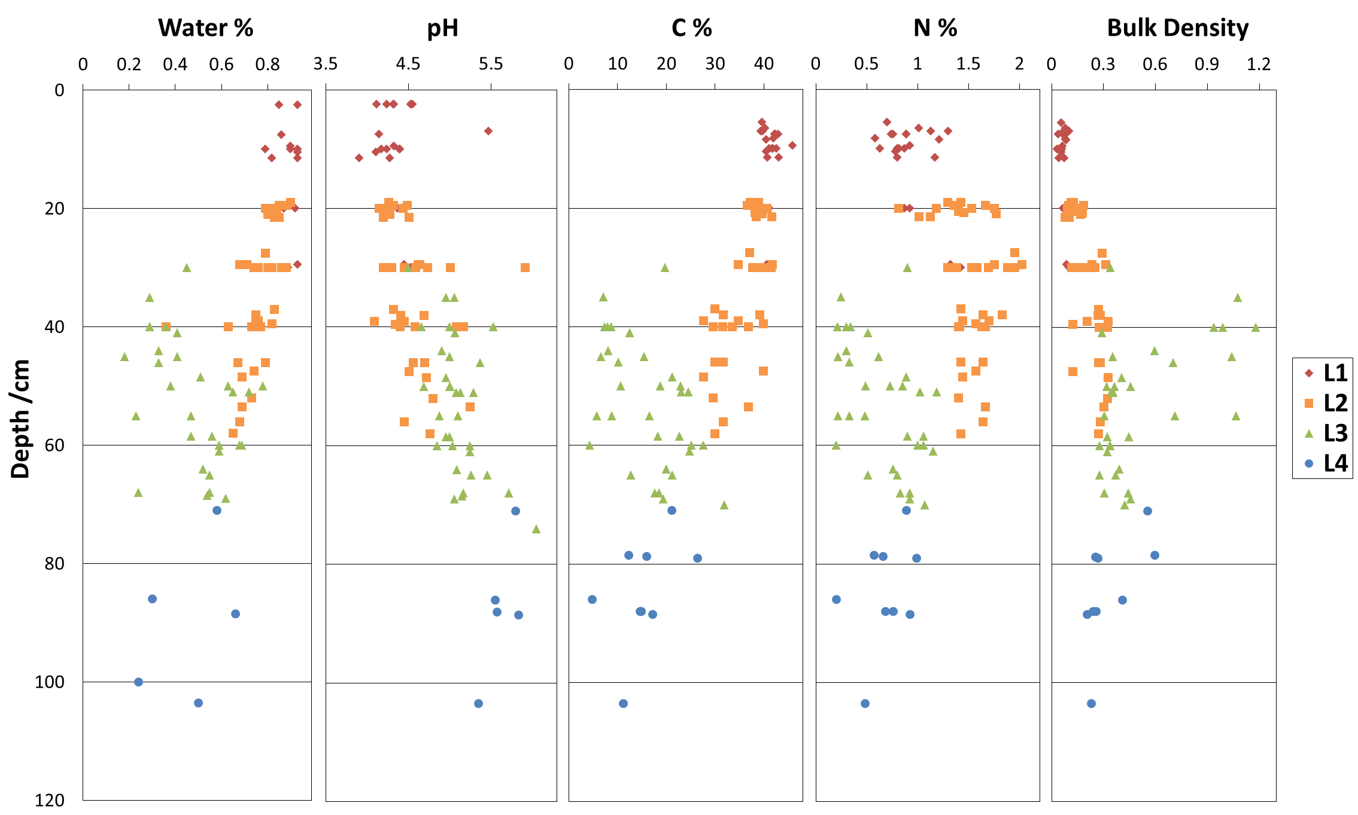

**Figure S1**. Changes of moisture, pH, C and N content, as well as bulk density along soil depth.

**Table S2**: Dissimilarity test of community structures among soil layers by ADONIS

|  |  |
| --- | --- |
|  | ADONIS *Pr* |
| L1 vs L2 | ***0.001*** |
| L1 vs L3 | ***0.001*** |
| L1 vs L4 | ***0.001*** |
| L2 vs L3 | ***0.001*** |
| L2 vs L4 | ***0.001*** |
| L3 vs L4 | ***0.001*** |



**Figure S2**. The maximum (a), minimum (b) daily temperature, and the daily temperature variation (c) of Ex, Mo and Mi sites in May, 2004.

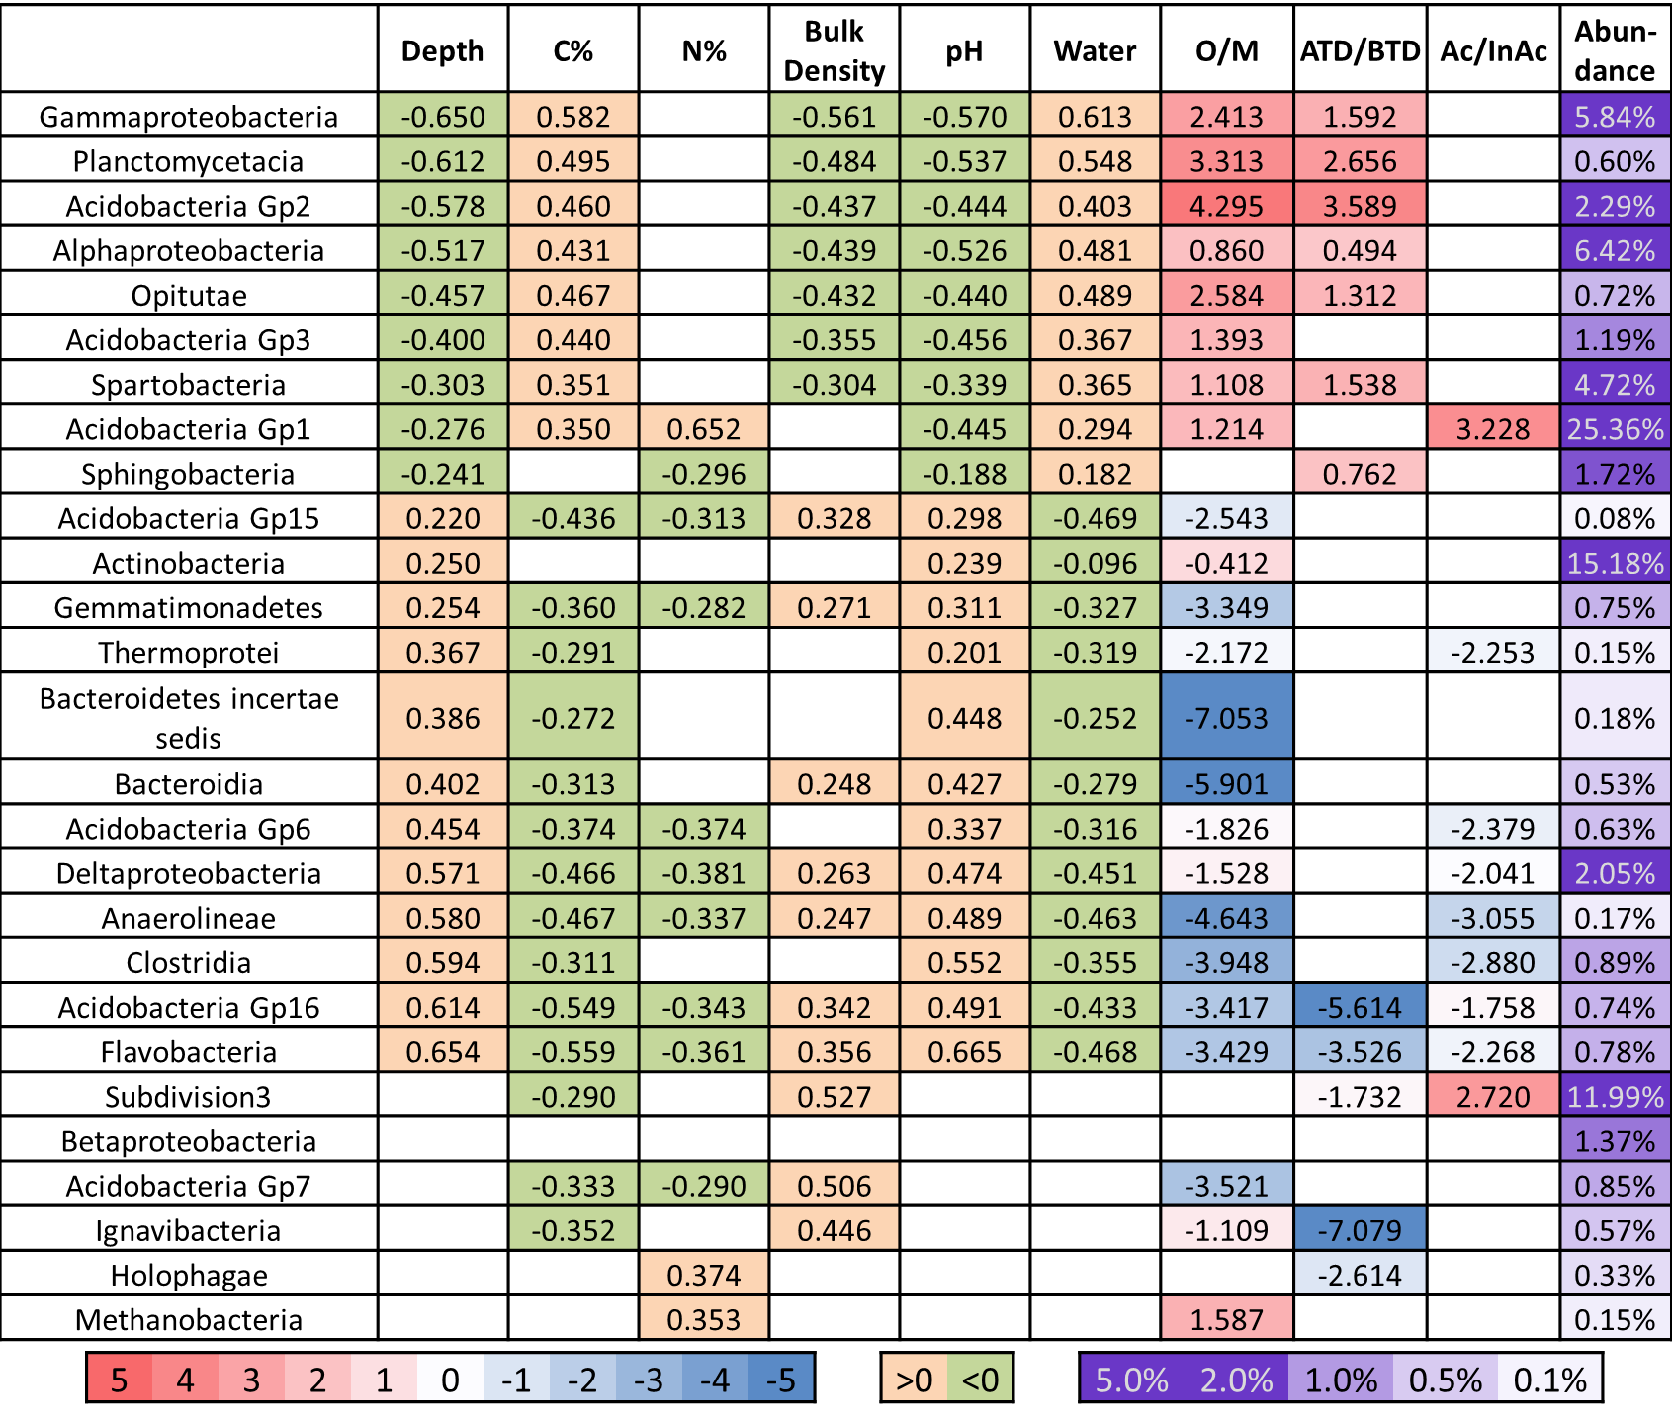

**Figure S3.** Association of major classes (>1000 in normalized sequence number) with soil physical-chemical attributes. The first six columns correspond to correlations of the abundance of each class with soil depth and soil chemical properties including C and N content, soil bulk density, pH and moisture (*P* <0.05). The next three columns correspond to logarithmized fold changes (*P* < 0.05 by T test) of Organic vs. Mineral layers (O/M), Above Thaw Depth vs. Below Thaw Depth layers (ATD/BTD), and Active vs. Inactive (Ac/InAc) layers. The last column shows the relative abundance of the corresponding class. The *P* values have been corrected for multiple tests using the method by Holm (Holm 1979).

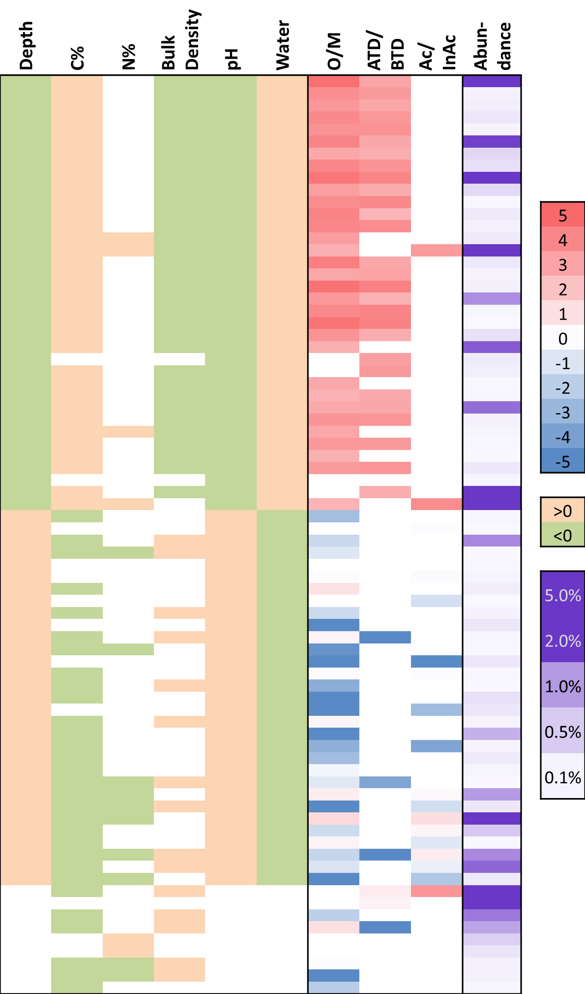

**Figure S4.** Association of major genera ( >500 in normalized sequence number) with soil physical-chemical attributes. The first six columns correspond to correlations of the abundance of each class with soil depth and soil chemical properties including C and N content, soil bulk density, pH and moisture (*P* <0.05). The next three columns correspond to logarithmized fold changes (*P* < 0.05 by T test) of Organic vs. Mineral layers (O/M), Above Thaw Depth vs. Below Thaw Depth layers (ATD/BTD), and Active vs. Inactive (Ac/InAc) layers. The last column shows the relative abundance of the corresponding genus. The *P* values have been corrected for multiple tests using the method by Holm.

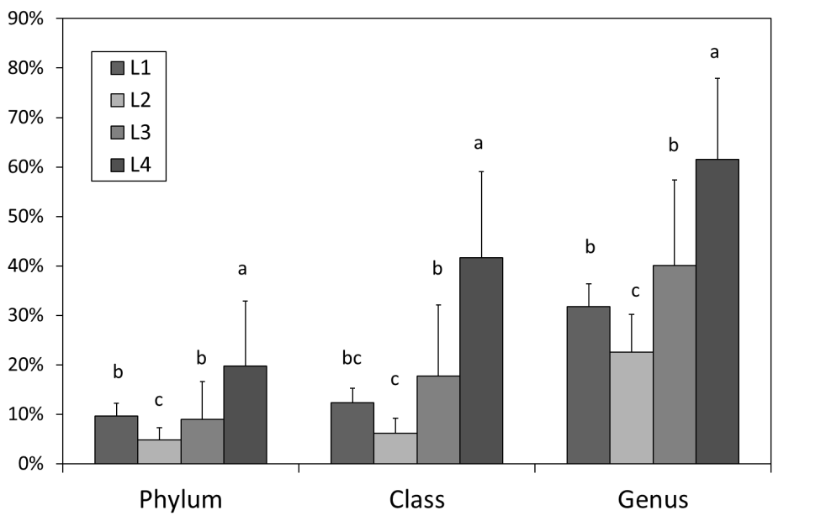

**Figure S5.** Proportions of unclassified population at three taxonomic levels (phylum, class and genus) in the four soil layers.

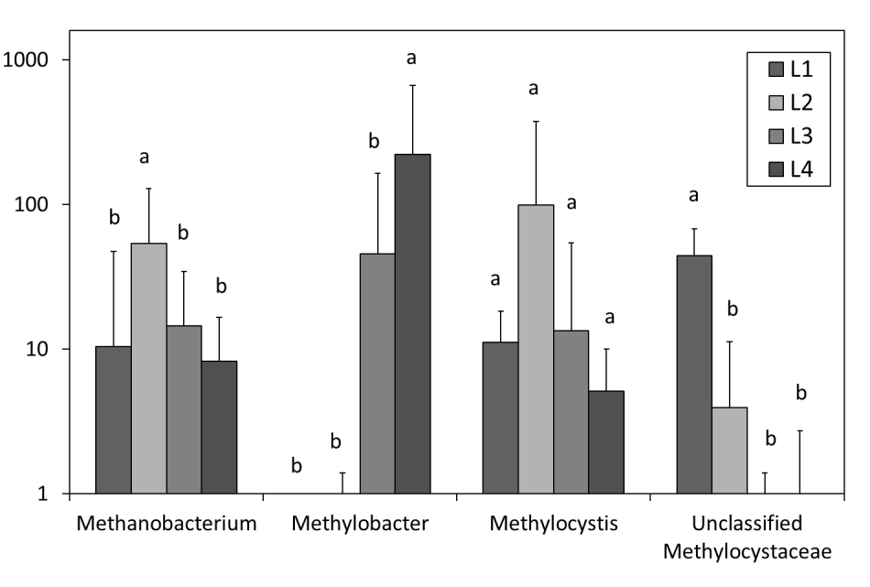

**Figure S6.** Abundance of dominant groups involved in methane cycling in the four soil layers.

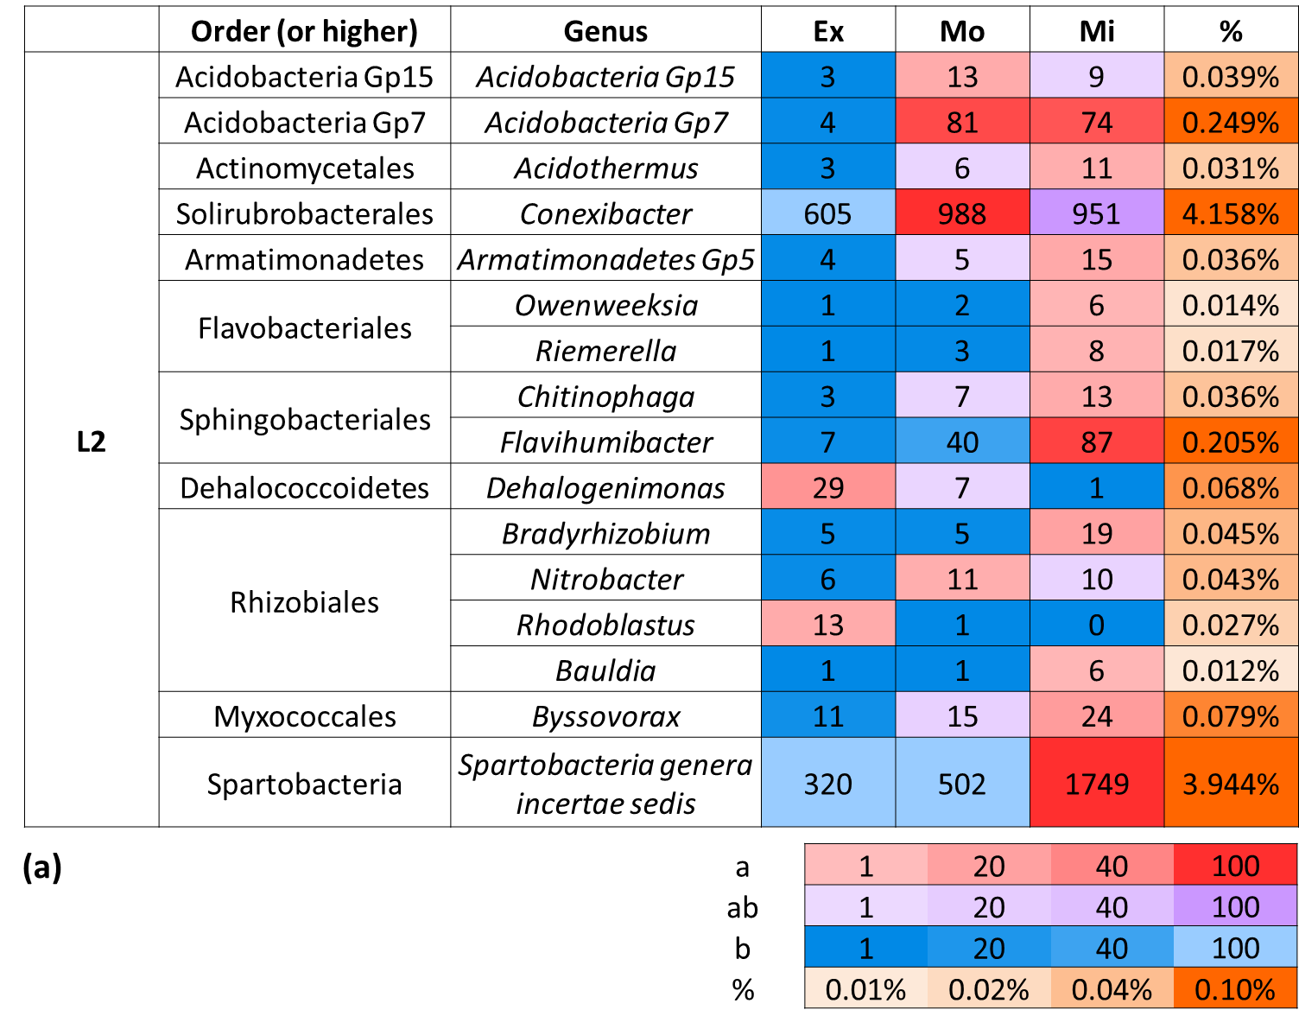

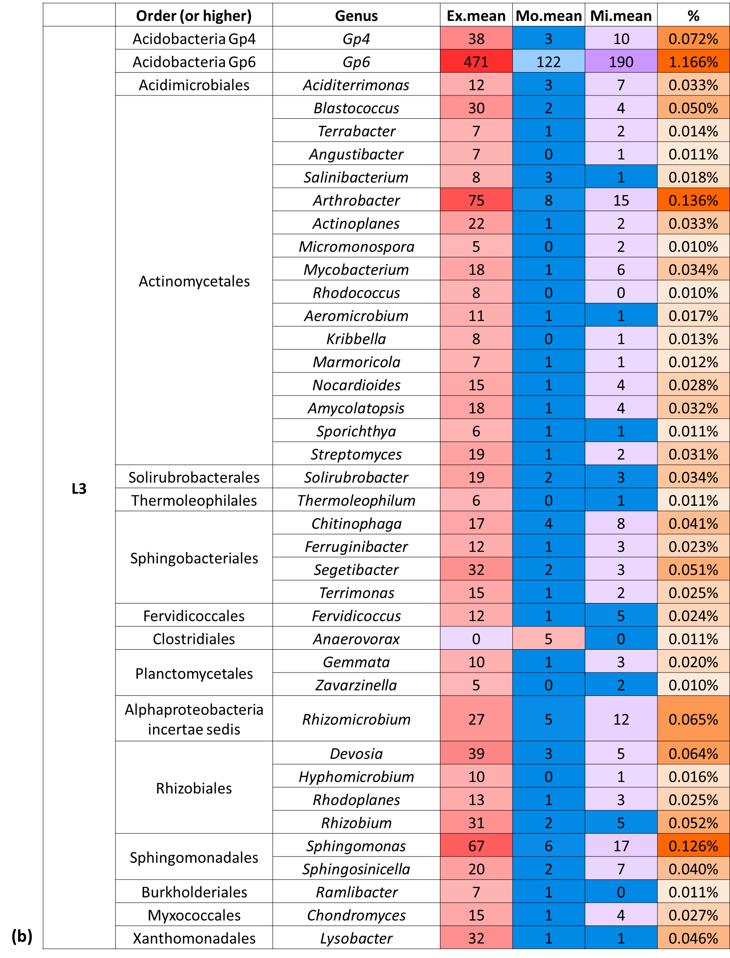

**Figure S7.** Complete list of genera (with relative abundances > 0.01%) with different abundance levels among sites within the L2 and L3-L4 soil layers. The color panel under “Ex”, “Mo” and “Mi” reflects both the absolute abundance (sequence count) of the corresponding genus and the relative abundance level at each site by LSD test. Red toned cells (a) represent the highest abundance level; Blue toned cells (b) represent significant lower abundance levels compared to (a); Purple toned cells (ab) represent intermediate abundance levels between (a) and (b). The absolute abundances were reflected by the color gradient within the red, blue and purple tones. The color panel under “%” reflects the relative abundance of the corresponding genus.

**References:**

Caporaso JG, Lauber CL, Walters WA*, et al.* (2012) Ultra-high-throughput microbial community analysis on the Illumina HiSeq and MiSeq platforms. *Isme Journal* **6**, 1621-1624.

Caporaso JG, Lauber CL, Walters WA*, et al.* (2011) Global patterns of 16S rRNA diversity at a depth of millions of sequences per sample. *Proceedings of the National Academy of Sciences of the United States of America* **108**, 4516-4522.

Holm S (1979) A simple sequentially rejective multiple test procedure. *Scandinavian Journal of Statistics* **6**, 65-70.

Schuur EAG, Crummer KG, Vogel JG, Mack MC (2007) Plant species composition and productivity following permafrost thaw and thermokarst in alaskan tundra. *Ecosystems* **10**, 280-292.

Zhou J, Wu L, Deng Y*, et al.* (2011) Reproducibility and quantitation of amplicon sequencing-based detection. *ISME J* **5**, 1303-1313.