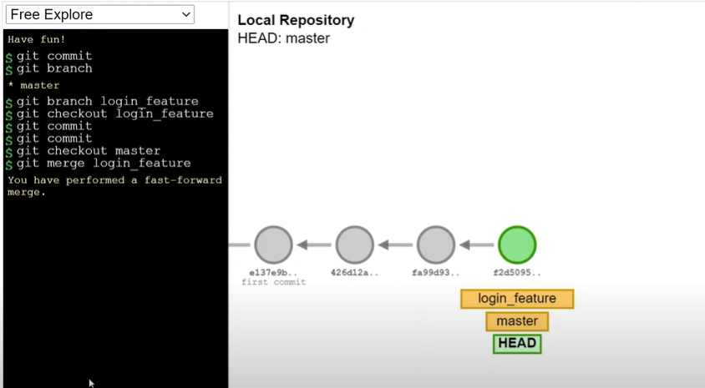

Fast-forward merge => when we created the branch login_feature after that the master didn’t have any new commits, hence fast-forward merge

Git merge login_feature => iss time pe we are in the master branch and git merge login_feature means master branch k sath login_feature merge hua

No new commits in the current pointing branch means fast forward hoga

In the next screen shot u can see there will be no fast-forward merge as we have committed some new things in the master

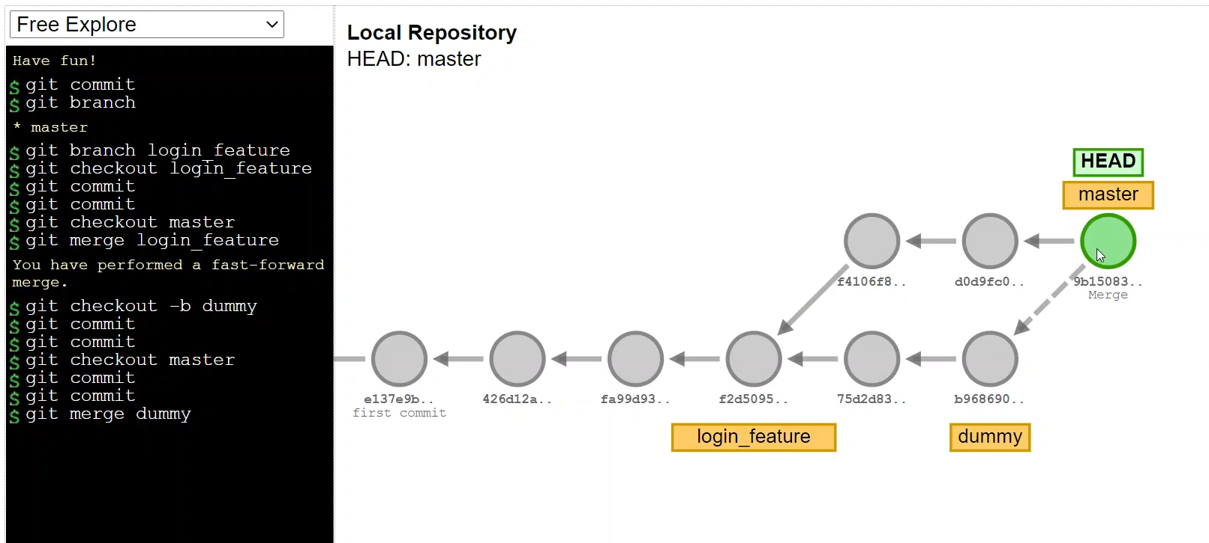

We can abort the merge also by git merge –abort