Laboratory Work #0 - SOLID
Author: Gîncu Olivia
Git repository: https://github.com/livia994/lab_tmps

Objectives:
- Get familiar with the SOLID Principles;
- Choose a specific domain;
- Implement 2 SOLID letters in a simple project.
Used SOLID Principles:
- Single Responsibility Principle
- Open/Closed Principle
Implementation
This implementation follows the Single Responsibility Principle by dividing responsibilities among different classes: Book for storing book data, BookManager for managing the collection of books, and BorrowManager for handling book borrowing. It also adheres to the Open/Closed Principle by allowing easy extension of borrowing policies (e.g., StandardPolicy, PremiumPolicy) without modifying existing code.

```
class Book:
def __init__(self, title, author):
self.title = title
self.author = author
self.borrowed = False

class BookManager:
def __init__(self):
self.books = []

def add_book(self, book):
self.books.append(book)

class BorrowPolicy:
def can_borrow(self, borrowed_count):
raise NotImplementedError

class StandardPolicy(BorrowPolicy):
def can_borrow(self, borrowed_count):
return borrowed_count < 3```
Output:
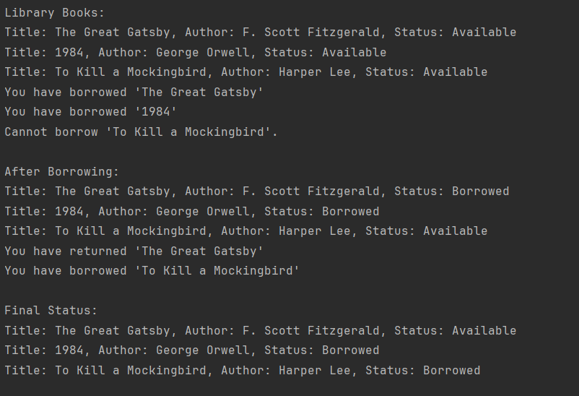
Conclusion:
In this laboratory work, I successfully implemented two SOLID principles—Single Responsibility Principle (SRP) and Open/Closed Principle (OCP)—in a book-related project. By adhering to SRP, the code was structured with clear, well-defined responsibilities across classes, making it easier to understand, maintain, and test. Each class had a single focus, reducing complexity and promoting cleaner code.
By applying OCP, the project was designed to allow future extensions (such as new borrowing policies) without modifying existing code. This promotes flexibility and reduces the risk of introducing bugs when making updates. Together, these principles enhance code scalability, maintainability, and adaptability, ensuring that the system can evolve over time without requiring significant rework.

