EEG-Based Eye State Classification Using Machine Learning and Cognitive State Monitoring
  - SEMESTER PROJECT

Student: Canache Livia

Discipline: Knowledge-Based Systems

Contents
1 Introduction 2
1.1 General context 2
1.2 Objectives 2
1.3 Specifications 3
2 Dataset exploration and analysis 4
2.1 Environment Set Up 4
2.2 Dataset Description and Structure 4
3 Dataset pre-processing 5
3.1 Data Preprocessing 5
3.2 Outlier Detection Using IQR 5
2.3 Correlation Analysis 8
4 System modeling and training 10
4.1 Rolling Window Statistics 10
4.2 Feature Matrix Construction 10
4.3 Train–Test Split 11
4.4 Feature Scaling 11
4.5 Classification Models 11
4.6 Evaluation Metrics 12
4.6.1 Accuracy 12
4.6.2 Precision 12
4.6.3 Recall 12
4.6.4 F1-Score 12
4.6.5 ROC-AUC 13
4.7 Model Performance Comparison 13
4.8 Confusion Matrix Analysis 14
4.9 ROC Curve Analysis 14
4.9 Feature Importance Analysis 15
5 Cognitive State Monitoring 16
5.1 Blink Detection 16
5.2 Attention Score 17
5.3 Fatigue Index 17
6 Conclusions 20
7 Bibliography (1-2 pages) 21

Introduction

General context
Eye-state detection (open vs. closed eyes) is an important problem in EEG-based human monitoring because it provides a direct signal of alertness, fatigue, and attention. While cameras can detect eye closure visually, they may fail in poor lighting, occlusions, or when the user does not want video monitoring. EEG signals offer an alternative because they measure brain activity directly and can capture changes associated with eye closure.
In this project, we build a supervised machine learning system that classifies the eye state (open/closed) using EEG data recorded with an Emotiv EEG Neuroheadset. The dataset contains continuous EEG measurements collected over a short recording (117 seconds) and a binary label indicating whether the eyes are open or closed. The label was produced by video-based observation during recording and manually assigned to each moment in time. The records are stored in chronological order (earliest samples first).
From an application perspective, reliable eye-state detection can contribute to cognitive-state monitoring (attention, fatigue), neurofeedback systems, driver drowsiness and sleep onset analysis, and human computer interaction, where eye closure patterns may indicate rest or disengagement.

Objectives
The objectives of this project are:
- Understand and explore the dataset
- Analyze EEG feature distributions, verify label balance (open vs. closed), and check data quality issues (missing values, outliers, noise patterns).
- Prepare the EEG data for machine learning
- Apply preprocessing steps such as normalization/scaling and (if needed) feature selection or extraction in order to improve model stability and performance.
- Train and compare classification models
- Build one or more supervised models (e.g., logistic regression, random forest, or other methods) that can predict eye state from EEG measurements.
- Evaluate performance with standard metrics
Evaluate models using accuracy, precision, recall, and F1-score and interpret the results.
- Deliver a reproducible workflow

Specifications
Input:
- A dataset containing chronological EEG measurements recorded using the Emotiv EEG Neuroheadset over approximately 117 seconds.
- A binary target label Eye State, where 0 = eyes open and 1 = eyes closed, manually assigned based on camera/video frame analysis during recording.
Output:
- A trained classification model that predicts eye state (open/closed) for EEG samples.
- A performance report including accuracy, precision, recall, and F1-score.
Functional requirements:
- Load and parse the EEG dataset correctly while preserving the label mapping (0=open, 1=closed).
- Perform dataset exploration (statistics + visualizations) and data quality checks.
- Apply preprocessing (at minimum scaling/normalization; additional noise handling if required).
- Train at least one supervised classification model and evaluate it using the defined
- Ensure experiments are reproducible (fixed random seeds where relevant, documented steps).
Non-functional requirements / constraints:
- The solution should be runnable in a standard Python ML environment (e.g., Jupyter Notebook), with clearly stated dependencies.
- The approach should be explainable: include a short justification of model choice and what features/steps influenced performance.
- The dataset is short in duration; conclusions should acknowledge limitations in generalization due to recording length and data scope. (This is a reasonable constraint implied by the 117-second dataset size.)

Dataset exploration and analysis

Environment Set Up
The analysis was conducted in a Python-based scientific computing environment using Jupyter Notebook. The main libraries used were:
- Pandas for data manipulation and inspection
- NumPy for numerical operations
- Matplotlib and Seaborn for visualization
- Scikit-learn for preprocessing utilities
The dataset was stored locally in CSV format and loaded directly into memory. Given the dataset size (approximately 15,000 samples and 15 columns), computational requirements were minimal and suitable for execution on a standard personal computer.

Dataset Description and Structure
The EEG Eye State dataset consists of:
- 14 EEG channels (AF3, F7, F3, FC5, T7, P7, O1, O2, P8, T8, FC6, F4, F8, AF4)
- 1 binary target variable „eyeDetection”
Each row corresponds to a single time-point measurement recorded at a sampling rate of 128 Hz.
The dataset structure was verified during loading:
- Number of samples: approximately 14,980
- Number of input features: 14
- Target variable: binary (0 = Eyes Open, 1 = Eyes Closed)
The column names were validated, and data types were confirmed to be consistent and numerical.

Dataset pre-processing

Data Preprocessing
The preprocessing phase was designed to ensure data integrity, remove noise, and prepare the EEG signals for reliable classification. The pipeline included three main stages: data loading and inspection, outlier detection using the Interquartile Range (IQR) method, and correlation analysis between EEG channels.
- Data Loading and Initial Inspection
The EEG Eye State dataset was loaded from a CSV file and inspected for structural consistency. The dataset contains 14 EEG channels and one binary target variable representing eye state. During inspection, the following checks were performed:
- Dataset shape and dimensionality verification
- Column name validation
- Missing value detection
- Duplicate record detection
- Descriptive statistical summary
The analysis confirmed:
- No missing values were present in the dataset.
- No corrupted or inconsistent entries were detected.
- Duplicate samples, if any, were identified for potential removal.
- All EEG channels exhibited meaningful variability (no zero-variance features).
The class distribution analysis revealed that the dataset is relatively balanced, with a slight predominance of one class. The class balance ratio remained within an acceptable range for supervised learning, eliminating the need for resampling techniques.

Outlier Detection Using IQR
EEG signals are highly sensitive to artifacts caused by eye movements, muscle activity, and external interference. To reduce the influence of extreme amplitude values, outliers were detected using the Interquartile Range (IQR) method.
For each EEG channel:
- The first quartile (Q1) and third quartile (Q3) were computed.
- The interquartile range was calculated as:
$$IQR=Q3-Q1$$
Samples falling outside:
$\left[Q1-1.5⋅IQR, Q3+1.5⋅IQR\right]$, were considered outliers.
Outliers were detected across multiple channels and subsequently removed. After removal, the dataset size decreased slightly, but the reduction remained small relative to the total number of samples, indicating that the dataset was generally clean. This step improves model robustness by preventing extreme values from disproportionately influencing decision boundaries.

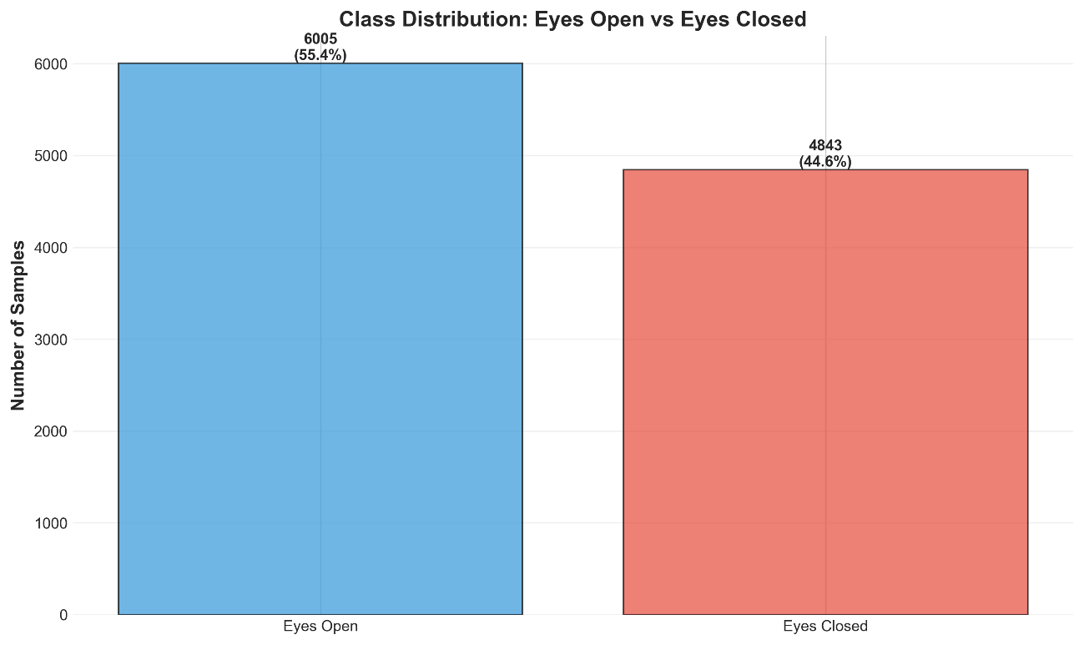

Figure 1. Class Distribution after outliers removal.

Histograms for all 14 EEG channels (Figure 2.) illustrate the distribution of amplitude values. The mean amplitude differs across electrodes, reflecting regional differences in neural activity. The variability observed across channels justifies feature scaling in subsequent modeling stages.

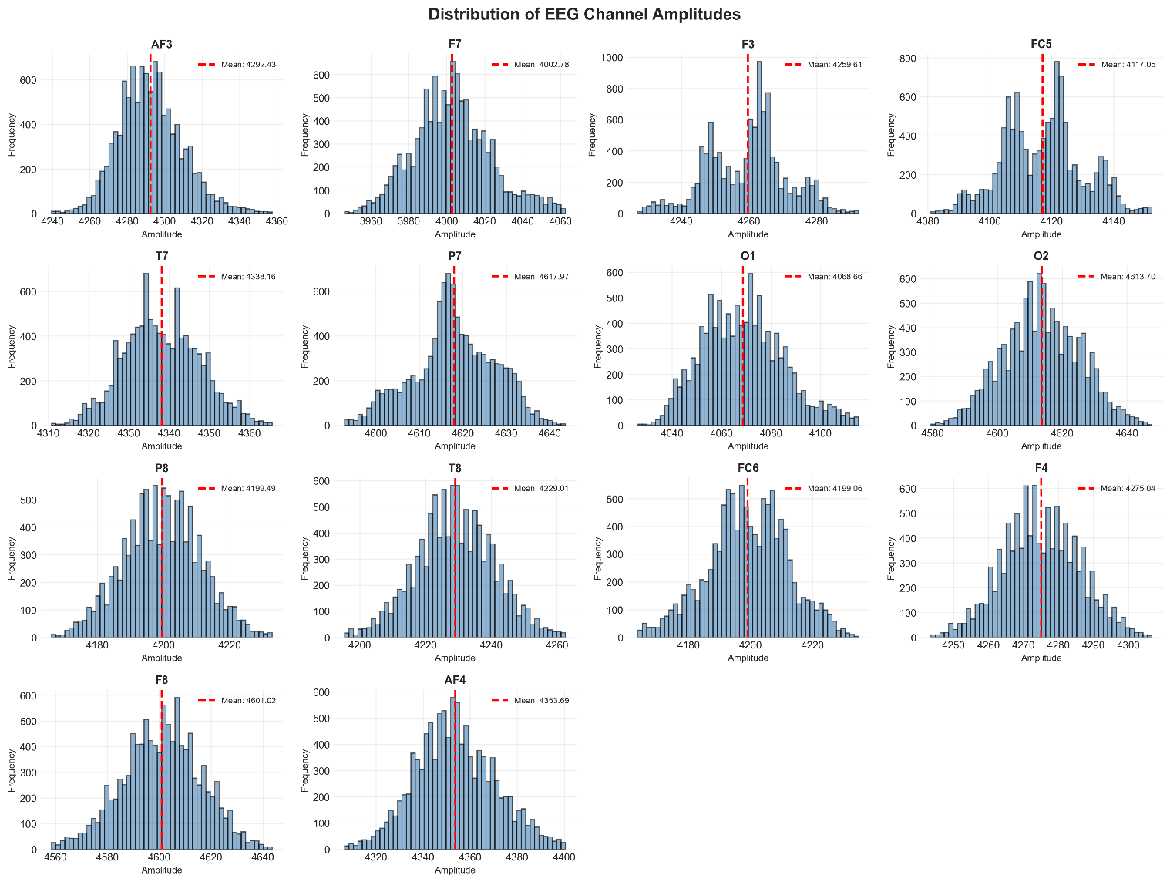
Figure 2. EEG Channel Distribution

The time-series visualization (Figure 3) presents the first 1,000 samples of each EEG channel, with background shading indicating eyes closed intervals. The visual separation between eyes-open and eyes-closed segments suggests that EEG features contain discriminative temporal patterns suitable for machine learning classification.
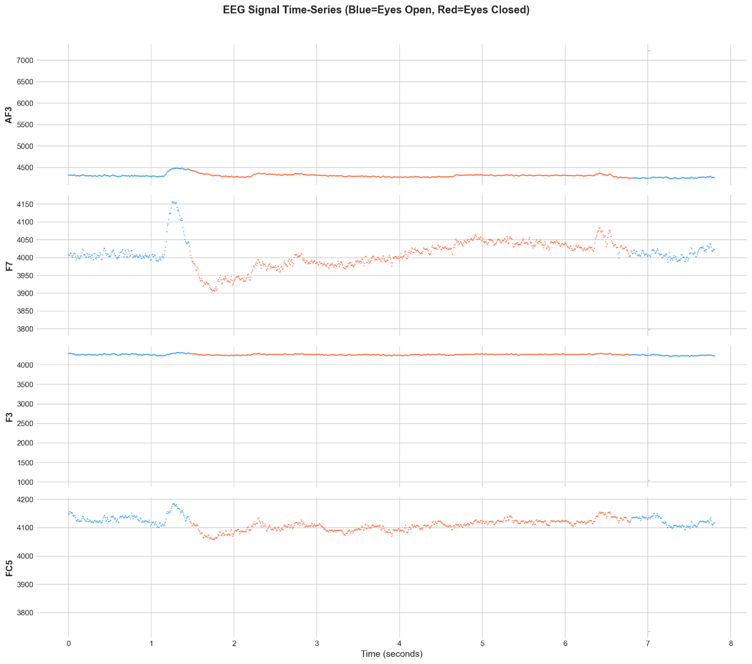
Figure 3. EEG time series

2.3 Correlation Analysis
A correlation matrix was computed between EEG channels to evaluate inter-channel relationships.
Moderate correlations were observed between spatially adjacent electrodes, which is consistent with known EEG properties such as:
- Volume conduction
- Overlapping cortical activation
- Functional connectivity between neighboring regions
No perfect multicollinearity was detected. Therefore, all 14 channels were retained for modeling. Correlation analysis is particularly relevant for linear classifiers, where highly correlated predictors can reduce interpretability and increase coefficient instability.
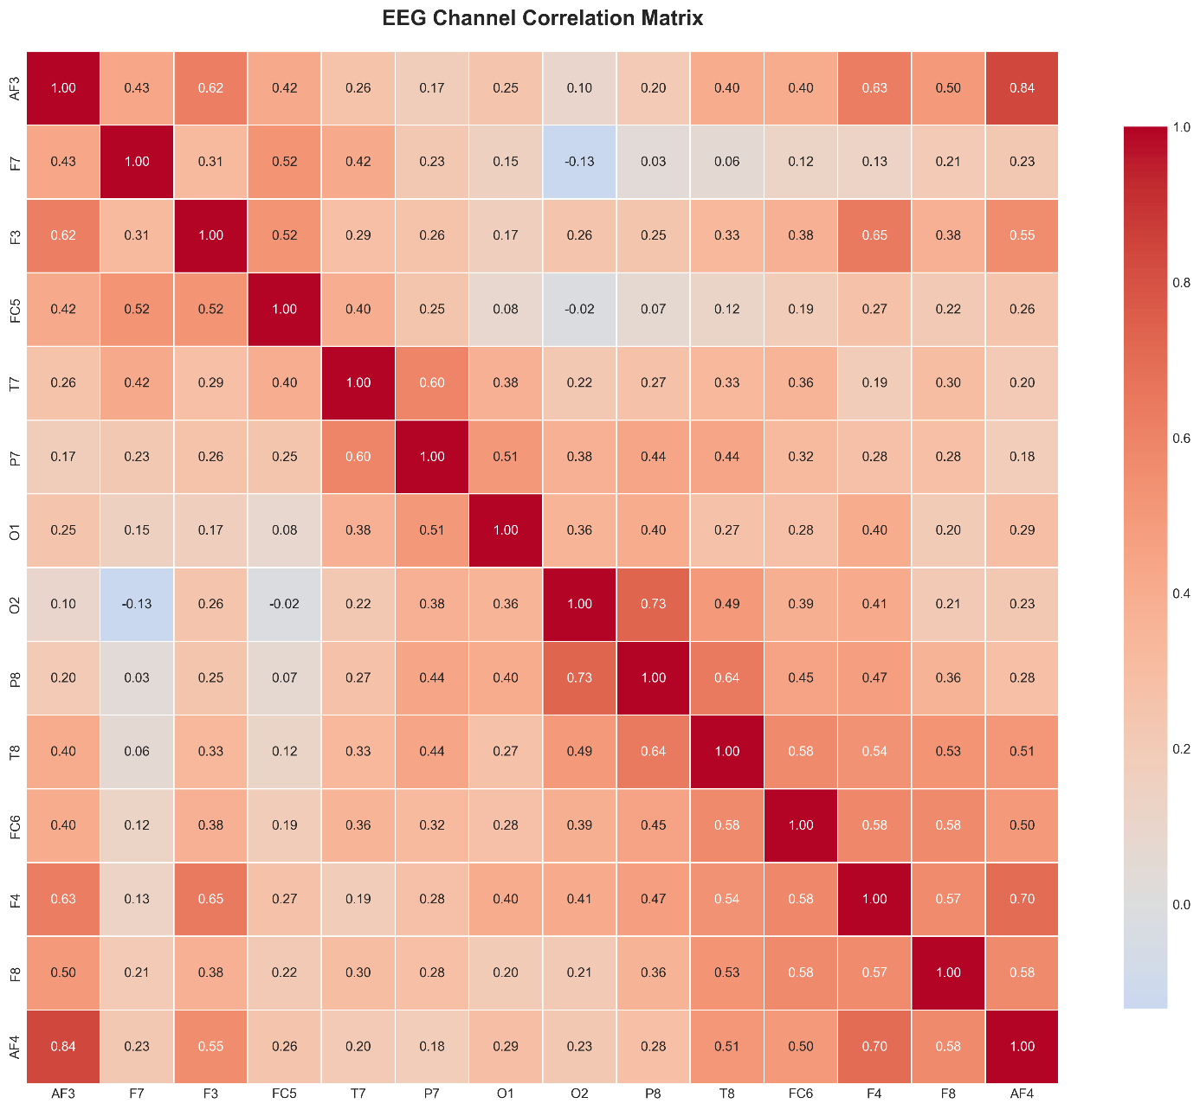
Figure 4. EEG time series

System modeling and training
Feature extraction techniques were performed to enhance the discriminative power of the EEG signals by incorporating temporal dynamics and ensuring proper numerical conditioning for machine learning algorithms. The pipeline consisted of rolling window feature extraction, feature scaling, and stratified train test splitting.

Rolling Window Statistics
EEG signals are inherently time-dependent and exhibit short-term fluctuations that may not be fully captured by instantaneous amplitude values alone. To incorporate local temporal information, rolling window statistics were computed for each EEG channel.
Using a window size of 10 samples, the following statistics were calculated for every channel:
- Rolling mean
- Rolling standard deviation
- Rolling minimum
- Rolling maximum
For a signal $x_{t}$, the rolling mean over a window of size $w$ is defined as:
$$μt​=\frac{1}{w }\sum_{i=t-w+i}^{t}{xi}$$
These features capture: local signal trends (mean), short-term variability (standard deviation), local extrema (min and max). Since the dataset contains 14 original EEG channels, this procedure generated:
- 4 rolling features per channel
- 56 new features
The total number of input features increased from: 14 original features to 70 total features (14 + 56 rolling features)
This expansion enriches the feature space by embedding temporal context directly into the input representation, allowing static classifiers to leverage short-term signal dynamics without requiring recurrent architectures.

Feature Matrix Construction
After rolling feature generation, the feature matrix $X$and target vector $y$were constructed. The resulting feature matrix had the shape:
$$X∈R^{n*70}$$
where: n is the number of cleaned samples after outlier removal, 70 represents the combined original and rolling features
The target vector: $y∈\{0,1\}$ represents the eye state classification problem.

Train–Test Split
To evaluate model generalization performance, the dataset was divided into training and testing sets using an 80–20 split. Stratified sampling was applied to preserve the original class distribution in both subsets. This ensures that the proportion of eyes-open and eyes-closed samples remains consistent and evaluation metrics are unbiased.
Stratification is particularly important in classification tasks to prevent distorted performance estimates due to uneven label distribution.

Feature Scaling
Before model training, feature scaling was applied using StandardScaler normalization.
For each feature:
$$z=\frac{x-μ}{σ}$$where:$μ$ is the mean of the training feature, $σ$ is the standard deviation.
Standardization ensures that each feature has approximately zero mean, each feature has unit variance.
This step is essential for: Distance-based models (e.g., K-Nearest Neighbors), Margin-based classifiers (e.g., Support Vector Machines), Gradient-based optimization (e.g., Logistic Regression, Neural Networks).
Without scaling, features with larger numeric ranges would dominate the learning process. Importantly, the scaler was fitted only on the training data and the same transformation was applied to the test set. This prevents data leakage and ensures valid evaluation.

Classification Models
To evaluate the discriminative capacity of the engineered EEG features, six different classifiers were trained and compared:
- Logistic Regression – Linear baseline classifier
- K-Nearest Neighbors (KNN) – Distance-based instance learning
- Decision Tree – Non-linear interpretable model
- Random Forest – Ensemble tree-based method
- Support Vector Machine (SVM) – Kernel-based classifier
- Multi-Layer Perceptron (MLP) – Feed-forward neural network
These models represent diverse learning paradigms:
- Linear vs. non-linear
- Parametric vs. instance-based
- Single model vs. ensemble
- Classical ML vs. neural networks
This diversity ensures a comprehensive evaluation of the EEG feature space.

Evaluation Metrics
Model performance was assessed using standard classification metrics:

Accuracy
$$Accuracy=\frac{TP+TN}{TP+TN+FP+FN}$$
Measures overall correctness.

Precision
$$Precision=\frac{TP}{TP+FP}$$
Measures correctness of positive predictions.

Recall
$$Recall=\frac{TP}{TP+FN}$$
Measures ability to detect true positives.

F1-Score
$$F1=2⋅\frac{Precision⋅Recall}{Precision+Recall}$$
Balances precision and recall.

ROC-AUC
The Area Under the Receiver Operating Characteristic curve evaluates the trade-off between sensitivity and specificity across thresholds.

Model Performance Comparison
The performance comparison is shown in Figure 5.1.
Key observations:
- Multi-Layer Perceptron achieved the highest F1-score (approx. 0.996)
- K-Nearest Neighbors and Support Vector Machine also achieved near-perfect performance
- Random Forest performed slightly below SVM but still very high (approx 0.97+ F1)
- Decision Tree showed moderate performance (approx. 0.92 F1)
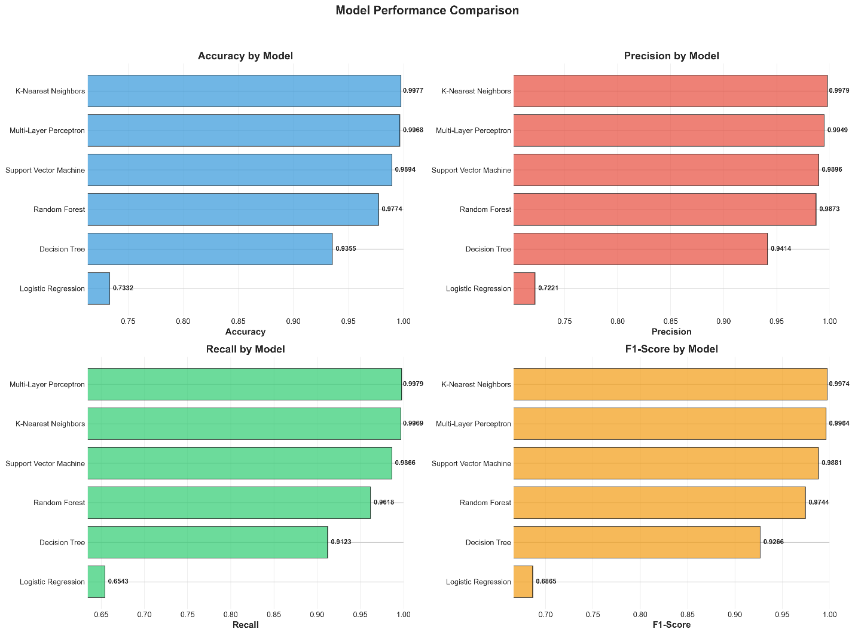

Figure 5.1. Model performance

Confusion Matrix Analysis
Confusion matrices for all models are presented in Figure 5.2.
The best-performing models (MLP, KNN, SVM) show:
- Extremely low false positives
- Extremely low false negatives
- Near-perfect separation of eye states
Logistic Regression demonstrates higher misclassification rates, particularly in distinguishing subtle transitions between open and closed states.
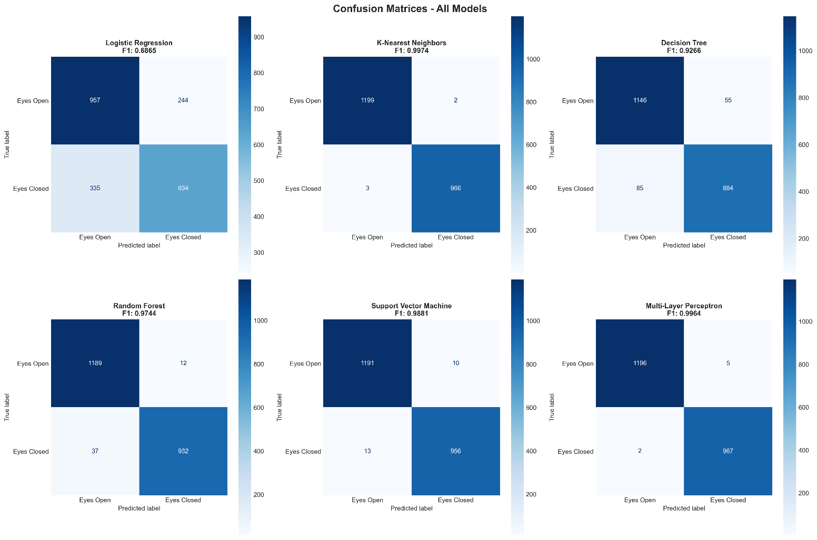
The confusion matrices confirm that advanced non-linear methods effectively capture EEG temporal patterns.
Figure 5.2. Confusion Matrices on all models

4.9 ROC Curve Analysis
Figure 5.3 presents ROC curves for all models.
Observations:
- MLP achieved AUC ≈ 1.000
- KNN and SVM achieved AUC ≈ 0.999+
- Random Forest achieved AUC ≈ 0.998
- Logistic Regression achieved AUC ≈ 0.80
The ROC analysis confirms that most non-linear models provide excellent class separability across decision thresholds.
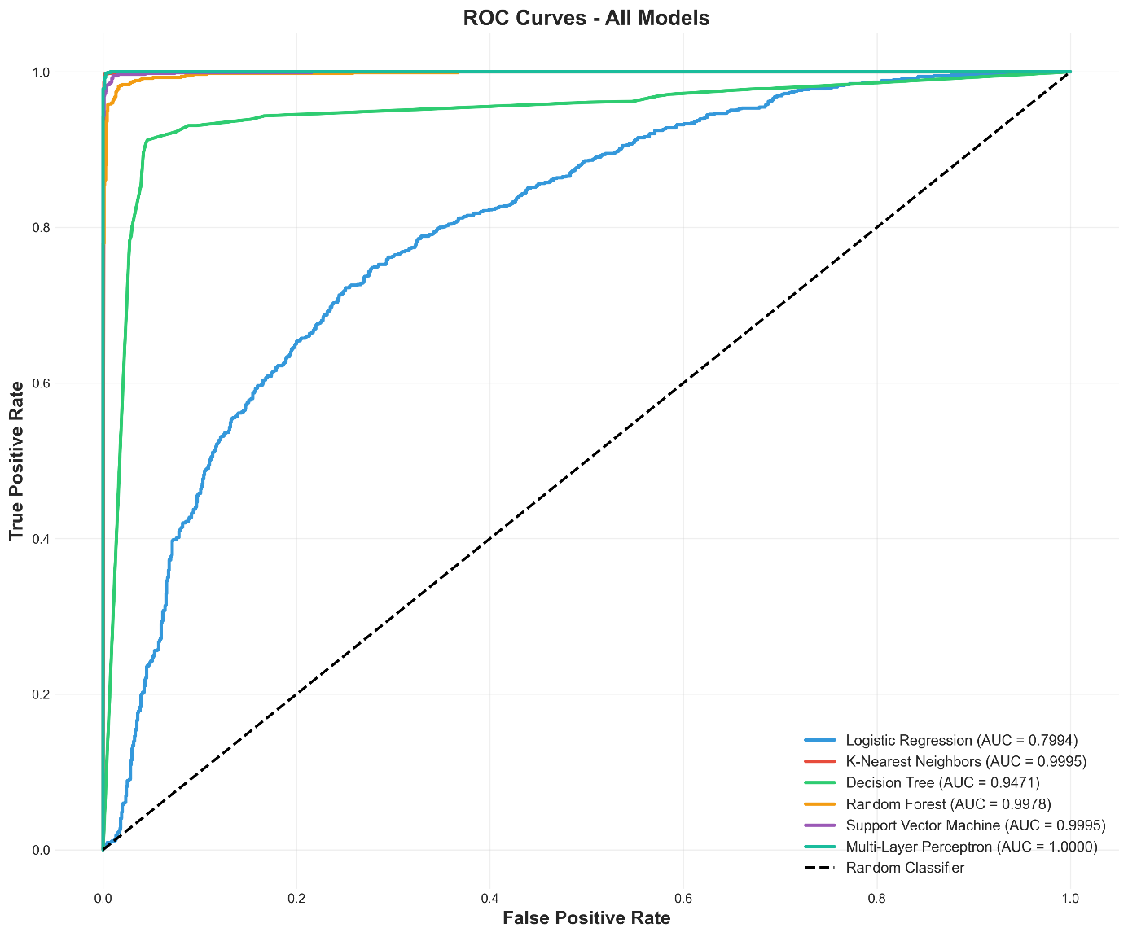
The near-perfect AUC values indicate strong discriminative signal information within the EEG features.
Figure 5.3. ROC Curves for all models

Feature Importance Analysis
Feature importance analysis was performed using the Random Forest model.
The most influential features include:
- Rolling statistics from occipital and parietal electrodes
- Local extrema features (rolling min/max)
- Rolling mean features
This suggests that:
- Temporal variability plays a crucial role
- Short-term signal dynamics are more informative than raw amplitudes alone
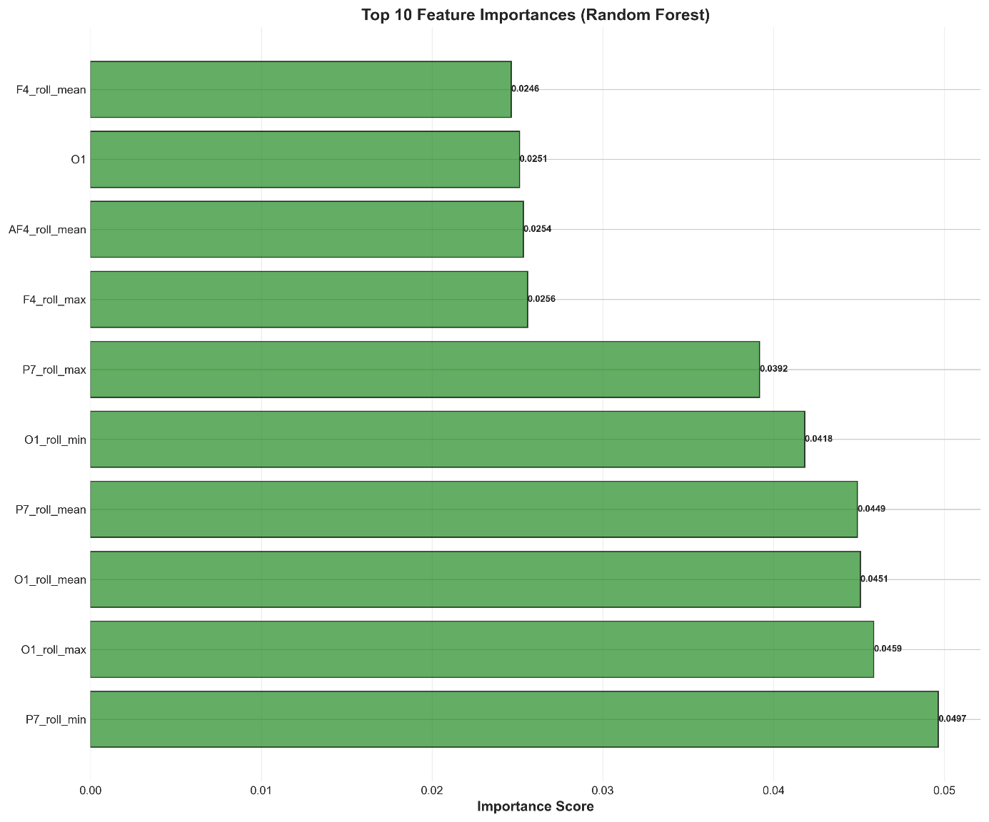
The dominance of rolling window features confirms the importance of temporal context in EEG classification.
Figure 5.4. Top 10 Feature Importances

Cognitive State Monitoring

Blink Detection
Blink events were identified as transitions from open (0) to closed (1) states followed by reopening.
From the full recording:
- Total blinks were detected
- Blink rate (blinks per minute) was computed
- Average blink duration was calculated
Blink rate is a known physiological marker of cognitive load and fatigue.

Attention Score
Attention was estimated based on blink frequency.
Assumptions:
- Lower blink rate → Higher attention
- Normal blink rate ≈ 15–20 blinks/min
The computed attention score ranged between 0 and 100.
Figure 5.1 shows attention fluctuations over time.
The mean attention score remained high, suggesting sustained cognitive engagement during recording.

Fatigue Index
Fatigue was estimated using sliding windows of 1,000 samples.
Fatigue index = percentage of eye-closed samples per window.
Windows exceeding 40% closure were flagged as high-fatigue alerts.
Figure 5.2 shows:
- Temporal fatigue fluctuations
- Mean fatigue level (approx. 45%)
- Multiple high-fatigue alert windows
These results demonstrate how EEG-based eye state classification can be extended toward real-time cognitive monitoring applications.
Perfect — I’ll give you concise, well-written concluding paragraphs that directly follow and strengthen your existing Section 5, without repeating everything or adding unnecessary structure.
The cognitive monitoring analysis demonstrates that eye-state classification can be effectively extended beyond simple binary detection toward higher-level behavioral interpretation. The blink detection results show that the system successfully identifies eye-closure events and captures meaningful temporal patterns in blink frequency and duration. The variability observed in blink rate across time windows indicates that the subject’s cognitive state was not static but dynamically fluctuated throughout the recording. (Figure 5.5)
The attention score analysis suggests that overall cognitive engagement remained high during most of the recording, with only brief decreases in attention. The generally elevated attention levels, combined with a relatively low mean blink rate, are consistent with sustained visual focus. Short attention dips appear to be temporary rather than indicative of prolonged disengagement.
The fatigue index further supports this interpretation. Although several high-fatigue alerts were detected due to windows with increased eye closure percentages, these episodes were intermittent and not persistent over long durations. The absence of extended high-fatigue periods suggests that the subject did not experience continuous cognitive exhaustion but rather short moments of reduced alertness. (Figure 5.6).
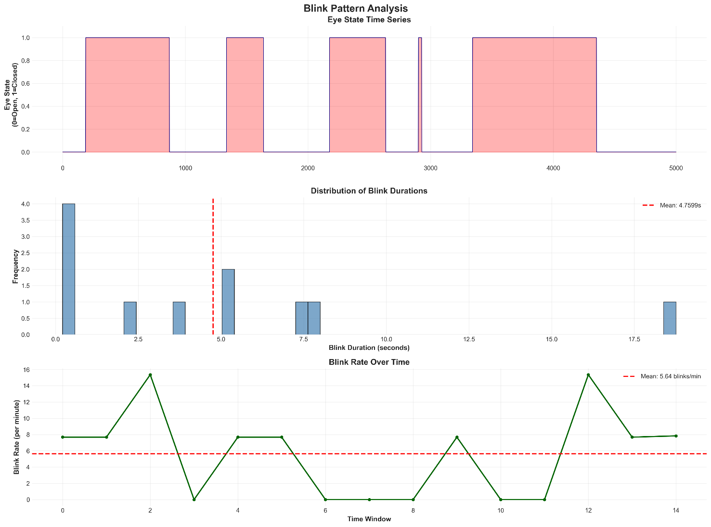
Overall, the cognitive monitoring results confirm that EEG-based eye-state detection can serve as a reliable foundation for estimating attention and fatigue-related indicators. The system demonstrates the potential to support real-time cognitive assessment applications, where eye behavior acts as a non-invasive proxy for mental state dynamics.

Figure 5.5. Blink Pattern
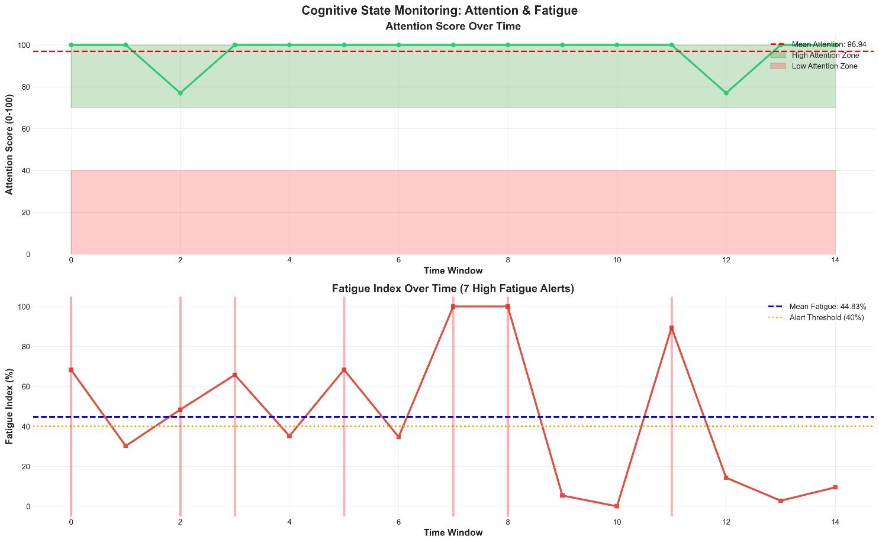
Figure 5.6 Attention and fatigue

Conclusions
This project explored the classification of eye states using EEG signals and extended the analysis toward cognitive state monitoring. By combining signal preprocessing, temporal feature engineering, supervised machine learning, and behavioral interpretation, a complete analytical pipeline was developed.
The preprocessing stage ensured data quality through missing value inspection, duplicate detection, outlier removal using the IQR method, and correlation analysis between EEG channels. These steps improved dataset reliability and reduced noise that could negatively influence model performance.
Feature engineering played a crucial role in enhancing classification performance. By incorporating rolling window statistics (mean, standard deviation, minimum, and maximum), temporal dynamics were embedded into the feature space. This transformation significantly enriched the representation of EEG signals, enabling static classifiers to capture short-term signal variations.
Six classification models were trained and compared: Logistic Regression, K-Nearest Neighbors, Decision Tree, Random Forest, Support Vector Machine, and Multi-Layer Perceptron. The results demonstrated that non-linear models substantially outperformed the linear baseline. In particular, the Multi-Layer Perceptron, K-Nearest Neighbors, and Support Vector Machine achieved near-perfect performance across accuracy, precision, recall, F1-score, and ROC-AUC metrics. These results indicate that the EEG feature space is highly discriminative but non-linearly separable.
Feature importance analysis further confirmed that temporal rolling features contributed significantly to classification performance, highlighting the importance of short-term signal variability in eye-state detection.
Beyond classification, the project successfully extended eye-state predictions into cognitive indicators. Blink detection, blink rate analysis, attention score estimation, and fatigue index calculation demonstrated how EEG-based eye-state classification can support higher-level behavioral interpretation. The cognitive monitoring results showed generally high attention levels with intermittent fatigue alerts, illustrating the feasibility of dynamic cognitive state tracking.
Overall, the project confirms that EEG signals contain strong and reliable patterns for eye-state recognition and that these patterns can be leveraged for real-time cognitive monitoring applications. The integration of machine learning techniques with signal-derived behavioral metrics provides a solid foundation for future systems in driver monitoring, human computer interaction, neuroergonomics, and fatigue detection.

Bibliography

[1] | P. Both Roxana, Knowledge Based Systems Course and Laboratory Work -Faculty of Computer Science, 2025.
[2] | Teplan, M., “Fundamentals of EEG Measurement,” Measurement Science Review, vol. 2, no. 2, pp. 1–11, 2002.
[3] | Niedermeyer, E., and Lopes da Silva, F., Electroencephalography: Basic Principles, Clinical Applications, and Related Fields, Lippincott Williams & Wilkins, 2005.
[4] | Stern, J. A., Boyer, D., and Schroeder, D., “Blink Rate: A Possible Measure of Fatigue,” Human Factors, vol. 36, no. 2, pp. 285–297, 1994.
[5] | Pedregosa, F., et al., “Scikit-learn: Machine Learning in Python,” Journal of Machine Learning Research, vol. 12, pp. 2825–2830, 2011.

