***Software Requirements Specification***

***For***

***Pharmaget***

***Version 1.0 Approved***

***Prepared by: Klea Murati***

***Livia Hazizaj***

***Rigers Poleshi***

***Shendi Stana***

***Epoka University***

***20.05.2024***

***Abstract***

*In this project , we are going to present our website called “Pharmaget”.*

*Pharmaget is a pharmacy website , which sends all the products that are needed to our clients with just one click.*

*This website also allows the client to send a photo of the doctor’s prescription , and our team will directly demonstrate what that recipe says , and send to your doorstep all the pills that you need.*

*The best thing that out website has , is that even though our clients send us all their personal information , like : name , surname , e-mail address , phone number , house address for our team to send the shipping , all that information is secured.*

*It is only seen by our staff that needs to do the shipping.*

*1*

***Table of Contents***

***Table of Content***

***Revision History***

***1.Introduction***

*1.1 Purpose…………………..3*

*1.2 Document Conventions ……………………...4*

*1.3 Intended Audience and Reading Suggestions……………….4*

*1.4 Products Scope…………………...4*

***2.Overall Description***

*2.1 The Perspective of the Product……………5*

*2.2 Products Functions……………………5*

*2.3 User Classes and Characteristics……………………5*

*2.4 Operating Environment……………….6*

*2.5 Design and Implementation Constraints………………….6*

*2.6 User Documentation………………………………6*

*2.7 Assumption and Dependencies……………………….6*

***3.Software Project Requirements***

*3.1 User Requirements……………………………..7*

*3.2 Hardware Interfaces……………………………..9*

*3.3 Software Interfaces………………………………9*

*3.4 Communications Interfaces………………………….10*

***4.System Features***

*4.1 Log In…………………..11*

*4.2 Product Order by Client……………………12*

*4.3 Getting Doctors Notes as Perscriptions……………………….13*

*4.4 Adding and Deleting Products……………………….14*

***5.Other Nonfunctional Requirements***

*5.1 Performance Requirements…………………..15*

*5.2 Safety Requirements……………………15*

*5.3Security Requirements…………………17*

*5.4 Software Quality Attributes……………..18*

*5.5 Business Rules……………………..18*

*2*

***1.Introduction***

* 1. ***Purpose***

**Product Name:** *Pharmaget*

**Version Number:** *1.0*

*Pharmaget is a web-based platform that is designed for pharmaceutical companies and their customers.*

*The primary purpose of Pharmaget is to make a better interaction between pharmaceutical companies , and their clients by easily managing products information , orders , file orders with the doctor’s prescription and customer support through a single system.*

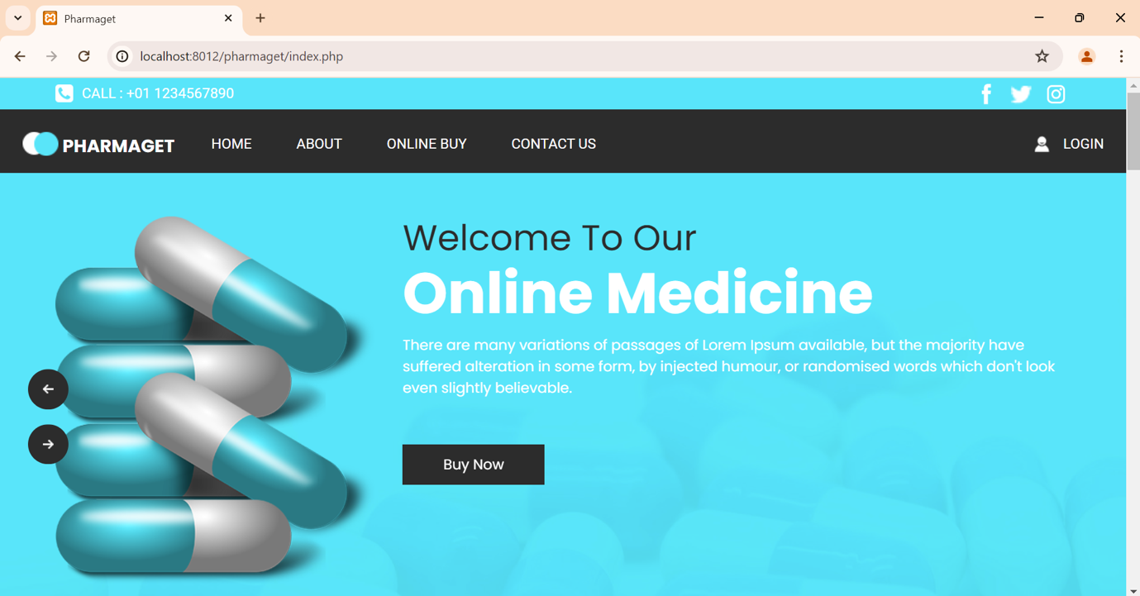

*3*

* 1. ***Document Conventions***
* ***Bold Italic Text –*** *Used for key terms and the headings of each section.*
* *Italic Text –* Used for writing important concepts and introducing the terms in their first appearance.
  1. ***Intended Audience and Reading Suggestions***

*This document is for a very diverse audience.*

*It is for us as developers , project managers and marketing staff to understand the functional and non-functional requirements in a very detailed way , to gain knowledge into the scope and the objectives for the project , to develop test cases and scenarios based on the requirements that the system has and to show the features and the benefits that the system has.*

*It is also for the people that will use this website (users) to get a good overview of the capabilities and functionalities that the system has.*

***1.4 Product Scope***

*Pharmaget aims to make a revolution into the pharmaceutical industry by providing a platform that is more centralized and makes the management and distribution of the product simpler.*

*The primary goal of Pharmaget is to have an operation of the products more efficient and to improve the client’s satisfaction.*

*The system will support many functionalities which include the user management , product catalog , order management , product management and customer support.*

*4*

***2.Overall Description***

***2.1 Product Perspective***

*Pharmaget is a newly developed , self-contained website that integrates multiple functionalities to provide a better and comprehensive solution for the pharmacies.*

*The website´s purpose is to give the costumers the answers to many questions that they might have regarding to the doctors notes they cannot read , by sending us the prescription as a photo , and giving them the right product that they require or the doctor has appointed them , through the import file option or order product option.*

***2.2 Product Function***

*The software will include an online order of any pharmaceutical products , reducing waiting times in pharmacies to get the product that the client needs , with just one click the product asked from the client will be at their doorstep.*

*It will also provide a detailed and more accessible information about each of the products that the pharmacy offers , and there is also a feedback section about how the service was offered ,and last but not least , the security measures that protect the patients data like the name , surname , email address and house address that the system requires to send to product from unauthorized access.*

***2.3 User Classes and Characteristics***

*The Pharmaget Software is designed to meet the requirements of various user types , each with unique requirements and traids.*

*The main users , who are the costumers value an easy browsing experience to use , because they need a general public access to the product and their “job” is to place orders. The Administrators have full access to all functionalities , and are also responsible for managing the platform.*

*The Pharmaceutical Representatives manage with the products listing , interacting with other healthcare professionals and have to handle with the orders.*

*And the healthcare Professionals have access to the products information , place the orders and need to seek for support.*

***5***

***2.4 Operating Environment***

*Pharmaget is a web-based application that can be accessed through modern web browsers in all types of devices , including desktops , tablets and smartphones.*

*The system is hosted on an infrastructure that ensures accessibility and reliability.*

***2.5 Design and Implementation Constrains***

*There are lots of requirements that affect the way that a pharmacy website is designed and implemented.*

*One of them and the most critical one is the Regulatory Compliance which means that the system needs to meet the pharmaceutical regulations and standards.*

*The Integration and External Systems means that Pharmaget must integrate with payment gateways , logistics providers and regulatory databases.*

*A very important point in a pharmaceutical website is the Security Requirement , that means that the system must implement security measures to protect user data and to ensure secure transactions.*

***2.6 User Documentation***

*Pharmaget will include some points to support its users by having detailed instructions for using the systems features and functionalities.*

*The staff will give Online help , that means help accessible from within the website.*

***2.7 Assumption and Dependencies***

*Assumptions:*

*Users will have basic computer knowledge and familiarity with web-based websites.*

*The system will be primarily accessed by using all kinds of web browsers such as Google Chrome , Firefox and Safari.*

*Dependencies:*

*The system relies on a third -party service for payment processing.*

*Users should have stable internet connection to access the platform.*

*The platform will be optimized for use on various devices , including desktops , tablets , smartphones etc.*

*6*

***3.Software Process Requirements***

***3.1 User Requirements***

*A number of crucial elements are included in the logical characteristics of user interfaces between the pharmacy website and its users to guarantee that the interface is user – friendly , consistent and fits their demand.*

*These elements include the homepage which has quick access to all sections and an overview of the site´s offerings , the homepage of a pharmacy website acts as the main point of contact for visitors. It is designed to be use-friendly , educational and visually beautiful.*

*The Product Order is where the order process consists multiple important elements that are meant to make sure that the costumer experience is easy and quick. Product searches , item selection , cart addition and payment completion are all included in the process.*

*Product details page is a page where users can manage and view past purchases on the order history page. It offers details in every order , such as its progress , the products that have been purchased and its overall cost.*

*The Order History can manage and view pas purchases on the order history page.*

*The User Account Page is for clients to track the order , manage personal information and gaining access to extra services.*

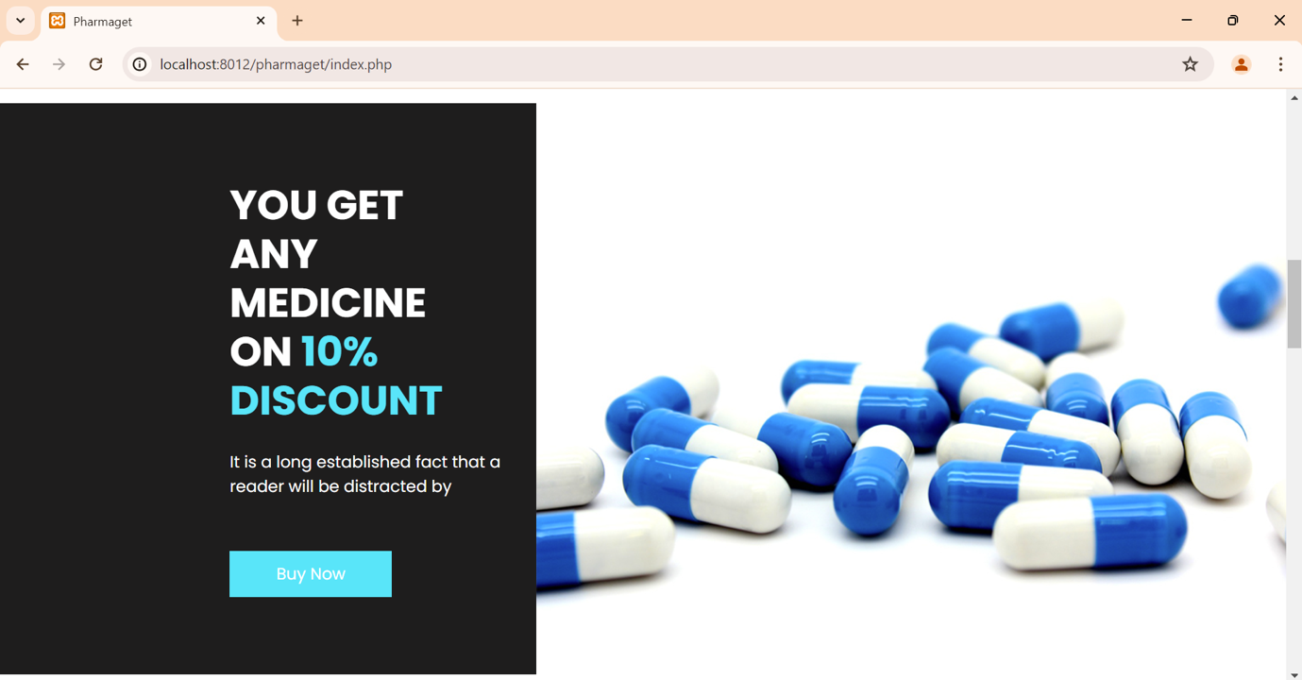

*7*

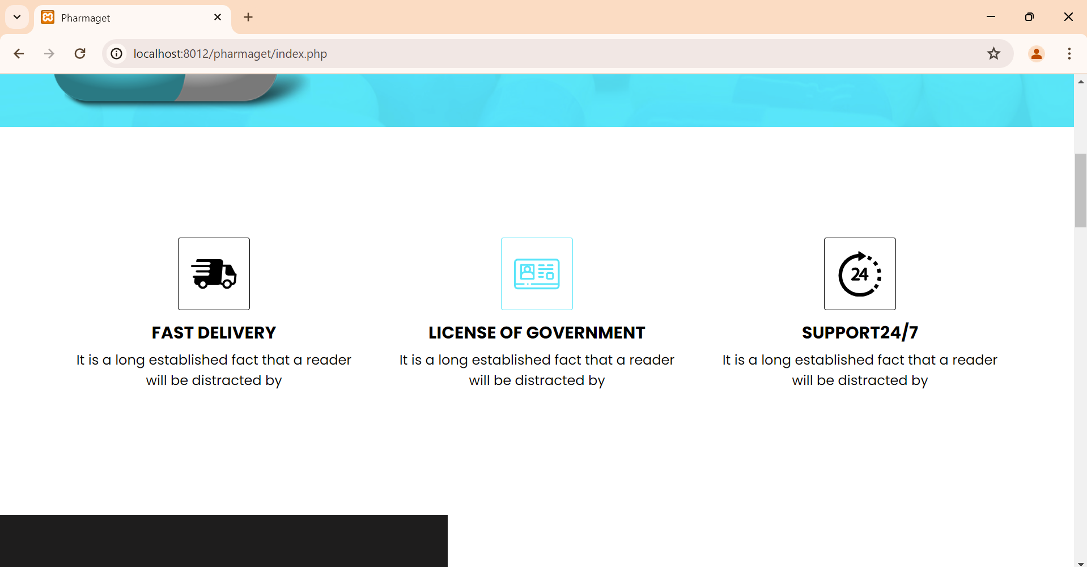

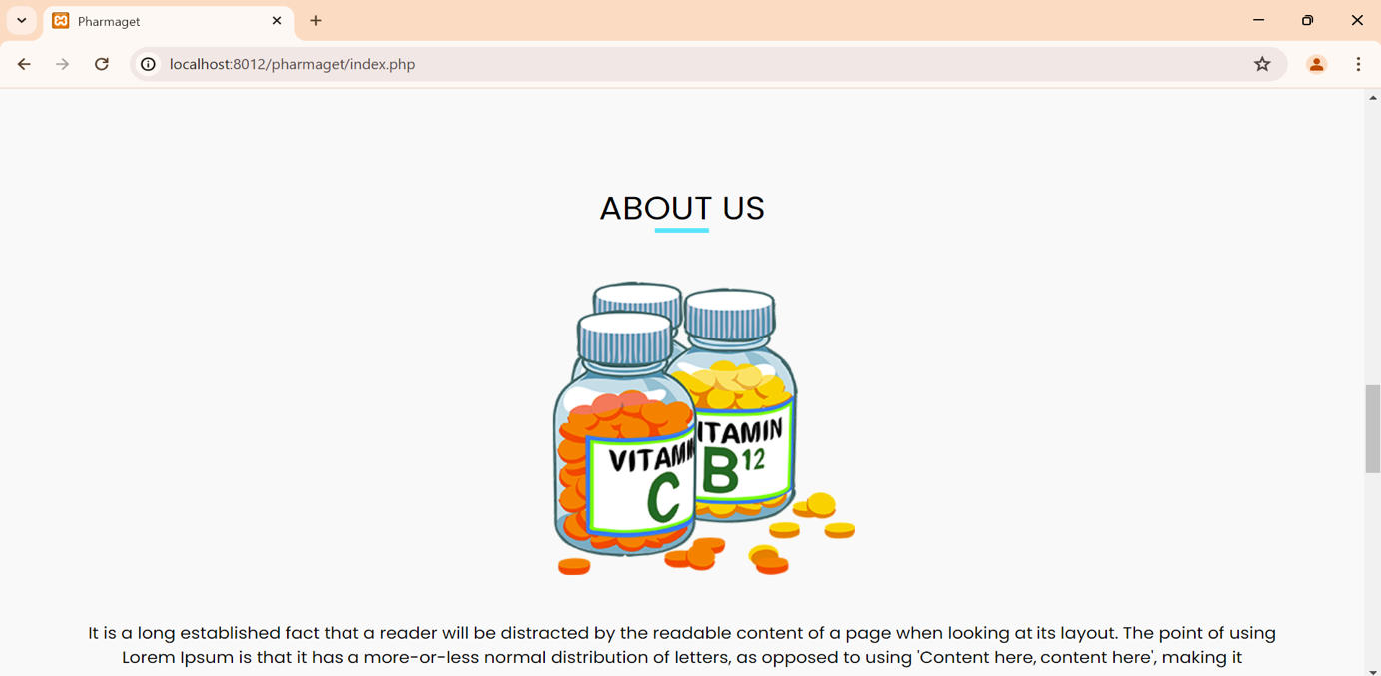

*8*

***3.2 Hardware Interfaces***

*Taking into consideration , it must be given to both , logical and physical aspects of hardware interfaces when describing the hardware interfaces.*

*Through these interfaces , the systems underlying hardware and software can communicate with each other.*

* *Logical Characteristics : are the supported device types as desktop , laptop , mobile phone etc.*

*The data flows between software and hardware , including input sensor readings , scanned data and output printer commands , display output is referred to as data interactions.*

***3.3 Software Requirements***

*The process of creating software interfaces for pharmacy websites entails the integration of multiple components to guarantee smooth operation and user engagement. Database Interfaces : The system used is MYSQL and the purpose is to store and manage product information, user data and orders . It makes it easier to retrieve, insert, edit, and delete data with ease, guaranteeing strong inventory, user, and transaction record management that is essential to the functioning and user experience of the website. Operating system :Client devices communicate with the server via HTTP/HTTPS protocols for web traffic and SSH for remote server management. These devices include Windows 10, macOS, iOS, and Android. This configuration allows for safe server environment administration, supports a variety of client environments, and guarantees reliable server-side operations. The website improves overall efficiency and user accessibility by utilizing these interfaces to maintain stability, scalability, and effective management across many operating systems. Tools and Libraries : Together, these frameworks and technologies make it possible to create an interface that is both aesthetically pleasing and easy to use, all the while streamlining database integration and backend operations to provide a consistent user experience across several browsers and devices. Integrated Commercial Components: The smooth processing of credit card payments made possible by this connection increases user confidence and convenience while checking out. Services and Data Sharing : The shared data includes email addresses, order details, and SMS content, facilitating personalized customer interactions and operational efficiency across the platform.*

*9*

***4.4 Communication Interfaces***

*Moving away from graphical user interfaces (GUIs) and toward other forms of interaction that make full use of our senses is necessary when it comes to operating these systems. In order to remedy this, hardware interface design connects physical forms and objects with digital data such that the user can manipulate, grip, and move the physical forms in use to influence virtual data flow.*

*10*

***4.System features***

***4.1 Log in System***

*Log In System is one of our critical components in Pharmaget , ensuring secure access to authorized users.*

*It does involve a user authentication process where users provide with their credentials which is : Username and Password to gain access to their Pharmaget account.*

*Some of the features in the Log in System are : the user authentication which validates the credentials that match with the stores database entries.*

*Password encryption which ensures passwords that are securely stored using the encryption techniques.*

*User Roles which differentiate roles as costumer or admin to provide role-based control.Admins will be able to change all types of products in the system and check all orders of the costumers , meanwhile costumers will be able to just check the products that they ordered.*

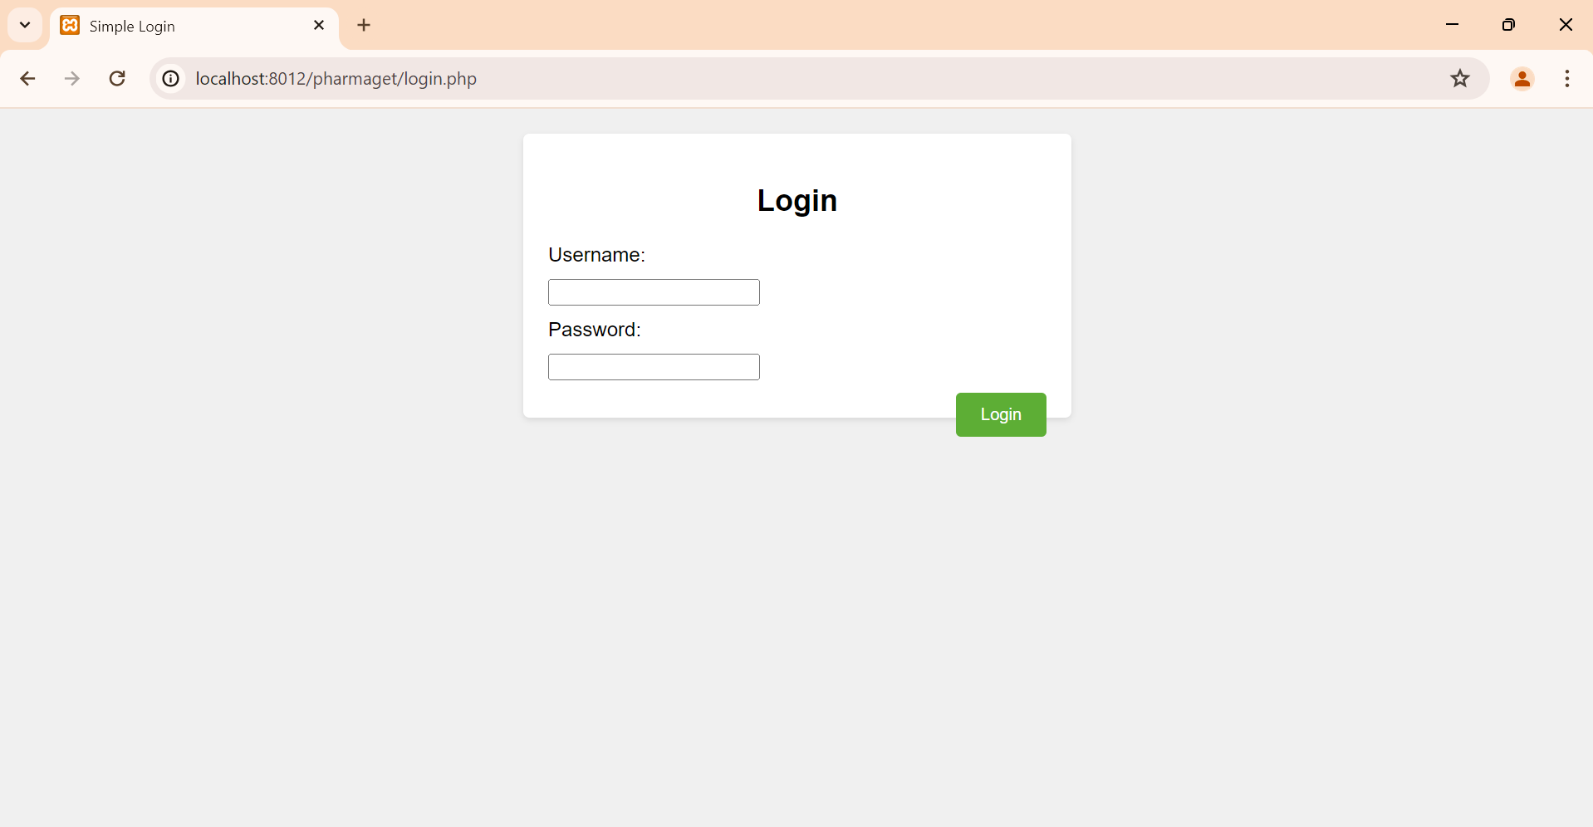

*11*

***4.2 Products Ordered by Costumers***

*This feature of the system allows the client to browse , select and order the products that are available in the website.*

*It includes functionality to add products to the card , check the products and make purchases.*

*The product catalog will help the costumers to check all the products that Pharmaget has to offer , and with the products name , description and price.*

*Searching the product that they need will be easier when the costumer is allowed to filter regarding the product that is needed.*

*And the last one is the Checkout process , which after checking the products ,this process makes sure that the purchase is complete and will be sent to the shipping information that the client has given.*

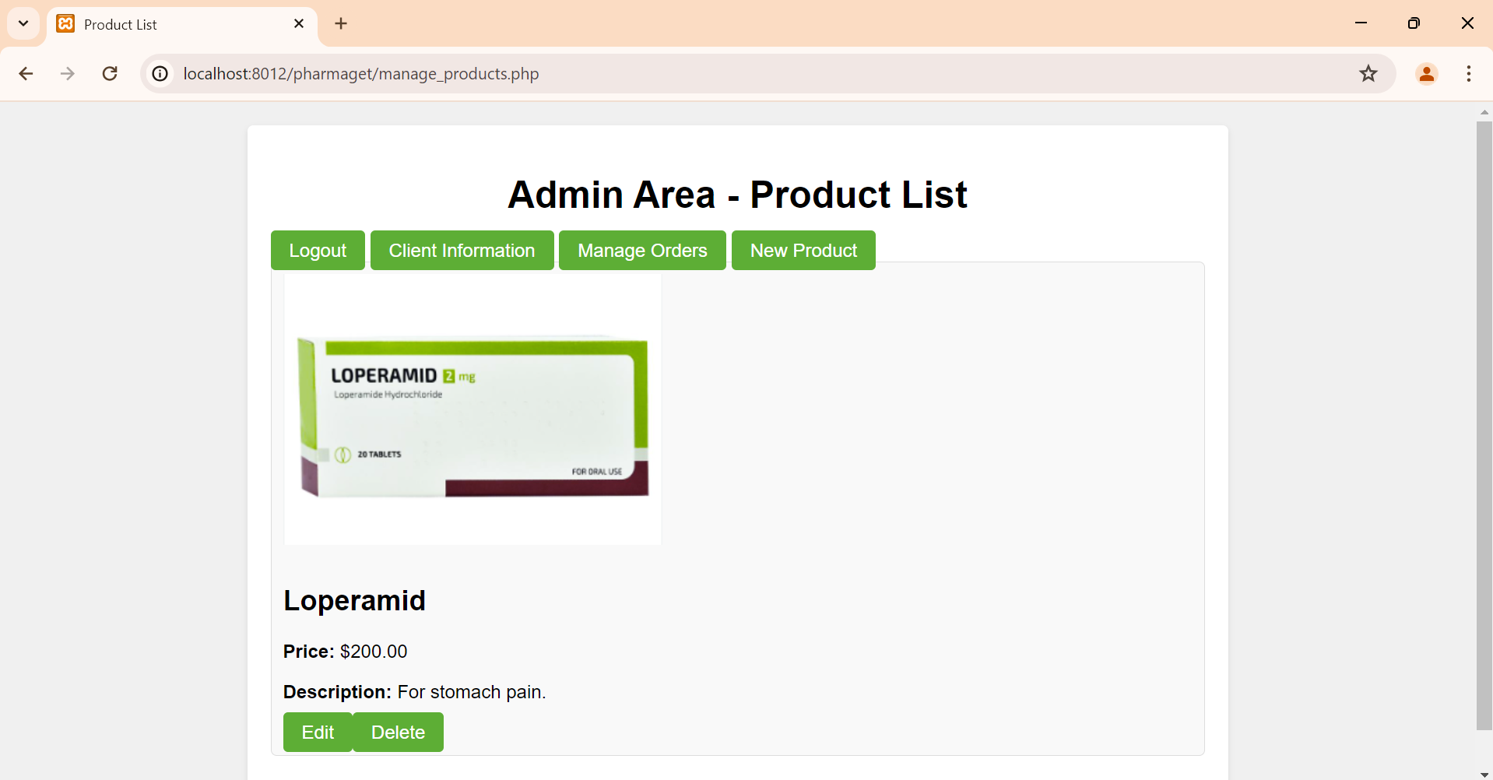

*12*

***4.3 Getting Doctors Note and Prescription***

*This is a feature that allows clients to upload the doctors notes or prescription when ordering the products.*

*This will make sure that the pharmacy verifies the prescription in the best way before sending the medicine .*

*The feature is called “Upload prescription” which allows the client to upload an image or PDF of their doctors note.*

*And the other feature is the “Prescription Verification” that allows our staff to review and verify the uploaded prescription.*

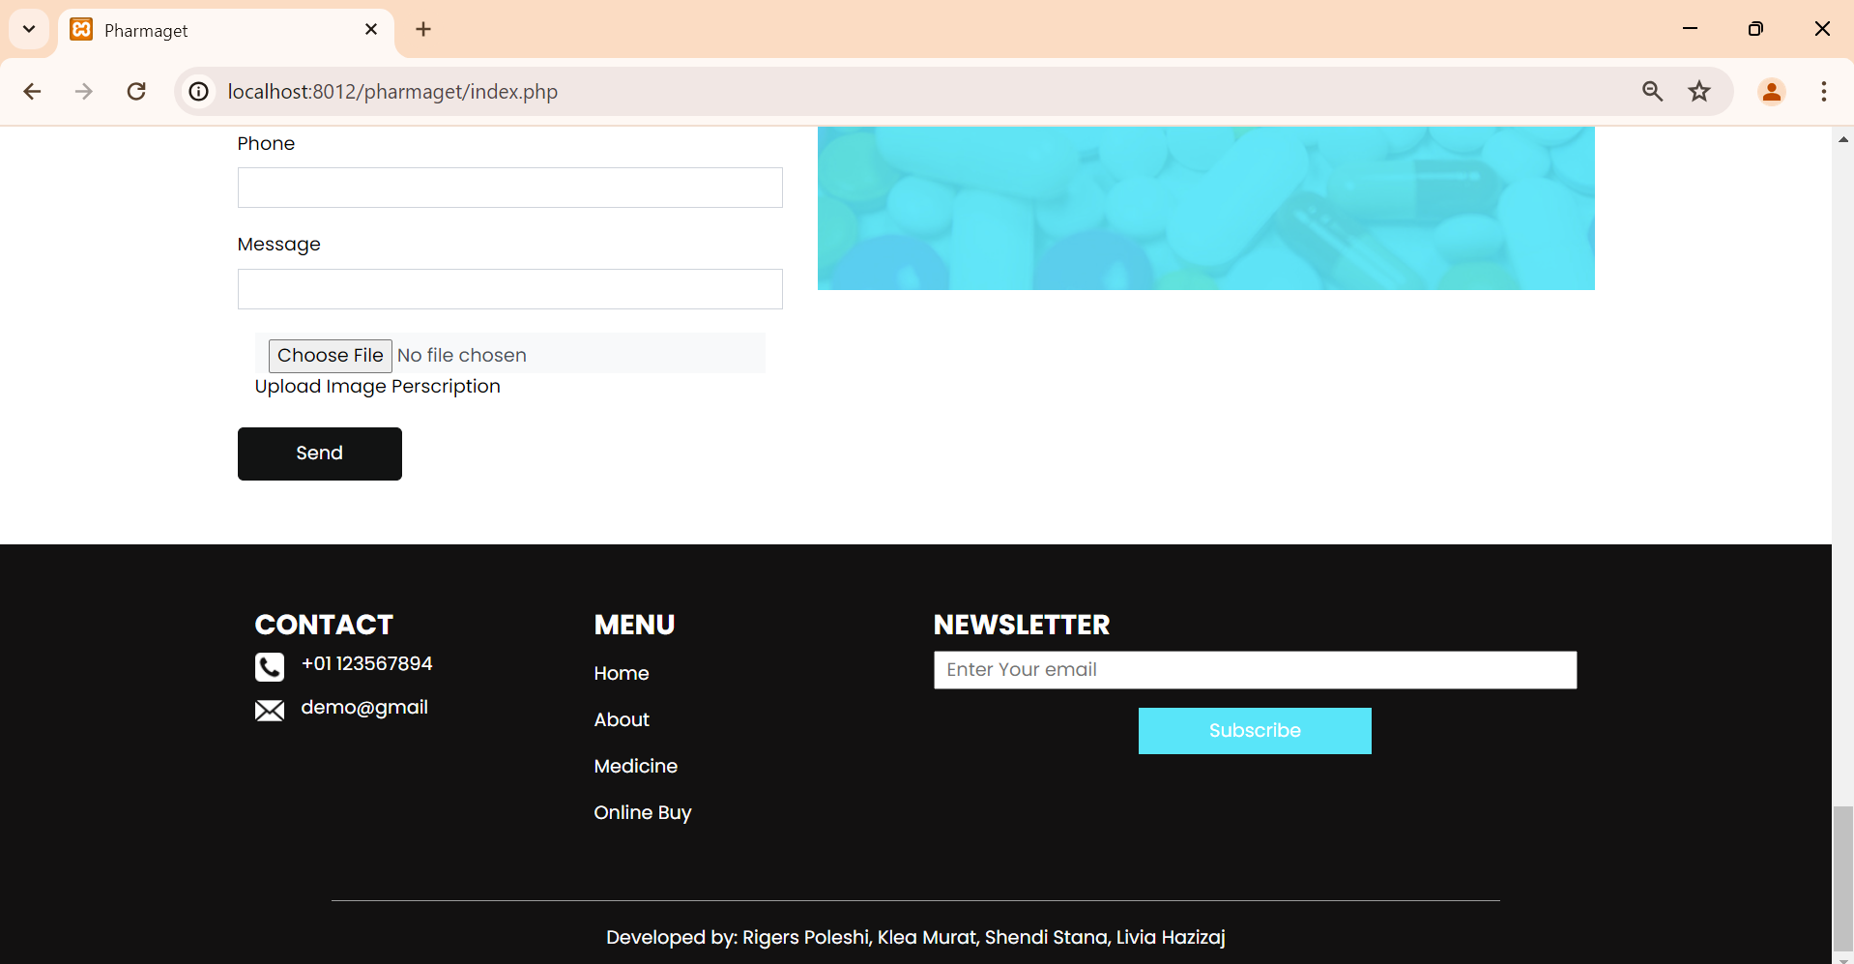

*13*

***4.4 Adding and Deleting Products***

*This feature is mostly for admin users that allows them to add or delete the products based on their stock and new products in the store.*

*“Add Product” field is where the admin can fill the form for a new product such as name , description , category and price.*

*“Delete Product” field is where authorized admin users remove the products from their catalog based on their stock.*

*“Edit Products” field is where the admin can change the feature of existing products on web.*

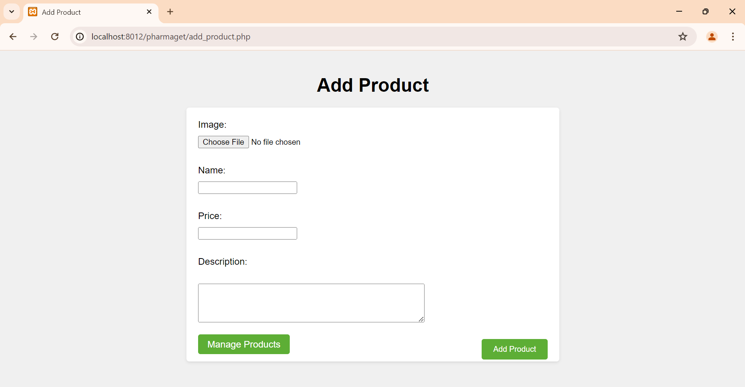



*14*

***5.Other Nonfunctional Requirements***

***5.1 Performance Requirements***

*The performance of the website is that it is a very fast website.*

*It does not open the photos slowly , and has very idealized and optimized quality of the photos . This happens in every kind of equipment desktop , mobile phones , all.*

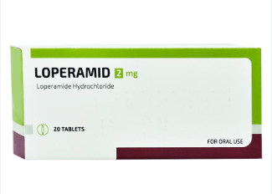

***5.2 Safety Requirements***

*Adding the products happens in a dashboard for the admin , where the admin is the only person that has access.*

*In this case all the changes are made by this admin and all the information given in the system will only be shown to the admin.*

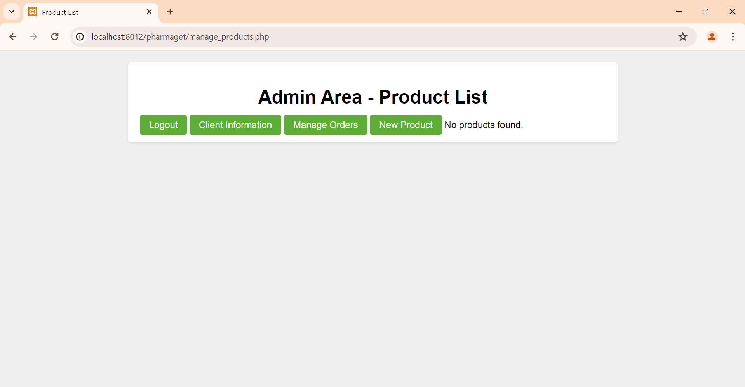

*15*

**

*16*

***5.3 Security Requirements***

*Since we said that the information that the client puts are only seen by the admin , this mean that all the information that the client has put is very secured.*

*This is also a good way to earn the client’s trust.*

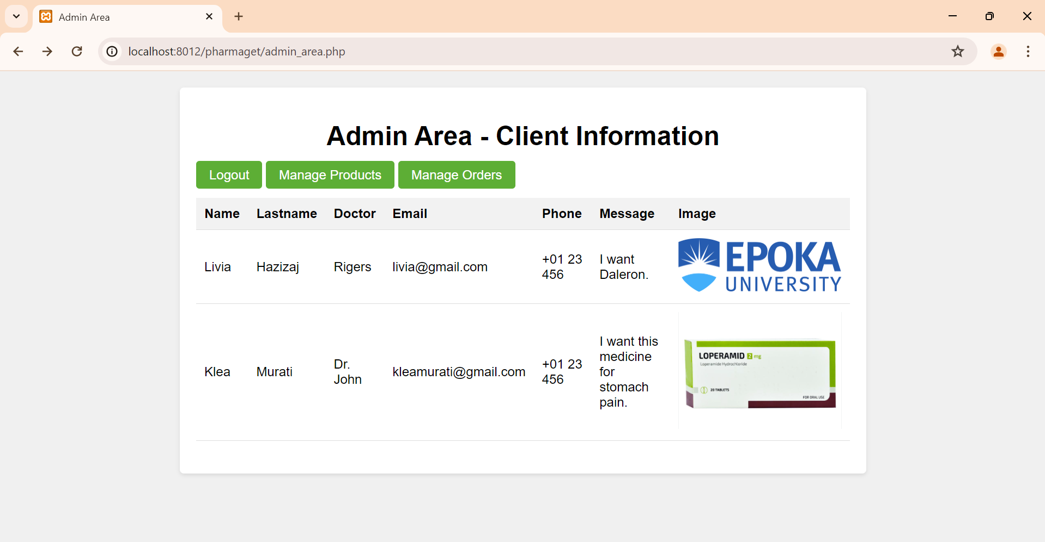

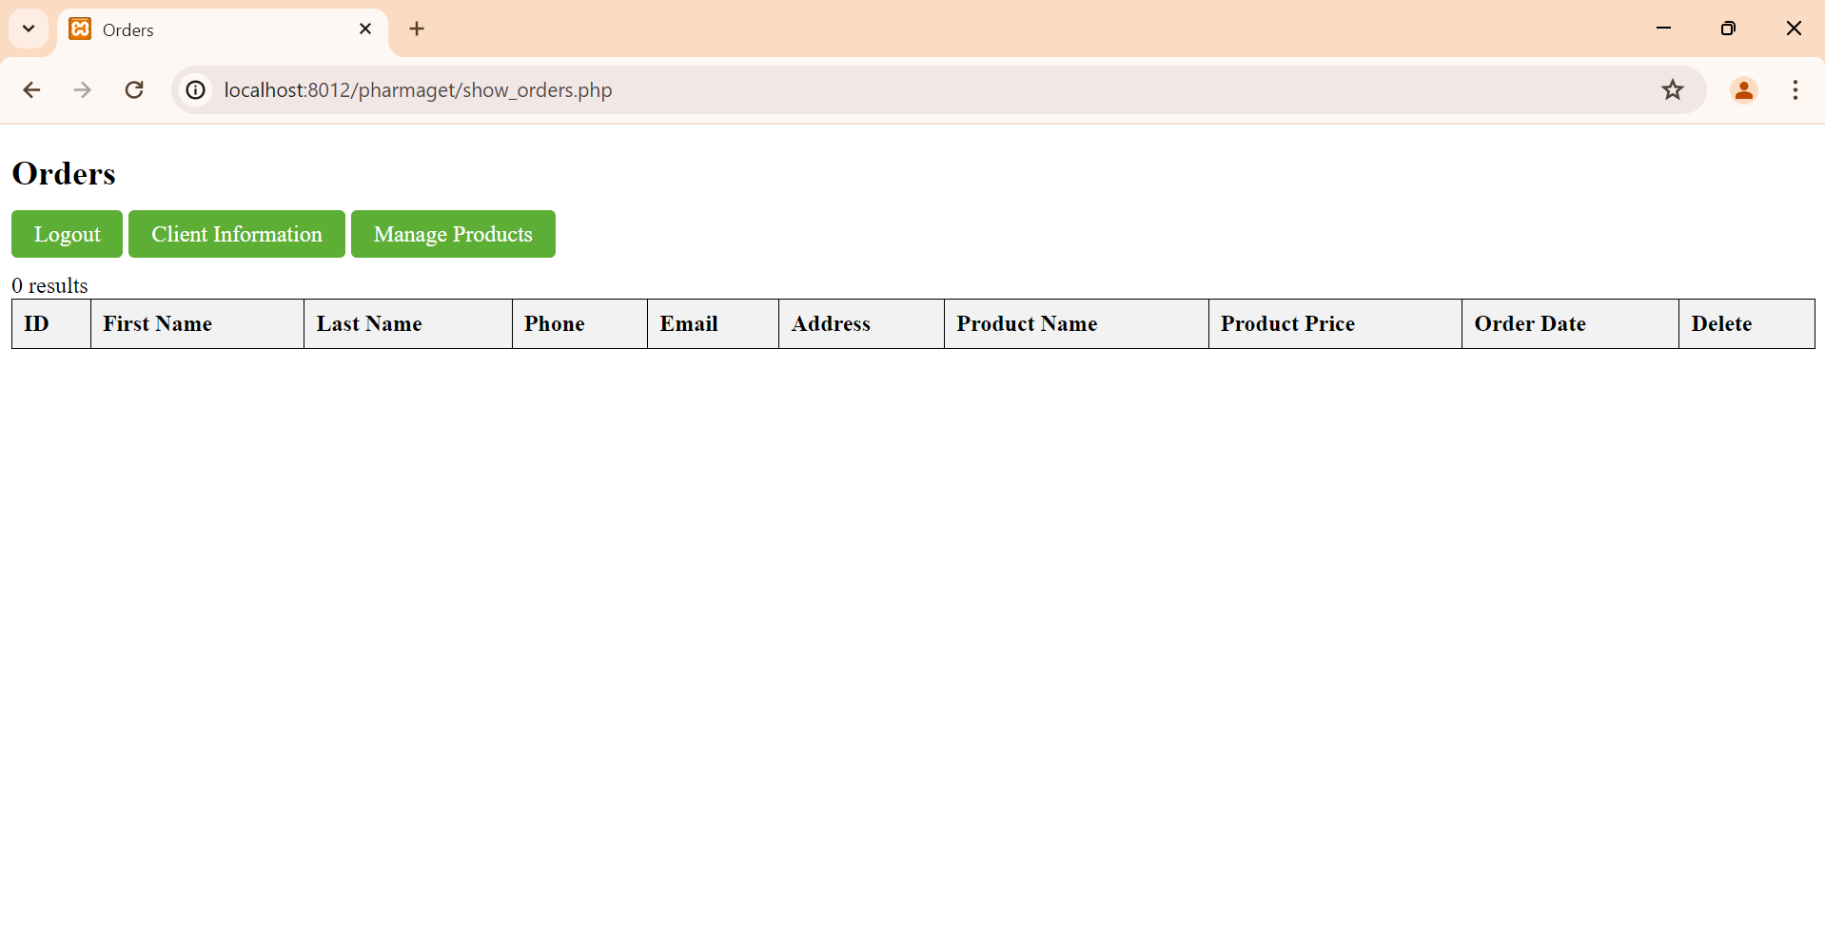

*17*

***5.4 Software Quality Attributes***

*It is easier for the admin to add the products that may be on stock and it is also easier for the users because they can see the last products at the front page .*

*The users can also see the information with just one click in the dashboard.*

***5.5 Business Rules***

*As we said , the admin adds the products which appear in the front end , to be seen by the users or clients.*

*In the front end the users can buy products or to contact with the admin for all the questions that they have.*

***CONCLUSION:***

*Pharmaget is a web based platform for the pharmaceutical industry, which enhances the interactions between pharmaceutical companies and their customers.*

*It centralizes product management , order processing , and customer support , ensuring efficiency and improved client satisfaction.*

*Key features include secure user authentication , comprehensive product catalog ,and reliable prescription verification , making Pharmaget a valuable tool for modern pharmacies.*

*18*