**Experiment -3 Using Tableau and dataset, create visualization**

**with Filtering and sorting of data**

**AIM:** To utilize Tableau for creating interactive visualizations that allow filtering and sorting of dataset attributes for enhanced data analysis.

**OUTPUT:**

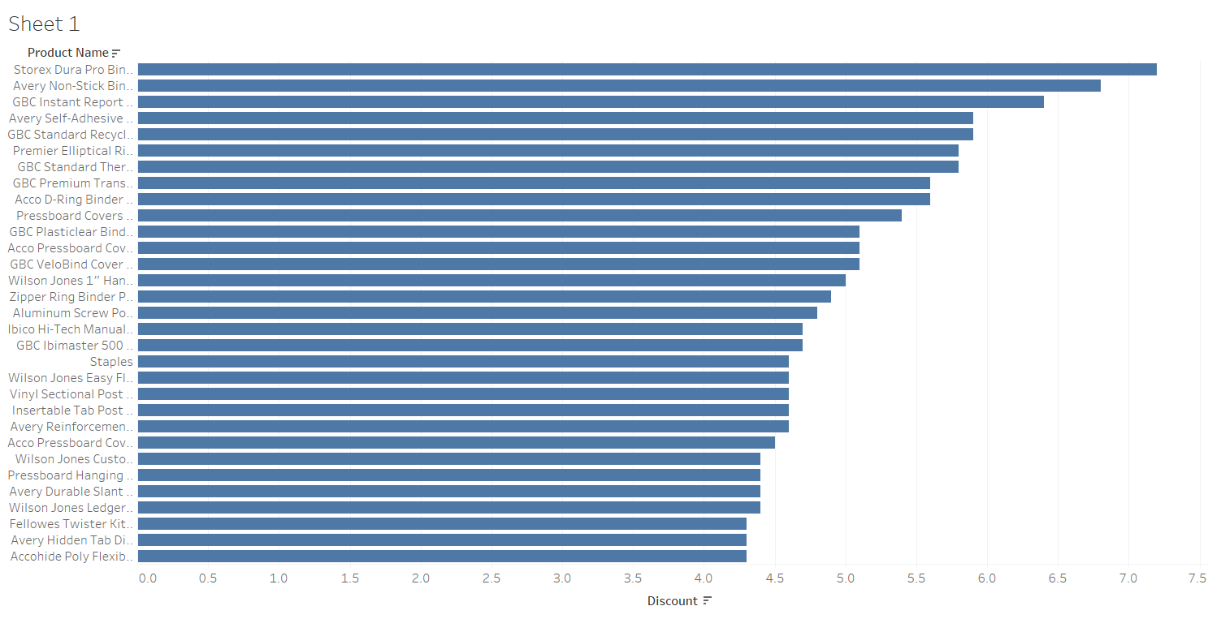

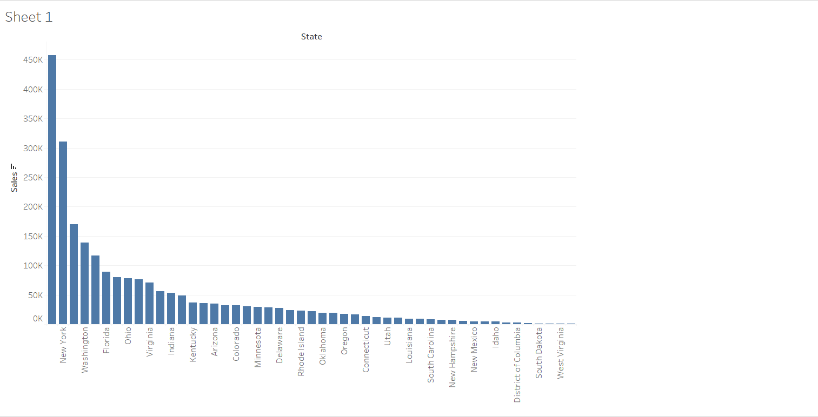

**RESULT:** The experiment is executed successfully