Game Design Document

Fill up the following document

1. Write the title of your project.

The Mouse World

1. What is the goal of the game?

In this game there is a girl and she needs to cross this mouse world to reach her home.

1. Write a brief story of your game.

In between this game the mouses will come and the girl needs to shoot

the mouses and reach home and also in between the jungle obstacles

will come.There will be three life….If the girl touches the mouse or obstacles ,one life will go. If all the lives will be over then game over.

1. Which are the playing characters of this game?

* Playing characters are the ones who respond to the user based on the input from the user.
* Cars, monkeys, dinos, wizards, etc., are the playing characters in the game.

|  |  |  |
| --- | --- | --- |
| Number | Character Name | What can this character do? |
| 1 | Hoodie(Girl) | She needs to cross this mouse world to reach her home and she can shoot the mouses also. |
| 2 |  |  |
| 3 |  |  |
| 4 |  |  |
| 5 |  |  |
| 6 |  |  |
| 7 |  |  |
| 8 |  |  |

1. Which are the Non-Playing Characters of this game?

* Non-Playing characters are the ones that don't have an action or behavior when the user interacts with the game.
* Hurdles, stones, bananas, coins, etc., are non-playing characters in the game.

|  |  |  |
| --- | --- | --- |
| Number | Character Name | What can this character do? |
| 1 | Mouse 1 and Mouse 2 | They will come randomly and decrease the life of Hoodie. |
| 2 | Stone | It will also come randomly and decrease the life of Hoodie. |
| 3 |  |  |
| 4 |  |  |
| 5 |  |  |
| 6 |  |  |
| 7 |  |  |
| 8 |  |  |

Draw your imagination of this game. What does this game look like?

* Draw the game either on your computer or on paper.
* Add images of the game scenes to show each of the playing and non-playing characters at least once.

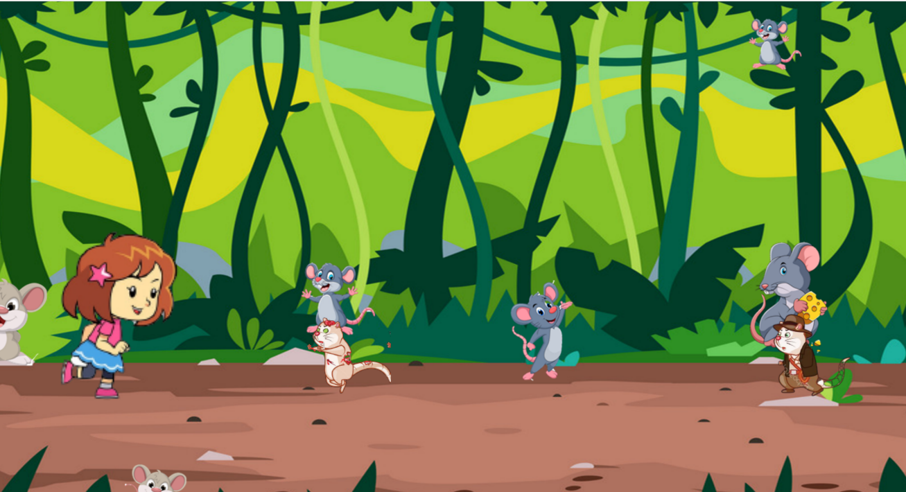

How do you plan to make your game engaging?

By adding more mouses.