Table of Contents

References 1

ARIMAX Models with Exogenous Variables 1

SARIMA Introduction 4

Seasonal ARIMA Elements 4

1. ARIMA Elements 4

2. Seasonal Elements 4

SARIMAX Models 8

Day Ahead Predictions 9

Back-Test Simulations 11

Simulations for Other Data Domains 13

## References

<https://machinelearningmastery.com/sarima-for-time-series-forecasting-in-python/>

<https://machinelearningmastery.com/how-to-grid-search-sarima-model-hyperparameters-for-time-series-forecasting-in-python/>

<https://www.machinelearningplus.com/time-series/arima-model-time-series-forecasting-python/>

<https://alkaline-ml.com/pmdarima/tips_and_tricks.html>

## ARIMAX Models with Exogenous Variables

ARIMAX models are ARIMA models which contain exogenous variables. An **exogenous variable** is an alternate feature and is different than the lagged feature.

Example 1: Temp Preditctioon with Exogenous

This example uses a lagged closing price as an exogenous variable to make predictions for opening stock prices. When running this example, the RMSE is 5.734. The exogenous variable appears to detract from the results when compared to an RMSE of 3.288 when no exogenous variable is used. Remove the highlighted code to remove the exogenous variable. Still, hopefully you recognize the potential for being able to supply additional exogenous variables with your ARIMA models. This article shows an example where an exogenous variable does make an improvement <https://www.machinelearningplus.com/time-series/arima-model-time-series-forecasting-python/>

|  |  |
| --- | --- |
| With exogenous variable.  RMSE: 5.734 | Without exogenous variable.  RMSE: 3.288 |

Here is the code:

|  |
| --- |
| import numpy as np  import matplotlib.pyplot as plt  import pandas as pd  import pandas_datareader as pdr  import datetime  import pmdarima as pm  def getStock(stk, ttlDays):  numDays = int(ttlDays)  dt = datetime.date.today()  dtPast = dt + datetime.timedelta(days=-numDays)  df = pdr.get_data_yahoo(stk,  start=datetime.datetime(dtPast.year, dtPast.month,  dtPast.day),  end=datetime.datetime(dt.year, dt.month, dt.day))  return df  # Show all columns.  pd.set_option('display.max_columns', None)  # Increase number of columns that display on one line.  pd.set_option('display.width', 1000)  dfStock = getStock('AAPL', 1200)  print(dfStock)  TOTAL_DAYS = 5  # Build feature set with backshifted closing prices.  dfStock['Close_t_1'] = dfStock['Close'].shift(1)  dfStock = dfStock.dropna()  dfX = dfStock[['Open', 'Close_t_1']]  size = len(dfX) - TOTAL_DAYS  train, test = dfX[0:size], dfX[size:]  # Create training set and copy of the training set.  train.tail(TOTAL_DAYS)  history = train.copy()  predictions = []  # Iterate to make predictions for the evaluation set.  for i in range(0, len(test)):  lenOpen = len(history[['Close_t_1']])  print("\n\nModel " + str(i))  print(history.shape)  model = pm.auto_arima(history[['Open']],  exogenous=history[['Close_t_1']],  start_p=1, start_q=1,  test='adf', # Use adftest to find optimal 'd'  max_p=3, max_q=3, # Set maximum p and q.  d=None, # Let model determine 'd'.  trace=True,  error_action='ignore',  suppress_warnings=True)  fc, confint = model.predict(n_periods=1,  exogenous=np.array(  history.iloc[lenOpen-1]['Close_t_1']).reshape(1,-1),  return_conf_int=True)  predictions.append(fc)  open = test.iloc[i]['Open']  close_t_1 = test.iloc[i]['Close_t_1']  history = history.append({"Open":open, "Close_t_1":close_t_1},  ignore_index=True)  plt.plot(test.index, test['Open'], marker='o',  label='Actual', color='blue')  plt.plot(test.index, predictions, marker='o',  label='Predicted', color='orange')  plt.legend()  plt.xticks(rotation=70)  plt.show()  from sklearn.metrics import mean_squared_error  from math import sqrt  rmse = sqrt(mean_squared_error(test['Open'], predictions))  print('Test RMSE: %.3f' % rmse) |

SARIMA Introduction  
Seasonal Autoregressive Integrated Moving Average, SARIMA or Seasonal ARIMA, is an extension of ARIMA model that explicitly supports univariate time series data with a seasonal component.

SARIMA models add three new hyperparameters to specify the autoregression (AR), differencing (I) and moving average (MA) for the seasonal component of the series. An additional parameter is also used to specify the period of the seasonality.

## Seasonal ARIMA Elements

The SARIMA model contains two sets of elements.

### ARIMA Elements

The same ARIMA model elements are included as before in the first set:

p: Trend autoregression order.

d: Trend difference order.

q: Trend moving average order.

### Seasonal Elements

In the second set, there are four seasonal elements that are not part of ARIMA model. These capitalized parameters include;

P: Seasonal autoregressive order.

D: Seasonal difference order.

Q: Seasonal moving average order.

m: The number of time steps for a single seasonal period.

Together, the notation for an SARIMA model is specified as:

SARIMA(p,d,q)(P,D,Q)m

For example, here is a model summary for a monthly model:

SARIMA(3,1,0)(1,1,0)12

Time periods for ***m*** include:

1 – daily

12 – monthly

4 – quarterly

52 – weekly

Example 2: Observing Seasonal Differencing

This example visually explores differences between ways to treat seasonal patterns. As you can see, the seasonal spikes remain intact after applying usual differencing (lag 1). Seasonal differencing in the plot at the bottom shows that the pattern is removed.

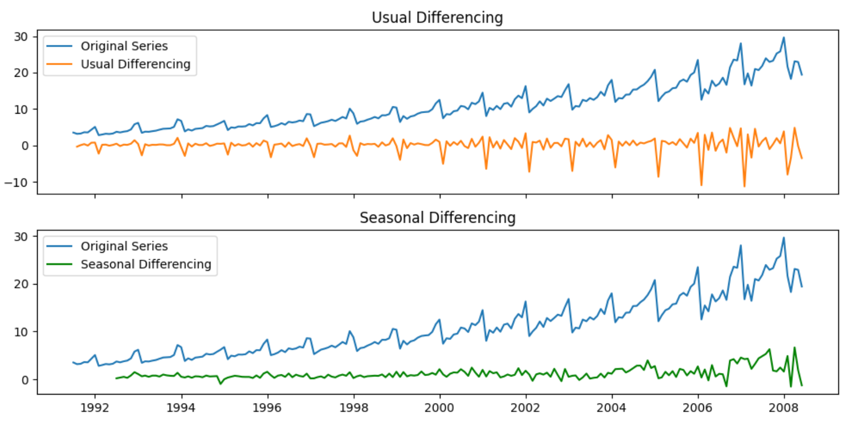

Here is the code which loads the drugSales.csv, performs two separate differencing techniques and visualizes the outcome. The data in the graph at the top is differenced with the instruction:

data[:].diff(1)

The data in the graph at the bottom is differenced with the instruction:

data[:].diff(12)

|  |
| --- |
| import pandas as pd  PATH = "/Users/pm/Desktop/DayDocs/data/"  FILE_NAME = "drugSales.csv"  import matplotlib.pyplot as plt  # Import  data = pd.read_csv(PATH + FILE_NAME, parse_dates=['date'], index_col='date')  # Plot  fig, axes = plt.subplots(2, 1, figsize=(10,5), dpi=100, sharex=True)  # Usual Differencing  axes[0].plot(data[:], label='Original Series')  axes[0].plot(data[:].diff(1), label='Usual Differencing')  axes[0].set_title('Usual Differencing')  axes[0].legend(loc='upper left', fontsize=10)  # Seasonal Differencing  axes[1].plot(data[:], label='Original Series')  axes[1].plot(data[:].diff(12), label='Seasonal Differencing', color='green')  axes[1].set_title('Seasonal Differencing')  plt.legend(loc='upper left', fontsize=10)  plt.show() |

Example 3: Build SARIMA Model

In this example, we recognize the monthly seasonal effect on our data so we will build a SARIMA model. The best model chosen appears to be SARIMAX(3, 0, 0)x(0, 1, 1, 12). This model has an AIC of 516.995 and all p-values are significant.

|  |
| --- |
| Fit ARIMA(2,0,2)x(1,1,2,12) [intercept=True]; AIC=525.207, BIC=554.525, Time=4.698 seconds  Fit ARIMA(1,0,0)x(1,1,2,12) [intercept=True]; AIC=593.876, BIC=613.421, Time=1.616 seconds  Fit ARIMA(1,0,2)x(1,1,2,12) [intercept=True]; AIC=524.213, BIC=550.273, Time=4.700 seconds  Fit ARIMA(3,0,0)x(1,1,2,12) [intercept=True]; AIC=516.995, BIC=543.055, Time=3.125 seconds  Near non-invertible roots for order (3, 0, 0)(1, 1, 2, 12); setting score to inf (at least one inverse root too close to the border of the unit circle: 0.993)  Fit ARIMA(3,0,2)x(1,1,2,12) [intercept=True]; AIC=518.565, BIC=551.140, Time=4.788 seconds  Near non-invertible roots for order (3, 0, 2)(1, 1, 2, 12); setting score to inf (at least one inverse root too close to the border of the unit circle: 0.990)  Total fit time: 48.123 seconds  SARIMAX Results  ===============================================================================================  Dep. Variable: y No. Observations: 204  Model: SARIMAX(3, 0, 0)x(1, 1, [1, 2], 12) Log Likelihood -250.498  Date: Wed, 14 Oct 2020 AIC 516.995  Time: 20:52:50 BIC 543.055  Sample: 0 HQIC 527.550  - 204  Covariance Type: opg  ==============================================================================  coef std err z P>|z| [0.025 0.975]  ------------------------------------------------------------------------------  intercept 0.0205 0.027 0.748 0.454 -0.033 0.074  ar.L1 0.0397 0.048 0.825 0.409 -0.055 0.134  ar.L2 0.4330 0.039 11.152 0.000 0.357 0.509  ar.L3 0.4347 0.056 7.782 0.000 0.325 0.544  ar.S.L12 0.8393 0.121 6.965 0.000 0.603 1.075  ma.S.L12 -1.6430 0.160 -10.285 0.000 -1.956 -1.330  ma.S.L24 0.8395 0.126 6.646 0.000 0.592 1.087  sigma2 0.6953 0.081 8.580 0.000 0.536 0.854  ===================================================================================  Ljung-Box (Q): 63.30 Jarque-Bera (JB): 118.33  Prob(Q): 0.01 Prob(JB): 0.00  Heteroskedasticity (H): 13.06 Skew: 0.44  Prob(H) (two-sided): 0.00 Kurtosis: 6.74  ===================================================================================  Warnings:  [1] Covariance matrix calculated using the outer product of gradients (complex-step) |

Note that the following parameters are set when initializing the auto_arima() search for the seasonal model:

start_P=0, # Set the starting seasonal autoregessive value to 0

seasonal=True, # Allow searching for the seasonal component parameters

d=None, # Let the routine find the best difference for ARIMA

D=12, # Set the starting seasonal differencing to D=1 by default

Here is the code which uses the auto_arima() function to find the model.

|  |
| --- |
| import pandas as pd  PATH = "/Users/pm/Desktop/DayDocs/data/"  FILE_NAME = "drugSales.csv"  import matplotlib.pyplot as plt  # Import  data = pd.read_csv(PATH + FILE_NAME, parse_dates=['date'], index_col='date')  import pmdarima as pm  # Seasonal - fit stepwise auto-ARIMA  smodel = pm.auto_arima(data, start_p=1, start_q=1,  test='adf',  max_p=3, max_q=3, m=12,  start_P=0, seasonal=True,  d=None, D=1, trace=True,  error_action='ignore',  suppress_warnings=True,  stepwise=True)  print(smodel.summary()) |

Example 4: Making Predictions and Plotting the Confidence Interval

This example shows how to use the SARIMAX model to make predictions over 24 months. Confidence intervals were extracted from the predictions as well.

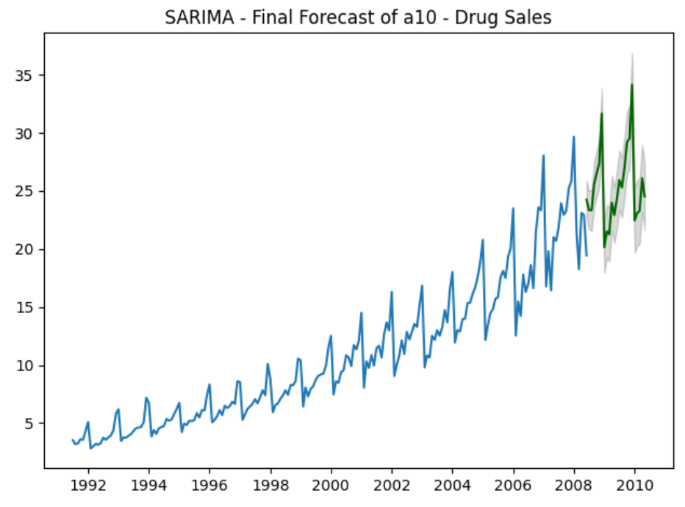

|  |
| --- |
| # Forecast  NUM_TIMESTEPS = 24  fitted, confint = smodel.predict(n_periods=NUM_TIMESTEPS, return_conf_int=True)  index_of_fc = pd.date_range(data.index[-1], periods = n_periods, freq='MS')  # make series for plotting purpose  fitted_series = pd.Series(fitted, index=index_of_fc)  lower_series = pd.Series(confint[:, 0], index=index_of_fc)  upper_series = pd.Series(confint[:, 1], index=index_of_fc)  # Plot  plt.plot(data)  plt.plot(fitted_series, color='darkgreen')  plt.fill_between(lower_series.index,  lower_series,  upper_series,  color='k', alpha=.15)  plt.title("SARIMA - Final Forecast of a10 - Drug Sales")  plt.show() |

## SARIMAX Models

Similar to the ARIMAX model, you can also include an exogenous variable array to supplement the SARIMAX model. An example of how to build the SARIMAX model can be found at <https://www.machinelearningplus.com/time-series/arima-model-time-series-forecasting-python/>

Note there is an error in the code in the SARIMAX example at the site:

exogenous=np.tile(seasonal_index.value, 2).reshape(-1,1),

Should really be like this:

exogenous=np.tile(seasonal_index.seasonal, 2).reshape(-1,1),

Exercise 1 (3 marks)

Run the following code to load the energy production data set.

|  |
| --- |
| import pandas as pd  PATH = "/Users/pm/Desktop/DayDocs/data/"  FILE_NAME = "Energy_Production.csv"  import matplotlib.pyplot as plt  # Import  data = pd.read_csv(PATH + FILE_NAME, index_col=0)  data.index = pd.to_datetime(data.index) |

Show the first few rows of data frame here:

|  |
| --- |
|  |

Use the describe() function on the data frame and show the results here:

|  |
| --- |
|  |

Exercise 2 (4 marks)

Using code like the code in Example 2 to visualize the effects of seasonal differencing. Use a monthly period of 12. Show the plots here:

|  |
| --- |
|  |

Exercise 3 (4 marks)

Run the auto_arima() function for the Energy_Production.csv data set to discover the optimal SARIMA p,d,q values. You can assume m=12. Show your ARIMA p,d,q values and your seasonal component p,d,q parameters.

**Note**: If you do receive a memory error you can truncate the data set to   
a smaller size before implementing the auto_arima.  
  
This code truncates the data set to 300 rows.  
#data = data[0: 300]

|  |
| --- |
|  |

Exercise 4 (4 marks)

Plot the predictions for 24 periods and actual values together on a graph. Show your results here:

|  |
| --- |
|  |

Day Ahead Predictions with Exogenous Variables

*Example 5: Day Ahead Prediction with Two Exogenous Features*

This code is making day-ahead predictions for the opening price of stock. The model uses the closing price (**Close_t_1**) and volume (**Volume_t_1**) from the day before to predict the (**Open**) price.

Currently, the ways that we could evaluate the model are limited. In this case, an RMSE for the past 15 days is calculated. However, performing an evaluation with such a small amount of data is not a robust approach.

|  |
| --- |
| import numpy as np  import matplotlib.pyplot as plt  import pandas as pd  import pandas_datareader as pdr  import datetime  import pmdarima as pm  def getStock(stk, ttlDays):  numDays = int(ttlDays)  dt = datetime.date.today()  dtPast = dt + datetime.timedelta(days=-numDays)  df = pdr.get_data_yahoo(stk,  start=datetime.datetime(dtPast.year, dtPast.month,  dtPast.day),  end=datetime.datetime(dt.year, dt.month, dt.day))  return df  # Show all columns.  pd.set_option('display.max_columns', None)  # Increase number of columns that display on one line.  pd.set_option('display.width', 1000)  dfStock = getStock('AAPL', 1200)  print(dfStock)  TOTAL_DAYS = 15  # Build feature set with backshifted closing prices.  dfStock['Close_t_1'] = dfStock['Close'].shift(1)  dfStock['Volume_t_1']= dfStock['Volume'].shift(1)  dfStock = dfStock.dropna()  dataDf = dfStock[['Open', 'Close_t_1', 'Volume_t_1']]  splitRowNum = len(dataDf) - TOTAL_DAYS  trainDf, testDf = dataDf[0:splitRowNum], dataDf[splitRowNum:]  # Create training set and copy of the training set.  trainDf.tail(TOTAL_DAYS)  history = trainDf.copy()  predictions = []  FEATURE_LIST = ['Close_t_1', 'Volume_t_1']  # Iterate to make predictions for the evaluation set.  for i in range(0, len(testDf)):  # Find the best model with most recent features.  model = pm.auto_arima(history[['Open']],  exogenous=history[FEATURE_LIST],  start_p=1, start_q=1,  test='adf', # Use adftest to find optimal 'd'  max_p=3, max_q=3, # Set maximum p and q.  d=None, # Let model determine 'd'.  seasonal=False, # No Seasonality.  trace=True,  error_action='ignore',  suppress_warnings=True,  stepwise=True)  lenHistory = len(history)  subDf = history[FEATURE_LIST]  featureArray = np.array(subDf)  lastFeatureRow = featureArray[lenHistory - 1]  # Make prediction with most recent data prior to prediction.  pred, confint = model.predict(n_periods=1,  exogenous=lastFeatureRow.reshape(1,-1),  return_conf_int=True)  predictions.append(pred)  # Extract next row in the test set.  open = testDf.iloc[i]['Open'] # Open price morning.  close_t_1 = testDf.iloc[i]['Close_t_1'] # Close price day before.  volume_t_1 = testDf.iloc[i]['Volume_t_1'] # Volume day before.  # Add most recently available training data.  history = history.append({  "Open":open,  "Close_t_1":close_t_1,  "Volume_t_1":volume_t_1},  ignore_index=True)  plt.plot(testDf.index, testDf['Open'], marker='o',  label='Actual', color='blue')  plt.plot(testDf.index, predictions, marker='o',  label='Predicted', color='orange')  plt.legend()  plt.xticks(rotation=70)  plt.show()  from sklearn.metrics import mean_squared_error  from math import sqrt  rmse = sqrt(mean_squared_error(testDf['Open'], predictions))  print('testDf RMSE: %.3f' % rmse) |

*Exercise 5 (Not for marks)*

Why would it not be appropriate to include Open t-1, Open t-2 or other lags for the Open price in the exogenous variable?

|  |
| --- |
| Because there will be better RMSE without exogenous variables because these exogeneous variables are alternate features and are different than the lagged feature. For the stock market prediction we know the value of the variable during the forecast period. (Seasonal pattern) |

*Exercise 6 (Not for marks)*

Can other prices and volumes for other stocks or trade indexes be included as exogenous variable features?

|  |
| --- |
| Yes, as long as it is seasonal. |

Back-Test Simulations

Since the ability to obtain current data is limited, we can develop a back-testing simulation to help evaluate our model. Back-testing allows us to evaluate our model’s ability to achieve specific goals with a larger data set. However, be cautious with back-test simulations since external factors outside the model which affect the outcome will also change over time also.

*Example 6: Back-Testing Simulation*

The strategy being back-tested in this example involves buying stock at the end of the day and selling at the next open when a higher price is expected at the opening. To begin, start with the code for Example 5.

The simulation tries to predict the gains over time. To observe how the routine would have performed during the past 45 days, change the duration of the back-test by setting TOTAL_DAYS to 45.

|  |
| --- |
| TOTAL_DAYS = 45 |

Next, place the following code before the loop in Example 5. The code starts with a balance of $20,000. The function implements a routine to purchase stock at the close of the day, sell the stock at the next opening and update the cash balance.

|  |
| --- |
| cashBalance = 20000  def udpateCashBalance(cashBalance, purchasePrice, sellPrice):  qty = int(cashBalance / purchasePrice)  cost = purchasePrice * qty  cashBalance -= cost  revenue = sellPrice * qty  cashBalance += revenue  return cashBalance |

Next, at the end of the loop, add this code to update the cash balance whenever the opening price is predicted to be higher than the closing price.

|  |
| --- |
| if(pred > close_t_1):  cashBalance = udpateCashBalance(cashBalance, close_t_1, open) |

At the end of the time series, show the final cash balance.

|  |
| --- |
| print("The final cash balance is: " + str(cashBalance)) |

After running the simulation, the output appears as follows (but without the formatting):

The final cash balance is: **$20,353.72**

If you ran the trial again without including volume (at the time this document was written) you would notice that the final cash balance would be the same. If you ran the trial again and included the close_t_2 within the exogenous feature set you would notice the final cash balance would be:

**$20,360.16**

Here are some other use cases that you try (if you had time):

* Set the TOTAL_DAYS to include one full year.
* Include in stock prices from a stock from the same sector within the exogenous variable feature set.

Simulations for Other Data Domains

With stocks the back-test would often evaluate the success of a trade strategy. Other knowledge domains may demand creative adjustments to provide a worthwhile simulation to evaluate the model’s ability to achieve specific goals. For example, when trying to simulate predictions of sales for Walmart, you could examine how close total accumulated sales predictions match the actual values over a fixed duration.