UML diagram

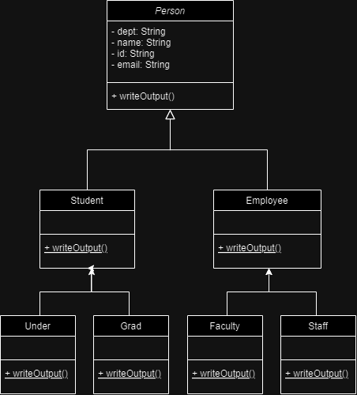

**Polymorphism:**

In this system, polymorphism is used to interact with different types of Person objects (such as Under, Grad, Faculty, Staff) through a common interface (the Person class). This allows the program to treat all person objects uniformly, even though they might be instances of different subclasses.

**Method Overriding:**

The writeOutput() method is defined in the abstract superclass Person and is overridden in each subclass (Under, Grad, Faculty, Staff).