**“Minic me” project report**

Task 1: Display Features Points

For task 1 all the feature points detected by Affectiva’s library have been drawn using the javascript drawing functions. In particular each point is drawn as a small circle centered in the coordinates of each feature point.

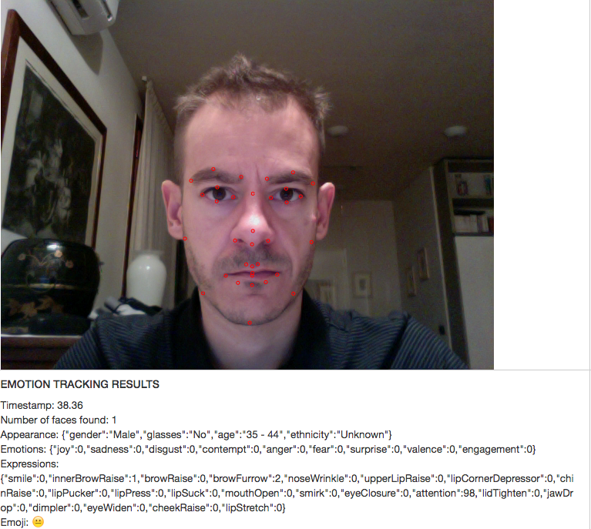

Task 2: Show dominant Emoji

Since an Emojis is represented as a sequence of special characters, in order to show the dominant Emoji the javascript function that draw a particular string of text in a specific position has to be used. In order to locate the emoji close to the face the following approach has been considered. First I identified the feature point that I used as anchor for the emoji, in particular I chose the “outer right eye” feature, than I draw the emoji at the location of the feature shifted by a suitable offset in order to not cover to much the face with emoji. Additionally in this task it has been implemented a mechanism to change the size of the emoji based on the size of the detected face. In order to estimate the size of the detected face, it has been calculated the distance on x axis between two symmetrical features (outer right eye and outer left eye). If this distance is greater than the 20% of the drawing canvas width we use the bigger font to draw the emoji, otherwise we use the smaller font.

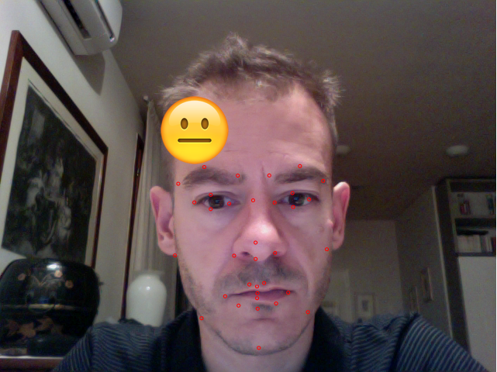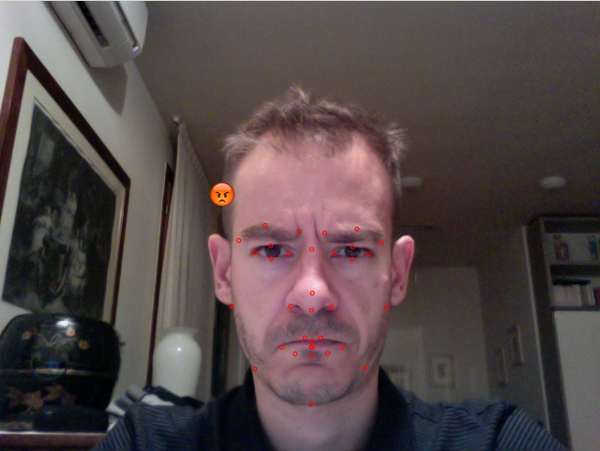

Task 3: Mimic me game