Windows Forms – Validation, Exceptions, ListView, TreeView
Contents
1. Data Validation 1
2. Complex Visualization Controls 2
2.1. ListView 2
2.2. TreeView 5
3. Exception Handling 7
3.1. Custom Exceptions 7
3.2. Standard Exceptions 8

Data Validation
Assignment
Sample code available at http://online.ase.ro – “ValidationCustomExceptions” Sample
- Create a new project with the name “ValidationCustomExceptions”
- Create the following UI.
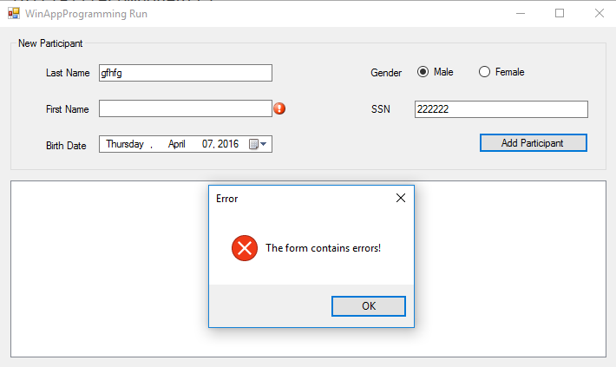
- Add ErrorProviders for the LastName and FirstName fields: epLastName, epFirstName
- Handle the Validating event on tbLastName as follows.
string lastName = ((TextBox) sender).Text.Trim();

if (string.IsNullOrWhiteSpace(lastName))
{
e.Cancel = true; //prevents the user from changing the focus to another control

epLastName.SetError((Control)sender, "The Last Name should not be empty!");
}
- Handle the Validated event on tbLastName as follows.
epLastName.Clear();
- Handle the Validating and Validated events for the tbFirstName in a similar manner.
- Handle the Click event on the “Add Participant” button as follows.
private void btnAdd_Click(object sender, EventArgs e)
{
string firstName = tbFirstName.Text.Trim();
string lastName = tbLastName.Text.Trim();
DateTime birthDate = dtpBirthDate.Value;

bool isValid = true;

if (string.IsNullOrWhiteSpace(lastName))
{
epLastName.SetError(tbFirstName, "The Last Name should not be empty!");
isValid = false;
}

if (string.IsNullOrWhiteSpace(firstName))
{
epFirstName.SetError(tbFirstName, "The First Name should not be empty!");
isValid = false;
}

if (!isValid)
{
//An ErrorProvider control should
MessageBox.Show("The form contains errors!",
"Error", MessageBoxButtons.OK, MessageBoxIcon.Error);

return;
}
}
- Why is it recommended to have the validations both on the individual controls and in the handler for the “Add Participant” button?

Complex Visualization Controls

ListView
Assignment
Sample code available at http://online.ase.ro – “ListViewSample” Sample
- Create a new project with the name “ListViewSample”
- Rename “Form1” to “MainForm”
- Create the following UI
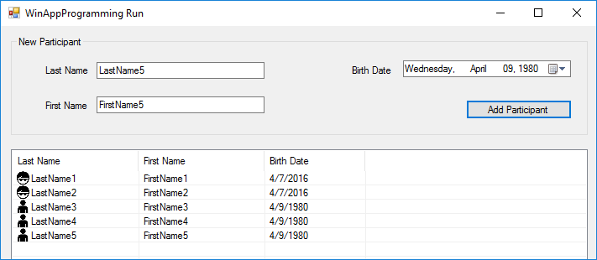
Figure 1 ListView
- Add a new folder to your project and name it “Entities”
- Inside the “Entities” folder add the following “Participant” class
internal class Participant
{
public string LastName { get; set; }
public string FirstName { get; set; }
public DateTime BirthDate { get; set; }

public Participant(string lastName, string firstName, DateTime birthDate)
{
LastName = lastName;
FirstName = firstName;
BirthDate = birthDate;
}
}
- Final form of the “MainForm” class
public partial class MainForm : Form
{
#region Properties
private List<Participant> Participants { get; set; }
#endregion

public MainForm()
{
InitializeComponent();

Participants = new List<Participant>();
}

public void DisplayParticipants()
{
lvParticipants.Items.Clear();

foreach (Participant participant in Participants)
{
var listViewItem = new ListViewItem(participant.LastName);
listViewItem.SubItems.Add(participant.FirstName);
listViewItem.SubItems.Add(participant.BirthDate.ToShortDateString());

//approximate calculation of the age
if ((DateTime.Now - participant.BirthDate).TotalDays / 365 >= 18)
listViewItem.ImageKey = "adult.png";
else
listViewItem.ImageKey = "child.png";

lvParticipants.Items.Add(listViewItem);
}
}

#region Events
private void btnAdd_Click(object sender, EventArgs e)
{
string firstName = tbFirstName.Text;
string lastName = tbLastName.Text;
DateTime birthDate = dtpBirthDate.Value;

var participant = new Participant(lastName, firstName, birthDate);
Participants.Add(participant);

DisplayParticipants();
}
#endregion
- Add buttons for changing the current “View” of the list, as shown in Figure 2 .
- Display the participants in groups (“Children” and “Adults”) as shown in Figure 2 .
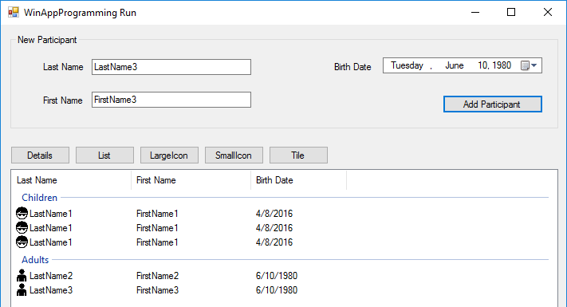
Figure 2. ListView with Groups

TreeView
Assignment
Sample code available at http://online.ase.ro – “TreeViewSample” Sample
- Create a new project with the name “TreeViewSample”
- Create the following UI
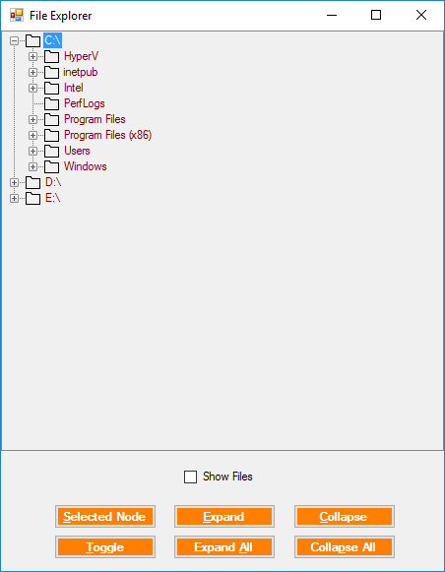
- Add the following methods
#region Methods
private void FillDirectoryTree()
{
// Suppress redraw until tree view is complete
tvw.BeginUpdate();

// First clear all the nodes.
tvw.Nodes.Clear();

// Get the logical drives and put them into the root nodes.
// Fill an array with all the logical drives on the machine.
string[] strDrives = Environment.GetLogicalDrives();

// Iterate through the drives, adding them to the tree.
// Use a try/catch block, so if a drive is not ready,
// e.g. an empty floppy or CD, it will not be added to the tree.
foreach (string rootDirectoryName in strDrives)
{
try
{
// Find all the first level subdirectories.
// If the drive is not ready, this will throw an
// exception, which will have the effect of
// skipping that drive.
Directory.GetDirectories(rootDirectoryName);

// Create a node for each root directory
TreeNode ndRoot = new TreeNode(rootDirectoryName);

// Add the node to the tree
tvw.Nodes.Add(ndRoot);

// Add subdirectory nodes.
// If Show Files checkbox checked, then also get the filenames.
GetSubDirectoryNodes(ndRoot, cb.Checked);
}
catch (IOException)
{
// let it through
}
catch (Exception e)
{
// Catch any other errors.
MessageBox.Show(e.Message);
}
}

tvw.EndUpdate();

}

private void GetSubDirectoryNodes(TreeNode parentNode, bool getFileNames)
{
// Exit this method if the node is not a directory.
DirectoryInfo di = new DirectoryInfo(parentNode.FullPath);
if ((di.Attributes & FileAttributes.Directory) == 0)
{
return;
}

// Clear all the nodes in this node.
parentNode.Nodes.Clear();

try
{
// Get an array of strings containing all the subdirectories in the parent node.
string[] arSubs = Directory.GetDirectories(parentNode.FullPath);

// Add a child node for each subdirectory.
foreach (var subDir in arSubs)
{
DirectoryInfo dirInfo = new DirectoryInfo(subDir);
// do not show hidden folders
if ((dirInfo.Attributes & FileAttributes.Hidden) != 0)
{
continue;
}

TreeNode subNode = new TreeNode(dirInfo.Name);
subNode.ImageIndex = 0;
subNode.SelectedImageKey = "openFolder.png";
parentNode.Nodes.Add(subNode);
}

if (getFileNames)
{
// Get any files for this node.
string[] files = Directory.GetFiles(parentNode.FullPath);

// After placing the nodes,
// now place the files in that subdirectory.
foreach (string str in files)
{
FileInfo fi = new FileInfo(str);
TreeNode fileNode = new TreeNode(fi.Name);
parentNode.Nodes.Add(fileNode);

// Set the icon
switch (fi.Extension.ToUpper())
{
case ".JPG":
case ".JPEG":
fileNode.ImageKey = "jpgFile.png";
fileNode.SelectedImageKey = "jpgFile.png";
break;
case ".TXT":
fileNode.ImageKey = "textFile.png";
fileNode.SelectedImageKey = "textFile.png";
break;
default:
fileNode.ImageKey = "file.png";
fileNode.SelectedImageKey = "file.png";
break;
}
}
}
}
catch (UnauthorizedAccessException)
{

}
}
#endregion

Exception Handling

Custom Exceptions
Assignment
Sample code available at http://online.ase.ro – “ValidationCustomExceptions” Sample
- Add the following “InvalidBirthDateException” class

public class InvalidBirthDateException : Exception
{
public DateTime BirthDate { get; set; }

public InvalidBirthDateException(DateTime birthDay)
{
BirthDate = birthDay;
}

public override string Message
{
get
{
return "The birthDate " + BirthDate + " is invalid";
}
}
}
- Update the “BirthDate” property in the “Participant” class in order to validate the received value
#region BirthDate
private DateTime _birthDate;
public DateTime BirthDate {
get { return _birthDate; }
set
{
if(value >= DateTime.Today)
throw new InvalidBirthDateException(value);
_birthDate = value;
}
}
#endregion
- Update the event handler for the “Add Participant” button in order to handle the potential exceptions.
try
{
var participant = new Participant(lastName, firstName, birthDate, gender, ssn);
//TODO Logic for adding the participant to the list bellow
}
catch (InvalidBirthDateException ex)
{
//Expected exception
MessageBox.Show(string.Format("The birth date {0} is invalid!", ex.BirthDate));
}
catch (Exception)
{
//UnExpected exception
MessageBox.Show("An exception has been encountered! Please contact the technical support.");

//Log the exception using:
// - Log4Net
// - Application Insights
}
finally
{
Debug.WriteLine("Always executed");
}

Standard Exceptions
- common exception types: System.NotImplementedException, System.DivideByZeroException, System. FormatException
Further reading: link
Assignment
- Create a new project with the name “StandardExceptions”
- Create the following UI
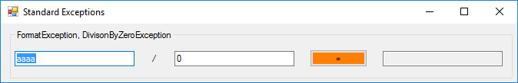
- Handle the possible exceptions
try
{
int value1 = int.Parse(tbValue1.Text);
int value2 = int.Parse(tbValue2.Text);

tbResult.Text = (value1/value2).ToString(CultureInfo.InvariantCulture);

//Throwing an exception:
//throw new NotImplementedException();
}
catch (FormatException ex)
{
MessageBox.Show(ex.Message);

//Rethrowing the exception
//throw; //Handled by Program.Application_ThreadException
}
catch (DivideByZeroException ex)
{
MessageBox.Show(ex.Message);
}
catch (Exception ex)
{
MessageBox.Show(ex.Message);
}
- Catching all uncaught exceptions in an application can be done by subscribing to the “ThreadException” event in the “Program” class.
static class Program
{
/// <summary>
/// The main entry point for the application.
/// </summary>
[STAThread]
static void Main()
{
Application.ThreadException += Application_ThreadException;

Application.EnableVisualStyles();
Application.SetCompatibleTextRenderingDefault(false);
Application.Run(new MainForm());
}

private static void Application_ThreadException(object sender, System.Threading.ThreadExceptionEventArgs e)
{
MessageBox.Show(e.Exception.Message);
}
}

