com.livos.appdemo

This app is a demo app to demonstrate MVP architecture and the uses of several popular libraries.
Libraries used :
- Retrofit 2 (Http client library for REST Api)
- GSON (Retrofit 2 dependency)
- Dagger 2 : dependency injection
- ButterKnife : views databinding
- RxAndroid / RxJava 1 : Reactive programming
This app call two separate API from two different sources to get top movies informations (Title, country) and show this in a RecyclerView.
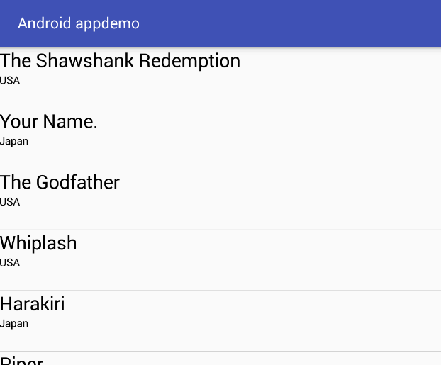

This app is packaged by feature : 1 feature => 1 package
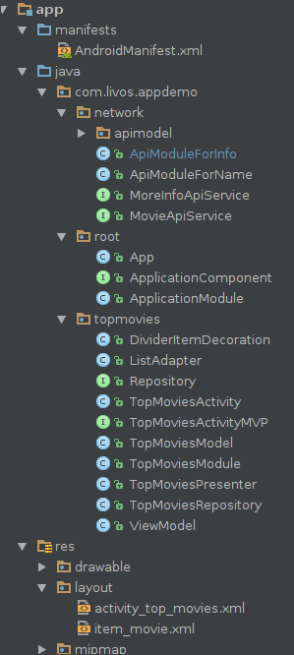

TopMoviesActivity.java (class)
- Implements TopMoviesActivityMVP.View
- Bind RecyclerView from activity_top_movies.xml (ButterKnife)
- Inject TopMoviesActivityMVP.Presenter (Dagger)

TopMoviesPresenter.java (class)
- Implements TopMoviesActivityMVP.Presenter
- Instanciate TopMoviesActivityMVP.Model
- Instanciate TopMoviesActivityMVP.View
- Subscribe to TopMoviesModel.result() (Rxjava)
- Update data in view sending ViewModel as parameter
- Unsubscribe from TopMoviesModel.result() (Rxjava)

TopMoviesModel.java (class)
- Instantiate Repository
- Instantiate ViewModel an set its data with the ones from API
- Return ViewModel containing data from API

ViewModel.java (class)
Object that will contains data from API. The main purpose of the ViewModel is that it adapts the representation of inner entity model to a specific model which aligns well with the actual view which is presented to the user.

TopMoviesActivityMVP.java (interface)
- Declare Interfaces View, Presenter and Model and their methods.

Repository.java (interface)
- Declare Observables methods to get result from memory or network

TopMoviesModule.java (class)
It's the Dagger module. This is where Dagger will keep track of the dependencies. In such module Dagger will look for variable methods and possible instance providers.
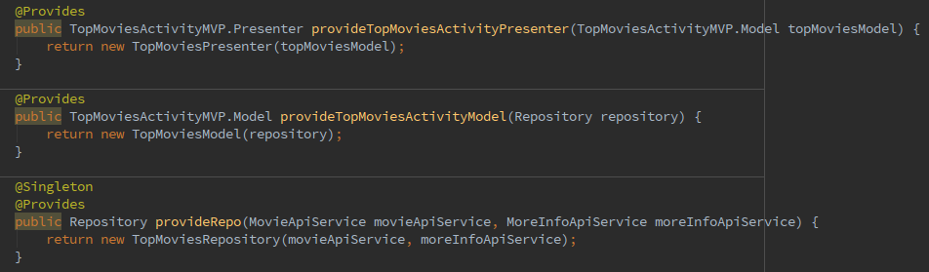
Instance providers in this module :

TopMoviesRepository.java
- Implements Repository
- Get data from API through :
  - MovieApiService or memory (cache)
  - MoreInfoApiService or memory (cache)
- Return data from API as Observable

MovieApiService.java (interface)
Declare Get top rated movies Retrofit method (returns Observable)

MoreInfoApiService.java (interface)
Declare Get movie country Retrofit method (returns Observable)

ApiModuleForName.java (class)
Dagger module providing :
- OkHttpClient
- Retrofit
- MovieApiService (sent to TopMoviesRepository as parameter)
  - Request the API using OkHttp and Retrofit

ApiModuleForInfo (class)
Dagger module providing :
- OkHttpClient
- Retrofit
- MoreInfoApiService (sent to TopMoviesRepository as parameter)
  - Request the API using OkHttp and Retrofit

