Acknowledgment
This project is the outcome of consistent effort, continuous learning, and valuable collaboration. I would like to express my sincere gratitude to everyone who supported me throughout this journey.
First and foremost, I extend my heartfelt thanks to the Department of Computer Science at St. Xavier’s College (Autonomous) for providing a strong academic foundation, essential resources, and the necessary guidance to successfully complete this project.
I would like to express my special appreciation to Techmicra IT Solutions for offering me the opportunity to work on a real-world application and for providing meaningful industry exposure. Their mentorship, technical support, and professional guidance played a significant role in enhancing my understanding of full-stack development and enterprise-level system design.
I am deeply thankful to my internal guide, Professor Ashwini Kshatriya, for her constant encouragement, expert guidance, and insightful suggestions. Her support, especially in system design, architecture, and implementation strategies, contributed greatly to the successful completion of this project.
I would also like to extend my gratitude to my external industry mentor, Mr. Pallav Mamtora, for his valuable feedback and practical insights. His guidance in areas such as requirement analysis, system workflows, Data Flow Diagrams (DFDs), Data Dictionary preparation, coding, and UI/UX design was instrumental in refining this project.
I am grateful to (Fr.) Johnson, Vice Principal of the Department of Computer Science at St. Xavier’s College, for his encouragement and continuous support throughout the academic session.
Internal Guide: Professor Ashwini Kshatriya
External Guide: Pallav Mamtora
Project Developer: Vasava Vishwanath
Roll Number: 22-CS-018

INDEX
S.NO. TOPIC PAGE NO.

1. Screen layout 3
Landing page 3
Student pages 4
Teacher pages 13
Admin Pages 20
2. Report layout 27
Csv reports of system 27
Pdf reports system 28
3. Conclusion : 31
4. Bibliography : 32

Screen layout

Landing page
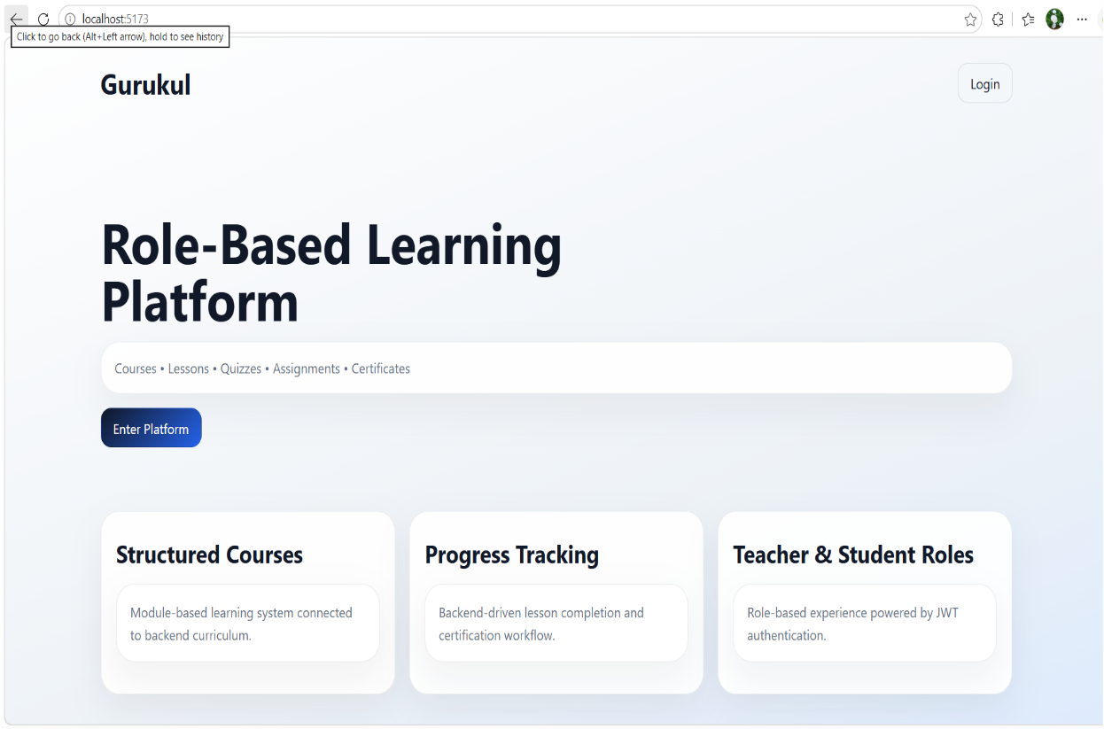
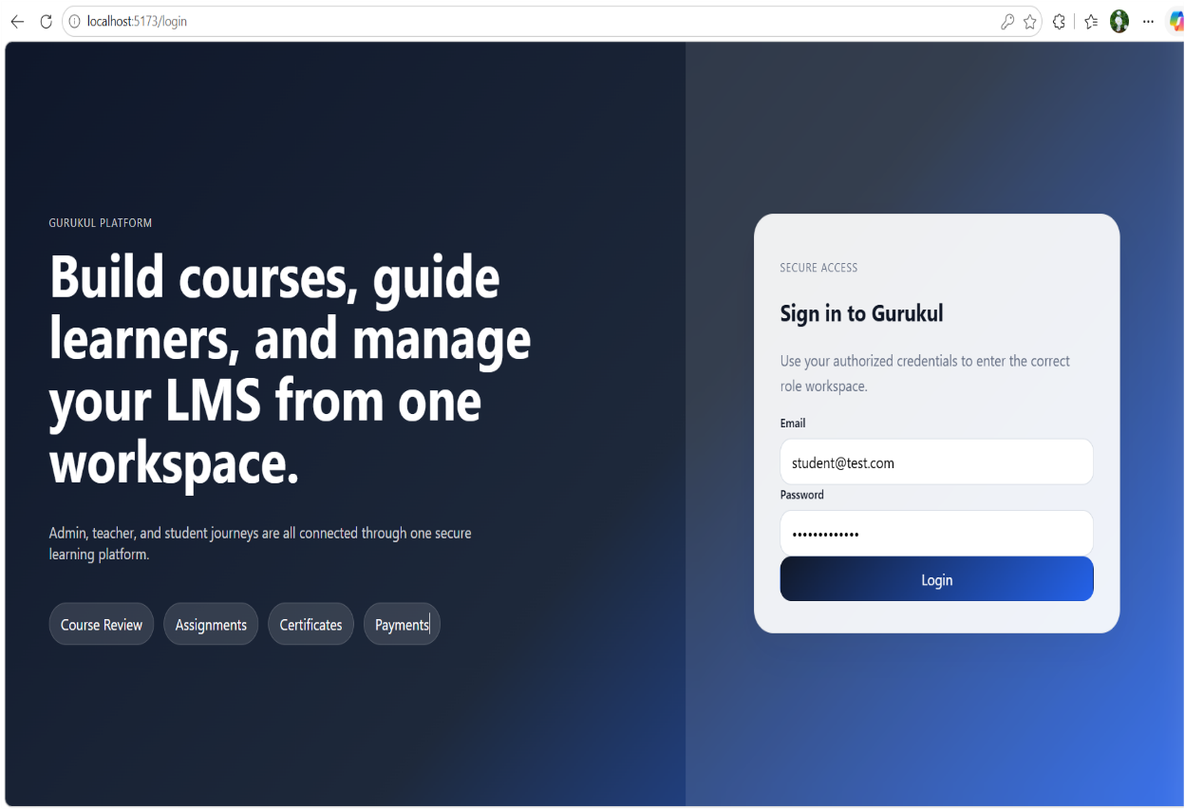
- This is the landing page of gurukul website. It shows the features offered by the Gurukul.
Login page

- This is login page. This page provides secure login to all users like student, teacher and admin.

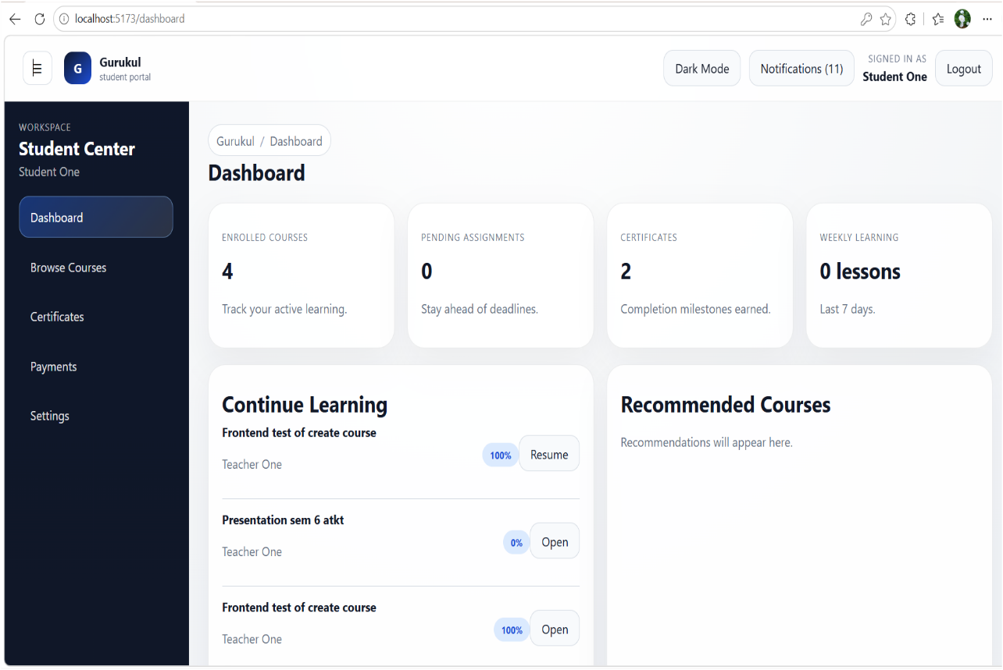
Student pages
Dashboard page
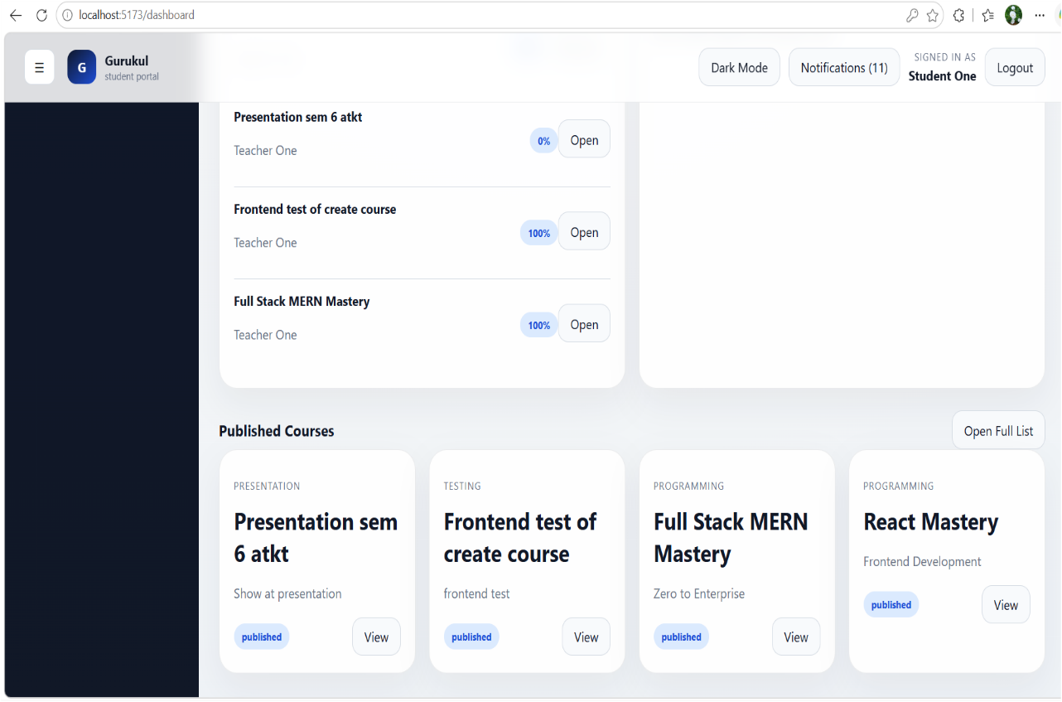
- A centralized student dashboard that provides real-time access to courses, progress tracking, assignments and performance analytics in a single interface.

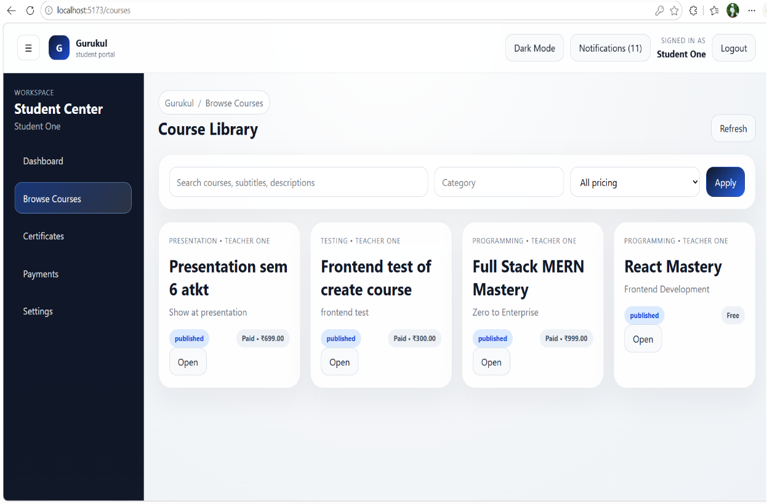
Course View page
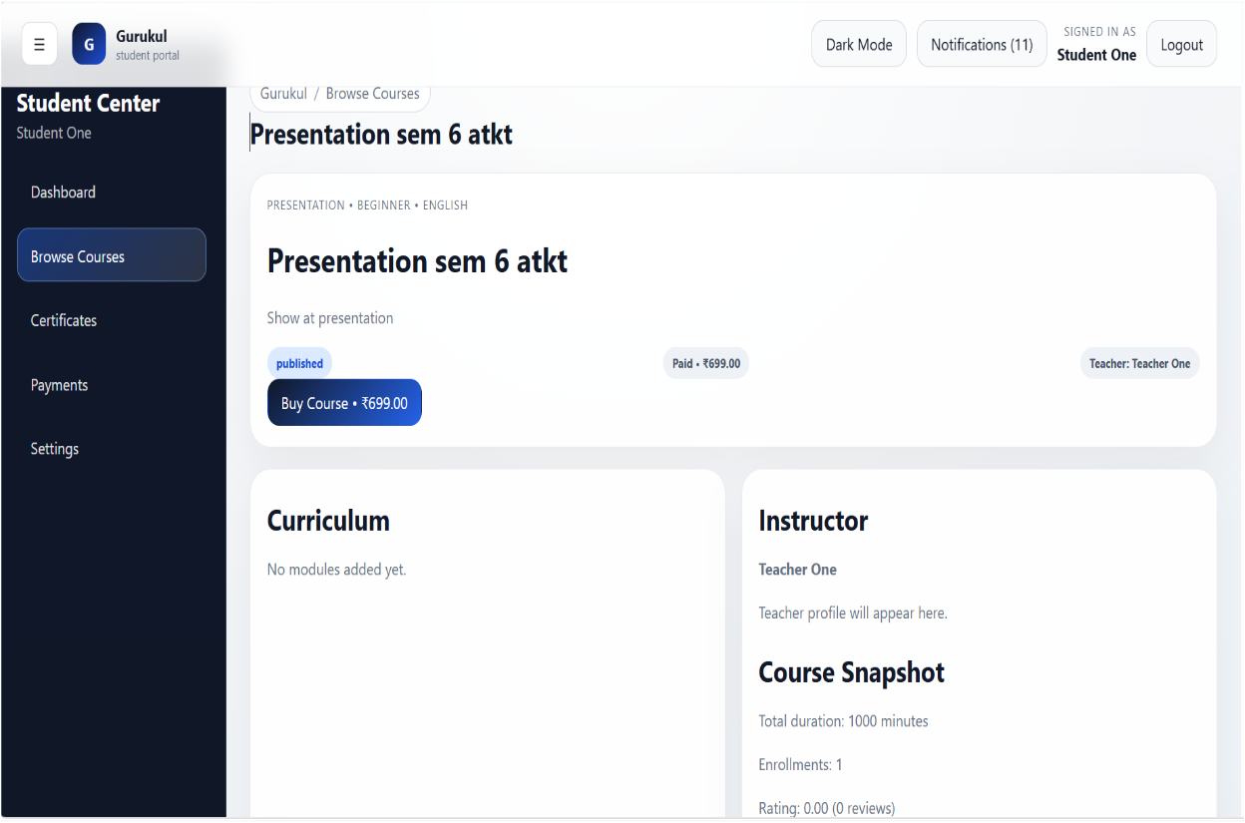
- A dynamic course library interface enabling students to search, filter, and access available courses with real-time pricing, status, and instructor details.
- A detailed course overview page displaying course information, pricing, instructor details, and curriculum with an option to enroll or purchase.
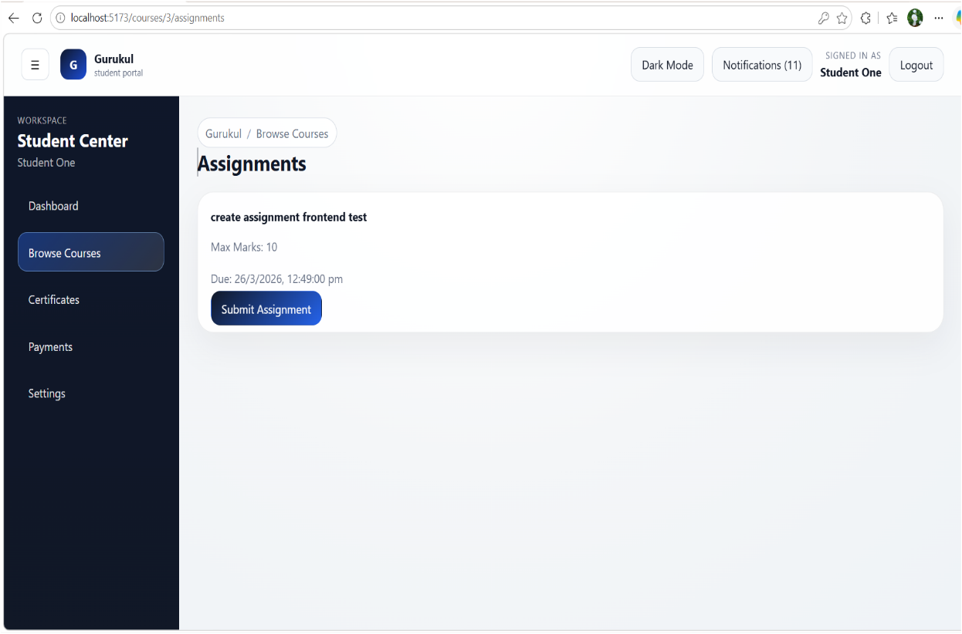
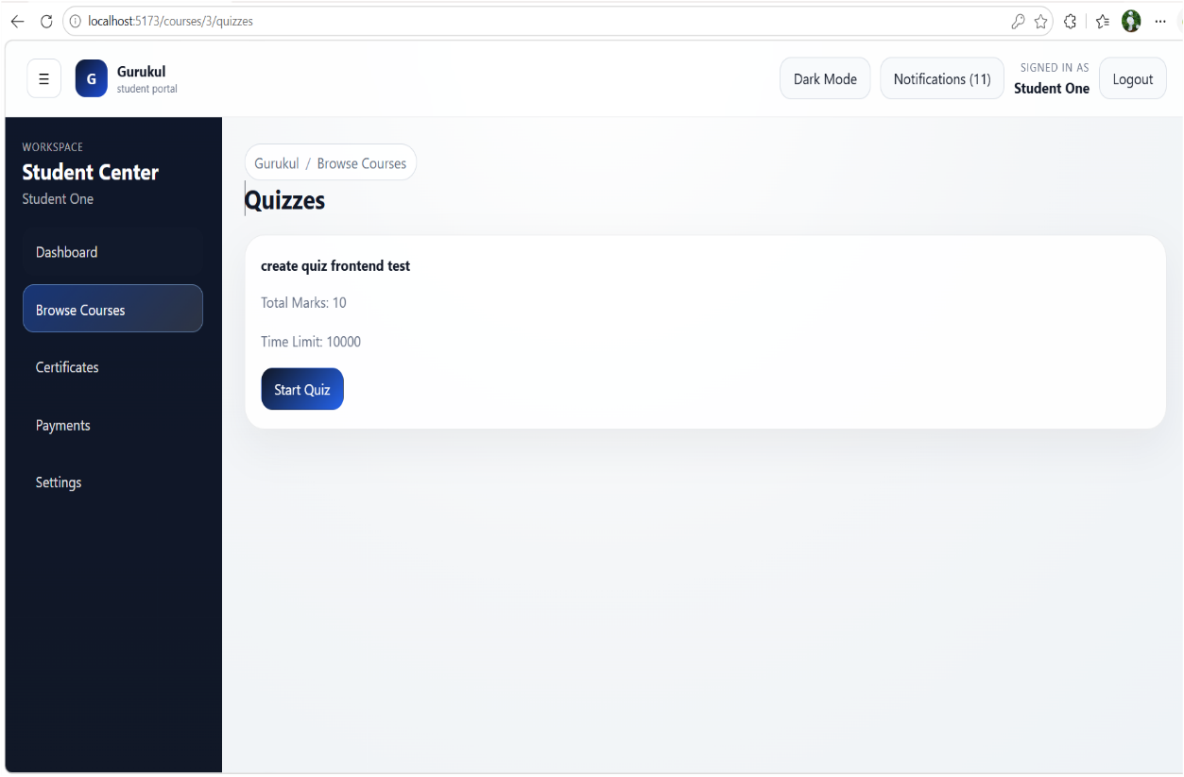
Assignment and quizzes page
- A task management interface where students can view deadlines, marks, and submit assignments efficiently.
- An assessment interface enabling students to attempt quizzes with defined marks and time constraints.

View and verify certificate page
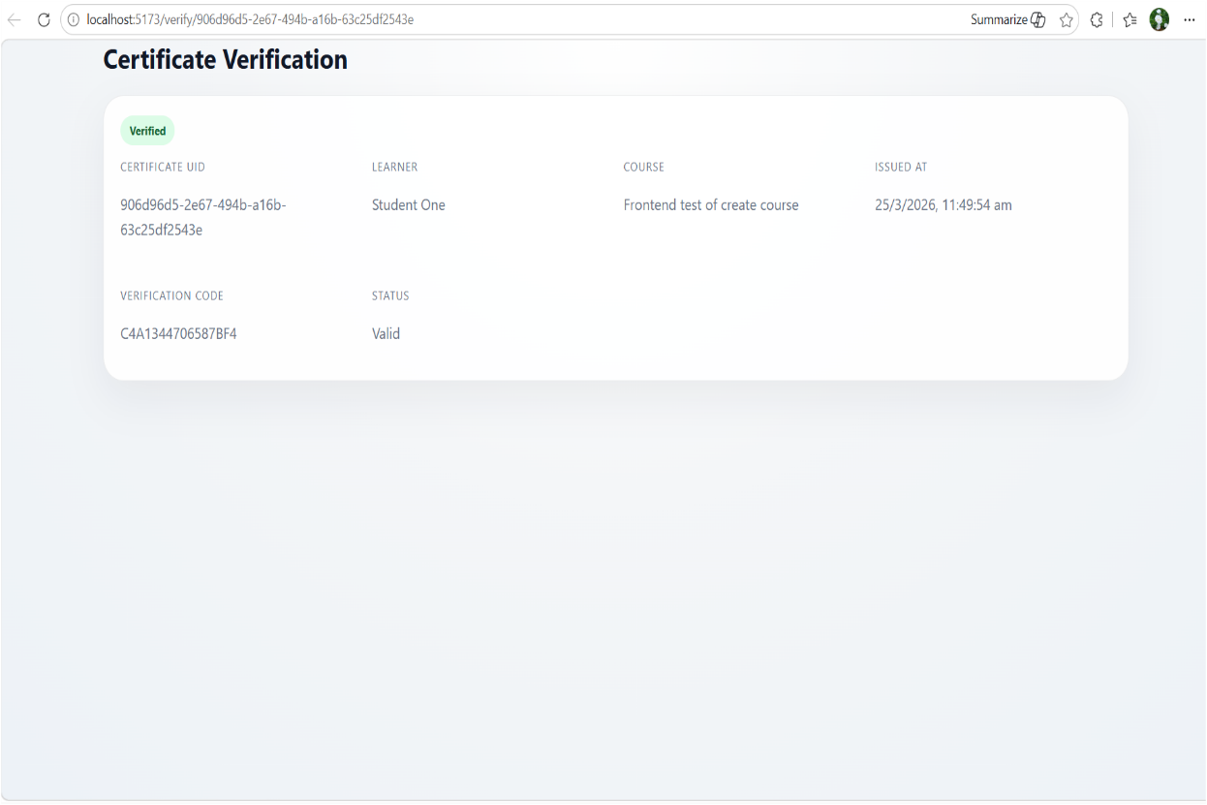
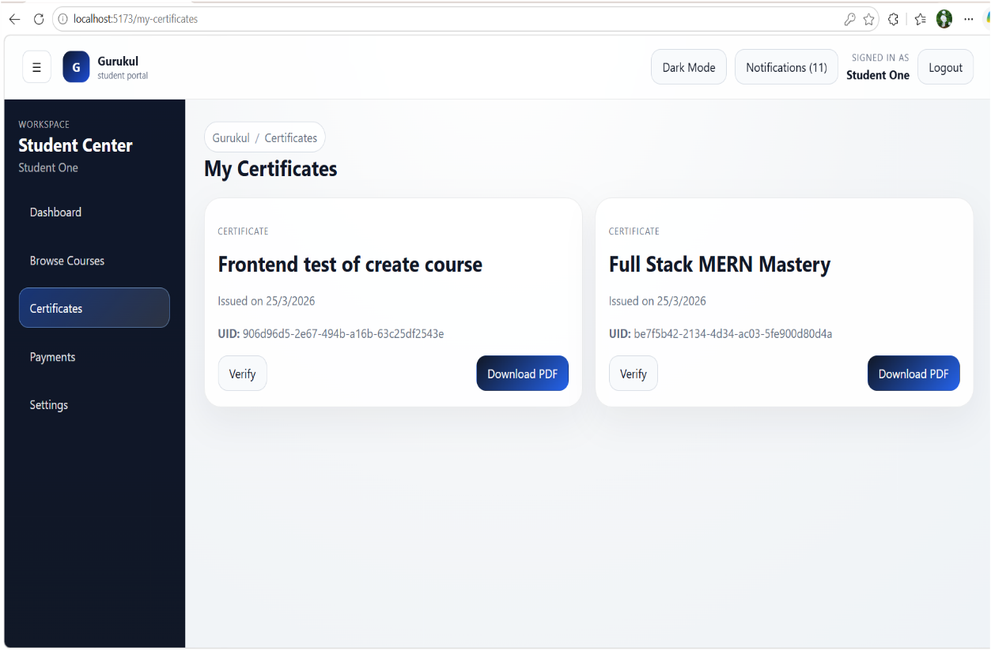
  - A secure certificate verification page that validates learner credentials using a unique certificate ID and verification code with real-time status display.
- A certificate management page where students can view, verify, and download their earned certificates with unique IDs and issue details.

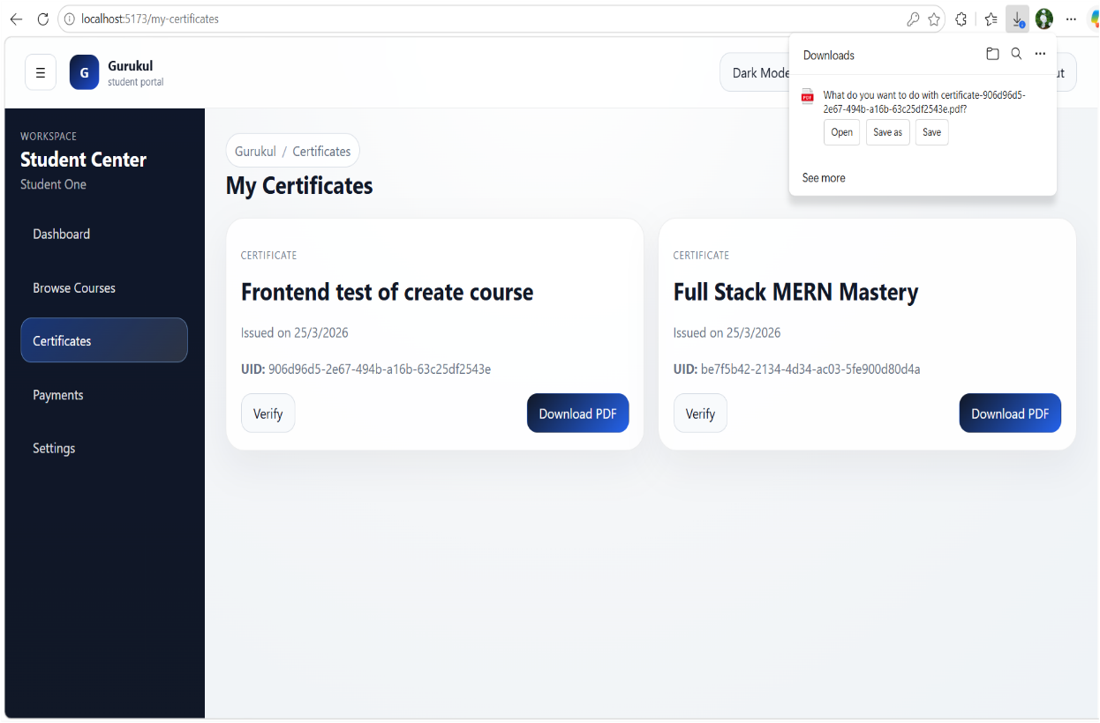
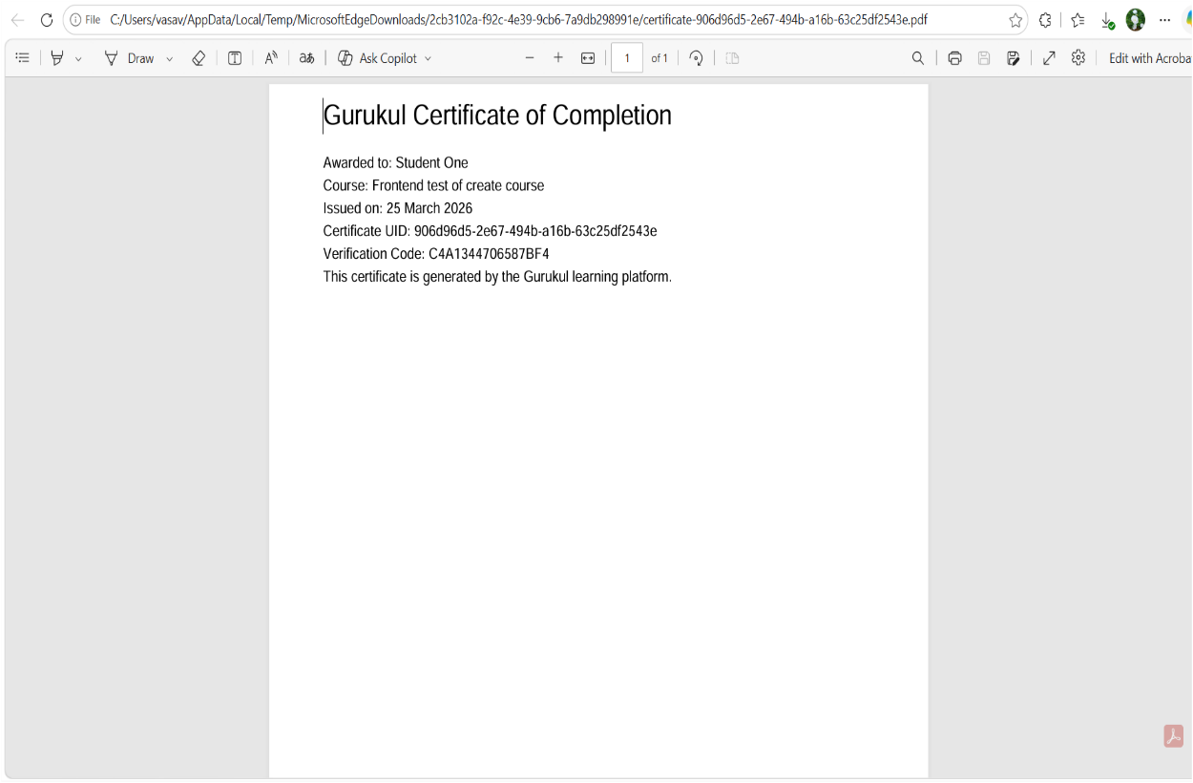
- A downloadable certificate document providing official proof of course completion with unique identification and verification details.
- A student certificate dashboard enabling quick verification and secure PDF download of earned certificates.

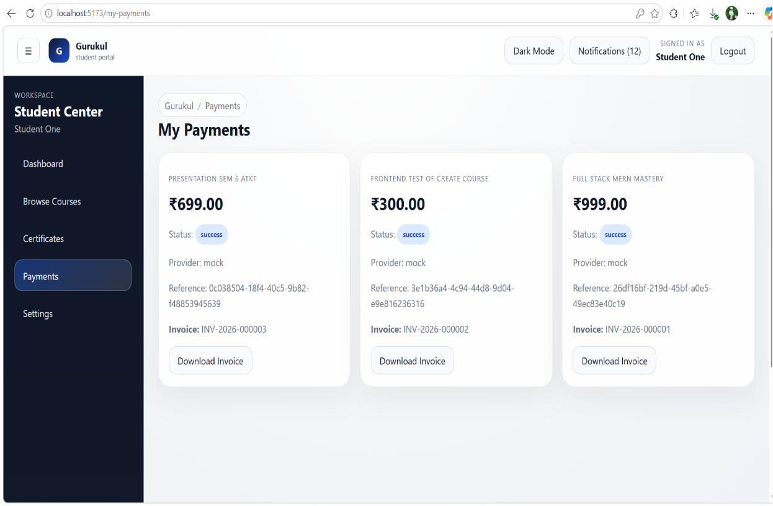
Payment Page

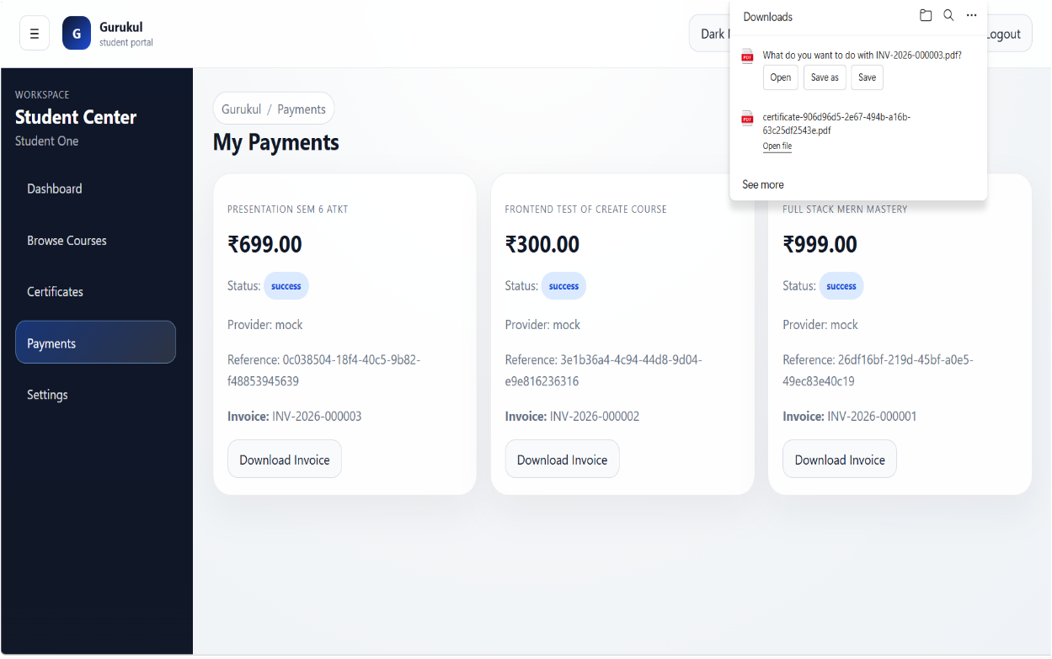
- A student payments interface for monitoring transaction history and securely downloading invoices in PDF format.
- A payment history dashboard where students can track transactions, view status, and download invoices for purchased courses.
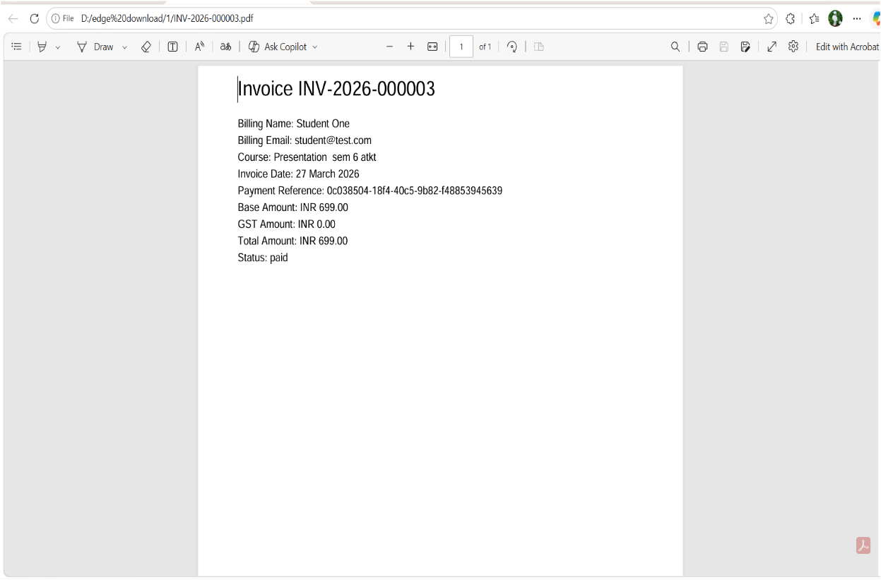

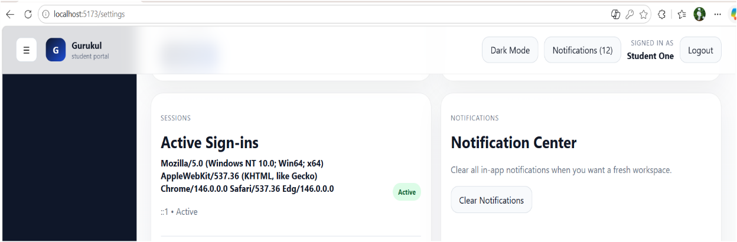
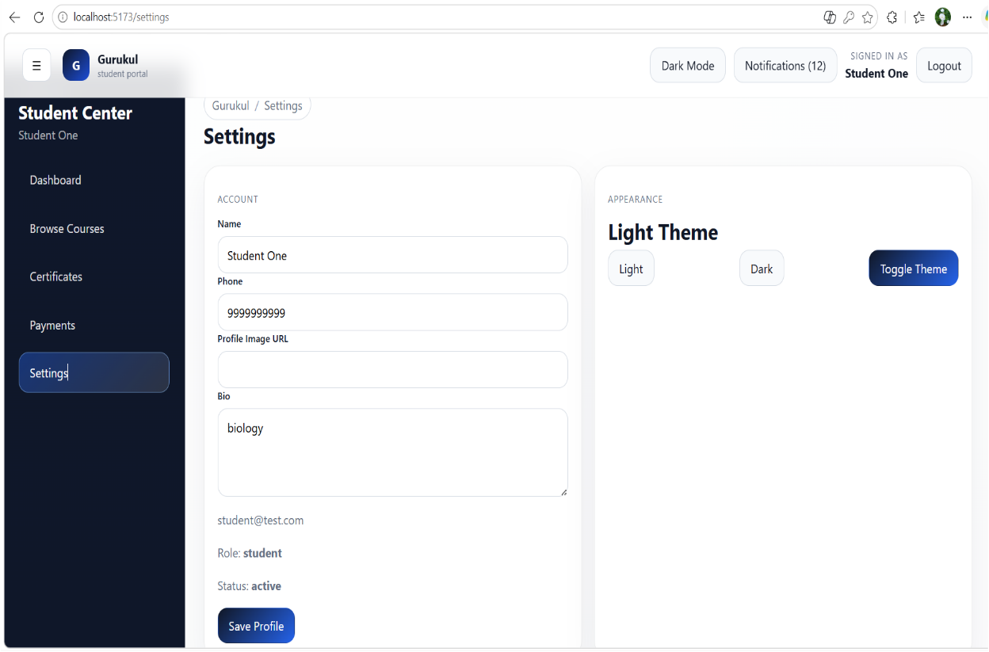
- A downloadable invoice document providing detailed payment breakdown, transaction reference, and billing information for student purchases.
- A student settings panel for managing profile details, account preferences, active sessions, notifications, and theme customization.
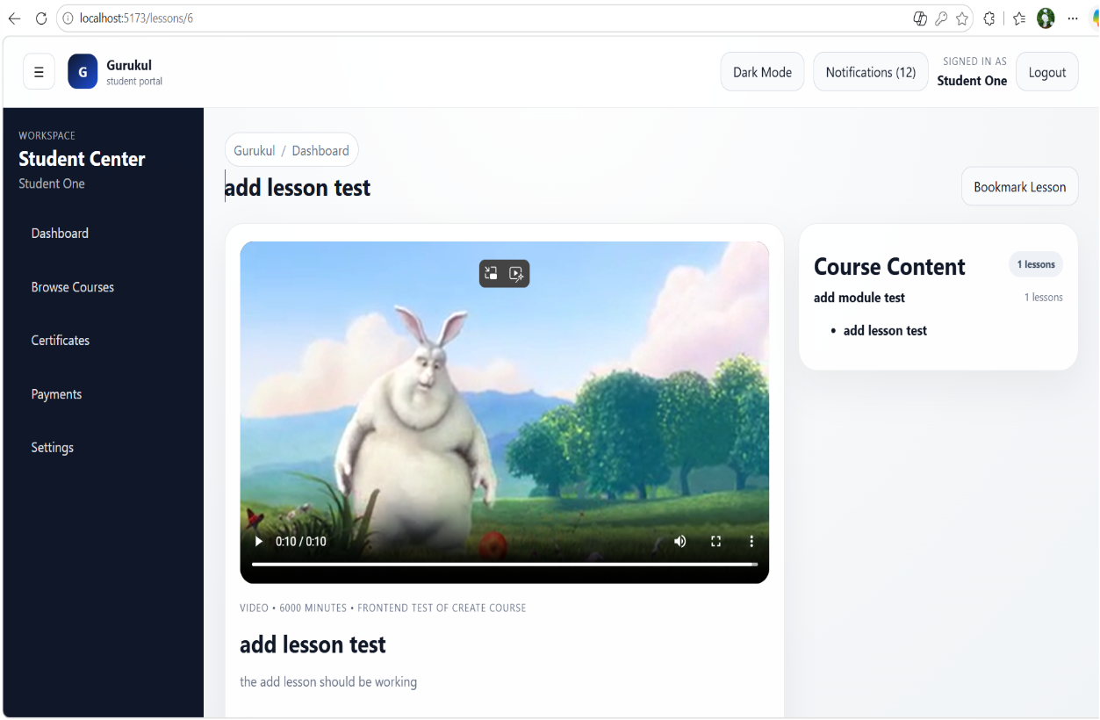
Course, lesson view page
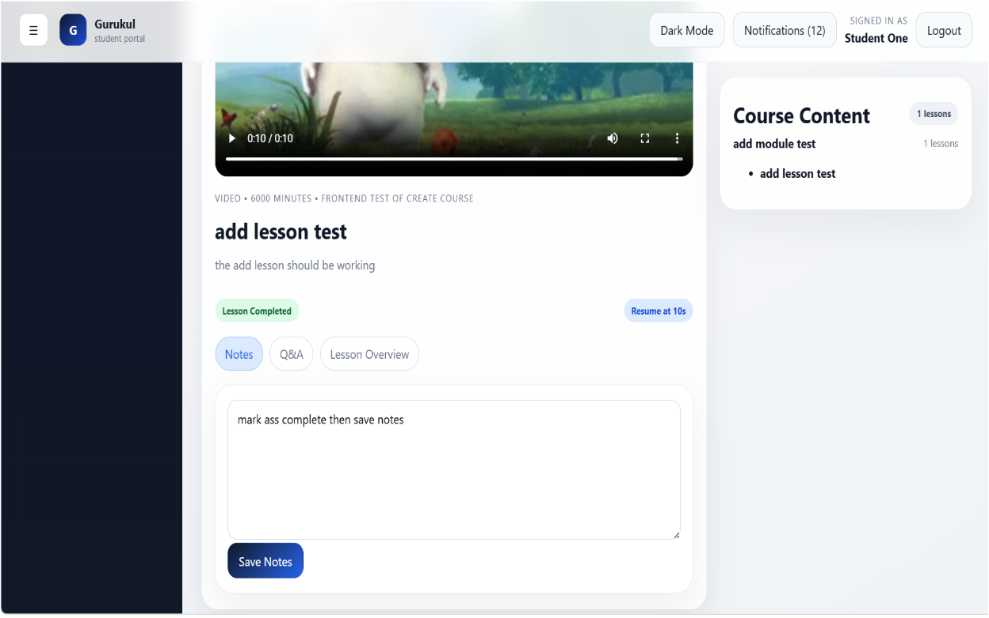
- An interactive lesson player where students can watch videos, track progress, take notes, and navigate course content efficiently.
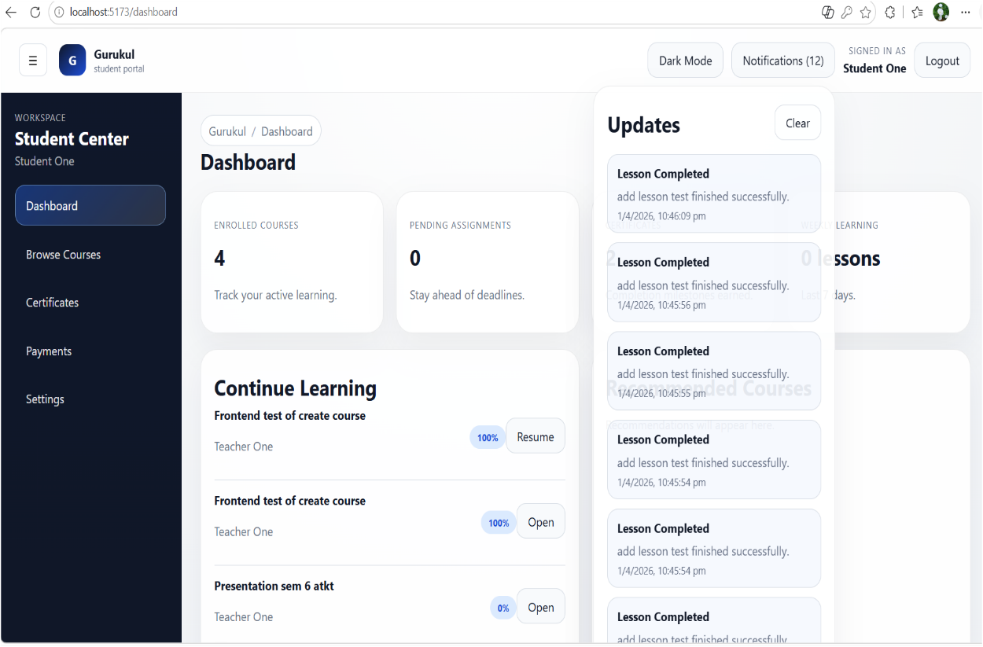
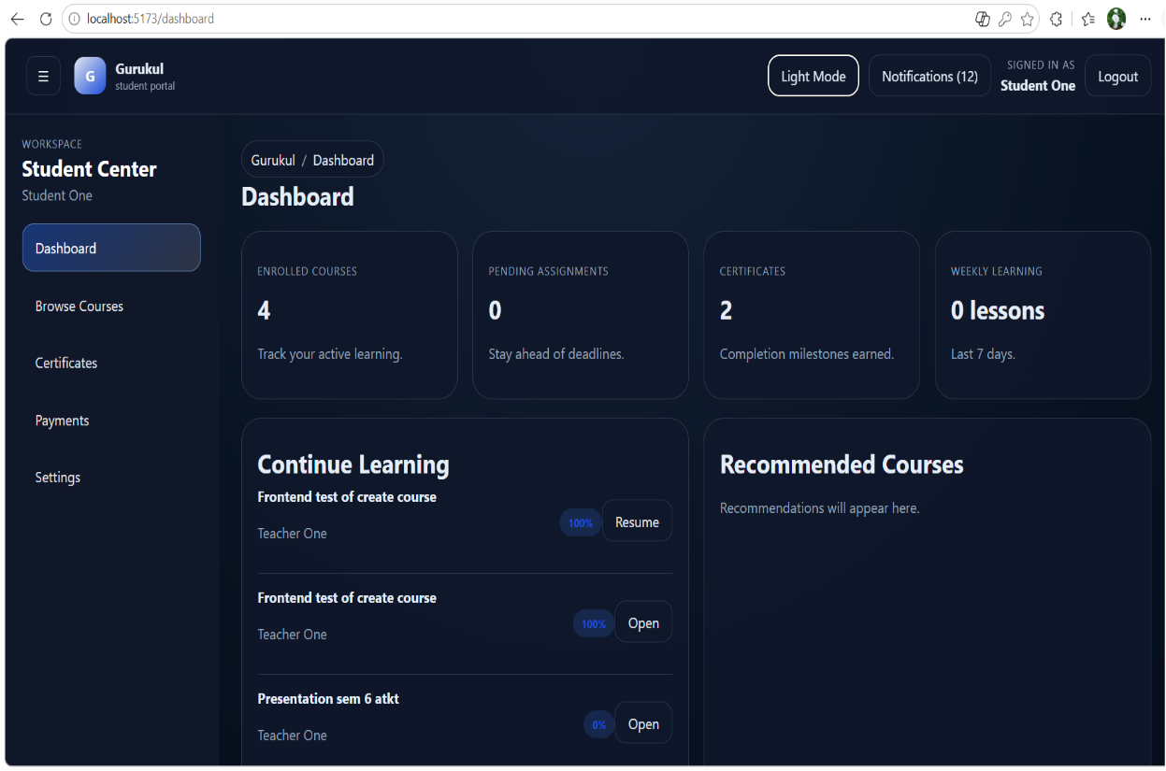
- A dark-mode student dashboard providing a focused view of learning progress, course activity, assignments, and personalized recommendations.

- A notification system that delivers real-time alerts for course updates, assignments, payments, and important student activities.

Teacher pages
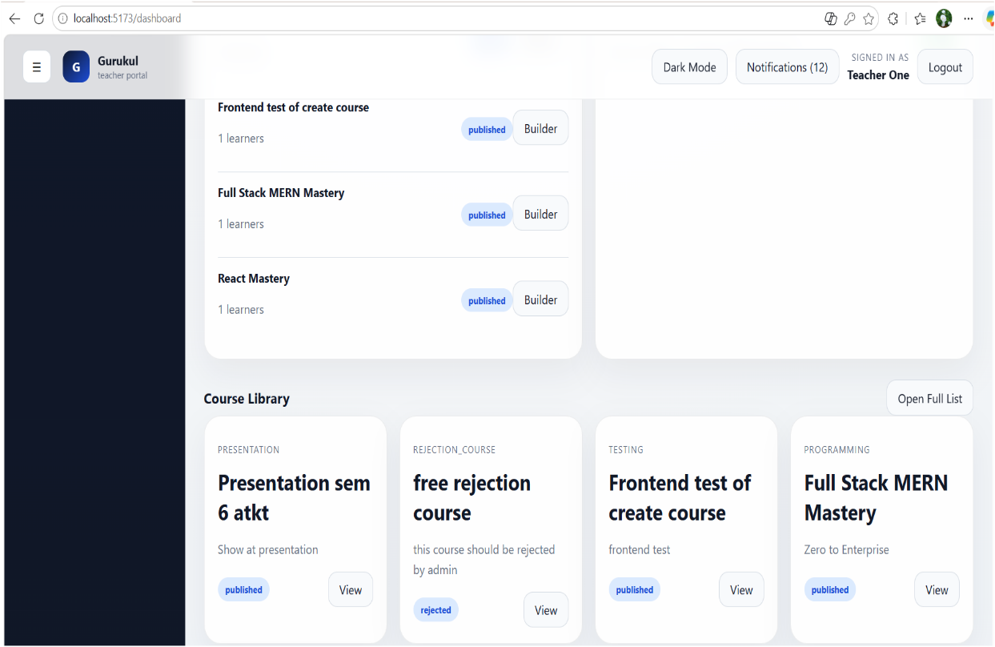
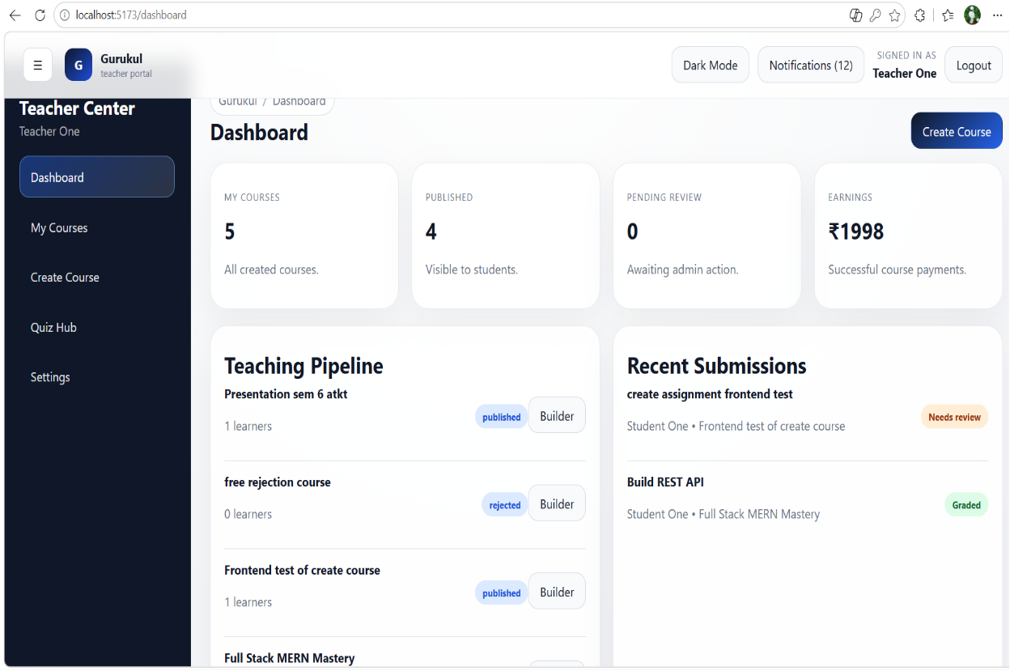
- A teacher dashboard for managing courses, tracking student submissions, monitoring performance, and overseeing earnings in one centralized interface.
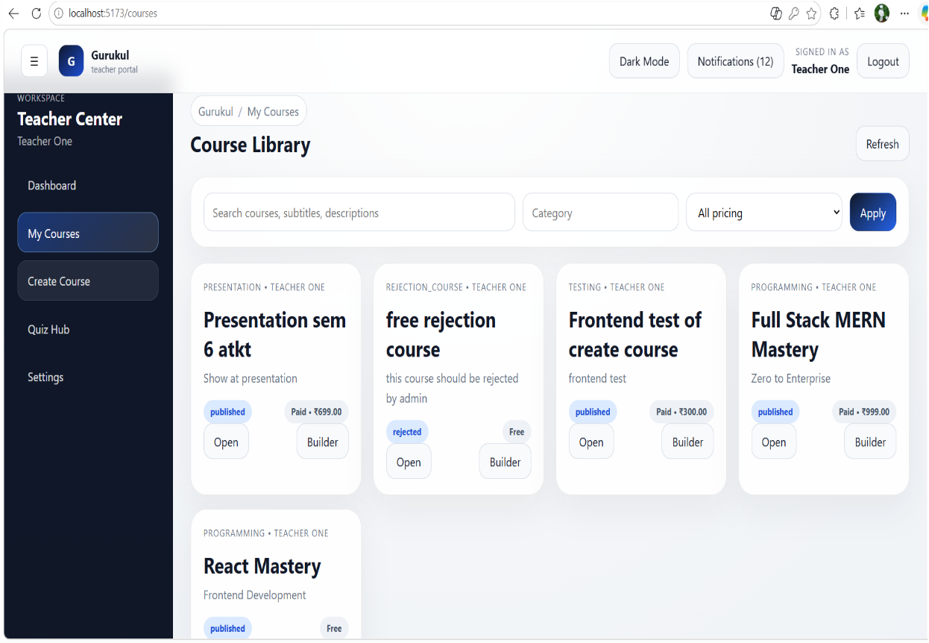
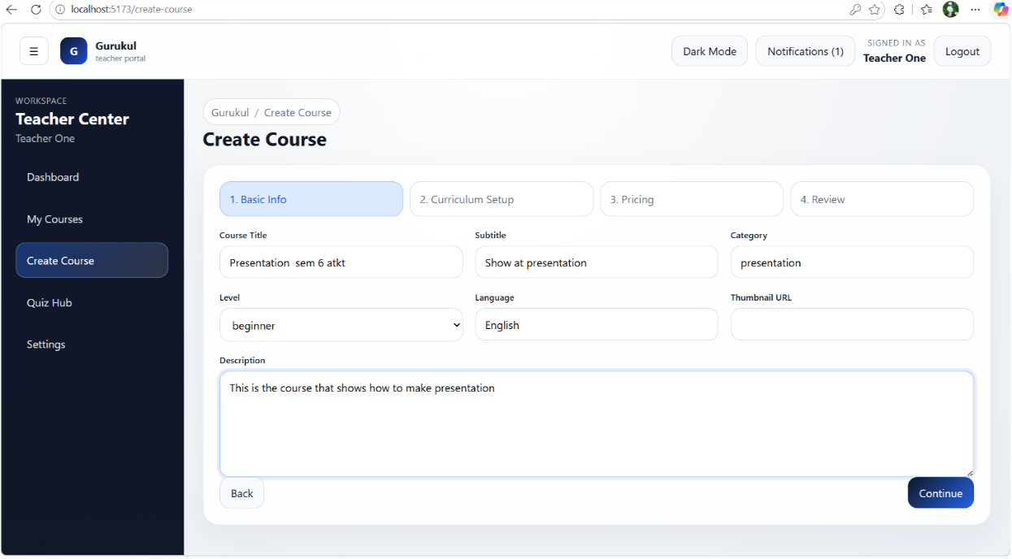
- A structured course creation interface enabling teachers to define course details, curriculum, pricing, and review before publishing.
- A course management library for teachers to create, edit, review, and monitor the status and pricing of their courses.
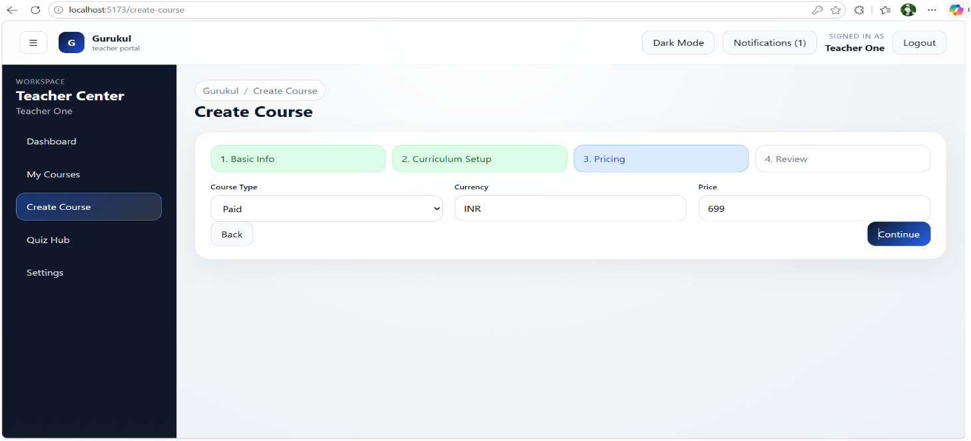
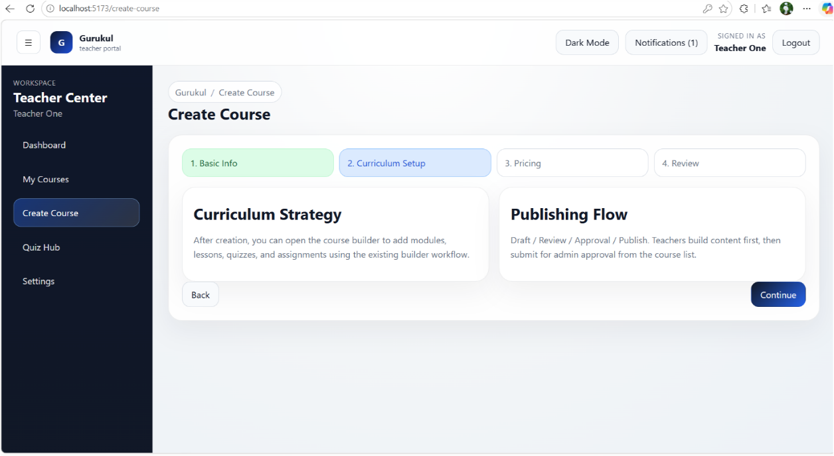
- A curriculum setup step guiding teachers to structure course content and understand the publishing workflow before final submission.
- A pricing configuration step where teachers define course type, currency, and price before publishing.

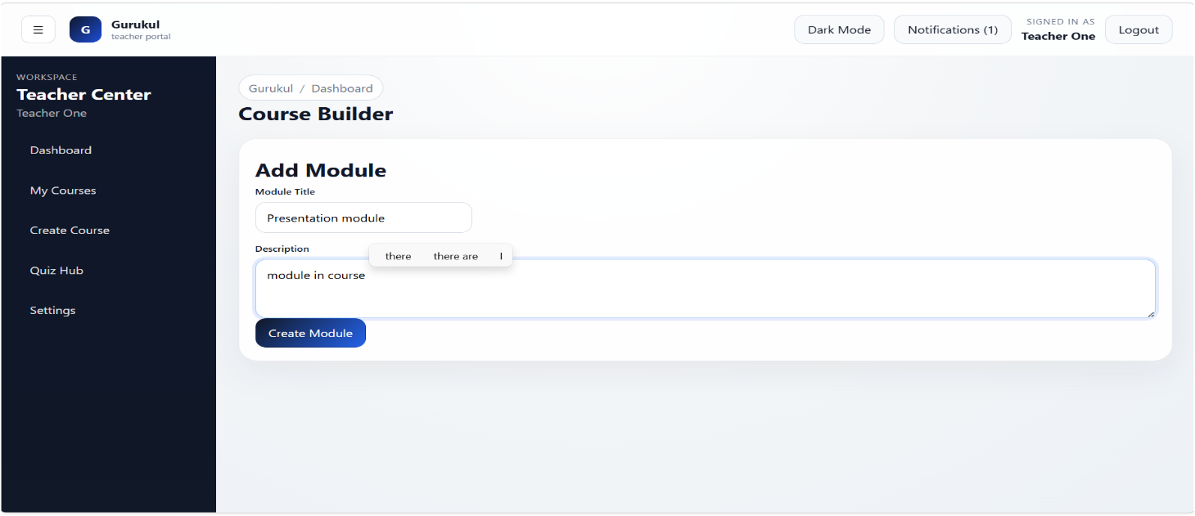
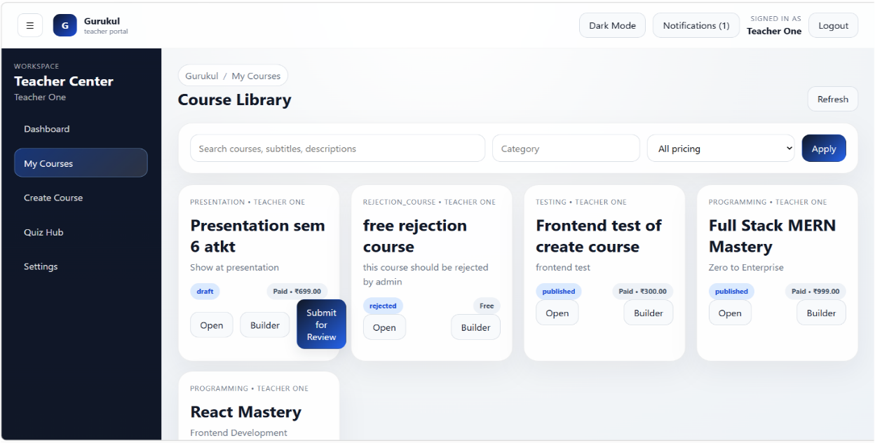
- A submission action that sends the course to admin for approval before it becomes publicly available to students.
- A course builder interface allowing teachers to create and organize modules with titles and descriptions.

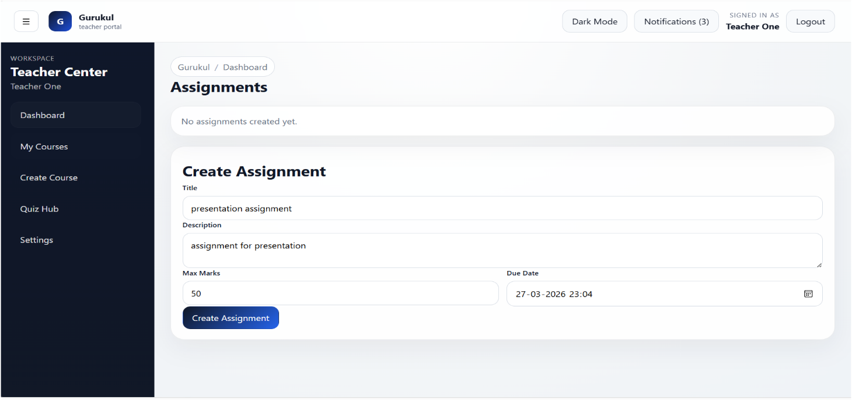
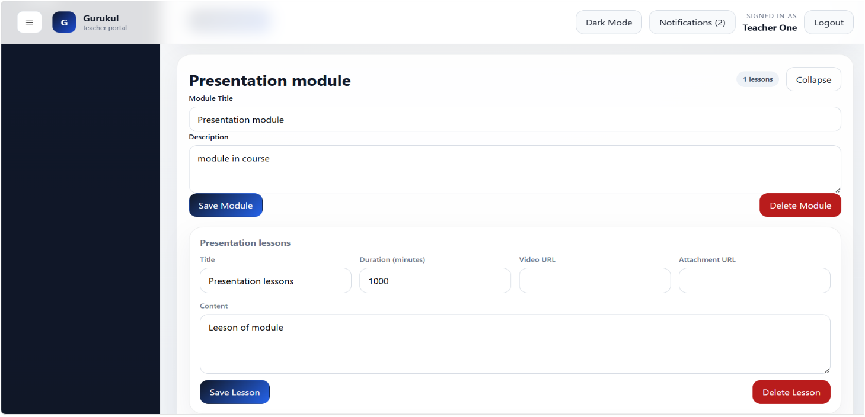
- A module management interface where teachers can edit modules, add lessons with content and media, and manage course structure efficiently.
- An assignment creation interface allowing teachers to define tasks, set marks, and assign deadlines for students.

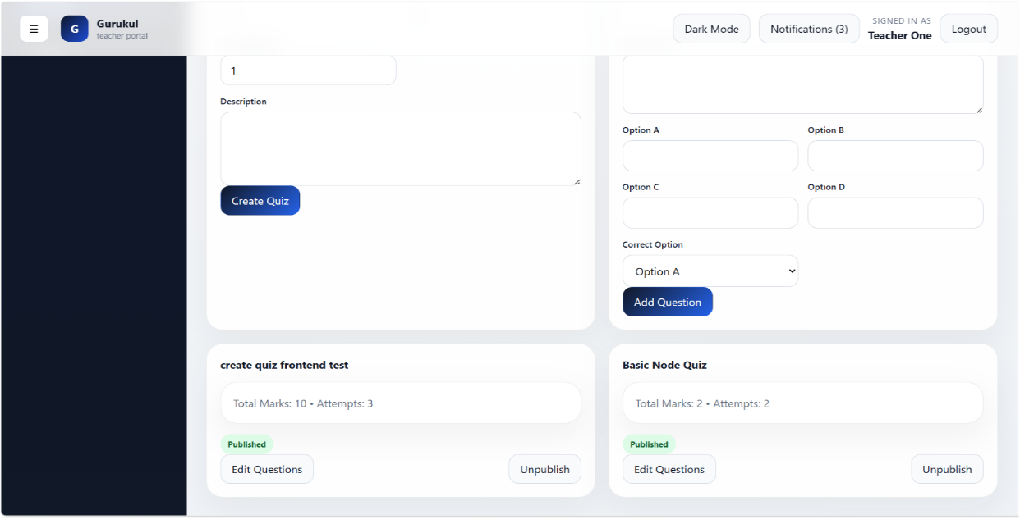
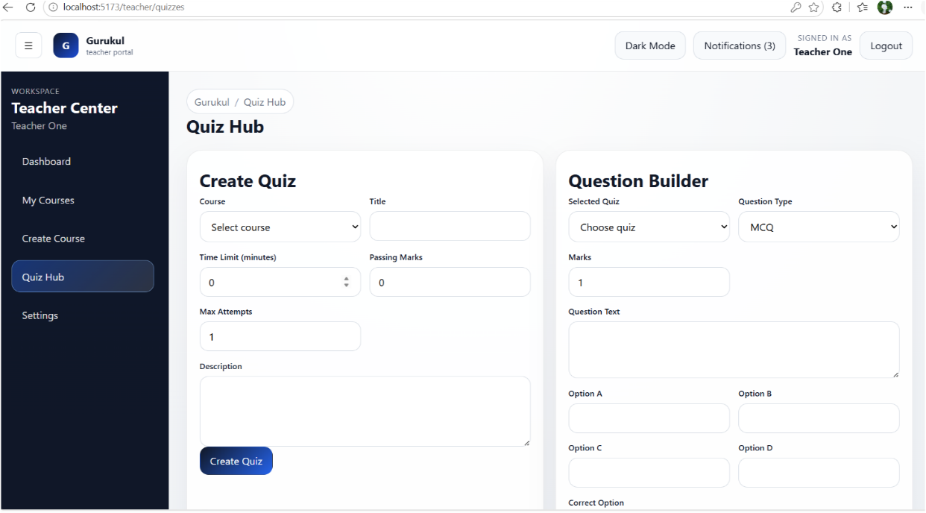
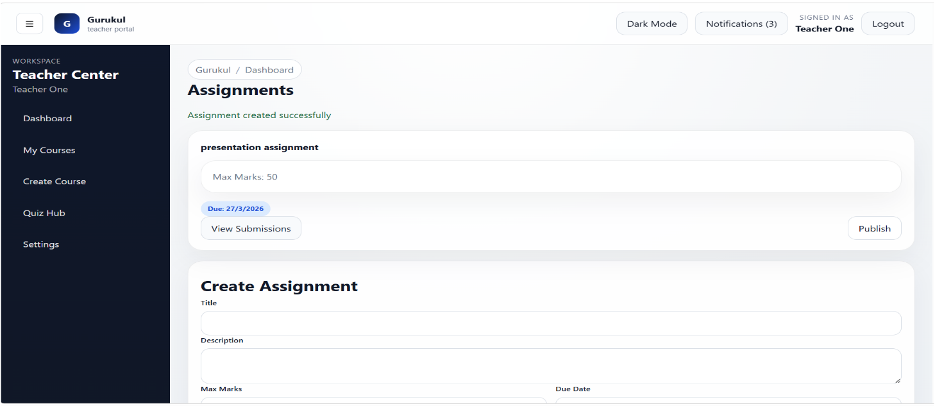
- An assignment management view where teachers can track created assignments, review submissions, and publish them for students.

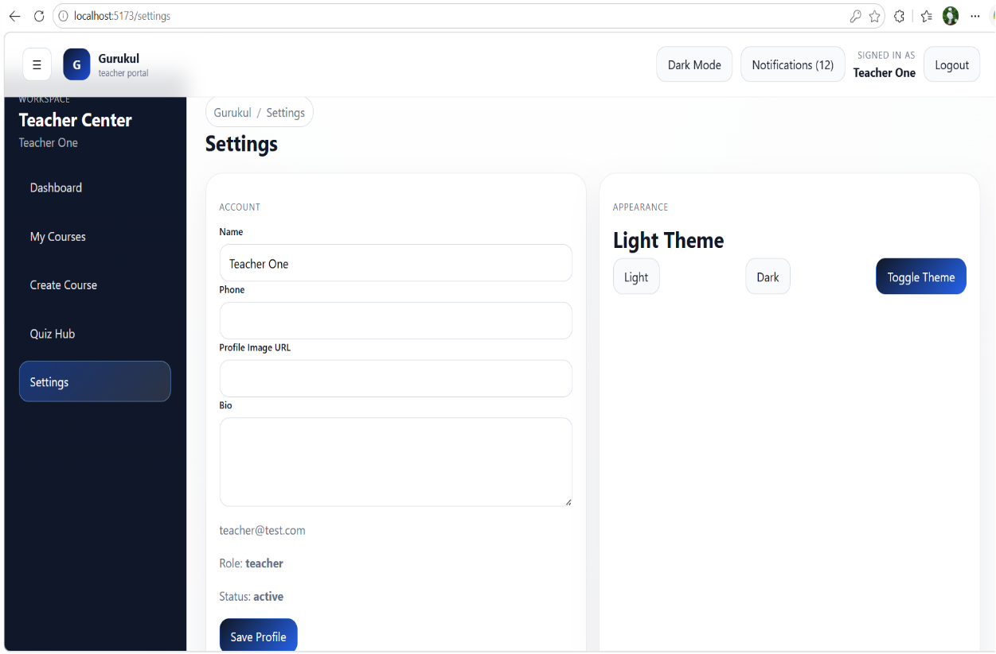
- A quiz management hub where teachers can create quizzes, build questions, set rules, and publish or manage assessments efficiently.
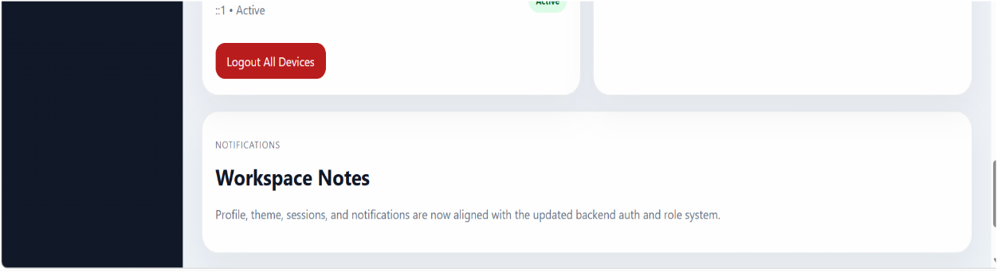
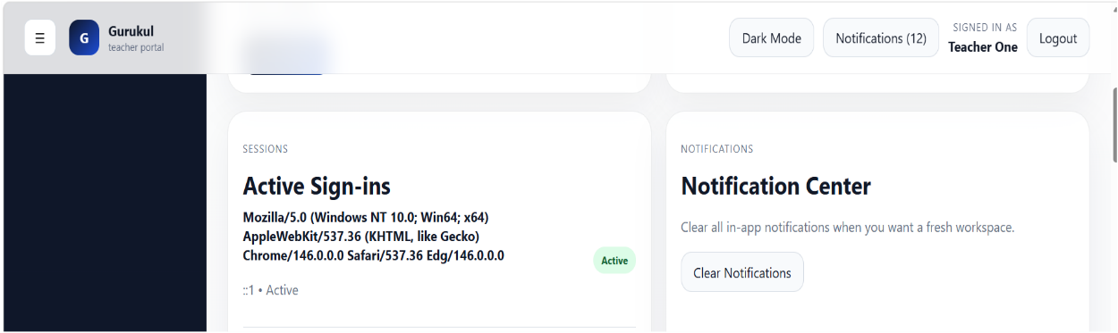
- A teacher settings panel for managing profile details, theme preferences, active sessions, and notification controls.

Admin Pages
- An admin dashboard for overseeing platform activity, managing course approvals, monitoring users, and tracking revenue and analytics.
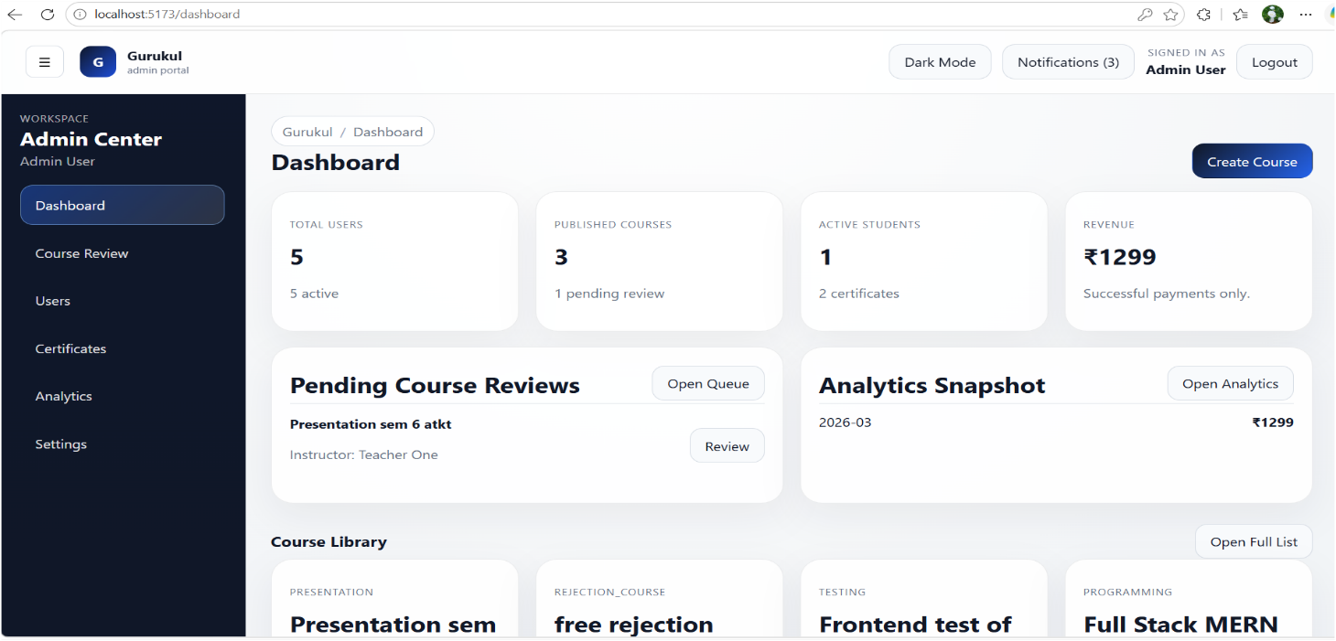
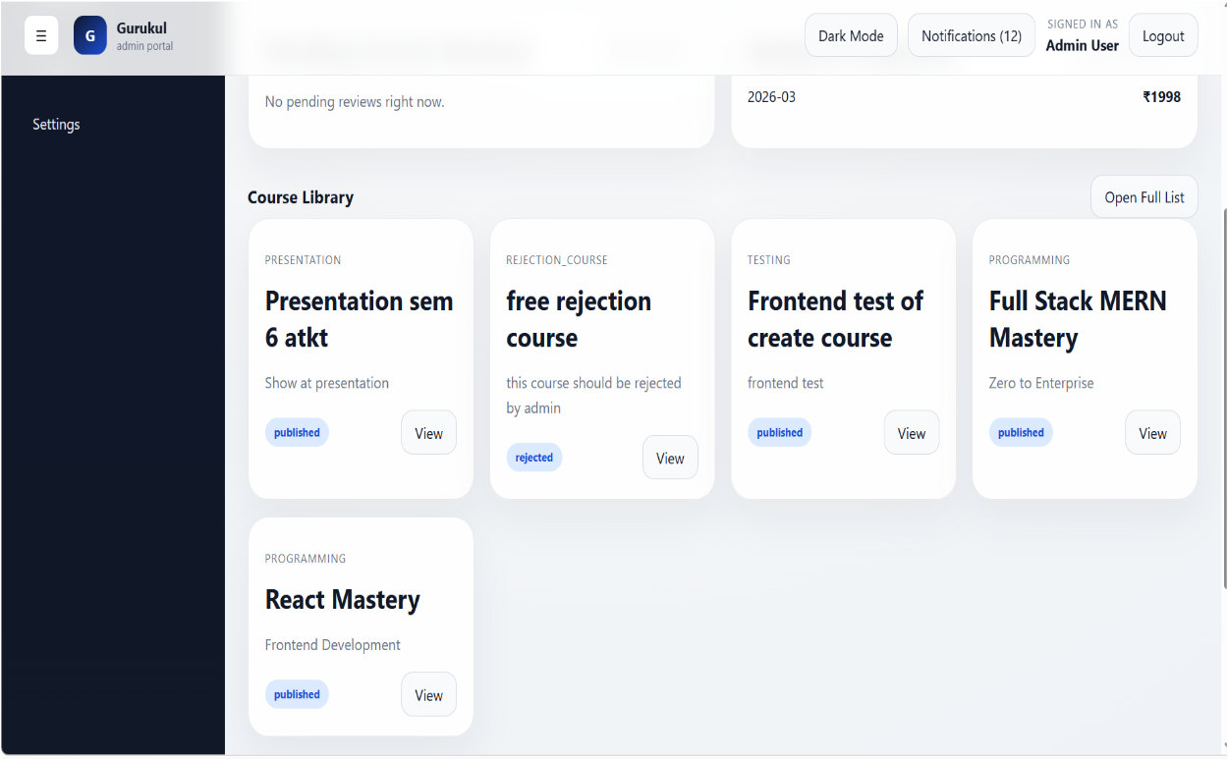

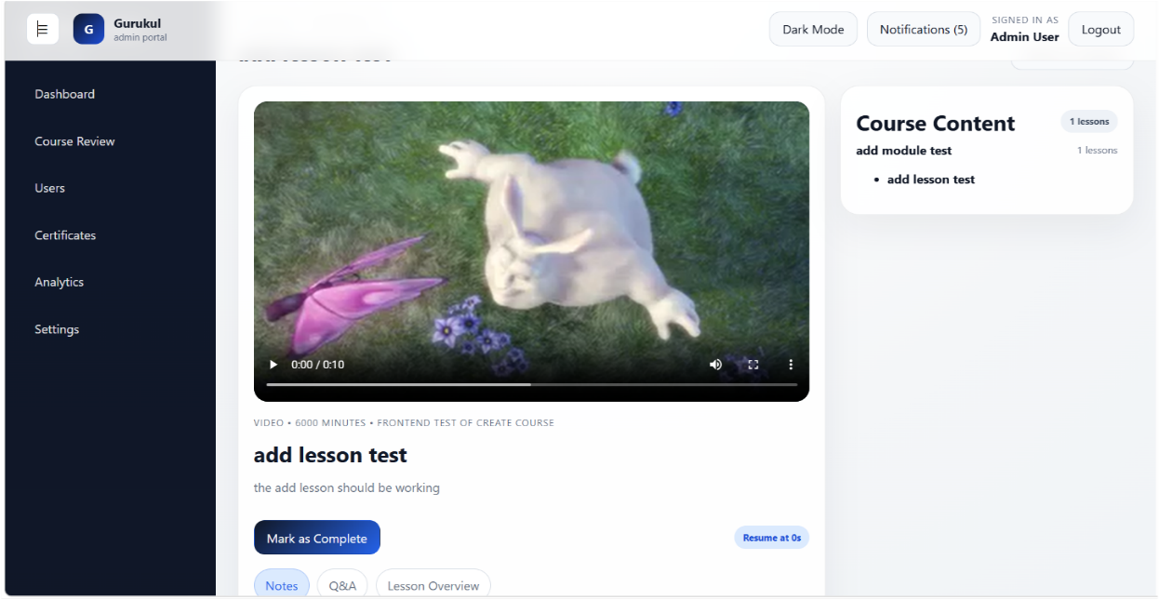
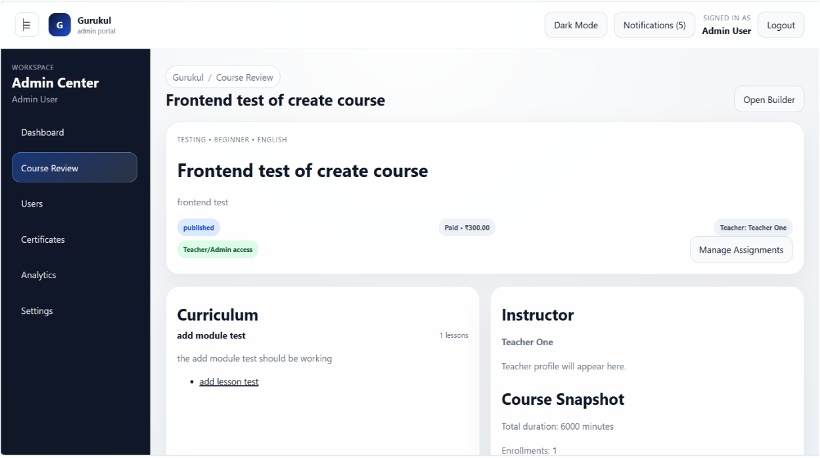
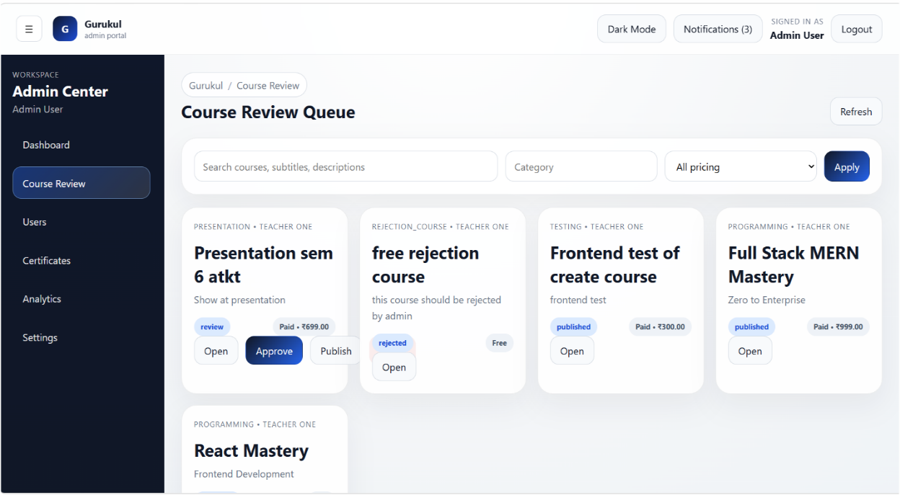
- A course review queue where admins evaluate, approve, or reject courses before publishing them to students.

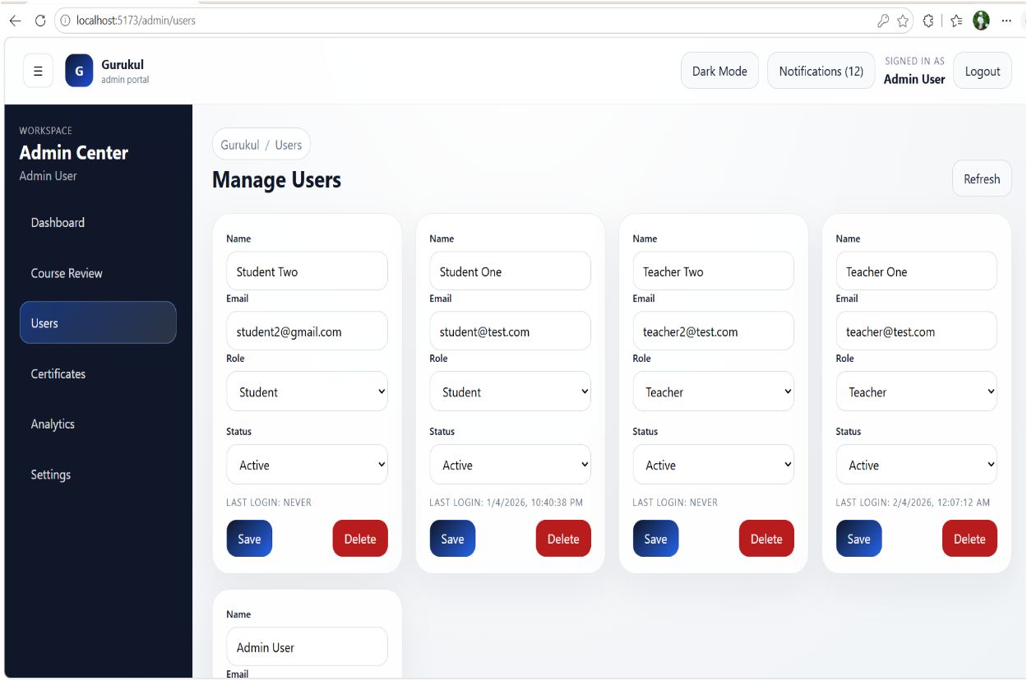
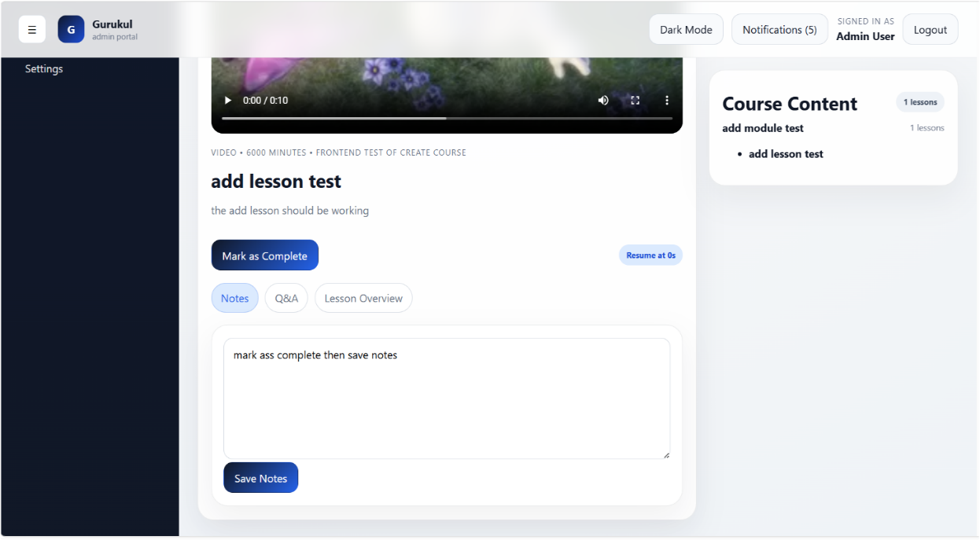
- An admin course detail view for inspecting curriculum, previewing lessons, and managing course content before or after approval.
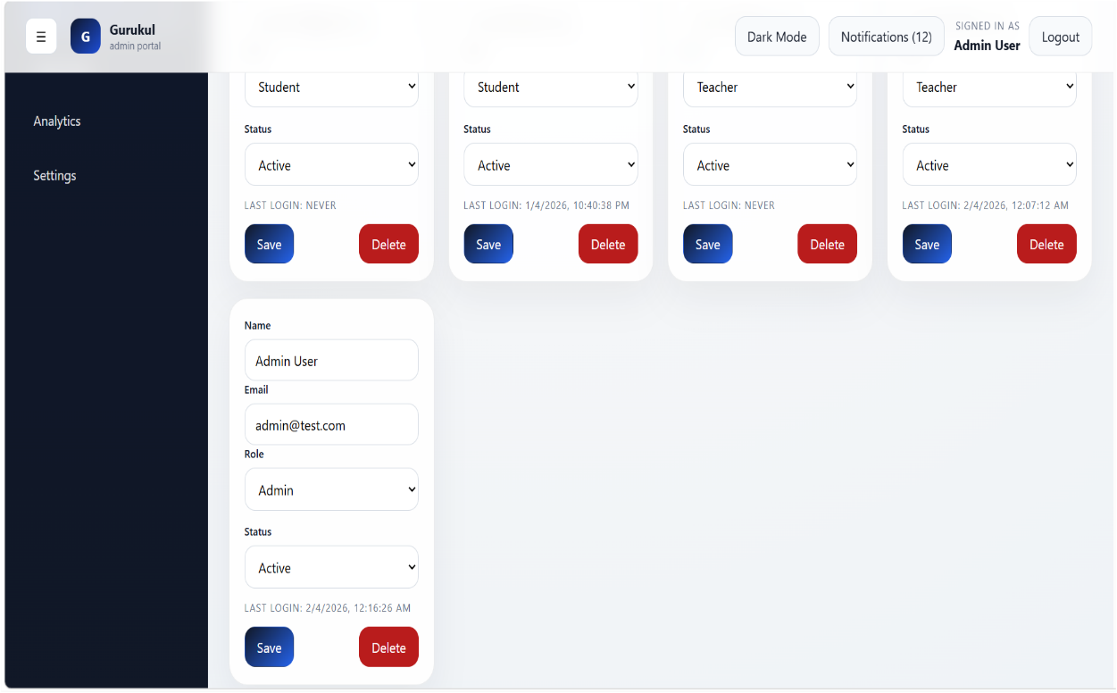

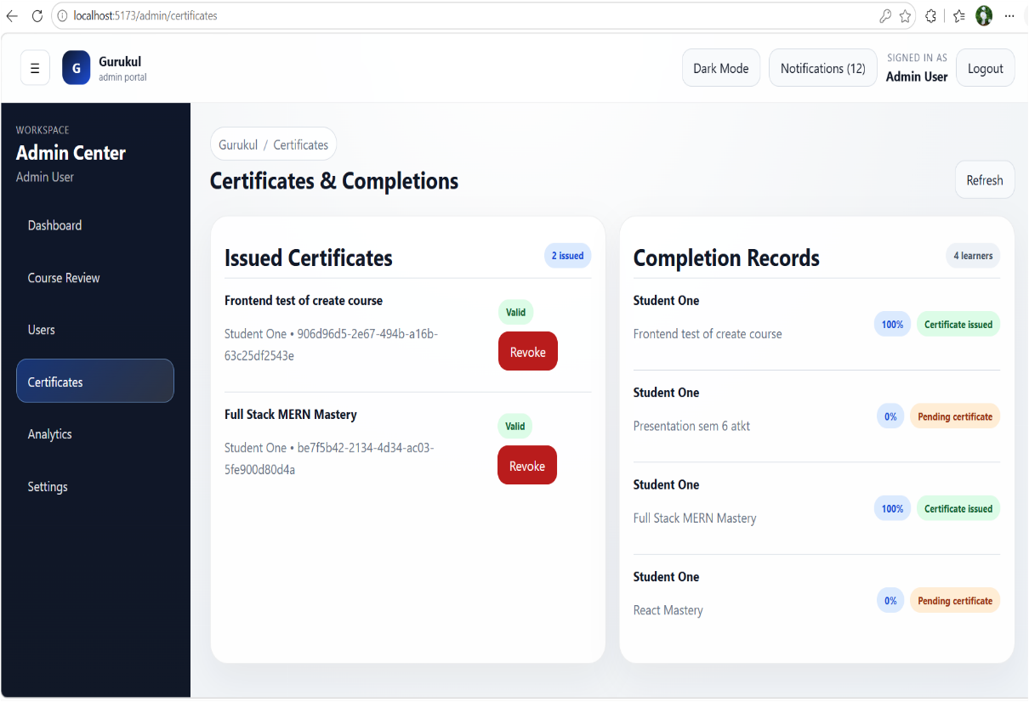
- A user management interface where admins can view, update roles/status, and control access by editing or deleting users.

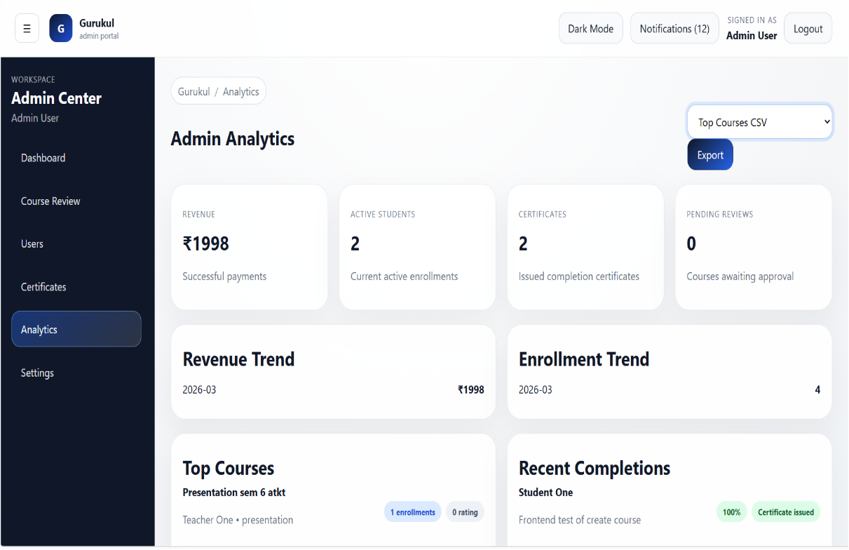
- An admin certificate management panel for issuing, tracking, and revoking certificates based on course completion status.
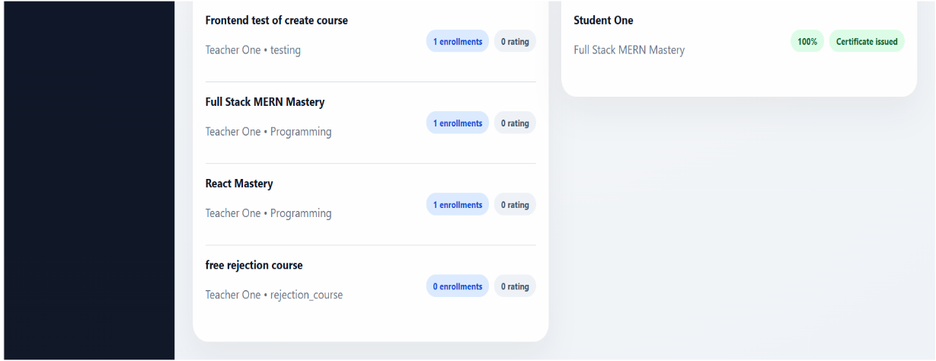

- An admin analytics dashboard providing insights into revenue, enrolments, certificates, and course performance trends with export capabilities.
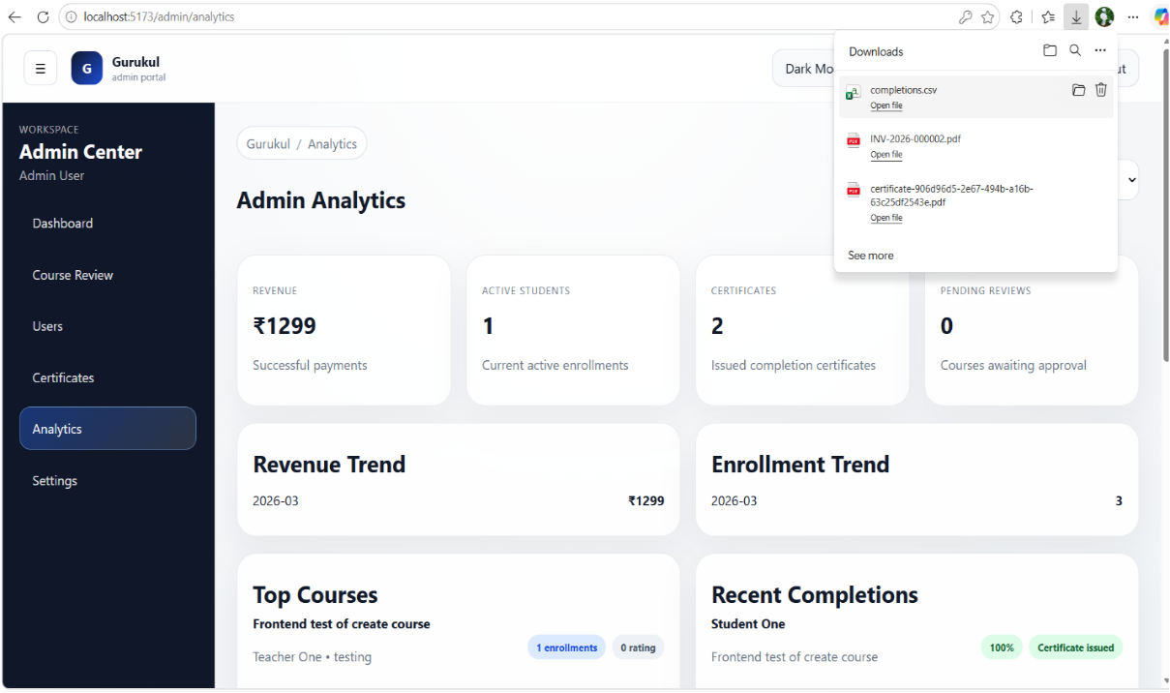
- An admin analytics view with export functionality for downloading reports on revenue, enrollments, and course performance.

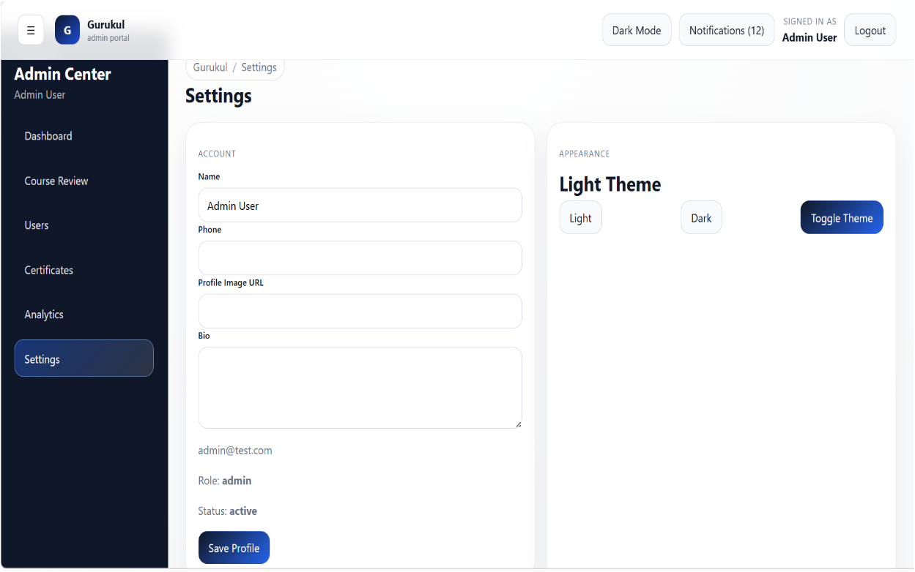

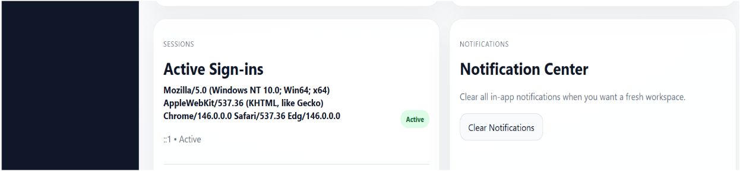
- An admin settings panel for managing profile information, system preferences, sessions, and notification controls.

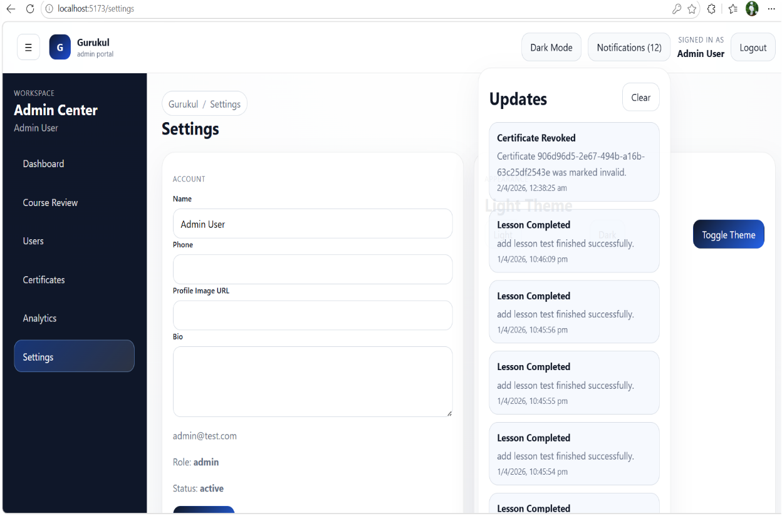
- An admin notification panel displaying real-time system updates such as certificate actions, course progress, and platform activities.

Report layout

Csv reports of system
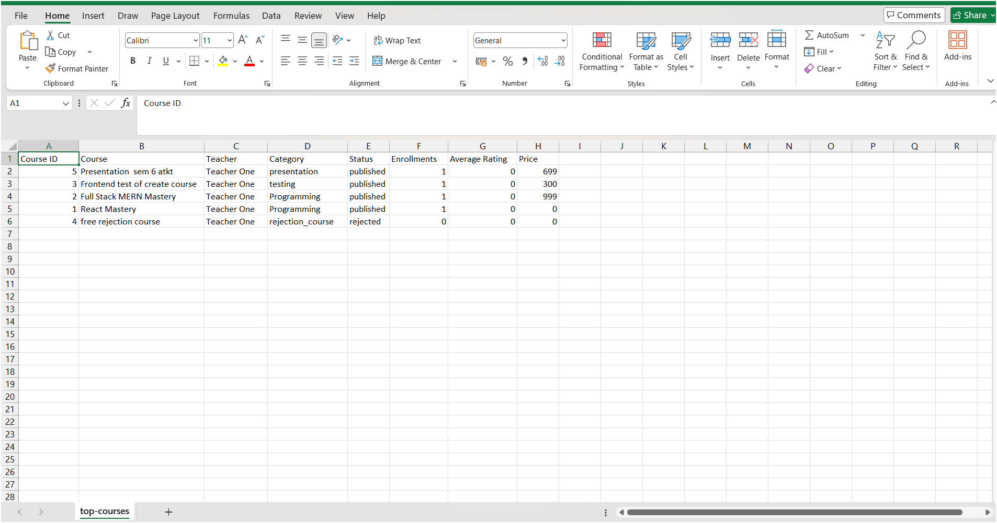
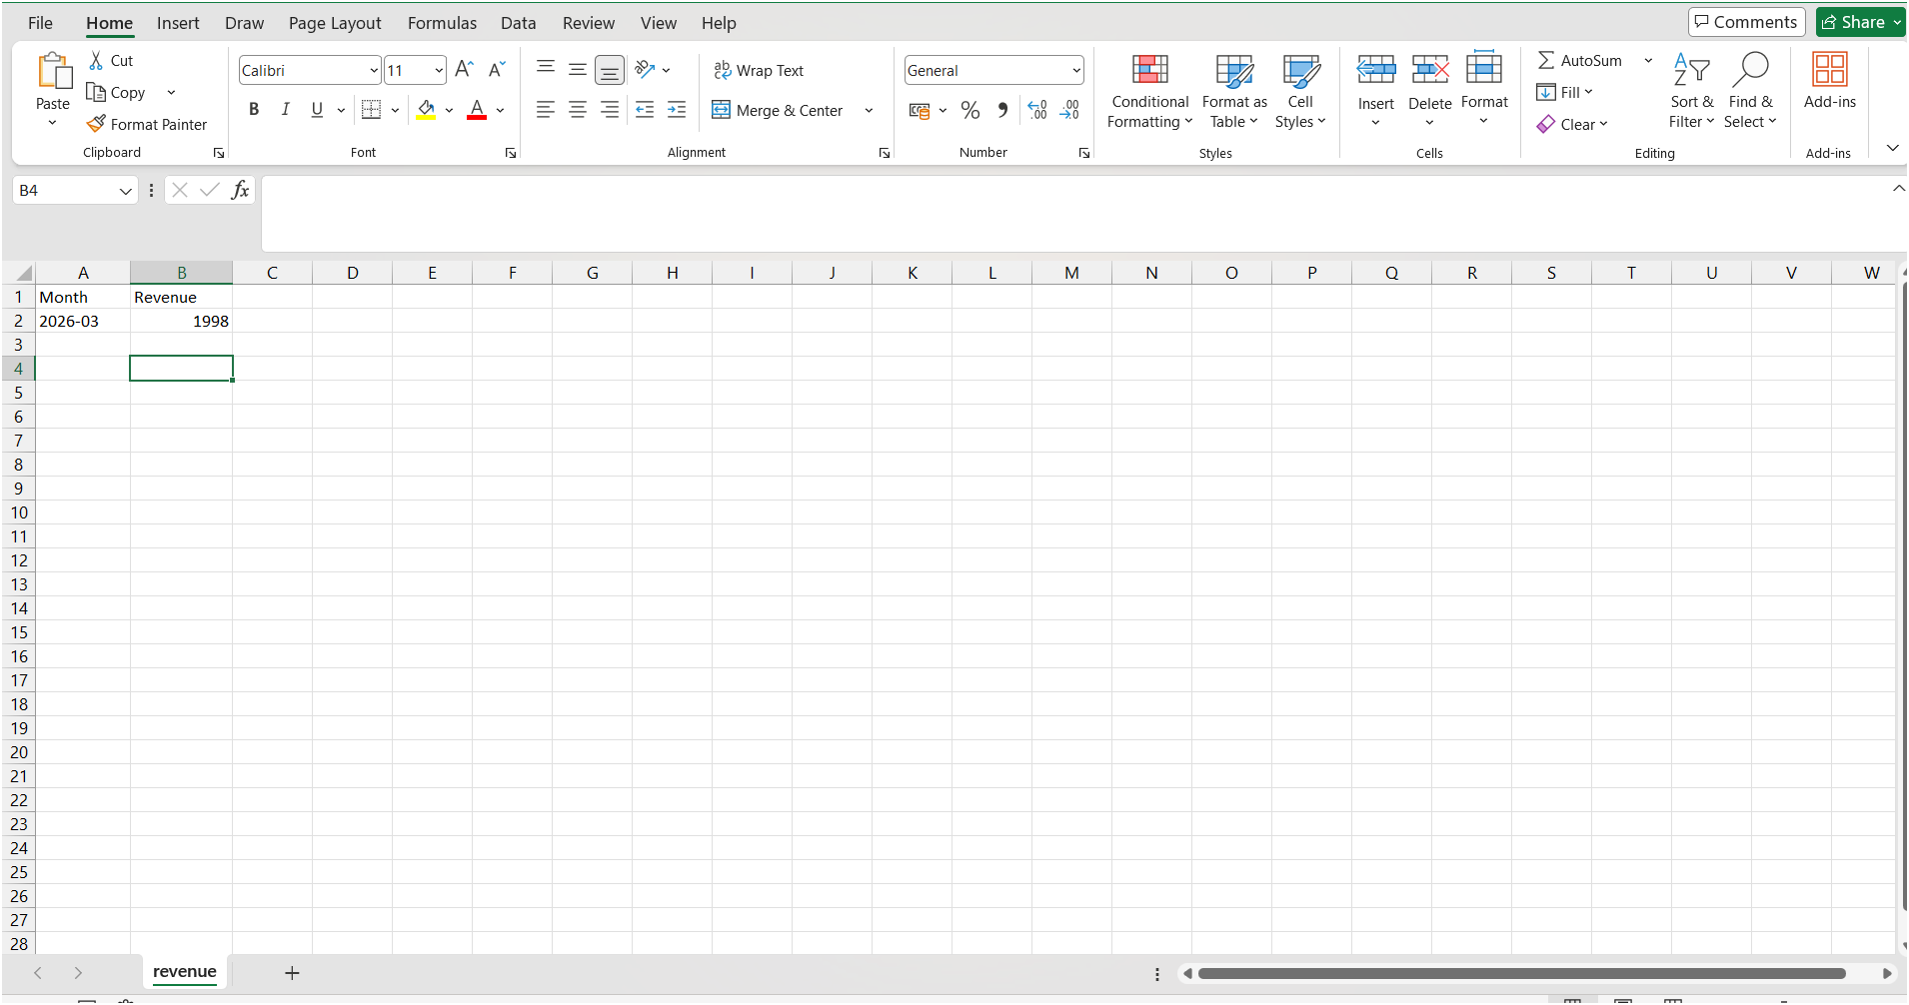
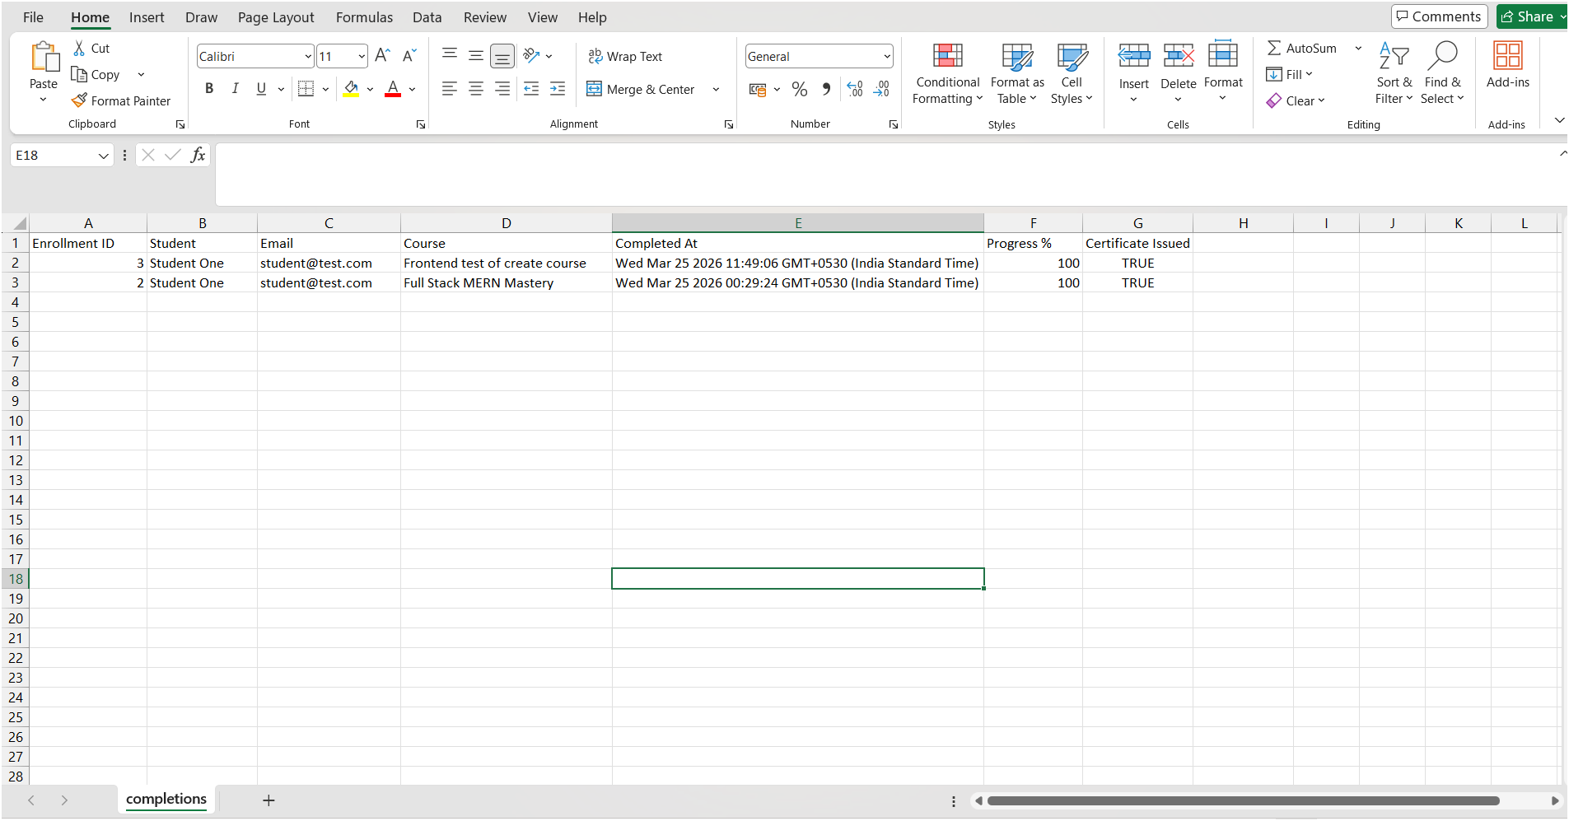
- Exported analytics reports showing course performance, student completions, and revenue insights in structured spreadsheet format.

Pdf reports system
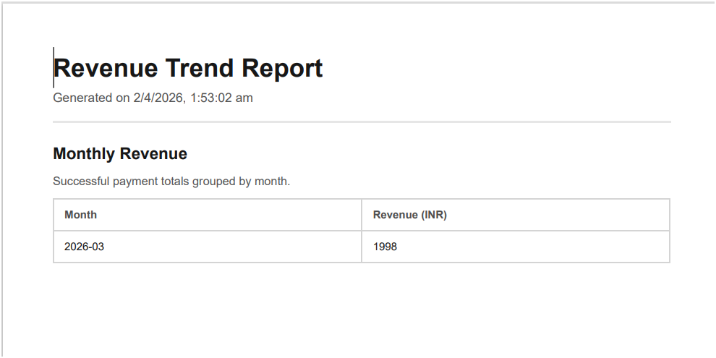
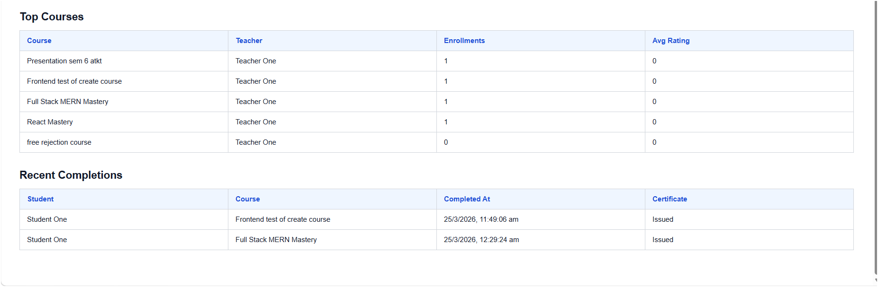
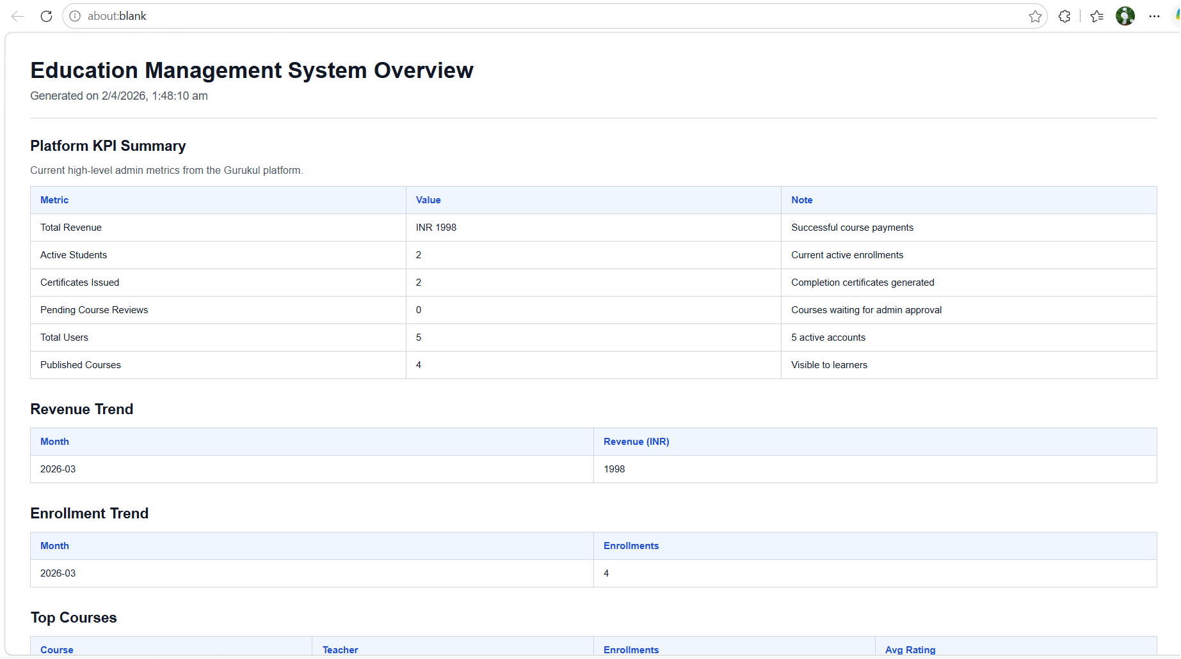

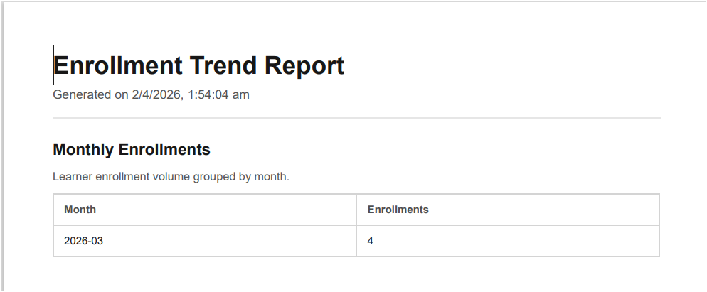
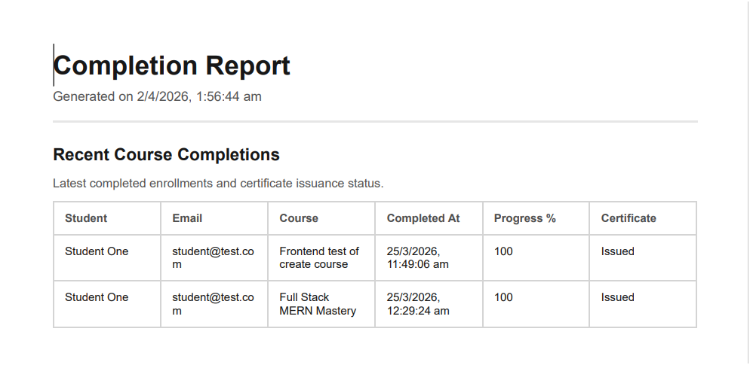
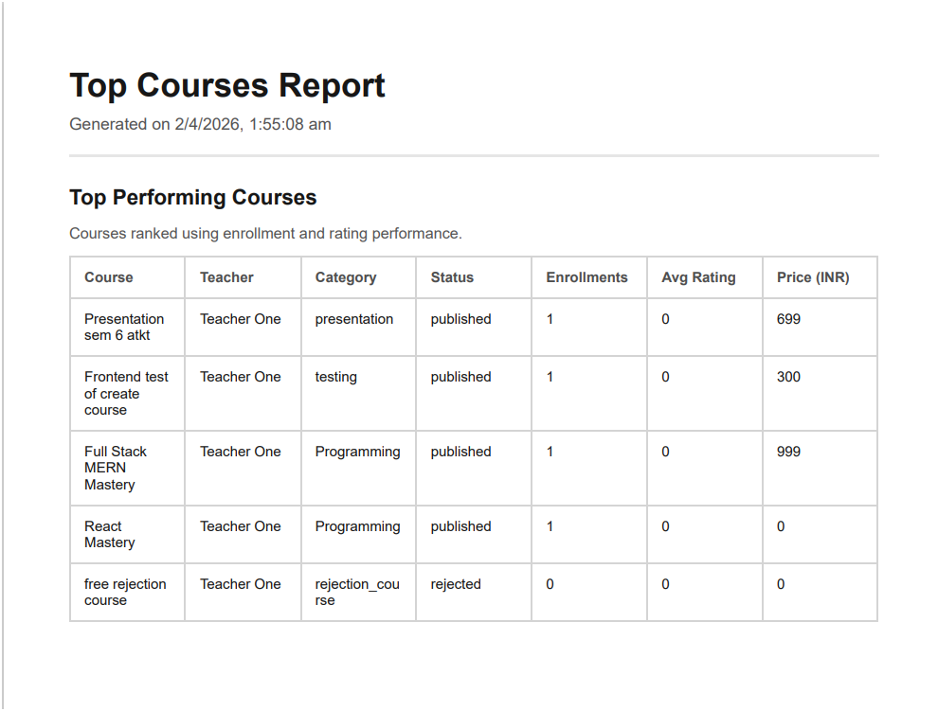

- An admin-generated PDF report summarizing course completions, enrolments, and top-performing courses for structured analysis and sharing.

Conclusion :
As the conclusion of my 3rd-year Software Development Project (SDP) titled Gurukul – E-Learning Platform, developed under the guidance of academic mentors, I have successfully designed and implemented a comprehensive digital learning system aimed at enhancing the online education experience for students, teachers, and administrators. Over the span of one year, this project has provided me with extensive exposure to real-world software development practices, project planning, and systematic execution.
The development journey of Gurukul has been a significant learning milestone, during which I addressed multiple technical and architectural challenges while building a scalable and user-centric web application. By leveraging modern technologies such as React.js, CSS3, and Vite for the frontend, along with Node.js and Express.js for backend services, and MySQL for structured data management, I ensured that the system is robust, efficient, and aligned with current industry standards. Additionally, tools such as VS Code, Git, and GitHub facilitated streamlined development, effective version control, and smooth collaboration throughout the project lifecycle.
Throughout this project, I gained hands-on experience in implementing core e-learning functionalities such as course management, module and lesson structuring, student enrolment, progress tracking, assignment submission, and assessment systems. By simulating real-world educational workflows and incorporating multiple user roles—including students, teachers, and administrators—I developed a deeper understanding of the complexities involved in digital learning environments and designed solutions that effectively meet diverse user requirements.
In conclusion, the development of the Gurukul E-Learning Platform has played a crucial role in strengthening my technical expertise, analytical thinking, and problem-solving capabilities. It has also enhanced my understanding of full-stack development, system architecture, and user experience design. I take pride in delivering a feature-rich and scalable platform and am confident that Gurukul can serve as a valuable educational solution, contributing to the advancement of digital learning ecosystems.

Bibliography :
The development of the Gurukul – E-Learning Platform was supported by various official documentations, technical resources, and industry-standard tools. The following references were utilized throughout the design, development, and implementation phases of the project.
Frontend Technologies
• React.js Documentation
https://react.dev/
Used for building dynamic and component-based user interfaces.
• CSS3 Specification & Guides
https://developer.mozilla.org/en-US/docs/Web/CSS
Used for styling, layout design, and responsive user interface development.
• Vite Documentation
https://vitejs.dev/
Used for fast frontend development and optimized build processes.
Backend Technologies
• Node.js Documentation
https://nodejs.org/
Used for server-side application development.
• Express.js Documentation
https://expressjs.com/
Used for building RESTful APIs and backend routing.
Database
• MySQL Documentation
https://dev.mysql.com/doc/
Used for structured data storage and relational database management.
Development Tools
• Visual Studio Code
https://code.visualstudio.com/
Used as the primary IDE for coding, debugging, and extension support.
Documentation & Presentation
• Microsoft Word
Used for preparing project documentation.
• Microsoft PowerPoint
Used for creating project presentations.
Version Control & Collaboration
• Git Documentation
https://git-scm.com/doc
Used for tracking code changes and version management.
• GitHub
https://github.com/
Used for repository hosting, collaboration, and cloud storage of the codebase.
Additional Learning Resources
• MDN Web Docs
https://developer.mozilla.org/
Used as a reference for web development standards and best practices.
• Stack Overflow
https://stackoverflow.com/
Used for troubleshooting, community discussions, and problem-solving.
• W3Schools
https://www.w3schools.com/
Used for basic to intermediate concept references and examples.

