Meeting Federal Petroleum Reduction Mandates Using Alternative Fuel Vehicles
A Look at Vehicle Allocation and Data Reporting Methods

Olivia Jeffers
Department of Veterans Affairs
Green Management Program
July 22, 2011

On my honor as a University student, on this assignment I have neither given nor received unauthorized aid as defined by the Honor Guidelines for Papers in Science, Technology, and Society Courses.
Executive Summary
In order to meet the growing demands from federal alternative fuel vehicle (AFV) purchasing requirements and petroleum reduction mandates, improvements in AFV allocation and data reporting need to be made in facility-level fleet management. Interviews with facility fleet managers and analysis of past fleet data reports indicate that fleet managers throughout the Department of Veterans Affairs (VA) are having difficulty meeting the increasing reporting requirements associated with new federal AFV purchasing and petroleum reduction mandates.
AFVs need to be efficiently managed and allocated in order to offset their high upfront costs and contribute to VA petroleum reduction. Fleet managers need to be provided the tools to make these decisions. In addition, the VA needs better data reporting in order to show that they are meeting federal petroleum reduction and AFV purchasing requirements. Efficient allocation and data reporting must be implemented together in order for VA AFV policy to be effective.
This policy analysis reviews alternatives for facility-level AFV allocation and improvements in data reporting methods. Two options are introduced for AFV allocation and three options are introduced for data reporting methods. Options are analyzed using effectiveness in meeting federal mandates, cost effectiveness, timeliness, and political feasibility as framework criteria. All options are compared to the status quo.
As the VA is no longer meeting all of the federal fleet mandates, it is recommended that the VA move away from the status quo. For immediate action, it is recommended that the VA educate facility-level fleet managers on the technical and cost savings benefits of AFVs in order to improve allocation; and require that all AFVs use onboard automated data reporting systems.
Table of Contents
Executive Summary i
List of Figures iii
List of Tables iii
Acknowledgments iv
Introduction 1
Federal Definition of Alternative Fuel Vehicles 2
Overview of Governing Mandates 2
VA Fleet Performance in Accordance with Mandates 2
Importance of Effective Allocation and Data Reporting 4
VA Organizational Background 5
Current Allocation and Data Reporting Methods 8
Proposed Alternatives 12
Criteria 15
Analysis 15
Outcomes Matrix 23
Recommendation 24
Appendix A 25
Appendix B 28
Appendix C 30
Appendix D 32
Appendix E 34
Works Cited 36

List of Figures
Figure 1: Vehicle Inventory Trends by Fuel Type [FAST, 2010] 3
Figure 2: Petroleum Fuel consumption Trends compared to Baseline Reduction [FAST, 2010] 4
Figure 3: Veteran's Health Administration VISN Geographic Distribution 5
Figure 4: Fleet Management Hierarchy and Responsibilities 7
Figure 5: FAST Data Discrepancy 11
Figure 6: Alternative Options for Allocation and Data Collection 12
Figure 7: VA Vehicle Allocation Methodology (Page 1) 30
Figure 8: VA Vehicle Allocation Methodology (Page 2) 31
Figure 9: Vehicle Specs Sheet for Electric Vehicles Used in the GSA Pilot Program 32
Figure 10: Cost/Benefit Analysis of EVs, Dual Fuel Vehicles, E-85, and Gasoline Vehicles 33

List of Tables
Table 1: VA Fleet Missions 8
Table 2: Outcomes Matrix 23
Table 3: Petroleum Reduction Mandates 28
Table 4: Alternative Fuel Vehicle Purchasing Mandates 29
Table 5: Cost Savings of Telematics by FleetPulse 34

Acknowledgments
I would like to thank all those on the Green Management Team for providing me a solid experiential education in government policy making and sustainable asset management. I would like to specially thank my mentors, Christina Stamper, Frederick Thielke, and Regina Larrabee, for providing guidance and many opportunities to learn. Thanks to CJ Cordova for being a really cool boss, Phyllis Stange for being a “wall breaker”, and John Park for ushering everyone out to lunch.
I would like to thank Joe Sabel, Christina Stamper, and Regina Larrabee for providing editorial and structural support for this policy analysis. And of course, thanks to my parents James and Hongwei Jeffers who listened to me try to brainstorm effective policy solutions.
I would also like to thank Jim Turner and Professor Michael Rodemeyer for running the Policy Internship Program, for having high hopes for their students, and for giving us all the opportunity to participate in a great summer experience.
I want to thank George Schaubhut (GSA), Butch Springer, and Benjamin Dunford for giving me their time and expertise on VA and GSA fleet management.

Introduction
“Keeping our promises to Veterans through sustainability.”
- Green Management Program Services Motto

The Department of Veterans Affairs is first and foremost concerned with serving and honoring the men and women who are America’s Veterans. The VA’s Green Management Program focuses on using sustainability and energy conservation as methods of improving quality of care and cutting costs in order to achieve this mission. The VA maintains a growing vehicle fleet in order to care for our Veterans on VA hospital campuses and through outreach programs like Healthcare for Homeless Vets and Job Rehabilitation Therapy. Additional federal mandates and laws place requirements on petroleum use and AFV purchasing that directly impact VA fleet management and policy.
To assist the VA in meeting federal petroleum reduction mandates, this policy analysis will investigate facility-level fleet management in order to recommend improvements for AFV allocation and data reporting methods.
The paper will first go over the federal definition of an AFV followed by a summary of fleet-related federal mandates and an overview of VA’s past performance. Current management practices will be discussed followed by a detailed analysis of alternative fleet management policies. Overall, based on the criteria of meeting federal mandates, cost effectiveness, timeliness, and political feasibility, the policy analysis will recommend the following for immediate action:
- Educating facility fleet managers on the cost savings opportunities of AFVs in alignment with existing performance incentives.
- Implementing on-board, automated data systems in VA vehicles to streamline data reporting and cut maintenance costs.
It is important that both options be implemented in tandem, as both allocation and data reporting are vital to a successful AFV policy.

Federal Definition of Alternative Fuel Vehicles
Alternative fuel vehicles (AFVs) are defined by Executive Order 13514 and the Energy Policy Act of 1992 as amended (42 U.S.C. 13211) to include dedicated or dual fuel vehicles using alternative fuels such as methanol, alcohols, mixtures containing 85 percent ethanol (E-85), liquefied natural gas, fuels from biological materials, and electricity. AFVs also include hybrids, highly efficient vehicles, and low GHG vehicles in certain areas. For a full definition, refer to U.S. Code Title 42, 13211.

Overview of Governing Mandates
VA fleet performance is mandated by the Energy Policy Act of 2005 (EPAct 2005), Executive Order 13423, Energy Independence and Security Act of 2007 (EISA 2007), Executive Order 13514, and the May 24, 2011 Presidential Memorandum on Federal Fleet Performance (Appendix A). See Appendix B for a full summary of VA mandates relating to petroleum reduction and AFV purchasing.
Petroleum fuel consumption must be decreased 2% annually compared to the 2005 agency baseline, and alternative fuel consumption must be increased 10% annually according to the 2005 agency baseline. AFVs must be purchased whenever possible, preparing for the Presidential Memorandum requirement that all newly purchased or leased light-duty vehicle must be AFVs by December 2015. Current requirements mandate 75% of the light duty fleet acquisitions to be AFVs.

VA Fleet Performance in Accordance with Mandates
The VA currently has 14,704 vehicles with an annual operating cost of $73 million. Fuel costs account for over $7.5 million of this amount. VA uses 9.6 million gallons of petroleum fuel and 1 million gasoline gallon equivalents (GGEs) of alternative fuels such as E-85, biodiesel, and compressed natural gas (CNG) each year. GGEs are calculated from the price paid at the pump and divided by an average price for the year and are subject to price fluctuations; however, they are the only data that exist for tracking the mandated requirements.
Since 2006 the VA has been regularly reducing the amount of gasoline used per vehicle and miles traveled per vehicle, seemingly in accordance with mandates. However, beginning in 2008 the increases in Veteran outreach programs, such as home visits and Healthcare for Homeless Vets, have driven up the total miles traveled and annual acquisitions. As shown in Figure 1, total vehicle inventory has been increasing; however, the number of petroleum-fueled vehicles has been decreasing since 2005 while the number of AFVs has been rapidly increasing. As such, VA is meeting AFV acquisition mandates.
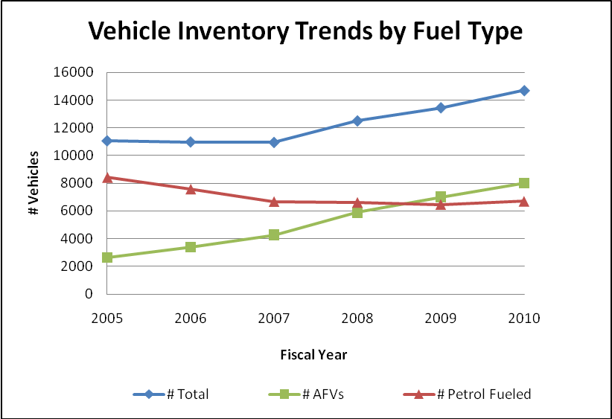
Figure 1: Vehicle Inventory Trends by Fuel Type [FAST, 2010]

Due to the increase in overall vehicles, VA’s total fuel consumption has been increasing steadily since 2008, matching the VA’s ramping up of Veteran outreach programs. However, even though total fuel consumption has been increasing, petroleum use has decreased 6.5% since 2005, but did not meet the 10% reduction for 2010 (Figure 2). In addition, there was a two year sharp decrease in petroleum fuel consumption followed by a gradual increase until present. If current trends continue, the VA will likely have increased total petroleum fuel us as compared to the 2005 baseline and will further fall out of alignment with mandates.
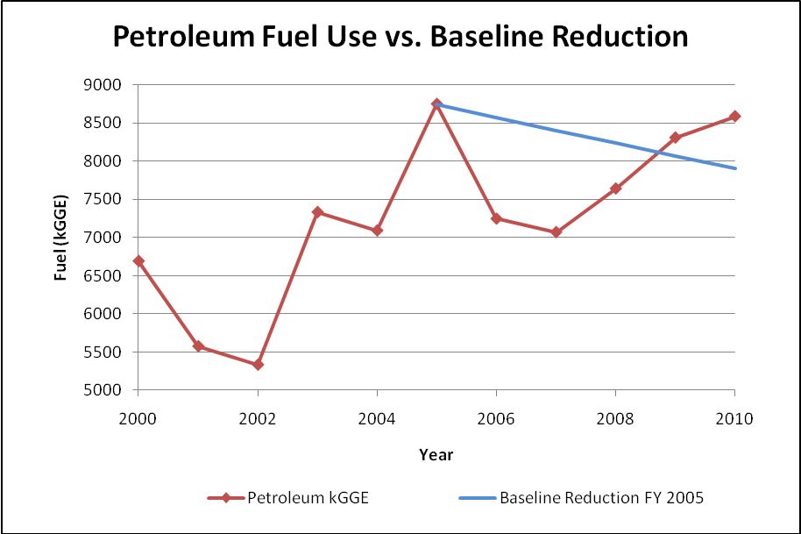
Figure 2: Petroleum Fuel consumption Trends compared to Baseline Reduction [FAST, 2010]
Alternative fuel consumption has increased nearly 3,000% since 2007, exceeding the 10% yearly increase as compared to the 2005 baseline. This shows compliance in implementing alternative fuel programs.

Importance of Effective Allocation and Data Reporting
In this policy analysis, allocation will refer to the placement of newly purchased AFVs and/or existing vehicles. Effective allocation and data reporting must be considered for successful vehicle deployment. AFVs have a high range of costs. The least expensive AFVs are the low GHG emitting vehicles which are nearly cost comparable to equivalent petroleum fueled vehicles. The most expensive commercially available AFVs are electric vehicles, ranging from $20,000 to $50,000, almost twice the price of an equivalent petroleum fueled vehicle. Effective vehicle allocation ensures that vehicles are used effectively in order to make returns on the high initial investment.
Accurate data collection and reporting allows the VA to take credit for improvements and objectively show that they meet federal mandates. Both effective allocation and correct reporting must occur in tandem in order to fully realize the benefits of using AFVs for petroleum reduction.

VA Organizational Background
Beyond the Central Office, the VA is split into three organizations: Veterans Health Administration (VHA), Veterans Benefits Administration (VBA), and the National Cemetery Association (NCA). As the VHA uses 90% of the VA fleet vehicles, this analysis will focus on VHA fleet use and management.
The VHA is split geographically into 21 Veterans Integrated Service Networks (VISNs) as shown in Figure 3. VISNs 13 and 14 were combined into VISN 23. Each VISN has VISN-level management followed by facility-level management.
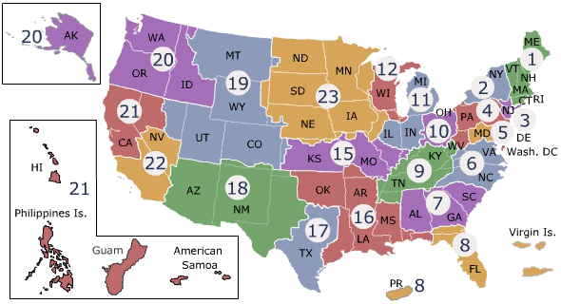
Figure 3: Veteran's Health Administration VISN Geographic Distribution

The VA has central and VISN-level management ranging from hospital use, building maintenance, energy management, and fleet management. For the discussion on fleet, the analysis will elaborate on VA central and facility-level management.

Central Office Fleet Management
The Green Management Program, under the Office of Asset and Enterprise Management, has a Central Office Fleet Manager who manages the Department of Energy Federal Automotive Statistical Tool (FAST) database and is responsible for fleet policy directives released to all VISN level fleet managers. The Central Office fleet manager is also responsible for oversight of AFV acquisitions and alternative fueling station installments.
Traditionally, the individual vehicle allocation falls on the facility-level fleet managers, not on Central Office decision makers. The reason for this is that VA’s Central Office cannot manage individual allocation for all 14,704 fleet vehicles and does not have the individual fleet data to be able to do so. The Central Office can dictate policy, but implementation is left to facility-level fleet managers.

VISN and Facility Fleet Management
Each VISN has a VISN-level fleet coordinator and subordinate facility fleet managers. The facility fleet managers are responsible for maintaining, assigning, and ordering vehicles for fleet use. shows a graphic of the VA fleet management structure, expanding in detail the facility fleet management hierarchy and responsibilities. Facility fleet managers are typically responsible for day-to-day and vehicle-to-vehicle responsibilities such as maintenance, dispatching, vehicle operator management, and reporting vehicle data to upper management through the vehicle databases; CARS, FAST, and Drive Thru.
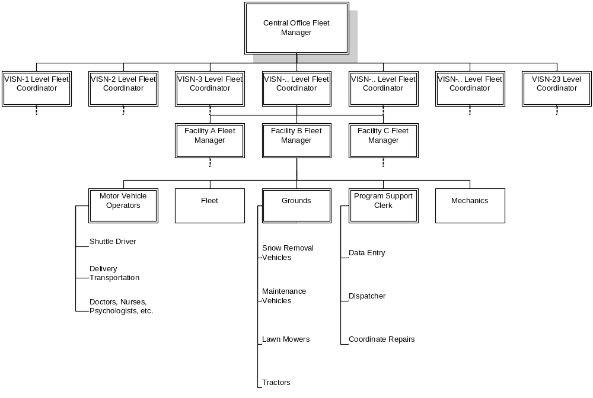
Figure 4: Fleet Management Hierarchy and Responsibilities

Historical Changes in Fleet Management
Federal fleets have undergone many changes in the past 20 years. The most notable changes have been in fleet size, reporting requirements, and types of vehicles. Fleet management responsibilities are different for small fleets versus large fleets and gasoline versus alternative fuel vehicles. Interviews with facility fleet managers indicate that fleet management may not be able to meet all reporting and management requirements, especially in places where fleet size and AFVs have grown in the past 20 years.

Current Allocation and Data Reporting Methods
VA fleets are highly regulated because of their high operational costs and potential for misuse. Fleets must only be used for accepted missions, detailed below, and must be managed according to VA directives and reporting standards. VA Central Office (VACO) defers allocation decisions to VISN-level and facility fleet managers. Facility-level fleet managers are responsible for reporting data to upper management.

Missions
All new fleet vehicles must meet federal safety standards and VA specific mission requirements. Missions include a variety of ranges; city and rural driving, emergency response, and on-campus delivery and/or shuttling. VA vehicles are used primarily for the following missions:
Table 1: VA Fleet Missions
Veterans Health Administration (VHA) | National Cemetery Association (NCA) | Management Services (VA Wide) & Veterans Benefits Administration (VBA)
- Recreation Therapy – day trips from community living centers and nursing homes  - Healthcare for Homeless Vets – outreach through employment assistance, disability registration assistance, case management, medical, and mental health treatment  - Consolidated Work Therapy – rehabilitation program for alcohol and drug dependent Veterans to obtain jobs  - Community-Based Outpatient Clinics – each CBOC has at least one fleet vehicle to shuttle patients to and from hospital centers  - Home-based Patient Care – caring for Veterans unable to travel to hospital centers  - Shuttles – provide easy access to parking lots and public transportation areas  - Emergency Vehicle – ambulances, fire trucks | - Cemetery Maintenance – transporting employees around grounds for maintenance  - Veteran Support – lead funeral processions and/or carry visitors to gravesite | - Business Office – fleet use for traveling between offices  - Veteran Services – fleet used to visit Veterans unable to come to VA offices,  - Police Services – on-campus security  - Executive Office – VISN and Medical Center Directors office vehicles  - Warehouse – shuttling supplies to and from campus  - Delivery – delivering supplies and/or medical specimens

The VA heavily uses fleet vehicles in order to meet these mission requirements. As the aging Veteran population requires more home-based care, the programs have had to increase in size as well as fleet vehicle use. Many VISNs also have relatively rural locations where transportation to-and-from Veterans’ homes and various hospital campuses are several hours’ drive away.

Data Collection
The data systems currently in use are the Department of Energy’s (DOE) Federal Automotive Statistical Tool (FAST), General Services Administration’s (GSA) Drive Thru, and Veterans Affairs’ (VA) Comprehensive Automobile Reporting System (CARS).
DOE’s FAST is used for the purpose of analyzing aggregate fuel use per class of vehicle in accordance with fuel use mandates. As a result, FAST loses much of the data clarity that GSA Drive Thru and VA CARS have.
GSA’s Drive Thru is for GSA leased vehicles which comprise roughly 75% of the VA fleet. GSA Drive Thru currently exports data to FAST. The data, however, are not reconcilable due to different data entry standards. For example, GSA Drive Thru gives data on miles driven and license plate information while FAST provides data on total gallons gasoline equivalent (GGE) alternative and petroleum fuel consumed per vehicle class. If a user tried to analyze GGE alternative fuel per miles driven using FAST they would not be able to reconcile the data.
VA CARS is the comprehensive fleet management database for all VA vehicles, whether GSA leased, commercially leased, or agency owned. CARS manages vehicle status updates, such as operational, in maintenance, damaged or stolen; and also manages license plate and vehicle make and model data.

Inconsistencies in FAST Data Gathering and Reporting
Gathering data has proved difficult because of the sheer amount of required and requested data. Currently site fleet managers have to input similar data into three different systems: GSA’s Drive Thru, VA’s CARS, and DOE’s FAST.
FAST data is spotty and has discrepancies throughout the VA. These discrepancies were verified via data analysis and through interviews with facility fleet managers. For example, VISN-5 fleet managers spend hours trying to input the correct information, but must input “0” where it is not appropriate simply to get the forms to submit. Through analyzing FAST data, it was found that only 628 out of 5,940 data points were considered “good data”. “Good data” were selected based on the criteria that where there are operational costs there must be miles driven. For example, a vehicle class with 5,000 miles driven cannot have $0 operational costs and vice versa.
Another example is shown below in Figure 5, where the annual operating costs increased by a factor of 7 in 2005 from $41,000,000 to $279,000,000. It is interesting to note that 2005 is also the baseline year petroleum fuel reduction. Further analysis revealed that the discrepancy was in the sedan class and heavy duty vehicle operational costs, which had also increased by almost a factor of 10 from earlier and later values.
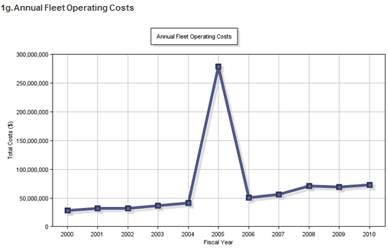
Figure 5: FAST Data Discrepancy
FAST has shown inconsistencies in the data but overall data trends are useful in showing general direction and magnitude of petroleum use and vehicle allocation trends.

Vehicle Allocation – The Vehicle Allocation Methodology (VAM) Tool
As of 2005, facility fleet managers are mandated to use VAMs to justify vehicle acquisitions. The VA VAM was created in 2010 by VA contractor SRA International as an Excel spreadsheet calculator; a tool for facility fleet managers to input anticipated miles driven, mission type, and utilization status of similar vehicles in order to determine whether or not acquisition of an additional vehicle is justified. Depending on the objective rating, the facility fleet managers can justify requesting a new vehicle, or be advised to consider using an existing vehicle to meet mission requirements. See Appendix C for a full view of the VA VAM.
A noted problem with the VAM is that the numbers are not easily verifiable. For example, a manager can estimate the numbers of miles traveled upward or downward to get the desired usage. By reporting that existing vehicles are “overutilized” they can justify receiving more vehicles. Alternatively, it can be beneficial for managers to keep the vehicles slightly underutilized because the cost of reimbursing for personal vehicle use is much higher than maintaining an underutilized vehicle.

Proposed Alternatives
Two alternatives for allocation and three alternatives for data reporting are proposed as shown in .
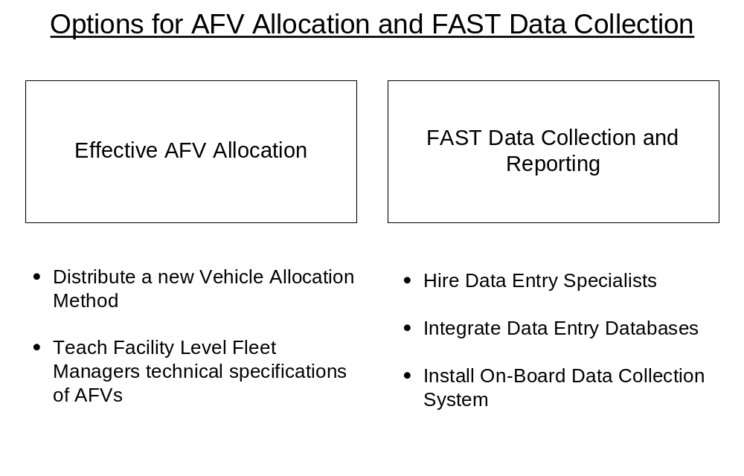
Figure 6: Alternative Options for Allocation and Data Collection

Effective AFV Allocation
In order to fully realize the benefits of AFVs, the vehicles must effectively be allocated with respect to miles traveled, availability of fueling stations, and mission use. The analysis proposes two methods for achieving effective AFV allocation.

Option 1 – Distribute a New Vehicle Allocation Methodology
The VA will hire SRA International to upgrade the VAM to include considerations for all AFVs. The current VAM, as shown in Appendix C only has the capability to analyze readiness for E-85 and hybrid vehicles. The new VAM will be distributed to facility fleet managers to help them determine which locations might be better for other types of AFVs such as electric vehicles.

Option 2 – Educate Facility Fleet Managers on Technical Specifications of AFVs
The allocation decision is left to facility-level fleet managers. The incentive structure for cost savings in petroleum reduction already exists. The VA will train facility and VISN-level fleet managers in the technical specifications of AFVs. Training will occur by sending out a fleet directive with technical instructions for vehicle allocation. For example, facility fleet managers will be informed how too effectively use a Chevy Volt (a dual fuel vehicle with electricity and gasoline) versus a Nissan Leaf (a purely electric vehicle) based on facility resources, demand, and mission requirements. See sample documents in Appendix D.

FAST Data Collection and Reporting
In order to be recognized for any reductions in petroleum use, the VA needs to be able to accurately and efficiently report fuel consumption and vehicle use. FAST is how all agencies are evaluated according to fuel consumption and AFV use standards. Therefore, it is imperative that FAST data reporting be improved if the VA is to more widely use multiple types of AFVs.

Option 1 – Hiring a Data Entry Specialist
With the increase in fuel consumption reduction mandates, fleet managers must be increasingly aware of their vehicle management duties. Traditionally fleet managers are concerned with cutting fuel, saving cost, and maintaining the vehicles. Given the inconsistencies in data reporting through FAST, it is clear that the additional responsibility of data entry and compliance has shown to be too much for fleet managers to appropriately handle. This option suggests hiring data entry specialists to remove the burden of reporting from the fleet manager.

Option 2 – “Telematics” – Retrofitting VA Vehicles for On-board, Automated Data Tracking
Telematics allows the vehicle to directly communicate with computer databases, inputting live data for miles traveled, location, and fuel consumption. Regarding new AFVs, the VA will require that newly purchased vehicles be equipped with on-board data systems like OnStar® and FleetPulse®. VA vehicles that do not already have telematics will undergo retrofits. The VA will purchase the telematics option on GSA leased General Motors vehicles. Facility-level fleet managers and VISN-level coordinators will be responsible for contracting with individual companies and for installations done by onsite staff. The VA’s Center for Engineering, Occupational Safety and Health (CEOSH) will be responsible for data configurations between the onboard data system and VA CARS, GSA Drive Thru, and DOE FAST.

Option 3 – Interagency Data Integration
The VA can allow CARS to import data from GSA Drive Thru and to export data to DOE FAST. In this manner, fleet managers only have to input the data once. In order to allow for interagency data integration, changes to CARS will be slight but important. For example, CARS will be altered to “speak the language” of FAST. The languages differ in that CARS requires detailed descriptions of vehicle weight class and size while FAST requires only a class description; sedan, pickup, light duty truck, etc. This small change will make CARS and FAST reconcilable.

Criteria
This analysis will focus on successfulness with respect to the following criteria:
- Meeting Mandates: Does the alternative offer a way for VA to meet petroleum reduction, alternative fuel consumption, and AFV purchasing requirements?
- Low Cost: How much would implementing the alternative cost?
- Timeliness: How much time would it take to realize the benefits of the alternative?
- Political Feasibility: How well do the current incentives for policy makers and fleet managers line up with the supporting the alternative?

Analysis

Meeting Mandates
The VA did not meet petroleum reduction mandates in 2010. The VA has reduced petroleum consumption by 6.5% versus the required 2% yearly reduction (10% reduction in 2010).
The current management practice places excessive and unrealistic expectations on fleet managers to effectively manage vehicles according to petroleum reduction mandates. Given the anticipated increase in fleet use programs, AFV acquisitions, and miles traveled, it is unlikely that the current method of management will be able to meet increasingly stringent petroleum requirements.
Allocation Option 1, to distribute an updated VAM, will be a useful tool for those managers who use it. Success can only be measured by how many people use it, and given how new the VAM is, its usefulness is as yet undetermined.
Allocation Option 2, to educate facility fleet managers on AFV technical requirements, aligns with current incentives. Fleet managers already aggressively seek to cut costs. Introducing an AFV as a new method for cost cutting will be more positively received than if AFVs are introduced as federal mandates.
Given that Allocation Option 2 follows closely with the direction and incentives of the status quo, it is recommended for use according to the effectiveness criteria.
Data Option 1, hiring data entry specialists, will more likely ensure that the data entry is completed. If the fleet managers are able to fully manipulate and use the data, instead of having to focus on obtaining and reporting the data, they may be able to further implement cost cutting methods through efficiency and AFV usage.
Data Option 2, using on-board “telematics” software, will ensure that all data are automatically updated and entered into CARS, Drive Thru, and FAST. This eliminates the need for a data entry specialist and also removes the burden of data entry from the fleet manager. In addition, according to the FleetPulse® cost/benefit analysis in Appendix E, telematics systems offer up to 4% fuel reduction through better maintenance and vehicle operation.
Data Option 3, interagency database integration, will ensure that data needs only be input once into CARS, and then CARS will relay the same data to DOE FAST and GSA Drive Thru. This will alleviate the reporting burden from fleet managers and will help ensure that the data is more accurate.
Data Options 1, 2, and 3 are equally effective at meeting data reporting requirements. Option 2 meets both data reporting and petroleum reduction requirements.

Low Cost
Outside of purchasing the electric vehicles and charging stations, the current fleet management system runs on the following costs:
- Fleet Management: Roughly $50 million
- Operational Costs: Currently $73 million
Allocation Option 1, to distribute an updated VAM, will require contracting with SRA International. This could cost at minimum $20,000 for a small update. Historically the cost to create the original VAM was $300,000.
Allocation Option 2, to educate facility fleet managers on AFV technical requirements, will require sending out a policy directive and technical instructions by email. Cost will be minimal.
Given that Allocation Option 2 has roughly no cost in comparison to hiring SRA International, Allocation Option 2 is recommended.
Data Option 1, hiring data entry specialists at a GS-7 grade, will cost roughly $35,000 per new employee and total cost, plus overhead and benefits, will cost $87,500 annually per employee hired. This option is already being implemented, with some fleet managers being allocated one to two “program support clerks” who are responsible for data management, dispatching, and scheduling maintenance. However, funding priority for this type of clerical support is low and some facilities that were allocated new clerks have not yet received them due to the “hiring freeze”.
Some VA fleets are not large enough to merit a support clerk; some are large enough to require two. Using the assumption that on average, each fleet has 70 vehicles, and out of 14,704 vehicles there are roughly 210 fleets, then we can assume that only half of the 210 fleets require one support clerk. If Option 1 were implemented, assuming only half of the 210 fleets are large enough to require clerical support, the option would cost roughly $9.2 million.
Data Option 2, using on-board “telematics” software, will cost nothing in new cars like the Chevy Volt and Nissan Leaf that already have them. From the cost/benefit analysis in Appendix E by FleetPulse® it shows that in a fleet of 650 vehicles, an average of $2,479 can be saved from lost time idling, better fuel consumption management, and better maintenance records. As this data is from a company aiming to sell telematics, this analysis will assume the numbers are over-idealistic and, to be conservative, will decrease the amount of savings to $1,500 per year. Using these assumptions, the VA fleet is set to save $22 million yearly in operational and maintenance costs.
Based on the Washington D.C. VAMC fleet, the cost of a telematics system from GPS Fleet Solutions is $230 per vehicle, with onsite staff installation, and a monthly monitoring fee of $27. The VA owns roughly 3,700 vehicles. Using these numbers, total retrofit costs are around $2.1 million for the first year and $1.2 million annual maintenance afterwards. Regarding GSA vehicles, GSA General Motors vehicles come with On-Star which the VA may choose to activate. Some VISNs are also purchasing telematics with vehicles that they lease from GSA. Telematics for GSA vehicles, at $27 a month, is a $3.6 million yearly additional cost. The total additional cost for VA fleet telematics installation will be $5.7 million in the first year with $4.8 million maintenance yearly.
In the long term, based on these assumptions, the VA has the potential to save $17 million in operational costs yearly, while additionally reducing wasted petroleum fuel in order to meet mandates.
Data Option 3, interagency database integration, will have the lowest cost if only the VA CARS database were changed. Costs will be higher if more intensive database integrations are done. This fiscal year, Secretary Shinseki announced spending roughly $300 million for 16 major IT programs (Federal Computer Week), one of which was Blue Button, an electronic health care database for veterans. On average, the VA is already spending $18 million per project, with some projects being more, some being less. The cost for CARS database integration will certainly be over $1 million and likely between $5 and $10 million depending on depth of integration.
Given the current budgetary climate and associated cost savings, Data Option 2, using on-board telematics systems is financially the best option.

Timeliness
Allocation Option 1, to distribute an updated VAM, will take roughly 18 months for SRA International to complete. It will take roughly an additional 2 weeks to be put on the Office of Asset and Enterprise Management Fleet Management Webpage, where the existing VAM currently is. Facility-level fleet managers will not have to undergo VAM training as they were already trained when the first VAM was distributed in 2010.
Allocation Option 2, to educate facility fleet managers on AFV technical requirements, will take only the time necessary to research and write the directive. Sending out the document takes minimal time via email. Estimated time is 3 weeks.
Allocation Option 2 is recommended according to the timeliness criteria.
Data Option 1, hiring and training data entry specialists at a GS-9 grade, given the current “hiring freeze” will take an undetermined amount of time. If these positions are deemed mission critical, it will take between 2 and 3 years to hire the data specialists. If the positions are not mission critical, specialists will not be hired until the “hiring freeze” is alleviated by an increase in VA budget.
Data Option 2, using on-board “telematics” software, will take no time in new cars like the Chevy Volt and Nissan Leaf that already have them. The process of retrofitting the existing fleet includes selecting a contractor, installing the purchased telematics system through onsite staff, and syncing the onboard software with the VA CARS program. Installations are currently being done by some facility-level fleet managers and VISN-level coordinators. Selecting contractors and initiating the purchase takes between 3 and 6 months with actual installation taking only a day. Once the purchase order is sent through, delivery takes around 3 business days. Overall time is estimated to be roughly 3 to 6 months.
Data Option 3, interagency database integration, will require opening a bid and selecting a contractor for changing the CARS database. Because this is an interagency project, members from all three agencies will need to coordinate. Estimated time for agreement is 6 months to 1 year. Contractors will be selected, with estimated time between 3 and 6 months. Actual database integration is likely to take up to 1 year. Overall the process could take between 2 and 3 years.
Data Option 2, onboard telematics, is recommended according to the timeliness criteria.

Political Feasibility
Before the Presidential Fleet Memorandum there was little political push for meeting federal fleet mandates. The only penalty for failing to meet mandates was a “red” on the Office of Management and Budget’s Sustainability Scorecard for Federal Agencies. However, with the Presidential Fleet Memorandum, attention from GSA, and increasing petroleum prices, there is currently a very supportive climate regarding fleet management
Allocation Options 1 and 2, distributing a new VAM and educating fleet managers, should face little political resistance as they are internal VA fleet management policy measures and are not resource intensive.
Data Option 1, hiring data entry specialists at a GS-9 grade, will face difficulty given the current “hiring freeze”. Given the current budgetary climate, Option 1 is unlikely.
Data Option 2, using on-board “telematics” software, faces little political resistance. Telematics programs have shown great success in cost cutting and petroleum reduction measures with the 22,000 vehicle UPS fleet (CIO). Option 2 is the only option that costs less than $1 million and offers a return on investment. Given the budgetary climate, Option 2 will likely be supported.
Data Option 3, interagency database integration, can be politically difficult as it requires convening a large number of people and money in order to update the database. However, the VA political climate regarding IT is positive as Secretary Shinseki has already allocated over $300 million toward IT infrastructure projects at the VA for this fiscal year and has committed to programs until FY 2017 (Federal Computer Week). It is likely that during this period of IT investment, the VA will be able to invest in fleet management interagency database integration.
Given the current political climate, Data Options 2 and 3 are recommended. Option 2 is better for immediate implementation; Option 3 should be evaluated for implementation over the next several years.

Outcomes Matrix
The outcomes of the analysis are shown in the following matrix:
Table 2: Outcomes Matrix
Criteria  (Unit of Measurement) | Effective Allocation |  | FAST Data Reporting
Criteria  (Unit of Measurement) | Option 1 | Option 2 | Option 1 | Option 2 | Option 3
Criteria  (Unit of Measurement) | Introduce a New VAM | Teach Facility Managers About AFV Technical Specifications | Hire Data Entry Specialists | Use On-Board "Telematics" Software | Integrate Interagency Databases
- Effectiveness in Meeting Mandates (Yes, Likely, Unknown, No) | Unknown | Likely; option follows existing incentive structure | Yes | Yes | Yes
- Cost ($) | $20,000 to $300,000 | No Additional | $9.2 million | First Year Installation and Maintenance $5.7 million; Yearly Maintenance $4.8 million; Cost Savings $17 million | $5-10 million
- Timeliness (months, years) | 19 months | 3 weeks | 1-3 years | 6 months to 1.5 years | 2-3 years
- Political Feasibility (Yes, No) | Yes | Yes | No; Hiring Freeze | Yes | Yes
Overall Recommendation |  | Recommended |  | Recommended

Recommendation
In order to meet federal mandates for petroleum reduction, the VA needs to aggressively focus on efficient AFV allocation and improving FAST data reporting. Any decision regarding AFV allocation and FAST reporting should be made in tandem. Without effective allocation, there will be no results to report. Without reporting, VA will not receive credit for the results. Either decision on its own will not yield desired results.
On the basis of cost, timeliness, effectiveness, and political feasibility, the analysis recommends that Allocation Option 2 and Data Option 2 for immediate implementation; teaching facility fleet managers technical specifications of AFVs for effective allocation and using on-board telematics systems to automatically input the data to FAST. These alternatives allow facility managers the agility and information to effectively allocate AFVs and allow the VA to fully realize the benefits of using AFVs to reduce petroleum consumption.

Appendix A

Presidential Memorandum--Federal Fleet Performance

The White House
Office of the Press Secretary
For Immediate Release
May 24, 2011
The Federal Government operates the largest fleet of light duty vehicles in America. We owe a responsibility to American citizens to lead by example and contribute to meeting our national goals of reducing oil imports by one-third by 2025 and putting one million advanced vehicles on the road by 2015.
Living up to that responsibility means the Federal fleet should operate only as many vehicles as needed to work efficiently, leveraging Federal purchasing dollars to build manufacturing capacity for more alternative fueled vehicles, and reducing petroleum consumption through efficiency and alternative fuels.
In Executive Order 13514 of October 5, 2009, Federal Leadership in Environmental, Energy, and Economic Performance, my Administration set a goal of reducing petroleum use in the Federal fleet. In order to provide guidance to executive departments and agencies (agencies) to help achieve my Administration's Federal fleet performance goals, and to ensure that agencies are in compliance with Executive Order 13514, I hereby direct the following:
Section 1. Vehicle Technologies. (a) By December 31, 2015, all new light duty vehicles leased or purchased by agencies must be alternative fueled vehicles, such as hybrid or electric, compressed natural gas, or biofuel. Moreover, agency alternative fueled vehicles must, as soon as practicable, be located in proximity to fueling stations with available alternative fuels, and be operated on the alternative fuel for which the vehicle is designed. Where practicable, agencies should encourage development of commercial infrastructure for alternative fuel or provide flex fuel and alternative fuel pumps and charging stations at Federal fueling sites.
(b) Pursuant to motor vehicle management regulations, set forth at 41 C.F.R. 102-34.50, executive fleets are required to achieve maximum fuel efficiency; be limited in motor vehicle body size, engine size, and optional equipment to what is essential to meet agency mission; and be midsize or smaller sedans, except where larger sedans are essential to the agency mission. Within 180 days of the date of this memorandum, any executive fleet vehicles that are larger than a midsize sedan or do not comply with alternative fueled vehicle requirements must be disclosed on agency websites.
(c) The Department of Energy shall assist the United States Postal Service (USPS) in evaluating the best alternative fuel technologies for the USPS fleet.
Sec. 2. Optimum Fleet Size. Within 90 days of the date of this memorandum, the General Services Administration (GSA) shall develop and distribute to agencies a Vehicle Allocation Methodology (VAM) for determining the optimum inventory with emphasis placed on eliminating unnecessary or non-essential vehicles from an agency's fleet inventory and ensuring lifecycle cost-effectiveness of maintaining such inventory. In addition, the VAM shall address composition for agencies' light duty fleets based on their missions. In doing so, the GSA shall consider existing Federal VAMs as appropriate. The VAM shall assist agencies in selecting vehicle options based on lifecycle cost analysis, including projected fuel costs, warranty, operations, mileage, maintenance, and disposal.
Sec. 3. Fleet Management. (a) Within 180 days of the GSA's dissemination of the VAM referenced in section 2 of this memorandum, agencies shall determine their optimal fleet inventory using the VAM, and shall post their optimal fleet inventory targets on agency websites. At the same time, agencies shall submit to the Administrator of General Services (Administrator) fleet management plans to achieve these targets no later than December 31, 2015.
(b) Within 30 days of receiving agency fleet management plans, the Administrator shall submit a summary of the plans to the Director of the Office of Management and Budget and to the Chair of the Council on Environmental Quality.
(c) Within 90 days of receiving agency fleet management plans, the Administrator shall provide each agency and military service with recommendations for the acquisition of alternative fueled vehicles to implement fleet optimization plans, including shared fleet-on-demand services where applicable.
(d) Agencies shall incorporate new fleet management plans into their Annual Strategic Sustainability Performance Plans prepared in furtherance of Executive Order 13514, beginning with their June 2012 plan submission.
Sec. 4. Applicability. (a) With respect to law enforcement and emergency vehicles, the GSA shall, within 180 days of the date of this memorandum, and in coordination with the Departments of Defense, Homeland Security, Justice, and the Treasury, and other appropriate agencies, issue guidance to agencies on the applicability and implementation of alternative fueled vehicle requirements.
(b) Consistent with the guidance developed in section 4(a) of this memorandum, the head of an agency may exempt vehicles used for law enforcement, protective, emergency response, or military tactical operations of that agency from the provisions of this memorandum.
(c) This memorandum shall apply to the activities, personnel, resources, and facilities of each agency that are located within the United States. The head of an agency may apply this memorandum to activities, personnel, resources, and facilities
of the agency that are not located within the United States, to the extent the head of the agency determines that doing so is in the interest of the United States.
Sec. 5. Definitions. (a) "Alternative fueled vehicle" means an alternative fuel vehicle as defined by Executive Order 13514 and an alternative fueled vehicle as defined by 42 U.S.C. 13211(3), including a "new qualified fuel cell motor vehicle" as defined in 26 U.S.C. 30B(b)(3) and a "new qualified hybrid motor vehicle" as defined in 26 U.S.C. 30B(d)(3).
(b) "Agency" means an agency as defined in Executive Order 13514.
(c) "United States" means the fifty States, the District of Columbia, the Commonwealth of Puerto Rico, Guam, American Samoa, the United States Virgin Islands, and the Northern Mariana Islands, and associated territorial waters and airspace.
Sec. 6. General Provisions. (a) This memorandum shall be implemented consistent with applicable law, including international trade obligations, and subject to the availability of appropriations.
(b) Nothing in this memorandum shall be construed to impair or otherwise affect:
(1) authority granted by law to a department, agency, or the head thereof; or
(2) functions of the Director of the Office of Management and Budget relating to budgetary, administrative, or legislative proposals.
(c) This memorandum is not intended to, and does not, create any right or benefit, substantive or procedural, enforceable at law or in equity by any party against the United States, its departments, agencies, or entities, its officers, employees, or agents, or any other person.
BARACK OBAMA

Appendix B

Governing Petroleum Reduction Fleet Mandates

Table 3: Petroleum Reduction Mandates
 | Increase total fuel consumption that is non-petroleum-based | Reduce petroleum consumption
EO 13423 | Section 701: Operate AFVS on alternative fuels all the time except for DOE-waivered AFVs | Reduce fleet consumption of petroleum products 2% annually through end of FY 2020 (baseline FY 2005). [§2(a)(iii)(C)]  Use low-GHG-emitting vehicles. [§2(a)(iii)(A)]  Optimize number of vehicles in fleet.  [§2(a)(iii)(B)]
EISA 2007 | 10% annually vs. 2005 baseline | "20%" annually vs. 2005 baseline (assumed to be a typo in final law-should read "2%")
EO 13514 | 10% annually vs. 2005 baseline | Reduce vehicle petroleum consumption 2% annually through FY 2015. (Baseline FY2005). [§2(g)] Achieve 10% increase in non-petroleum fuel consumption annually (baseline FY2005). [§2(g)]
Presidential Memorandum |  | Operate according to GSA's Vehicle Allocation Method (VAM) to optimize fleet size and incorporate changes into June 2012 Annual SSPP
VA Status | 2,782% increase from baseline, but many vehicles still fail to use alternative fuels that are available | VA achieved a 6.5% reduction versus the required 10%

Table 4: Alternative Fuel Vehicle Purchasing Mandates
 | Increase number of AFVs in agency fleet | Use electric plug-in hybrid (PIHs) vehicles
EPAct 2005 | EPAct: 75% of covered vehicle acquisitions must be AFVs *EPAct 1992/ECRA 1998 | Must use when commercially available at a cost reasonably comparable to non-PIHs on a life cycle cost basis
EO 13423
EISA 2007 |  | Use plug-in hybrids (PIH) when  commercially available at a life-cycle cost reasonably comparable to non-PIH vehicles. [§2(g)]
Presidential Memorandum | By December 31, 2015 all new light duty vehicles leased or purchased by agencies must be AFVs
VA Status | VA has exceeded this goal in each of the past 5 fiscal years. | PIHs are now commercially available but not at a comparable cost

*The red, yellow, and green under “VA Status” indicate, respectively, noncompliant, work in progress, and compliant with mandates.

Appendix C

Vehicle Allocation Methodology (VAM)

Figure 7: VA Vehicle Allocation Methodology (Page 1)
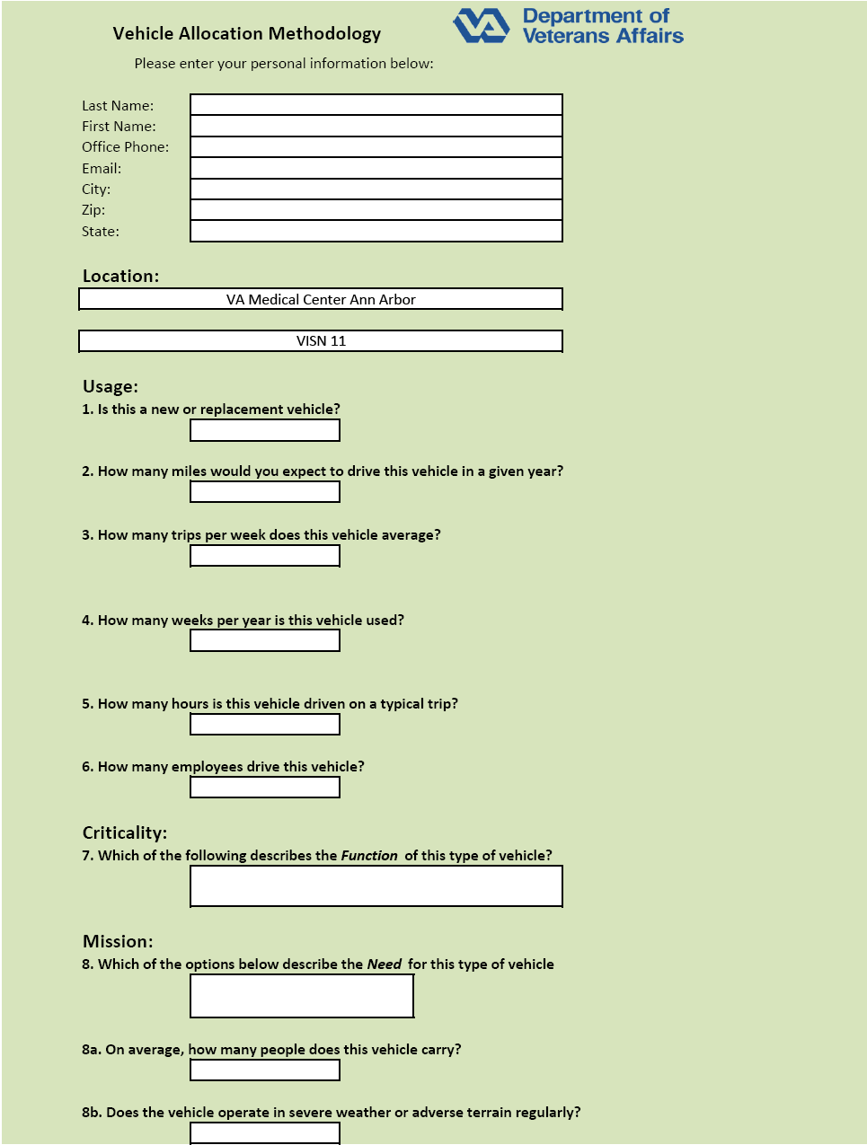
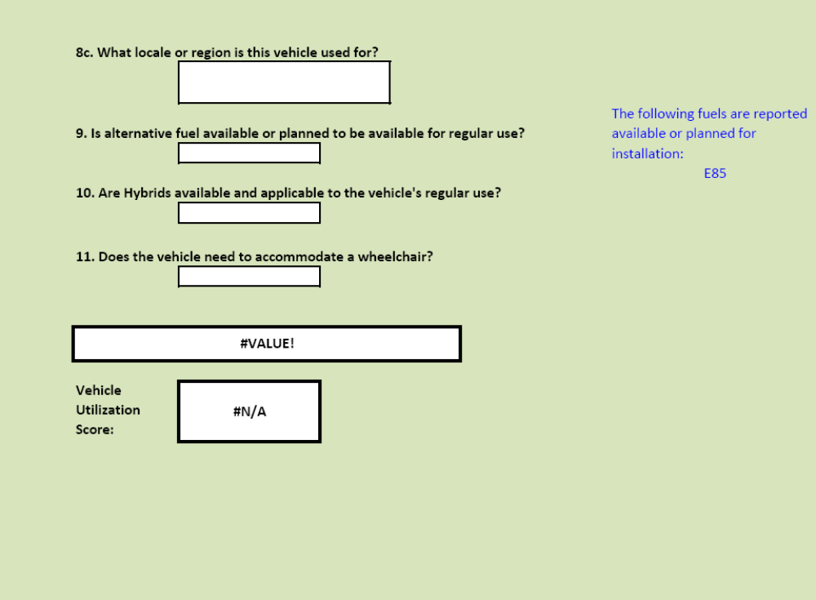
Figure 8: VA Vehicle Allocation Methodology (Page 2)

Appendix D
Sample Alternative Fuel Vehicle (Electric Vehicle) Information Sheets 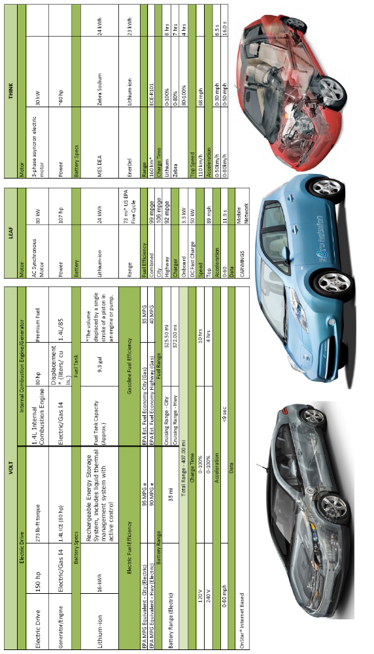
Figure 9: Vehicle Specs Sheet for Electric Vehicles Used in the GSA Pilot Program
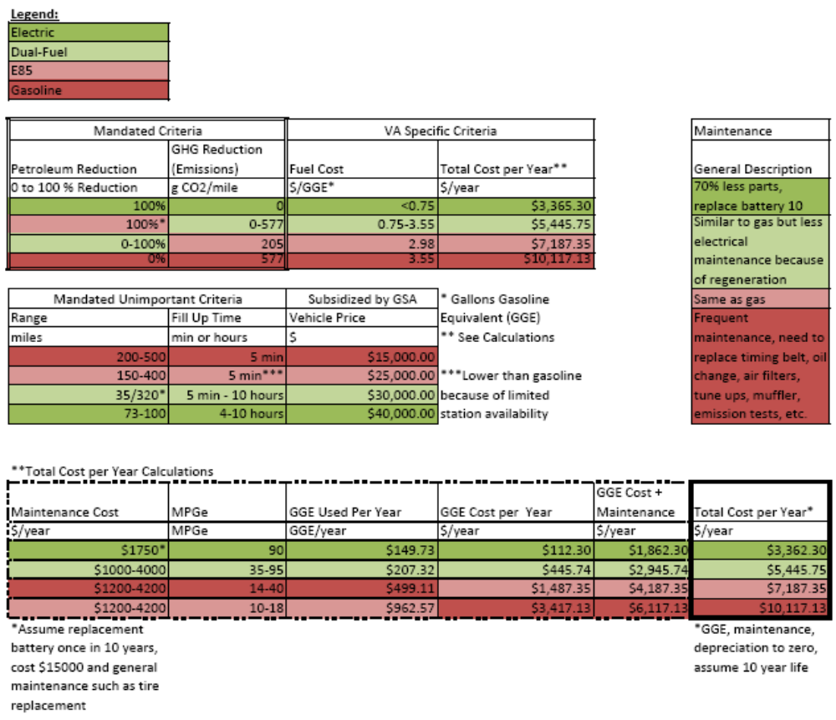
Figure 10: Cost/Benefit Analysis of EVs, Dual Fuel Vehicles, E-85, and Gasoline Vehicles

Appendix E

Vehicle Telematics Cost/Benefit Analysis from Fleet Pulse®

Table 5: Cost Savings of Telematics by FleetPulse
Cost Savings Achieved with FleetPulse® | Savings per Year ($)
Fuel Savings from Reduced Idling  30 minutes of discretionary idling can be reduced from an 8-hour driving day. Additional benefits: Longer engine life, fewer oil changes and better fuel economy.  Assumptions: 3.8L (or 1 Gallon) of fuel is typically consumed per hour for an idling light to medium duty vehicle. This rate is affected by many factors such as environment, vehicle options running, etc. | $288,990
Fuel Savings from Improved Driving Behavior and Vehicle Fitness  Reducing speeding occurrences, aggressive braking and acceleration while improving overall vehicle fitness lowers fuel costs. Additional benefits: Less wear on brakes, tires, engine and transmission, and improved public image and driver safety.  Assumptions: 4% average savings in fuel. Calculations assume 10L/100Km (23 MPG), 100Km/day (60 miles), 90¢/L ($3/gallon). | $60,840
Reduced Fuel Cost with Less Fuel Theft  Automatic and accurate tracking of vehicle fuel consumption coupled with billing record monitoring reduces abuse of fuel theft or slippage.  Assumptions: Calculation assumes a 3% reduction in fuel through decreased theft and 10L/100Km, 100Km/day, 90¢/L. | $45,630
Fuel Usage Credit for PTO Usage  Some governments give credit for fuel consumption while operating a vehicle-powered PTO. Convenient tracking of these events allow easy and timely applications.  Assumptions: Credit of 14.7¢/litre (55¢/gallon) was used. Idle fuel rate of 3.8 litres/hour (1 gallon/hr). 20 hours/week with PTO engaged. | $348,566
Reduced Number of Road Accidents  Accurate vehicle and driver data in conjunction with driver training programs can result in a substantial reduction of road accidents. Additional benefits: Reduced insurance premiums and driver costs, decreased delays associated with transferring from one vehicle to another, reduced equipment repair costs and improved customer service. | Lowered accident-related costs by significant %
Better Understanding of Total Cost of Ownership  With accurate vehicle information, more intelligent decisions regarding disposal and utilization across the fleet can be made. Additional benefits: Longer fleet life, better customer service and budget planning and peace of mind from a more reliable fleet. | Optimized  total cost of ownership
Reduced Green House Gas (GHG) and Other Air Pollutants  Reducing unnecessary idling and other detrimental driving behaviors will also reduce air pollutants such as CO2. Each litre (or gallon) of fuel consumed produces 2.4 kg (or 20 lbs) of CO2. Many commercial and government organizations have Clean Air programs that are difficult to monitor. FleetPulse allows easy monitoring of reduced idling by vehicle or driver. | Reduced  kilotons of  green house gas (GHG)
Increased Vehicle Utilization and Availability  Accurate fleet maintenance helps eliminate unnecessary down time, resulting in improved vehicle availability and usage. This helps to right size the fleet and reduce the total number of vehicles.  Assumptions: Calculation assumes an increase of 1% in equipment availability. This translates into seven additional vehicles available for new business or a reduction of capital and operating costs for seven vehicles within the fleet. | $39,000
Accurate Warranty Tracking  Combining accurate mileage and engine hour reporting with remote diagnostics allows for more accurate warranty tracking. Accurate warranty tracking reduces unnecessary purchases.  Assumptions: Calculation assumes one slip is caused by bad vehicle data each year. Annual savings/vehicle: $50/year. | $3,250
Annual Savings per Vehicle: | $2,479
Annual Savings per Fleet (based on 650 vehicles): | $1,611,296

Works Cited
CIO. (2010). Retrieved from UPS's New Telematics System Cuts Fuel Costs and Makes Drivers More Efficient: http://www.cio.com/article/355913/UPS_s_New_Telematics_System_Cuts_Fuel_Costs_and_Makes_Drivers_More_Efficient_
Department of Veterans Affairs - Office of Inspector General. (2007). Audit of Veterans Health Administration Vehicle Fleet Management. Washington, D.C.
DOE FEMP. (2010). Department of Energy Federal Energy Management Program. Retrieved from A Chronological History of Federal Fleet Actions and Mandates: http://www1.eere.energy.gov/femp/pdfs/fs_federal_fleets.pdf
Federal Automotive Statistical Tool. (2010). Department of Energy Federal Energy Management Program.
Federal Computer Week. (n.d.). Federal Computer Week - Strategy and Business Management for Government Leaders. Retrieved from VA CIO describes cloud, Blue Button and EHR programs: http://fcw.com/Articles/2011/05/05/VA-CIO-Roger-Baker-describes-cloud-Blue-Button-and-EHR-initiatives.aspx?admgarea=TC_HLS&Page=1
FleetPulse. (2011). Retrieved from Telematics Cost/Savings Analysis: http://www.netistix.com/resources/vehicletelematics/telematicscostbenefit.aspx
SRA International. (2010). GSA Schedule. Retrieved from http://www.sra.com/contracts/gsa-schedule/docs/GS-35F-4594G.pdf
U.S.C. (2011). U.S. Code. Retrieved from http://www.law.cornell.edu/uscode/42/usc_sec_42_00013211----000-.html

To see a full chronology visit the Department of Energy Federal Energy Management Program website listed in the Works Cited (DOE FEMP).
A directive is only effective if read. The analysis assumes the directive will be read, however, this may differ in real life. The reader should think about ways to distribute the information most effectively such as classrooms, conferences, or teleconferences.
Calculated by using the following assumptions: VA has 14,704 fleet vehicles. At roughly 70 vehicles per fleet, VA has roughly 210 fleets. Each fleet has one facility fleet manager with $50,000 salary, approximately 1 support clerk with $30,000 salary, and 21 VISN level managers with $80,000 salary. With overhead and benefits, costs are multiplied by 2.5. Assumptions are extremely conservative; it is likely that the number is higher.
Calculated by using the following assumptions: Contractor costs at $200 an hour (SRA International), working for 6 weeks, 3 hours a day, 5 days a week. Using this estimate cost is $18,000; a more conservative estimate is $20,000.

