**Homework 04: Nonparametric Regression**

I wrote Nonparametric Regression using R programming language by following the steps below.

1. I read file “hw04_data_set.csv” using the data_set variable.
2. I split the data into two as training and test data.
3. Set bin width and origin parameter.
4. I calculated left_borders and right_borders.
5. Regressogram for calculator p_head values. (Formula: 8.24 books)
6. Plot drawing in the below.
7. Drawing a lines in the below .

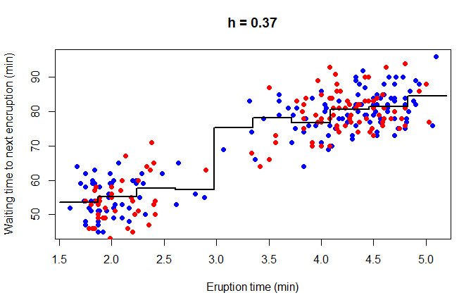

1. Calculator RMSE in formula.
2. Running mean smoother for calculator p_head values. (Formula: 8.25 books)
3. Plot drawing in the below:
4. Drawing a lines in the below .

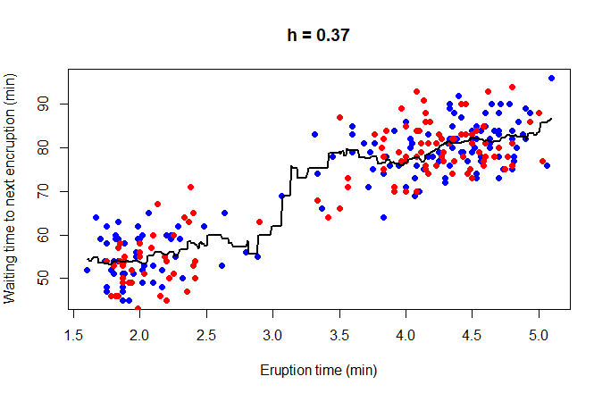

1. Calculator RMSE in formula.
2. Kernel smoother for calculator p_head values. (Formula: 8.26 books)
3. Plot drawing in the below:
4. Drawing a lines in the below .

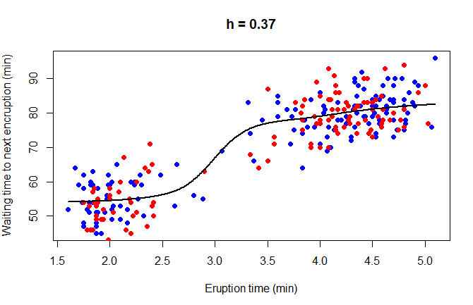

1. Calculator RMSE in formula.

Şeyhmus Aydoğdu