CSC236 Programming Assignment

# IA64

For this assignment, we are going to use an online tool, Compiler Explorer, to investigate 64-bit assembly language code.

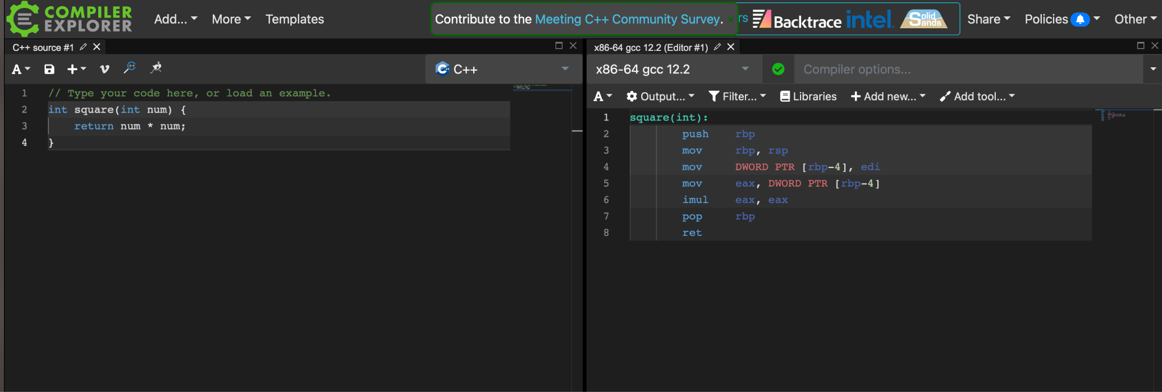

**Go to https://gcc.godbolt.org**

**Paste in the C code from the RLC assignment**

**Create a text file named ia64.ans and answer the following questions**

**Choose "x86-64 gcc 12.2” as the compiler**

1. How many instructions are written?
2. Find an instruction that we did not go over in class and describe it in your own words
3. Set compiler option to “-O1”, what happened to the number of instructions?
4. Find another instruction that we did not go over in class and describe it in your own words
5. Set compiler option to “-O2”, what happened to the number of instructions?

**Change compiler to “arm64 msvc v19.33” with no compiler options**

1. How many instructions are written?
2. Find an instruction that we did not go over in class and describe it in your own words
3. Set compiler option to “-O1”, what happened to the number of instructions?

**Submit your ia64.ans file**