(a) 000001000100000101 (read access)

->000001 000100000101

Page number is 1, which is mapped to frame 0 in the physical memory.

TLB HIT

Physical address=0000 000100000101

Page Table

virtual page frame valid dirty read-only reference

0 2 1 0 1 0

1 0 1 0 0 1

2 1 1 0 1 1

3 5 1 0 0 1

4 3 1 0 0 0

TLB

virtual page frame valid dirty read-only reference

2 1 1 0 1 1

1 0 1 0 0 1

(b) 000000000011000100 (write access) ->

000000 000011000100

Page number is 0, which is mapped to frame 2 in the physical memory.

TLB HIT

Physical address=0010 000011000100

Since it is read only, we can’t write it.

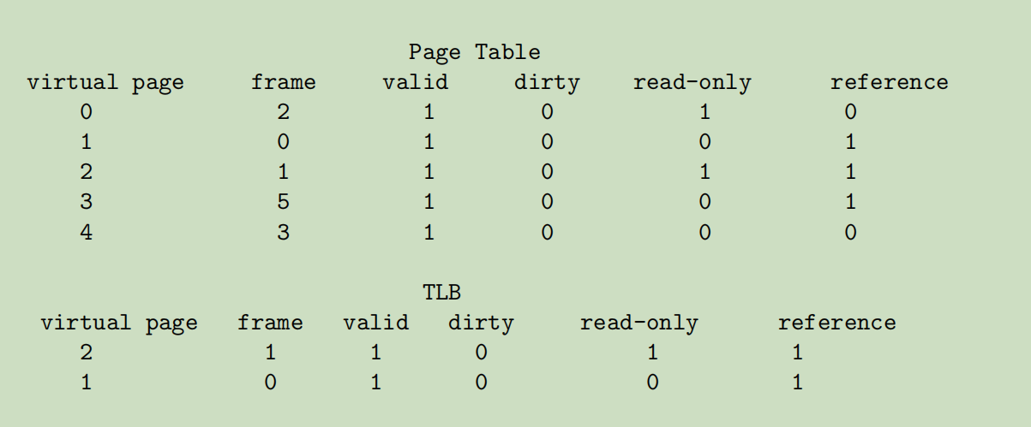

(c) 000011000101100100 (write access)

-> 000011 000101100100

Page number is 3, which is mapped to frame 5 in the physical memory.

Physical address=0101 000101100100

TLB miss

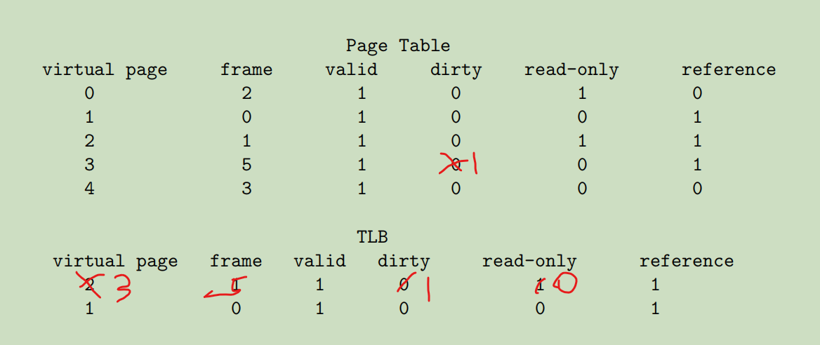

(d) 000010000101010100 (read access)

-> 000010 000101010100

Page number is 2, which is mapped to frame 1 in the physical memory.

Physical address=0001 000101010100

TLB miss

