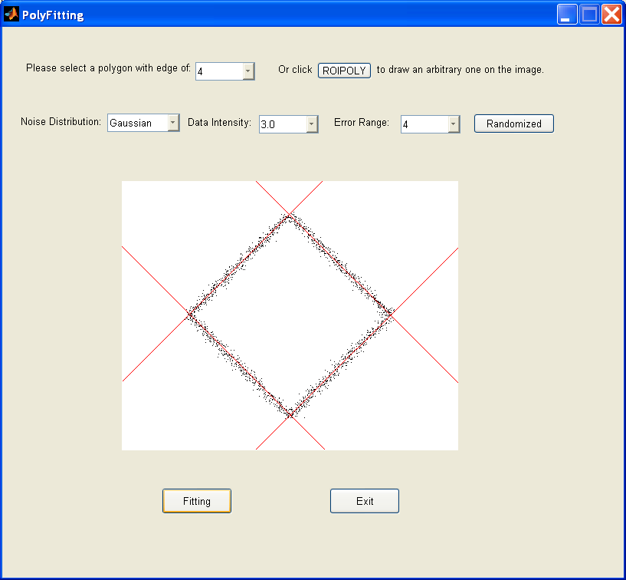

As shown in the figure, we first need to create the polygons for grand truth. This can be done in two different ways. One is to choose the edge number for polygon from the popup menu to create pre-defined polygons. Another way is to click "ROIPOLY" button to draw an arbitrary polygon on the image using mouse, which is done by calling roipoly() Matlab function.
After a polygon is created by either of the above methods, we can generate some random simulated data for the polygon by clicking on the "Randomized" button. Three parameters are used to control the random data generator.
The first parameter is used to determine the noise distribution, which could be either Gaussian or uniform distribution. The default value for the popup menu is Gaussian distribution. The second parameter is used to indicate the density of the random data generated around the edges of the polygon. And the third parameter is error range in pixels around the true point coordinates. This error range is the standard deviation for Gaussian distribution and half of the uniform distribution. For example, if the parameter set is ('uniform', 3, 4), this means the distance from random data to the line could be between -4 pixels to 4 pixels (4.0*randn() for Gaussian distribution) and there are 3 points generated for each point (pixel) along each edge of the polygon.
After the "Randomized" button is clicked, a set of simulated "Point Cloud" is generated around the edges of the polygon. The point cloud data is used as the input for line fitting to recover the polygon. Right now, I am using Hough Transform (HT) for line fitting. By clicking on the "Fitting" button in the bottom of the image, we can see the result of the line fitting. I have not calculated the intersection points from the fitted lines to get the vertices of the polygon yet, which will be one of my next step tasks.

Known bugs:
1. Sometimes, multiple lines are fitted for the random data of the same edge.
2. When the edge is short, it cannot be detected as a line. This is because of the HT implementation. I will fix it soon.

