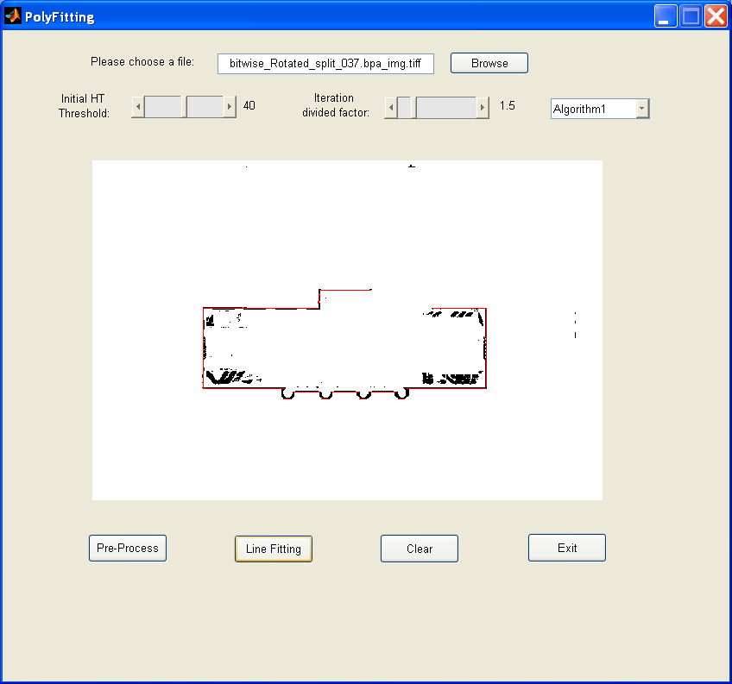

A result based on real data is shown in the above figure.

1. Data loading and conversion.
The image files are generated from the original .bpa files using "hunter_load_data.m" written in Matlab. The images are of size 360x540, which can be set to other size to regenerate the images by changing the parameters in hunter_load_data.m. The coordinate data for images are extracted from column 1 and column 3 in .bpa files and times 5 to be fit into 360x540 resolution. The image files are saved in tiff format.

2. Parameters for Hough Transform
The first parameter as shown in the above figure is the initial threshold for HT and the second one is the iteration divide factor, which determines the pace of decrease of the HT threshold. For example, assuming initial threshold is 40, and divide factor is 1.5. Then, in the first iteration, the HT threshold is 40, and in the second iteration, the threshold is 40/1.5, the third iteration threshold is (40/1.5)/1.5... until all the data have been fitted into lines.

3. Pre-processing algorithms.
Because the images contain a lot of noise, the pre-processing on images is needed in order to apply our recursive HT. Two strategies are implemented to improve the image. The first algorithm is to do thinning on the images, then all the connected components (CC) are computed. Based on these CCs, the noise outside and inside of the building are removed.
The second algorithm is trickier: After removing the noise pixels outside of the building, a scanning processing is used to find out out-most pixels of the building from four directions (left, right, top, bottom).
We can choose either algorithm to do the preprocessing by selecting "Algorithm1" or "Algorithms2" from the popup menu.

4. Performance improvement.
With the original Matlab HT code, the computing for HT takes more than 20 seconds. In order to speed up this computation, I rewrote the core HT code in C++ and let Matlab code call the HT function generated by the above c++ code (myht.mexw32) to speed up the computing. Now, it takes less than 1 second to do the HT. The two preprocessing algorithms are also implemented in C++ (preprocess.mexw32 & preprocess_2.mexw32)

5. The functional buttons.

"Pre-Process": show the pre-processed image.
"Line Fitting": show lines fitted on pre-processed image.
"Clear": clear the red fitted lines.
"Exit": quit the program.

Future work:
1. Improve the pre-processing algorithm to improve the image.
2. Try to infer the missing data to generate closed shape/polygon.
3. Try SNAKE or other algorithms and compare these methods.

