Project Progress

1. Key slice detection from the other two directions.
Done: see the below section of algorithm descriptions.
2. Model representation
* Extrusion: represent the whole boundary up to a height for extrusion
??? (improve) Can we break the whole boundary into parts, and extrude each
part to different height.
* Tapered: case1: Line to point
case 2:Long line to short line
case 3: Partial long line to short line
0. the represent is a 3D/2D coordinate, which enables any resolution.
1, define base polygon points, just like regular ascii file. BEGIN/END POLY
2, define end points for each base point,
3, first define a representation file, then generate a layered images, and then 3D
dxf file.
Example :
BEGIN POLYGON
x1, y1
...
TAPERED? (EXTRUSION, no further coords info, followed by HEIGHT)
x1', y1'
...
HEIGHT
z
END POLYGON

3. Tapered structure inference
* ASSUMPTIONS:
*. the corner points between layers lie on a straight line
*. all corner points converge in same speed, namely, there is no such case where some points are keep unchanged. we need a treatment for this case.

* step1: detect the line part and track the line accordingly
assume we know the starting height of the tapered structure, we can first apply line fitting or line regression on the data to find the long lines. To track the line changes, see below:

* step2: detect the changed set of points and unchanged set of points
first do dilation on the previews polygon lines. then test the current lines projected to the previews dilated image to track the changed lines.

* step3: find the corresponding points between two slices
find the feature points to locate the correspondings. the feature point could be
I : a corner point, which means the angle between its two adjacent point is big and similar between the 2 slices.
II : heuristic matched points. For example, assume two adjacent points has been
found, for the third slice, one can make use of the proportion relation among these slices to get a hypothesis point, and then prove this hypothesis based on real data.
III: after finding a bunch of layers of corresponding points, we could apply data fitting or line regression in 3D to get the line and compute the intersection points for the bottom and top layers, so that we can record these points accordingly.
* Need to figure out the order of these points, which has been lost.
IV: Or we should use RANSAC algorithm to get the correct line, since this method will ignore those outliers, and focus on true data.

Q1: How to find the exact corner points where more than corner points are existed as the polygon points.
1. use HT lines, and compute the intersection point, which has been done in the code. BUT, it is not good for this case, since there are one more intersection. To solve this issue, one can test the correctness of a point: starting at this point, compute the two directions, which lead to data points; testing the distance from this point to the nearest data point.

2. use long segments, and try to remove the short, intermediate one. for the bottom big base slices, one can choose the long lines, and merge those short line. for the top small slices, one can extend the bottom corner points to current slice. BUT, in reality, there might be no long lines, only short lines, with slightly different slope.

3. may have to combine 1 and 2. Namely, first apply 1 when the boundary lines are long enough, but after several iteration, use 2 instead, because it is hard to precisely define the HT lines.

Q2: How to find the corresponding points between two layers.
1. use hypothesis testing: * find the NEAREST feature point. * test the correctness by comparing the angle based on this feature point and its corresponding previous feature point. Give a warning message if they do not match.

* step4: preprocessing on the other direction to get the polygon of the projection

* step 5: verification processing to make sure the detected tapered structure is correct. use a objective function to minimize the error.

4. Implementation
P1: for the rep2.txt in the NDoc/project/current folder, the No. 35 slice is wrong because of the pixels lit by the long low slope line. Another problem is assert(6) (line: 11572) error in rev. 365.
Solution for P1: I would be able to re-implement the algorithm using pure math computation in stead of the current st_table based method.

To-Do list:
* Generate DXF format from left-right bound slices
* Segment the structure of the roof, and get the tapered representation.

Related Information

- Gene Yu’s dissertation proposed was on May 1st, 2008.
THESIS: PIECEWISE PLANAR RECONSTRUCTION FROM RANGE DATA
ABSTRACT: Modern range scanners can capture the geometry of large urban scenes on an unprecedented scale. While the volume of data is overwhelming, urban scenes can be approximated well by parametric surfaces such as planes. Piecewise planar representation can reduce the size of the data dramatically, and it is ideal for rendering and other high-level applications. We propose a method for extracting a piecewise planar representation from a collection of range images. Central to our approach is a novel segmentation algorithm that extracts a piecewise planar function from an individual range image. Many existing methods for large datasets utilize local surface fitting for speed, at the expense of verifiably planar output components. Our novel framework unifies local and global fitting to guarantee truly planar components. By concentrating on the segmentation problem early in the processing pipeline, our goal is to simplify subsequent 3D modeling and rendering stages by replacing raw data with high-level 2.5D primitives. To demonstrate the effectiveness of our approach, we propose a method for converting the segmentation results into a triangle mesh suitable for rendering using a standard 3D graphics engine.

- Hadi Fadaifard’s second exam was on May 28th, 2008.
THESIS: 3D SHAPE MATCHING USING GEOMETRIC FEATURES: A SURVEY
ABSTRACT: 3D shape matching refers to the process of determining the amount of similarity between two 3D shapes. A large class of matching methods use feature-based descriptors to determine shape similarity. The use of these descriptors, or feature vectors, enables the 3D matching methods to be applied to a large class of 3D problems such as registration, shape retrieval, shape recognition and classification. In this paper we provide a survey of feature-based approaches to 3D matching, particularly as they apply to global and partial shape matching. Partial shape matching is a more difficult problem than global matching, since the location, size, orientation, or overlap of the 3D models that need to be matched are not known a priori. To alleviate this problem, the majority of partial 3D matching methods use some criteria to pick salient or distinctive points on the models, referred to as feature points. We investigate the different criteria used in selecting these feature points.
Algorithm for Key Slices detection from other direction

Algorithm – based on slope (not used)

If we have found a key slice in the other directions, say Y axis, it is trivial to map it back to the corresponding slice or slice range in the original slices. The method is to reverse compute the slice number in the function load_point_cloud_as_image(). See the formula details in the comments at the beginning of this function.

The big problem is the key slice definition. It should be a range based on curvature. However, for different slice, this range may change. Usually, the center of this range is kept. So we can compute the center of each curvature, which is relatively stable, as well as the range for this curvature, which varies in certain range. A key slice here is really a range of curvature.

For each slice, we can find some curvature range and its center. For other slices, we might find some other curvature and centers. So we have to vote for these curvature and centers to determine whether they are real curvatures or just some noise from BPA and data acquisition or unstable structures. Some centers may very close to each other. If most of their range is overlapped, then we consider them as the same curvature. This is used for voting. Therefore, we need a data structure to store the center and the range of the curvature. For two curvatures, if their centers are very close to each other, say less than 2 pixels, AND the range are overlapped, then, we treat them as the same curvature.

For all curvatures found, to map them back to the key slices, we have to define two key slices for each range. The low-bound and upper-bound key slices of the curvature range. Depends on the size of the range, we need to get more than 1 key slice among the range. The first one is of course the center of the curvature. Between the low-bound and upper-bound key slices, we might need to create another 2, or 4, or 8 key slices.

Some curvature range might not be symmetry to each other. So the center of the curvature should be defined as the point which is the most far away from the track. This applies except the upper ledger of the building, which the center might be a small range.

To find a curvature, we go through the BPA points. Predefine a primary direction or slope of two consecutive points as the criteria slope. If the slope for two points is close to this criteria or the second point’s X axis is close to the first one, go to the next point. If the slope is away from the criteria and the second point is not far away from the first point, keep looking into the next one. If the next on is the same thing as the previous one, write the previous one as the starting point of the curvature; also keep track of the point most far away from the track as the center point. As the point observed started fall back to the track, record the last point as the end point of this curvature. Check the distance between the center point and the track; also check the number of points in this curvature to make sure this is a good curvature. If a good curvature is found, try to search for existence of this curvature in the array based on the Y axis of the center point, and the overlap of the curvature range.

Pseudo code –

Compute_curvature (curvature_arr, primary_slope)
Vector curvature_arr;
Float primary_slope
{
While (point has not reach the top point)
{
// compute the slope of two points.

// check the slope with primary_slope and the distance between these two points to see whether they could be considered as a starting of a curvature.

// if this point is not a curvature point, and a curvature is identified, set this point as a end point of the curvature; and search for this curvature in the
array of the curvature – search_for_curvature().

// if this point is a new point of the current curvature, compute the out-most point for center point of the curvature.

// if a possible curvature is found, record the starting point of this curvature, and the most out point see so far.

}

}

Search_for_curvature(curvature_arr, curvature)
Vector curvature_arr;
Curva curvature;
{
Bool found = false;
// curvature is ordered in the array
forEachArrayItem(curv)
{
// check the center of the curvature with curv. If > curv+delta, continue.
// If < curv – delta, insert this curvature before this curv in vector; break;

// if |curvature – curv| < delta
// compare the range of this curvature. Adjust the range if necessary

}
}
Algorithm – based on points (currently adopted)

Alternatively, we have another way to find the curvature, if they are. The idea is to only look at X and Y axis, and find out the curvature part of the points. We can assume that the curvature parts only have limited length, so we can check the input data one by one. We define a reference point of X axis as the median point of the observed point set. This reference point will be dynamically changed when a new curvature is found, and a new searching processing for the next curvature is started. For the implementation, to simply the searching of the median point, one can order the observed vector at the beginning, and each time, when a new point is observed, it is trivial to be inserted into a right position in the vector.

If the current visiting is NOT IN a curvature, and if the point just visited is FAR enough to its previous point or the OFFSET of the X axis between this point and the reference point is smaller than a threshold, then this new observed point should be consider a new point of non-curvature point, and one should add this point into the point vector for median point adjustment.

If the current visiting is NOT IN a curvature, and if the point just visited is CLOSE enough to its previous one and the OFFSET distance between this point and the reference point is BEYONG the threshold, then one should treat this point as a starting point for a curvature, that is a new curvature is found. Once a new curvature is identified, one should stop adding point into the median point set, and set the status as IN a curvature. In order to characterize this curvature, three attributes of the curvature is recorded: the center, the low bound and the high bound of the curvature. At the beginning, all these three attributes are set to be the starting point.

If the current visiting is IN a curvature, and the point just visited is FAR enough to its previous point or the number of small slope accumulated from the starting point is larger than a threshold, then it should be consider as going out of the curvature, and start to reset all control variables, including curvature region variable, median vector, small slope number, sign variable. Also we need to update the high bound of the curvature, add this curvature into array and create a new curvature structure for next round computation.

If the current visiting is IN a curvature, and the conditions do not satisfy any of above ones, then, this point it is still consider in the curvature. The following things need to be updated: if the slope between this point and its previous point is small, than increase the small slope number by 1; to update the center point, one has to know which direction the curvature is reside, say left or right, a sign variable is used to determine and store this information. In our system, if sign is less than 0, the curvature is facing towards the left; otherwise, it faces toward the right.

// test this later.
If the total number of points found in the curvature is less than a threshold, then we should discard this curvature. The reason is that the false alarm might occur because of the 2nd condition.
Algorithm for merging curvatures

The above algorithm will generate all curvatures for a particular image slice. To detect key curvature for the whole layer, one could union all these curvature and could treat them as key slice regions. However, this might introduce a lot of false alarm. That is, some curvature detected by the above approach might not be accurate. To make the key slice detection more reliable, one can vote each curvature from each slice and select those curvature whose appears is larger than certain threshold.

Before voting for each curvature, one can also set a cur-off height based on the prior knowledge about the building. For example, one could know the starting point of the roof structure. Since the roof structure usually causes some trouble or confusion for curvature detection, set the cut off at the bottom of the roof is a good idea. All curvature beyond this point can be ignored.

Currently, we only choose a curvature's low and high boundary value as two criteria and insert them into the key slices. One could also add more criteria, such as the center of the curvature. The more we add, the more key slices we have and therefore the more details we will obtain for the final model. But we also need more space to store this information. Each key slice is checked whether it has been recorded in the global key slice array. If there exist a key slice close enough to this key slice, the counter of this exist key slice is increase by 1. Otherwise, we add this key slice as a new slice into the global key slice array. When all curvatures in all slices have been checked, we obtain a global key slice array together with the number of time they appeared in all the slices. As mentioned, before, some of curvature might be noise and should be removed based on a counter threshold. After this removal, we obtain an array of key slice position, which can be further incorporated into the standard key slice detection procedure.

The following figures show a slice of image and the final detected curvatures at the same scale.

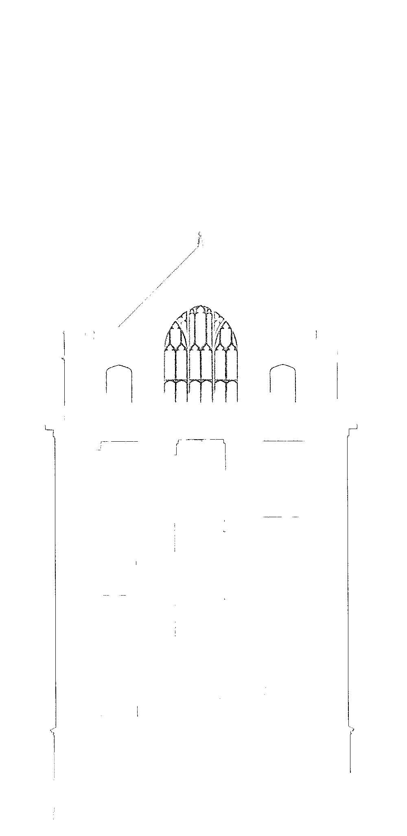

Algorithm for combination of BPA and HT

The adaptive ball-pivoting algorithm will generate the boundary of the image accurately and effectively if there is no noise data on the data. In real life, especially for the range data, noise is always existed. The BPA algorithm is very sensitive to the noise []. Though we have tried to remove most of the noise during the pre-processing via bounding box, the noise around the boundary might still cause trouble.

To tackle this problem, we could combine BPA with Hough transform as a post processing. The intuition behind this hybrid method is that HT is capable of computing the global boundary lines and therefore is less affected by noise data. On the other hand, HT is not so accurate compared with BPA. By combining two methods, we could get an more accurate boundary from the images.

The inputs for the combination include the output of adaptive BPA process (a set of boundary vectors) and the results of Hough transform line segments, which was introduced in the section [xxx]. The rough idea for combination is first doing image dilation on the BPA boundary image. And then for each HT line segment, checking whether most of its body, say 90%, is lying on the dilated part. If so, removing all the intermediate points in the BPA point vector.

In detail, after HT, the line segments have been sorted from long to short. To make sure a robust replacement, choose a threshold (40 pixels) to rule out short lines. This ensure that the line segments detected by HT are effective. Now, the HT lines are stored in replace_lines, and ready to be used as a substitutions for BPA points. A dilation image of the BPA skeleton has been generated, the width is define by HT_MASK in clear_data() function. This image is used as a reference, in which each HT lines are mapped back. By counting what percentage of the HT line segments in pixel is falling inside the dilation image, this HT line is determined whether it should be used as a substitution or not. If most of its pixels (90%) are falling inside the dark dilation region, it is chosen to replace some boundary points.

If a HT line segment is chosen to replace BPA points, two BPA points, closest to HT line segment's two end points respectively, are computed. On the other hand, the HT line segment's pixels are checked from each side, until two pixels are found to close enough to the BPA points. Therefore, two new pixels on the HT line segments are determined, so that extra pixels of HT line can be removed. Once all the above information is computed, the remaining task is how to replace part of the BPA points with this new HT line segment.

General speaking, each BPA boundary is a closed boundary and might consist of a couple of sub closed boundaries. In our implementation, a closed boundary is represented or stored using a point vector. For example, for a length of n point boundary, the index of the boundary could be 0, 1, 2, ... , n-1. The point stored in index 0 and index n-1 is the same. Now, suppose we found that two closest BPA points to the HT line segments two end points is 5 and n - 5. Since it is a closed boundary, there are two possible ways to replace the middle points of BPA point vector: remove all points between index 5 and index n-5, which is straightforward. Another way is keep all points between 5 and n - 5, but remove all points starting from 0 to 5, and points between n-5 and n-1. To find out which way to use, we observed that usually the number replaced points are much smaller than the total number of boundary points. Therefore, for any two points to be replaced, we compute the number of points for the above two cases, and choose the way containing smaller number of points to work on.

As a matter of fact, the middle points were not really removed from the vector during each HT line segment computation. Instead, they are just marked for further process. After all HT line segments are checked, the final point vector is computed as following: go through each point of the original point vector, if a point is not marked, it is pushed into the final point vector. Or if it is marked, but it is a starting or ending point of the replaced point, it is pushed into the vector too. In other words, only those points which were marked and were not the end points of the HT line segments are removed.

The following two images show the two results of boundaries, BPA boundary and BPA+HT boundary:

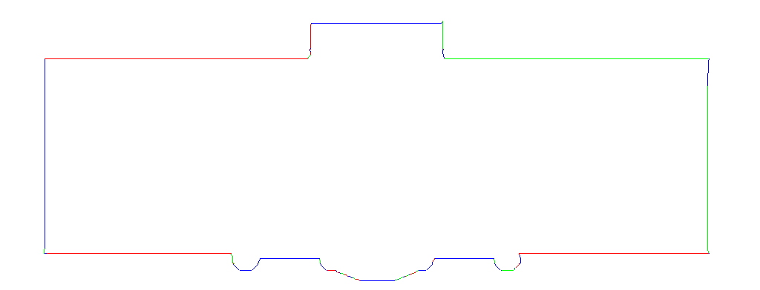
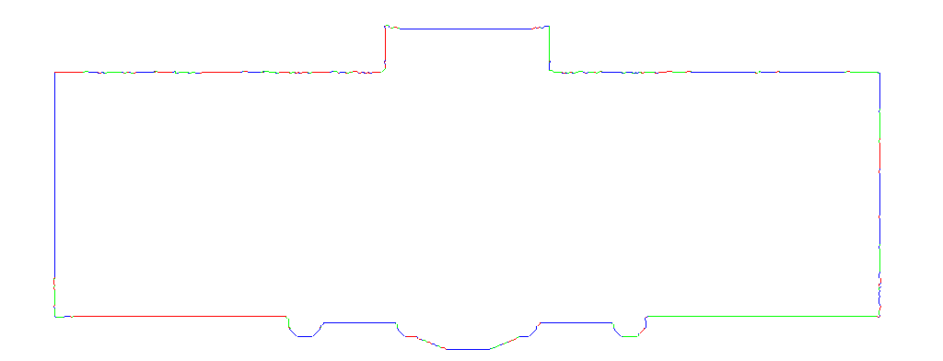

Algorithm of adaptive BPA

an old try for boundary detection. Namely try to find the next point in certain local region in certain angle. What's the problem?

Ball pivoting algorithm was first proposed for inferring planes from 3D range data. Here, we borrow it from 3D to 2D image for boundary detection. The algorithm itself is very straightforward, which pivots a ball around an axel in 3D or a circle around a point in 2D until it touches a new point.

In our 2D case, we could just sweep the image from 4 directions to get the boundary points of the image. However, there are some drawbacks on this method: our data is very noisy, so sometimes the sweep might give us some unwanted boundary points, for example, for a gap region, there are some points reside far away from the gap surround points. Second, there are some occlusions among the structures, which makes the sweep algorithm not applicable. To conquer these problems, we introduced 2D BPA algorithm for boundary detection.

The key point of this algorithm is the selection of the ball size. Since there are some gaps and missing data in the range data, if the ball size is too small, the boundary will be separated by the gaps, which is not desirable. On the other hand, one shall lose a lot of fine structure when the ball size is too big. To conquer these problems, we proposed an adaptive size of the BPA algorithm for boundary detection, which consists of regular BPA and the refinement of the BPA.

The regular BPA on 2D image

Algorithm for BPA refinement

Algorithm for Adaptive HT

Algorithm for breaking a boundary into multiple boundaries

Algorithm for inferring tapered structure

The basic idea is to avoid shape inference, no matter it is rectangle, circle or any shape, we should be able to come up with a generic algorithm to detection the tapered part.

we can work with the line segments one by one, detect the unchanged part and changing part in a series of slices.

Characteristics of the System:

* Cross-platform - Windows v.s. Linux
* Automatically compression and concise representation.

Thesis Framework

Abstract

1. Introduction

2. Related Work

2.1 Procedural Modeling of Buildings

2.2 Reverse Engineering

2.3 Medical Image Reconstruction

