1 列名不能有mysql的关键字，可查阅下表1-1。

2 默认csv文件第一列为主键，不能有重复数据。单前不支持多主键，之后有需求再改。

3目前支持的列的类型有 int，bool(值用1和0表示对错)，float，date，string 5种类型，支持大小写。int,float若为空，默认为0.

4 默认建表字符串长度为200，当表的某一列的汉字超过200个时，插入会失败。这个之后有需求再修改。

5 当前支持日期的格式 yyyy-MM-dd hh:mm:ss(年-月-日时:分:秒)， yyyy-MM-dd hh:mm， yyyy-MM-dd hh， yyyy-MM-dd。

6 csv 前三行分别代表列名，列的类型，列的注释。列名和列的类型不能为空、列的注释。

7 单前读取csv的编码格式为utf-8，要统一，不然中文会乱码。可通过 NotePad 打开csv文件查看编码。如下图。

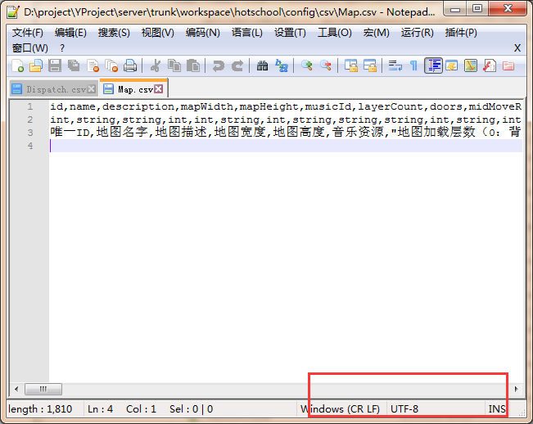

网上找了一个mysql的保留字列表，仅供参考。

|  |  |  |
| --- | --- | --- |
| ADD | ALL | ALTER |
| ANALYZE | AND | AS |
| ASC | ASENSITIVE | BEFORE |
| BETWEEN | BIGINT | BINARY |
| BLOB | BOTH | BY |
| CALL | CASCADE | CASE |
| CHANGE | CHAR | CHARACTER |
| CHECK | COLLATE | COLUMN |
| CONDITION | CONNECTION | CONSTRAINT |
| CONTINUE | CONVERT | CREATE |
| CROSS | CURRENT_DATE | CURRENT_TIME |
| CURRENT_TIMESTAMP | CURRENT_USER | CURSOR |
| DATABASE | DATABASES | DAY_HOUR |
| DAY_MICROSECOND | DAY_MINUTE | DAY_SECOND |
| DEC | DECIMAL | DECLARE |
| DEFAULT | DELAYED | DELETE |
| DESC | DESCRIBE | DETERMINISTIC |
| DISTINCT | DISTINCTROW | DIV |
| DOUBLE | DROP | DUAL |
| EACH | ELSE | ELSEIF |
| ENCLOSED | ESCAPED | EXISTS |
| EXIT | EXPLAIN | FALSE |
| FETCH | FLOAT | FLOAT4 |
| FLOAT8 | FOR | FORCE |
| FOREIGN | FROM | FULLTEXT |
| GOTO | GRANT | GROUP |
| HAVING | HIGH_PRIORITY | HOUR_MICROSECOND |
| HOUR_MINUTE | HOUR_SECOND | IF |
| IGNORE | IN | INDEX |
| INFILE | INNER | INOUT |
| INSENSITIVE | INSERT | INT |
| INT1 | INT2 | INT3 |
| INT4 | INT8 | INTEGER |
| INTERVAL | INTO | IS |
| ITERATE | JOIN | KEY |
| KEYS | KILL | LABEL |
| LEADING | LEAVE | LEFT |
| LIKE | LIMIT | LINEAR |
| LINES | LOAD | LOCALTIME |
| LOCALTIMESTAMP | LOCK | LONG |
| LONGBLOB | LONGTEXT | LOOP |
| LOW_PRIORITY | MATCH | MEDIUMBLOB |
| MEDIUMINT | MEDIUMTEXT | MIDDLEINT |
| MINUTE_MICROSECOND | MINUTE_SECOND | MOD |
| MODIFIES | NATURAL | NOT |
| NO_WRITE_TO_BINLOG | NULL | NUMERIC |
| ON | OPTIMIZE | OPTION |
| OPTIONALLY | OR | ORDER |
| OUT | OUTER | OUTFILE |
| PRECISION | PRIMARY | PROCEDURE |
| PURGE | RAID0 | RANGE |
| READ | READS | REAL |
| REFERENCES | REGEXP | RELEASE |
| RENAME | REPEAT | REPLACE |
| REQUIRE | RESTRICT | RETURN |
| REVOKE | RIGHT | RLIKE |
| SCHEMA | SCHEMAS | SECOND_MICROSECOND |
| SELECT | SENSITIVE | SEPARATOR |
| SET | SHOW | SMALLINT |
| SPATIAL | SPECIFIC | SQL |
| SQLEXCEPTION | SQLSTATE | SQLWARNING |
| SQL_BIG_RESULT | SQL_CALC_FOUND_ROWS | SQL_SMALL_RESULT |
| SSL | STARTING | STRAIGHT_JOIN |
| TABLE | TERMINATED | THEN |
| TINYBLOB | TINYINT | TINYTEXT |
| TO | TRAILING | TRIGGER |
| TRUE | UNDO | UNION |
| UNIQUE | UNLOCK | UNSIGNED |
| UPDATE | USAGE | USE |
| USING | UTC_DATE | UTC_TIME |
| UTC_TIMESTAMP | VALUES | VARBINARY |
| VARCHAR | VARCHARACTER | VARYING |
| WHEN | WHERE | WHILE |
| WITH | WRITE | X509 |
| XOR | YEAR_MONTH | ZEROFILL |

表1-1